Introduction to irreducible polynomials.

A simple problem. We begin our introduction to the notion of an ‘irreducible’ polynomial with a simple problem, that of solving the equation 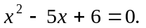 Coming straight from school the usual approach to solving that equation is to do something like this:

- First, factorize 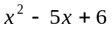by noting that 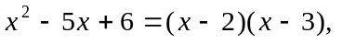
- Note that whenever 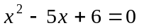then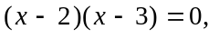
- Note that whenever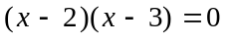then either 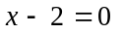or 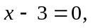and so
- Finally the solutions of are 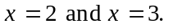

Many equations - and not just quadratic ones, like here - can be solved in this way.
However - and this is what these notes are about - not all equations like the above can be solved by ‘factoring’; one would informally say that there are quadratics that do not factor ‘nicely’. We have to give a precise meaning to what we mean by ‘nicely’, and that is what I now move on to do.

Another simple (looking) problem. Let us now try to solve the quadratic equation 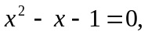and again let us try to solve it by ‘factoring.’ Coming straight from school the usual attempts tend to entail nothing more than trying to make the following sort of ‘fit’: 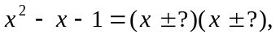 and, since the constant term on the left hand side is ‘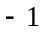’, then say something like: ‘oh, the only possible looking factorization is this one: 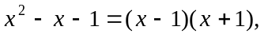which is obviously false since 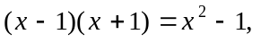
which is not the same as 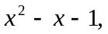since it has no ‘’ term in it.’

A widening up of the factoring approach. That naïve attempt is simply too limited, as there are many, many other possible factorisations. For example, it is not just
x times x that gives x squared, but also - e.g. - 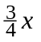multiplied by 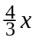also gives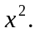 Thus here is a possible factorisation of 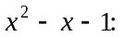 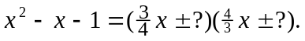
And now, what about the other terms in the brackets? Here is a possible ‘fit’: 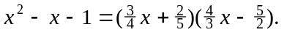 That is a possible fit because 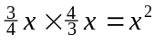and 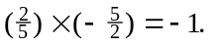 However it does not lead to an overall complete factorization because the other terms - the 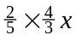and 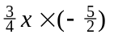- do not come together to produce the ‘middle’ term, namely Instead they tidy up to produce:

which is not But that last effort is only one of an infinite number of other possible attempts at a factorization of and the question we now ask ourselves is this: is there a successful factorization of 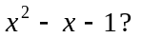

We are at the point at which we have to be very careful as to what we mean by a (nice) ‘factorization.’ By a ‘rational’ factorization of 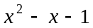 we mean having:

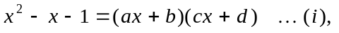

for some 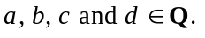 Thus, in our attempted factorization above, we had 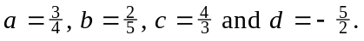

Now one could (and you should) try many possible combinations of values of a, b, c and d, and each time one would find that one had not obtained an actual factorization of 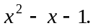 However, could one draw any conclusion from that? Not really. It would not answer the question as to whether there was a factorization; one would merely know that one hadn’t found one.

Now we come to the fundamental point: does not factor ‘nicely.’ Meaning? Meaning there are no rational numbers of a, b, c and d such that 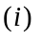holds.

This brings us to our formal definition (which I am giving for quadratic polynomials, but I should point out that the definition is easily extended to polynomials of degree greater than 2, which I will comment on later, but just briefly in passing):

Definition. Let then 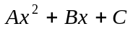is said to be reducible over the rational numbers Q if 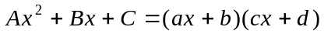
for some 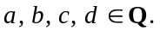 If is not reducible over Q then it is said to be irreducible over the rational numbers Q.

Examples. All of the following polynomials are reducible over Q, because of the factorisations that I give for them:

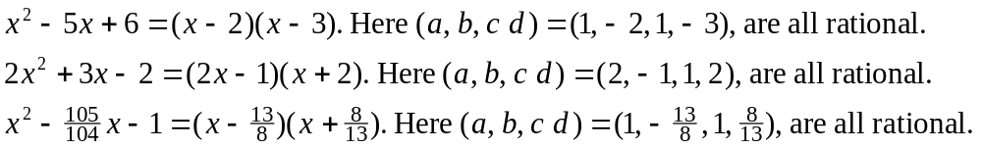

Example. is irreducible over Q.

How, though, can one PROVE such a (big) claim? After all, there are an INFINITE number of possible ways in which might factor in accordance with (I) above. [The key to proving this claim ultimately rests on the important fact that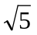is an irrational number. The details are as follows.]

Proof. Suppose that is reducible over Q. Then we would have:

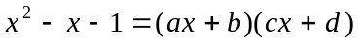

for some 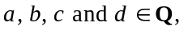 and thus the solutions of the equation 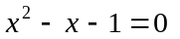would be given by:
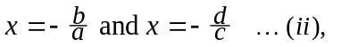

and both of these solutions would be rational numbers. Why? Well, first, since a and b are rational numbers then 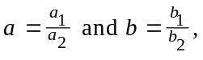for some 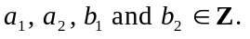 Thus 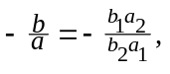 which is a rational number, and similarly for the other solution,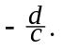

Now, the solutions of - using the classic ‘minus b plus or minus b squared minus etc. - are given by:

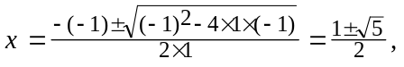

and so the solutions of are:

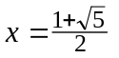and 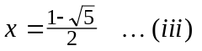

Finally, in view of the fact that both solutions are rational numbers it now follows that both 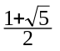and 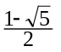are rational numbers. However, neither of those numbers is rational. Why? Well just take the first of them, 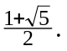 If it was a rational number then one would have: 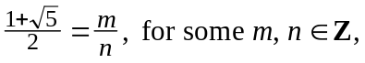 from which one would then have:
In other words it would follow that if was reducible over Q thenwould be a rational number. However, we know thatis not a rational number, and so cannot be reducible over Q. [End of proof.]

That is WHY attempts at ‘solving’ the equation by attempting to ‘factorize’ are simply doomed to failure. One just has to come to terms with the fact that a factorization of in accordance with is impossible.

What’s ‘going on’ here? An analogy with ‘prime’ and ‘composite’ numbers.

You should gain some insight into what I have explained above from this: you are familiar with ‘prime numbers’ and ‘composite numbers’. ‘Primes’ are natural numbers, greater than 1, whose only factors are 1 and themselves. ‘Composites’ are natural numbers, greater than 1, which have factors besides 1 and themselves. So, 29 being a ‘prime number’ means 29 does not have any factors other than 1 and 29, whereas 39 being a ‘composite number’ means 39 does have a factor other than 1 and 39: 3 is a factor of 39. In short, some natural numbers (the composite ones) do ‘factor’:

whereas some natural numbers (the composite ones) don’t ‘factor’ in the same sort of way:
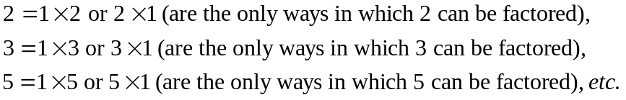

For polynomials, the terms that are used for ‘composite’ and ‘prime’ are ‘reducible’ and ‘irreducible.’ That is NOT to say - however - that can’t be factored by ANY MEANS!! Here, in fact, is a factorization of it:

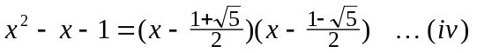

Check that by ‘expanding’ (‘multiplying out’) the right hand side of (iv) to see:

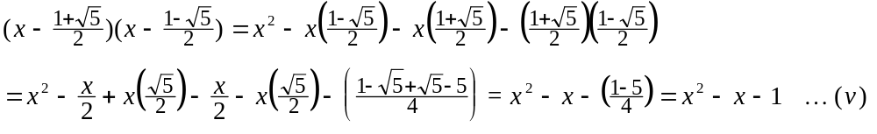

Question. Is that factorisation not in conflict with the earlier claim that
doesn’t factor ‘nicely’; that it is ‘irreducible’ (over Q)? Reply. Not at all. It’s all a question of what one means by ‘nicely’. That latter factorisation only factors as a product involving irrational numbers, whereas we were making an aesthetic judgement in considering (defining) ‘nicely’ to mean ‘with rational coefficients’.

Final comments.

- I’m sure you realise that isn’t the only quadratic irreducible over Q.
Other examples can be argued in almost identical fashion. Here I will just do one
more example:

Claim. 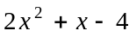is irreducible over Q.
Proof. If was reducible over Q we would have:

and it would follow that the solutions of the equation 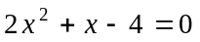would both be rational numbers, namely 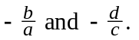 However the solutions of the equationare given by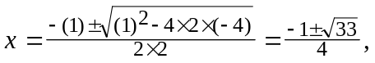and so the solutions are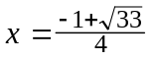and 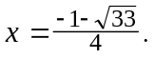 Neither of these, however, is rational because if 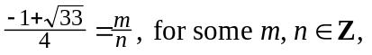then we would have 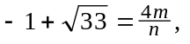and so have Thus we would have that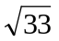is a rational number, which it is not. It follows that cannot be reducible over Q, and so it is irreducible over Q.

- The nature of the solutions - as you should by now be suspecting - is the key to
knowing if the quadratic is reducible or not:

if the solutions are rational numbers then the quadratic is reducible over Q, but

if the solutions aren’t rational numbers then the quadratic is irreducible over Q.

The principle being used here is: if A and B are ‘numbers’ and
It is absolutely incorrect to ‘solve’ by: “or 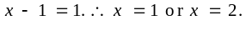” Why is this incorrect? Firstly, it should be noticed that the ‘solutions’ aren’t solutions anyway: then 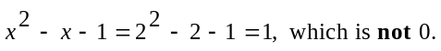 Secondly, and more fundamentally, it should be realised that the source of the error is using a totally incorrect form of deduction, namely “if the product of two numbers is 1, then either the first of those numbers is 1, or the second of them is 1.”
On the grounds that ‘x by x gives x squared.’
There are infinitely many, in fact.
If one is using some CAS (Computer Algebra System) - like Maple, for example - then one will get results like these: > factor(x^2 - 5*x + 6); 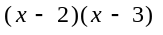 > factor(x^2 - x - 1); 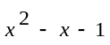 The first of these is the familiar factorization of 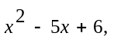but what does the second one mean? Does it mean ‘sorry, I don’t know how to do that one,’ or does it perhaps mean something else?
It’s a very ‘big’ claim because there are an infinite number of possible cases.
A consequence of supposing that there is a factorization of 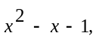as in 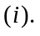
From our studies of ‘irrational’ numbers.
Meaning that 39 is equal to 3 times some natural number (other than 1 or 39). It happens to be that 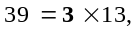and 13 is a natural number which is neither 1 nor 39.
Of course, all natural numbers factor ‘trivially’, in the following sense: and in the same way all quadratic polynomials factor ‘trivially’, in the following sense: But such factorisations would be useless as far as solving equations would be concerned.
One’s eye latches on to the telltale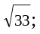it is irrational. Why? Here we are allowing ourselves the luxury of quoting the general result that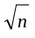is irrational for all 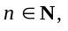except