An introduction to L- and R-approximations (to 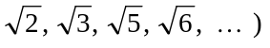

Introduction. Our starting point is that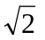is an irrational number, meaning thatis not equal to any rational number. However, although that is so, there are rational numbers which are very, very close to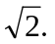 These notes are essentially about:

- finding such numbers (not just for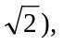
- making some simple observations about them,
- asking some obvious questions about them,
- and proving some of the basic things that can
be said about such numbers.

We start with a few simple observations: the rational number 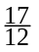is quite close to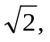in that its square is very close to 2:
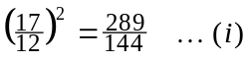

What is worth commenting about in 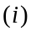is that the numerator ‘289’ is just 1 more than ‘288’, and that had the numerator been ‘288’ then one would have had:

Of course, the numerator is not ‘288’. It is, however, as close as it could possibly be to the right of 288, given thatis an irrational number.

Contrast it with, for example:
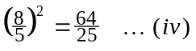

where the numerator ‘64’ is not remotely close to 50.

On the other hand, just a slight change to the numerator ‘8’ produces another interesting number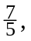and one has:
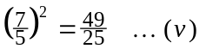

and that holds the same sort of interest for us as the earlier 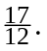 Here the numerator ‘49’ is 1 less than‘50’, and that had the numerator been ‘50’ then one would have had:

Of course, the numerator is not ‘50’. It is, however, as close as it could possibly be
to the left of 50, given thatis an irrational number.

Bringing out the essential point. What is so special about those two rational numbers, and is that they are examples of the following:

Definition 1. Let 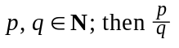is said to be an R-approximation toif :
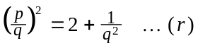
Definition 2. Let is said to be an L-approximation toif :
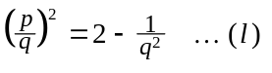

That is , L- and R-approximations toare (roughly speaking) rational numbers whose squares are as close as they can possibly be to 2, bearing in mind thatis an irrational number.

Are there any other examples besides the ones above? [Of course there are!!]
We will try to find some more, but before doing so it helps to re-write the equations
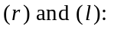 multiplying both sides by 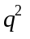makes them become:

and in these (simpler) forms it is a routine matter to systematically look for L- and
R-approximations to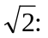

- choose a denominator ‘q’,
- form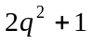and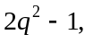and then
- calculate their square roots to see if we get a whole number ‘p’.
- if we do get a whole number then we have an L- or an R-approximation, but
- if we don’t, then we can try some others:

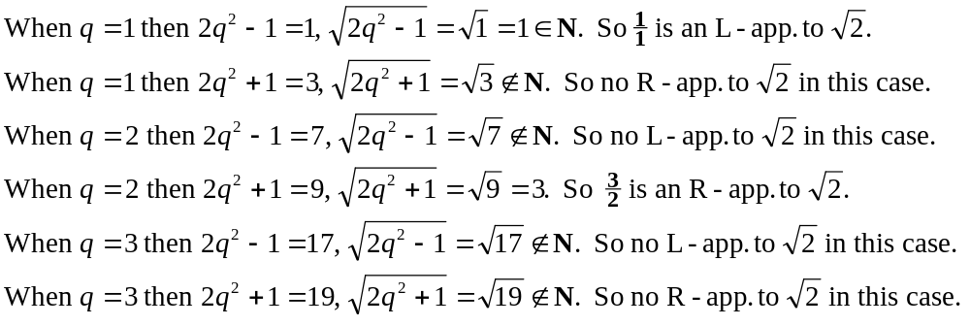
and so on … . This is an entirely routine computational matter, which you should:

- practice by hand, using your head, or
- use a calculator (and your head!) when the numbers begin to get big, or
- use Maple (and your head!, and − when you learn how − programming)
when the numbers get really big.

And what does one find? Let’s say that one did these calculations up as far as 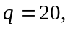then one would find just four nice rational numbers: 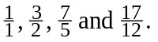

Anyone looking at those should be immediately struck by two things:

- They alternate: L-approx., R-approx., L-approx., R-approx.
- The numerators and denominators appear to be connected.

How ‘connected’? Well it simply jumps out at you [if your eyes are open … ]!!

- 1 plus 1 is 2, 1 plus 2 is 3.
- 3 plus 2 is 5, 2 plus 5 is 7.
- 7 plus 5 is 12, 5 plus 12 is 17.

We must ask ourselves if this sort of thing continues to happen. So,

- if we add the 17 and 12 (giving 29),
- and then add the 12 to the 29 (giving 41),
- and then form the rational number 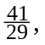
do we then get an L-approximation to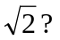 Yes, we do! And how do we verify that? We check to see if 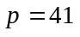and 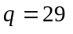are connected by the earlier equation 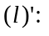

and so
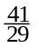 is an L-approximation to Alternatively, check to see if they are connected by a slight alteration to 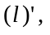namely:

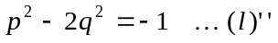

They are indeed connected like that: when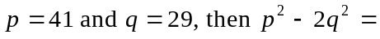
You are now ready for:

Simple Theorem One.

- Let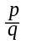be an L-approximation tothen 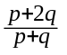is an R-approximation toand
- Letbe an R-approximation tothen is an L-approximation to

Proof. 1. Sinceis an L-approximation tothen 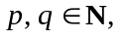and so (automatically)
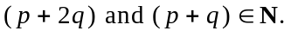 Also, we have:

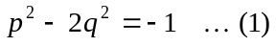

Now let us consider the value of 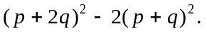 We have:

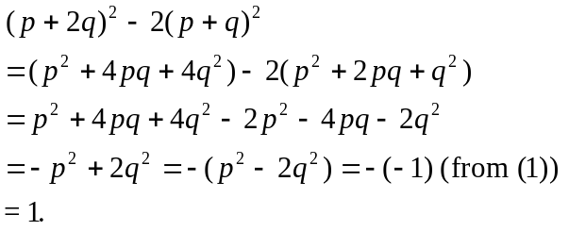

It follows immediately that is an R-approximation to

[It should be absolutely obvious to you as to how one now proves the second part of this theorem:]

2. Since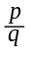is an R-approximation tothen then and so (automatically)
Also, we have:

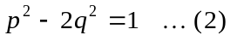

(As before) We consider the value of We have:

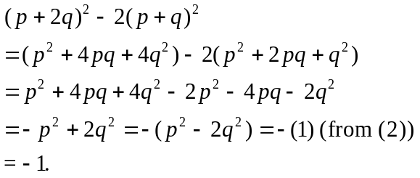
It follows immediately that is an L-approximation to [End of proof.]

Some questions, and answers. There are a million and one questions that I could go on to ask (that’s what makes Mathematics so fascinating - there are so many questions to be asked, and sometimes one gets some answers!), for example:

We see that whenever we have an L-approximation tothen we can form from it an R-approximation to and from it we can form an L-approximation toand so on ad infinitum. Thus, from 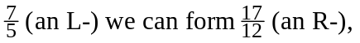and from that can form 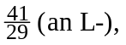… .

Looking at those denominators −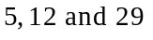− we wonder if we have missed some denominators between 5 and 12, we wonder if we have missed some denominators between 12 and 29. So, might 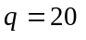have given rise to an L-approximation to
or maybe to an R-approximation to Let’s check to see:

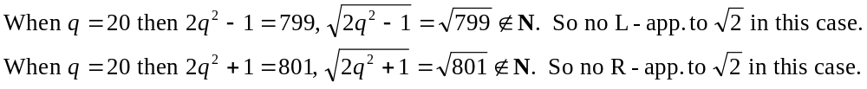
But what about the other denominators?

And what about other ones, the ones between 29 (exclusive) and 70 (exclusive)?
And what about … ? I will let out that there are no missing ones:
every L- and R-approximation tois obtained by starting withand repeatedly applying the construction to it, forming the infinite sequence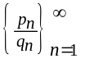of alternating L- and R-approximations to

Here’s a simple Maple programme to generate these some p’s and q’s:

> p[1] := 1:
q[1] := 1:
for k from 2 to 60 do # one can put whatever one likes in place of ‘60’
p[k] := p[k-1] + 2*q[k-1]:
q[k] := p[k-1] + q[k-1]:
od:

Some sample outputs are:

> p[60]/q[60]; # ‘imported’ into this Word 7 document from Maple:
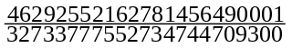
> evalf(p[60]/q[60], 45); # an alternative - a better one - to ‘Digits’

>evalf(sqrt(2.0), 45); # see the complete agreement to 45 decimal places

> evalf(p[60]/q[60], 46);

>evalf(sqrt(2.0), 45); # differ just on the 46th decimal place:

And what about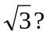 The rational number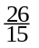is quite close to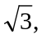in that its square does this: 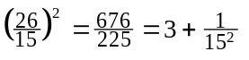 [that will be an R-approximation to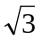]
We make two new definitions, along the lines of those already seen above:

Definition 3. Let 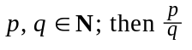is said to be an R-approximation toif:

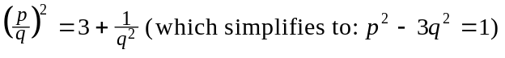

Definition 4. Let is said to be an L-approximation to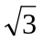if :

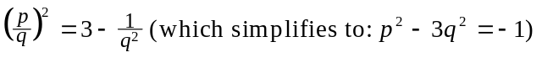

Here, though, something quite different happens. We start our search:

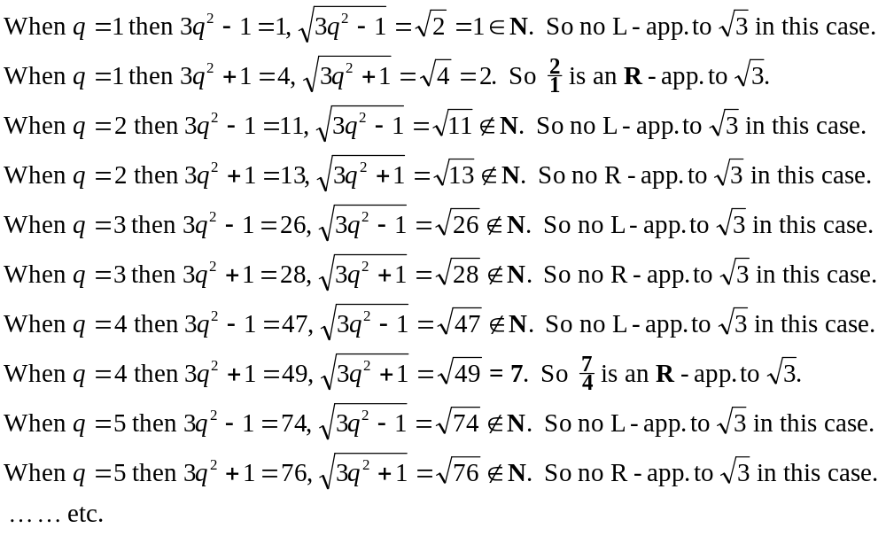
we find that we get two R-approximations toon the trot! So? Perhaps that’s how it goes here? Maybe we then find two L-approximations toon the trot? And then perhaps two further R-approximations?, and then … ? [There are so many different things that could have happened!]

What actually happens. If we carry on as above, trying one denominator after another, 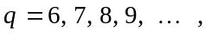we find that we don’t come upon another interesting ‘q’ until
And if one ploughed on some more then the next interesting q-value is 56, which produces yet another R-approximation to 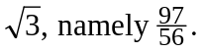

At this point we have found four R-approximations toon the trot, and not a single L-approximation to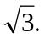

Two obvious questions, and answers.

- Are the R-approximations toconnected in some way (as happened withthough in the case ofwe had both L- and R-approximations)
- Doeshave any L-approximations?

As far as R-approximations are concerned, we make progress if we keep our eyes open. We look at the first four already found (for an eagle-eyed person perhaps the first three might have sufficed):

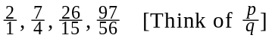
Thinking aloud: Adding p and q (as we did with 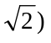is not the thing to do: they would produce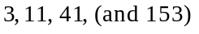which are not 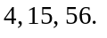 But if we notice by how much they are short of 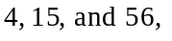then we are on our way!!

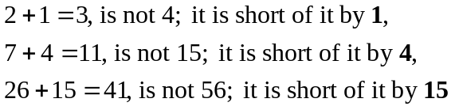

We make a leap in the dark: maybe it’s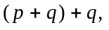 i.e.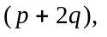that we need?
It’s certainly true for the first three of them; we wonder if that might be true in general, and we try out another one just to see:

Now ask: is there an R-approximation towith denominator 209? Well, let’s see:

Now we feel it in our gut that it’s and now we want to find the possible formation of the numerator. Here once again keeping one’s eyes open and trying the same sort of approach as above leads to 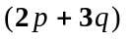as being the appropriate rule.
That’s the real work, and now we have the elementary:

Simple Theorem Two. Letbe an R-approximation tothen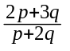is an
R-approximation to

Proof. Sinceis an R-approximation toand so (automatically)
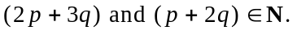 Also, we have:

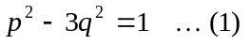

Now let us consider the value of 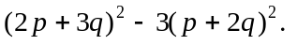 We have:

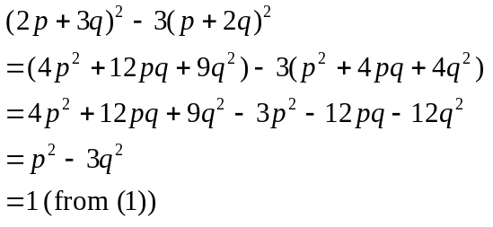

It follows immediately that is an R-approximation to

An important point. We now know that given any R-approximation towe could immediately form another one, and from that form yet another one, and so on ad infinitum. Now, note this:

Vacuous Theorem Two. Letbe an L-approximation tothenis an
L-approximation to

Proof. Sinceis an L-approximation tothenand so (automatically)
Also, we have:

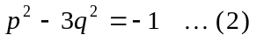

Now let us consider the value of We have:
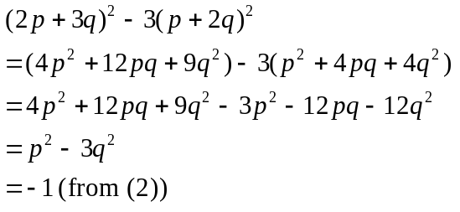

It follows immediately that is an L-approximation to

Why ‘vacuous’? This theorem is ‘vacuous’ − empty − because there are NO
L-approximation to

Simple Theorem Three. doesn’t have any L-approximations.

Proof. Suppose has an L-approximation; there would be 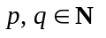such that 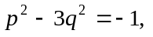then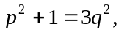and so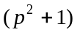would be divisible by 3.

[Aside. I will now argue that that is impossible, and in doing so I am drawing your attention to an important property of the number 3, namely that 3 never divides the square of an integer plus 1.
That should be contrasted with, e.g., the behaviour of the numbers :

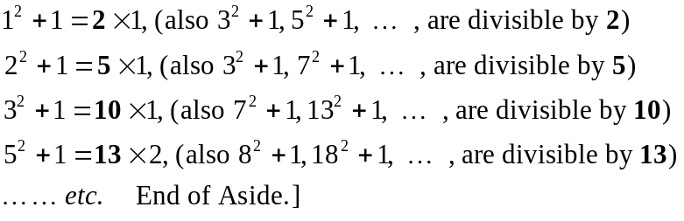

For any 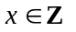we have 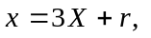where X is some integer, and r is 0, 1 or 2.
But then
But with
Thus:
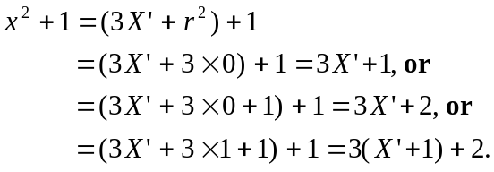

In no case do we have that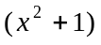is divisible by 3. It follows thatis not divisible by 3, and sodoesn’t have an L-approximation.

Comments.

- 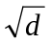 has L- and R-approximations for these values of d: 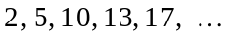
and there are ‘connections’. Here, for example, is what happens in the case of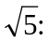
Letbe an L-approximation to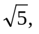then 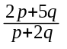is an R-approximation to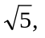and Letbe an R-approximation tothen is an L-approximation to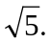
- has no L-approximations for these values of d: 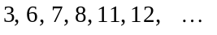,
[you should know how to prove those ones], but
- has R-approximations for all values of d, and there are always ‘connections.
Here, for example, is what happens in the case of 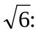
Letbe an R-approximation to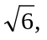then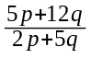is an R-approximation to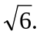
[You should be able to prove that, and other similar results.]
- There is a way of quickly finding what the ‘connections’ are, but I am not going into that in the first year.
- Finally (just to convey some idea as to how surprising this vast field of study can be) I mention two consecutive examples:
in the case of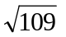the first R-approximation is 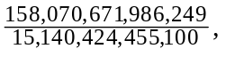while
in the case of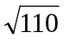the first R-approximation is 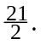

I hope you said ‘wow!!’ …
______________________

This is not standard mathematical terminology. If you were to tell someone that you have studied ‘L- and R-approximations’ they would not know what you were talking about; you would have to explain to them what these terms mean.
For a proof of that you should see the notes ‘Rational numbers, and an introduction to irrational numbers.’
Meaning that one tries one denominator after another, starting with the lowest denominator possible, ‘1’, and then successively try 2, 3, 4, 5, 6, … .
Though remember the old warning “one [in this case two!!] swallow doesn’t make a Summer”.
With only such small numbers involved this on its own is hardly any cause for joy, BUT …
Getting warmer!!
There’s got to be something to this? Surely!!
This is the approach that I would urge you to use, for reasons which will be apparent shortly.
The proof is entirely elementary. The real work was in the discovery of this theorem. Once the theorem has been discovered the rest - the proof - just follows in its wake.
Why? Why should we do this? We do this because in order to know if 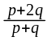is an R-approximation to 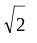then we need to calculate the square of its numerator, and subtract from that 2 times the square of the denominator, so as to see if that comes to ‘1’.
But I will not be proving it. The proof requires quite a bit of extra work to get it.
That’s HOW mathematical knowledge comes into existence: by asking questions, by guessing, trying things out, seeing if they work, backtracking a bit if they don’t, … . Ultimately, though, there is no mathematical knowledge without proof.
That alone is not enough; we will need proof.
Meaning ‘empty’. The reason for calling it so will be apparent shortly.
In other words, no matter which integer ‘x’ one has, x - on division by 3 - will leave remainder 0, 1 or 2.
Of course, only non-square values of d are of interest.
And the same here.
Non-square, of course.
It involves finding only the first of the L-approximations (if there is one!), or the first of the R-approximations when there is no L-approximation.

