COLÁISTE PHÁDRAIG, BAILE ÁTHA CLIATH
(Coláiste de chuid Ollscoil Chathair Bhaile Átha Cliath)

ST PATRICK’S COLLEGE, DUBLIN
(A College of Dublin City University)
_________________________

SUMMER EXAMINATIONS 1999
____________________

B.Ed. Degree and B.A. Degree in Humanities Examination
____________________

Mathematics (Number Theory and Cryptography)

Paper Three

Time: Three hours

Answer six questions.

1 (a) Let 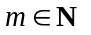with 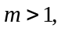 and let 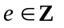with 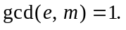 Prove there
is a unique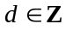with 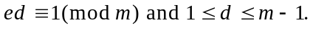

Calculate d when 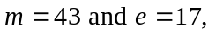and verify your calculation.

(b) Let p be prime and let 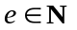 with 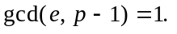 Let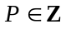such that
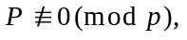and let C be defined by 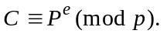 Prove that if
d is chosen so that 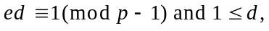then 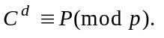

(c) Given the usual understandings about plaintext and ciphertext being
expressed in numerical form, explain how two people may communicate
using the Pohlig-Hellman private-key cryptographic method.

2 (a) Let p and q be distinct primes, and let 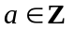such that 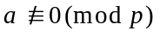
and 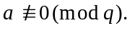 Prove that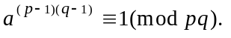

(b) For the Rivest-Shamir-Adleman public-key cryptographic method,
how are the standard ‘public’ n and e, and ‘private’ d, defined?

Suppose A declares his/her RSA public-key to be 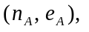 and communicates
that to B. How would B encrypt a message to A?

When A receives B’s encrypted message, how would A decrypt it?

(c) Suppose A and B have RSA public-keys 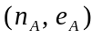and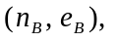and that these
keys are known to each other. Explain how B can ‘digitally sign’ a message
to A so that A can be confident the received message really has come from B.
You may suppose that 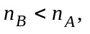but indicate what should be done if 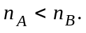

3 (a) Let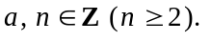 Define the order of a modulo n (notation: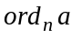),
and calculate 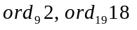 and 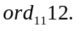
Prove that does not exist if 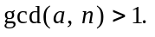

(b) Let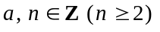 and let 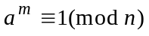 for some 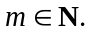
Prove that 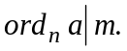

(c) Let 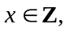and let p be an odd prime divisor of 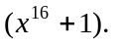Prove that
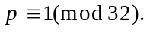
Define the Fermat numbers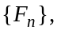and state Euler’s theorem on prime
divisors of the Fermat numbers.

4 (a) Let 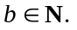 What is meant by the ‘binary form’ of b?
Write down the binary form of 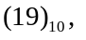and convert 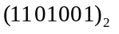
to base 10 form.

(b) Use repeated division by 2 to find the binary form of 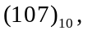
and verify your calculation.

(c) Write a Maple procedure which accepts as input a natural
number b, and which outputs the binary digits of b.

(d) Use the ‘square-and-multiply’ method to calculate the output from
the following Maple command:
> a := 84:
b := 107:
n := 73:
a&^b mod n;

[You need not repeat the work of part (b).]

5 (a) 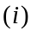 What is the minimal value of k such that 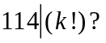
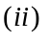What is the minimal value of k such that 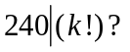

(b) Write a Maple procedure which accepts as input an integer n,
and outputs the minimal value of k with 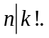

(c) Let p be prime and let 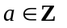such that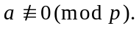 Prove that
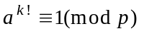for sufficiently large values of k.

(d) Briefly explain the ideas behind Pollard’s 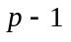factoring method.

(e) Write a Maple procedure which would put into effect the ideas of
Pollard’s factoring method.
6 In the following you may assume that 133 and 1387 are both composite.

(a) Use Pollard’s 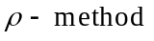with polynomial 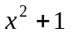and seed 2 to find
a proper factor of 133.

(b) Use Pollard’s with polynomial 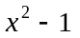and seed 2, together
with Floyd’s cycle finding algorithm to find a proper factor of 1387.

7 (a) Let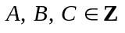with 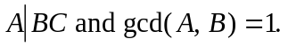 Prove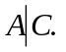

(b) Let 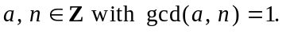 Prove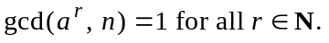

(c) Let 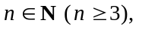and suppose there is an such that 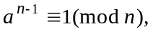
and 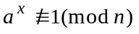 for all x with 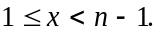 Prove that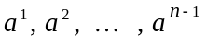
are congruent mod n - in some order - to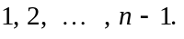

(d) Lucas’ 1876 theorem states:

Let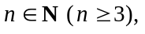and suppose there is an such that
and for all x with 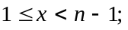
then n is prime.

Prove that theorem, and use it to verify that 5 and 7 are prime.

8 (a) State Pocklington’s theorem (1914), and use it to verify that 19 is prime.

(b) A version of Proth’s theorem (1878) states:

Let Suppose there
is an such that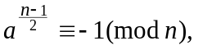then n is prime.

Prove that theorem, and use it to verify that 13 is prime.
_________

