Encryption, decryption, and digital signatures.

Introduction. First I set down the details for encryption and decryption for both the Pohlig-Hellman private-key, and the Rivest-Shamir-Adleman (RSA) public-key methods. The two methods are similar, but are also quite different: the private one is based on trust between the parties, whereas the private one is based on caution.

In both systems it is understood that the plaintext (the original, text form of the message− “Please send me money as quickly as possible”) is transformed into numerical form according to some agreed convention (‘a’ is 01, ‘b’ is 02, … , ‘z’ is 26, ‘A’ is 27, ‘B’ is 28, etc. ‘0’ is 53, ‘1’ is 54, ‘2’ is 55, etc.), and then that numerical form is itself transformed in some way. In both PH and RSA, that number (or blocks of numbers) is (are) subjected to modular exponentiation:

- where the modulus is a prime p, in the PH case
- where the modulus n is the product of two primes in the RSA case

The Pohlig-Hellman case. How may two people−A and B−communicate using the PH private-key cryptographic method?

The details. Having shared their ‘private keys’−namely

- prime p (the modulus),
- encryption power e, and
- decryption power d

related by

- 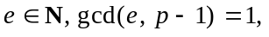and
- 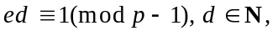

A and B proceed as follows: A (say) would convert the plaintext T into numerical form−P (say)−by agreed convention, and would break that number P into numerical blocks

- 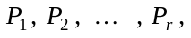each having positive numerical value less than p.

- A then forms the numbers 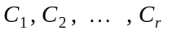 (‘C’ for cipher) as follows (this is the encryption of the P’s):

where the values of 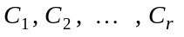 are chosen so their numerical values are positive and less than p. A then transmits those numerical blocksto B.
On receipt of those blocks of numbers, B proceeds to decrypt (and so recover the original plaintext) by computing the numbers 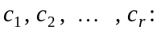

with the values of 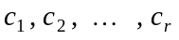chosen so that their numerical values are positive and less than p.

Then−and this is now the whole point of all of this−those numbersare, in fact, the numbers 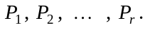
____________

The Rivest-Shamir-Adleman case. How may two people−A and B−communicate using the RSA public-key cryptographic method?

The details. A (say) having chosen his/her ‘keys’−namely

- 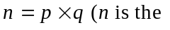modulus), for distinct (and, in practice, large) primes p and q,
- encryption power e, and
- decryption power d

related by

- 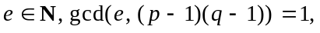and
- 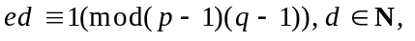

A and B proceed as follows: A (say) having made his/her ‘public-key’−namely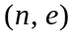−known to B, B would then communicate with A as follows: B would convert the plaintext T into numerical form−P (say)−by agreed convention, and would break that number P into numerical blocks:

- each having positive numerical value less than n.
- B then forms the numbers (‘C’ for cipher) as follows (this is the encryption of the P’s):

where the values of are chosen so their numerical values are positive and less than n. B then transmits those numerical blocksto A.

On receipt of those blocks of numbers, A proceeds to decrypt by computing the numbers

with the values of chosen so that their numerical values are positive and less than n.

Then−and this is now the whole point of all of this−those numbersare, in fact, the numbers
____________

‘Signing’ messages using the RSA cryptographic method.

Preliminary background. Suppose you received a message from someone; how would you know the message really came from them? For example, suppose you received the following message: Please call to see me on Wednesday at 3.00 P.M. John Cosgrave.

It would be almost certain that the message came from me, especially if I signed it, and you know what my signature looks like. However, someone could have forged my signature, and you would be misled into thinking that I had asked you to visit me. You would turn up at my office on Wednesday at 3.00 P.M., and (possibly) find that I wasn't there ... . Of course it wouldn't really matter; the worst that would have happened is that you would have wasted your time.

Suppose, though, that an army general received a message saying something like:

At 6.00 A.M. tomorrow, send 1,000 troops to Place X to meet up with other troops who are coming from elsewhere, and wait there until you receive further instructions from us. We are planning a surprise attack on the enemy. (Signed by the) Commander-in-Chief.

How can the general be certain that the message really has come from the C.-in-C.? The message could have been forged by the ‘enemy’, who already has huge forces waiting in hiding at ‘Place X’, and who could have a real surprise in store!

In earlier times, documents or messages were authenticated by a physical signature or seal (though they could have been forged). In recent times there is increasing reliance on electronic means of communication (by government, diplomatic circles, military, business, banking, political groupings, criminal organisations, private individuals, etc.) which do not allow−of course−for a physical signature. With electronic communication, authentication is guaranteed by a ‘digital signature’.

These notes explain explain how public-key cryptography can be used to provide a digital signature, and in separate Maple notes you will see how it can be carried out in practice.

Continuation. These notes take for granted that the reader is already familiar with the Rivest-Shamir-Adleman cryptographic method, and the purpose of these notes is to explain how it is possible to ‘sign’ messages using that method so that the recipient of a message can have confidence that the message really has come from the person who claims to have sent it. The idea behind it is very, very simple, and is essentially this: First recall that a person using the RSA method requires three special numbers:
- their public modulus n (formed by 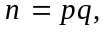etc.)
- their public encryption power e, and
- their private decryption power d, with the e and d satisfying:
- 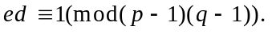

Now, that connection between e and d (namely 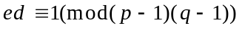) can be rewritten as 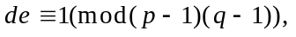where the e and d have simply been interchanged.

That simple interchanging has a very, very powerful consequence: It enables a user of RSA to sign a message. This is all they have to do:

To illustrate, let us return to my earlier: “For example, suppose you received a message saying: Please call to see me on Wednesday at 3.00 P.M. John Cosgrave.” This is what I can do (assuming I am a user of RSA, and you know my public-key (n, e)) that will convince you that the note you receive from me, really is from me:

I can encrypt a message to you by:

- using my private decryption power d (which only I know) as my encryption power

and then, on receipt of my message, you can decrypt it by:
- using my public encryption power d (which you, and possibly others, know) as your decryption power

An objection. You might (rightly) say that anyone who can intercept my message, and who knows my public-key, can also decrypt my message to you. That is a simple fact. I will illustrate this in a Maple worksheet.

Of course it is not a worrying matter if my message only to ask you to call to see me at a certain time, but is a far more serious business if - for example - I am not just John Cosgrave asking you to visit me at a certain time, but instead am the Irish government sending a top secret message to the Irish embassy in London, and don’t wish the message to be known to anyone else.

Fortunately public-key cryptography once again comes to our rescue. If I want to ‘sign’ my message to you and I don't want anyone but you to be able to read the contents of my message to you, I can then achieve my aim by performing a double encryption:

- First I use my private-key to do an initial encryption (and in the process ‘sign’ my message to you),
- then I use your public-key to perform a second encryption before sending my message.

When you receive my doubly-encrypted message you can then read it by performing a double decryption:

- First you use your private-key to perform the first decryption,
- then you use my public-key to perform the second decryption, and so read my message.

A way of visualising this which you might (I hope) find useful: Think of public-key cryptography in terms of paints and paint-removers. My public-key is some paint which I have made, and which, if it is used, only I can remove by applying the secret paint remover which I also have made, and which only I have access to.

You have to allow your imagination to allow the paint and paint remover to be used in reverse!! By that I mean that if something is covered with my paint then not only can it be uncovered by applying my paint remover, but that the same is true in reverse: if something is first covered with my paint remover then what is now there can be uncovered by applying my paint!!

Anyone who wishes to send me a secret message simply writes a message, gets some of my paint, and paints (encryption) over my message. When I receive your message I apply my paint remover (decryption) to it, and so read your message. Everything I have said about ‘I’ applies to you: you have your paint and your paint remover ... .

Now form a mental image of what I have described above:

- First I use my secret paint remover to do an initial painting (encryption, and in the process ‘sign’ my message to you),
- then I use your public paint to perform a second encryption before sending my message.

When you receive my doubly-encrypted message you can then read it by performing a double decryption:

- First you use your private paint remover to perform the first decryption,
- then you use my public paint to perform the second decryption, and so read my message.
Basic understanding: We assume that A has public key 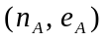 with private key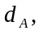 and that B has public key 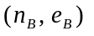with private key 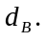

Question: How can B ‘sign’ a message to A (equally A send one to B) so that A can have confidence that the message received has come from B?

Answer: It can be done quite easily, but it depends on which is the smaller: 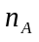 or 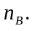 That is, it depends on whether:
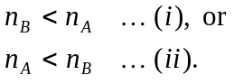

The details: Let us suppose that (i) happens (namely that 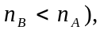and suppose that B wants to (securely) send and ‘sign’ a message P to A.

We make the usual understanding that P (the numerical form of the plaintext) has been put into numerical form according to some convention (a is 01, b is 02, etc.).

This, then, is what B does:

- B breaks P up into blocks of numberseach having numerical value less than 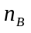(and so are automatically less than since 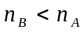), and each relatively prime to both and 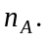 [I will discuss this point in class.] B then ‘signs’ using his/her private key by doing this:

- B forms the numbers 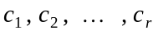 as follows:

the chosen with positive values, less than 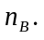

3. B then forms the following blocks of ciphertext, and sends those to A:

the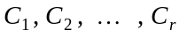chosen with positive values, less than 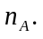

In summary,

- B first signs with their own private key,
- and then sends the newly formed ciphertexts in the usual way, using A’s public key.
On receipt of the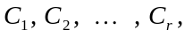this is what A does:

- A partially decrypts the numbers −using their own private key−by forming the numbers 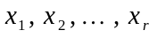 as follows:

the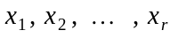chosen with positive values, less than
(Those are−of course−none other than 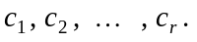

2. A completes the decoding by forming the following blocks of ciphertext:

the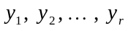 chosen with positive values, less than

The whole point is now that those 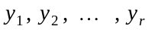 are none other than B's original plaintext message, namely 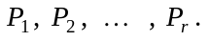
If, however we had 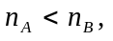 then this is what B would do: suppose that B wants to send message P to A. B breaks P up into blocks of numbers 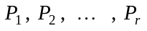(each having value less than (and so are automatically less than since 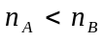), and each relatively prime to both and ). This, then, is what B does to ‘sign’ the message to A:

First B forms the numbers by using A’s public key−just as in an ordinary unsigned message−as follows:

the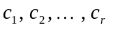 chosen with positive values, less than

Then B (and this is what ‘signs’ for B, the using of B’s ‘secret’) sends to A the following blocks of ciphertext:

the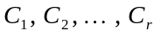 chosen with positive values, less than In short, B first encodes in the usual way using A’s public key, and then ‘signs’ using their own private key. On receipt of this is what A does:

First A partially decodes the numbers 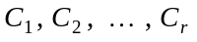−using B’s public key−by forming the numbers as follows:

the chosen with positive values, less than (Those are−of course−none other than

Then A completes the decoding by forming the following blocks of ciphertext:

the chosen with positive values, less than

The whole point is, again, that those are none other than B’s original plaintext message, namely

Once again, I will illustrate all of this in an accompanying Maple worksheet.

That’s what ‘Theorem 3’ in the notes ‘The mathematical basis of the Pohlig-Hellman etc.’ is all about: disguise (encrypt) the P (or P’s) by raising it (them) to the power of e, calculated mod p−forming the C (or C’s)−and then recover (decrypt) the P (or P’s) by raising C (or the C’s) to the power of d, calculated mod p.
But, and again in practice, not just ‘large’, but one would have to be careful about choosing the p and q so that n could not be easily factored.
That’s what ‘Theorem 4’ in the notes ‘The mathematical basis of the Pohlig-Hellman etc.’ is all about: disguise (encrypt) the P (or P’s) by raising it (them) to the power of e, calculated mod n−forming the C (or C’s)−and then recover (decrypt) the P (or P’s) by raising C (or the C’s) to the power of d, calculated mod n.
The ideas behind all of this were first described (in a now very famous paper) by Whitfield Diffie (who features prominently in the Channel 4 documentary mentioned later, in which he is called “the world’s greatest living cryptographer”) and Martin Hellman (of the Pohlig-Hellman cryptographic method) in their paper “New Directions in Cryptography”, published in the Transactions on Information Theory (of the Institute of Electrical and Electronic Engineers) in Nov.’76.) That paper is the one in which the very idea of public-key cryptography was first proposed.
This is not a fanciful example. In the mid 1980’s the British government were able to decrypt Irish government diplomatic messages because the Irish government was using encryption techniques supplied to them by the US government, who in turn were passing on the decryption keys to the British government. [My source for this allegation is a contribution by Steven Dorril−author of ‘The Silent Conspiracy’−26 minutes into a programme on cryptography broadcast on Channel 4 in August ‘95.]
Assuming you are using RSA, and I know your public-key.
Actually which I do first depends on whether my public modulus is smaller than your public modulus: - If my public modulus is smaller than yours then what I have described above is in fact what I would (and should) do, but: - If my public modulus is greater than yours then what I have described above should be done in reverse order, by me and you.
Later we will see what to do if (ii) happens.
Actually all that B and A do is to do what they previously did, except to do it in reverse order.

