Lucas-Proth--(Pocklington)-(Lehmer-Selfridge) Theorems

Background: Let 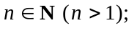how can one tell whether n is a prime or composite? Although the Eratosthenes test (if n has no prime factor between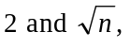then n is prime, and if n has a prime factor betweenthen n is composite) ‘works’, it is absolutely useless for large integers.

The serious, modern study of primality testing commences with using Fermat’s ‘little’ theorem, which states: Let p be any prime and let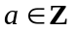with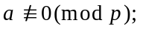 then 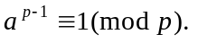 [In words: if p is any prime number, and a is any integer not divisible by p, then a to the power of (p minus one) leaves remainder one when divided by p.]

An obvious question to ask: is the converse of this theorem true?

That is, if 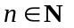and 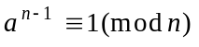− where a is some integer − must n be a prime?

Clearly this cannot have an obvious affirmative answer. If one chose a to be ‘1’, then one would haveno matter what value n had. So, let’s be more serious: suppose one had a natural number n, and that one also had an integer a such that − where 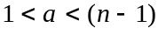− would n have to be a prime number? [Since we are going to be operating mod n, then there is no point in choosing values of a outside this range.] To get us started, let n be odd and subject it to a base 2 ‘Fermat test’; that is, we calculate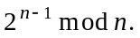 If that isn’t ‘1’, then automatically n isn’t prime (we say n ‘fails’ the Fermat base-2 test). But what if n ‘passes’ the Fermat base-2; that is, what can we deduce if it turns out that 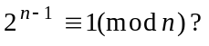 Does it follow that n is prime? Not at all! n could be a ‘pseudoprime.’ Of course one could then subject n to a Fermat base-3 test, and … .

However, we do not ‘throw out the baby with the bath-water’!! There are several important theorems − starting with one of Lucas’ (1876) − which all roughly say something like this: if 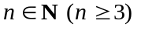and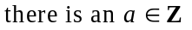such that 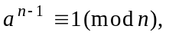
then − providing certain other things also happen − n must be a prime. Such theorems almost all depend in one way or another on the Lucas 1876 theorem, which I now state and prove:

Theorem 1 (Lucas, 1876). Let such that:

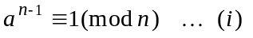
and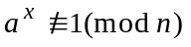for all x with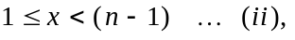

then n is prime. [In other words: if n is a natural number, and a is an integer with
but none of 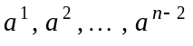is congruent to 1 mod n, then n is prime.]

Two examples to help clarify:

- Let 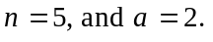 Then 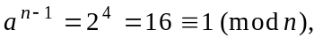but
and none of those is ‘1’ mod 5. Thus 5 is prime, by Lucas’ 1876 theorem.
- Let 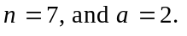 Then 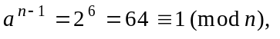but
and here, because of that ‘1,’ no conclusion may be immediately drawn about 7.
However if one chooses another value for a, 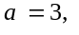 then 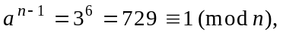
but now
and none of those is ‘1’ mod 7. Thus 7 is prime, by Lucas’ 1876 theorem.

Alternative wording of Theorem 1. Let 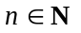and suppose there is some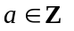such that 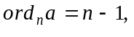 then n is prime.
Lucas’ own proof of his 1876 theorem required using the ‘Euler-Fermat theorem’− a generalisation of Fermat’s ‘little’ theorem − but that theorem requires quite a bit of preliminary work to prove it, and I here give a proof of the Lucas 1876 theorem which manages to circumvent using Euler-Fermat. First, however, I require some elementary side results to be recalled:

Recall work from 2nd year. Two important result we need are:
- Let
- Let
Proof of Lucas’ 1876 theorem. We begin by proving (in two steps) that as a simple consequence of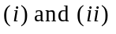the numbers 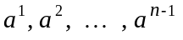 are congruent mod n − in some order − to the numbers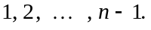
Firstly, none of is 0 mod n, because if 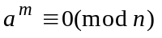for some 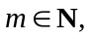then 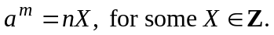 Now, let 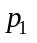be a prime with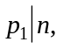we would have 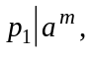 and so would have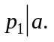 But 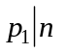and 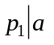would conflict with 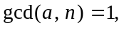and so none of is 0 mod n. Secondly, no two of are congruent to each other mod n. [Why?] Well, if some two of 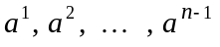were congruent mod n then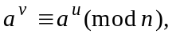for some u, v with 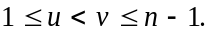 But then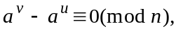and so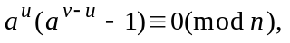from which, since 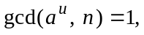it follows that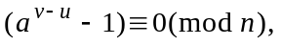and setting we have 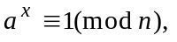where 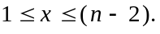That conflicts with 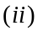above, and it follows that no two of are congruent to each other mod n. Thus are congruent mod n, in some order, to

Now we suppose n is composite, and show that is impossible. Since n is composite then it must be divisible by some prime number p with 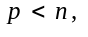and so p is one of the numbers in the range 2 to 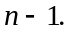 Then, from above, we know there is some natural number r 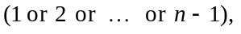 such that 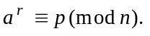But then 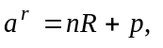for some 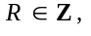from which, with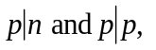we obtain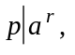and so we then have 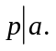 That (p dividing n and a) conflicts with and so n cannot be composite. Thus n is prime. [end of proof]

Exercises. Use Lucas’ 1876 theorem to verify that 11 and 13 are prime.

Comment: This theorem is really useless from a computational point of view since to use it requires not only having a value of a for which 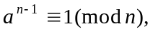but it means having to calculate, in extremis, the values of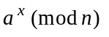for all x with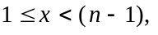 to check that none of them is 1. Heavens, that’s much more calculation than the already useless method of Eratosthenes!! It is, of course, a true (partial) converse of Fermat’s ‘little’ theorem, but nevertheless you might reasonably ask what is the point in recording it since it is so useless. I do so because there are several very important improvements or extensions to it, not all of which will be developed here. One simple extension of it (and easily proved), which Lucas himself gave, was his

Theorem 2 (Lucas, 1878). Let such that:

and
for all x with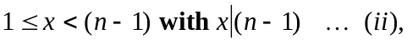

then n is prime.

Comment. This obviously represents an improvement since now one doesn’t have to worry about 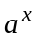not being 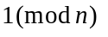for all x between 1 and 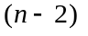(inclusive), but only about not being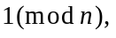 for all x between 1 and (inclusive) for which is a factor of 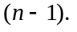 There were-in time-two much more substantial improvements of Lucas’ theorem. One is the powerful (in applications):

Lucas-(Kraitchik)-Lehmer 1927) Theorem. Let 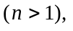and let the complete prime factorisation of 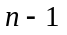be 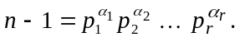 Suppose there is an with:

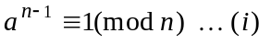
and 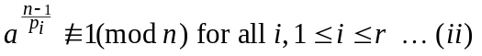
then n is prime.

And a further improvement of that is the highly effective:

Selfridge’s (1967) ‘change of base’ theorem Let 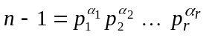be the complete prime factorisation of 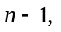and suppose there are integers 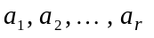 (not necessarily distinct) such that:
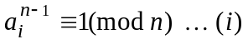
and 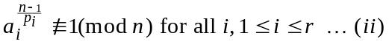
then n is prime.

Comment. All of these theorems required that one knew the complete factorisation of 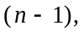but one earlier highly effective result frequently allowed one to establish the primality of n without needing to know the complete factorisation:

(A version of) Pocklington’s (1914) theorem: Let 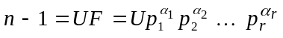be an incomplete factorisation of (where U is the ‘unfactored part’ of 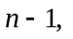 and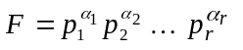is its factored part) with 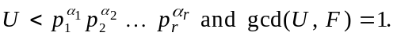 Suppose there is an a such that:
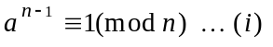
and 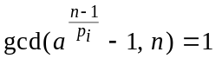for all 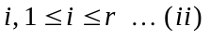
then n is prime.

In these notes I will not prove any of the last three theorems (Lehmer, Selfridge, nor Pocklington), but will prove the following theorem of Proth (1878):

Proth’s Theorem (in its original form, 1878). Let 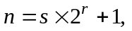where 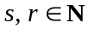and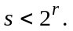Suppose there is an such that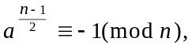 then n is prime.
Comment. This is the original formulation of Proth’s theorem, and the standard proof of it (which makes an argument which eventually depends on an appeal to Lucas’ 1876 theorem) is a little awkward. In February 1999 I improved the ‘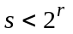’ condition (whose use in the standard proof is very artificial) to this:

Proth’s Theorem (in its original form, 1878). Let where and 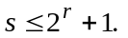 Suppose there is an such that then n is prime.

Proof. First, note the standard result about prime divisors of the ‘generalised’ Fermat numbers: let x be any integer and m any non-negative integer, then every odd prime divisor q of 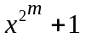 satisfies 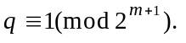 Now, let p be any prime divisor of n, then 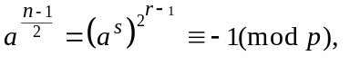and so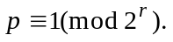Thus, if n is composite, n will be the product of at least two primes each of which has minimum value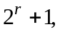and then it follows
Thus 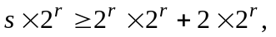and then dividing by 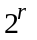gives 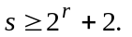That, however, is incompatible with Thus n is prime. [end of proof]
__________

Second year work from page two of these notes:

Theorem. Let 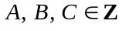such that 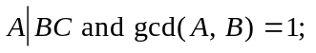then 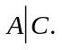
Proof. Since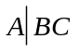then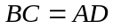for some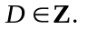Also, since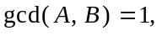then -
by the Euclidean Algorithm - we have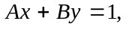 for some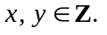 Thus
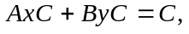and so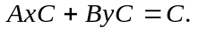 Then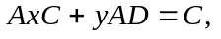and so 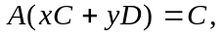and therefore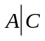 since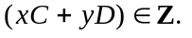

Theorem. Let 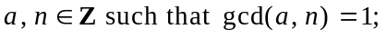then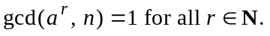

Proof. Suppose 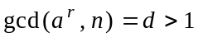for some 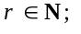then some prime p divides d, and so 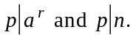 Thus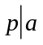(because a prime dividing a product of integers must divide at least one of those integers) and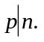 That, however, conflicts with 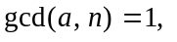and so we must have
__________

In these notes only the Lucas (1876) and Proth (1878) theorems will be proved.
Another trivial case is
Proofs of these two results are given at the end of these notes.
The original Lucas proof involved using a theorem (the famous ‘Euler-Fermat theorem’) whose own proof involves quite a lot of extra work. Here I give a proof which avoids such a reference.
This is where we are using the two 2nd year results.
This part is not so bad, and it will be a feature of all the later improvements of this first theorem of Lucas.
Just how good it is varies from one integer to another. Basically it’s better for n’s for whichhas a small number of divisors. Thus an n like 47 would be good, whereas one like 61 would not.
This theorem−which is incorporated into Yves Gallot’s remarkable program−was the basis of my finding the 49,642 digit prime 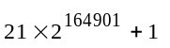on April 28th/29th 1999. (See Irish Times Computimes page of Monday 3rd May 1999.)
Some texts add an entirely irrelevant requirement that s be odd.
Here too I have altered the standard proof.
This theorem is in the Maple notes on ‘Introduction to order of a modulo n.’
Recall the Fermat numbers are the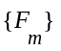with 