The Lucas-(Kraithcik)-Lehmer-Selfridge Theorem
Background: Let 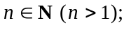how can one tell whether n is a prime or composite? Although the Eratosthenes test (if n has no prime factor between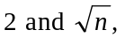then n is prime, and if n has a prime factor betweenthen n is composite) ‘works’, it is absolutely useless for large integers. Let n be odd and subject it to a base 2 ‘Fermat test’ (to start with); if n ‘fails’ the test then one immediately knows that n is composite, but if n ‘passes’ the test does it follow that n is prime? Not at all! n could be a ‘pseudoprime’.
We now begin our study of a very important sequence of theorems (the first two are due to Edouard Lucas, the next to D. H. Lehmer, and the final one to John Selfridge) which guarantee that a number is a prime providing certain conditions are satisfied. Here is the first of a number of theorems which guarantee that a number is prime:
Theorem 1 (Lucas, 1876). Let such that:
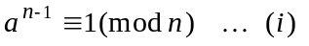and 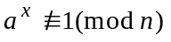for all x with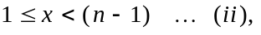
then n is prime.
Alternative wording of Theorem 1. Let 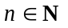and suppose there is some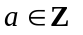such that 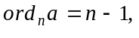 then n is prime.
Recall work from 2nd year. Two important result we need to recall are these:
- Let
- Let
Proof of Lucas’ 1876 theorem. Suppose n is composite; we will show that that is impossible, and so n must be prime. We show from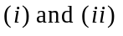that 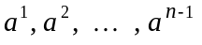 are congruent mod n - in some order - to 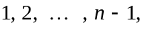 and then argue that is impossible. Firstly, none of is 0 mod n, because if 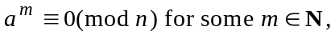 then 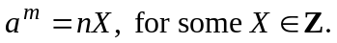 Now, let p be a prime with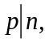we would have 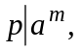 and so would have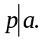 But 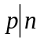and 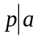would conflict with 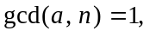and so none of is 0 mod n. Secondly, no two of are congruent to each other mod n. How do we know that?: If some two of 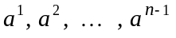were congruent to each other mod n then we would have:
But then:
from which, since 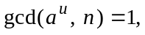it follows that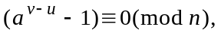and so setting we have 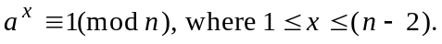 That conflicts with 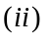above, and it follows that no two of are congruent to each other mod n. It follows that are congruent mod n, in some order, to
and so for one of those integers r 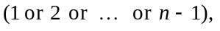we would have that 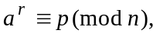where p is the earlier prime dividing n (and so 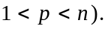 That is impossible since 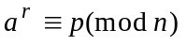means that 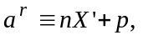for some 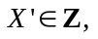from which, with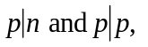we obtain 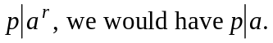 That conflicts with and so n cannot be composite. Thus n is prime.
Example to illustrate. Use the above theorem to verify that 7 is prime.
Solution. 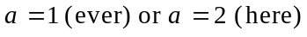useless: 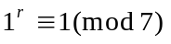for all r, and 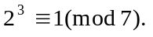 With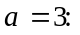 So, with 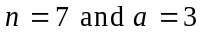we have 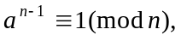and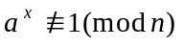for all x with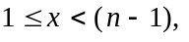 and thus 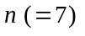is prime.
Exercises. Use theorem 1 to verify that 3, 5, 11 and 13 are prime.
Comment: This theorem is really useless from a computational point of view since to use it requires not only having a value of a for which but it requires calculating, in extremis, the values of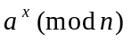for all x with so as to check that none of those is 1. Heavens, that’s much more calculation than the already useless method of Eratosthenes!! It is, of course, a true (partial) converse of Fermat’s ‘little’ theorem, but nevertheless you might reasonably ask what is the point in recording it since it is so useless. I do so because there are improvements to it - the first due to Lucas himself, then another to D. H. Lehmer (in 1927, producing a really fine, and very practical test for primality), and another fine one by John Selfridge (in 1967) - and all the proofs of those require the first Lucas theorem to back them up. An improvement (a good one, but not good enough) on the above theorem is:
Theorem 2 (Lucas, 1891). Letsuch that:
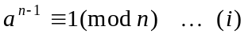and
for all x with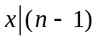and

then n is prime.
Comment. Before proceeding to look at the proof (which is much shorter than the one we have just seen!), let us first see appreciate that this theorem is superior to the earlier one.
Example. Use theorem 2 to verify that 7 is prime.
Solution. [As before, we still need to get an ‘a’ that satisfies condition 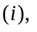but now we don’t have to do as much calculation so as to satisfy condition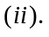] As before, choosing useless: for all r, and Now, we have So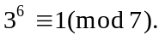 Next, instead of needing all natural numbers that are less than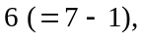we only need all the natural numbers less than 6 that are factors of 6. They are 1, 2 and 3, and so we do these calculations only: 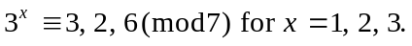 Thus 7 is prime. Comment. This 1891 theorem of Lucas is, of course, superior to his earlier 1876 theorem. However it is still not very useful (except in very rare circumstances). Admittedly you don’t have to calculatefor all x with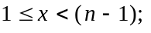you only need to calculations for those x’s which are factors of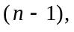that are less than 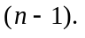 Nevertheless that can still entail a large amount of computation if 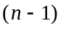 has many factors.
Proof of theorem 2. Since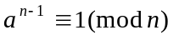then and thus 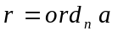exists. Then, from we have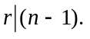 But since for all x with and it follows that r must equal 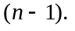 It immediately follows from the earlier Lucas theorem that n is prime.
Exercises. Use theorem 2 to verify that 5, 11, 13 and 17 are prime.
Comment. A vastly superior theorem to theorem 2 is the one which I now call the ‘Lucas-(Kraitchik)-Lehmer theorem’, whose statement and proof are given below. (Kraitchik played only a very small part in it. It is clear from some writings of his from the early 1920’s that he realised the following theorem 3 is true, but he gave no proof of it.)
Lehmer’s own (1927) statement of this theorem was a bit archaic, and the proof that he went on to give of it was a little difficult (for students!) to follow. So I am restating his theorem, and giving a simpler (I hope!) proof of it:
Theorem 3 (what I call the ‘Lucas-Kraitchik-Lehmer Theorem’). Let with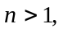 and suppose there is some with:
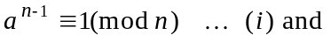
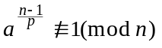 for all primes p with 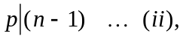
then n is prime.
Comment. This is a powerful theorem, whose power will only be properly realised when you do Maple work with some very large numbers whose primality can be established incredibly quickly with this theorem.
Proof. [Aside: the strategy of the proof is to show that 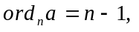from which it follows from Lucas’ theorem of 1876 that n is prime.] Let 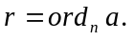 Then 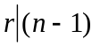and so we have 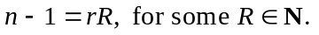 [Our aim now is to prove that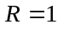- from which we obtain 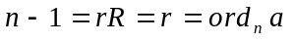- and we achieve that by supposing that R is greater than 1, and so get our hands on a prime p dividing R with which we play … .]
Suppose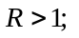then some prime p divides R, and so 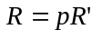 for some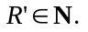 Thus:
and so p is a divisor (prime) of 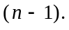 But, since 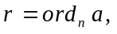then:
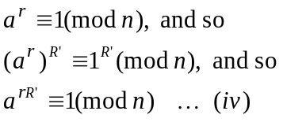
But from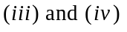we then have:
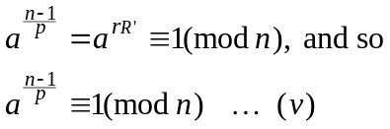

But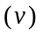is incompatible with and so R cannot be greater than 1. It follows that 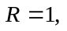
and so 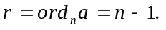 Thus, by Lucas’ theorem (of 1876), it follows that n is prime.
Comment. The Lehmer 1927 theorem is sometimes referred to - for obvious reasons - as the ‘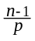’ theorem. There is a further important improvement (dating from 1967) of D.H. Lehmer’s theorem that is due to another American mathematician John Selfridge. I will not be proving this theorem, but will state it below. You will only appreciate the value of Selfridge’s improvement after you have had experience with using the above theorem with Maple computations. Selfridge’s theorem is sometimes referred to as the ‘change of base’ theorem, for reasons which will become apparent when you use it.
Theorem 4 (what I call the ‘Lucas-(Kraitchik)-Lehmer-Selfridge Theorem’). Let with and suppose that for each prime 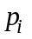with 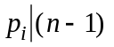there is some 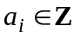with:
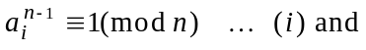
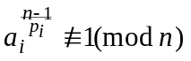
then n is prime. [I won’t prove this theorem, though it isn’t any more difficult.]
Reminder. Remind me to show you a group photograph (taken in Oxford University in August 1969) of various mathematicians in which you will see D. H. Lehmer, John Selfridge, and yours truly (J.C.).

The original Lucas proof involved using a theorem (the famous ‘Euler-Fermat theorem’) whose own proof involves quite a lot of extra work. Here I am giving a proof which avoids such a reference.
This is where we are using the two 2nd year results.
This part is not so bad, and it will be a feature of all the later improvements of this first theorem of Lucas.

