The mathematical basis of the Pohlig-Hellman (PH) and
Rivest-Shamir-Adleman (RSA) cryptographic methods

A crucial mathematical fact that underlies PH and RSA is:

Fermat’s ‘little’ theorem. Let p be prime,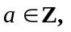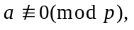then 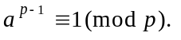

In the case of the PH method (a private-key method) it is Fermat’s ‘little’ theorem that is needed; in the case of the RSA method (historically the first of the public-key methods) it is a slight extension of Fermat’s ‘little’ theorem that is needed, namely this:

Theorem 1. Let p and q be distinct primes, and let 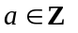with 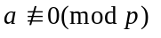and
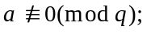then 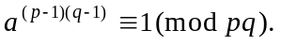

Proof. Since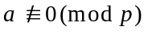 then − by Fermat’s ‘little’ theorem − we have 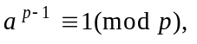and so raising both sides to the power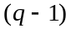we obtain:

Similarly, since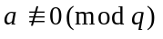 then − by Fermat’s ‘little’ theorem − we have

Now, from (i) we have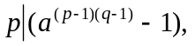and from (ii) we have 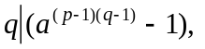 and thus − since 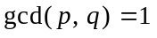(as p and q are distinct primes) − it follows that 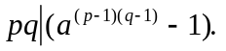
Thus

The use of Fermat’s ‘little’ theorem, or of the 2-prime extension of it, in Cryptography. In cryptographic applications, the ‘a’ (or several such a’s − when blocks of text are needed), will be the ordinary numerical form of the ‘plaintext’. The idea then is to first transform (this is the encryption step) the value of ‘a’ by disguising it: that is done by raising ‘a’ to the encryption power ‘e’ and calculating 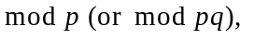and then, on receipt of the transformed (encrypted) value, the original value ‘a’ (or several such values) is recovered (and this is the decryption step) by raising the received value to the decryption power and calculating 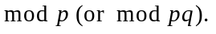
Relationship of the ‘decryption’ power to the ‘encryption’ power. In the Pohlig-Hellman and Rivest-Shamir-Adleman cryptographic methods we have encryption powers ‘e’ and decryption powers ‘d’.

With the Pohlig-Hellman (private-key) method the connection between d and e is:

- 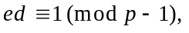where p is a prime number, and 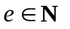such that 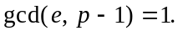
In practice d is chosen so that 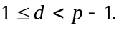
Small hand-performed example #1. Choose p to be 13, then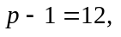and let’s choose e to be 5. Now we want the (unique) value of ‘d’ with 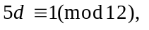and we can do that by direct calculation:

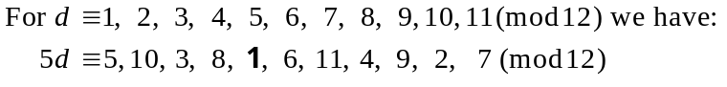

No more calculation after the ‘’ was necessary; I only continued with the later ones so as to emphasise the uniqueness of ‘d’ in the range 1 to 10. As it happens − in this case − the decryption power has come out to have the same value as the encryption power.

With the Rivest-Shamir-Adleman (public-key) method the connection between d and e is:

- 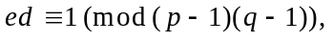 where p and q are distinct prime numbers, and such that 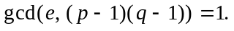 In practice d is chosen so that 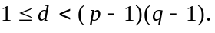
Small hand-performed example #2. Choose p to be 5 and q to be 11, then we have
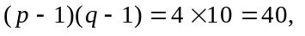and let’s choose e to be 7. Now we want the (unique) value of ‘d’ with 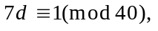and we could do that by direct calculation:

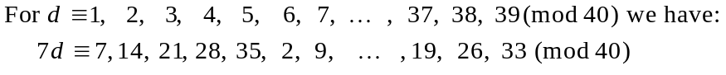

I write ‘could’ for obvious reasons; it’s taking too long. The terms of the second line are only increasing by ‘7’ at each stage, and then getting reduced mod 40. We could speed it up a little bit by doing this: what we are looking for is a multiple of 7 that is 1 more than some multiple of 40: so, a multiple of 7 coming to be one of these:

and so d comes to be 23.
And that is only with a small modulus, 40. The amount of calculation needed to find
‘d’ from ‘e’ and ‘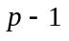’ becomes increasingly large (in general) as the modulus gets
larger and larger.

As you will see coming up now, the really practical way to find ‘d’ (in PH or RSA) is to use the ‘extended Euclidean algorithm’.

Theorem 2. Let 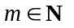with 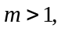 and let 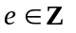with 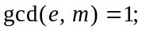then there is
a unique 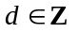with 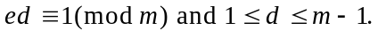

Examples.

- If 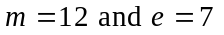 then there is a unique natural number d − having value somewhere between 1 and 11 − such that 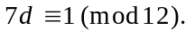
- If 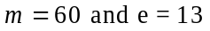 then there is a unique natural number d − having value somewhere between 1 and 59 − such that 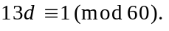

Notes:

- In the case of the Pohlig-Hellman method, m will have value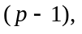 where p will be a prime (greater than 2).
- In the case of the Rivest-Shamir-Adleman method, m will have value 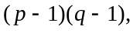
where p and q will be distinct primes.

Proof of Theorem 2. Since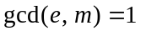then − by the ‘extended Euclidean algorithm’ − we have 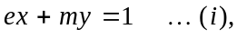for some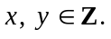 Now, let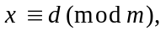where d is chosen so that 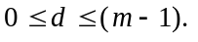 Then 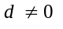(because if 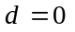then 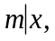and so from (i) we would have 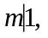 and that is impossible since 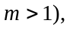and so we have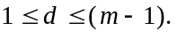

Also, from 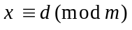we have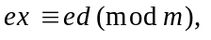 and then − since 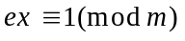
(from (i)) − it follows that 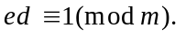 Furthermore, there is a unique such d. Why? Well if we had:

for some then from 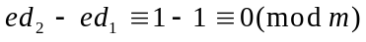
we would have 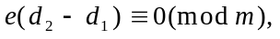 and then − since 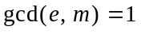− we would have 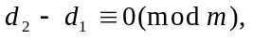which is impossible 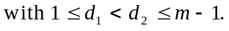)

Worked Example. Find the value of d when 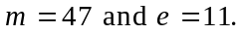

Solution. We use the Euclidean algorithm to calculate 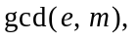 namely 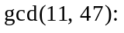

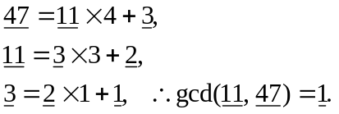

Now − using the extended Euclidean algorithm − by expressing 1 as an integral linear combination of 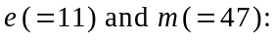

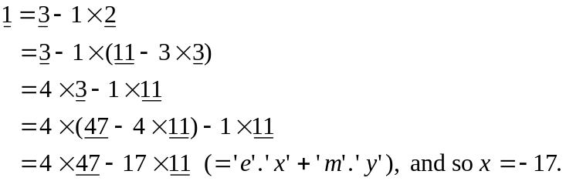

d is then obtained from: 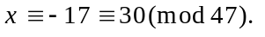

Verification:

Recall the Maple commands and outputs for the above:

> igcdex(11, 47, 'x', 'y'); # the 11 and 47 are the e and m
1
> x;
-17
> x mod 47;
30

or, a better one is to do this:

> igcdex(11, 47, 'x', 'y');
1
> d := x mod 47;
d := 30

‘better’, because when doing actual encryption/decryption work in Maple, you will want to carry − as it were − the actual value of the decryption power ‘d’ around with you, rather than retype it by using your eye.

Theorem 3 (The Pohlig-Hellman case.) Let

- p be prime, and 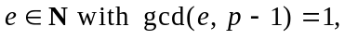
- 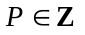with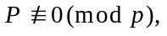and C be defined by 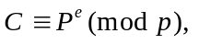 and
- d be chosen so that with

then 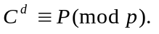

Proof. Since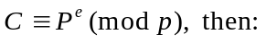

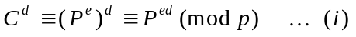

(We need the ‘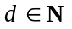’ to guarantee that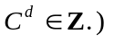 Now, since 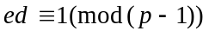then 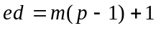for 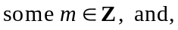in fact, 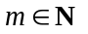since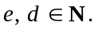

Thus (i) becomes:

Then, by Fermat’s ‘little’ theorem, since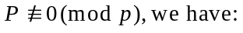

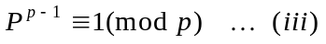

Thus (ii) becomes:

____________________

Theorem 4 (The Rivest-Shamir-Adleman case.) Let

- p and q be distinct primes, and
- with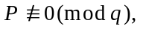and C be defined by 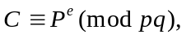 and
- d be chosen so that with

then 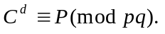

Proof. Since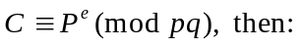

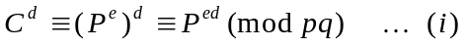

(We need the ‘’ to guarantee that

Now, since 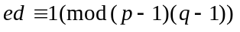then 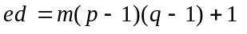for in fact, since Thus (i) becomes:

Then, by the 2-prime extension of Fermat’s ‘little’ theorem, since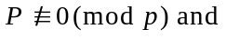 then we have that:

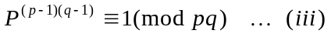

Thus (ii) becomes:

Parting comments. Who would have ever believed that Fermat’s ‘little’ theorem − which was discovered by Fermat in connection with his studies of ‘Mersenne primes’ − would one day come to play a pivotal role in ‘secure communications’? Of course it also plays a fundamental role in connection with many related matters:

- primality testing
- John Pollard’s 1974-published ‘factorization method’ (a critically important matter to be borne in mind when choosing the two primes if one is using the RSA method: if the primes are not correctly chosen then the decryption key can be calculated, because the ‘n’ can almost certainly be factored using his method.)

These matters will be studied elsewhere.

Study advice. Repeat to yourself before breakfast, and before going to bed every night:

“the plaintext raised to the encryption power produces the ciphertext;
the ciphertext raised to the decryption power produces the plaintext.”

Incidentally, when p and q are equal, what then happens is that 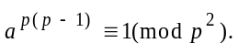 The proof, incidentally, requires a different approach to the above, since now one doesn’t have 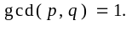
In practice, that calculation is performed remarkably quickly by using the ‘square-and-multiply’ method.
The choice of e to be 1 would obviously be rather foolish!, and choosing e to be any of 2, 3 or 4, would violate the 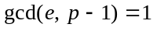condition. The choice 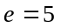is the first sensible one, but we could also have chosen 7 or 11 had we wished to do so.
This now is the guarantee that when the numerical value of the ‘plaintext’ P is encrypted using ‘e’ - thus forming the numerical form of the ‘ciphertext’ C - and C is then decrypted using ‘d’, then the upshot of all of this is to recover P, the original plaintext (rather its numerical form, which one then translates back into ordinary text).
Exactly the same comment here as in the previous footnote. The plaintext just gets jumbled up by the decryption power, and gets unscrambled by the decryption power. It’s as simple as that!!
Its numerical form, of course. And the same for the ciphertext.
Using modular exponentiation, of course. And the same for the ciphertext.

