Rational numbers, and an introduction to irrational numbers.

These notes are a direct continuation of those concerning exact decimal values. The sort of question that concerns us here is: not every real number has a terminating decimal value; might it however be the case that every real number is a rational number?

The early Greek belief was that every number is a rational number. That meant − in particular − that whenever one wanted to quantify the length(s) (or area, or volume) of something(s) then the number(s) would be rational. So, for example, with a unit square (one where the sides have unit length), the length of the diagonal would be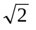 units, and, believing that all numbers were rational, the question was: what are the values of the integers (whole numbers) m and n such that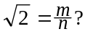

Definition. Let 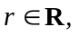 then r is said to be a ‘rational’ number if 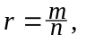for some
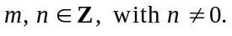
Examples. All integers are rational: 3 is rational because 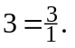 In general, if 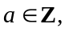then a is rational because 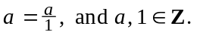 The following numbers are all rational:

Notation. The standard notation for ‘the rationals’ is Q, and so we write, for example,

Some elementary properties of rational numbers. Many elementary properties of the rational numbers are themselves simple consequences of elementary properties of the integers (for example, that the sum, difference or product of any two integers is an integer).

1. Claim 1. The sum of any two rational numbers is also a rational number.

For example,

The formal proof of the general result is entirely elementary, and is as follows:
Proof. Let 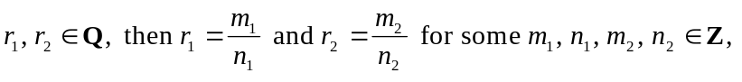 with
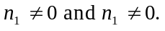 Thus:
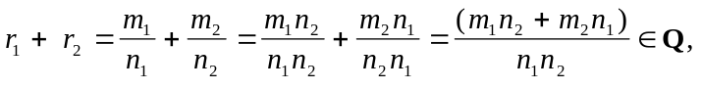

because
You should be able to prove other similar results yourself:

Claim 2. The difference of any two rational numbers is also a rational number.
Claim 3. The product of any two rational numbers is also a rational number.
Claim 4. (The ratio of two rational numbers, and here one has to be careful with the
statement.) Let 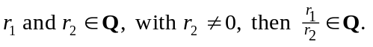 (In words: the ratio of any two rational numbers − where the denominator is not zero − is also a rational number.

Proof of Claim 4. Since with 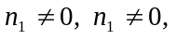and also 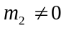because of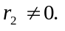 Thus:

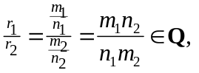

because

Numerical computations. It could have been that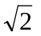is a rational number.
For example the following Maple calculations:

> evalf(sqrt(2), 20);
1.4142135623730950488
> evalf(4478554083/3166815962, 20);
1.4142135623730950488

show it is possible thatcould equal 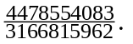

Of course if one increased the digits setting beyond the ‘20’ mark, it would become clear that althoughand 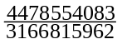 agree to 20 decimal places, they are not − in fact − equal to each other. That however does not rule out the possibility that there is some ‘better’ rational number than 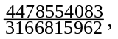one which might agree withnot only to 20, 200 or 2000 decimal places, but to any number of places, by virtue of being equal to it.

Our big step forward (in terms of mathematical knowledge and understanding) is to prove thatis not a rational number. How can we argue this, how can we prove that the square-root of 2 is not a rational number? It is not terribly difficult to do so, but at the same time it is not easy. You have to keep your wits about you, and really think.
I am going to argue there are no integers m and n such that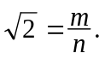 There are many, many different ways in which it can be done, but perhaps the simplest one is the one which I have chosen to do with you here. I am going to do two things with you:

- First I will take you through a series of easy steps, which lay before you the ideas behind the proof (it would be correct to describe this part as the ‘teaching’ part of my task), and when you have come to terms with the ideas behind the proof I will then:
- Present the proof in what one might call the classic formal style.
In short I will take you through an informal stage (the ‘learning’ stage), and then a
formal stage (the ‘rigorous’ stage).

To begin with, you need to be quite clear in your mind about certain elementary properties of even and odd integers; in fact you first need to be quite clear about what even and odd numbers actually are. So, let us ask, and then answer the following

Questions:

- What is an even number?,
- What is an odd number?, and
- Why can’t an even number ever be an odd number?

Answers:

- a is an even number if 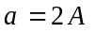for some 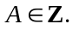(So, an even number is a number that is two times some whole number). So the even numbers are: 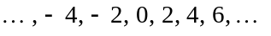 .
- b is an odd number if 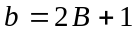for some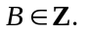(So, an odd number is a number that is two times some whole number). So the odd numbers are: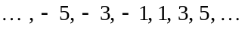 .

- An even number cannot ever be an odd number. Why? Well, suppose some even number a equalled some odd number b. Then we would have 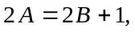for some integers A and B. We would then have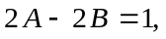and so would have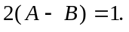 That is impossible, as it leads to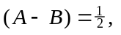because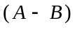is an integer (since A and B are integers), whereas is not an integer.

From such elementary material as this we will eventually forge a proof thatis not equal to any rational number. We start with:

Step One. I will argue thatcould not equal (the one with 20-digit agreement above). I give this reason:
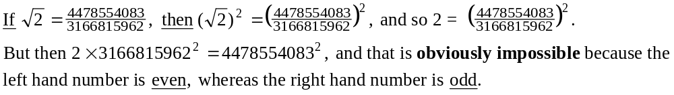

Now this simple (but oh!, so important) observation can be immediately extended to cover an infinite number of other similar cases, namely:

Simple observation 1. is not equal to any rational number whose numerator is odd.

Proof. Suppose 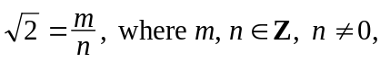and suppose that m is odd. Then 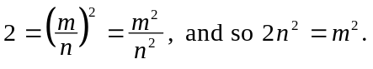 But that is impossible because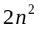is even, whereas 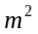is odd. It follows that is not equal to 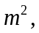 and sois not equal to any rational number whose numerator is odd.

Simple consequence 1. If is a rational number, then the numerator of that rational number must be even.

Step Two. I will argue that the number 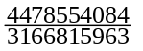 couldn’t be equal to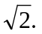 I give this reason:
Now we need to stop and think. We cannot argue as we did before, namely we cannot now say ‘that is impossible because the left hand number is even whereas the right hand number is odd,’ because now the left hand and right hand numbers are both even. All is not lost however, because we can do the following:
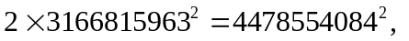

and, because 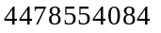is even, we can rewrite it as 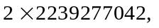and so the last equation can be rewritten as:

and so dividing by 2 we get: 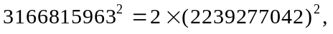 and that is impossible because the left hand number is odd, whereas the right hand number is even.

Now we are able to make a general observation:

Simple observation 2. is not equal to any rational number whose denominator is odd.

Proof. Suppose and suppose that n is odd. We already know (from ‘simple consequence 1’ above) that m must be even.

Now, But, since m is even, then 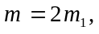for some
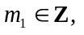 and so 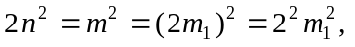and so 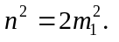 That, however, is impossible because 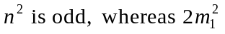is even.

Simple consequence 2. If is a rational number, then not only must the numerator of that rational number be even, but so also must the denominator be even.

Step Three. Now we come to the final hurdle (the one you really have to get your brain engaged with): If was a rational number, then both its numerator and denominator would have to be even. However one can argue that that too is impossible, and here is the key to it:

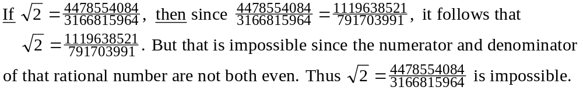
____________________

Time for reflection. In fact, what we have here - when we properly organise our arguments - is a proof that could not be equal to any rational number.

Summary. One is now at the point when it should be absolutely clear (from the point of view of understanding) thatis not a rational number. But that is not the same as giving a definitive proof. I still have to write down an absolutely rigorous proof thatis not a rational number. In the meantime one now has a new kind of number:

Definition. An ‘irrational’ number is a real number that is not rational.

Some immediate consequences. Now that one knows that there is at least one irrational number -- it immediately follows that there are an infinite number of irrational numbers. Here is how one can easily show that: Given thatis an irrational number, it follows automatically that the number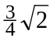is also an irrational number. Why? Well, suppose (for example) thatwas a rational number. Then one would have:
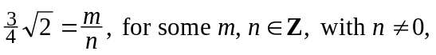
which leads to: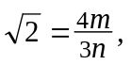 which would mean thatwas a rational number because 4m and 3n are both integers (with 3n non-zero since n is non-zero). We already know, however, thatis not a rational number, and so it follows that could not be rational.

It should be immediately clear that there is nothing at all special about 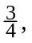except that it is a non-zero rational number. In other words, the following is true:

Simple Theorem. If r is any non-zero rational number then 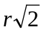is irrational.

Proof. Since r is a non-zero rational then and
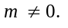 Suppose thatis rational; then 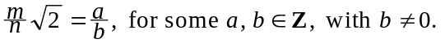 But then 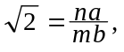 which would mean thatwas a rational number because na and mb are both integers (and mb is non-zero since m and b are non-zero). That, however, is not so, and socould not be rational.

Some observations.

1. Because there are an infinite number of non-zero rational numbers it follows
automatically that there are an infinite number of irrational numbers.

2. It should be obvious that one has to insist on r being non-zero, in order to be able
to claim that is irrational . If r was zero, thenwould be 0, which is rational.

3. It should also be clear that there is nothing particularly special about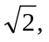other than
it is irrational. In other words, this is true: If r is any non-zero rational number, and
is any irrational number, then is irrational.
____________________

A new key concept. An important observation concerning the rational number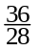is that it can be 'reduced', meaning this: 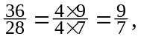and so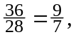and the ‘’ cannot be 'further reduced'. The sense of this should be clear, but a few definitions should clarify matters:

Definition. If divide a if 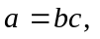for some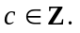
Examples.

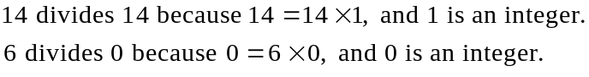

Standard notations. If 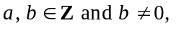and b divides a, then we write: 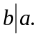
On the other hand, if b does not divide a, then we write: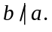

Examples.
[In words, 6 divides 12, minus 3 divides 12, etc., 4 does not divide 1, minus 11 does not divide 12, etc.]

Definition. Let 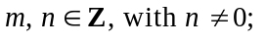 then the rational number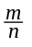is said to be in reduced form if there is no integer d, with 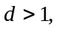 such that 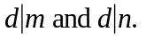

Examples. The rational numbers 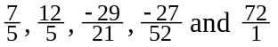 are all in reduced form,

whereas none of the rational numbers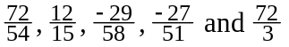 are in reduced form.

Important observation. Every rational number can be expressed in reduced form.

Example. Let us look at each of the previous examples of rational numbers, none of which are in reduced form - - and express each of them in turn in reduced form:
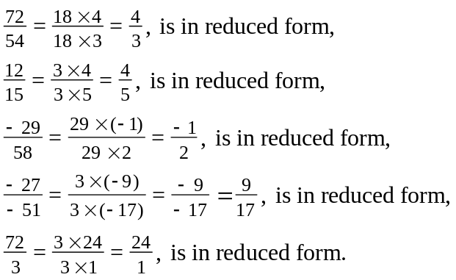

These are merely examples, but they illustrate the idea whereby one can prove the general case for all rational numbers:

Simple (but important) theorem. Every rational number can be expressed in reduced form. (meaning: if is in reduced form).

Before we prove this theorem we need three new terms: ‘divisor,’ ‘common divisor,’ and ‘greatest common divisor.’

Definition: Let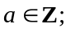then d is a divisor of a if 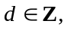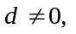and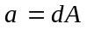for some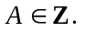
Examples: 5 is a divisor of 10, 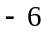is a divisor of 12, 2 is a divisor of , etc.

Definition: If 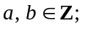 then d is a common divisor of a and b if d is a divisor of both
a and b.
Examples: 4 is a common divisor of 16 and 24, 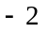is a common divisor of 16 and 24,
1 is a common divisor of 12 and 14, 10 is a common divisor of 10 and 20, etc.

Definition: If 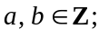then d is the greatest common divisor (usually abbreviated to gcd) of a and b if d is a common divisor of a and b, and 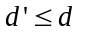for all common divisors 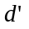of a and b.
Examples: 8 is gcd of 16 and 24, 3 is the gcd of 15 and 24, 1 is the gcd of 12 and 17, 10 is the gcd of 10 and 20, etc.

We are now ready to prove the above:

Theorem. Every rational number can be expressed in reduced form; meaning this:
if r is a rational, then 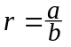 where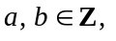 with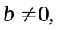and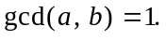

Proof. Since r is rational then 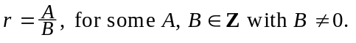

Now, let 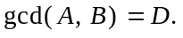 Thenfor some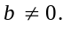
Then 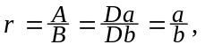and 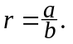 Also, Why? Well, suppose
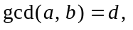 where 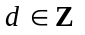with 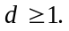 We then have 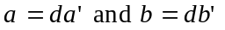 for some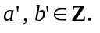 But then we have:

and thus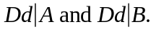 If 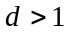we would have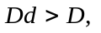which would conflict with 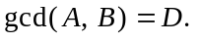 Thus it must be that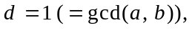and thus r, with , has
been expressed in reduced form.

Comment on this proof. You should realise that this proof is really quite simple. It is merely writing down the obvious: if you have a rational number, then that number is the ratio of two integers (with non-zero denominator). If those two integers happen to have their gcd equal to 1, then their ratio is already in ‘reduced form’, and if their gcd happens to be greater than 1, then simply by ‘reducing’ the numerator and denominator by that divisor, produces a ‘reduced form’ value of the original ratio. That’s all there is to it.

Now we are home and dry. Everything is now in place for:

Theorem.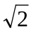 is an irrational number.

Proof. Suppose that is rational. Then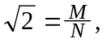 for some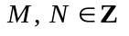with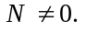
Now,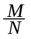 can be expressed in reduced form, and so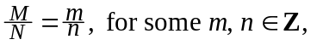with
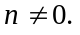 [Now comes the real detail:] Then 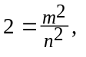 and thus 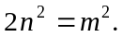 But then we have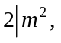 and it follows from that that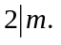 Why? Well, since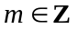 then 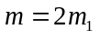
or 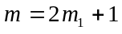 for some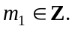 So, we have 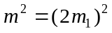 or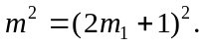 But we have:
,

for some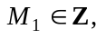and from that we see that when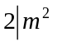it follows that

Thus for some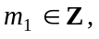so from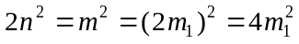 we get that
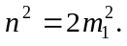 But then we have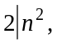 and from that it follows that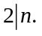

But then we have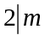 and 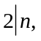 which is in direct contradiction with 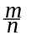 being in reduced form. It follows that cannot be a rational number; it is therefore an irrational number.
____________________

Everything that you have learned here in connection with proving the irrationality of the square-root of 2 can be easily adapted so as to prove the irrationality of other similar numbers: The study of this is continued in another set of notes.

And one can produce even more impressive agreement, as you will know (or will come to know).
The famous English mathematician G.H.Hardy details this in his much read A Mathematician’s Apology, by way of giving (for non-mathematical readers) an example of real, serious Mathematics.
Note that this number is the one obtained from by changing the final digits of the numerator and denominator to ‘4’ and ‘3’.
We are at the end of the ‘teaching’ stage; the rigorous stage can wait a while.
This is the idea we need to complete a rigorous proof that 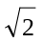- and numbers like it - is irrational.
Our ambition is to show that this is impossible.
This is the point at which we make our observations about ‘even’ (divisible by 2) and ‘odd’ (not divisible by 2; or to put it another way, leaving remainder 1 on division by 2). This is exactly what we were doing at the ‘teaching stage.’
This is merely stating that if the square of the numerator is even then the numerator itself is also even. Once again, this is precisely what we argued about in the earlier ‘teaching stage.’
This is merely stating that if the square of the denominator is even then the denominator itself is also even. Once again, this is precisely what we argued about in the earlier ‘teaching stage.’
This is merely stating that if the square-root of 2 is rational then both numerator and denominator are even.

