St. Patrick’s College, Drumcondra. Solutions to, and some
comments on, First Year Mathematics Test of October 1998

Note. There are no ‘perfect’ solutions, only correct ones. Also, as regards some of my comments (below), I cannot possibly comment on every single point, or refer to all the errors that I encountered in reading work handed in. Whenever I make a comment, or refer to some common or unusual error, it should be understood that that comment refers not only to the case in question, but to all other similar usages elsewhere (and not just in this test). You must carefully read my solutions, ask me about any parts that do not make sense to you, and reflect on my comments (all of which are preparing the ground for work done in the near future and also later in the year).

Question One

- Calculate 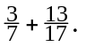
Solution: 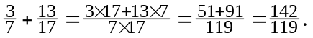
Comment. One should not write things like:
“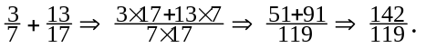”
That is a completely incorrect usage of ‘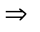.’ ‘’ means ‘implies’, which is not the same as ‘’, which means ‘equals.’ And just read something like it aloud to hear that it sounds completely wrong; imagine saying “one half plus one third implies five sixths” … .
Here − by way of an example − is a correct usage of ‘’:
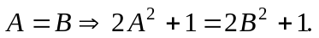
Read that aloud to hear it. “A equals B implies that two times A squared plus one is equal to two times B squared plus one.” In other words, if 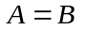then (it follows that − that’s what ‘implies’ actually means)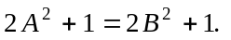
- Calculate 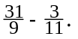
Solution: 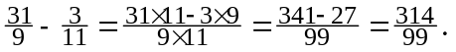
- Calculate 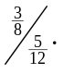
Solution. 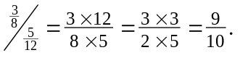
- Calculate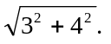
Solution.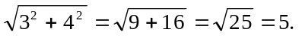 [Someone might say: should it not
be ‘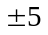’, since the square-root of 25 has two values? It’s a point.]
Comment. I was interested to see if anyone would make an error like:
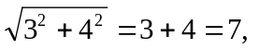on the (wrong) grounds that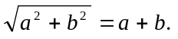
Some did. One wrote:
“”
- Calculate 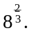
A solution. 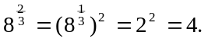
Alternative solution. 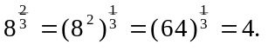
Comment. The topic of powers - one which is frequently, and unnecessarily, a source of difficulty - is one that I will treat in some (fast) detail in lectures at
some stage.
- Calculate 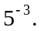
Solution. 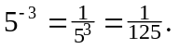
Comment. One could - if one wished - correctly continue the solution (though there would be little point in doing so) with, say: 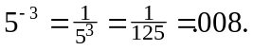
- Calculate 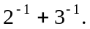
Solution. 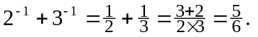
Comment. Here, however, it would be incorrect to continue the solution with, say:
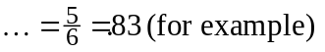
or even with:
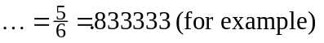
Question. What is incorrect about those two?
Answer, together with some important comments (which will have considerable bearing on work you will do in your course). The use of the final ‘’ is the issue.
It is incorrect:
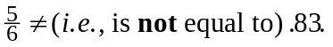
The very meaning of ‘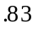’ is 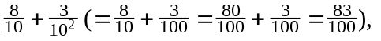and it is clear that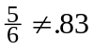from:
And so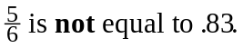 is, in fact, greater thanby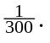
Better still (in terms of a mental image), 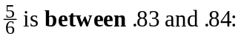 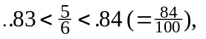
as is seen from:
All in all, then, you should have this number line picture - which I deliberately made appear to true scale - in your mind:
And the other one. Not only is 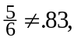but 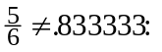
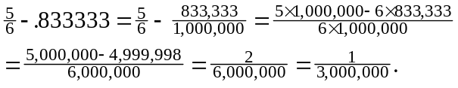
And so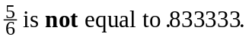 is, in fact, greater than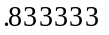by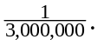
In fact,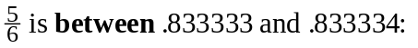
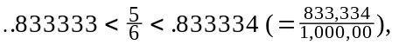
as is seen from:
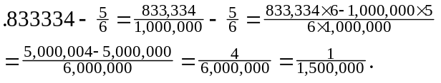
And a true scale picture to have in your mind:
Return to the comment in part #6. There it was perfectly acceptable to write:
“”
That though is because 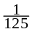 is equal to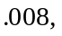as is verified by the meaning of .008:
An important point to which I am trying to draw your attention. There is a fundamental mathematical difference between the numbers 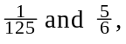and it is this:
although they are of a kind in that they are both ‘rational’ numbers - that is they are both the ratio of two ‘integers’ (i.e. whole numbers) - they are of quite different types as regards their ‘decimal’ values:
- has a ‘terminating decimal value’, meaning it has a decimal value of the following form:
meaning:
where are integers having values between 0 and 9.
[Examples:
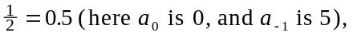
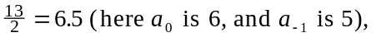
and an important question: which rational numbers have terminating
decimal values?]
- does not have a terminating decimal value (why? how does one know? … )
Rather it has a ‘non-terminating’ decimal value:
(‘ad infinitum’)
‘ad infinitum’ means? The literal meaning is ‘to infinity’, but what does that mean? Here, now, we have arrived at a point where no quick, simple explanation can be given, and this is a topic that we will return to at some length in the course of time.
For the moment, however, suffice it to say - and this is close to the real meaning -
that when we say that the decimal expansion of is ‘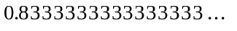,’
we mean that the n-th. term of the infinite sequence of numbers:
gets ‘arbitrarily close’ toas we increase the value of n.
But what does that ‘arbitrarily close to’ mean? It means that the difference between and the n-th. term of the sequence gets nearer to 0 (zero) as n is increased in size.
Some partial detail:
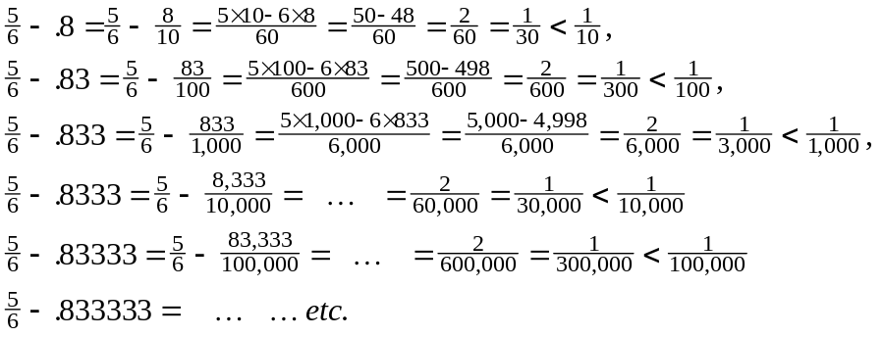
Can you guess the general pattern? I will take up in later lectures.
- Calculate 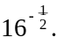
Solution. 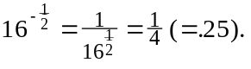
- Find x given that 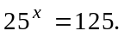
An acceptable solution.
Thus the solution is 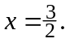
Comment. That was fairly straightforward (though a number of you did not do it).
Of course I deliberately choose those numbers ‘25’ and ‘125’ so that the ‘solution’ came out nicely. No awkward numbers.
What would you have done − though − if I had worded the question as follows?:
Another problem. Find x given that 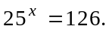
Think about that, and let me know what you tried.
Question Two

- (a) Solve the equation 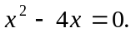
An acceptable solution.
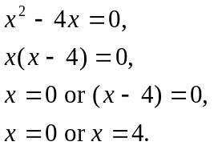
Thus the solutions are 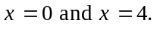
Comment. That was the obvious way to solve that equation. It would be rather like using a sledge-hammer to have solved it − as someone did − by using the ‘formula’,
the ‘minus b plus or minus etc.’
(b) Solve the equation 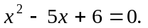
Another acceptable solution (by ‘factoring’).
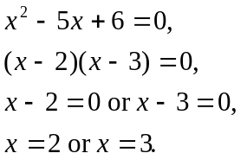
Thus the solutions are 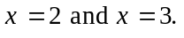
Solution (by using the classic ‘minus b plus or minus etc.’).
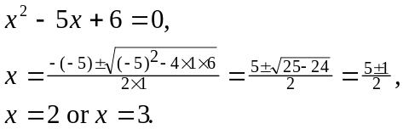
Thus the solutions are
(c) Solve the equation 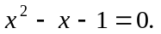
Solution (by using the classic ‘minus b plus or minus etc.’).
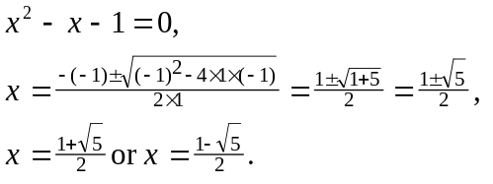
Thus the solutions are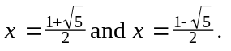
Comment. Here the real interest for me was to see if any of you would attempt
to solve the equation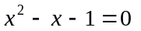by attempting to ‘factor.’ That leads to very, very interesting mathematics, as you will see in lectures, and is dealt with in great detail in another set of notes which I will give you - on another occasion - on irreducible polynomials.
Further comment. Of course there is a completely incorrect attempt at a ‘solution’:
“
” [Those are clearly not solutions! Just substitute 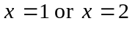 into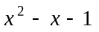 to see … ]
Where is the error? The error crept in at the “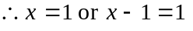”.
It is simply not true to assert that if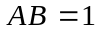then either 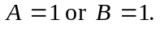
For example 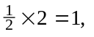but neither 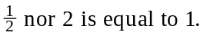
(d) Solve the equation 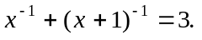
An acceptable solution.
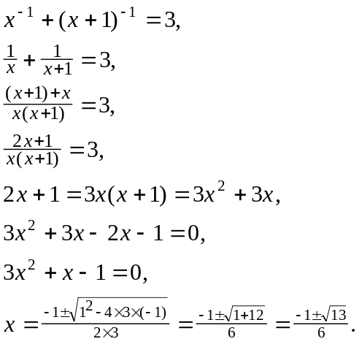
Thus the solutions are 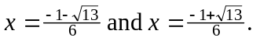
Comment. Here my interest was to see how many of you would handle this slightly unusual type of equation. Several of you did do it, but with varying degrees of accuracy. One who obtained the line ‘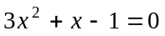’ − as in my solution above − arrived at it, but for all the wrong reasons. He/she wrote this (others wrote similar, error-laden contributions):
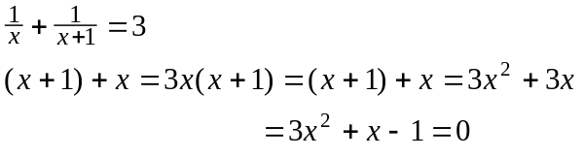
So, what’s wrong with that? Well it contains many of the classic horrors!! And what are they? Well, look at it and tell me!! I’ll leave that one for class time.
- Factorise the following expressions as far as possible:
(a) 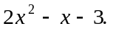
Solution. 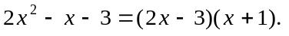
Comment. Someone gave as his/her solution:
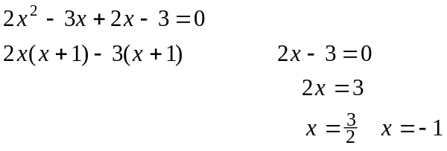
And what’s wrong with that? Well, you tell me.
(b) 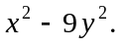
Solution. 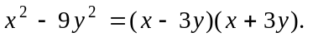
(c) 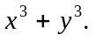
Solution. 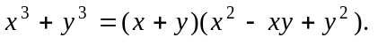
Comment. These are standard ‘algebraic factorisations’, especially (c) − ‘the sum of two cubes is ….’ You should know them, and − more importantly − be able to verify them. I’ll have more to say about that in class.
- The triangle ABD, right-angled at D, has sides AB and AD of length 20 and 12 respectively. C is a point on BD such that the length of AC is 15. Find the area
of the triangle ABC.
A solution. [One should attempt to draw a reasonably good diagram:]
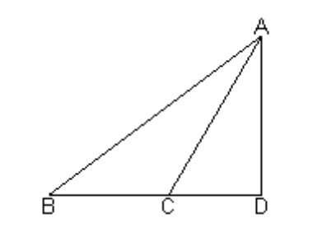
We have 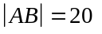 and 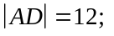also we have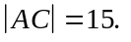
[Diversion. Now, to think! We want the area of the triangle ABC, and immediately we should start asking ourselves: what information about a triangle will enable us to calculate its area? If one starts to grab at formulae out of one’s bag of tricks − the area is a half of ab times sin of C, etc. − then anything is likely to happen. One obvious approach − from one’s bag of formulae − is, of course, the well known half the base times the perpendicular height. The problem is, though, which base to consider? Should one use as base AB, or BC, or AC? In one’s mind one should then briefly consider the consequences of a particular choice … . A moment’s reflection should convince one that by far the best choice is to take BC as the base, which means that the perpendicular is AD. We do know 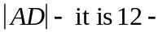 and so what we need is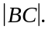 Now that we know what we need, the next thing is to look about us to see how to relate (and this is a perfectly general approach that we should adopt):
- what we know to
- what we want to know (the problem − of course! − is how to do it) ]
We can find the length of BD from: 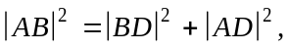and so 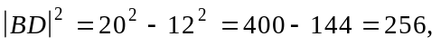giving 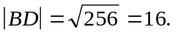
Also we can find the length of CD from: 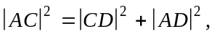and so 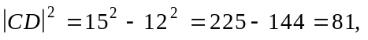giving 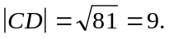
Thus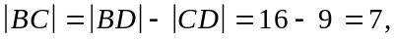and so the area of the triangle ABC
is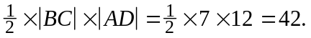
Comment. A simple problem, which some of you ‘made a meal of ’ … .
Question Three Let C be the curve whose equation is 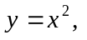and let P be the point on C with x co-ordinate 3. Let T be the tangent at P to the curve C. At what distance from the origin O does T intersect the x-axis?
A solution (one that a number of you gave − in some sort of way − though I am expressing it a bit more correctly). [It helps to draw a reasonable diagram.
C, P, T and O are as stated in the question. Q − which I have introduced − is the
point on the x-axis where T intersects it. And that ‘R’? It is the point on the x-axis
with co-ordinates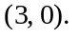 My reason for introducing it will be clear later.]
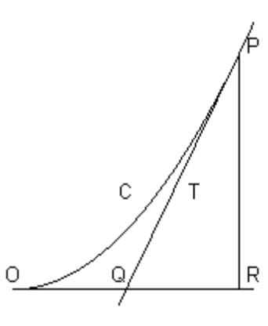
Since the equation of the curve C is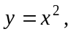then the slope of a tangent to C at
the point with co-ordinates 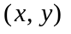− namely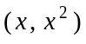− is given by 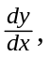namely
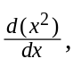which is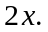 Thus the slope of the tangent at the point P is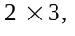namely 6.
Thus the equation of the line T (the tangent to C at P) is (continued below):
[Aside. And this uses the fact that one knows two things that are relevant: the co-ordinates of P, and the slope of the tangent at P. And here one needs to know the standard ‘y minus y_one equals m times x minus x_one’ 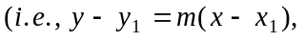
where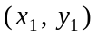are the co-ordinates of the point through which the line passes, and ‘m’ is the slope of the line through 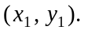]
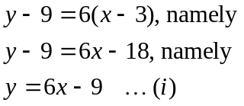
[And where does T intersect the x-axis? At the point where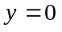on T.]
Setting in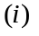gives 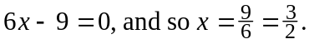 Thus the x-co-ordinate of the point Q is 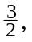and so the distance of Q from O (the ‘origin’, the point 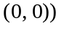is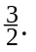
A much better solution (‘better’ in the sense that it gets right to the heart of the matter, and cuts out the unnecessary calculation of the equation of the tangent T.)
[Start off as before:] Since the equation of the curve C isthen the slope of a tangent to C at the point with co-ordinates − namely− is given by
namely which is Thus the slope of the tangent at the point P is
namely 6. [Now get straight to the point:] Let R be the point with co-ordinates 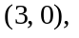then − since the slope of the line T is 6 − it follows that 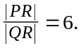
But 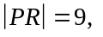and so 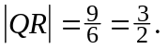 It follows that 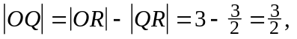
and so T intersects the x-axis at distancefrom the origin O.
Comment. This was a question which enabled me to judge quite a number of things about the class as a whole. Who knows what, and who doesn’t know what … .
The ideas that you encountered in its solution are fundamentally important, and form the basis of the ‘Newton-Raphson method’ which you will study in the course of time. That incredibly simple, but powerful method will enable you to understand how − for example − Maple calculates square-roots (and much, much more besides) to whatever degree of accuracy one wishes.
Question Four. Some of the following statements are true, and some are false. Indicate - by writing alongside either ‘this is true, without exception’ or ‘this is sometimes false, for example … ’ - those which you believe to be true, and those which you believe to be false.

(a) If a and b are numbers such that 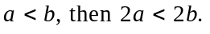
- If a and b are numbers such that 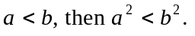
- If a and b are numbers such that 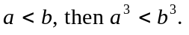
- If a and b are numbers such that 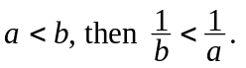
Comment. (a) and (c) are ‘true without exception.’ [Why are they true … ?]
(b) and (d) are ‘sometimes false’, for example:

(b):
and so 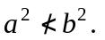 In fact 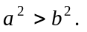
(c) 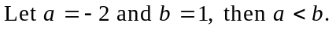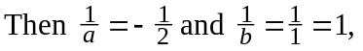
and so 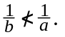 In fact 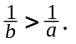
What point was I trying to make? I posed you some simple questions involving ‘inequalities’, and most − thought not all of you − fell for the common errors … .
This important topic − inequalities − is something which you will study at some point in your first year course. Why are (a) and (c) true without exception … ? Some of you gave examples in connection with those two. Here were some typical examples:

and so 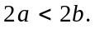
and so 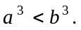

But these examples − correct thought they are − would prove nothing. They would merely be examples which are consistent with the assertion that (a) and (c) are true without exception. How do we know for certain that there are no examples to show that they are − perhaps − sometimes false? A complete answer to that question will require a proper study of ‘inequalities.’
Question Five (just out of interest)

- Write the names of any ‘famous’ mathematicians of whom you have heard.
Comment. A number of you did not furnish me with even a single name … .
However I did get many, many interesting contributions. A common one was Pythagoras (please note the spelling!! I got many a ‘Pythagourous’, and others … ).
I also got a number of Newton-Raphsons (Newton and Raphson are two people, not someone with a double-barrelled name). I got Einstein quite a few times, though for a mathematician it is amusing that he is probably the ‘most famous mathematician of all time’, though he was not a mathematician; he was a (great) physicist who used mathematics, and he needed the assistance of mathematics with his mathematical work.

- Have you ever heard of an irrational number? If so, would you briefly
describe what it is, and give an example of one.
Comments. Here I got much to interest me!!!!!!! Whereas some of you might have heard from someone (a good teacher, perhaps) of an irrational number, I would not have expected any of you to have been able to give me a precise definition of the term irrational number. Of course it is possible for someone to have given me correct examples of irrational numbers without having given a precise definition of the term!
First I should remark that not one of you gave me a correct definition of the term ‘irrational’ number (though some were quite close). I also got some really weird definitions, from which I have learned a great deal about certain misunderstandings that a number of you have.
What is an ‘irrational’ number? First of all some other numbers:

- The ‘natural’ numbers. These are − by definition − the positive, whole numbers.
The natural numbers are the numbers: 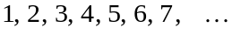
- The ‘integers’. These are − by definition − the whole numbers.
The integers are the numbers:

- The ‘rational’ numbers. These are − by definition − the numbers obtained by forming all possible numbers of the form 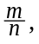where:
- m and n are integers, and n (the denominator in 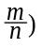is non-zero.
Here are some (obvious) examples of rational numbers:
and here are some (less obvious) examples of rational numbers:

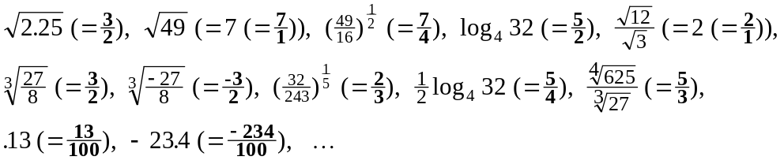
The rational numbers, then, are all the numbers:

(denominator 1)
(denominator 2)
(denominator 3)
(denominator 4)
.
.
.
(denominator 31)
.
.
.
ad infinitum

and as for those with negative denominators, well they just duplicate the one above.
That’s simply because − for example − 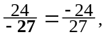or 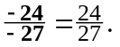

So, what is an ‘irrational’ number? An irrational number is a number that is not
a rational number!! That’s all!!

But behind that simple sounding definition is a lot of mathematics!! A lot of history!! A lot of effort!! A lot of things that are known!! An even vaster amount of things that are unknown!! In short, a lot for you to learn about!!
I record here all the contributions − as they appeared on paper (I have made no attempt to polish them up in any way) that I got (some of you made no contribution
whatever), and later I will comment on all of them at a later stage in class. In the meantime − and in the light of what you know an irrational number to be from above − you should attempt to find some fault with every single one of the contributions (including your own!!):

- “The square-root of a number which isn’t a perfect square. e.g. 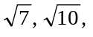
a surd.”
- “An irrational number is any number less than 0. 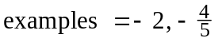”
- “Irrational numbers are numbers which can’t be expressed as integers or quotient of an integer. e.g. 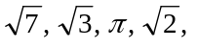 etc.” [together with a diagram which would be hard for me to reproduce here.]
- “Irrational numbers are those which can be expressed as a decimal but which continues indefinitely and cannot be expressed as a fraction. e.g. 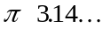”
- “An irrational number is not a whole number. e.g.
- “An irrational number is a surd. e.g.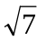”
- “Irrational numbers are all negative numbers to infinity 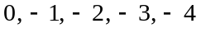 etc.”
- “An irrational number is a number that can’t be expressed in the form 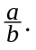 for example non ending decimals.”
- “A number which cannot be written in the form e.g.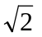”
- “Yes. Irrational numbers are numbers such as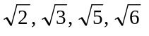 etc. which cannot
be written as fractions.”
- “I have heard, but I can’t remember what it means.”
- “Irrational numbers are real numbers such as all positive whole numbers (1, 10,
65, 80 etc.) all negative whole numbers 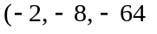 etc.) and all terminating or
repeating decimal (fractions) 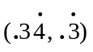and all non-repeating, non-terminating
decimals.
- “An irrational number is an un-real no. e.g.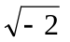”
- “Yes, it is a number that can’t be written as a fraction. e.g.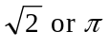 ”
- “It is a number which cannot be written as a fraction. e.g.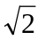”
- “I think it is a number that is not a fraction. e.g. 2 ”
- “A number which is written as a variable inside a root. e.g.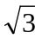”
- “An irrational number are numbers that cannot be expressed as a fraction.
e.g.”
- “ 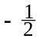 ”
- “ e.g.”
- “Irrational numbers are fractions. e.g.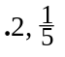”
- “Yes, but I do not remember what it is.”
- “Yes, It is any number below 0, e.g. 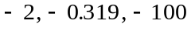
[“-ve” no’s cannot be rational numbers because no square-root is “-ve”]”
- “Yes, irrational numbers are real numbers
all positive eg(5, 10, 62)
and all negative eg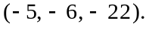”
- “I have heard of it but I can’t remember − is it a fraction? ie as opposed to a
whole number?”
- “Yes. It is a square-root of a number that is not a true square”
- “Yes, ”

- “An irrational number is a variable written in surd form. i.e.”
- “An irrational number is a fraction. e.g. ”
- “An irrational number is made up of natural nos, integers, rational nos and real nos
but not complex nos”
- “A number that can’t be expressed as 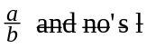or/an 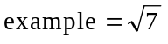
not perfect squares ”
- “Yes. An example of one isand is generally referred to as a surd. It is not a
perfect square.”
- “Yes. A number that can’t be written as a fraction, in the form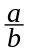 where a and
b are whole numbers. e.g. 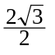”
- “Yes. Fractions/Decimals”
- “Non-recurring, non-terminating decimal. e.g.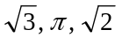”
- “Yes, ”
____________________

This would appear to be a formula that is known to students − in that it can be quoted − but it would appear that it is unknown in the sense that none of you could show how it is obtained. It will be … .
If L is a line segment, we use the notation 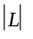 to denote the length of L.
I wonder how many of you can correctly justify it … . A challenge to you!!
More precisely expressed by ‘one half of the length of the base times the length of the perpendicular height.’ Think about it: one doesn’t multiply two lines together (that has no meaning); rather one multiplies the lengths of those lines. Cultivate precise expression!!
Using the theorem of Pythagoras. How many of you can give a precise statement of that?, and how many of you can give a proof of it?

