St. Patrick’s College, Drumcondra
First Year Mathematics Test
October 1998

Name (in BLOCK CAPITALS, please)

Your Leaving Cert. grade (please indicate Honours/Ordinary)

Attempt all questions, and show all written work on the same page as
the question (if need be, use the reverse side of page to do rough work)

Question One

- Calculate 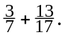
- Calculate 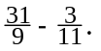
- Calculate 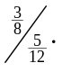
- Calculate 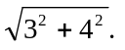
- Calculate 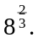
- Calculate 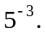
- Calculate 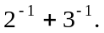
- Calculate 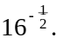
- Find x given that 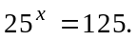
Question Two Solve the following equations:

- 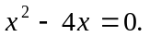
(b) 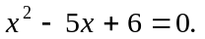
(c) 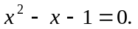
(d) 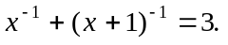
- Factorise each of the following expressions as far as possible:
(a) 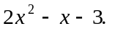
(b) 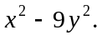
(c) 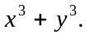
- The triangle ABD, right-angled at D, has sides AB and AD of length 20 and 12 respectively. C is a point on BD such that the length of AC is 15. Find the area
of the triangle ABC.
Question Three Let C be the curve whose equation is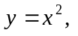and let P be the point on C with x co-ordinate 3. Let T be the tangent at P to the curve C. At what distance from the origin O does T intersect the x-axis?

Question Four Some of the following statements ((a), (b), etc.)−in all of which a, b, c are ‘numbers’−are true, and some are false. Indicate-by writing alongside either ‘this is true, without exception’ or ‘this is sometimes false, for example … ’-those which you believe to be true, and those which you believe to be false.

- If 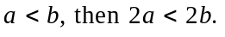
(b) If 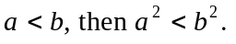
(c) If 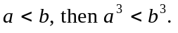

(d) If 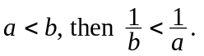

(e) If 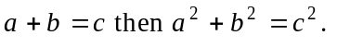

Question Five (just out of interest)
(a) Write the names of any famous mathematicians of whom you have heard.

(b) Have you ever heard of an irrational number? If so, would you briefly
describe what it is, and give an example of one.

