FESTIVAL

AIM:
To prepare a PowerPoint presentation on the topic “FESTIVAL”

SLIDE 1


SLIDE 2
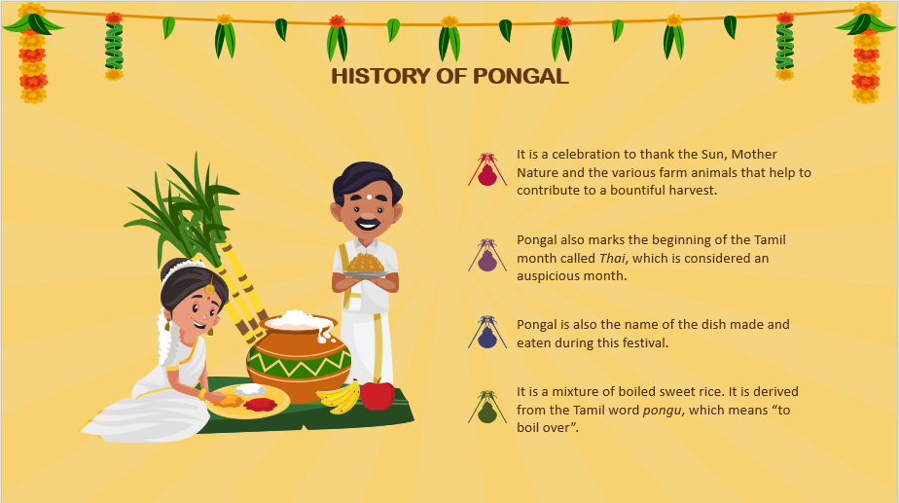
SLIDE 3
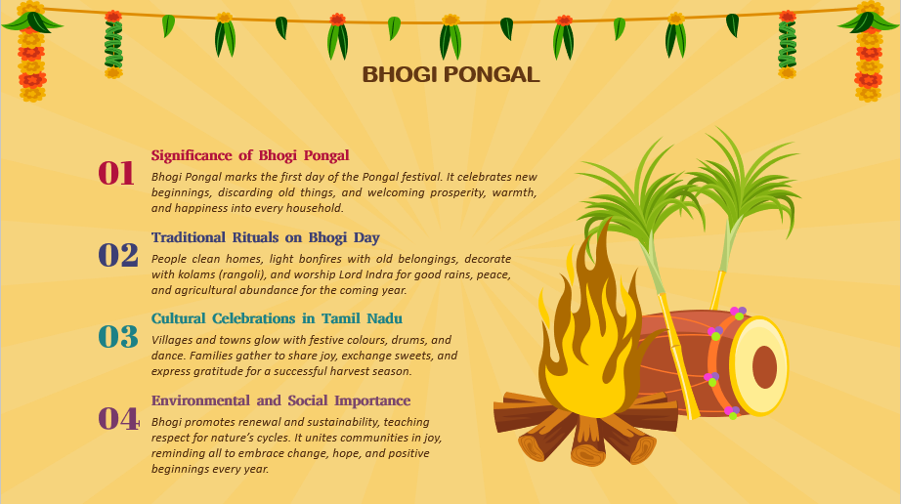

SLIDE 4
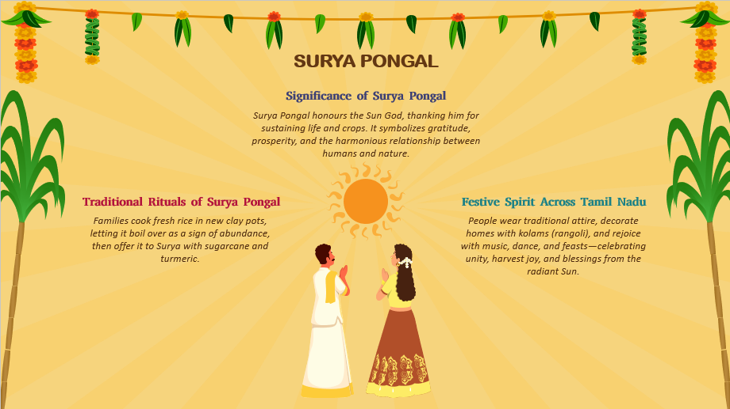

SLIDE 5
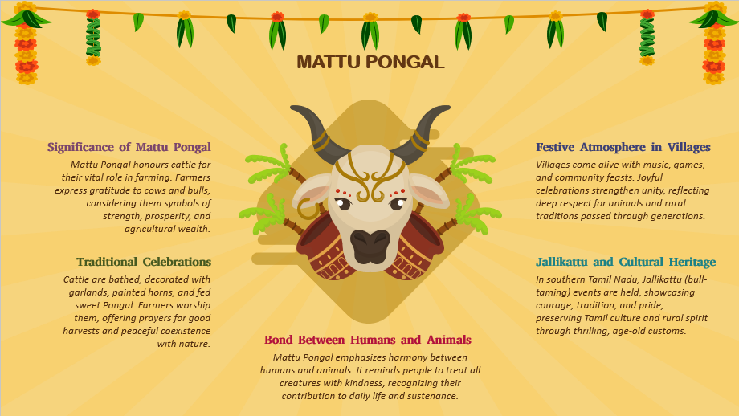
SLIDE 6
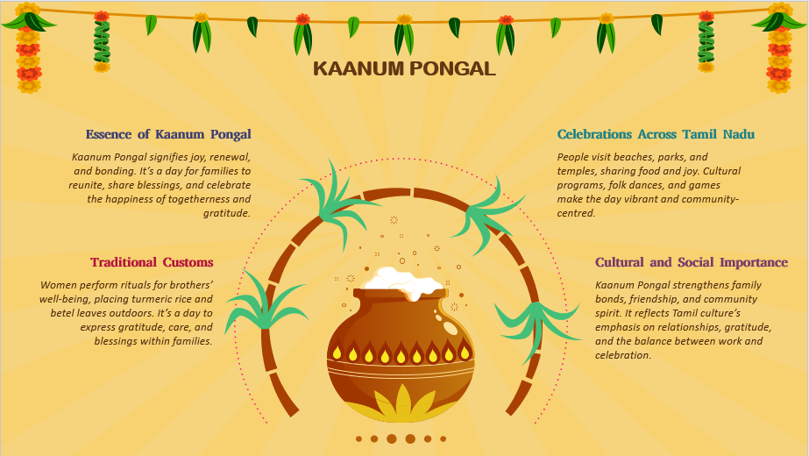

SLIDE 7
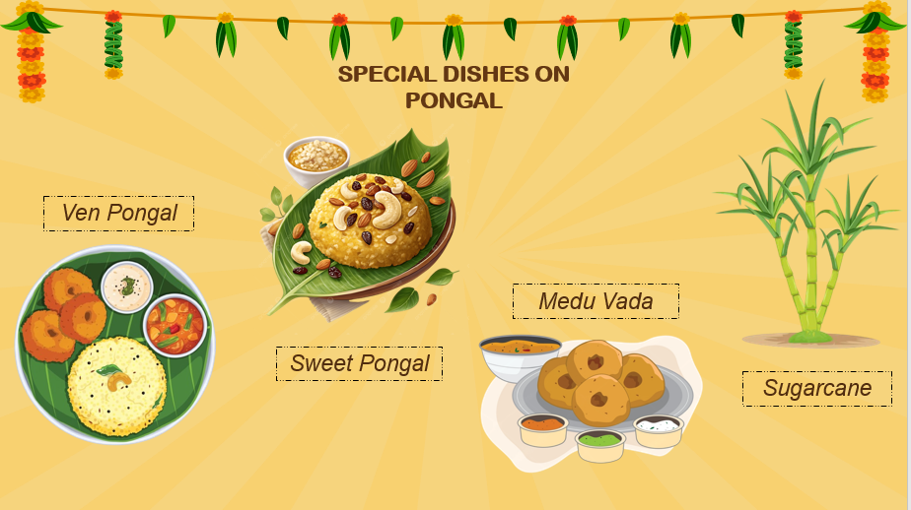

SLIDE 8
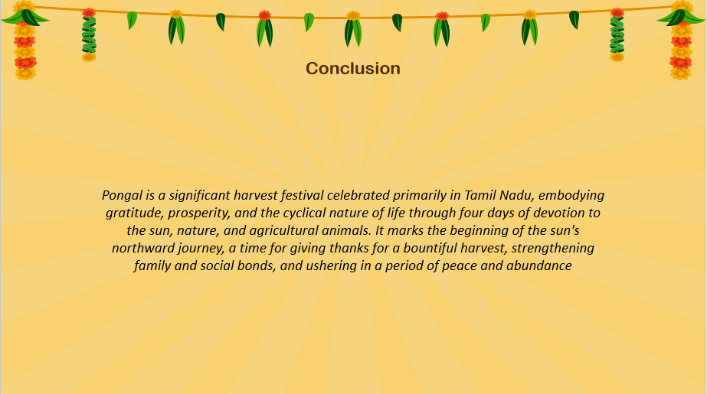

Result
Thus, a PowerPoint presentation on the topic “FESTIVAL” has been prepared.
SPORTS

AIM:
To prepare a PowerPoint presentation on the topic “SPORTS”

SLIDE 1:
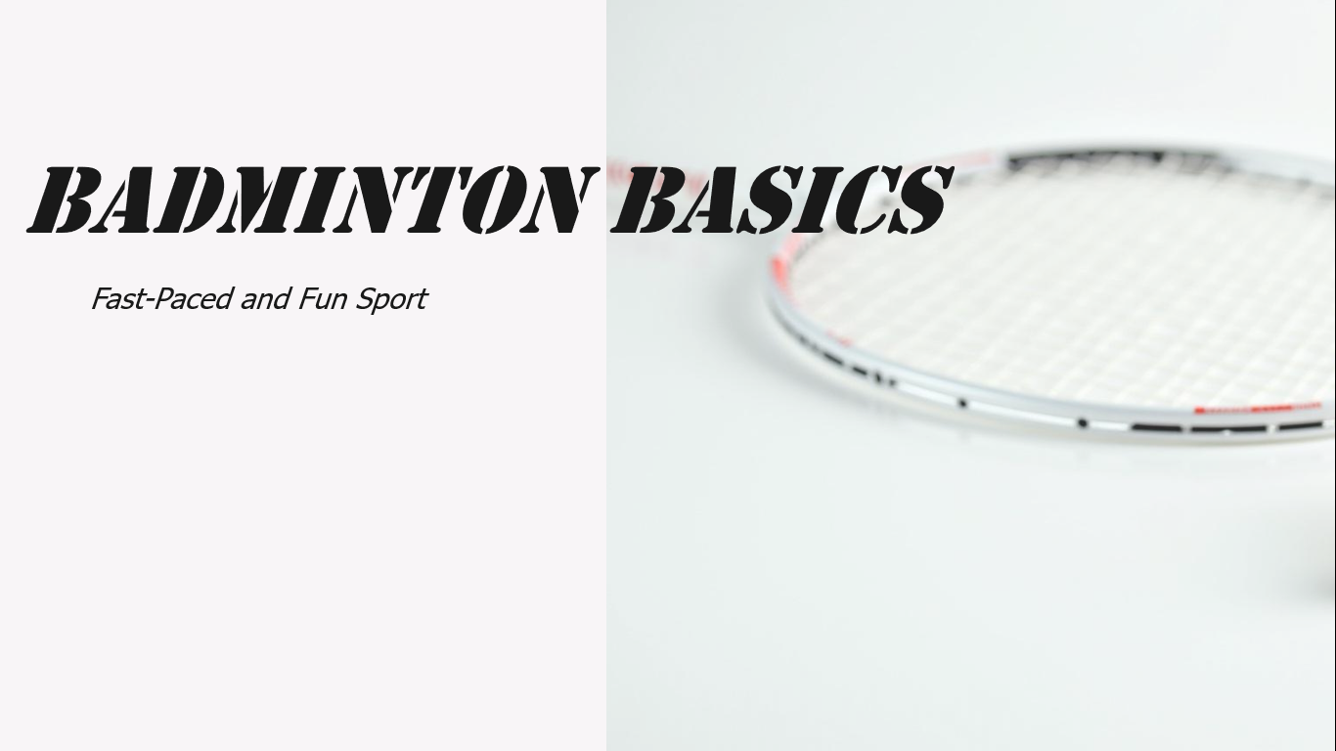
SLIDE 2:
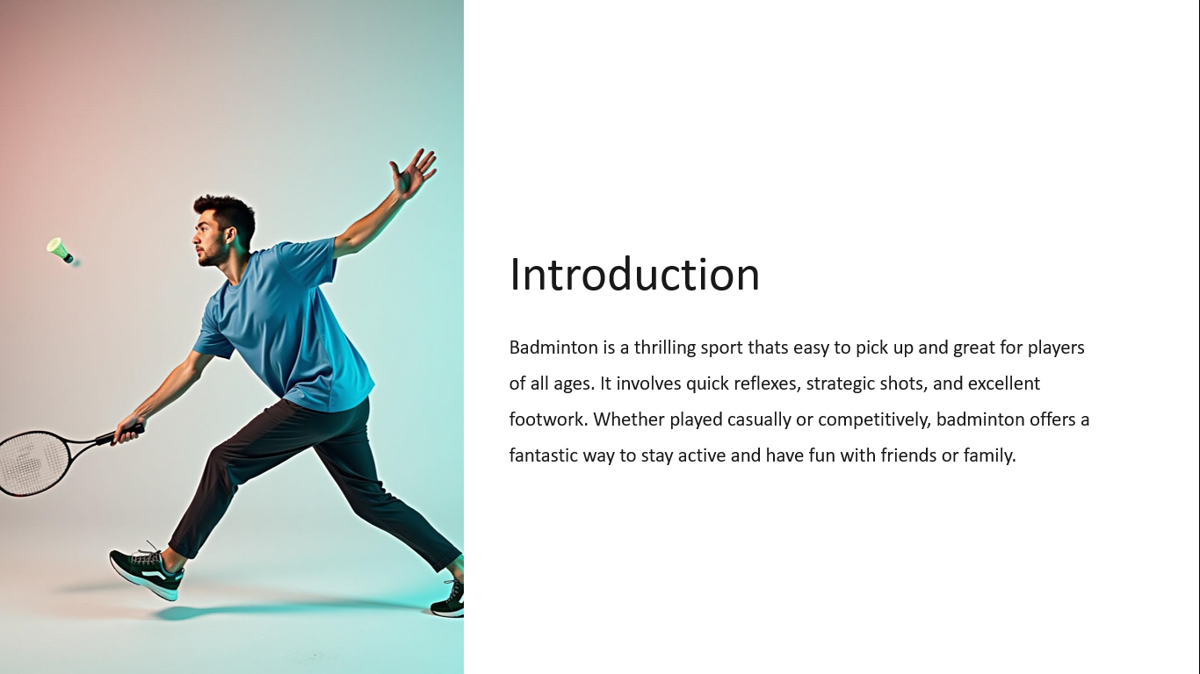
SLIDE 3:
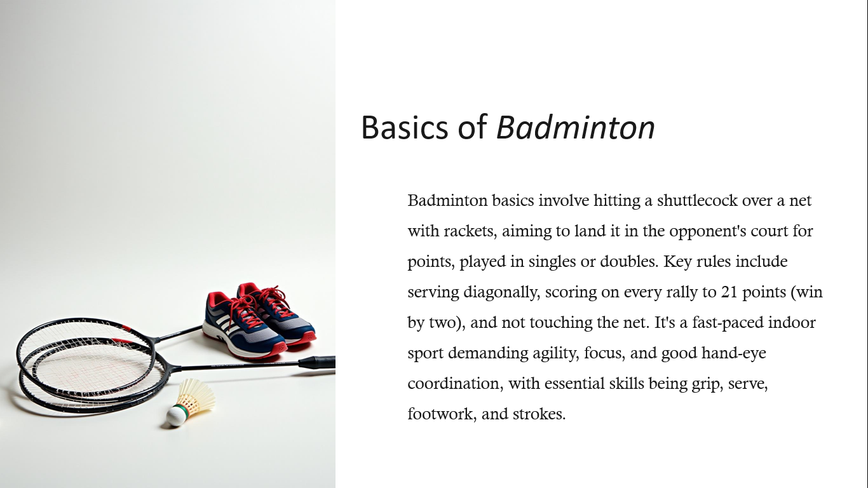
SLIDE 4:
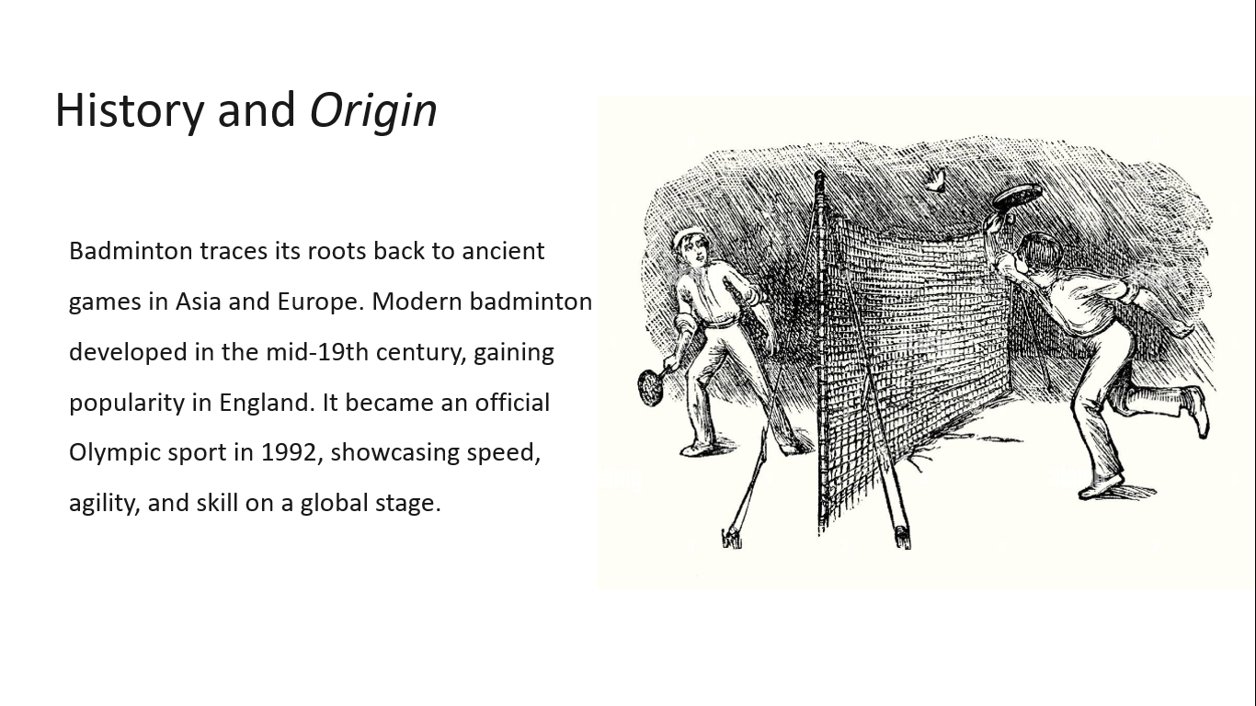

SLIDE 5:
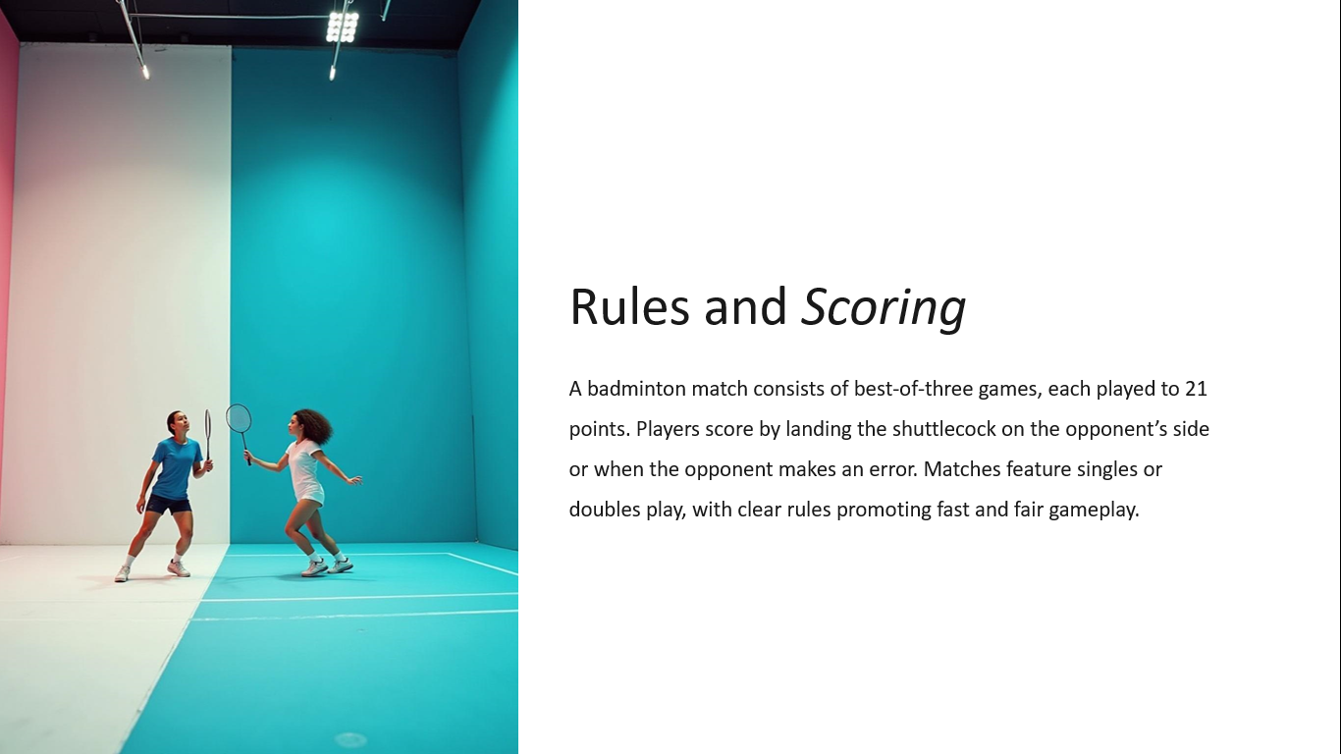
SLIDE 6:
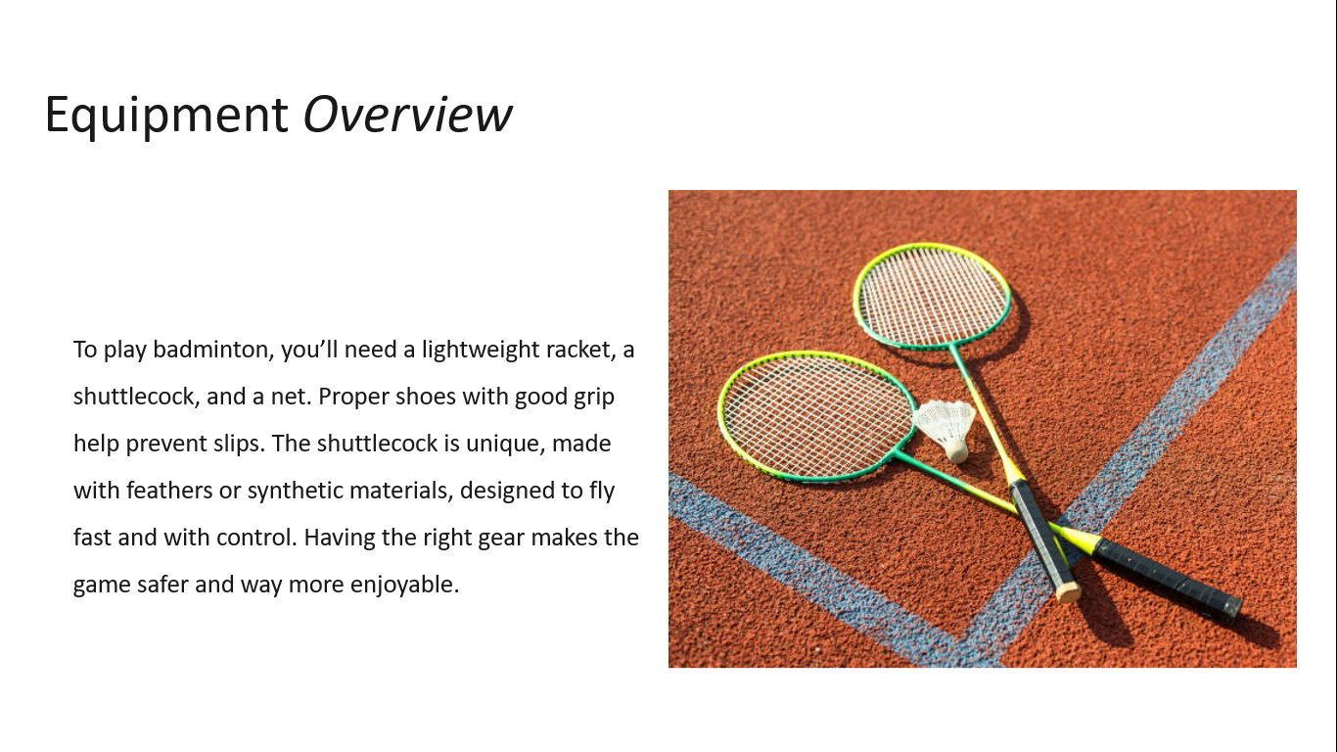

SLIDE 7:
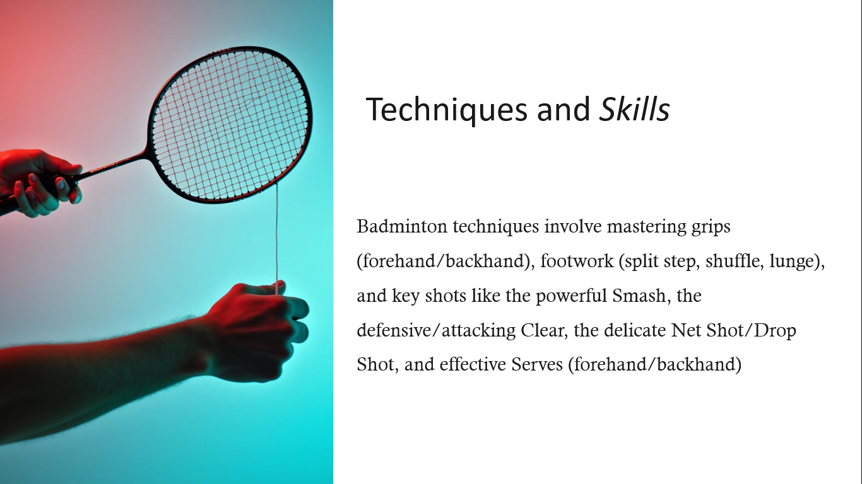
SLIDE 8:
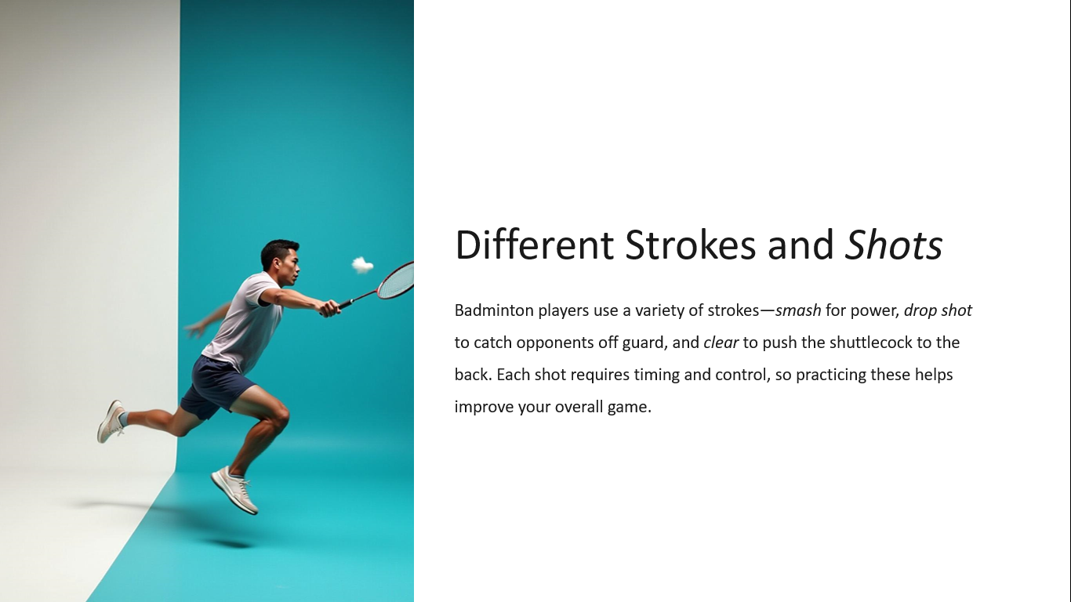

SLIDE 9:
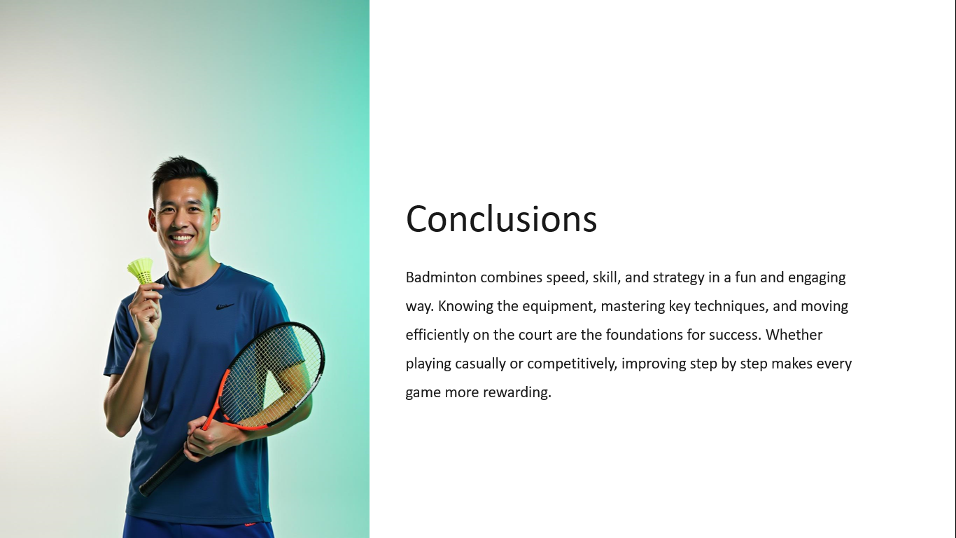

Result
Thus, a PowerPoint presentation on “SPORTS” has been prepared.

PLACE

AIM:
To prepare a PowerPoint presentation on the topic “PLACE”

SLIDE 1:
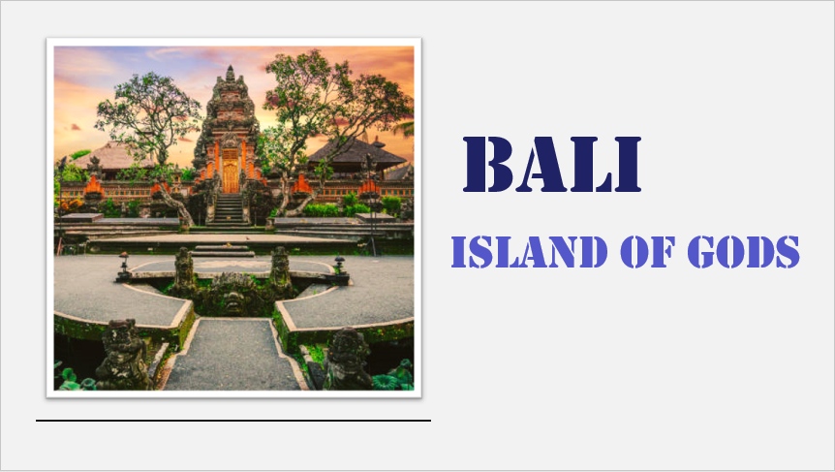

SLIDE 2:
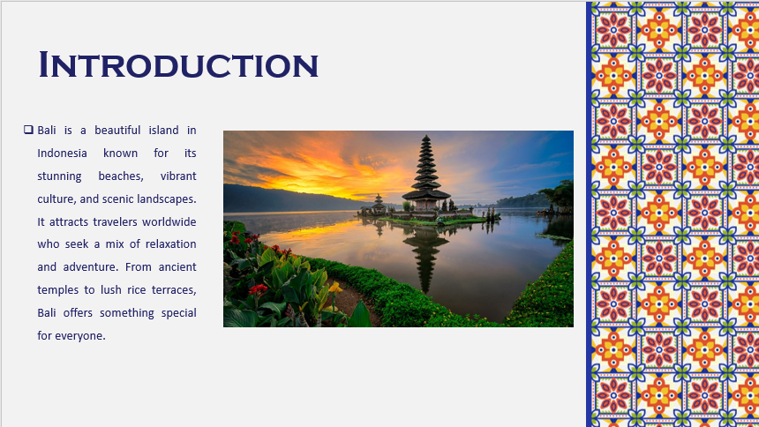

SLIDE 3:
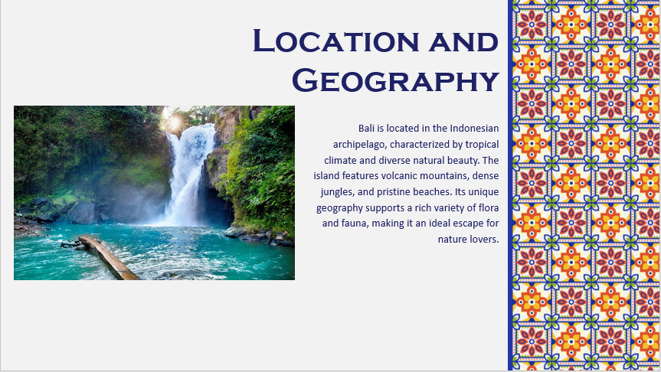

SLIDE 4:
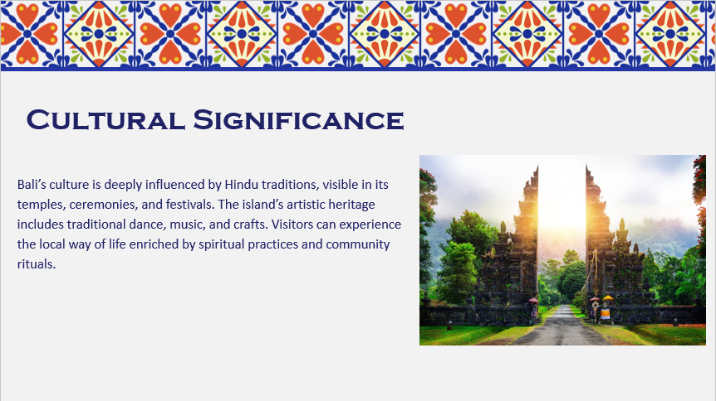

SLIDE 5:
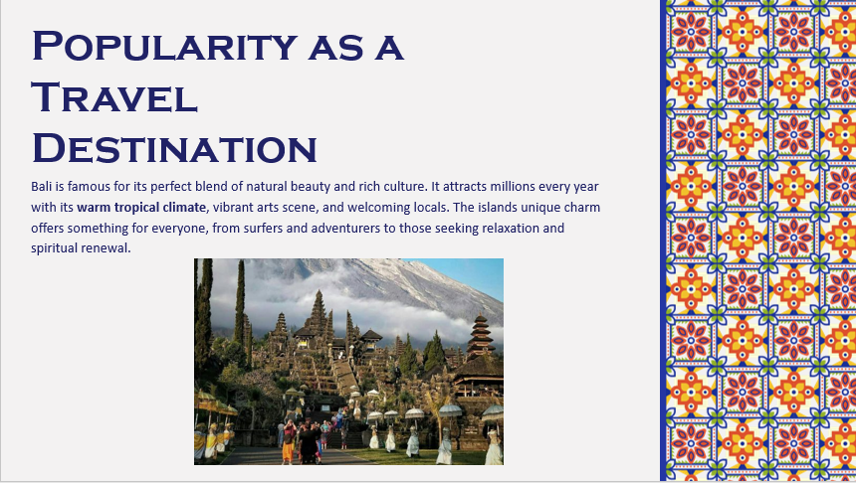

SLIDE 6:
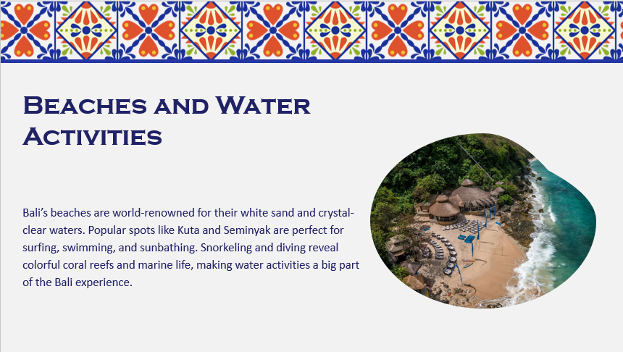

SLIDE 7:
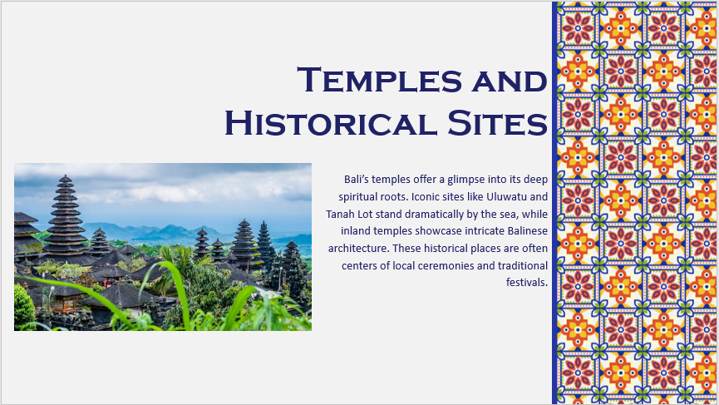

SLIDE 8:
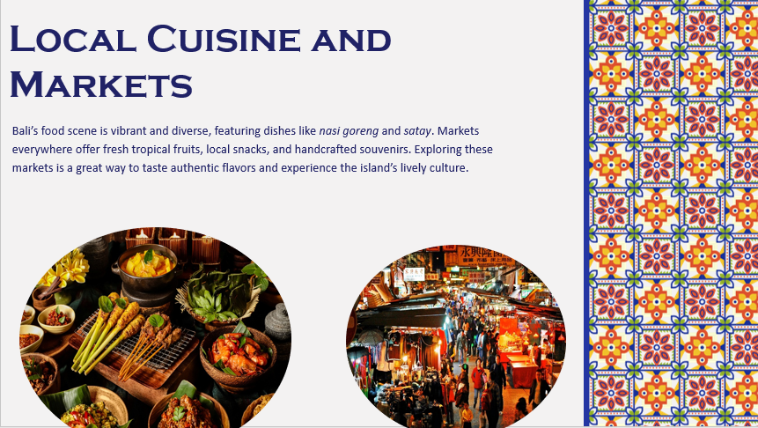

SLIDE 9:
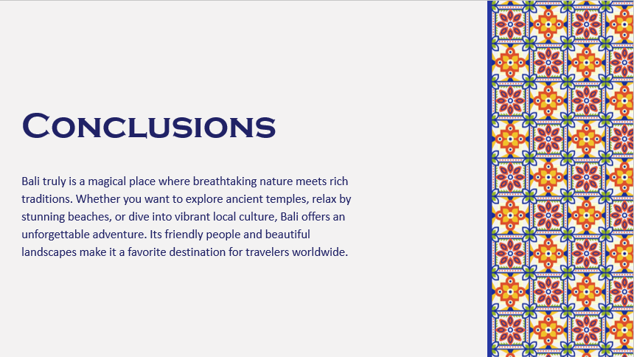
SLIDE 10:


Result
Thus, a PowerPoint presentation on “PLACE” has been prepared.

FOOD

AIM:
To prepare a PowerPoint presentation on the topic “FOOD”

SLIDE 1:

SLIDE 2:
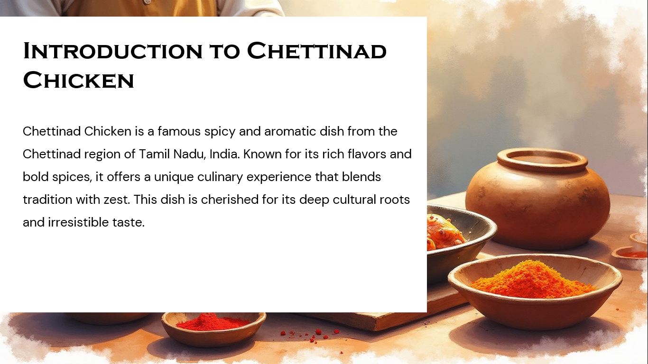
SLIDE 3:
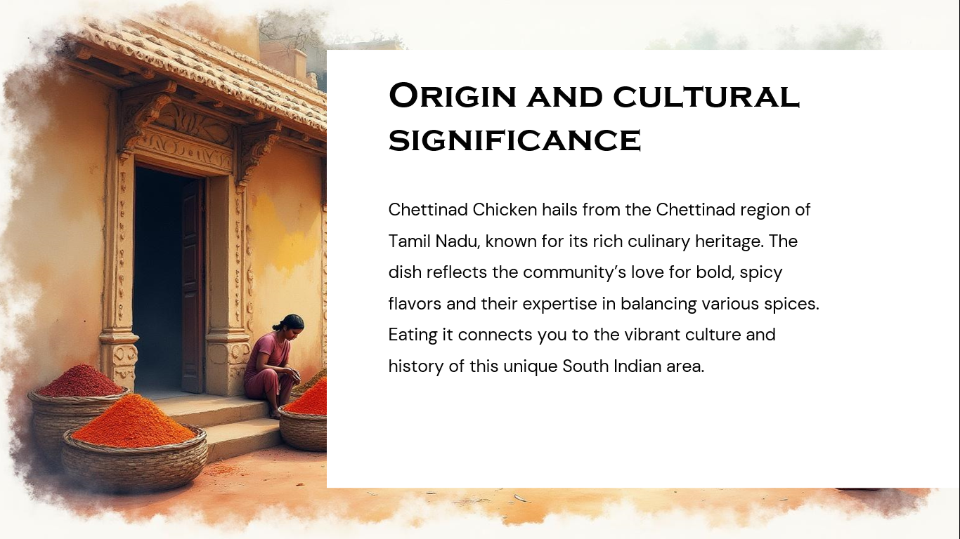

SLIDE 4:
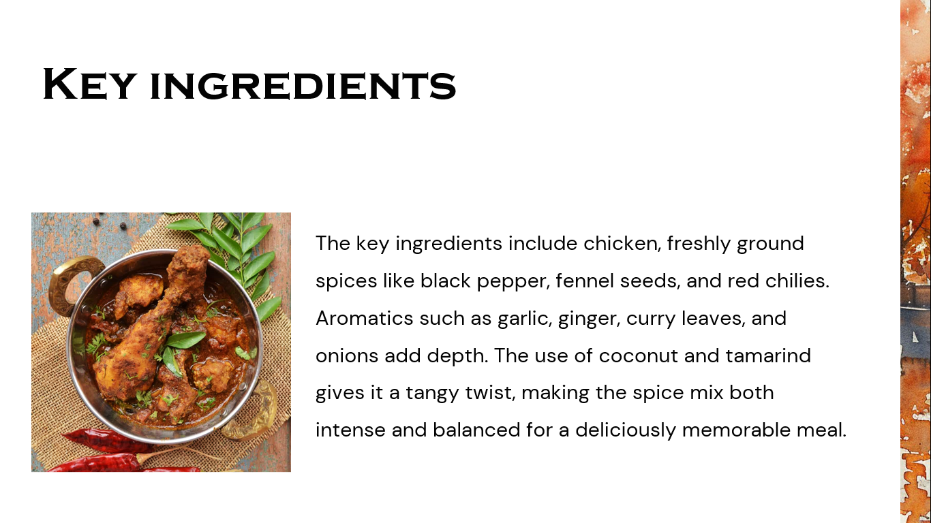

SLIDE 5:
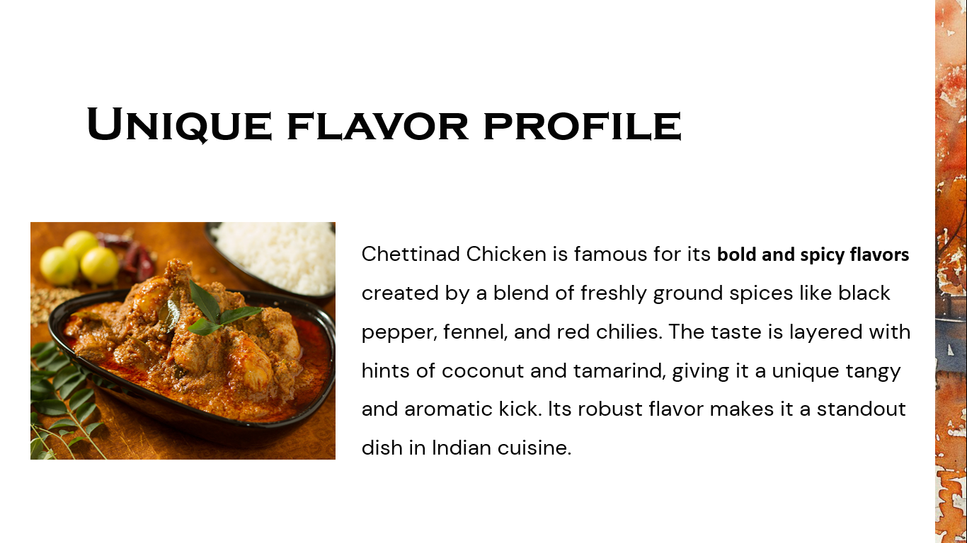
SLIDE 6:
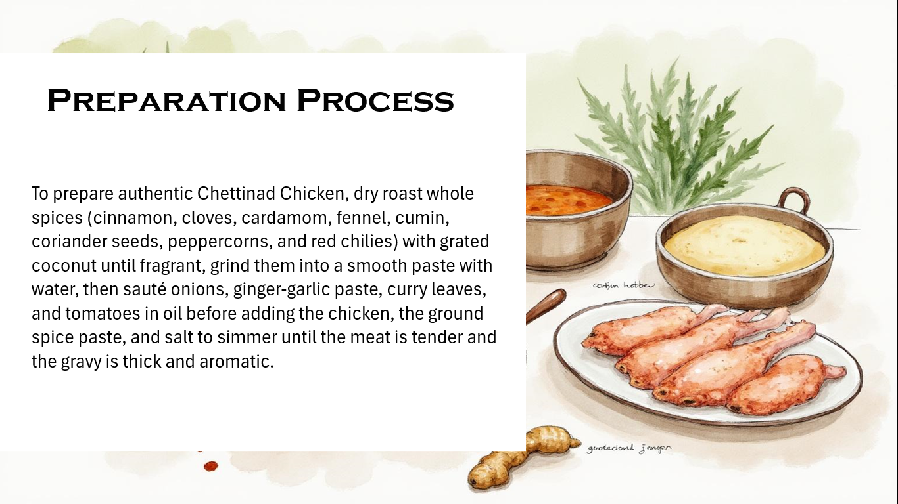

SLIDE 7:
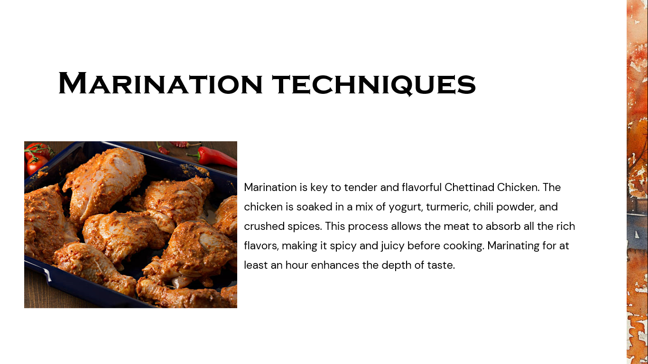
SLIDE 8:
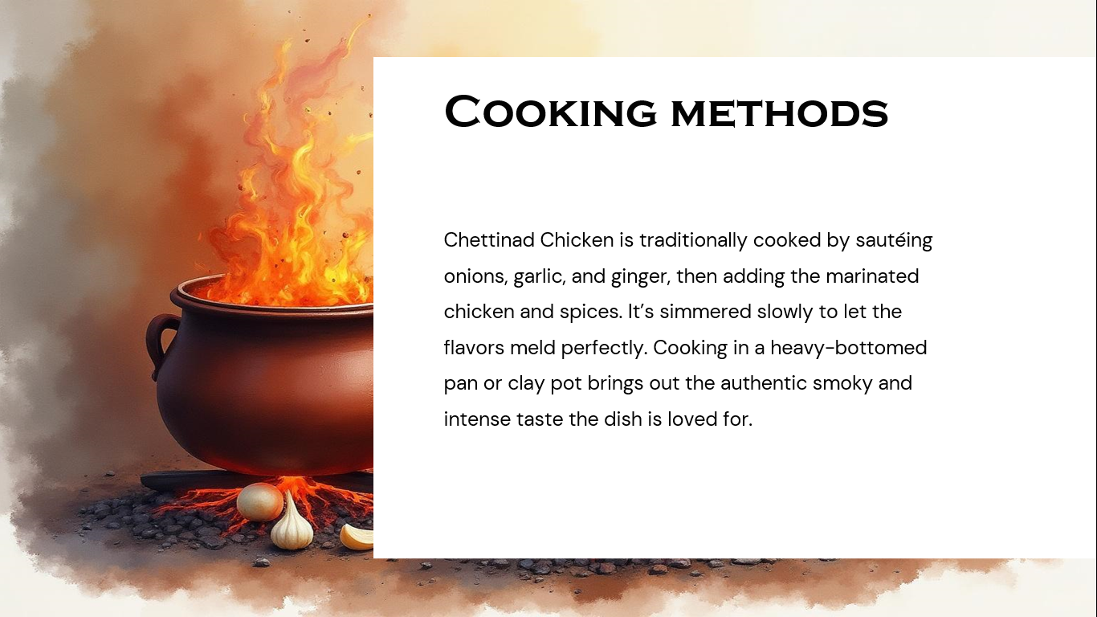

SLIDE 9:
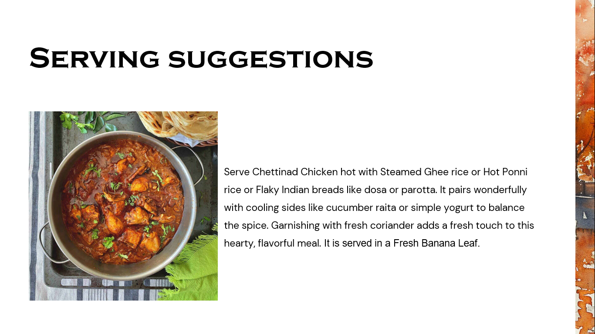
SLIDE 10:
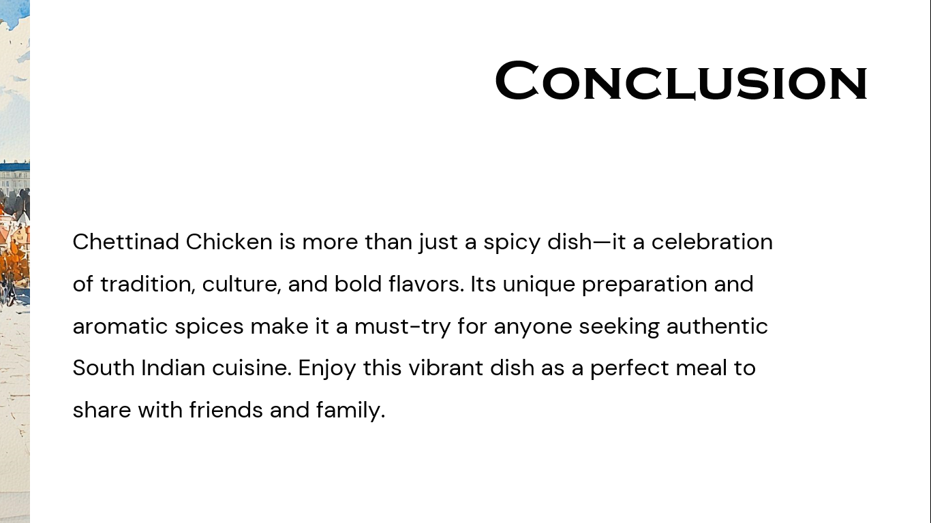

Result
Thus, a PowerPoint presentation on “FOOD” has been prepared.

