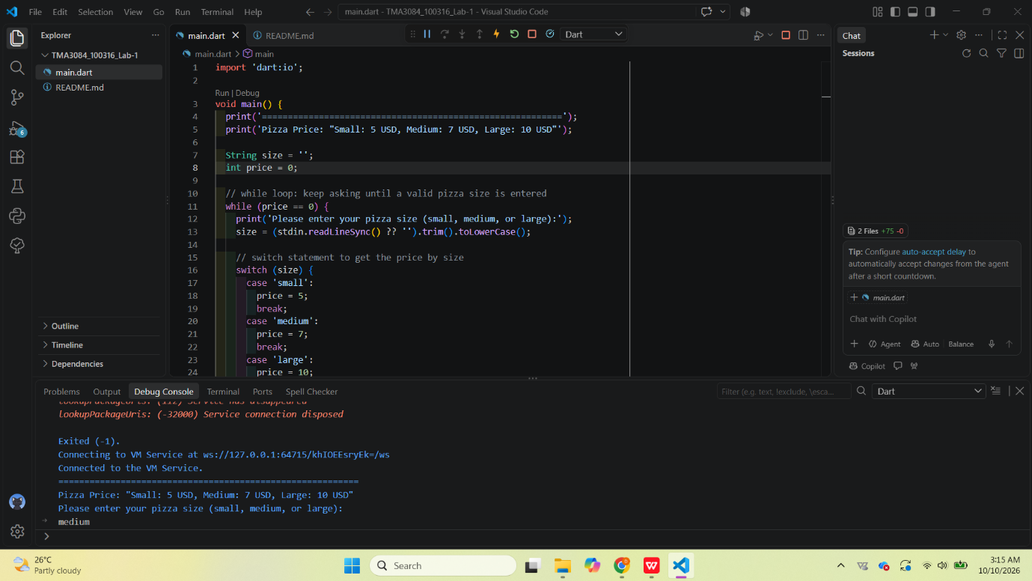
Repo URL : https://github.com/d-amirah03/TMA3084_100316_Lab-1.git

