To create .arff file

Step1: open notepad

Step2: Write as follows to create table with attributes and data.

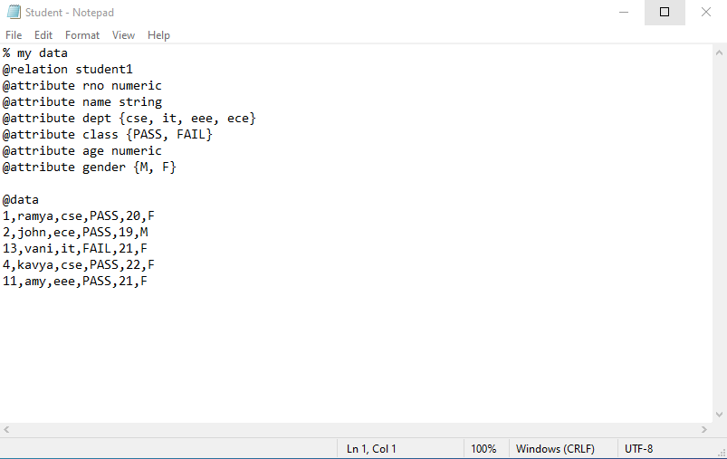

Step 3: save as ‘filename.arff’

Step 4: Go to the location where file is saved and open it. It will open in Weka.