To create .arff file

Step1: open notepad

Step2: Write as follows to create table with attributes and data.

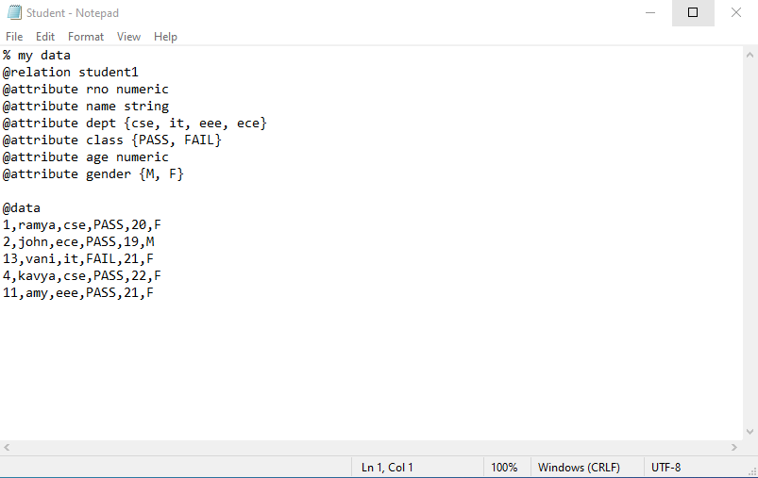

Step 3: Save as ‘filename.arff’

Step 4: Open Weka. Go to explorer.

Step 5: Select ‘C’ drive -> program files -> data -> choose dataset.

Step 6: Load the file in Weka.

**Iris dataset**

* Attributes:
* sepallength : Numeric
* sepalwidth : Numeric
* petallength : Numeric
* petalwidth : Numeric
* class : Nominal
* Records:
* Attributes - 5
* Instances – 150
* Class Attribute
* Class - {Iris-setosa, Iris-versicolor, Iris-virginica}
* Records for each class:
* Iris-setosa - 50
* Iris-versicolor – 50
* Iris-virginica – 50

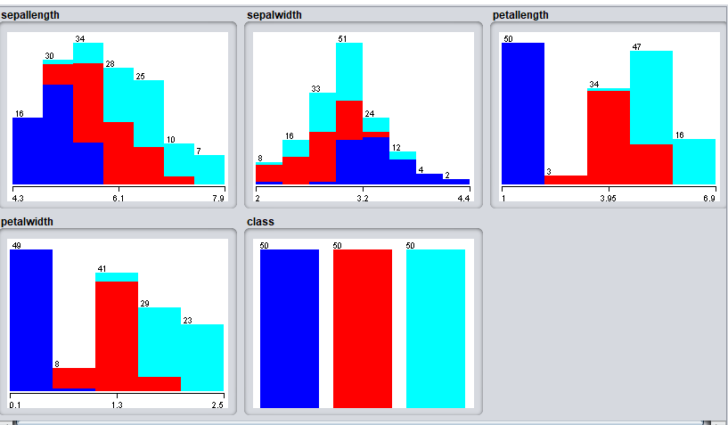

**German Credit:**

* Attributes:
* checking_status : Nominal
* duration : Numeric
* credit_history : Nominal
* purpose : Nominal
* credit_amount : Numeric
* savings_status : Nominal
* employment : Nominal
* instalment_commitment : Numeric
* personal_status : Nominal
* other_parties : Nominal
* residence_since : Numeric
* property_magnitude : Nominal
* age : Numeric
* other_payment_plans : Nominal
* housing : Nominal
* existing_credits : Numeric
* job : Nominal
* num_dependents : Numeric
* own_telephone : Nominal
* foreign_worker : Nominal
* class : Nominal
* Records:
* Attributes - 21
* Instances – 1000
* Class Attribute
* checking_status –
  + <0 : 274
  + 0<=X<200 : 269
  + >=200 : 63
  + no checking : 394
* credit_history –
  + no credits/all paid : 40
  + all paid : 49
  + existing paid : 530
  + delayed previously : 88
  + critical/other existing credit : 293
* purpose –
  + new car : 234
  + used car : 103
  + furniture/equipment : 181
  + radio/tv : 280
  + domestic appliance : 12
  + repairs : 22
  + education : 50
  + vacation : 0
  + retraining : 9
  + business : 97
  + other :12
* savings_status –
  + <100 : 603
  + 100<=X<500 : 103
  + 500<=X<1000 : 63
  + >=1000 : 48
  + no known savings : 183
* employment –
  + unemployed : 62
  + <1 : 172
  + 1<=X<4 : 339
  + 4<=X<7 : 174
  + >=7 :253
* personal_status –
  + male div/sep :50
  + female div/dep/mar: 310
  + male single : 548
  + male mar/wid :92
  + female single : 0
* other_parties –
  + none : 907
  + co applicant : 41
  + guarantor : 52
* property_magnitude –
  + real estate : 282
  + life insurance : 232
  + car : 332
  + no known property : 154
* other_payment_plans –
  + bank : 139
  + stores : 47
  + none : 814
* housing –
  + rent : 179
  + own : 713
  + for free : 108
* job –
  + unemp/unskilled non res : 22
  + unskilled res : 200
  + skilled : 630
  + high qualif/self emp/mgmt. : 148
* own_telephone –
  + none : 596
  + yes : 404
* foreign_worker –
  + yes : 963
  + no : 37
* Class –
  + good : 700
  + bad : 300

