QC Summary for A25-15568FINAL (Metadata: A25-15568, Date: 27/11/2025)
Laboratory: Actlabs

This batch includes 16 total samples, consisting of 13 CRM samples, 1 duplicate samples, and 2 blanks.

Understanding the digestion chemistry and detection technique is important for interpreting CRM recoveries, duplicate precision, and blank performance. The method used for this batch is summarized below.

Aqua regia digestion (HCl–HNO₃) combined with ICP‑MS detection provides high sensitivity for trace elements. The digestion effectively dissolves sulfides, carbonates, and other labile hosts, but does not fully decompose silicate minerals or refractory phases such as zircon, chromite, barite, or monazite. As a result, elements hosted in resistant minerals may show systematic under‑recovery. ICP‑MS offers low detection limits but is susceptible to matrix‑dependent polyatomic interferences (e.g., Cl‑based species, oxide/hydroxide clusters), depending on whether collision/reaction cell technology is used. Precision is typically 5–10% RSD for analytes present at ≥10× the detection limit, with recoveries influenced by mineralogy, matrix composition, and interference‑control settings.

CRM Behaviour:
CRM performance provides insight into digestion consistency, calibration stability, interference behaviour, and whether the method is operating within its expected analytical envelope.

CRM tolerance applied: 80–120% recovery.
• CRM Recovery (%):
Recovery % = (Measured Value / Certified Value) × 100
• CRM Bias (%):
Bias % = ((Measured Value – Certified Value) / Certified Value) × 100

The CRM results show 45 analyte‑level deviations across 13 CRM runs. Deviations by analyte:

• Ag: 123.9%
• Al: 77.0–121.9% (3 runs)
• As: 65.8–71.8% (4 runs)
• Au: 66.9–124.9% (3 runs)
• Ca: 73.0–132.1% (5 runs)
• Hf: 27.4%
• La: 73.4%
• Li: 70.6%
• Mo: 72.8%
• P: 76.0%
• Pr: 77.3%
• Sb: 120.5%
• Sc: 79.0%
• Se: 72.7%
• Sm: 138.5–150.6% (2 runs)
• Sn: 79.9–129.5% (2 runs)
• Sr: 63.8–78.0% (2 runs)
• Ti: 71.6–141.7% (3 runs)
• Tl: 121.8%
• Zr: 26.0–150.0% (10 runs)

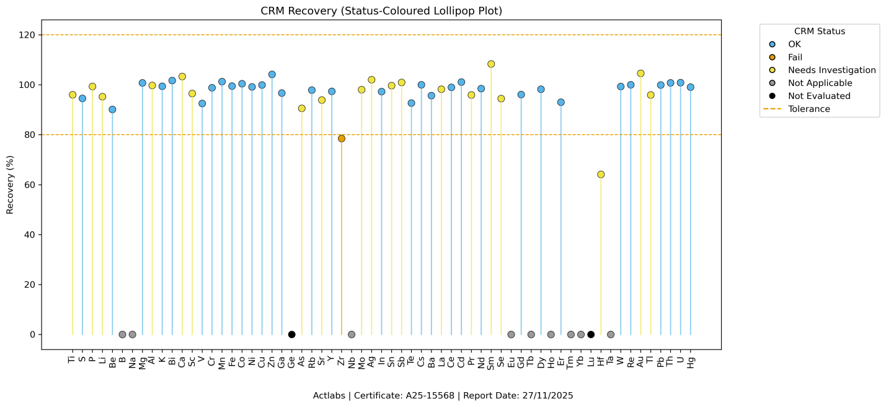

The CRM deviations occur across 7 different CRMs. When multiple CRMs show similar patterns, this may indicate method‑level effects such as digestion inefficiency, calibration drift, or interference‑related bias.

When CRM deviations occur, review digestion conditions, calibration stability, and interference‑control settings to confirm whether the method is performing within its expected analytical envelope.

Duplicate Behaviour:
Duplicate samples evaluate analytical precision. For analytes present at ≥10× the detection limit, precision is typically 5–10% RSD. Elements near the detection limit, or are sensitive to adsorption, partial digestion, or matrix effects commonly show higher RPD values.

Duplicate tolerance applied: ≤30% RPD.
• Duplicate Relative Percent Difference (RPD):
RPD % = |Sample1 – Sample2| / ((Sample1 + Sample2) / 2) × 100

The duplicate samples show that all analytes above 10× DL meet the ≤30.0% RPD precision criterion, indicating stable analytical precision for this batch.

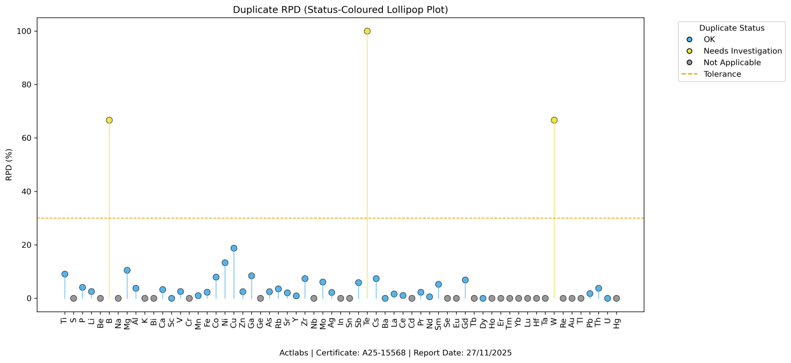

These samples are soils, which commonly contain variable clay content, organics, and oxide coatings. Moderate variability in duplicate precision is not unusual, particularly for elements sensitive to adsorption or partial digestion.

Blank Behaviour:
Blank samples help identify contamination, memory effects, and instrument carryover. Exceedances should be considered when interpreting low‑grade sample results, particularly for coarse blanks.

Blank tolerance applied: values > 3.0× DL flagged.
BDL substitution rule applied: half.
• Blank Mean:
Blank Mean = Σ(blank values) / n
• Blank Standard Deviation (SD):
Blank SD = sqrt( Σ(x – mean)² / (n – 1) )

The blank results show 3 analytes exceeding blank thresholds, suggesting possible low‑level contamination, memory effects, or instrument carryover. Affected analytes include:
• Zn (0.4 > DL 0.1)
• Mo (0.08 > DL 0.01)
• Ba (6.75 > DL 0.5)
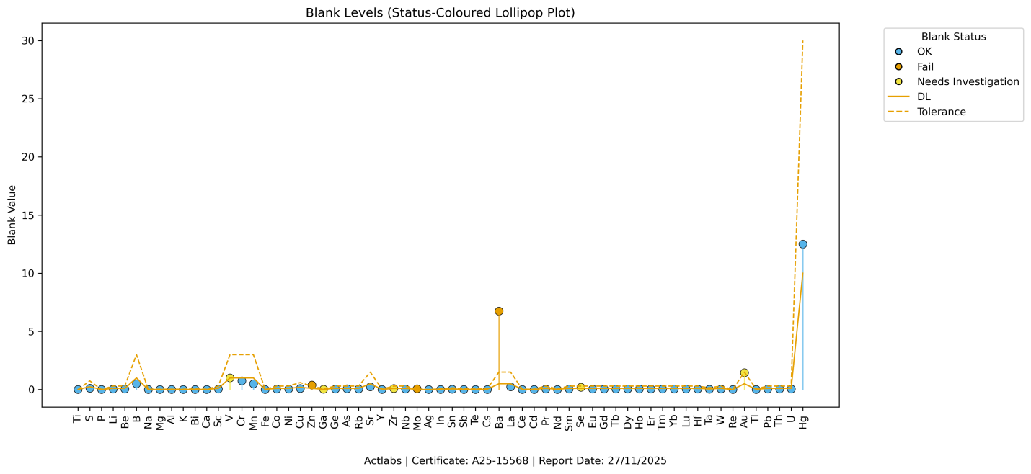

When blank exceedances occur, review recent high‑grade samples, rinse sequences, and contamination‑control procedures. Consider whether affected analytes could influence the interpretation of low‑grade samples in this batch.

The internal laboratory QC assays for batch A25-15568FINAL performed within expected analytical parameters. CRM recoveries show analyte-level drift consistent with digestion limitations and interference effects, but these deviations were accommodated within the batch and do not indicate systemic failure. Duplicate precision meets expected thresholds for analytes above 10× DL, and blank exceedances are low-level and isolated. {Reviewer added context – not in the coding}

When reviewing sample results, small variations should be expected for analytes with CRM deviations, particularly those influenced by mineralogy, partial digestion, or matrix effects. These QC patterns suggest the method is operating within its expected envelope, with no evidence of calibration instability or contamination that would compromise batch integrity. {Reviewer added context – not in the coding}

Note: QC results reflect internal laboratory quality‑control performance for this batch. They highlight patterns that may warrant further review but should be interpreted alongside laboratory documentation and project context.

Status Definitions:
- OK: Assay results fall within the defined tolerance.
- Fail: Assay results exceed the defined tolerance.
- Fail_RPD: Duplicate RPD exceeds the precision tolerance.
- BDL_Substitution: One value is below the detection limit and a substitution was applied.
- BothBDL: Both values are below the detection limit; evaluation is not meaningful.
- Below10xDL: Values are below 10× the detection limit; evaluation is not meaningful.
- Needs Investigation: Conditions prevent reliable evaluation (e.g., certified ≥ DL but measured < DL, or borderline blank values).
- NotApplicable: Certified value or both measurements are below DL; evaluation is not required.
- NotEvaluated: Required assay data are missing.

