*Dylan Bryan*

*SDEV-300 | Professor Johnson | December 7, 2020*

*lab 8*

Final Website Submission

Table of Contents

Pylint 2

user.py 2

routes.py 2

app.py 3

Decryption 3

Morse Code 3

Base 64 4

Cesarian Shift 4

Test Cases 5

Failed login attempts 5

Login page 6

User Profile Page 7

Update Password Page 8

Registered Users File 10

# Pylint

## user.py

## routes.py

## app.py

# Decryption

## Morse Code

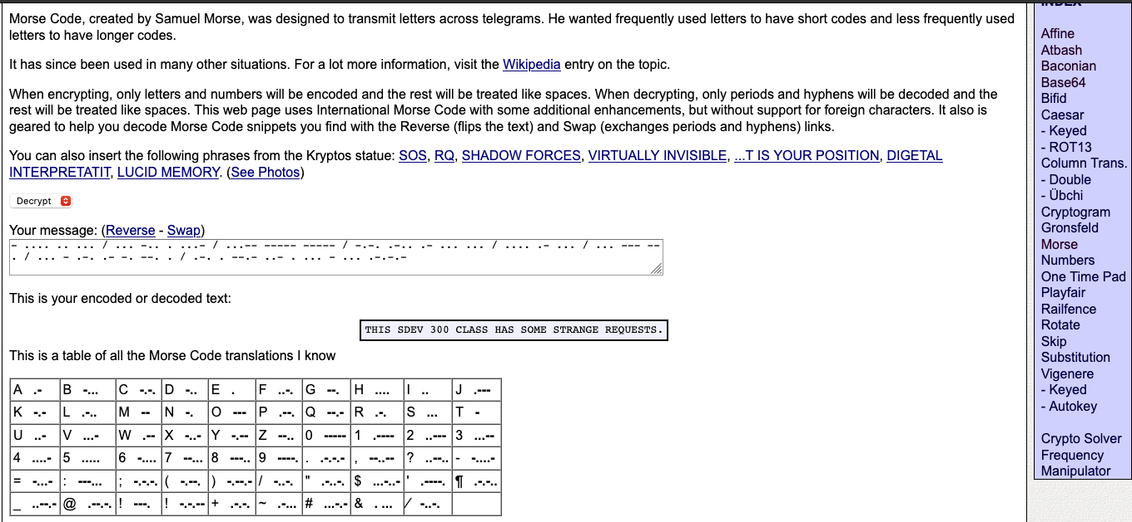

## Base 64

## Cesarian Shift

* I must admit this one had me going for some time, I thought that it was One Time Pad for some time. I had a notepad out, figured out that the letters in OTP shifted a specific number to the right depending on the key message by a specific letter. After about 20 minutes and an eraser later, I went on to other options. I knew it could not be a SHA encryption because it was too short, so I tried this one and managed to get it decrypted.

# Test Cases

## Failed login attempts

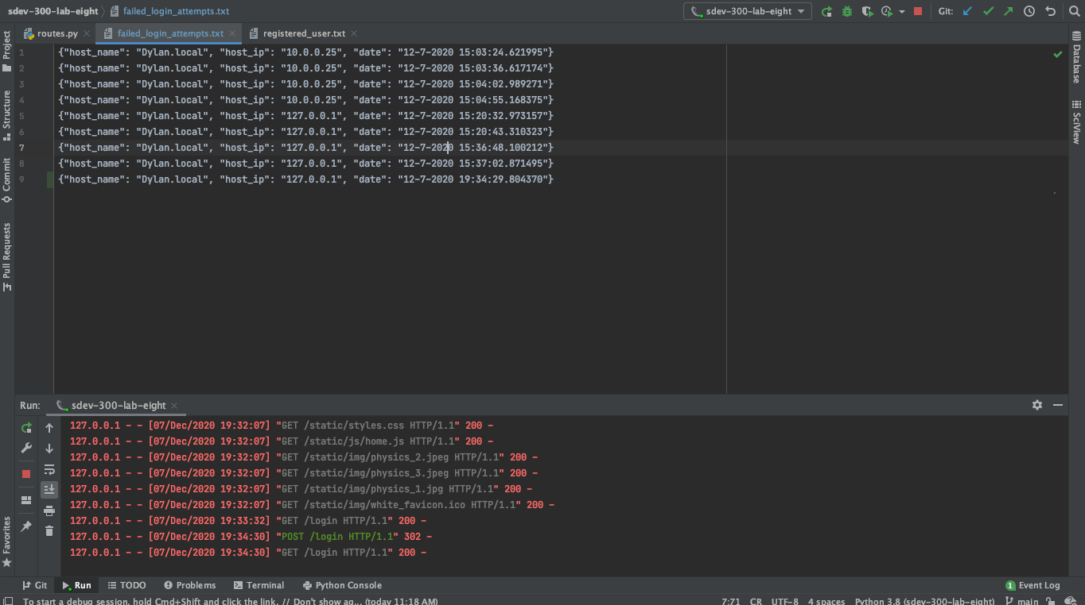

## Login page

## User Profile Page

## Update Password Page

## Registered Users File

