HELTERMAA
L , m | 96
B, m | 14,6
Tfull, m | 6,56
Tlight, m | 2,86
DISMfull, t | 6681
DISMlight, t | 2531
DW, t | 4150
KGlight, m | 6,66
Xglight, m | 42,7
Aw, sq. m | 782,45
Mzlight, t*m | 16856,46
Mxlight, t*m | 108073,7

TANKID | Kasutamine | Maht, m^3 | Kg, m | Xg, m | L, m | B, m | H, m | Lasti tihedus, Kg/l^3 | Vedelike Mass, t | Mz, t*m | Mx, t*m | GGv,m
Voorpiik | Ballast | 200 | 6,8 | 93 | 5 | 6,666667 | 6 | 0 | 0 | 0 | 0 | 0
1PP | Ballast | 69,2 | 0,97 | 79,2 | 16,3 | 2,18835 | 1,94 | 1,025 | 70,93 | 68,8021 | 5617,656 | 0,002275613
1TP | Ballast | 69,2 | 0,97 | 79,2 | 16,3 | 2,18835 | 1,94 | 1,025 | 70,93 | 68,8021 | 5617,656 | 0,002275613
2PP | Ballast, Kutus | 38,3 | 0,67 | 63,3 | 15,53 | 1,840444 | 1,34 |  | 0 | 0 | 0 | 0
2TP | Ballast, Kutus | 38,3 | 0,67 | 63,3 | 15,53 | 1,840444 | 1,34 |  | 0 | 0 | 0 | 0
3PP | Ballast, Kutus | 23,6 | 0,67 | 51,8 | 8,7 | 3,5 | 1,34 |  | 0 | 0 | 0 | 0
3TP | Ballast, Kutus | 23,6 | 0,67 | 51,8 | 8,7 | 3,5 | 1,34 |  | 0 | 0 | 0 | 0
4PP | Ballast | 18 | 0,67 | 42,7 | 9,4 | 1,429025 | 1,34 | 1 | 18 | 12,06 | 768,6 | 0,00035652
4TP | Ballast | 18 | 0,67 | 42,7 | 9,4 | 1,429025 | 1,34 | 1 | 18 | 12,06 | 768,6 | 0,00035652
5PP | Ballast | 30,1 | 0,67 | 15,2 | 11 | 2,042062 | 1,34 | 1 | 30,1 | 20,167 | 457,52 | 0,001217409
5TP | Ballast | 30,1 | 0,67 | 15,2 | 11 | 2,042062 | 1,34 | 1 | 30,1 | 20,167 | 457,52 | 0,001217409
6PP | Ballast | 59,7 | 0,67 | 15,2 | 11 | 4,050204 | 1,34 | 1,025 | 61,1925 | 40,99898 | 930,126 | 0,009736072
6TP | Ballast | 59,7 | 0,67 | 15,2 | 11 | 4,050204 | 1,34 | 1,025 | 61,1925 | 40,99898 | 930,126 | 0,009736072
7. | Kutus | 67 | 1,84 | 6,6 | 4 | 4,55163 | 3,68 |  | 0 | 0 | 0 | 0
8PP | Kutus | 44,6 | 0,67 | 64 | 15,53 | 3,5 | 1,34 | 0,85 | 37,91 | 25,3997 | 2426,24 | 0,007355822
8TP | Kutus | 44,6 | 0,67 | 64 | 15,53 | 3,5 | 1,34 | 0,85 | 37,91 | 25,3997 | 2426,24 | 0,007355822
9PP | Kutus | 53,1 | 0,67 | 51,8 | 8,7 | 4,554812 | 1,34 | 0,85 | 45,135 | 30,24045 | 2337,993 | 0,0090821
9TP | Kutus | 52,2 | 0,67 | 51,8 | 8,7 | 4,477612 | 1,34 | 0,85 | 44,37 | 29,7279 | 2298,366 | 0,008628081
12PP | Kutus | 52,2 | 0,67 | 42,7 | 9,4 | 4,144173 | 1,34 | 0,85 | 44,37 | 29,7279 | 1894,599 | 0,007390895
12TP | Kutus | 52,2 | 0,67 | 42,7 | 9,4 | 4,144173 | 1,34 | 0,85 | 44,37 | 29,7279 | 1894,599 | 0,007390895
13. | Kutus | 58,7 | 0,67 | 42,7 | 9,4 | 4,66021 | 1,34 |  | 0 | 0 | 0 | 0
Kokku: |  | 1102,4 |  |  |  |  |  |  | 614,51 | 454,2797 | 28825,841 | 0,074374843

LAEVA KOKKUVOTE Salt water
T sw, m | DisV sw, m^3 | Kreeninurk, ° | 0 | 15 | 30 | 45 | 60 | 75 | XB sw, m | KM sw, m | TPCsw, t/cm | MTCsw, t*m/cm | XF sw, m
6,3 | 6183 | KN,m | 0 | 1,62 | 3,14 | 4,42 | 5,2 | 5,49 | 47,82 | 6,16 | 11,48 | 69,27 | 46,49
6,4 | 6299 | KN, m | 0 | 1,62 | 3,14 | 4,4 | 5,18 | 5,48 | 47,79 | 6,18 | 11,54 | 70,22 | 46,37
6,362452481 | 6255,444878 | KN, m | 0 | 1,62 | 3,14 | 4,40751 | 5,1875095 | 5,483754752 | 47,80126426 | 6,17249 | 11,5174715 | 69,86329857 | 46,41506
 |  | GZ sw, m | 0 | 0,1294118 | 0,260405 | 0,335147 | 0,1999041 | -0,079196227
 |  | Tangent sw | 0 | 0,1294118 | 0,258824 | 0,388235 | 0,51764711 | 0,647058888
 |  | GZfsrf sw , m | 0 | 0,1234711 | 0,248928 | 0,318916 | 0,18002605 | -0,101367312

Lastimahutavus | 5767
Jaakkandevoime, t | 269,169
Jaakmahutavus, m^3 | 0,01626
DISM, t | 6411,831
DISV sw, m^3 | 6255,444878
KG, m | 5,759190642
XG, m | 47,60841318
Mz, t*m | 36926,95709
Mx, t*m | 305257,0995
GM, m | 0,413299854
Ix, m^4 | 16598,05867
BM, m | 2,653377816
Iy, m^4 | 717619,2
BML, m | 114,7191309

Trim sw, cm | -17,69925725
d trim Aft sw, cm | -8,557417026
d trim Fore sw, cm | -9,141840224
Taft sw, m | 6,448026651
Tfore sw, m | 6,271034079
Trimming arm sw, m | -0,192851074
Trimming moment, t*m | -1236,528494

VABAPINNA EFFECT
GGv tanks 3 & 8, m | 0,022953195
KG new, m | 5,782143837
Gm sw new, m | 0,390346659

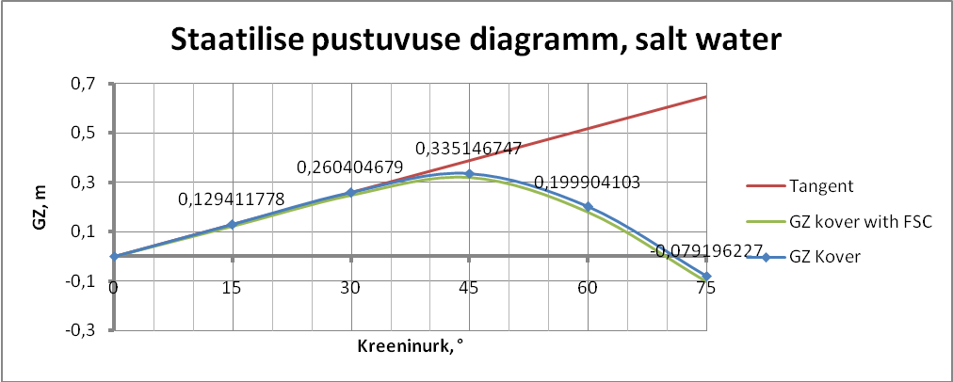

Imo Res. 749 nouete kontroll |  |  | With FSC | Without FSC
1 Max GZ kreeninurk >= 30 ° ? |  |  | Yes | Yes
2 Kaadumisnurk >= 60°? |  |  | Yes | Yes
3 Pind 0°-30° >= 0,055 m*rad? |  |  | 0,065169 | 0,06817379
4 Pind 0°-40° >= 0,09 m*rad? |  |  | 0,111701 | 0,11519173
5 Pind 30°-40° >= 0,03 m*rad? |  |  | 0,046532 | 0,04701795
 | GZ 40° = | 0,33
 | GZfsc 40° = | 0,32

LAEVA KOKKUVOTE Fresh water
T fw, m | Disv fw, m^3 | Kreeninurk, ° | 0 | 15 | 30 | 45 | 60 | 75 | XB fw, m | KM fw, m | TPC fw, t/cm | MTCfw, t*m/cm | XF fw, m
6,4 | 6299 | KN, m | 0 | 1,62 | 3,14 | 4,4 | 5,18 | 5,48 | 47,79 | 6,18 | 11,54 | 70,22 | 46,37
6,5 | 6414 | KN,m | 0 | 1,62 | 3,13 | 4,37 | 5,16 | 5,47 | 47,76 | 6,2 | 11,58 | 71,15 | 46,25
6,498113913 | 6411,831 | KN, m | 0 | 1,62 | 3,130189 | 4,370566 | 5,16037722 | 5,470188609 | 47,76056583 | 6,199623 | 11,5792456 | 71,13245939 | 46,25226
 |  | GZ fw, m | 0 | 0,1294118 | 0,250593 | 0,298203 | 0,17277182 | -0,092762371
 |  | Tangent fw | 0 | 0,1294118 | 0,258824 | 0,388235 | 0,51764711 | 0,647058888
 |  | GZfsrf sw, m | 0 | 0,1234711 | 0,239117 | 0,281973 | 0,15289377 | -0,114933455

Lastimahutavus | 5767
Jaakkandevoime, t | 269,169
Jaakmahutavus, m^3 | 0,01626
DISM, t | 6411,831
DISV fw, m^3 | 6411,831
KG, m | 5,759190642
XG, m | 47,60841318
Mz, t*m | 36926,95709
Mx, t*m | 305257,0995
GM fw, m | 0,440432141
Ix, m^4 | 16598,05867
BM, m | 2,653377816
Iy, m^4 | 717619,2
BML, m | 114,7191309

Trim fw, cm | -13,71493478
d trim Aft fw, cm | -6,607778902
d trim Fore fw, cm | -7,107155877
Taft fw, m | 6,564191702
Tfore fw, m | 6,427042354
Trimming arm fw, m | -0,152152644
Trimming moment, t*m | -975,5770412

VABAPINNA EFFECT
GGv tanks 3 & 8, m | 0,022953195
KG new, m | 5,782143837
Gm fw new, m | 0,417478945

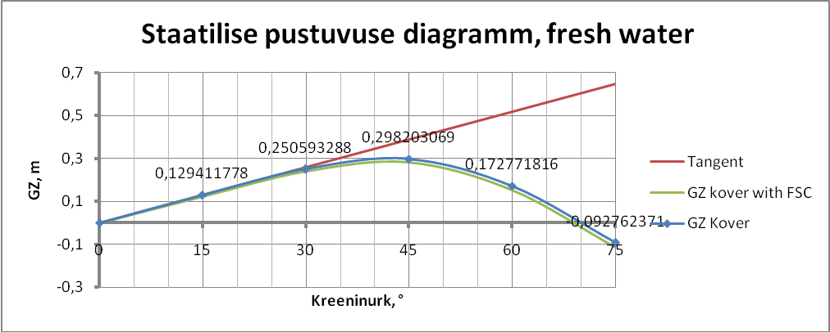

Imo Res. 749 nouete kontroll |  |  | With FSC | Without FSC
1 Max GZ kreeninurk >= 30 ° ? |  |  | Yes | Yes
2 Kaadumisnurk >= 60°? |  |  | Yes | Yes
3 Pind 0°-30° >= 0,055 m*rad? |  |  | 0,062601 | 0,06560517
4 Pind 0°-40° >= 0,09 m*rad? |  |  | 0,097738 | 0,10471976
5 Pind 30°-40° >= 0,03 m*rad? |  |  | 0,035138 | 0,03911459
 | GZ 40° = | 0,3
 | GZfsc 40° = | 0,28

Momentidetabel
Asukoht | Nimetus | P | KG | Mz | XG | Mx
Light ship | Light ship | 2531 | 6,66 | 16856,46 | 42,7 | 108073,7
LR 1 | Rukis Kottides | 346,75 | 3,78 | 1310,715 | 79,3 | 27497,28
VH 1 | Paevalilleseemned kottides | 269,047 | 7,69 | 2068,971 | 79,6 | 21416,14
LR2 | Rukis Kottides | 548,05 | 3,48 | 1907,214 | 63,4 | 34746,37
VH 2 | Paevalilleseemned kottides | 259,523 | 7,21 | 1871,161 | 63,6 | 16505,66
LR 3 | Rukis Kottides | 529,87 | 3,46 | 1833,35 | 46,8 | 24797,92
VH 3 | Rukis Kottides | 54,551 | 5,729824 | 312,5676 | 46,7 | 2547,532
VH 3 | Paevalilleseemned kottides | 238,432 | 7,129822 | 1699,978 | 46,7 | 11134,77
LR 4 | Rukis Kottides | 420,779 | 4,96 | 2087,064 | 13,7 | 5764,672
VH 4 | Paevalilleseemned kottides | 199,319 | 9,99 | 1991,197 | 12,9 | 2571,215
Luuk 2 | Konteinerid | 160 | 11,395 | 1823,2 | 63,4 | 10144
Luuk 3 | Konteinerid | 240 | 11,295 | 2710,8 | 46,8 | 11232
1PP | Ballast | 70,93 | 0,97 | 68,8021 | 79,2 | 5617,656
1TP | Ballast | 70,93 | 0,97 | 68,8021 | 79,2 | 5617,656
4PP | Magevesi | 18 | 0,67 | 12,06 | 42,7 | 768,6
4TP | Magevesi | 18 | 0,67 | 12,06 | 42,7 | 768,6
5PP | Magevesi | 30,1 | 0,67 | 20,167 | 15,2 | 457,52
5TP | Magevesi | 30,1 | 0,67 | 20,167 | 15,2 | 457,52
6PP | Ballast | 61,1925 | 0,67 | 40,99898 | 15,2 | 930,126
6TP | Ballast | 61,1925 | 0,67 | 40,99898 | 15,2 | 930,126
8PP | Kutus | 37,91 | 0,67 | 25,3997 | 64 | 2426,24
8TP | Kutus | 37,91 | 0,67 | 25,3997 | 64 | 2426,24
9PP | Kutus | 45,135 | 0,67 | 30,24045 | 51,8 | 2337,993
9TP | Kutus | 44,37 | 0,67 | 29,7279 | 51,8 | 2298,366
12PP | Kutus | 44,37 | 0,67 | 29,7279 | 42,7 | 1894,599
12TP | Kutus | 44,37 | 0,67 | 29,7279 | 42,7 | 1894,599
Kokku |  | 6411,831 |  | 36926,96 |  | 305257,1

LR 1 |  | Mass, t | SF, m^3/t | V, m^3 | Kg, m | Xg, m | Mz, t*m | Mx, t*m | Taismaht, m^3 | L, m | B, m
Kaup 1 | Rukis Kottides | 346,75 | 1,54 | 533,995 | 3,78 | 79,3 | 1310,715 | 27497,275 | 534 | 15,7
Kaup 2 | Paevalilleseemned kottides |  | 2,94 | 0 | 3,78 | 79,3 | 0 | 0 |  | Porandakorgus, m | H, m
Kaup 3 | Konteinerid |  | 0 | 0 | 3,78 | 79,3 | 0 | 0 | Jaakmaht, m^3 | 1,98 | 3,6
Kokku: |  | 346,75 |  | 533,995 | 3,78 | 79,3 |  |  | 0,005
Vahetekk 1 |  | Mass, t | SF, m^3/t | V, m^3 | Kg, m | Xg, m | Mz, t*m | Mx, t*m | Taismaht, m^3 | L, m | B, m
Kaup 1 | Rukis Kottides |  | 1,54 | 0 | 7,69 | 79,6 | 0 | 0 | 791 | 15,7
Kaup 2 | Paevalilleseemned kottides | 269,047 | 2,94 | 790,99818 | 7,69 | 79,6 | 2068,97143 | 21416,1412 |  | Porandakorgus, m | H, m
Kaup 3 | Konteinerid |  | 0 | 0 | 7,69 | 79,6 | 0 | 0 | Jaakmaht, m^3 | 5,24 | 4,9
Kokku: |  | 269,047 |  | 790,99818 | 7,69 | 79,6 |  |  | 0,00182
LR 2 |  | Mass, t | SF, m^3/t | V, m^3 | Kg, m | Xg, m | Mz, t*m | Mx, t*m | Taismaht, m^3 | L, m | B, m
Kaup 1 | Rukis Kottides | 548,05 | 1,54 | 843,997 | 3,48 | 63,4 | 1907,214 | 34746,37 | 844 | 15,3
Kaup 2 | Paevalilleseemned kottides |  | 2,94 | 0 | 3,48 | 63,4 | 0 | 0 |  | Porandakorgus, m | H, m
Kaup 3 | Konteinerid |  | 0 | 0 | 3,48 | 63,4 | 0 | 0 | Jaakmaht, m^3 | 1,43 | 4,1
Kokku: |  | 548,05 |  | 843,997 | 3,48 | 63,4 |  |  | 0,003
Vahetekk 2 |  | Mass, t | SF, m^3/t | V, m^3 | Kg, m | Xg, m | Mz, t*m | Mx, t*m | Taismaht, m^3 | L, m | B, m
Kaup 1 | Rukis Kottides |  | 1,54 | 0 | 7,21 | 63,6 | 0 | 0 | 763 | 15,3
Kaup 2 | Paevalilleseemned kottides | 259,523 | 2,94 | 762,99762 | 7,21 | 63,6 | 1871,16083 | 16505,6628 |  | Porandakorgus, m | H, m
Kaup 3 | Konteinerid |  | 0 | 0 | 7,21 | 63,6 | 0 | 0 | Jaakmaht, m^3 | 5,31 | 3,8
Kokku: |  | 259,523 |  | 762,99762 | 7,21 | 63,6 |  |  | 0,00238
LR 3 |  | Mass, t | SF, m^3/t | V, m^3 | Kg, m | Xg, m | Mz, t*m | Mx, t*m | Taismaht, m^3 | L, m | B, m
Kaup 1 | Rukis Kottides | 529,87 | 1,54 | 815,9998 | 3,46 | 46,8 | 1833,3502 | 24797,916 | 816 | 14,4
Kaup 2 | Paevalilleseemned kottides |  | 2,94 | 0 | 3,46 | 46,8 | 0 | 0 |  | Porandakorgus, m | H, m
Kaop 3 | Konteinerid |  | 0 | 0 | 3,46 | 46,8 | 0 | 0 | Jaakmaht, m^3 | 1,46 | 4
Kokku: |  | 529,87 |  | 815,9998 | 3,46 | 46,8 |  |  | 0,0002
Vahetekk 3 |  | Mass, t | SF, m^3/t | V, m^3 | Kg, m | Xg, m | Mz, t*m | Mx, t*m | Taismaht, m^3 | L, m | B, m
Kaup 1 | Rukis Kottides | 54,551 | 1,54 | 84,00854 | 5,729824148 | 46,7 | 312,5676371 | 2547,5317 | 785 | 17,7
Kaup 2 | Paevalilleseemned kottides | 238,432 | 2,94 | 700,99008 | 7,129821687 | 46,7 | 1699,977644 | 11134,7744 |  | Porandakorgus, m | H, m
Kaup 3 | Konteinerid |  | 0 | 0 | 6,98 | 46,7 | 0 | 0 | Jaakmaht, m^3 | 5,58 | 2,8
Kokku: |  | 292,983 |  | 784,99862 | 6,98 | 46,7 |  |  | 0,00138
LR 4 |  | Mass, t | SF, m^3/t | V, m^3 | Kg, m | Xg, m | Mz, t*m | Mx, t*m | Taismaht, m^3 | L, m | B, m
Kaup 1 | Rukis Kottides | 420,779 | 1,54 | 647,99966 | 4,96 | 13,7 | 2087,06384 | 5764,6723 | 648 | 15,8
Kaup 2 | Paevalilleseemned kottides |  | 2,94 | 0 | 4,96 | 13,7 | 0 | 0 |  | Porandakorgus, m | H, m
Kaup 3 | Konteinerid |  | 0 | 0 | 4,96 | 13,7 | 0 | 0 | Jaakmaht, m^3 | 2,86 | 4,2
Kokku: |  | 420,779 |  | 647,99966 | 4,96 | 13,7 |  |  | 0,00034
Vahetekk 4 |  | Mass, t | SF, m^3/t | V, m^3 | Kg, m | Xg, m | Mz, t*m | Mx, t*m | Taismaht, m^3 | L, m | B, m
Kaup 1 | Rukis Kottides |  | 1,54 | 0 | 9,99 | 12,9 | 0 | 0 | 586 | 15,8
Kaup 2 | Paevalilleseemned kottides | 199,319 | 2,94 | 585,99786 | 9,99 | 12,9 | 1991,19681 | 2571,2151 |  | Porandakorgus, m | H, m
Kaup 3 | Konteinerid |  | 0 | 0 | 9,99 | 12,9 | 0 | 0 | Jaakmaht, m^3 | 8,74 | 2,5
Kokku: |  | 199,319 |  | 585,99786 | 9,99 | 12,9 |  |  | 0,00214
Luuk 1 |  | Mass, t | SF, m^3/t | V, m^3 | Kg, m | Xg, m | Mz, t*m | Mx, t*m |  | L, m | B, m
Kaup 1 | Rukis Kottides |  | 1,54 | 0 |  | 79,3 | 0 | 0
Kaup 2 | Paevalilleseemned kottides |  | 2,94 | 0 |  | 79,3 | 0 | 0 |  | Porandakorgus, m | H, m
Kaup 3 | Konteinerid |  | 0 | 0 | 12,495 | 79,3 | 0 | 0 |  | 11,2
Kokku: |  | 0 |  | 0
Luuk 2 |  | Mass, t | SF, m^3/t | V, m^3 | Kg, m | Xg, m | Mz, t*m | Mx, t*m |  | L, m | B, m
Kaup 1 | Rukis Kottides |  | 1,54 | 0 |  | 63,4 | 0 | 0
Kaup 2 | Paevalilleseemned kottides |  | 2,94 | 0 |  | 63,4 | 0 | 0 |  | Porandakorgus, m | H, m
Kaup 3 | Konteinerid | 160 | 0 | 0 | 11,395 | 63,4 | 1823,2 | 10144 |  | 10,1
Kokku: |  | 160 |  | 0
Luuk 3 |  | Mass, t | SF, m^3/t | V, m^3 | Kg, m | Xg, m | Mz, t*m | Mx, t*m |  | L, m | B, m
Kaup 1 | Rukis Kottides |  | 1,54 | 0 |  | 46,8 | 0 | 0
Kaup 2 | Paevalilleseemned kottides |  | 2,94 | 0 |  | 46,8 | 0 | 0 |  | Porandakorgus, m | H, m
Kaup 3 | Konteinerid | 240 | 0 | 0 | 11,295 | 46,8 | 2710,8 | 11232 |  | 10
Kokku: |  | 240 |  | 0
Luuk 4 |  | Mass, t | SF, m^3/t | V, m^3 | Kg, m | Xg, m | Mz, t*m | Mx, t*m |  | L, m | B, m
Kaup 1 | Rukis Kottides |  | 1,54 | 0 |  | 12,9 | 0 | 0
Kaup 2 | Paevalilleseemned kottides |  | 2,94 | 0 |  | 12,9 | 0 | 0 |  | Porandakorgus, m | H, m
Kaup 3 | Konteinerid |  | 0 | 0 |  | 12,9 | 0 | 0 |  | 12,3
Kokku: |  | 0 |  | 0
Tekk |  | Mass, t | SF, m^3/t | V, m^3 | Kg, m | Xg, m | Mz, t*m | Mx, t*m |  | L, m | B, m
Kaup 1 | Rukis Kottides |  | 1,54 | 0 |  | 50 | 0 | 0
Kaup 2 | Paevalilleseemned kottides |  | 2,94 | 0 |  | 50 | 0 | 0 |  | Porandakorgus, m | H, m
Kaup 3 | Konteinerid |  | 0 | 0 |  | 50 | 0 | 0 |  | 9,5
Kokku: |  | 0 |  | 0
 |  | Mass paigal, t | SF, m^3/t | V antud, m^3 | Mass antud, t | Mass jaanud, t |  |  | V paigal, m^3 | Kogumaht, m^3
Kaup 1 | Rukis Kottides | 1900 | 1,54 | 2926 | 1900 | 0 |  |  | 2926 | 5767
Kaup 2 | Paevalilleseemned kottides | 966,321 | 2,94 | 2940 | 1000 | 33,679 |  |  | 2840,98374
Kaup 3 | Konteinerid | 400 | 0 | 0 | 400 | 0 | Mz, t*m | Mx, t*m | 0 | Vabamaht, m^3
Kokku |  | 3266,321 |  | 5866 | 3300 | 33,679 | 19616,21739 | 168357,5585 | 5766,98374 | 0,01626

Salt water
 | Kreeninurk, ° |  | -30 | -15 | 0 | 15 | 30 | 45 | 60 | 75
 | GZ sw, m |  | -0,2604047 | -0,1294118 | 0 | 0,12941178 | 0,2604047 | 0,33514675 | 0,1999041 | -0,0791962
 | g, m/s^2 | 9,81 | P, N/m^2 | 504
 | A, m^2 | 782,45
 | Z, m | 8,80877376 |  |  |  |  |  |  | Tr= | 15,8971133
 | lw, m | 0,05522701 | lw2, m | 0,08284051 |  |  |  |  | s= | 0,04446299
 | fi1 | 16,9927425 | k= | 0,9 | x1= | 1 | x2= | 1 | r= | 0,67482361
 | fi0 | 6,6
 | fi2 | 50
 | fic | 66,8
B on suurem kui A
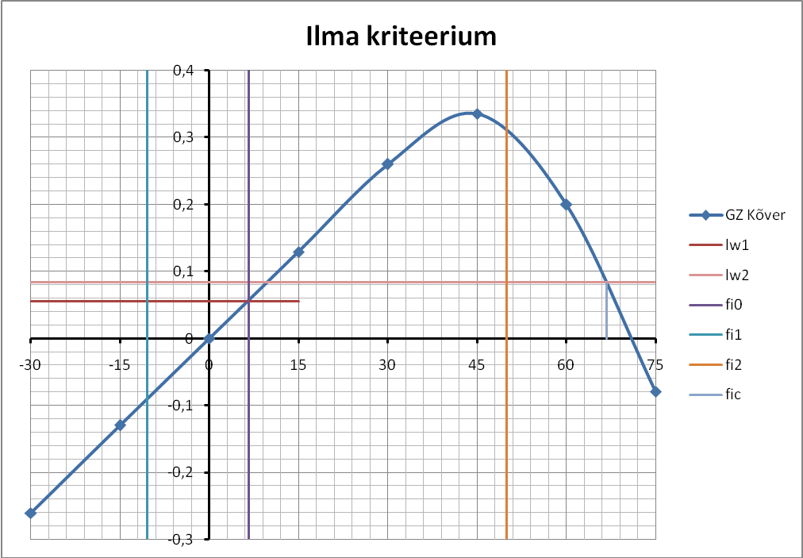
 | Ahterpiik | LR4 | Masinaruum | LR3 | LR2 | LR1 | Vöörpiik
Pikkus, m | 9,88 | 16,68 | 16,44 | 17,77 | 15,53 | 16,32 | 13,38
Alg X koord, m | 0 | 9,88 | 26,56 | 43 | 60,77 | 76,3 | 92,62
Lõpp X koord, m | 9,88 | 26,56 | 43 | 60,77 | 76,3 | 92,62 | 106
Kaalujaotus, t/m
Tühi laev | 7,59 | 21,48 | 53,44 | 25,29 | 24,53 | 17,7 | 7,59
Kaup | 0 | 37,176139 | 0 | 59,81165 | 62,30348 | 37,73266 | 0
Tankid | 0 | 10,946343 | 0 | 12,05656 | 4,882164 | 8,692402 | 0
Kokku | 7,59 | 69,602482 | 53,44 | 97,1582 | 91,71564 | 64,12506 | 7,59
Shipdes input:
Ta Fw, m | 6,564
Tm Fw, m | 6,495
Tf Fw, m | 6,427

Kaare X koord, m | 0 | 2,75 | 5,15 | 7,55 | 9,95 | 12,35 | 14,75 | 19,55 | 24,35 | 29,15 | 33,95 | 38,75
Veealune pindala , m^2 | 0 | 0,222 | 2,554 | 5,73 | 15,17 | 24,294 | 34,36 | 55,142 | 71,99 | 83,284 | 88,82 | 91,736
Kaare X koord, m | 43,55 | 48,35 | 53,15 | 57,95 | 62,75 | 67,55 | 72,35 | 77,15 | 81,95 | 86,75 | 91,55 | 93,95
Veealune pindala , m^2 | 93,052 | 93,268 | 93,168 | 93,058 | 92,238 | 91,382 | 88,65 | 82,76 | 77,334 | 54,21 | 31,398 | 19,448
Kaare X koord, m | 96,35 | 98,75 | 101,15
Veealune pindala , m^2 | 8,91 | 2,448 | 0

Kaalujaotus, t/m | 0 | 7,59 | 7,59 | 69,60248 | 69,60248 | 53,44 | 53,44 | 97,1582 | 97,1582 | 91,71564 | 91,71564 | 64,12506 | 64,12506 | 7,59 | 7,59 | 0
X Koordinaat | 0 | 0 | 9,88 | 9,88 | 26,56 | 26,56 | 43 | 43 | 60,77 | 60,77 | 76,3 | 76,3 | 92,62 | 92,62 | 106 | 106
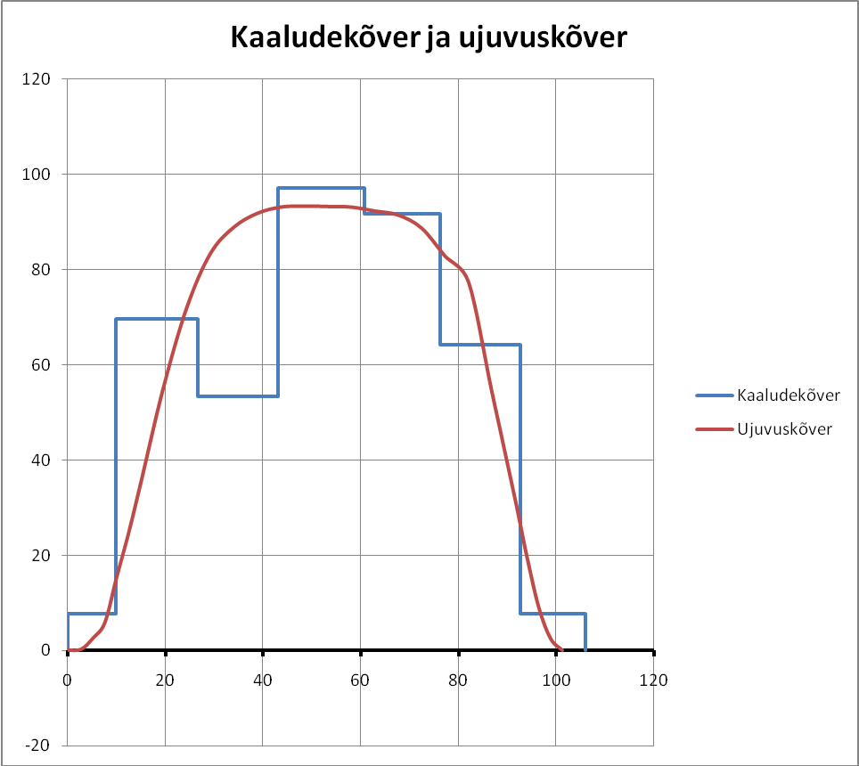

Koormused
Suurus | -44,985 | 6,6165 | -368,3092 | 12,8689 | 571,4488 | -77,0461 | 2,1488 | -28,1338 | 102,8419 | -151,725 | 35,8632 | -57,9472
Lõppunkt X koord | 8,0704 | 9,9 | 23,615 | 26,56 | 43 | 60,77 | 65,7157 | 76,3 | 84,5665 | 92,62 | 96,7069 | 106
Lõikejõud | 0 | -44,985 | -38,3685 | -406,678 | -393,809 | 177,64 | 100,5939 | 102,7427 | 74,6089 | 177,4508 | 25,7256 | 61,5888 | 3,6416
Koordinaat X | 0 | 8,0704 | 9,9 | 23,615 | 26,56 | 43 | 60,77 | 65,7157 | 76,3 | 84,5665 | 92,62 | 96,7069 | 106

Koord X | 106 | 96,7069 | 92,62 | 84,5665 | 76,3 | 71 | 65,7157 | 60,77 | 52 | 43 | 37,8895 | 32 | 26,56 | 23,615 | 15 | 9,9 | 8,0704 | 0
Pmom jooksev A | 0 | 303,0963 | 178,4226 | 818,1406 | 1041,826 | 432,7597 | 505,8115 | 502,8209 | 1048,946 | 1423,163 | 453,9164 | -602,837 | -1627,99 | -1178,72 | -2506,98 | -544,922 | -76,2518 | -181,524
Koord X | 106 | 96,7069 | 92,62 | 84,5665 | 76,3 | 71 | 65,7157 | 60,77 | 52 | 43 | 37,8895 | 32 | 26,56 | 23,615 | 15 | 9,9 | 8,0704 | 0
Paindemoment (/20) | 0 | 15,154815 | 24,075945 | 64,98298 | 117,0743 | 138,7123 | 164,0028 | 189,1439 | 241,5912 | 312,7493 | 335,4451 | 305,3033 | 223,9038 | 164,968 | 39,61876 | 12,37265 | 8,560055 | -0,51612

