DAA ASSIGNMENT

DARAPUREDDI CHETAN KUMAR
CH.SC.U4CSE24209

1)Write a program to find the sum of first n natural numbers using user-defined function.
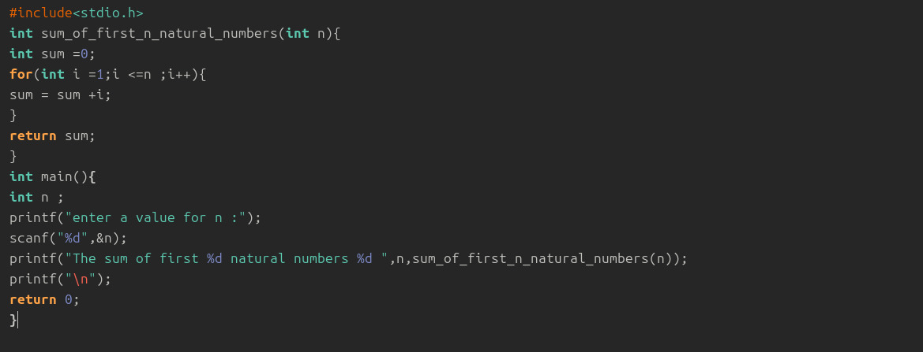

Space Complexity:
- The loop uses only two variables (s and i), and no extra memory grows with n.
- So, the memory used stays constant no matter the input size.
- Therefore, the space complexity is O(1).

2)Write a program to find the sum of squares of first n natural numbers using user-defined function.
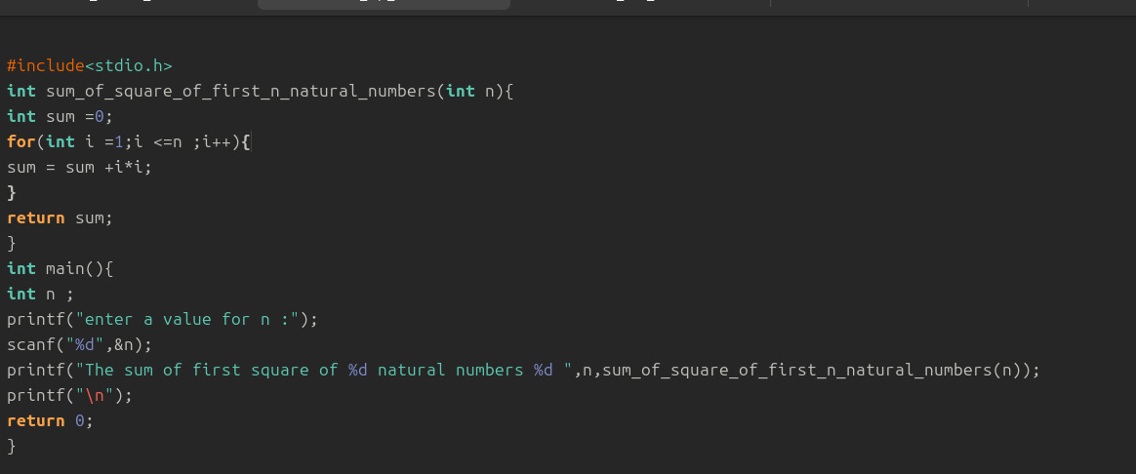
Space Complexity:
- The program uses only a few variables, and this number does not increase when n becomes bigger.
- Since the memory used stays the same all the time, the space complexity is O(1).

3)Write a program to find the sum of cubes of first n natural numbers.
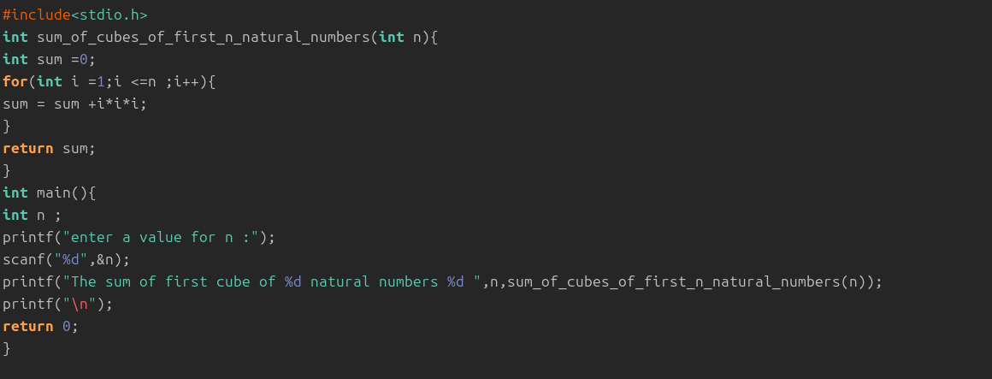
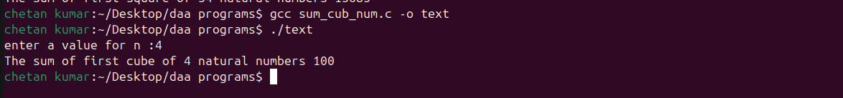
Space Complexity:
- The loop doesn’t create new memory again and again — it just reuses the same variables.
- Because the memory doesn’t grow when n grows, the space stays constant.
- So it is O(1) space.
4) Write a program to find factorial of a natural number using recursive function.
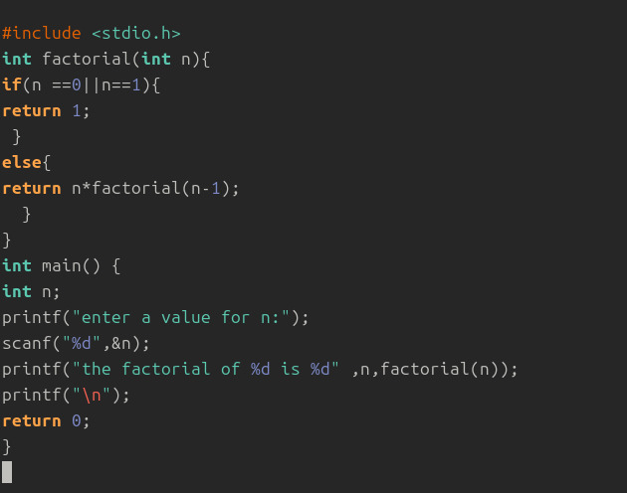
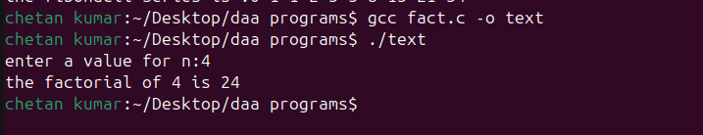
Space Complexity:
- The function calls itself many times, and each call uses some memory.
- More calls mean more memory is used, so memory increases with n.
- That's why the space complexity is O(n).
5) Write a program to transpose a 3×3 matrix.
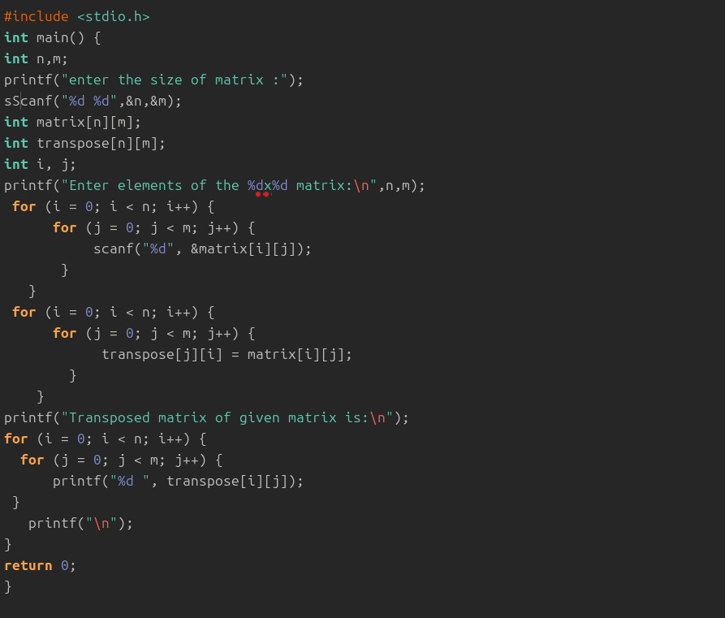
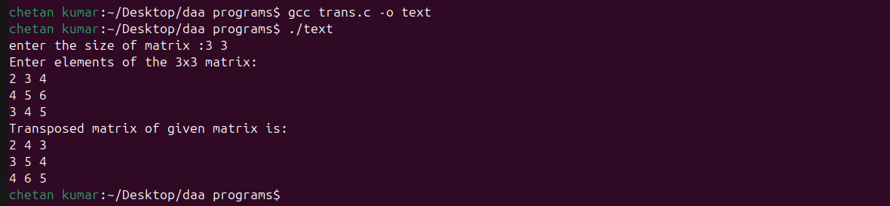
Space Complexity:
- The program creates a 3×3 array, which is fixed in size and does not grow.
- You only use a few extra variables for loops.
- So the space complexity is O(1)
6) Write a program to print the Fibonacci series up to a given number using user-defined function. (For first n natural numbers)
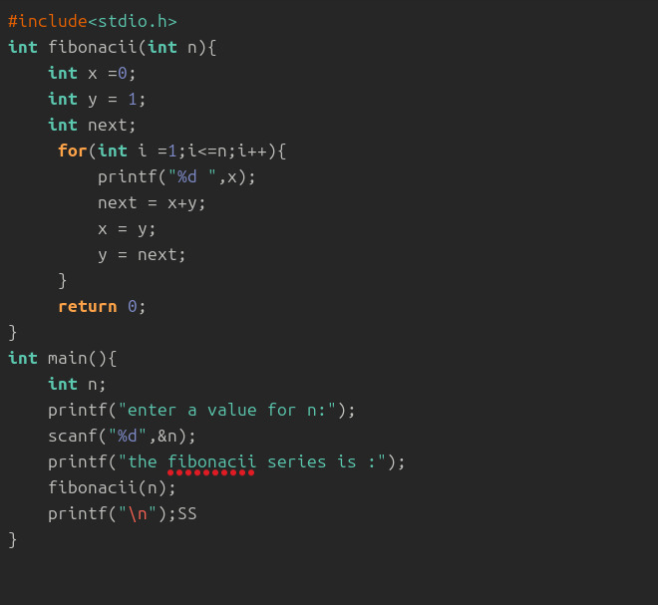
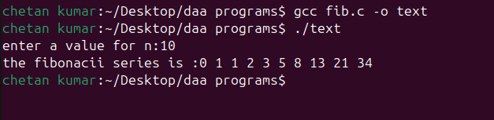
Space Complexity:
- The program only uses a few variables (a, b, sum, temp) and these do not increase when n increases.
- No extra memory grows with the loop.
- So the space complexity is O(1).

