LAB-4
PRIMS’S AND KRUSKAL’S ALGORITHM
NAME:D.CHETAN KUMAR
ROLL NO: CH.SC.U4CSE24209

PRIMS’S ALGORITHM:
Prim’s Algorithm is used to find a Minimum Spanning Tree (MST) of a graph.
- Connect all vertices
- Use no cycles
- Total edge cost is minimum
GRAPH DIAGRAM:
E
A
H
I
G
D
F
C
B

Weight of the graph:
- A–B = 4 A–C = 8 A–D = 6 A–E = 7
- B–C = 5 B–D = 3 B–F = 9 B–E = 6
- C–D = 4 C–E = 2 C–G = 10
- D–E = 5 D–F = 7 D–H = 6
- E–F = 4 E–G = 8 E–H = 9
- F–G = 3 F–H = 5 F–I = 6
- G–H = 4 G–I = 7
- H–I = 2

CODE:
#include <stdio.h>
#include <limits.h>
#define V 9
int minKey(int key[], int mstSet[]) {
int min = INT_MAX, min_index;
for (int v = 0; v < V; v++) {
if (!mstSet[v] && key[v] < min) {
min = key[v];
min_index = v;
}
}
return min_index;
}
void printMST(int parent[], int graph[V][V]) {
int cost = 0;
printf("Edge \tWeight\n");
for (int i = 1; i < V; i++) {
printf("%c - %c \t%d\n", parent[i] + 'A', i + 'A',
graph[i][parent[i]]);
cost += graph[i][parent[i]];
}
printf("Total MST Cost = %d\n", cost);
}
void primMST(int graph[V][V]) {
int parent[V];
int key[V];
int mstSet[V];
for (int i = 0; i < V; i++) {
key[i] = INT_MAX;
mstSet[i] = 0;
}
key[0] = 0;
parent[0] = -1;
for (int count = 0; count < V - 1; count++) {
int u = minKey(key, mstSet);
mstSet[u] = 1;
for (int v = 0; v < V; v++) {
if (graph[u][v] && !mstSet[v] && graph[u][v] < key[v]) {
parent[v] = u;
key[v] = graph[u][v];
}
}
}
printMST(parent, graph);
}
int main() {
int graph[V][V] = {
{0,4,8,6,7,0,0,0,0},
{4,0,5,3,6,9,0,0,0},
{8,5,0,4,2,0,10,0,0},
{6,3,4,0,5,7,0,6,0},
{7,6,2,5,0,4,8,9,0},
{0,9,0,7,4,0,3,5,6},
{0,0,10,0,8,3,0,4,7},
{0,0,0,6,9,5,4,0,2},
{0,0,0,0,0,6,7,2,0}
};
primMST(graph);
return 0;
}

OUTPUT:

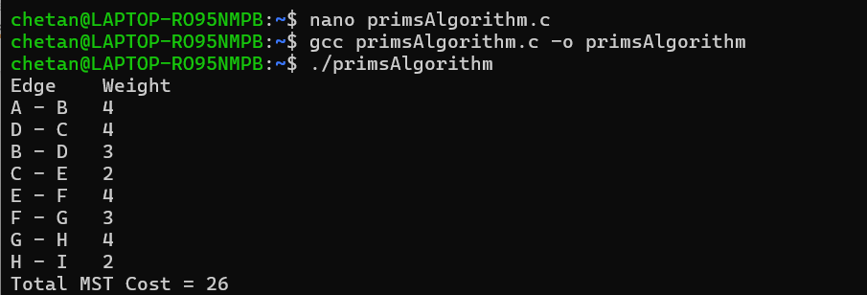
KRUSKAL’S ALGORITHM:

Kruskal’s algorithm constructs a minimum spanning tree by selecting edges in ascending order of weight without forming cycles.

GRAPH DIAGRAM:
F
G
E
D
C
B
A

Weight of the graph:
- A - B = 7 , A - D = 5
- B - C = 8 , B - D = 9 , B - E = 7
- C - E = 5
- D - E = 15 , D - F = 6
- E - F = 8 , E - G = 9
- F - G = 11

CODE:
#include <stdio.h>
#include <stdlib.h>
#define V 7
#define E 11
struct Edge {
int src, dest, weight;
};
struct Subset {
int parent;
int rank;
};
int find(struct Subset subsets[], int i) {
if (subsets[i].parent != i)
subsets[i].parent = find(subsets, subsets[i].parent);
return subsets[i].parent;
}
void Union(struct Subset subsets[], int x, int y) {
int xroot = find(subsets, x);
int yroot = find(subsets, y);
if (subsets[xroot].rank < subsets[yroot].rank)
subsets[xroot].parent = yroot;
else if (subsets[xroot].rank > subsets[yroot].rank)
subsets[yroot].parent = xroot;
else {
subsets[yroot].parent = xroot;
subsets[xroot].rank++;
}
}
int compare(const void *a, const void *b) {
return ((struct Edge *)a)->weight - ((struct Edge *)b)->weight;
}
void KruskalMST(struct Edge edges[]) {
struct Edge result[V];
int e = 0, i = 0;
qsort(edges, E, sizeof(edges[0]), compare);
struct Subset subsets[V];
for (int v = 0; v < V; v++) {
subsets[v].parent = v;
subsets[v].rank = 0;
}
while (e < V - 1 && i < E) {
struct Edge next = edges[i++];
int x = find(subsets, next.src);
int y = find(subsets, next.dest);
if (x != y) {
result[e++] = next;
Union(subsets, x, y);
}
}
int total = 0;
printf("Edge \tWeight\n");
for (i = 0; i < e; i++) {
printf("%c - %c \t%d\n",
result[i].src + 'A',
result[i].dest + 'A',
result[i].weight);
total += result[i].weight;
}
printf("Total MST Cost = %d\n", total);
}
int main() {
struct Edge edges[E] = {
{0,1,7},
{0,3,5},
{1,2,8},
{1,3,9},
{1,4,7},
{2,4,5},
{3,4,15},
{3,5,6},
{4,5,8},
{4,6,9},
{5,6,11}
};
KruskalMST(edges);
return 0;
}
OUTPUT:

