Intelligent Dashboard for Web Hosting Analysis
H. H. Teh, C. B. Ngo, Y. H. Choo, and N. A. Muda
Abstract— Digitalization enables big data analytics to happen and benefit various businesses including web hosting industry. The existing web site management tools supported by web hosting providers are usually limited to data capture, information retrieval, and basic statistical analysis. Descriptive analytics has become a common service offered by the web hosting providers to their clients. However, data captured in real time should be fully utilized to provide more business insights beneficial to the web hosting service clients. Actionable insights are far more meaningful to a web admin then merely describing what had happened in the past. Hence, predictive modelling and intelligent recommender are highly sought after in the web hosting industry. This paper aims to propose an intelligent analytical dashboard which can be adopted by web hosting provider as value added services. It aims to provide website performance recommendation based on the web log data. The proposed web hosting analytics framework consists of web performance segmentation clustering, web log patterns association rules generation, expert knowledge rule validation and pruning, and recommendation alerts generation. tool showcases the automated root cause analysis on web performance using the web activity log data. The proposed web hosting analytics use case is successfully realized with a proof-of-concept intelligent analytical dashboard. It feeds on the Innovate Malaysia Web Log data to construct the predictive model and later generate the recommendation alerts. Nevertheless, the proposed predictive model can be improved in the future with more data to overcome the generalization issue due to the limitation of training data.
Index Terms—intelligent dashboard, root cause analysis, clustering, Apriori, web analytics.

INTRODUCTION
T
he internet is one of the greatest discovery that has heavily impacted and changed the way human live their social life. Nowadays, the increasing penetration of internet facilities in the world drives the new business model in most of the trading and servicing industries. The internet provides an efficient medium for us to simplify our daily task and so, many processes has shifted towards relying on the internet for execution from its previous primitive ways of being executed. In a more general sense, a whole new horizon has been opened up by the ubiquity of Internet which includes the rise of web hosting industry.
The core business of web hosting industry is to provide website hosting services to its clients. The rapid growth of the web hosting industry due to the massive demand has led to the rise of various types of hosting service. For example, shared web hosting service, cloud hosting service, dedicated hosting service, file hosting service and many more. However, the clients are usually not satisfied with merely on the web hosting service, especially in this Big Data era. Providing more value added services, such as meaningful actionable insights is one of the business challenges desired by clients in the web hosting industry. This can be achieved through web hosting analytics, where the web hosting company is crunching and analyzing their massive web traffic data to generate patterns and trends using the machine learning and data-driven approaches. Learning from the general trends to provide personalized alerts tailored to different clients’ needs are valuable to every client to improve their business and digital identity.
The rest of this paper is organized as follows: Section II describes the basic framework of the intelligent web hosting analytics and its components. Section III elaborates the proposed predictive modelling which includes the methodology and approaches for data processing, unsupervised training, root cause generation and testing while in Section IV, the design of the front end dashboard is shown and explained. Lastly, Section V depicts the results and discussion whereas Section VI draws the conclusion and suggests the direction of future work.

The Framework of Intelligent Web Hosting Analytics
The overall framework of the proposed analytical dashboard can be adopted by the existing service platform of a web hosting providers to provide website performance recommendation. The goal of the intelligent analytical dashboard is to analyze and display the web performance of the website in an easily understood format to the owner of the website even if the individual has no prior knowledge to the field of programming or machine learning. The intelligent dashboard feeds the web log data into its predictive model at the backend machine learning engine to generate recommendations in the form of alerts. Figure 1 shows the proposed framework and its key modules.
The frontend act as the medium between the backend process and the user accessing the intelligent dashboard. The frontend will obtain the web log data from the user of the web site to be analyzed. The data will be passed to the backend and the prediction and recommendation returned from the backend will be displayed to the user.
The backend model created are based on the frequent problems occurring in the domain of online web sites. The most commonly known problem to websites which are a turnoff to the customer are first the server response speed, if the server is responds extremely slow, it will affect the customer browsing experience and would eventually cause an unsatisfactory visit. Such delay in browsing speed might either be caused by problems from the server side or the client side. If the problem root is from the server side, then the web server admin might have to take approaches to improve on the web traffic threshold which the website can take in the event of an increase in web traffic to prevent bottlenecks from happening. Where else, if the problems originate from the client side, and it occurs frequently, the web site admin might have to check whether there are any unconventional plugins or update not commonly support the browser of software from the client side which would cause problems on the client side when the web page is visited.

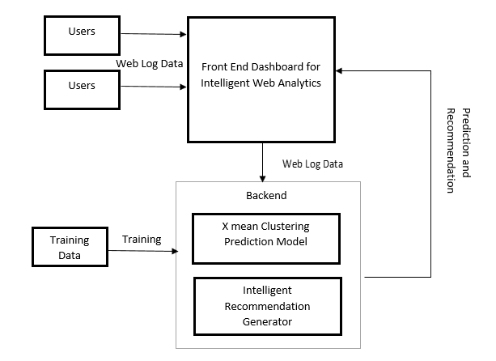

Figure 1: Intelligent Dashboard and Web Hosting Analysis Framework

Other than that, the analytical system also attempts to predict or emulate the satisfactory level of the client visits which directly gives an approximate on how engaging is the web site to its viewer and also on whether the web site provides the contents which are sought out by the target customer of the website. In the event that the website is found to be performing below average the performance threshold, the web admin can then be alerted to either to change the content of the web page as the web page might no longer be providing the content that is sought after by the viewers. At the same time, if the web page is not being received well by the audience, it might also be due to the lack of advertisement from the web admin site, therefore, the admin can be prompted to do so upon discovery.

The Proposed Predictive Modelling
The predictive model proposed in this paper consists of four major components, i.e. (1) the data acquisition and pre-processing module, (2) the web performance segmentation model, (3) the web log patterns generation, and (4) the intelligent recommender.
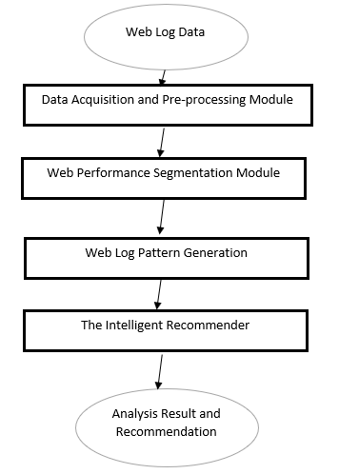
Figure 2: The Predictive Model

The Data Acquisition and Pre-processing Module
The Innovate Malaysia Web Log data is used in the model training phase to realize the proposed framework and the predictive model. The raw data is obtained through Google Analytics platform. First, the data is processed to prepare the data for the model training and prediction activity. The data is checked for empty data, and the data attributes with high percentage of missing values namely 50% and above are removed as they will not contribute to the mode. The special attributes and unique identification attributes for the rows of the data are also removed. Next, since the data being worked on is the web log data with mostly duration and also number of certain occurrence as the center of attention, normalization also is performed to prepare the data more efficiently for prediction result visualization and understanding. Normalization is carried out using Z-transformation to preserve the initial distribution of the data while standardizing the data range from the initial extreme data values.

Web Performance Segmentation
The web log data captured by the web hosting server is logged from time to time. It represents the current activity state of a website. This data contains underlying patterns on how a particular website is being accessed by the web users. Thus, segmenting the web log data is able to group the web traffic according to its performance from time to time. The clustering algorithm, i.e. the X-means algorithm is proposed to perform the segmentation process.
X-means algorithm [1] is a clustering algorithm which uses nearest neighbors to find the centroid of clusters. X-means algorithm is the extension of K-means algorithm, where X-means finds the best number of cluster based on the data distribution. The algorithm of X-means follows the primary two operations of improve parameters, and improve scoring model until the stopping criteria has reached, as follows [1]:

X-means:
- Improve parameters
- Improve scoring model
- If K > K_{max}, then stop and output the scoring model
Else, Goto 1.

In X-means [8], the algorithm runs multiple instance of K-means with different number of clusters. For example, in the first instance, X-means runs assuming the number of cluster K=1, and obtains the cluster result. On the next iteration, X-means runs with the number of cluster K= 2, and records the cluster results as well. After running a finite number of iteration, and when the stopping criteria has been fulfilled, X-means then performs model selection to decide the best model with the optimal number of cluster K.
In this paper, the X-means algorithm aims to group the web log data into normal performance and abnormal performance. We assume the abnormal states are in minority as compared to the common cases. Only those states with small clusters are seen to be interesting alerts, therefore required further analysis to generate recommendation to the web client.

Web Log Patterns Generation
After X-means clustering, the next step would be to generate the frequent item set for the abnormal data clusters, before leading towards rules generation. The web log patterns generation component consists of two modules, i.e. the web log patterns extraction, and the association rules generation. The FP-growth algorithm [6] is used for patterns extraction to allocates frequent item set in the web log data. It discovers the interesting reoccurring events in the web logs.
The FP-tree [7] is generated by mapping the instances of the clustered web log data to check for reoccurring rates of each event item. The following example shows the algorithm of the FP-tree with its assumption [7], the example shows part of the extracted web log data. To aid the visualization process, the attribute of the log data is represented by variable in the FP trees:

Assumptions
Web log to be passed through:
A = Avg. Server Response Time (sec) = range1 [-∞ - 6.570]
B = Session Duration = range1 [-∞ - 1.774]
C = Exits = range2 [1.417 – 3.502]
D = Entrances = range2 [1.417 – 3.502]
Sequence of the log= A, B, C; A, B, D; A, D

Algorithm
- The FP-tree [9] is created with the items of the first log, one node is added with each items from the log with their frequency each set to 1.
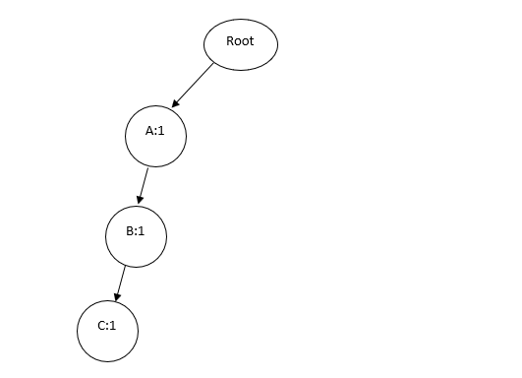
Figure 3: FP-Tree with First log (A, B, C)

- Next, the second log is passed into FP-Growth and the FP-Tree is updated accordingly. Item found to be reoccurring in the already existing FP-Tree will have the node’s frequency increased by 1, while new items will be added to the FP-Tree by adding new nodes. Figure 2 shows the tree changes after the second log is added.
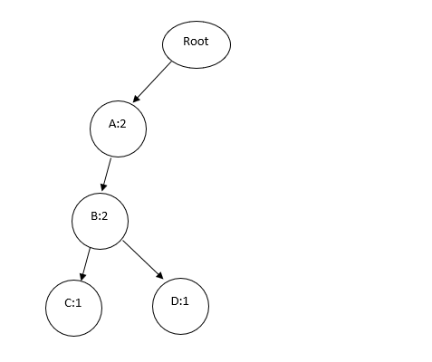
Figure 4: FP-Tree with second log added to it (A, B, D)

- The process is repeated for all the logs in the data set as shown in Figure 3.
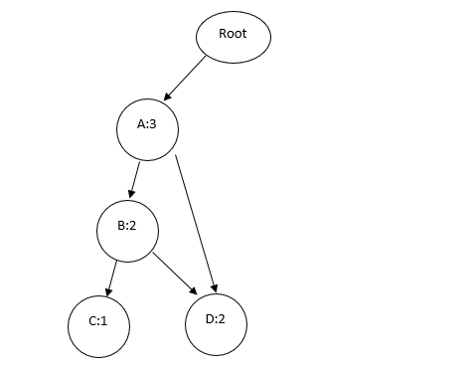
Figure 5: The FP-Tree with the third instance (A, D)

- Lastly, after creating the FP-Tree with all the web logs, a frequent item set list will be generated from the tree and converting the value of frequency of occurrence of each node into minimum support.

The association rules generation is performed after the FP-Growth patterns extraction to identify the interesting relationships exist among the reoccurring event items. Assuming that after the process of FP-Growth, we now have a table of frequent item set that can be used to perform rules generation which implication expression of one attribute of the item set to another. The basic concept of association rules generation is described by the implication expression of XY, where X and Y are individual disjoint reoccurring event items. Table 1 shows the generated frequent items from FP-growth algorithm on the web log data.

Table 1: Example table of frequent items
ID | A(Avg. Server Response Time (sec) = range1 [-∞ - 6.570]) | B(Session Duration = range1 [-∞ - 1.774]) | C(Exits = range2 [1.417 - 3.502]) | D(Entrances = range2 [1.417 - 3.502])
1 | 1 | 0 | 1 | 1
2 | 1 | 1 | 0 | 1
3 | 0 | 1 | 1 | 1

The instance with ID 1 in Table 1 produces an implication rule which is (A, C) -> D. Whenever A and B present, then D will present. Yet, it could also be said that, A(C, D), which means that if A presents, then C and D will present. As such, a single instance can generate multiple number of rules. Therefore, the rules are evaluated based on 2 criteria which are the minimum support and the confidence level. The minimum support of a rule means how often a rule is applicable in the target domain, whereas the confidence level of a rule is the frequency of the conclusion Y being implied with the antecedent X given rule XY.
The minimum support and confidence of the rules can be computed with equation (1) and (2):

$support\left(X→Y\right):\frac{count(X→Y)}{Number of total Instances}$ (1)

$Confidence\left(X→Y\right): \frac{Count(X→Y)}{count(X)}$ (2)

Hence, it is expected that the rules generation process will generate a large number of rules with some less significant or redundant to others. Therefore, determining the suitable set of minimum support criteria, and the confidence interval are essential to extract useful rules to represent meaningful insights.

Intelligent Recommender
The final process after the rules generation would be the intelligent recommender. After the association rules generation, a large set of rules will be generated. The rules will then be classified into 5 categories, as in Table 2, to generate recommendation alerts. Firstly, rules pruning is carried out to reduce non-significant rules while remaining the insightful ones.

Table 2: Recommendation Categories
Rule Category | Description
1 | Inefficient Server Causing bottlenecks
2 | Unengaging content which are unable to retain customer attention
3 | Lack in advertising
4 | Client side issue
5 | Ideal web performance

All of the rules generated in the previous process will be sorted into one of the categories as listed in Table 2. The rules can be used during prediction to evaluate how well the client web site is faring in the particular field. For example, if the rules under Category 1 has high hits, it will be summarized as the web site is inefficient during server high time with increase in web traffic, then we can advise the client to improve or update on the web site in that particular aspect. The number of hits for the rules in the particular category can be used to generate a percentage value on the web site efficiency in that category for easier customer understanding with the following formula.

$\% Efficiency=\frac{Number of hits for rules in that category}{Total number of rules in that category}$ (3)

The Dashboard Design
The proposed predictive model is demonstrated in the intelligent dashboard. The development description of the dashboard is explained according to the four phases of system development, i.e. the analysis, the design, the implementation, and the testing phases. The technology involved here is HTML, CSS and Javascript for designing the graphical user interface and REST connector to communicate with the backend server.

The Analysis
This phase focuses on identifying the requirements for the dashboard. The dashboard is developed to cater three main functional requirements, namely to provide an interface for the users to input the logs of their website for analysis, to act as a middleware that will send the raw data provided by the users to the backend analytic engine and receive back the analysis result from the backend analytic engine and to visualize the analysis result in a way that can be easily digested by the users, so the users can immediately gain insights and understands the potential threats faced by their website.
Beside the functional requirements, there are also three non-functional requirements analyzed. The first one is the performance where analytics application involves many data processing algorithms, so it usually consumes a lot of time and affects user experience. This dashboard aims to provide the analysis result in the shortest time possible. The second non-functional requirement is the security. To use the dashboard, users must upload raw logs of their website which is often considered as restricted sensitive data by many website owners. Hence, this dashboard will come with tight security measures, so these website owners can use the dashboard without worries. The last one is the accuracy where wrong and misleading insights will certainly lead to inappropriate decisions by the users, so this dashboard aims to visualize every analysis results in the most accurate way.

The Design
This phase focuses on designing the overall architecture of the dashboard which includes the module design and GUI design.
Web log
Users
Users
Users
Frontend Server
Backend Server
Users will access the dashboard served by the frontend server through their web browsers and they can input their web logs for analyzing.
Frontend server is responsible for the communication with the backend server and visualize all the analysis result through dashboard.
Web log
Dashboardd
Dashboardd
Web log
Dashboardd
Raw data
Analysis result

Figure 6: Overview of the Dashboard Architecture

The dashboard located in the frontend server consists of three main modules which corresponds to the three main functional requirements. The first one is the Data Input Module where this module handles the processes required for the users to upload their raw web log data. Currently this module only receive data in the form of csv but more data format will be supported in the future. The second one is the Communication Module where this module is responsible for the processes required to send data to be analyzed to the backend server and receive the analyzed result from the backend server. The last one is the Visualization Module where this module handles the visualization of analysis result to the users. The following figure demonstrates the prototyped dashboard design.

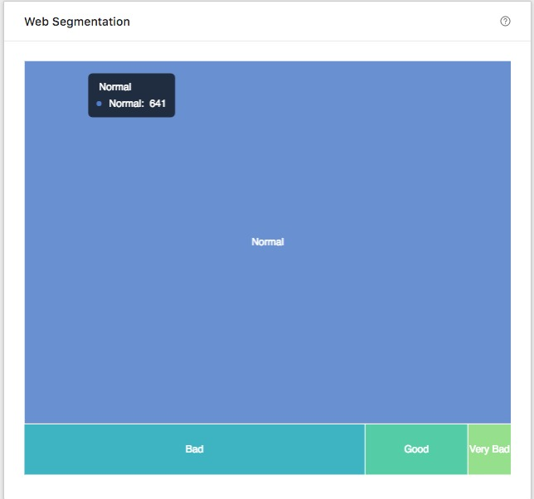

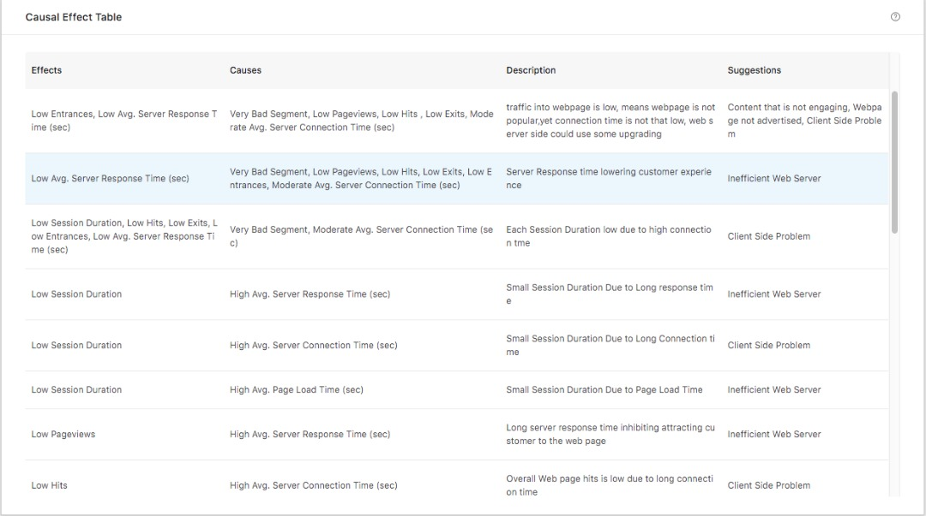
Figure 7: Treemap for Cluster Visualization

Figure 8: Table for Rules Visualization

The Implementation
This phase will focus the how to implement the dashboard design from the previous phase. This dashboard interface will be coded using Javascript with the help of the React.js, which is a Javascript library for building user interfaces. For the Data Input Module, a csv parsing library will be used to help in parsing the web logs uploaded by the user into the form of json data which will be sent later to the backend server for analyzing. The uploaded web logs will be deleted after the parsing has completed. For the Communication Module, the communication with the backend server will be done through the internet HTTP protocol and the data involves will be in json format. The last Visualization Module will use the Ant Visualization library for all the charting purposes and Redux for managing all the state in the interface to ensure the best user experience.

The Testing
Unit tests will be designed for each of the modules to ensure that they fulfill the predefined requirements and integration tests will also be prepared to smoothen the process of combining the modules into the final dashboard.

The Results and Discussion
The weblog data of the Innovate Malaysia web site is extracted from 1 March 2016 till 31 March 2018.

Data Preprocessing
The raw weblog data extracted from the google analytics web site regarding Innovate Malaysia 2018 initially has 36 attributes as shown below.
Table 3: Data Extracted from Google Analytics
Attribute Name | Data Type | Maximum Value | Minimum Value
Entrances | Integer | 0 | 964
%Exit | Real | 0 | 1
%New Session | Real | 0 | 0.895
Avg Session Duration | Real | 0 | 880.520
Avg Time on Page | Real | 0 | 360.833
Bounce Rate | Real | 0 | 1
Bounces | Integer | 0 | 461
Exits | Integer | 0 | 964
Hits | Integer | 0 | 4391
Pageviews | Integer | 0 | 4354
Pages/Session | Real | 0 | 12.750
Session Duration | Integer | 0 | 348572
Organic Searches | Integer | 0 | 148
Avg Document Interactive Time | Real | 0 | 188.769
Avg Domain Lookup Time | Real | 0 | 2.732
Avg Page Download Time | Real | 0 | 13.260
Avg Page Load Time | Real | 0 | 191.0386.393
Avg Redirection Time | Real | 0 | 6.393
Avg Server Connection Time | Real | 0 | 5.793
Avg Server Response Time | Real | 0 | 94.540
Page Download Time | Integer | 0 | 39781
Server Response Time | Integer | 0 | 189081
Server Connection Time | Integer | 0 | 63721
Redirection Time | Integer | 0 | 9022

From the table above, we can foresee that some of the data attributes contain only 0 values as the minimum and maximum values are only 0. Hence, 11 data attributes have been removed due to the reason for not being meaningful as they consist only of missing data. The date column is also removed as the unique identifier for each row.
After removing the data attribute with majority missing values, all 24 remaining data columns are normalized using z-transformation to obtain a standardized range of values for each column.

The Web Performance Segmentation
After this initial data processing, the processed data is then passed into X-means algorithm for clustering. The result of the clustering model is at follows.

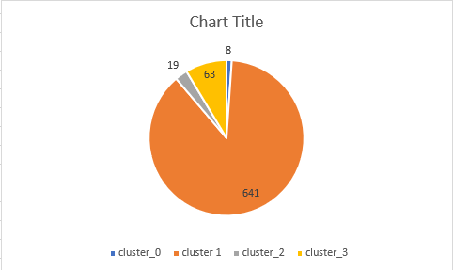

Figure 9: The results from the clustering

From the figure above, we can see that the X-means clustering has clustered the data into 4 main cluster namely: cluster 0, cluster 1, cluster 2 and cluster 3. And the majority of the data lies in cluster 1 followed by cluster 3 while cluster 2 and cluster 0 has the most minority in the respective sequence. From this result, it is safe to assume that cluster 1 are the norm for the website, and while whether this norm is good or bad has yet to be decided.

The Root Cause Knowledge Generation
In this process, the data passed in for root cause are only those of cluster 0, cluster 2 and cluster 3 as they are the minority and the abnormal cases. Before the root cause process, the clustered data for cluster 0 ,2 and 3 are put through simple attribute select with optimization to narrow down the number of attributes for the root cause input to save processing time. After that, the attribute selected will all be binned to 4 bins and then converted to binomial form as that is the requirement for the FP-growth input data.
For the root cause process, the minimum support was placed at 0.5 and 0.5 for the confidence interval during rules generation to experiment on the output. This initial test yielded more than 300 thousand rules, which is too much to be processed, hence the initial goal is to streamline the number of rules. With that in mind, the minimum support was set to 0.8 and the confidence interval set to also 0.8 to generate the rules. The end results are a satisfactory amount of 600 rules totaling from all 3 cluster 0,2 and 3.
After sorting through the rules of the 0.8 support and confidence, it is observed that the rules only include rules with bin 1 items regardless the attributes. After further inspection, it was found that because the majority of the instances from the clustered data lies in bin 1, and when support and confidence is set at high, the other bins are of course ignored being the minority. Hence, the rules with confidence of 0.2 and below are to be extracted too and processed along with the rules of confidence 0.8 and above. The example of part of the rules generation result is as shown in Figure 10:
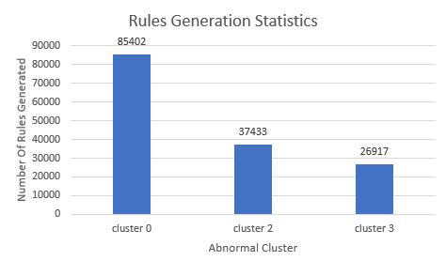
Figure 10: Result of the rules generation process

The Root Cause Knowledge Generation
After the rules are generated, the rules will be categorized into 5 categories manually with aid of human expert analysis and knowledge. The categories are namely:

- Inefficient Server Causing bottlenecks
- Unengaging content which are unable to retain customer attention
- Lack in advertising
- Client side issue
- Ideal web performance

After categorizing each rule into either one of the category mentioned above, each category will has a finite number of rules belonging to that category. During prediction, the input data of the web site to be evaluated can be matched with the rules to analyze the performance of the website, the number of hits for the rules in that category will then be able to produce a percentage which will be a score on how the web site is performing in that particular category.

Figure 11: Rules that has been filtered and sorted into category to be used in recommendation generation.

Conclusion

The proposed intelligent dashboard for web hosting analysis is an additional value added service module to be adopted by web hosting providers as their advanced analytics tools. The proposed predictive model and the intelligent recommender are able to generate actionable alerts to the web client based on their web site performance using the web log data. The intelligent web hosting analytics dashboard offers a mean of visualization on the website performance. It is believed to be beneficial to the web hosting providers as a distinguish feature, while enables web clients to take immediate actions based on real time website performance. However, there are room for improvements for this dashboard in the future, this is because the current project lacks a holistic training data set. It is believed that the whole approach is on the right track, and it can yield better and more accurate result given a proper training data set.

Acknowledgement
We officially acknowledge Dreamcatcher Innovate Malaysia as the data provider for the Intelligent Dashboard for Web Hosting Analysis. In accordance to that, we hereby acknowledge SAS, Exabytes, and UTeM as the financial supporter to this project and IMDC 2018 as the organizer for Innovate Malaysia 2018 which triggered the development of this project.

References
- Pelleg, D., & Moore, A. W. (2000, June). X-means: Extending k-means with efficient estimation of the number of clusters. In Icml (Vol. 1, pp. 727-734).
- (2008, January 10). Frequent Pattern Growth (FP-Growth) Algorithm Outline - Wim Leers. Retrieved April 16, 2018, from https://wimleers.com/sites/wimleers.com/files/FP-Growth%20presentation%20handouts%20%E2%80%94%C2%A0Florian%20Verhein.pdf
- (2015, August 30). machine learning - X-means algorithm and BIC - Cross Validated. Retrieved April 16, 2018, from https://stats.stackexchange.com/questions/169319/x-means-algorithm-and-bic
- (n.d.). Data Mining Apriori Algorithm Association Rule Mining (ARM). Retrieved April 16, 2018, from http://staffwww.itn.liu.se/~aidvi/courses/06/dm/lectures/lec7.pdf
- (n.d.). Frequent Pattern (FP)-Growth algorithm | Tobias Hardes. Retrieved April 16, 2018, from http://thardes.de/big-data-englisch/frequent-pattern-fp-growth-algorithm/
- Narvekar, M., & Syed, S. F. (2015). An optimized algorithm for association rule mining using FP tree. Procedia Computer Science, 45, 101-110.
- Lin, K. C., Liao, I. E., & Chen, Z. S. (2011). An improved frequent pattern growth method for mining association rules. Expert Systems with Applications, 38(5), 5154-5161.
- Hamerly, G., & Elkan, C. (2004). Learning the k in k-means. In Advances in neural information processing systems (pp. 281-288).
- Wang, L., Meng, J., Xu, P., & Peng, K. (2018). Mining temporal association rules with frequent itemsets tree. Applied Soft Computing, 62, 817-829.
- Wang, T., Wei, J., Zhang, W., Zhong, H., & Huang, T. (2014). Workload-aware anomaly detection for Web applications. Journal of Systems and Software, 89, 19-32.

