Denae Mendez
October 12th, 2026
Data Analytics
Prompts Revisions
- Explain Regression
  - “Explain this to me like I am five. You are a kindergarten teacher, trying to teach her five year old students complex concepts because you know these kids will be able to understand it as long as you break it to them in simple terms. Explain this to me, your kindergarten student, in one paragraph.”
  - 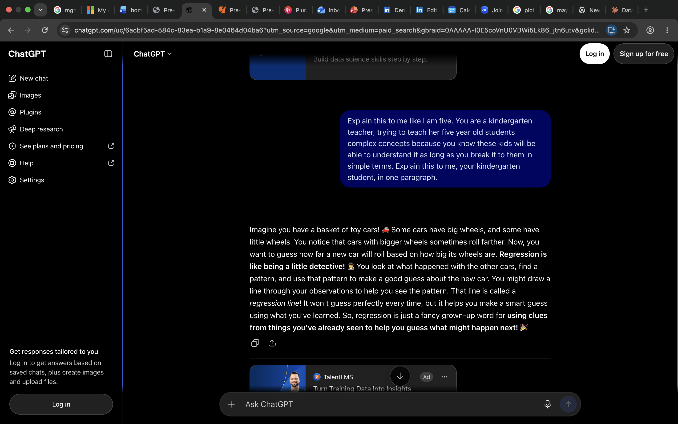
  - My prompt is stronger because I asked ChatGPT to explain regression to me in a way that was short and sweet and easy to understand. When I just typed in “explain regression”, ChatGPT gave me a very long response and the wording was a llitle difficult for me to understand.With this new prompt, ChatGPT’s response was shorter and east to understand.
- Help me understand SQL
  - You are a fifth grade teacher, teaching your ten-year-old students about SQL. They are having a hard time understanding it, so for now, you want to teach them the basics of SQL. Explain two SQL commands in simple words that’s easy to understand for ten-year-olds.
  - 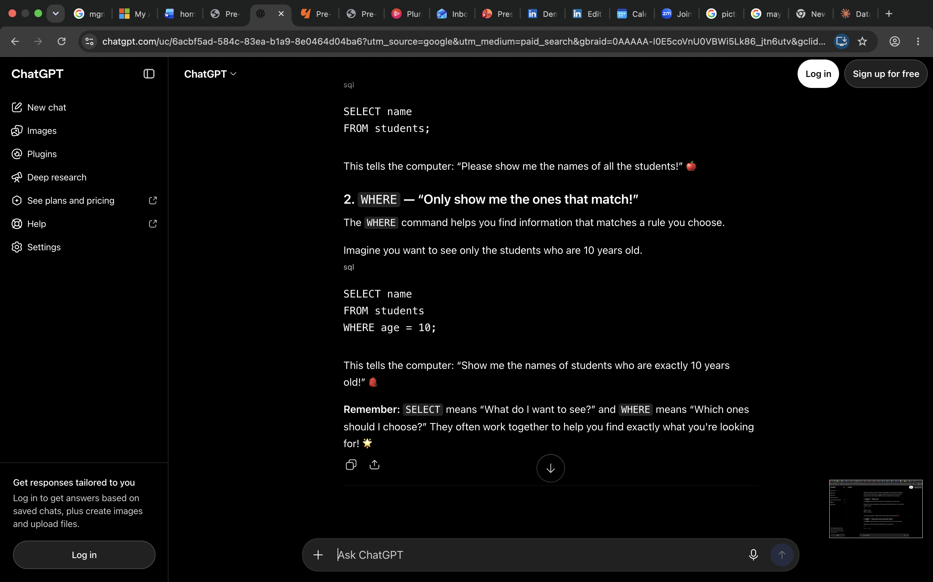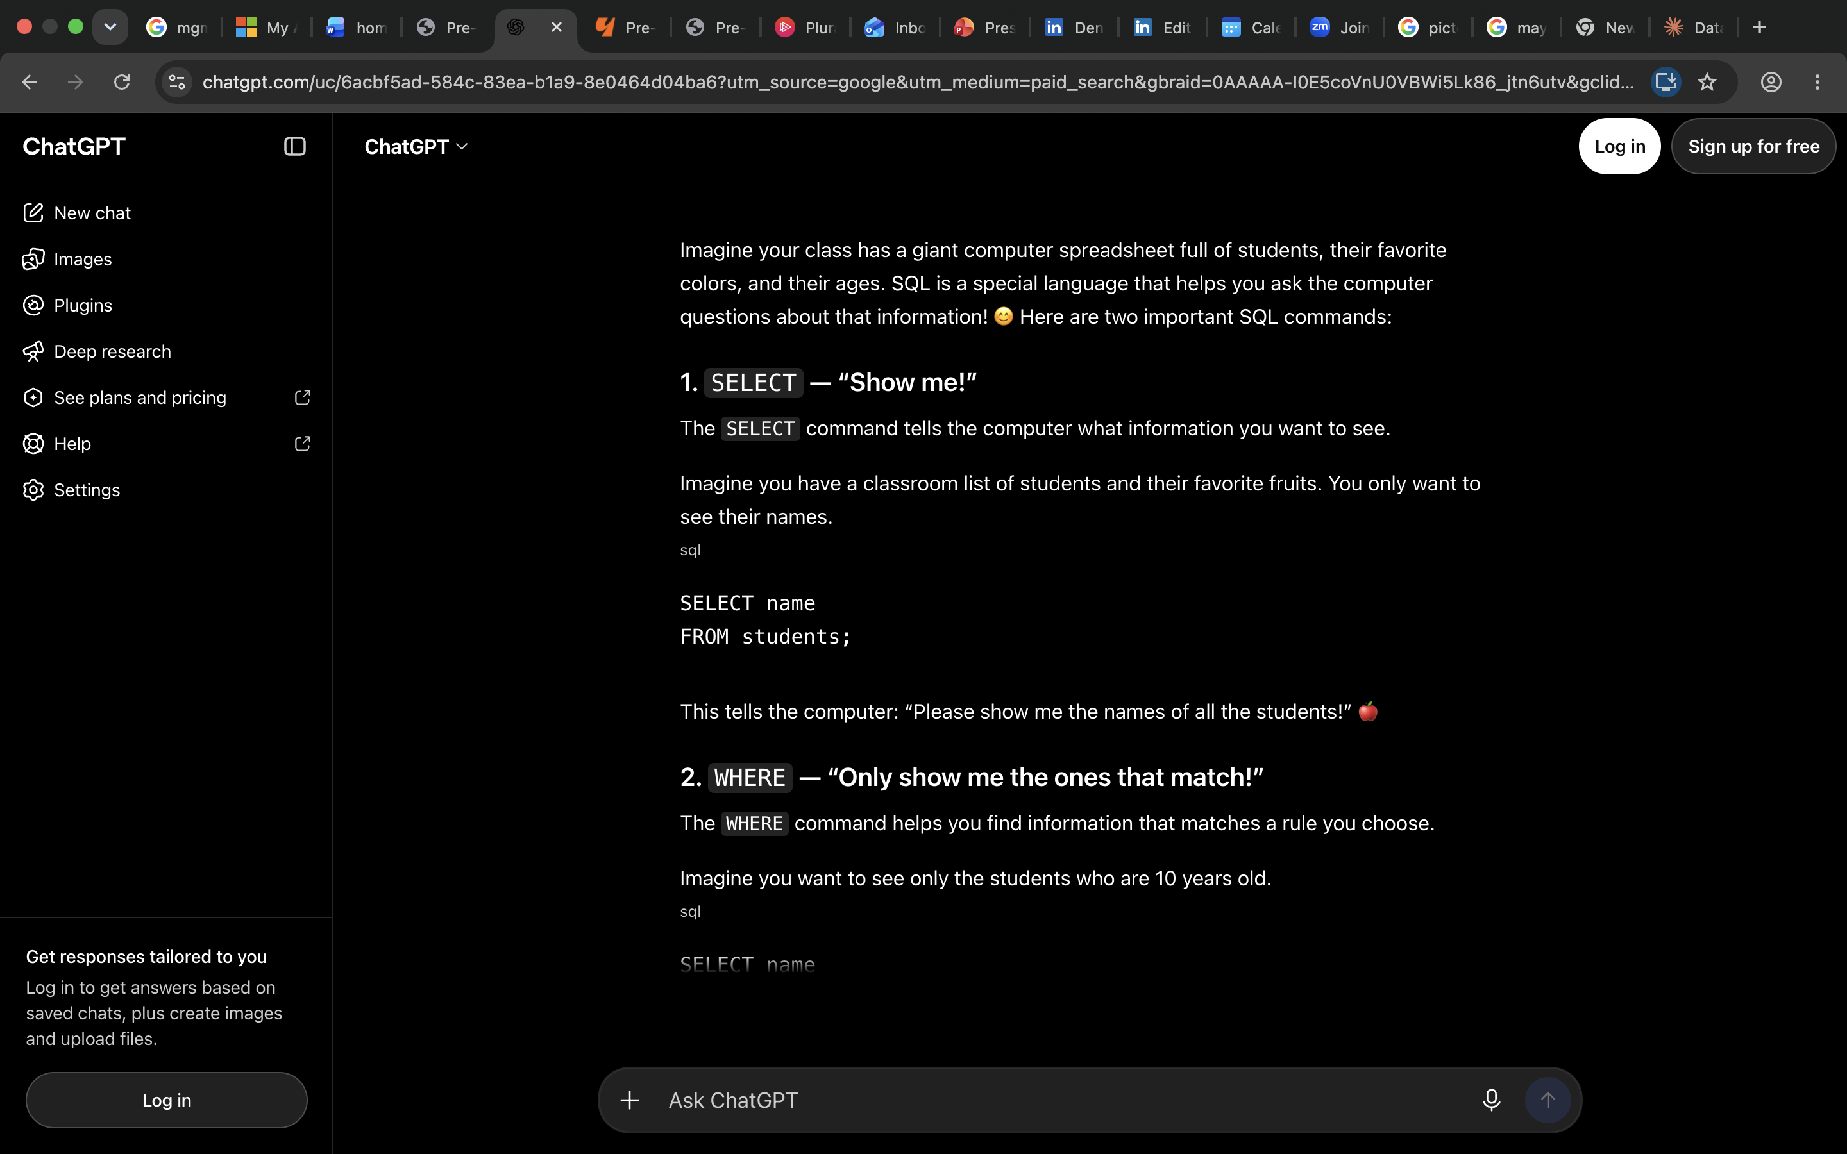
  - My prompt is stronger because it is a lot clearer. The request was to help the person understand SQL, but the person didn’t really say what they needed help with. I don’t know if they needed help with installing SQL, explaining the terminal, or something else. Because of that, I decided to ask ChatGPT if it could explain two commands in SQL. I asked for two because if this individual is struggling with SQL, more than two may be overwhelming for them.
- Create a dataset
  - Create a dataset showcasing how many people in Japan, ages 6 to 30, like each of the four main characters (Cure Spicy, Cure Precious, Cure Finale, and Cure YumYum) and Black Pepper in Delicious Party Precure. This is just a regular dataset. It has nothing to do with SQL. This is just for fun. I also want a chart dataset. I do want actual numbers, however, if you are unable to find actual data for this prompt, then title this chart "Fictitious Numbers". If you are able to find the data from an actual online source, please provide the link.
  - 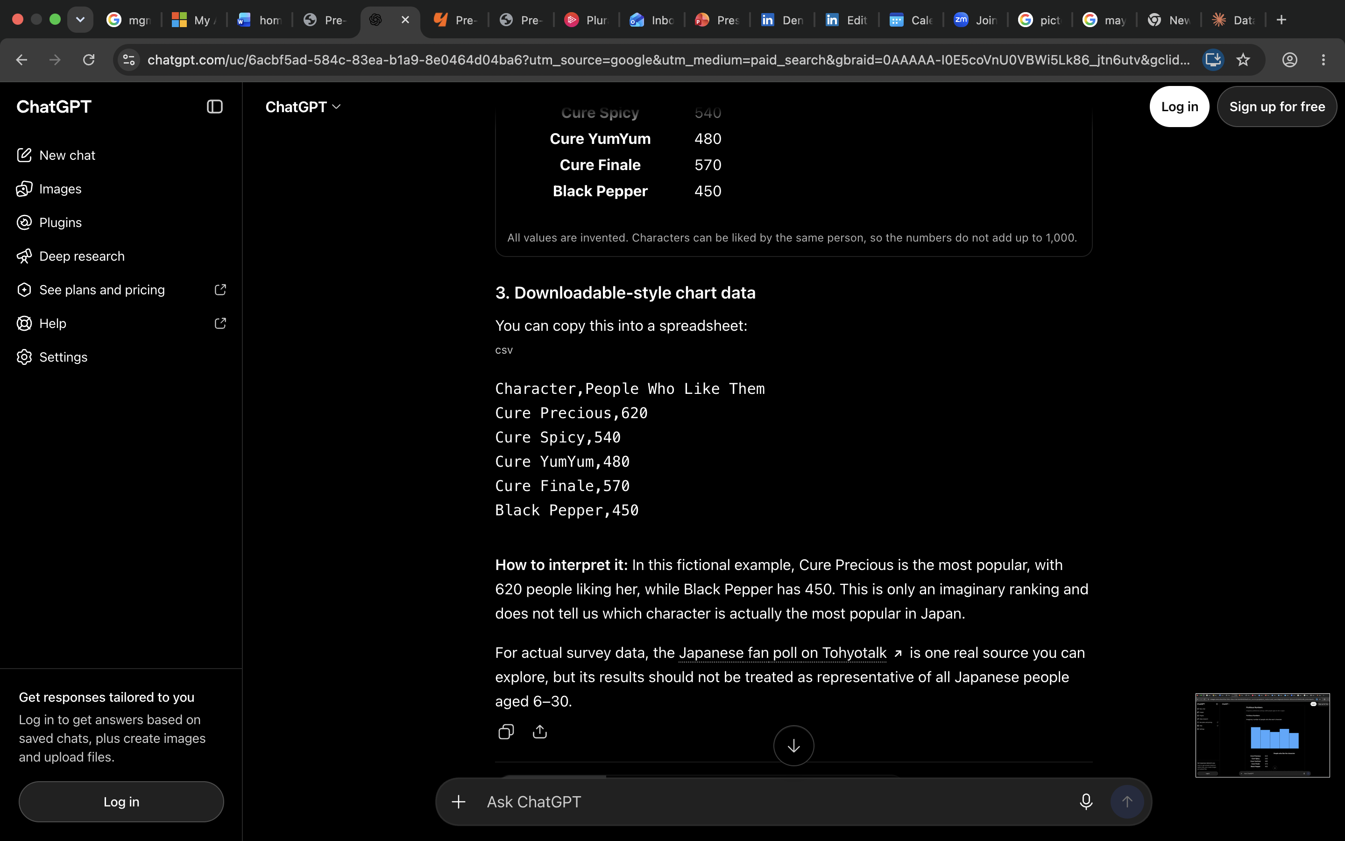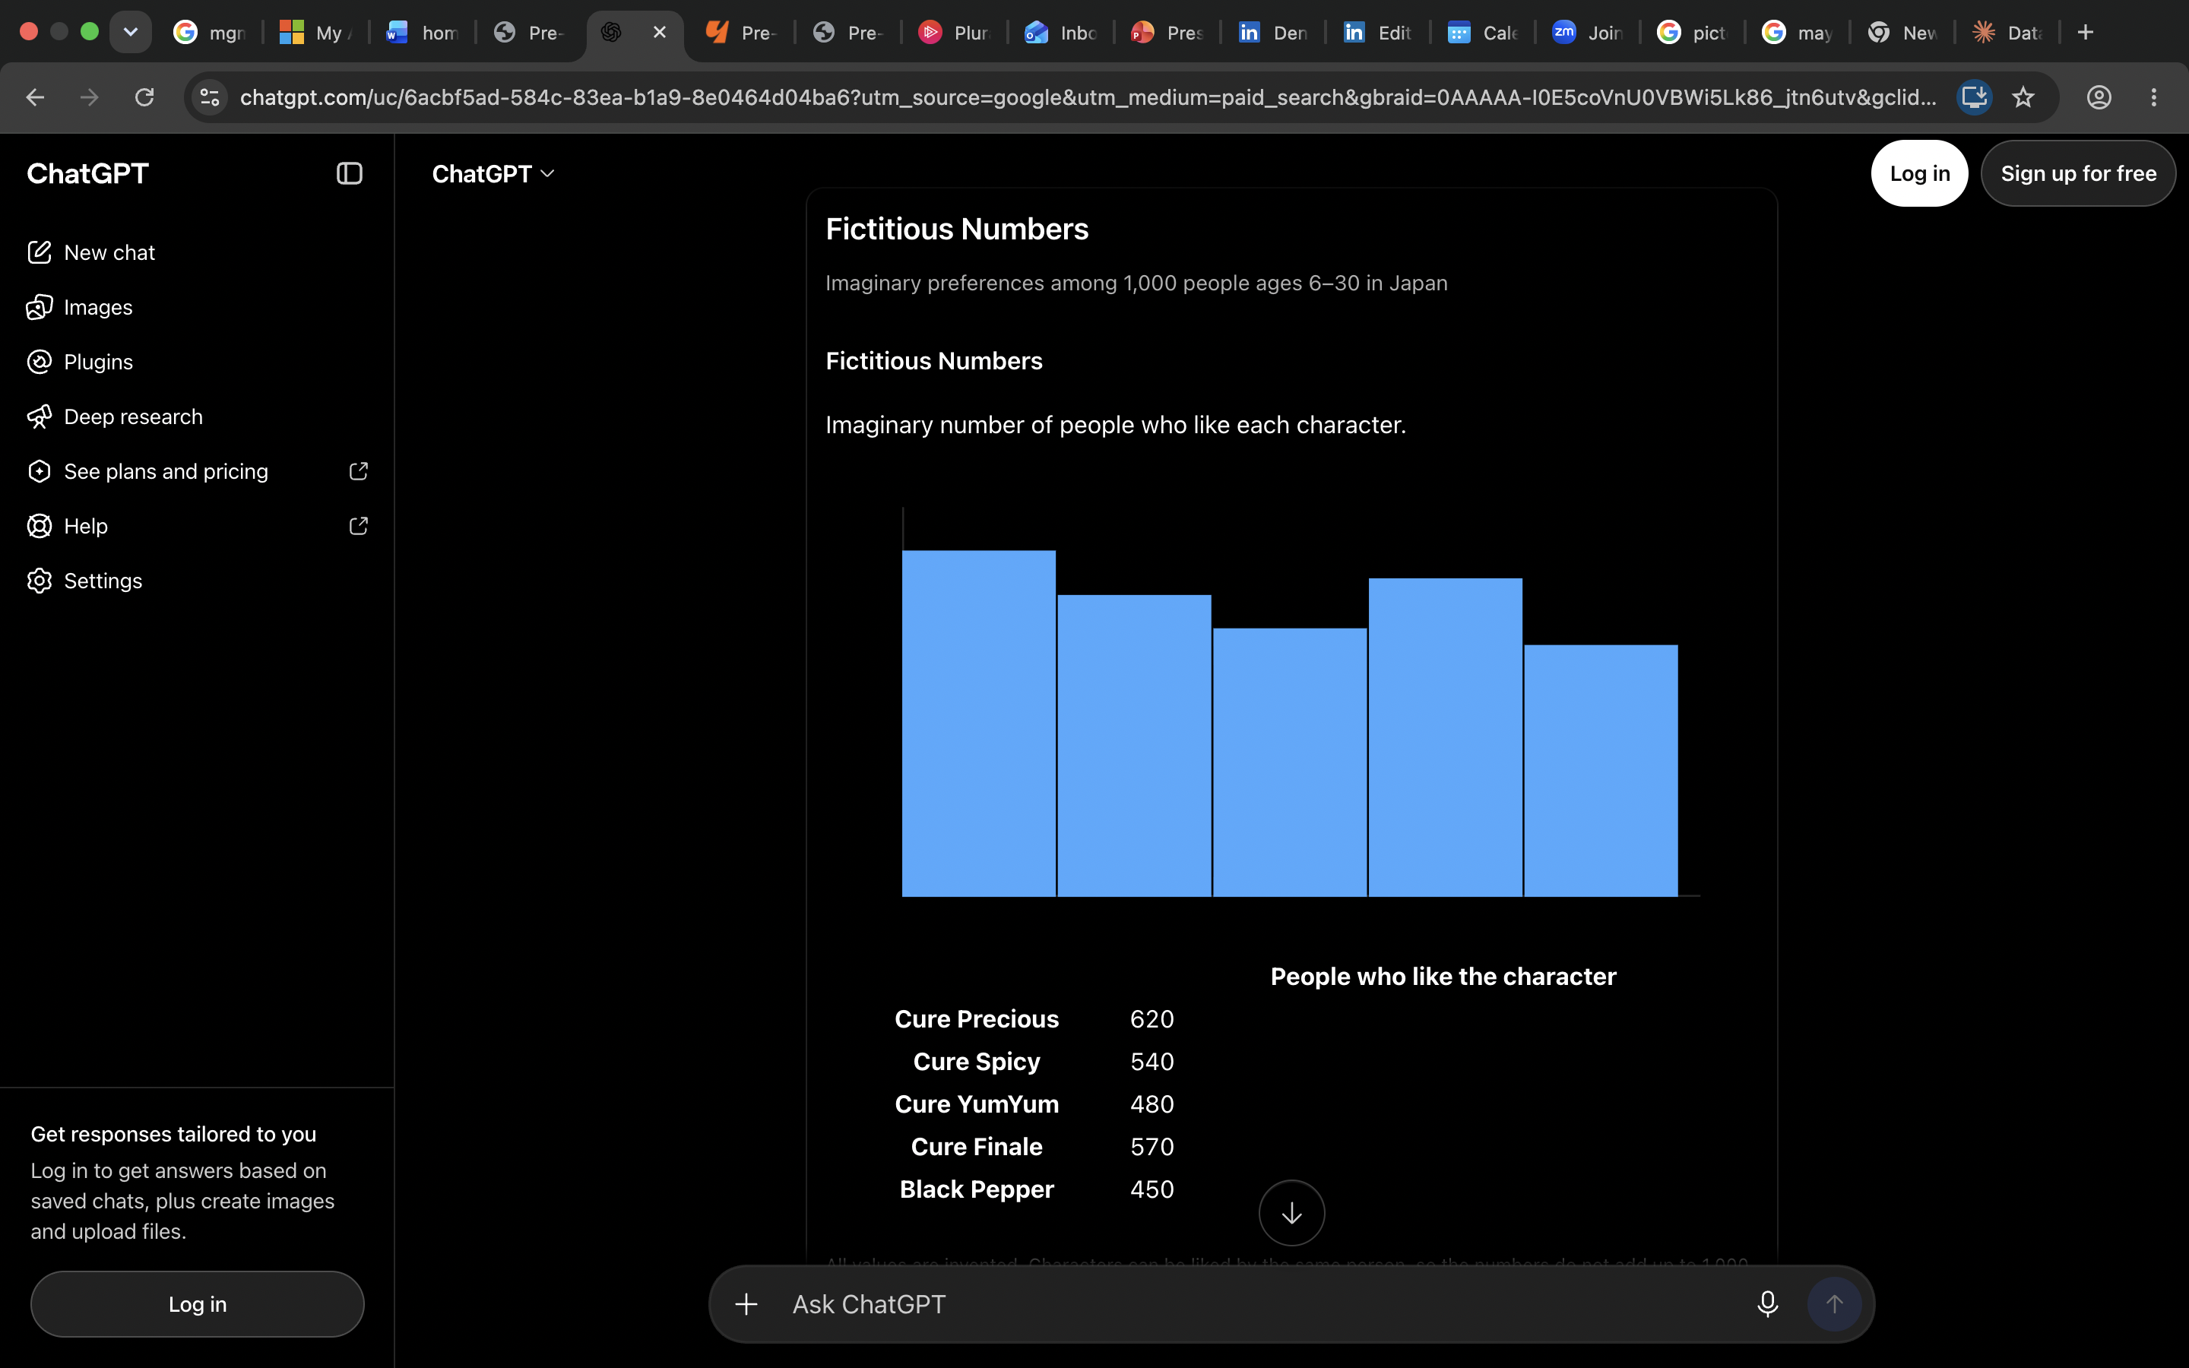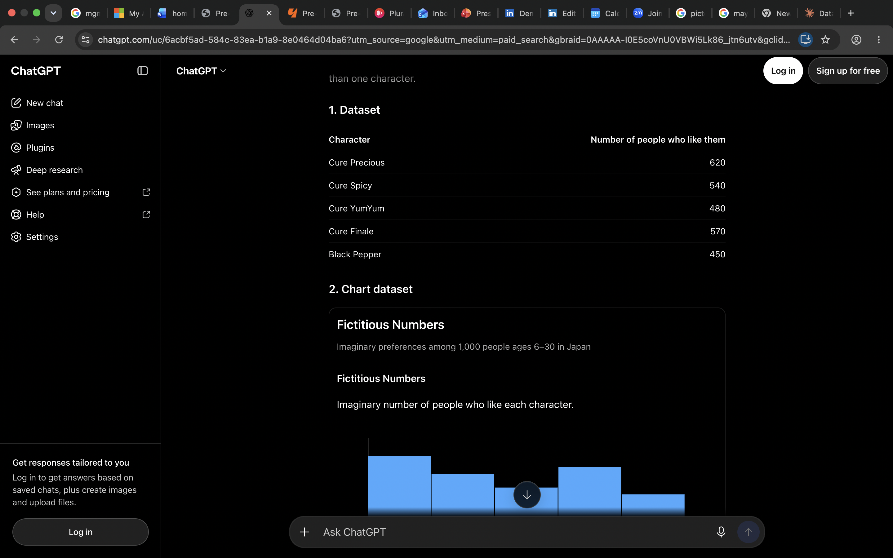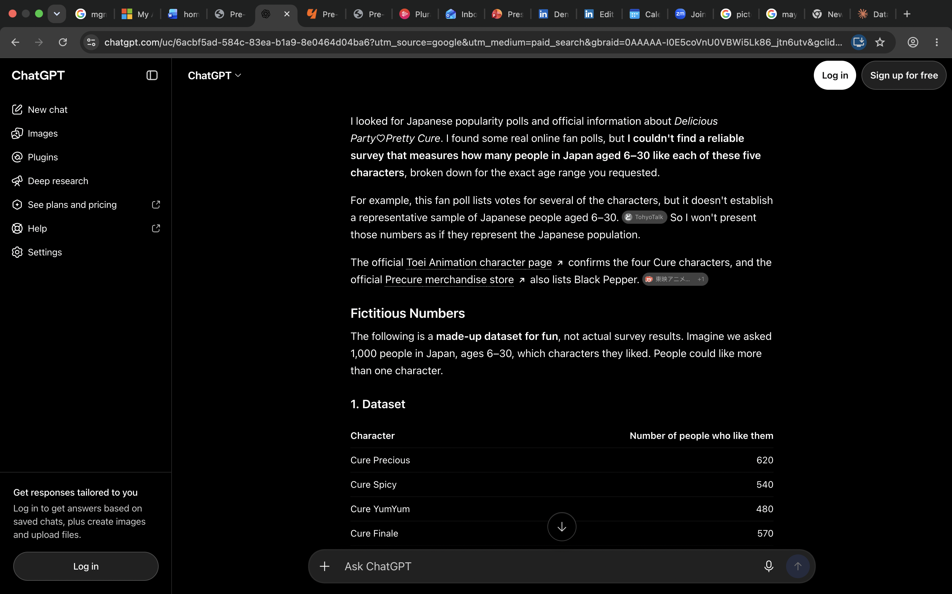
  - My prompt is stronger because again, it is much clearer. When I read “create a dataset” I was confused as to what I was supposed to make a dataset of. I am sure ChatGPT would be no different. I took the creative liberties to ask ChatGPT to make a dataset of something I was interested in. I clarified the format I wanted the dataset in and I told ChatGPT it has nothing to do with SQL because it thought this new prompt was related to the last prompt. Since ChatGPT can “hallucinate” I added extra precautions. I told it what to do if it cannot find actual data and how to notify me of that. And if it was able to find the data, I told it to provide the link so I could check for myself. Even with the link provided, ChatGPT can still hallucinate, which is why I wanted to check the website myself.

