Venus Alljoyn Test Tool

User Guide

Version 1.0

Prepared by: Duy Phan

# Testing input model

The input of test tool is divided into 3 json format files. The below diagram describe the relationship of them:

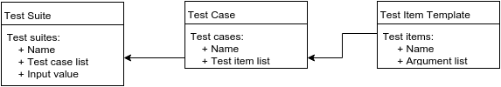

* Test Item Template (tesitem.json): collection of all action which test tool support along with its argument. The file is a template, so if alljoyn service on Venus add new supported action, just update its template into this file.
* Test case (testcase.json): this file is defined by tester by pick up test items from “testitem.json”. The order of test item inside each test case corresponding sequence of processing test item.
* Test Suite (testsuite.json): suite of test case which test tool will run. This file is created by tester. Each test case is pick up from testcase.json then fill in value of each item argument. Refer to testitem.json and this file <https://docs.google.com/spreadsheets/d/1na5J6G9NMe6GSvdZaFxxJcAEBldEFFbC88FDApVrCfI/edit?usp=sharing> to know necessary arguments and its valid value.

*Notice: keep the json format such as prototype to ensure the test tool parse correctly.*

# 2. How to define test case, test suit

Keep *testitem.json* as a template, tester just only define and edit test suite, test case of theirs.

* Based on test items, tester will create test cases for specific device type (zwave, zigbee, upnp) in *testcase.json*.
* Then create test suite by add corresponding test case information include test case name and its argument value.

Refer to below picture that show testing input sample consist of 3 json files and their relationship.



# 3. Run Alljoyn Test Tool

Get source code from:

user.name@192.168.1.154:/VERIK/git_repo/prj-aj-test-tool

Build source: navigate to root of source directory then issue command:

make

Run AlljoynTester along with input from own test suite:

source bin/.dev_env

./bin/AlljoynTester path_to_testsuit.json path_to_testcase.json

The exported result html file after run Test Tool are located at *output/*