DATA608 Knowledge and Visual Analytics (001)

Daniel Craig

9/23/23

# Executive Summary

## Topic: Gun Control Law Efficacy

#### Target Questions:

1. Do stricter firearm control laws help reduce firearm mortality?

**Table of Contents**

Executive Summary 1

Topic: Gun Control Law Efficacy 1

Target Questions: 1

Context 2

Firearm-Related Injury Death Rates: 3

Gun Control Laws by State: 5

*Conclusion* 7

#### Context

Gun control laws are subject to polarizing opinions, misleading news titles, and the cheap tactic of emotional manipulation. With bipartisan politics, and their associated news outlets, pushing very clear interests, it is difficult for the average citizen to determine the real impact of gun control. Harder still is to know what the laws actually do. Death Rates by Firearm-Injury as reported by the CDC and an analysis on firearm control laws by U.S. State. Using these two, this summary aims to answer the question: **“Do stricter firearm control laws help reduce firearm mortality?”**

Current Consumer Price Index, Federal Funds Rate, and Unemployment Rates for the past 25 years are below. This data was collected using *St. Louis Fed Web Services: FRED® API.*

***Methodology***

Firearm-Injury Death Rates were sourced from data.cdc.gov; [NCHS - VSRR Quarterly provisional estimates for selected indicators of mortality | Data | Centers for Disease Control and Prevention (cdc.gov)](https://data.cdc.gov/NCHS/NCHS-VSRR-Quarterly-provisional-estimates-for-sele/489q-934x). This data will be restricted to the year 2022 and serve as a basis to evaluate severity of firearm deaths.

Research on firearm control laws was done by utilizing <https://everytownresearch.org/>. This site compiles and updates a collection of all state laws related to firearms, which are employed by each state, and evaluate the relative importance of a law in its ability to reduce mortality rates. Some laws are evaluated with less-than scientific means as these laws start to become ephemeral in nature, but those lacking in numerical impact have reasoning that corroborates their relative importance. Each law was scored and categorized in a table to be used when developing the upcoming State scores and Likert Scale.

Each category will be portrayed on choropleth heat maps to connect geographic identity to numerical values using color.

#### Firearm-Related Injury Death Rates:

Darker states have lower death rates.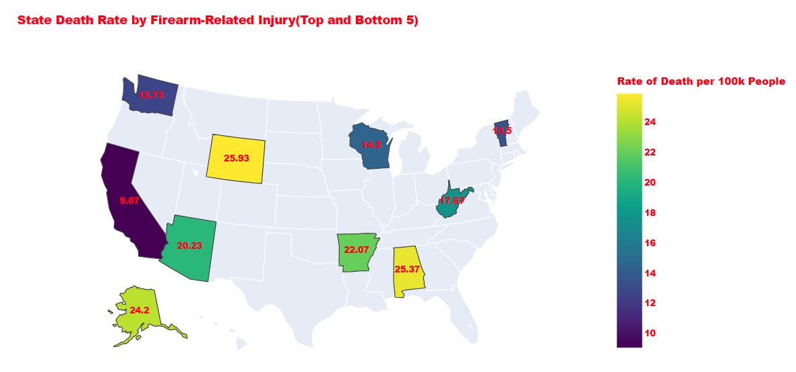 Brighter states have higher death rates. Wyoming leads out of all states for the highest death rate per 100,000 people. In the table shown below, Control_Score denotes how strict a state’s gun laws are. *Although expected* due to taking the top and bottom five states, *there is a notable inverse relationship between Death_Rate and Control_Score*.

**Lowest Firearm-Related Injury Death States:**

1. 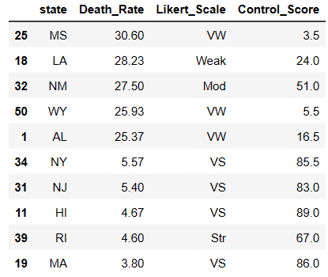Massachusetts

2. Rhode Island

3. Hawaii

4. New Jersey

5. New York

**Highest Firearm-Related Injury Death States:**

1. Mississippi

2. Louisiana

3. New Mexico

4. Wyoming

5. Alaska

#### 

**Patterns:**

1. Midsouth/Southeast have notably higher death rates

2. Midwest has a mixture of low and high death rate states

3. Northeast is exceedingly low

#### 

Revealing the entire map shows some geographical trends highlighted below. Surprisingly, many heavily populated states have low death rates. Texas in particular, despite being gun friendly, has a moderate death rate.

#### Gun Control Laws by State:

A catalog of all gun control related laws used by the States, ranked in accordance to efficacy, and given scores based on that efficacy is used to establish state scores. Laws were given scores of 6, 3, 1.5, and 1 pending their efficacy in reducing death rates and then summed for a total score to measure a state’s gun control laws. Note that **no single state has enacted all 50 of the potential laws** noted here for a total score of 103. An exhaustive list of laws and which states have enacted them is available with the Explore by Policy/State section at [EveryTownResearch.org](https://everytownresearch.org/rankings/) site.

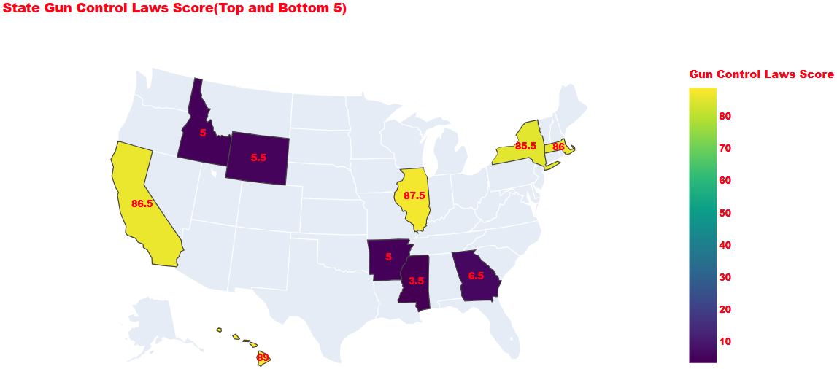**Lowest Control_Score States:**

1. M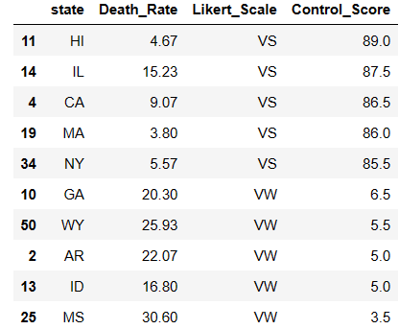ississippi

2. Indiana

3. Arkansas

4. Wyoming

5. Georgia

**Highest Control_Score States:**

1. Hawaii

2. Illinois

3. California

4. Maryland

5. New York

The previous, but expected pattern, is beginning to cement itself as we see **repeat offenders in the Southeast with low Control_Scores and high Death_Rates**. While in the Northeast, **high Control_Scores and low Death_Rates are reinforced**.

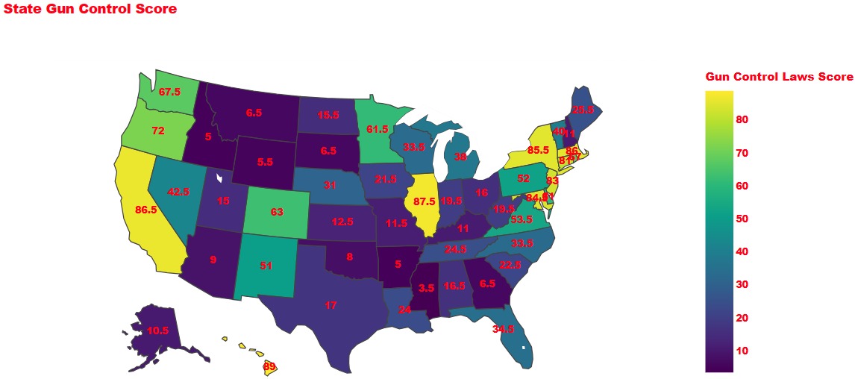

Observing the full map further reinforces the pattern we have seen thus far.

**Patterns:**

1. Midsouth/Southeast have notably lower Control_Scores

2. Midwest has a mixture of low and high Control_Scores

3. Northeast is exceedingly high in Control Scores

For ease of comparison, the State Death Rate by Firearm-Related Injury and the State Gun Control Scores are plotted below. Values and legends are removed to reduce clutter, but they are the same.

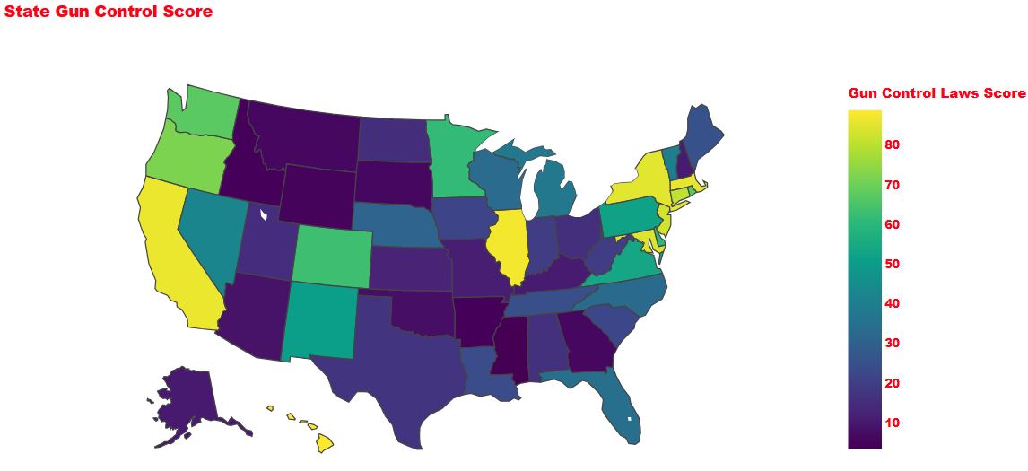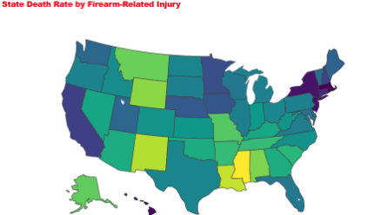

##### ***Conclusion***

A **Likert Scale of [VW, W, Mod, Str, VS] for [Very Weak, Weak, Moderate, Strong, Very Strong]** based on 20 point cuts from 0 to 103 of the Control_Score values were assigned and then plotted on a scatter plot to give a perspective of similarly rated control states near each other. A least squares regression line was added to emphasize trend.

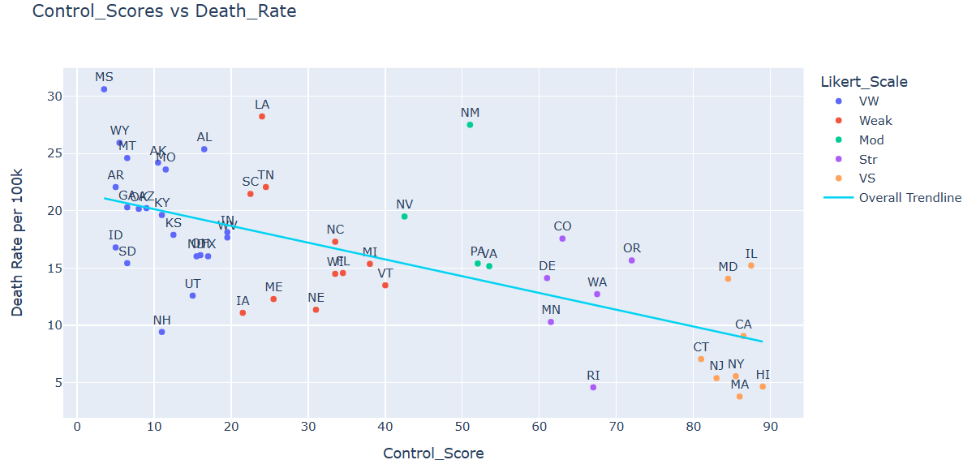

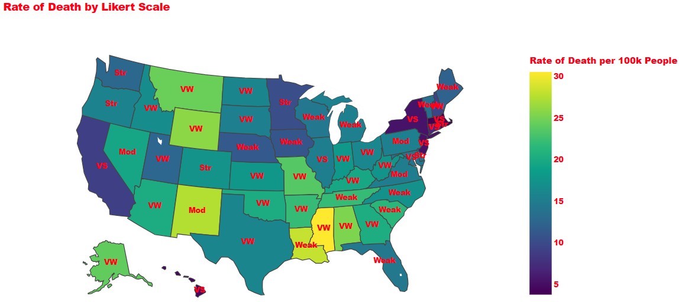

With Likert_Values on each state, one can compare the color representing Rate of Death with a state’s Control Score. We can see the relationship play out between Likert_Values, Death_Rates, and geographical location.

**“Do stricter firearm control laws help reduce firearm mortality?”**

Higher firearm control states enjoy a lower death rate related to firearm injuries. While there are outliers when observing each group, the trend is clear. For an extended analysis, low death rate and low control score states could be investigated for specific laws that may have more impact on death rate. The same is true for the inverse. Some arguments have been made about high control score states being surrounded by low control score states, but that is outside this analysis’ scope.

***References & Code Appendix:***

*NCHS - VSRR Quarterly provisional estimates for selected indicators of mortality | Data | Centers for Disease Control and Prevention*. (2023, July 27). https://data.cdc.gov/NCHS/NCHS-VSRR-Quarterly-provisional-estimates-for-sele/489q-934x

- Special Mention to Jiwaid Hakim(fellow student) for sharing this source in Classroom Slack

Everytown for Gun Safety Support Fund. (2023, May 8). *Gun safety policies save lives*. Everytown Research & Policy. https://everytownresearch.org/rankings/

Full Table for Plots

|  | **state** | **Death_Rate** | **STUSAB** | **Likert_Scale** | **Control_Score** |
| --- | --- | --- | --- | --- | --- |
| **0** | AK | 24.20 | AK | VW | 10.5 |
| **1** | AL | 25.37 | AL | VW | 16.5 |
| **2** | AR | 22.07 | AR | VW | 5.0 |
| **3** | AZ | 20.23 | AZ | VW | 9.0 |
| **4** | CA | 9.07 | CA | VS | 86.5 |
| **5** | CO | 17.57 | CO | Str | 63.0 |
| **6** | CT | 7.07 | CT | VS | 81.0 |
| **8** | DE | 14.13 | DE | Str | 61.0 |
| **9** | FL | 14.57 | FL | Weak | 34.5 |
| **10** | GA | 20.30 | GA | VW | 6.5 |
| **11** | HI | 4.67 | HI | VS | 89.0 |
| **12** | IA | 11.10 | IA | Weak | 21.5 |
| **13** | ID | 16.80 | ID | VW | 5.0 |
| **14** | IL | 15.23 | IL | VS | 87.5 |
| **15** | IN | 18.13 | IN | VW | 19.5 |
| **16** | KS | 17.90 | KS | VW | 12.5 |
| **17** | KY | 19.63 | KY | VW | 11.0 |
| **18** | LA | 28.23 | LA | Weak | 24.0 |
| **19** | MA | 3.80 | MA | VS | 86.0 |
| **20** | MD | 14.07 | MD | VS | 84.5 |
| **21** | ME | 12.30 | ME | Weak | 25.5 |
| **22** | MI | 15.37 | MI | Weak | 38.0 |
| **23** | MN | 10.30 | MN | Str | 61.5 |
| **24** | MO | 23.60 | MO | VW | 11.5 |
| **25** | MS | 30.60 | MS | VW | 3.5 |
| **26** | MT | 24.60 | MT | VW | 6.5 |
| **27** | NC | 17.30 | NC | Weak | 33.5 |
| **28** | ND | 16.03 | ND | VW | 15.5 |
| **29** | NE | 11.37 | NE | Weak | 31.0 |
| **30** | NH | 9.43 | NH | VW | 11.0 |
| **31** | NJ | 5.40 | NJ | VS | 83.0 |
| **32** | NM | 27.50 | NM | Mod | 51.0 |
| **33** | NV | 19.50 | NV | Mod | 42.5 |
| **34** | NY | 5.57 | NY | VS | 85.5 |
| **35** | OH | 16.13 | OH | VW | 16.0 |
| **36** | OK | 20.17 | OK | VW | 8.0 |
| **37** | OR | 15.67 | OR | Str | 72.0 |
| **38** | PA | 15.40 | PA | Mod | 52.0 |
| **39** | RI | 4.60 | RI | Str | 67.0 |
| **40** | SC | 21.47 | SC | Weak | 22.5 |
| **41** | SD | 15.43 | SD | VW | 6.5 |
| **42** | TN | 22.07 | TN | Weak | 24.5 |
| **43** | TX | 16.03 | TX | VW | 17.0 |
| **44** | UT | 12.60 | UT | VW | 15.0 |
| **45** | VA | 15.17 | VA | Mod | 53.5 |
| **46** | VT | 13.50 | VT | Weak | 40.0 |
| **47** | WA | 12.73 | WA | Str | 67.5 |
| **48** | WI | 14.50 | WI | Weak | 33.5 |
| **49** | WV | 17.67 | WV | VW | 19.5 |
| **50** | WY | 25.93 | WY | VW | 5.5 |

Law Scoring by State can be found in the State_Scoring.csv