Team Work

Project: Tasmanian Devil

1. Team name and members
2. Team name is **Tasmanian Devil**
3. Team members are:
4. Bojidar Penchev / thegodmode  
   (Blog: http://penchev.telerik-students.org)
5. Boyko Georgiev / boyko.georgiev   
   (Blog: http://bgeorgiev.com)
6. Denis Georgiev / d.georgiev.91   
   (Blog: http://denisgeorgiev.cloudvps.bg)
7. Nikolay Kutlev / Nikimoto

(Blog: http://nkutlev.wordpress.com )

1. Slav Yanev / NoXplode  
   (Email: syyanev@gmail.com)
2. Purpose of the project
3. Game – Battleship

We decided to develop a game. Its name is Battleship. The game is played at the Console. Two players can play the game – Human vs. Computer.   
The game field is separated on two boards. One is for human figures/ships and the other is for Enemy’s figures.

The game started with 10 vessels, generated and located randomly. All vessels are drown with its own figure and is marked with unique symbol (For instance: [S][S][S].

1. Class diagram -

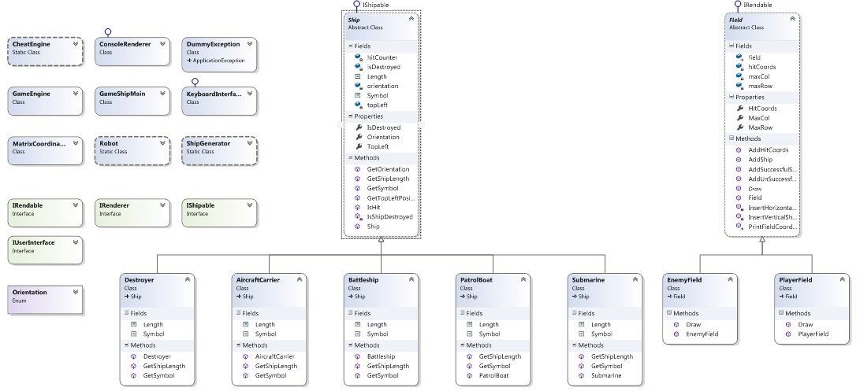

1. TFS address

<https://penchev.visualstudio.com>