Used technologies:

* Entity Framework .Net Core
* NUnit3 with NSubsitute
* WebApi .Net Core
* AutoMapper
* Swagger

Used patterns:

* Repository
* Unit of work

Layer architecture diagram of project:

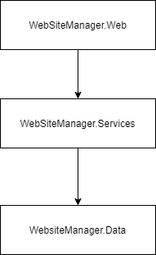

Area of improvements:

* Use some sort of password manager service if possible.
* Use Fluent validator to validate WebApi input