Software Requirements Specification
for
Crop Yeild Prediction
Prepared by <author>
<SCSCOE>
<date created>
Table of Contents
Table of Contents ii
Revision History ii
1. Introduction 1
1.1 Purpose 1
1.2 Project Scope 1

2. Overall Description 2
2.1 User Classes and Characteristics 2
2.2 Assumptions and Dependencies 3
3. External Interface Requirements 3
3.1 User Interfaces 3
3.2 Hardware Interfaces 3
3.3 Software Interfaces 3
3.4 Communications Interfaces 3
4. Functional Requirements /System Features 4
4.1 System Feature 1 4
5. Other Nonfunctional Requirements 4
5.1 Performance Requirements 4
5.2 Safety Requirements 5
5.3 Security Requirements 5
5.4 Software Quality Attributes 5
6. System Requirements/Other Requirements 5
Appendix A: Glossary 5
Appendix B: Analysis Models 5
Appendix C: To Be Determined List 6

Revision History
Name | Date | Reason For Changes | Version

Introduction

Purpose
Purpose for developing this project is as we say every part of world is developing but we can see that there is no such big achievement or development in soil or crop related issues. So we can give preference to this soil field and if we suggest suitable crop to farmers then it is beneficial for them.

Project Scope
An application of classifying the soil types and providing the necessary crop suggestions for the classified soil series. The proposed work will benefit farmers to maximize productivity in agriculture, reduce soil degradation in cultivated fields, and reduce fertilizer use in crop production by recommending the right crop considering various attributes. The proposed work aids framers to accurately select the crop for cultivation and attain sustainability

Overall Description

User Classes and Characteristics
Include things like age, job responsibilities, software, hardware, environment (for example, home, shared office, private office, shared public terminal), computer experience, and Web experience.

External Interface Requirements

User Interfaces
friendly application to interact with user.

Hardware Interfaces
- RAM : 8 GB
- Hard Disk : 40 GB
- Speed : 2.5 GHz
- Processor : Intel i5 Processor
- System Processors : Core2Duo

Software Interfaces
- Operating system : 64 bit Windows 10.
- Coding Language : Python(TKinter)
- IDE : Spyder.
- Python Library : Tensorflow, Keras, Opencv, Matplotlib
- Database : DBSqlite3

Communications Interfaces
In system communication interface CNN algorithm and Python Library.

System Features

System Feature 1
4.1.1 Functional Requirements
Functional Specification:
• The application is user friendly.
• It provides an easy interface to user.
• The accessibility or response time of the application should be fast.

Dependency and Constraints:
• End User application will be developed in Windows OS.
• All scripts shall be written in Python
• Application design pattern shall be Singleton.

Other Nonfunctional Requirements

Performance Requirements
The performance of the functions and every module must be well. The overall per formance of the software will enable the users to work eciently. Performance of encryption of data should be fast. Performance of the providing virtual environment should be fast Safety Requirement. The application is designed in modules where errors can be detected and xedeasily. This makes it easier to install and update new functionality if required.

Safety Requirements

The application is designed in modules where errors can be detected and fixed easily. This makes it easier to install and update new functionality if required.

Security Requirements

Only legitimate users can access the cop yeild prediction and use it after verification.

Software Quality Attributes
Our software has many quality attribute that are given below:-

Adaptability: This software is adaptable by all users.

Availability: This software is freely available to all users. The availability of the software is easy for everyone.

Maintainability: After the deployment of the project if any error occurs then it can be easily maintained by the software developer.

Reliability: The performance of the software is better which will increase the reliability of the Software.

User Friendliness: Since, the software is a GUI application; the output generated is much user friendly in its behavior.

Integrity: Integrity refers to the extent to which access to software or data by unauthorized persons can be controlled.

Security: Users are authenticated using many security phases so reliable security is provided.

Testability: The software will be tested considering all the aspects.

System Requirements
HARDWARE REQUIREMENTS:
- RAM : 8 GB
- Hard Disk : 40 GB
- Processor : Intel i5 Processor
Software Requirements:
- IDE :Spyder
- Coding Language : Python Version 3.7,3.8
- Operating System : Windows 10(64 bit)
Appendix A: Glossary
SRS – Software Requirements Specification
CNN – Convolutional Neural Network
IDE – Integrated Development Environment
GUI – Graphical User Interface
OS – Operation System

Appendix B: Analysis Models

Data Flow Diagram
DFD 0 –
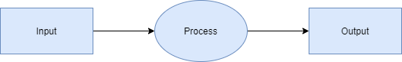

Data Flow diagram 0

DFD 1 –

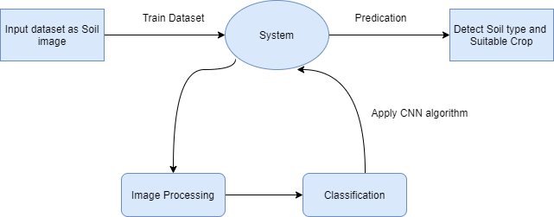
Data Flow diagram 1

DFD 2 –

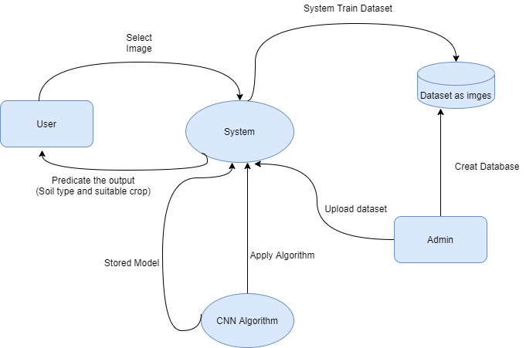
Data Flow diagram 2

UML DIAGRAMS
- Use case Diagram
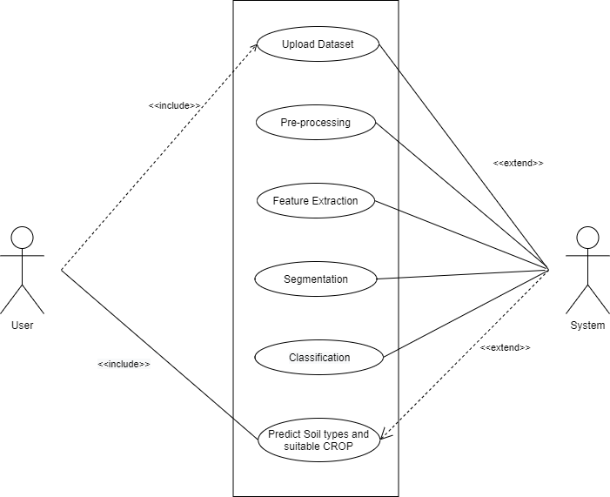

- Activity Diagram

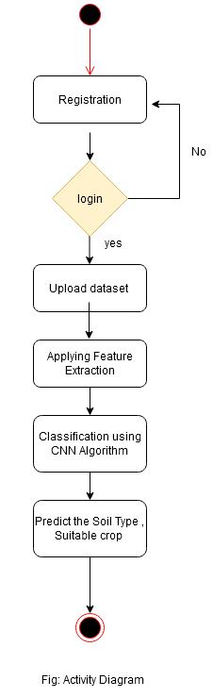

ER Diagram

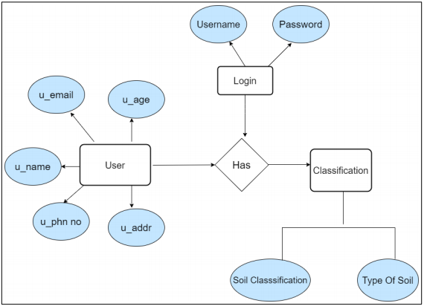

Appendix C: System Implementation Plan
NO | TASK | DURATION  (Days/Months) | START DATE | END DATE
1 | Group Formation
2 | Decide Area Of Interest
3 | Search Topic
4 | Topic Selection
5 | Sanction Topic
6 | Search Related Information
7 | Understanding Concept
8 | Search Essential Document  (IEEE & White Paper, Software)
9 | Problem Definition
10 | Literature Survey
11 | SRS
12 | Project Planning
13 | Modeling& design
14 | Technical Specification
15 | PPT

