

Avian Influenza
Surveillance in Country Z
A Case Study in Applied Epidemiology
Instructor Guide – Do not distribute to participants

Learning Objectives
After completing this case study, the participant should be able to:
- List and describe the steps of the surveillance cycle
- Describe the purpose and use of local surveillance data
- Compare human and avian surveillance data
- Complete a surveillance case report form
- Calculate and interpret incidence rates and case-fatality rates
- Identify and correct data errors
- Summarize and interpret surveillance data by person, place, and time using
rates, tables, and charts
- Identify how One Health can be applied to strengthening surveillance systems
and how different sectors can contribute to surveillance

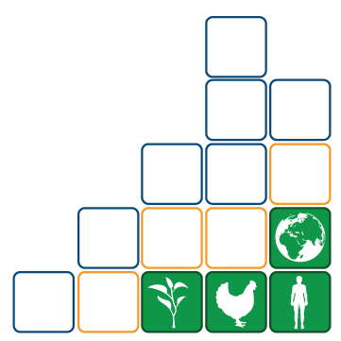

Workshop 1
FETP-Frontline 3.0

Instructor Notes

How to use FETP case studies: FETP case studies in applied epidemiology allow participants to practice applying epidemiologic skills in the classroom to address real-world public health problems. The case studies are used as a vital component of an applied epidemiology curriculum, rather than as stand-alone tools. They are ideally suited to reinforce principles and skills already covered in a lecture or in background reading.

Ideally, one or two instructors facilitate the case study for 8 to 20 students in a classroom or conference room. Traditionally, the instructor directs a participant to read aloud a paragraph or two, going around the room and giving each participant a chance to read. When the participant reads a question, the instructor directs all participants to perform calculations, construct graphs, or engage in a discussion of the answer. Sometimes, the instructor can split the class to play different roles or take different sides in answering the question. As a result, participants learn from each other, not just from the instructors.

Prerequisites: For this case study, participants should have received lectures or other instruction in:

- Introduction to Surveillance
- Ratios, Proportions, Rates/Summarizing Data
- Data Quality

Target audience: Residents in Field Epidemiology Training Programs (FETPs), Epidemic Intelligence Service (EIS) programs, public health students, public health workers who will be engaged in frontline disease surveillance activities, and others who are interested in this topic.

Level of case study: Frontline

Time required: Approximately 3 hours

Part A — Review of Influenza Data

The year is 2024. On a Monday morning in early March, you started a new job as a surveillance officer focusing on influenza at the District D public health office, located in Province A in Country Z. Before you arrived, you reviewed your notes on surveillance.

An estimated 85,000 people live in District D, where you are assigned. The district has one hospital (the General Hospital) and three health clinics: the District Clinic, the Children's Clinic, and the General Clinic.

Question 1 | List the steps of the surveillance cycle.
Answer 1 | - Detect, Diagnose  - Collect  - Compile, Analyze  - Interpret  - Communicate  - Take Action  Monitoring of the processes of the surveillance cycle should be continuous, and evaluation of the surveillance system should be periodic.

Question 2 | - Why conduct surveillance at the local/district level? (What is the reason for collecting surveillance data?)  - Why conduct surveillance of animal populations? (What is the rationale for sharing this surveillance data with the human sectors?)
Answer 2 | - To monitor disease occurrence in the community, so that action can be taken when necessary.  - To monitor the occurrence of diseases in animals. This is important for economic, social, and food supply reasons. Production animals can be people’s livelihoods and source of income. Some diseases can be transmitted to people through food products or contact with sick animals. Sharing information about zoonotic diseases or other types of health events in animals can allow public health staff to act early and work together with other sectors to increase surveillance and implement control measures to prevent transmission of disease between people, animals, and the environment.

Question 3 | Which of the steps in the surveillance cycle should be performed at the district level?
Answer 3 | All of them.

Since influenza was a major focus of your work and you are particularly interested in zoonotic diseases, you decide to review the avian influenza fact sheet for Country Z.
Refer to the Participant Guide to review the fact sheet (see next page).

Avian Influenza Fact Sheet
Influenza is a common zoonotic respiratory disease that can be transmitted from person to person. The influenza virus has two main types: type A, which has the potential to cause seasonal epidemics and pandemics; and type B, which is less common but can also cause seasonal epidemics and pandemics.
Avian influenza viruses are type A viruses that typically infect waterfowl. However, they can also infect other bird species (including domestic birds), humans, and other animals. When birds become infected with avian influenza viruses, they shed the virus through saliva, mucus, and feces. Humans can become infected with avian influenza viruses when the virus enters their eyes, nose, or mouth, or is inhaled. Human infection with an avian influenza virus is rare, but when it occurs, the disease can be asymptomatic, mild (with upper respiratory symptoms only), or severe (with pneumonia requiring hospitalization). The incubation period for avian influenza A viruses is usually 3 to 5 days.
In domestic poultry, such as chickens, ducks, and turkeys, exposure to avian influenza viruses can occur through direct contact with other infected birds or through contact with materials or surfaces contaminated with the virus. Among infected poultry, highly pathogenic avian influenza (HPAI) strains spread quickly and cause high mortality in the flock {USGS, 2018 #210}. Spread to other flocks beyond the initially-affected flock is common, causing catastrophic losses to poultry populations. This is a concern for farmers who raise poultry near infected flocks. Once an HPAI outbreak has occurred in a poultry flock, the primary method of control is depopulation (culling) of the flock to prevent spread to other animals or farms. Outbreaks can cause significant economic losses, from both the loss of the poultry themselves and from trade restrictions that are sometimes implemented to help contain the outbreak.
Worldwide, wild waterfowl are considered reservoirs that can infect domestic poultry and other bird and animal species with avian influenza A viruses. The movement and transmission of avian influenza viruses in wild birds can be affected by the migratory patterns of each host species.
Although avian influenza viruses spread quickly among birds, outbreaks only rarely spill over to humans. Humans who become infected with avian influenza viruses have nearly always had close contact with infected birds. Avian influenza often causes more severe disease and has a higher mortality rate than seasonal (human) influenza {CDC, 2024 #211}. Historic outbreaks of avian influenza among humans have been limited in size but have had high case-fatality rates. Early signs and symptoms of avian influenza in humans include high fever (≥38°C/100.4°F) and cough. This may be followed by difficulty breathing and, less commonly, sore throat, diarrhea, vomiting, abdominal pain, bleeding from the nose or gums, encephalitis, chest pains, and other complications of infection.
Treatment of avian influenza in humans should begin with influenza-specific antiviral medications as soon as symptoms begin. Hospitalization and supportive care may be necessary in severe cases. Seasonal (human) influenza vaccines are available and, although they do not prevent infection with avian influenza viruses, they can reduce the risk of co-infection with both human and avian influenza viruses at the same time. Vaccines against specific avian influenza viruses are also being developed and stockpiled for possible future use as needed.
While seasonal influenza epidemics usually occur annually, human cases of avian influenza are sporadic, require close contact with infected birds, and rarely spread between humans. However, these infections are important to public health because of the potential for avian influenza A viruses to cause a pandemic if these viruses mutate and become able to spread from person to person. Influenza viruses have RNA as their genetic material and thus have high rates of mutation.
Prevention of infection with avian influenza viruses is essential. In poultry-rearing or processing facilities, preventing contact between the poultry and wild birds, maintaining proper hygiene practices (biosecurity, such as personal protective equipment), and prompt reporting of sick or dying birds is important for prevention and control. For humans, avoiding exposure to infected birds, using appropriate protective equipment when working with birds, and isolation if one becomes ill after contact with sick birds are important considerations in preventing and reducing the spread of avian influenza infections. If people are sick with flu-like illness, they should stay home to avoid spreading their illness to other people or animals.

Case definition for avian influenza infection in humans
Probable case | Suspect case | Confirmed case
Recent exposure (<10 days) to avian influenza A virus through one of the following:  - Exposure to  infected birds  - Exposure to an  infected person  - Laboratory exposure  And clinical criteria including one or more of the following:  - Signs/symptoms consistent with acute or lower respiratory tract infection (e.g., cough, sore throat, fever, runny nose, fatigue, myalgia, arthralgia, headache, etc.)  - Conjunctivitis  - Complications of acute respiratory diseases without identified cause  A person meeting criterion for avian influenza A virus infection above and for whom laboratory test results do not provide a sufficient level of detail to confirm HPAI virus infection. | Meets the definition of probable case AND  The results of confirmatory laboratory tests are unknown or pending. | Meets the definition of probable case AND  A designated laboratory using approved methodologies has confirmed infection by a positive test.

Country Z is a major poultry meat producer and has made efforts to improve avian influenza surveillance over time. Historically, Country Z has experienced outbreaks of avian influenza on poultry farms in several districts. Human cases of avian influenza have historically been rare, and caused mild self-limiting disease in poultry workers. However, due to the concentration of poultry farms along migratory flyways for wild birds, there is always concern about the introduction and spread of new influenza viruses in poultry and people. There are also varying levels of influenza virus recorded in humans each year.

Figure 1. Annual incidence (per 100,000 people) of clinical diagnoses of influenza in humans by province, 2019 – 2024

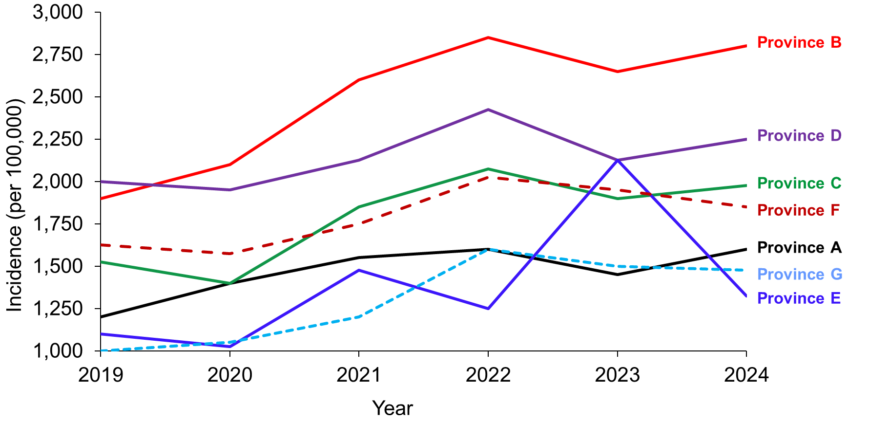

Figure 2. Annual incidence (per 100,000 chickens) of clinical diagnoses of avian influenza in poultry by province, 2019 - 2024

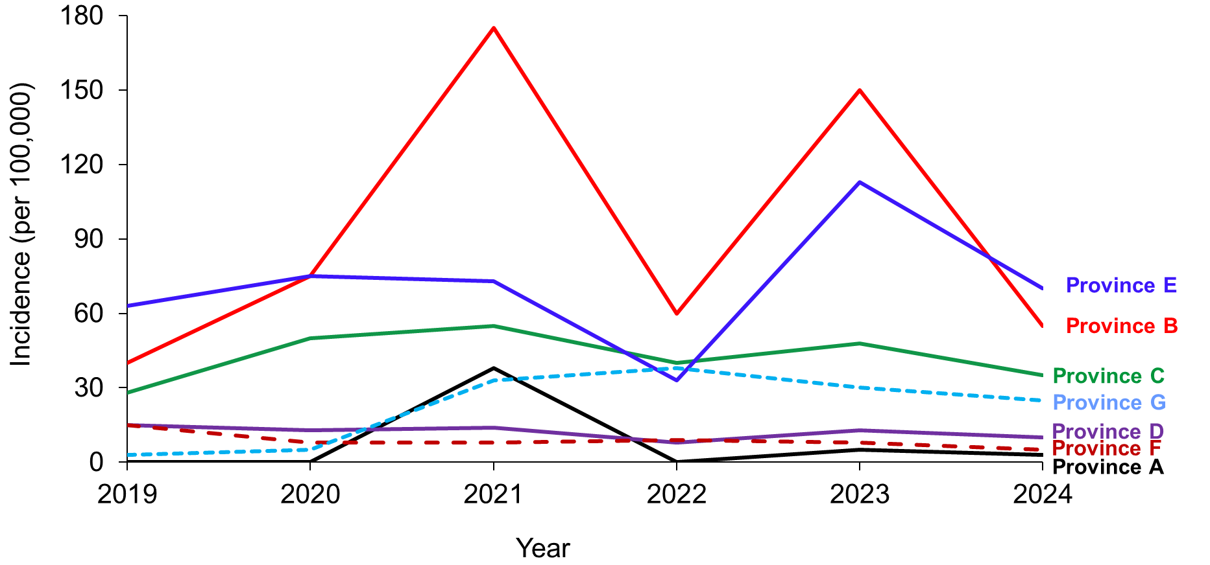

Question 4 | - According to Figure 1, which province has the highest overall incidence rate of human influenza between 2019 and 2024?  - According to Figure 2, which provinces may have had avian influenza outbreaks among their poultry from 2019 to 2024?
Answer 4 | - Province B appears to have the highest incidence rate of clinical cases of influenza between 2019 and 2024, although in 2019 the incidence rate was slightly lower than that of Province D.  - Provinces B and E may have experienced outbreaks among poultry, as shown by the peaks in Figure 2. Similarly, Province A may have experienced an outbreak in 2021.

Question 5 | According to Figure 1, Province E had a relatively low influenza incidence rate every year except for 2023. In 2023, Province E experienced a sudden increase in the incidence rate.  What may have caused this increase?
Answer 5 | The most likely explanation is that in 2023 there was an influenza outbreak in Province E. Multiple birds testing positive for avian influenza in a flock is considered an outbreak.

Question 6 | Comparing Figures 1 and 2, did influenza outbreaks occur in the poultry and human populations during the same years?
Answer 6 | - Yes, in Province E in 2023, there appear to have been both influenza outbreaks in humans and avian influenza outbreaks in poultry.  - This is likely a coincidence and does not necessarily suggest that humans are becoming infected with avian influenza. Due to the high case-fatality rates and severe disease that can occur when humans become infected with avian influenza, it is likely that avian influenza spreading in humans would be detected as an unusual event. In addition, because avian influenza does typically not spread well between humans, we would not expect to see major outbreaks of avian influenza in humans unless there was a mutation that enhanced person-to-person transmission.

Table 1. Human influenza incidence and mortality by province, 2024
Reported cases of human influenza (all types)
Province | Number of clinical cases | Clinical incidence rate (per 100,000) | Number of laboratory-  confirmed cases | Laboratory-  confirmed incidence rate (per 100,000) | Number of deaths | Case- fatality rate (%)
A | 3,696 | 1,600 | (ND) | (ND) | 3 | 0.08
B | 90,832 | 2,800 | (ND) | (ND) | 118 | 0.13
C | 126,341 | 1,975 | 1,388 | 21.7 | 51 | 0.04
D | 262,958 | 2,250 | 397 | 3.4 | 281 | 0.11
E | 87,119 | 1,325 | (ND) | (ND) | 96 | 0.11
F | 96,348 | 1,850 | 1,424 | 27.3 | 173 | 0.18
G | 42,760 | 1,475 | 1,230 | 2.4 | 26 | 0.06
Total | 762,653 |  | 4,439 |  | 1,143 | 0.15
Note: (ND) indicates that data on cases are not available and the rate cannot be calculated.

Question 7 | According to Table 1,  - Which province had the highest number of reported clinical cases of influenza?  - Which province had the highest reported influenza incidence rate?
Answer 7 | - Province D  - Province B

Question 8 | Why are the provinces different in your answers to question 7?
Answer 8 | - The incidence is calculated as the number of new cases of a disease divided by the population at risk.  - Although Province D reported the highest number of new cases, Province B had a smaller population.

Question 9 | According to Table 1,  - Which province had the highest number of laboratory-confirmed influenza cases?  - Which province had the highest laboratory-confirmed influenza incidence rate?
Answer 9 | - Province F  - Province F

Question 10 | - What is the value of reviewing the number of cases?  - What is the value of reviewing incidence rates?
Answer 10 | - The number of cases is essential for identifying outbreaks (more cases than expected) and for health planning, e.g., the number of treatment doses needed.  - Incidence rates demonstrate how quickly new cases are occurring in a specific population over a specific period of time. Incidence rates are most useful when compared across different time periods or between groups, like between different districts or within the same district over different years. It's a valuable tool for public health officials and leaders to monitor disease trends.

Question 11 | Calculate the influenza case-fatality rate for 2024.
Answer 11 | $$Case Fatality Rate = \frac{Number of deaths due to a disease}{Number of cases of that disease } ×Constant$$  $$2024 Influenza CFR = \left(1,143/762,653\right) x 100\% = 0.15\%$$

Question 12 | Province D had more deaths than Province F. So why was the case-fatality rate in Province F higher than the case-fatality rate in Province D?
Answer 12 | The case-fatality rate is calculated as the number of deaths due to a disease divided by the total number of cases of the disease. Although Province D had more deaths from influenza, the frequency of deaths among cases in Province F was higher.

Part B — Influenza Surveillance

In both 2021 and 2023, the country's economy was hit hard by outbreaks of avian influenza on its poultry farms, resulting in large-scale chicken mortality and reduced poultry exports. The government provided funding to the Ministry of Health's Influenza Program to strengthen human and poultry influenza surveillance, including improved molecular testing.

Since free health care is provided to all residents of Country Z, the government was confident that it could identify most influenza cases in the country and monitor for influenza viruses with pandemic potential. The following influenza surveillance activities are currently being conducted.

Surveillance of human influenza infections (includes all types)

- Case-based reporting by healthcare facilities, with collection of clinical specimens suitable for traditional laboratory testing from a subset of suspected cases.
- Weekly reporting of the number of cases of influenza-like illness from health facilities, including "0" reporting when no cases are identified.

Minimum data collection requirements include clinical, demographic and laboratory specimen collection data.

To strengthen surveillance for human infections with avian influenza and novel influenza A viruses, the Influenza Program in Country Z added the below activities.

Enhanced Influenza Surveillance

- Laboratory report of all positive influenza results, including "0" report when there are no positive results.
- Improved laboratory molecular testing in a subset of suspect cases to identify novel avian influenza viruses.
- Monthly visits to health centers and laboratories by district public health personnel to identify any unreported cases.

Question 13 | Is the avian influenza surveillance system active, passive, or both? Support your answer.
Answer 13 | - Both  - Active surveillance: public health officers collect data from health facilities and make routine visits and phone calls  - Passive surveillance: Notification by health centers and laboratories to district public health offices

Question 14 | What is the purpose and value of requiring healthcare facilities and laboratories to report zero cases if none have been seen that week?
Answer 14 | - To distinguish between there being no cases and a lack of notification  of cases.  - The zero-reporting requirement is to ensure that public health officials know that health care facilities and laboratories did not diagnose cases rather than underreporting or not reporting. Public health officials must be able to distinguish between zero cases and non-reporting, particularly during efforts to eliminate a disease.

Part C — Case Investigation

One of the most important aspects of influenza surveillance is the case investigation of suspected cases of avian influenza in humans.

As you are a new surveillance officer, you want to familiarize yourself with how to
investigate a suspected avian influenza case. To get more information, you approach an experienced colleague.

Your colleague conducted the required monthly visits to healthcare facilities in District D to conduct surveillance. He invited you to join him that day on his regular monthly visit to General Hospital X to review the hospital records for the month of November.

While reviewing records at General Hospital X, your colleague identifies two suspected cases of avian influenza that had not been reported. He asks you to complete an avian influenza investigation report form for one of the patients while he completes an investigation report form for the other patient.

Activity
Role-playing game scenario | In this activity, participants will assume different roles and interview each other and complete an influenza case investigation form.
Interview 1 | One person should play the role of Dr. One, who is the physician who sees the first influenza patient, Gamma. The other person should play the role of the new influenza surveillance officer, who will complete Case Investigation Form 1 based on the information provided by Dr. One. The new surveillance officer should interview Dr. One using the case report form provided on the next page. Complete as much of the form as possible. Dr. One should answer the questions using the information provided in Appendix 1.
Interview 2 | Switch roles so that the person who answered as Dr. One now plays the role of the more experienced surveillance officer (SC) and completes Case Investigation Form 2. The person who conducted the previous interview should now play the role of Dr. Two and answer questions about the second influenza patient, Alpha, using the information provided in Appendix 2.
Discussion | - How would interviewing a caretaker/owner of animals be different from interviewing a human patient or clinician?  - How would you handle any privacy/security concerns of the owner/caretaker reporting illness in their animals?
Discussion  (answers) | - Producers might be concerned about their livelihoods and economic or financial well-being, or industry reputation, if they have sick animals.  - Same privacy/security concerns in animal and human sector-confidentiality and protection of PII is important for ethical reasons and to maintain trust with the public.

INFLUENZA CASE INVESTIGATION FORM 1
PATIENT INFORMATION
Name: |  |  |  | Sex: M☐ F☐
If minor, name of parent: |  |  |  | Age:  Date of birth:
Address: |  |  |  | Occupation:
 |  |  |  | Physician:
Phone: |  |  |  | Initial diagnosis:
CLINICAL COURSE
Date of onset of illness: |  |  |  | Hospitalized? Yes ☐ No ☐  (If no, skip to next section)
Name of hospital/clinic: |  |  |  | Date of admission/visit:
Outcome: ☐Discharged alive; ☐Still in hospital; ☐Died |  |  |  | Hospital discharge/Date of death:___ /___
CLINICAL CHARACTERISTICS Y=Yes N=No D=Don't know
Fever? Y☐ N☐ D☐  Maximum temperature:  Duration: |  | Symptoms |  |  |  | Other symptoms
 |  | Difficulty breathing Y☐ N☐ D☐ |  |  |  | Chills Y☐ N☐ D☐
 |  | Vomit Y☐ N☐ D☐ |  |  |  | Jaundice Y☐ N☐ D☐
Feeling feverish Y☐ N☐ D☐  Duration: ____________ |  | Diarrhea Y☐ N☐ D☐ |  |  |  | Pallor or cold skin Y☐ N☐ D☐
 |  | Eye infection/ Y☐ N☐ D☐ redness |  |  |  | Nausea Y☐ N☐ D☐
Cough Y☐ N☐ D☐ |  | Rash Y☐ N☐ D☐ |  |  |  | Headache Y☐ N☐ D☐
Sore throat Y☐ N☐ D☐ |  | Lethargy, fatigue Y☐ N☐ D☐ |  |  |  | Other Y☐ N☐ D☐
Muscle pain Y☐ N☐ D☐ |  | Seizures Y☐ N☐ D☐ |  |  |  | Specify: ____________
INFLUENZA TESTING Y=Yes N=No D=Don't know
Was an influenza rapid diagnostic test (RDT) used on any respiratory specimens collected?
Y☐ N☐ D☐
If yes, when was the RDT sample collected? / / (DD/MM/YYYY)
Where was the specimen collected? Physician's office☐ Hospital ☐ Other, Specify ☐ _________
What was the result? Negative☐ Influenza A☐ Influenza B☐ Undistinguished influenza type☐
What brand of RDT was used? Specify: _______________________
Is the case suspected to be novel variant influenza A based on reverse transcription-polymerase chain reaction (RT-PCR)? Y☐ N☐ D☐ If yes, which subtype? _____________
When was the sample collected for the new influenza A variant test? / / (DD/MM/YYYY)
PATIENT EXPOSURE HISTORY Y=Yes N=No D=Don't know
In the 10 days before becoming ill, did the patient attend a live animal market? Y☐ N☐ D☐ |  |  | In the 10 days prior to becoming ill, did the patient have DIRECT contact with (e.g., touching or handling) any animals? Y☐ N☐ D☐
If yes, when? ___ /___ (DD/MM)  If yes, where? Specify: ____________ |  |  | If yes, which animals? (Check all that apply)  Horse☐ Swine☐ Poultry/wild☐ Other☐
Does the patient handle specimens (animal or human) suspected of containing influenza virus in a laboratory or other setting? Y☐ N☐ D☐ |  |  | During the past month, did the patient travel?  Y☐ N☐ D☐  If yes, where? Specify:
REPORTER INFORMATION
Name: |  |  |  |  | Phone:
Signature: |  |  |  |  | Date: |  | ___/___/____

ANSWER: INFLUENZA CASE INVESTIGATION FORM 1
PATIENT INFORMATION
Name: Gamma Delta |  |  |  |  | Sex: M☐ F☑
If minor, name of parent: Omicron |  |  |  |  | Age: 5 years  Date of birth: 18/JUL/2017
Address: 789 Flores Street |  |  |  |  | Occupation: Not applicable
 |  |  |  |  | Physician: One
Phone: 987-0214 |  |  |  |  | Initial diagnosis: measles
CLINICAL COURSE
Date of onset of illness: 07/JUL/2022 |  |  |  | Hospitalized? Yes ☑ No ☐  (If no, skip to next section)
Name of hospital/clinic: General |  |  |  | Date of admission/visit: 09/JUL/2022
Outcome: ☐Discharged alive; ☐Still in hospital; ☐Died |  |  |  | Hospital discharge/Date of death:___ /___
CLINICAL CHARACTERISTICS Y=Yes N=No D=Don't know
Fever? Y☑ N☐ D☐  Maximum temperature: 38.8º C  Duration: 2 days |  | Symptoms |  |  |  |  | Other symptoms
 |  | Difficulty breathing Y☐ N☑ D☐ |  |  |  |  | Chills Y☐ N☑ D☐
 |  | Vomit Y☐ N☐ D☐ |  |  |  |  | Jaundice Y☐ N☐ D☐
Feeling feverish Y☐ N☐ D☐  Duration: ____________ |  | Diarrhea Y☐ N☐ D☐ |  |  |  |  | Pallor or cold skin Y☐ N☐ D☐
 |  | Eye infection/ Y☐ N☐ D☐ redness |  |  |  |  | Nausea Y☐ N☐ D☐
Cough Y☐ N☑ D☐ |  | Rash Y☐ N☐ D☐ |  |  |  |  | Headache Y☐ N☐ D☐
Sore throat Y☐ N☐ D☐ |  | Lethargy, fatigue Y☐ N☑ D☐ |  |  |  |  | Other Y☐ N☐ D☐
Muscle pain Y☐ N☑ D☐ |  | Seizures Y☐ N☐ D☐ |  |  |  |  | Specify: ____________
INFLUENZA TESTING Y=Yes N=No D=Don't know
Was an influenza rapid diagnostic test (RDT) used on any respiratory specimens collected?
Y☑ N☐ D☐
If yes, when was the RDT sample collected? 09/JUL/2022
Where was the specimen collected? Physician's office☐ Hospital☑ Other, Specify☐ _________
What was the result? Negative☐ Influenza A☑ Influenza B☐ Undistinguished influenza type☐
What brand of RDT was used? Specify: _______________________
Is the case suspected to be novel variant influenza A based on reverse transcription-polymerase chain reaction (RT-PCR)? Y☑ N☐ D☐ If yes, which subtype? H3
When was the sample collected for the new influenza A variant test? 09/JULY/2022
PATIENT EXPOSURE HISTORY Y=Yes N=No D=Don't know
In the 10 days before becoming ill, did the patient attend a live animal market? Y☐ N☑ D☐ |  |  | In the 10 days prior to becoming ill, did the patient have DIRECT contact with (e.g., touching or handling) any animals? Y☐ N☐ D☑
If yes, when? ___ /___ (DD/MMM)  If yes, where? Specify: ____________ |  |  | If yes, which animals? (Check all that apply)  Horse☐ Swine☐ Poultry/wild☐ Other ☑
Does the patient handle specimens (animal or human) suspected of containing influenza virus in a laboratory or other setting? Y☐ N☐ D☑ |  |  | During the past month, did the patient travel?  Y☑ N☐ D☐  If yes, where? Specify: grandparents' estate in Zot Town, District D
REPORTER INFORMATION
Name: | <FETP-Frontline participant’s name> |  |  |  |  | Phone: |  | <phone number>
Signature: | <FETP-Frontline participant’s signature> |  |  |  |  | Date: |  | <today’s date>

INFLUENZA CASE INVESTIGATION FORM 2
PATIENT INFORMATION
Name: |  |  |  |  | Sex: M☐ F☐
If minor, name of parent: |  |  |  |  | Age:  Date of birth:
Address: |  |  |  |  | Occupation:
 |  |  |  |  | Physician:
Phone: |  |  |  |  | Initial diagnosis:
CLINICAL COURSE
Date of onset of illness: |  |  |  | Hospitalized? Yes ☐ No ☐  (If no, skip to next section)
Name of hospital/clinic: |  |  |  | Date of admission/visit:
Outcome: ☐Discharged alive; ☐Still in hospital; ☐Died |  |  |  | Hospital discharge/Date of death:___ /___
CLINICAL CHARACTERISTICS Y=Yes N=No D=Don't know
Fever? Y☐ N☐ D☐  Maximum temperature:  Duration: |  | Symptoms |  |  |  |  | Other symptoms
 |  | Difficulty breathing Y☐ N☐ D☐ |  |  |  |  | Chills Y☐ N☐ D☐
 |  | Vomit Y☐ N☐ D☐ |  |  |  |  | Jaundice Y☐ N☐ D☐
Feeling feverish Y☐ N☐ D☐  Duration: ____________ |  | Diarrhea Y☐ N☐ D☐ |  |  |  |  | Pallor or cold skin Y☐ N☐ D☐
 |  | Eye infection/ Y☐ N☐ D☐ redness |  |  |  |  | Nausea Y☐ N☐ D☐
Cough Y☐ N☐ D☐ |  | Rash Y☐ N☐ D☐ |  |  |  |  | Headache Y☐ N☐ D☐
Sore throat Y☐ N☐ D☐ |  | Lethargy, fatigue Y☐ N☐ D☐ |  |  |  |  | Other Y☐ N☐ D☐
Muscle pain Y☐ N☐ D☐ |  | Seizures Y☐ N☐ D☐ |  |  |  |  | Specify: ____________
INFLUENZA TESTING Y=Yes N=No D=Don't know
Was an influenza rapid diagnostic test (RDT) used on any respiratory specimens collected?
Y☐ N☐ D☐
If yes, when was the RDT sample collected? / / (DD/MM/YYYY)
Where was the specimen collected? Physician's office☐ Hospital☐ Other, Specify☐ _________
What was the result? Negative☐ Influenza A☐ Influenza B☐ Undistinguished influenza type☐
What brand of RDT was used? Specify: _______________________
Is the case suspected to be novel variant influenza A based on reverse transcription-polymerase chain reaction (RT-PCR)? Y☐ N☐ D☐ If yes, which subtype?
When was the sample collected for the new influenza A variant test? / / (DD/MM/YYYY)
PATIENT EXPOSURE HISTORY Y=Yes N=No D=Don't know
In the 10 days before becoming ill, did the patient attend a live animal market? Y☐ N☐ D☐ |  |  | In the 10 days prior to becoming ill, did the patient have DIRECT contact with (e.g., touching or handling) any animals? Y☐ N☐ D☐
If yes, when? ___ /___ (DD/MM)  If yes, where? Specify: ____________ |  |  | If yes, which animals? (Check all that apply)  Horse☐ Swine☐ Poultry/wild☐ Other☐
Does the patient handle specimens (animal or human) suspected of containing influenza virus in a laboratory or other setting? Y☐ N☐ D☐ |  |  | During the past month, did the patient travel?  Y☐ N☐ D☐  If yes, where? Specify:
REPORTER INFORMATION
Name: |  |  |  |  |  | Phone:
Signature: |  |  |  |  |  | Date: |  | ___/___/____

ANSWER: INFLUENZA CASE INVESTIGATION FORM 2
PATIENT INFORMATION
Name: Alpha Beta |  |  |  |  | Sex: M☐ F☐
If minor, name of parent: |  |  |  |  | Age: 32 years  Date of birth: 12/APR/1990
Address: 124 Camino Fuentes |  |  |  |  | Occupation: Butcher
 |  |  |  |  | Physician: Fuentes
Phone: 867-5309 |  |  |  |  | Initial diagnosis: Influenza
CLINICAL COURSE
Date of onset of illness: 02/JUL/2022 |  |  |  | Hospitalized? Yes☑ No☐  (If no, skip to next section)
Name of hospital/clinic: General |  |  |  | Date of admission/visit: 05/JUL/2022
Outcome: ☐Discharged alive; ☑Still in hospital; ☐Died |  |  |  | Hospital discharge/Date of death: ___/___
CLINICAL CHARACTERISTICS Y=Yes N=No D=Don't know
Fever? Y☑ N☐ D☐  Maximum temperature: 40.2º C  Duration: 3 days |  | Symptoms |  |  |  |  | Other symptoms
 |  | Difficulty breathing Y ☑ N ☐ D ☐ |  |  |  |  | Chills Y ☐ N ☑ D ☐
 |  | Vomit Y ☐ N ☐ D ☐ |  |  |  |  | Jaundice Y ☐ N ☐ D ☐
Feeling feverish Y☑ N☐ D☐ Duration: 5 days |  | Diarrhea Y ☐ N ☐ D ☐ |  |  |  |  | Pallor or cold skin Y ☐ N ☐ D ☐
 |  | Eye infection Y ☐ N ☐ D ☐ redness |  |  |  |  | Nausea Y ☐ N ☐ D ☐
Cough Y☐ N☑ D☐ |  | Rash Y ☐ N ☐ D ☐ |  |  |  |  | Headache Y ☐ N ☑ D ☐
Sore throat Y☐ N☐ D☐ |  | Lethargy, fatigue Y ☐ N ☐ D ☐ |  |  |  |  | Other Y ☐ N ☐ D ☐
Muscle pain Y☐ N☑ D☐ |  | Seizures Y ☐ N ☐ D ☐ |  |  |  |  | Specify _________________
INFLUENZA TESTING Y=Yes N=No D=Don't know
Was an influenza rapid diagnostic test (RDT) used on any respiratory specimens collected? Y ☑ N ☐ D ☐
If yes, when was the RDT sample collected? ___/ __ / ____(DD/MM/YYYY)
Where was the specimen collected? Physician's office☐ Hospital ☑ Other, Specify ☐ _________
What was the result? Negative ☐ Influenza A ☑ Influenza B ☐ Influenza type not distinguished ☐
What brand of RDT was used? Specify: _______________________
Is the case suspected to be novel variant influenza A based on reverse transcription-polymerase chain reaction (RT-PCR)? Y ☑ N ☐ D ☐ If yes, which subtype? H5
When was the sample collected for the new influenza A variant test? 05/JUL/2022
PATIENT EXPOSURE HISTORY Y=Yes N=No D=Don't know
In the 10 days before becoming ill, did the patient visit a live animal market? Y ☑ N ☐ D ☐ |  |  | In the 10 days prior to becoming ill, did the patient have DIRECT contact with (e.g., touching or handling) any animals? Y☑ N ☐ D ☐
If yes, when? 27/JUN/2022  If yes, where? Specify: Purchased chickens from the animal market |  |  | If yes, which animals? (Check all that apply)  Horse ☐ Swine ☐ Poultry/wild ☐ Other ☑
Does the patient handle specimens (animal or human) suspected of containing influenza virus in a laboratory or other setting? Y ☐ N ☑ D ☐ |  |  | During the past month, did the patient travel? Y ☐ N ☑ D ☐  If yes, where? Specify: _________________
REPORTER INFORMATION
Name: | <FETP-Frontline participant’s name> |  |  |  |  | Phone: |  | <phone number>
Signature: | <FETP-Frontline participant’s signature> |  |  |  |  | Date: |  | <today’s date>

Part D — Data Cleaning and Management

Your first week as a new surveillance officer went well. It is now Monday of the second week.

The hospital and three clinics in District D have submitted their weekly reports using a paper form, and the data entry clerk has already entered the data into the influenza electronic database.

Your supervisor announces that the District Chief Medical Officer would like an update on the influenza situation for this year. Data are only available for January through November. The District Chief Medical Officer wants the summary by tomorrow (Tuesday) morning.

You know that before you start analyzing surveillance data, you always must check the quality of the data. You will need to correct any errors to avoid submitting incorrect information to the District Chief Medical Officer.

Refer to Tables 2a-2e in the Participant Guide.

Instructor’s Note | You may divide the class into 4 groups, assign one question from 16-19 to each group. All groups must answer question 20 or answer the questions as a group.

Question 15 | - What data quality problems do you see in Table 2a?  - What steps should you take to correct the information?
Answer 15 | - The age of 153 years is incorrect (impossible).  - Review the case investigation form to correct the age.

Question 16 | What data quality problems do you see in Table 2b?
Answer 16 | The district has only four health facilities. The district does not have a Provincial Hospital.

Question 17 | What data quality problems do you see in Table 2c?
Answer 17 | - "Maybe" is not a valid option.  - According to the case investigation form, the valid options are "yes", "no" and "unknown".  - “Maybe” should be changed to “unknown.” Data cleaning steps, like this one, should be logged and kept as a record. An example of a data cleaning log for the data quality problems and corrections described so far in the case study is in table 2f.

Question 18 | What data quality problems do you see in Table 2d?
Answer 18 | - Table 2d shows there are 44 confirmed cases who have positive lab results from confirmatory testing (RT-PCR), and 23 people who were ruled out as cases because they had negative results on confirmatory testing. The data quality problem is that there is 1 person in the dataset who had negative results on confirmatory testing but is included as a confirmed case. According to the case definition, a confirmed case must test positive on confirmatory lab tests. The next step is to look at the line list (dataset) and/or case report forms to identify what the source is for this error. There are several possibilities. This could represent a data entry error in the line list. Alternately, perhaps this patient received multiple RT-PCR tests, at least one of which was positive. In which case, this person would be a confirmed case because they had at least one positive, even if the recorded RT-PCR results were negative. Looking at the source data (line list) that generated this 2x2 table and the raw data on the case report form can help you to identify and fix the data quality problem.  - The total of the "No" column is 44, but it should be 40.
Question 19 | What data quality problems do you see in Table 2e?
Answer 19 | - The 2024-01 record is incorrect as the onset date cannot be earlier than 2024.  - Only cases with a 2024 onset date should be reported to the district public health office.  - The 2024-01 record is also incorrect because the onset date is prior to the date of birth.  - The 2024-03 record is incorrect as the date the first sample was taken cannot be earlier than the onset date.  - The 2024-20 record is incorrect as there is no February 30 (date of birth).  - Record 2024-44 is incorrect, as the date of collection of the second sample

Use the following tables for Questions 15-19.

Table 2a
Age | Number of cases
2 | 2
5 | 3
6 | 1
8 | 1
9 | 2
10-63* | 29
64 | 1
67 | 2
73 | 1
77 | 1
153 | 1
Total | 44

* Note: Age group 10-63 are grouped only to fit the table on this page.

Table 2b
Installation | Number of cases
Children's clinic | 9
General clinic | 4
District clinic | 6
General Hospital | 24
Provincial Hospital | 1
Total | 44

Table 2c
Fever | Number of cases
Yes | 40
No | 2
Unknown | 1
Maybe | 1
Total | 44

Table 2d
 | Confirmed Case
 | Yes | No
RT-PCR positive | 44 | 0
RT-PCR negative | 1 | 23
Total | 45 | 23

Table 2e. Dates of symptom onset and specimen collection for human influenza cases in District D, Country Z, January to November 2024
Registration number | Date of birth | Onset date | Date RIDT  sample taken | Date RT-PCR sample was taken
2024-01 | 19JUN1999 | 03FEB1999 | 05FEB2024 | 10FEB2024
2024-03 | 21JAN2003 | 15MAR2024 | 16JAN2024 | 21MAR2024
2024-07 | 03SEP1985 | 23APR2024 | 27APR2024 | 01MAY2024
2024-20 | 30FEB1972 | 30JUN2024 | 04JUL2024 | 11JUL2024
2024-44 | 11NOV1956 | 27NOV2024 | 29NOV2024 | 08NOV2024

Table 2f. Data cleaning log for human influenza cases in District D, Country Z, January to November 2024
Cell identifier | Incorrect value | Corrected value | Explanation
F4 | 153 | 22 | Reviewed case investigation form to correct age
B29 | Provincial hospital | District clinic | Reviewed case investigation form to correct health facility – there is no provincial hospital
M41 | Yis | Yes | Typo
D26 | Maybe | Unknown | "Maybe" is not a valid option. According to the case investigation form, the valid options are "yes", "no" and "unknown" – changed to “unknown”

Part E – Data analysis

You updated the database with the corrections, then recorded the changes on a Corrections document. You sketched out an analysis plan of tables and figures you intended to create and listed the variables you would need to include in the analysis.
Sitting at your computer, you were about to start analyzing the data when the power went out. One of your colleagues contacted the power company and learned that the outage covered a wide area. The power company expected to restore power at 17:00 hours.
Since you must meet with the District Chief Medical Officer in the morning, you decided to perform the analysis by hand. You returned to the filing cabinet, pulled out the case investigation forms, and created a line list (see Table 3) of the 44 reported cases. Based on your analysis plan, you extracted only selected variables from the case investigation forms to summarize and present.

Question 20 | From the data in Table 3 (kindly sorted by age), calculate the median and mean age of the cases. Refer to Table 3 in the Participant Guide.
Answer 20 | - Median = 26 years  - Mean = 30.5 years

When you were developing your analysis plan, you wanted your age groups to match those used in previous Ministry reports. You found the following three age groupings in different reports:

Age groups option 1 | Age groups option 2 | Age groups option 3
≤10 years | ≤10 years | ≤9 years
10-20 | 11-20 | 10-19
20-30 | 21-30 | 20-29
30-40 | 31-40 | 30-39
40-50 | 41-50 | 40-49
50-60 | 51-60 | 50-59
60+ | >60 | 60+

Question 21 | Which age group option do you prefer and why?
Answer 21 | Age group 1 is not appropriate because some numbers are in more than one category (i.e., 10, 20, 30, 40, 50, and 60 years are each in two categories). Age groups 2 or 3 could both be acceptable. Age groupings can be selected based on what makes the most sense for a disease. It is important to ensure that the groups used are mutually exclusive.

Table 3. List of influenza case in District D, January through November 2024
Identification number | Date of Birth | Age  (years) | Sex | Town Name | Date of Onset | Hospitalized | Fatal | History of Animal Exposure | Date First Sample Taken
2019-13 | 31OCT2006 | 2 | Male | Arlie | 02JUN2024 | No | No | No | 03JUN2024
2019-33 | 28FEB2007 | 2 | Female | Tango | 08AUG2024 | No | No | No | 13AUG2024
2019-18 | 13APR2004 | 5 | Male | Zot | 24JUN2024 | No | No | No | 27JUN2024
2019-35 | 05SEP2003 | 5 | Female | Cerra | 24AUG2024 | No | No | No | 25AUG2024
2019-43 | 29DEC2003 | 5 | Female | Echo | 24NOV2024 | Yes | No | No | 25NOV2024
2019-03 | 21JAN2003 | 6 | Male | Zot | 15MAR2024 | No | No | No | 16MAR2024
2019-29 | 12OCT2000 | 8 | Female | Bravo | 20JUL2024 | No | No | No | 21JUL2024
2019-01 | 19SEP1999 | 9 | Female | Bravo | 03FEB2024 | No | No | No | 05FEB2024
2019-19 | 07JUN2000 | 9 | Male | Cerra | 28JUN2024 | No | No | No | 30JUN2024
2019-08 | 27MAR1998 | 11 | Female | Bravo | 01MAY2024 | No | No | No | 04MAY2024
2019-02 | 12DEC1993 | 15 | Male | Bravo | 07MAR2024 | No | No | No | 08MAR2024
2019-11 | 24MAY1993 | 15 | Female | Echo | 20MAY2024 | No | No | No | 23MAY2024
2019-04 | 25NOV1991 | 17 | Female | Arlie | 18MAR2024 | No | No | No | 22MAR2024
2019-40 | 01APR1992 | 17 | Male | Uniform | 20SEP2024 | No | No | No | 24SEP2024
2019-15 | 17JAN1990 | 19 | Female | Echo | 10JUN2024 | No | No | No | 15JUN2024
2019-24 | 03OCT1989 | 19 | Male | Uniform | 09JUL2024 | No | No | Yes | 15JUL2024
2019-12 | 25DEC1988 | 20 | Female | Tango | 27MAY2024 | No | No | No | 29MAY2024
2019-28 | 13JUN1986 | 23 | Male | Zot | 19JUL2024 | No | No | No | 25JUL2024
2019-07 | 09MAR1985 | 24 | Female | Zot | 23APR2024 | No | No | No | 27APR2024
2019-42 | 08JUL1985 | 24 | Male | Zot | 09OCT2024 | No | No | No | 12OCT2024
2019-09 | 07JUL1983 | 25 | Male | Uniform | 09MAY2024 | No | No | Yes | 11MAY2024
2019-22 | 17NOV1983 | 25 | Female | Delta | 03JUL2024 | No | No | No | 06JUL2024
2019-37 | 26JUN1982 | 27 | Female | Arlie | 30AUG2024 | No | No | No | 04SEP2024
2019-38 | 24MAR1982 | 27 | Female | Cerra | 12SEP2024 | No | No | No | 17SEP2024
2019-27 | 20MAY1981 | 28 | Female | Zot | 14JUL2024 | No | No | No | 18JUL2024
2019-16 | 16FEB1978 | 31 | Female | Bravo | 10JUN2024 | No | No | No | 13JUN2024
2019-41 | 16MAY1978 | 31 | Female | Arlie | 28SEP2024 | No | No | Yes | 30SEP2024
2019-05 | 15FEB1977 | 32 | Male | Cerra | 25MAR2024 | No | No | Yes | 26MAR2024
2019-30 | 15JUL1976 | 33 | Male | Tango | 27JUL2024 | No | No | No | 29JUL2024
2019-10 | 29JAN1972 | 37 | Male | Cerra | 16MAY2024 | No | No | No | 18MAY2024
2019-20 | 30FEB1972 | 37 | Female | Cerra | 30JUN2024 | No | No | No | 04JUL2024
2019-14 | 05AUG1965 | 43 | Female | Echo | 07JUN2024 | No | No | No | 08JUN2024
2019-26 | 31JAN1966 | 43 | Female | Arlie | 14JUL2024 | No | No | No | 19JUL2024
2019-32 | 04NOV1961 | 47 | Male | Arlie | 04AUG2024 | No | No | No | 06AUG2024
2019-06 | 11FEB1957 | 52 | Female | Delta | 11APR2024 | No | No | No | 16APR2024
2019-21 | 28JUL1956 | 52 | Female | Tango | 02JUL2024 | No | No | No | 06JUL2024
2019-44 | 11NOV1956 | 53 | Male | Bravo | 27NOV2024 | Yes | No | No | 29NOV2024
2019-36 | 19JAN1954 | 55 | Male | Delta | 24AUG2024 | No | No | No | 27AUG2024
2019-34 | 13SEP1947 | 61 | Male | Cerra | 16AUG2024 | No | No | No | 18AUG2024
2019-39 | 29AUG1945 | 64 | Female | Zot | 15SEP2024 | No | No | No | 18SEP2024
2019-17 | 27SEP1941 | 67 | Female | Delta | 18JUN2024 | No | No | No | 20JUN2024
2019-25 | 10OCT1941 | 67 | Female | Tango | 13JUL2024 | No | No | No | 18JUL2024
2019-23 | 28APR1935 | 73 | Female | Delta | 08JUL2024 | Yes | Yes | No | 12JUL2024
2019-31 | 31DEC1931 | 77 | Male | Uniform | 30JUL2024 | No | No | No | 03AUG2024

Table 2f
Age group (years) | Sex
 | Female | Male | Total
≤9 | 5 | 4 | 9
10-19 | 4 | 3 | 7
20-29 | 6 | 3 | 9
30-39 | 3 | 3 | 6
40-49 | 2 | 1 | 3
50-59 | 2 | 2 | 4
≥60 | 4 | 2 | 6
Total | 26 | 18 | 44

Question 22 | Complete Table 2f, which compares influenza cases by age group and sex. Refer to the Exercise Guide.
Answer 22 | See answers above.

Question 23 | Using the data in Table 2f,  - Compare the number of influenza cases between females and males.  - Compare the number of influenza cases among different age groups.  - Among females, which age group had the highest number of influenza cases?  - Among males, which age group had the highest number of influenza cases?  - In general, what age group was at highest risk for influenza?
Answer 23 | - Overall, more cases of influenza were reported among females than among males.  - Influenza occurred in all age groups, although the highest number of cases occurred in the age groups ≤9 years and 20-29 years.  - Among females, the highest number of influenza cases occurred among women aged 20-29 years.  - Among males, the highest number of influenza cases occurred among boys aged ≤9 years.  - Risk by age group cannot be calculated because the size of the population for each subgroup has not been provided.

Question 24 | Write an appropriate title for Table 2f.
Answer 24 | A suggested title is:  Human influenza cases by age group and sex in District D, January - November 2024
Table 2g. Number of influenza cases and cases per 10,000 in District D by town,
January to November 2024
Town name | Number of cases | Town population | Cases per 10,000 population
Arlie | 6 | 8,000 | 7.5
Bravo | 6 | 12,000 | 5.0
Cerra | 7 | 18,000 | 3.9
Delta | 5 | 6,000 | 8.3
Echo | 4 | 11,000 | 3.6
Tango | 5 | 15,000 | 3.3
Uniform | 4 | 7,000 | 5.7
Zot | 7 | 8,000 | 8.8
Total | 44 | 85,000 | 5.2

Question 25 | Review the data in Table 2g.  - Is influenza affecting all the towns in the district?  - Which town(s) is/are most affected?  - Which town(s) would you target for control measures?
Answer 25 | - All the towns in the district are affected.  - Zot and Delta are the most affected. We can tell by calculating the cases per 10,000, which is calculated as the number of cases/town population and multiplying by 10,000.  - Control measures should be adopted throughout the district. However, if there is a need to roll out measures town by town, the most affected towns should be prioritized first for interventions.

Question 26 | - Based on the line list data in Table 3, what proportion of patients with influenza were exposed to animals in the 10 days prior to the onset of their illness?  - What does this information tell you about where the patients may have contracted influenza?
Answer 26 | - (4/44) x 100% = 9.1%  - Most patients ill with influenza must have been infected by another sick person, not by animals.
Instructor’s Note | Only 4/44 influenza patients had contact with animals in the 10 days prior to onset of illness. However, we don’t know which species of animals they had contact with. Since the proportion of individuals who may have been infected by animals is low, most influenza patients must have been infected by another ill person. However, the possibility remains that at least some of those individuals with animal contact may have acquired a novel strain of influenza A, potentially avian influenza. Although human-to-human spread of avian influenza is uncommon, their history of animal contact could warrant further laboratory testing and possibly additional investigation.

Question 27 | Using the graph paper on the next page, graph the number of influenza cases in humans by month of occurrence. Remember to label the axes and title appropriately.
Answer 27 | 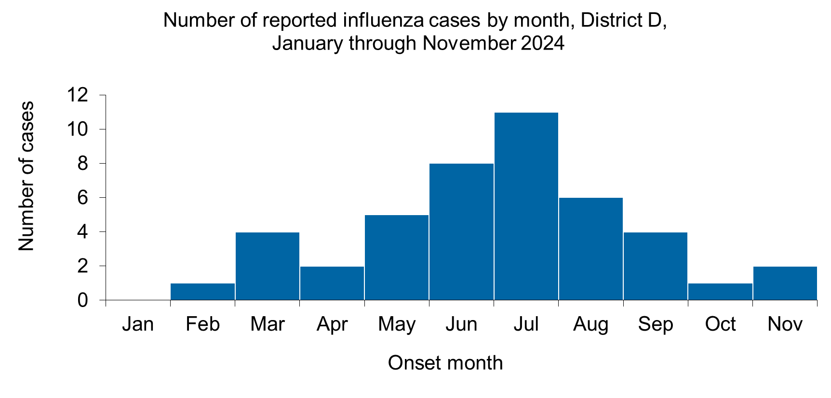  Number of reported influenza cases by month, District D,  January through November 2024  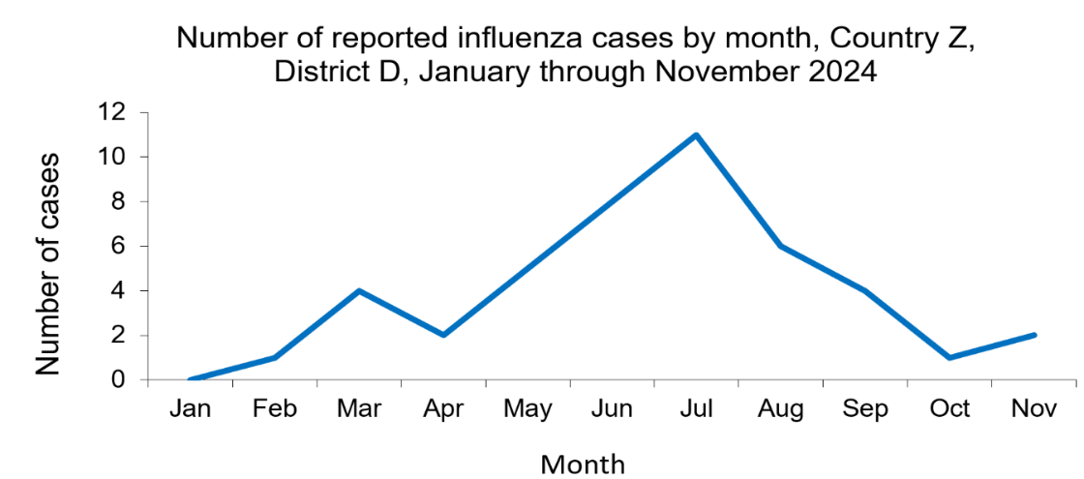  Number of reported influenza cases by month, District D,  January through November 2024

Question 28 | - Which month had the highest number of reported influenza cases?  - Which months had a relatively low number of reported influenza cases?
Answer 28 | - Influenza cases increased in May and June, peaked in July, and  then declined  - The months of January, February, and October had relatively low numbers

Table 2h. Start date and date of influenza rapid influenza diagnostic test (RIDT) sample collection, influenza cases, District D, 2024
Start date | Date RIDT Sample Taken | Difference |  | Start date | Date RIDT Sample Taken | Difference
03FEB2024 | 05FEB2024 | 2 |  | 08JUL2024 | 12JUL2024 | 4
07MAR2024 | 08MAR2024 | 1 |  | 09JUL2024 | 15JUL2024 | 6
15MAR2024 | 16MAR2024 | 1 |  | 13JUL2024 | 18JUL2024 | 5
18MAR2024 | 22MAR2024 | 4 |  | 14JUL2024 | 19JUL2024 | 5
25MAR2024 | 26MAR2024 | 1 |  | 14JUL2024 | 18JUL2024 | 4
11APR2024 | 16APR2024 | 5 |  | 19JUL2024 | 25JUL2024 | 6
23APR2024 | 27APR2024 | 4 |  | 20JUL2024 | 21JUL2024 | 1
01MAY2024 | 04MAY2024 | 3 |  | 27JUL2024 | 29JUL2024 | 2
09MAY2024 | 11MAY2024 | 2 |  | 30JUL2024 | 03AUG2024 | 4
16MAY2024 | 18MAY2024 | 2 |  | 04AUG2024 | 06AUG2024 | 2
20MAY2024 | 23MAY2024 | 3 |  | 08AUG2024 | 13AUG2024 | 5
27MAY2024 | 29MAY2024 | 2 |  | 16AUG2024 | 18AUG2024 | 2
02JUN2024 | 03JUN2024 | 1 |  | 24AUG2024 | 25AUG2024 | 1
07JUN2024 | 08JUN2024 | 1 |  | 24AUG2024 | 27AUG2024 | 3
10JUN2024 | 15JUN2024 | 5 |  | 30AUG2024 | 04SEP2024 | 5
10JUN2024 | 13JUN2024 | 3 |  | 12SEP2024 | 17SEP2024 | 5
18JUN2024 | 20JUN2024 | 2 |  | 15SEP2024 | 18SEP2024 | 3
24JUN2024 | 27JUN2024 | 3 |  | 20SEP2024 | 24SEP2024 | 4
28JUN2024 | 30JUN2024 | 2 |  | 28SEP2024 | 30SEP2024 | 2
30JUN2024 | 04JUL2024 | 4 |  | 09OCT2024 | 12OCT2024 | 3
02JUL2024 | 06JUL2024 | 4 |  | 24NOV2024 | 25NOV2024 | 1
03JUL2024 | 06JUL2024 | 3 |  | 27NOV2024 | 29NOV2024 | 2

Question 29 | To confirm the diagnosis of influenza, the first clinical specimen should be collected for laboratory analysis within 3-4 days of symptom onset.  What proportion of cases had their first sample taken within the first 4 days of symptom onset?  Refer to Table 2h in the Participant Guide.
Answer 29 | Thirty-seven of the 44 patients were sampled in the first 4 days: (37/44) x 100% = 84%

Question 30 | - What proportion of cases were hospitalized?  - What was the influenza case-fatality rate?  Refer to Table 3 in the Participant Guide.
Answer 30 | - 3 of the 44 patients were hospitalized: Proportion hospitalized = (3 / 44) x 100% = 7%  - 1 of the 44 patients died: Case-fatality rate = (1 / 44) x 100% = 2%

Question 31 | What was the year-to-date incidence rate of influenza in District D for 2024? Provide your response in cases per 100,000 persons per 11-month period.  Hint: Recall from Part A that the estimated population was 85,000.  Refer to Table 3 in the Participant Guide.
Answer 31 | Incidence rate = 44 / 85,000 x 100,000 =  52 cases per 100,000 in the 11-month period

Part F — One Health Investigation
(adapted from {Henning, 2011 #212})

Due to the avian influenza outbreaks in 2021 and 2023 and their associated economic losses, the Ministry of Agriculture decided to vaccinate domestic chickens and ducks to control and potentially prevent future avian influenza outbreaks. You meet with the veterinary surveillance officer of District D to review several studies to learn about highly pathogenic avian influenza (H5N1) vaccines and immune responses.

Influenza A viruses that infect poultry can be divided into 2 distinct groups according to the severity of disease they cause.

Highly pathogenic avian influenza (HPAI) can cause high mortality in chickens and turkeys and has a variable clinical effect (may or may not cause clinical signs and death) in domestic and wild waterfowl.

Low pathogenic avian influenza (LPAI), a localized infection resulting in mild disease, is found in wild bird populations. It can also infect domestic birds.

HPAI viruses can arise from LPAI through mutation or recombination of viruses. Influenza viruses are introduced into domestic poultry primarily through direct or indirect contact with infected wild birds. Transmission can occur through the movement of infected poultry, fomites, such as contaminated equipment or vehicles, and exposure to contaminated infectious organic material.

For these reasons, if biosecurity measures are implemented at the farm level, avian influenza infections can be prevented.

As outbreaks of HPAI have increased, vaccination has come to be considered an important tool for eradication, in addition to culling.

The veterinary surveillance officer reviewed a study of H5N1 in chickens and ducks raised on small farms. The birds were sampled monthly from May 2021 to May 2022.
Chickens are raised entirely indoors, while ducks are allowed outdoors during the day.

In the study, chickens and ducks on selected farms were vaccinated to induce an immune response to influenza. Serum was tested for the presence of H5 antibodies to influenza.
Vaccinated and unvaccinated chickens and ducks were compared to study the levels of antibodies in serum, reported as the seroprevalence of antibodies.

Figure 4 shows the H5 antibody seroprevalence among unvaccinated ducks (solid line) and domestic chickens (dotted line) from May 2021 to May 2022.
The overall prevalence during the study period was 43% (95% CI: 38-47) for ducks and 19.0% (95% CI: 14-47) for chickens.

Figure 4. Prevalence of H5 antibodies in unvaccinated ducks and domestic chickens, Mekong Delta, Viet Nam, May 2021 to May 2022

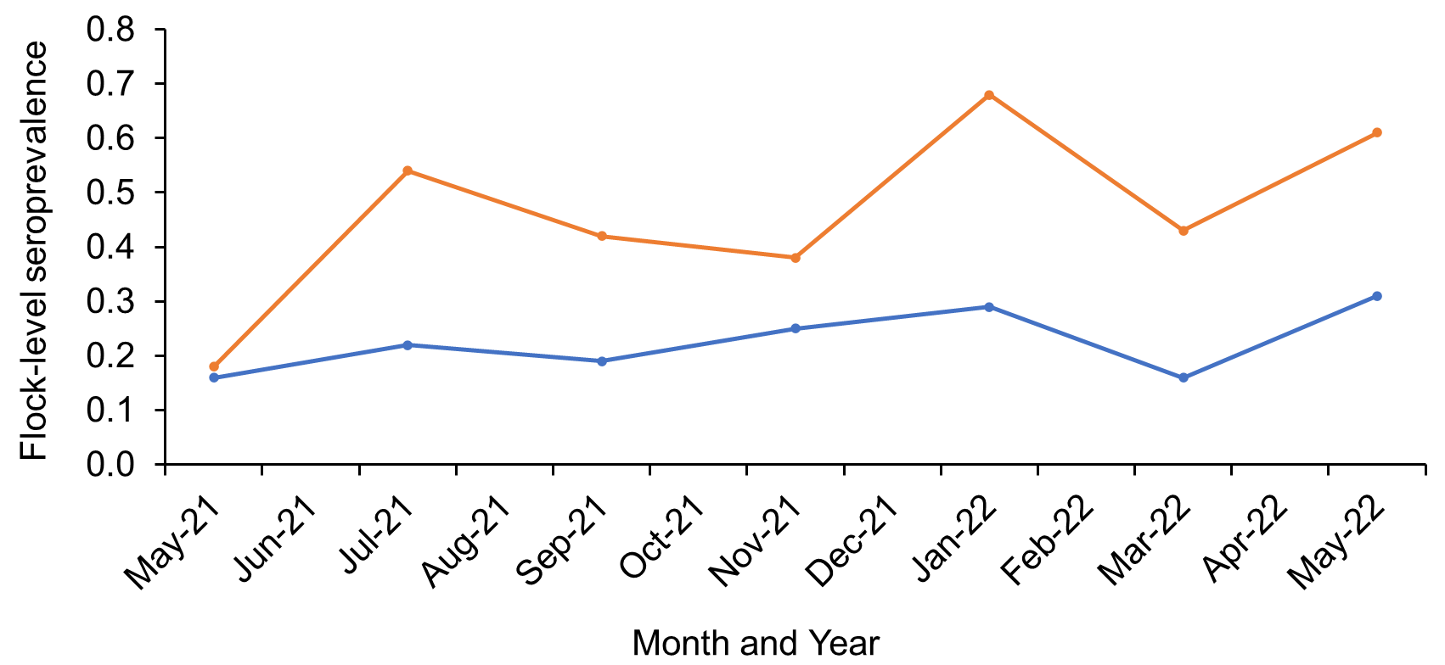
Ducks
Chickens

Question 32 | - Which months had the highest prevalence of antibodies in ducks? In chickens?  - What was the prevalence during these months?
Answer 32 | - January and May 2022 were high for both ducks and chickens  - Ducks - January 2022 (~68%) and May 2022 - (~61%)  Chickens – January 2022 (~29%) and May 2022 (~32%)

Question 33 | Why might there be a difference between the seroprevalence of ducks and chickens?
Answer 33 | - Environment  - Ducks may be more exposed to wild birds than chickens, since they usually have outdoor access  - Laboratory  - Different immune response per species  - Different immune response due to age when sampled  Other reasons?

Question 34 | What could be the cause of the peaks in January and May?
Answer 34 | - Potential causes:  - Exposure to wild birds during migration  - Changes in housing of animals during different seasons may result in different exposures  - Introduction of new birds into flocks during specific months  Other reasons?

In this area of Viet Nam, rice harvesting takes place in January and May. During this time, farmers often allow ducks to wander in their fields. Ducks eat pests like weeds and insects that pose a threat to rice production.

As a result of their wandering in the rice fields, the ducks receive increased exposure to the wild bird population during these months, which likely leads to higher antibody levels.

Figure 5 shows the prevalence of H5 antibodies in vaccinated ducks (solid line) and domestic chickens (dotted line) from May 2021 to May 2022. Vaccination campaigns were conducted in September and April. The prevalence during the study period was 54% (95% CI: 39-69) for ducks and 56% (95% CI: 47-64) for chickens.

Figure 5. Prevalence of H5 antibodies in vaccinated ducks and vaccinated domestic chickens, May 2021 to May 2022

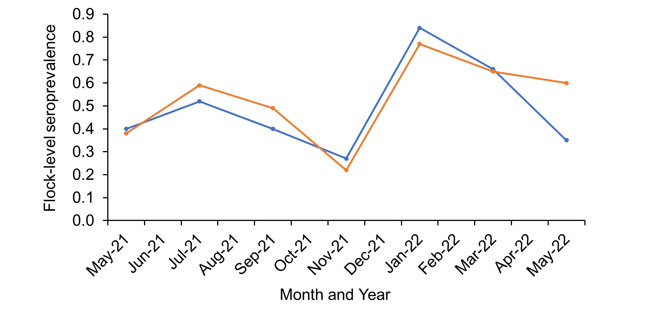
Chickens
Ducks

Question 35 | - Was antibody seroprevalence higher in vaccinated compared to unvaccinated chickens and ducks?  - Was the antibody response similar in the two species?
Answer 35 | - Chickens - Large increase; 19% to 56%  Ducks - Moderate increase; 42% to 54%  - Yes, except for May 2022

Question 36 | - Should vaccination have been recommended for the flocks in the study?  - Are the vaccination campaigns being conducted at an appropriate time?
Answer 36 | - Vaccination induced an antibody response in both species, so this may be an appropriate measure for prevention and control of outbreaks.  - Vaccination campaigns were conducted 2-3 months before the rice harvests, so antibody levels will be highest when exposure to wild birds occurs.

Part G — Results Report
With your analysis report in hand, you and your supervisor sat down for an informal meeting with the District Chief Medical Officer (DCMO).

The DCMO almost immediately asked you if you thought the human influenza incidence rate would be lower in 2024 than in 2023 (64 cases/100,000).

The population of district D is 85,000.

Question 37 | What is your response to the District Medical Officer?
Answer 37 | - As of November 2023, the influenza incidence rate was  44/85,000 = 52/100,000  - Incidence rate in 2022 was 64/100,000 = 54/85,000  - If <10 influenza cases occur during December, the incidence rate for 2023 should be lower than 2022.  - Since fewer influenza cases occur during the winter months (~November to February) in Country Z, the influenza incidence rate in 2023 is likely to be lower than in 2022.

Part H — Epilogue

After a few more questions, the DCMO thanked you and your supervisor for your time and hard work. The DCMO was pleased to learn that influenza surveillance was going well in the district.

The DCMO was scheduled to meet with the district governor at the end of the week to discuss health and funding priorities, and assured the surveillance team that he would ask the governor for continued support for influenza control efforts.

The district veterinary surveillance officer discussed his findings with the Regional Veterinary Officer and proposed the continuation of vaccination campaigns against avian influenza.

Appendix 1: Instructions for Dr. One

Use the following information to answer questions about your Gamma Delta patient.

Your name is Dr. One. You are a pediatrician at General Clinic. The General Clinic is located at 342 Health Lane in Zot. You can be reached by phone at 999-123-4567. Since you have been Gamma's pediatrician since she was born, you know that she has never moved from her residence in Echo.

Notes from Gamma's medical records:

Patient Information
Address | 789 Flores Street, Echo
Date of birth | 18JUL2017
Father | Omicron Delta
Mother | Sigma Delta
Telephone | 987-0214
Age | 5 years old
Sex | Female

Reason for visit
The mother was concerned about Gamma's health. On 07JUL2022, Gamma became ill with fever, chills, and cough. The next day, the fever persisted, and Gamma became lethargic and lost her appetite. She complained of body aches. The mother took Gamma to the clinic on 09JUL2022 because she was concerned that Gamma had not received her vaccinations. She had not been feeling well when the last vaccination campaign was conducted, so the mother refused the vaccinations. Gamma spends time with her neighbor, a six-year-old girl who attends summer school. When asked about recent trips, her father indicated that Gamma visited her grandparents last week in Zot Town in District D. Other cousins were visiting and went to a local zoo. That was her last trip away from home.

Summary of clinical examination
The patient was examined on 09JUL2022. Weight 16 kg, height 108 cm, blood pressure 93/52. Symptoms reported by the patient were fever, chills, rapid breathing, and cough. Examination showed an alert patient with increased respiratory rate, throat redness and enlarged neck lymph nodes. No evidence of rash was noted. No vomiting or diarrhea was reported, and the patient denied abdominal pain. A blood sample was taken, and a nasopharyngeal swab was performed for measles and influenza. The patient received intravenous fluids and acetaminophen. Gamma was directed home with instructions to remain isolated at home until the diagnosis was confirmed. The mother was also instructed to monitor Gamma's health and provide oral fluids and acetaminophen as needed.

Laboratory
Sample | Collection Date | Results
Blood | 09JUL2022 | White blood cell count low, normal platelet count
Nasopharyngeal swabbing | 09JUL2022 | PCR=negative, measles  Influenza Dx rapid test: positive=A  PCR=positive for subtype H3
Urine | 09JUL2022 | Normal (negative for blood)
Serum | 09JUL2022 | Measles IgM/G titer = negative

Appendix 2: Instructions for Dr. Two

Use the following information to answer questions about the patient, Alpha Beta.

Your name is Dr. Two. You are a general practitioner at General Hospital. General Hospital is located at 342 Health Lane in Zot. You can be reached by phone at 999-987-6543.

Notes from Alpha's Medical Records:

Patient Information
Address | 124 Camino Fuentes, Bravo
Date of birth | 12APR1990
Father | Deceased
Mother | Zeta Beta
Telephone | 867-5309
Age | 32 years old
Sex | Male

Reason for visit
Alpha's symptoms started with chills and fever on 07FEB2022. The next day he had a severe headache and started with cough and muscle aches. He started taking acetaminophen. On the morning of 07MAY2022, Alpha still had a high fever and was very weak, so a family member took him to the hospital.

Hospitalization Summary
Alpha was admitted to the hospital on 05JUL2022 with suspected influenza. On admission, Alpha's blood pressure was 110/70, temperature was 40.2 ºC. On physical exam, Alpha was found to be dehydrated with increased heart and respiratory rate. He started on intravenous fluids and acetaminophen. Blood samples were taken, and a nasopharyngeal swab was performed for analysis. His condition was closely monitored while awaiting results. Alpha was asked if he had recently spent time with people presenting with similar symptoms. He was also asked about his employment and possible exposure to animals. Alpha is a butcher who visits the animal market frequently to purchase animals for his store, usually poultry. His last visit to the live animal market was 27JUN2022, when he purchased chickens.

Laboratory
Sample | Collection Date | Results
Blood | 05JUL2022 | White blood cell count 6,340  Platelet count 155,000
Nasopharyngeal swabbing |  | Influenza Dx Rapid Test=Positive for A  PCR=positive for subtype H5
Urine | 05JUL2022 | Normal (negative for blood)

