Dustin James Kendall

kendalld@pnw.edu

Lab 4 FSM

ECE 371 Comp Organization

# Part 1

## State Transition Diagrams

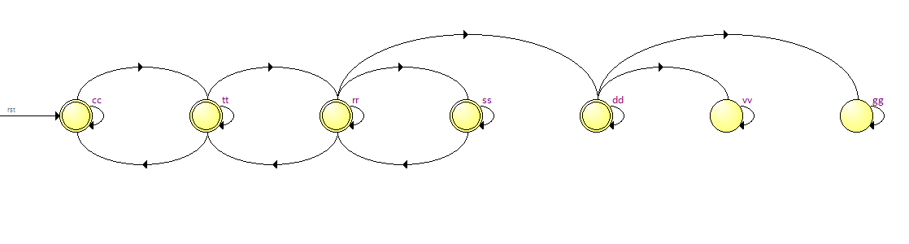

## VHDL Code

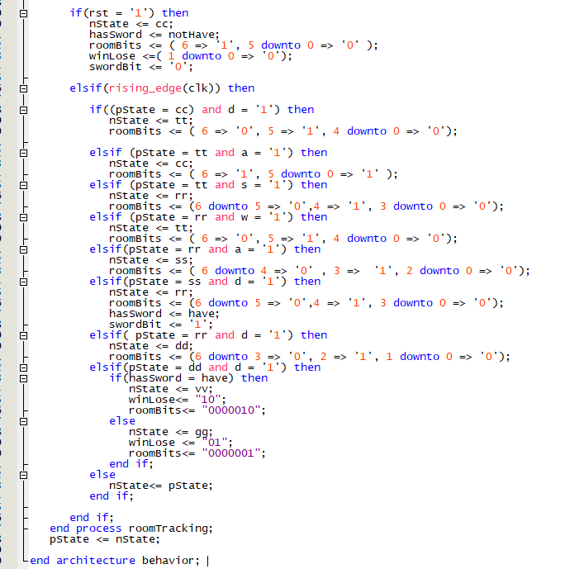

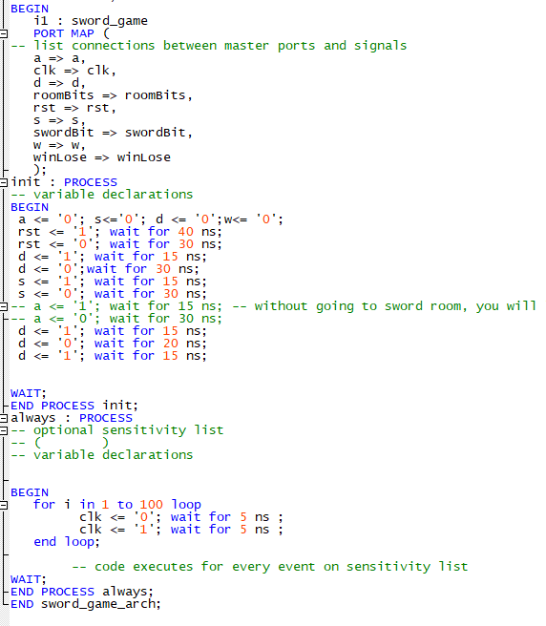

## Simulation Results

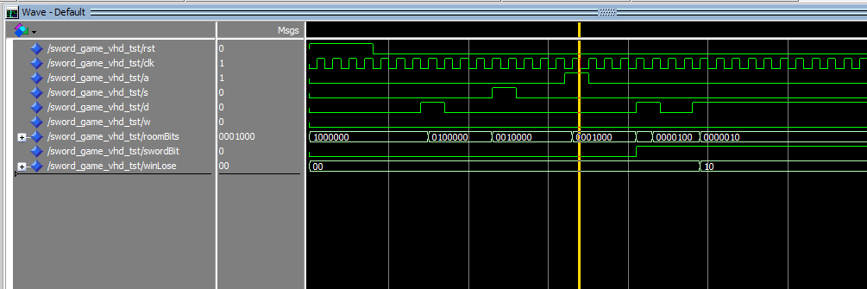

Figure 1 Winning Sim

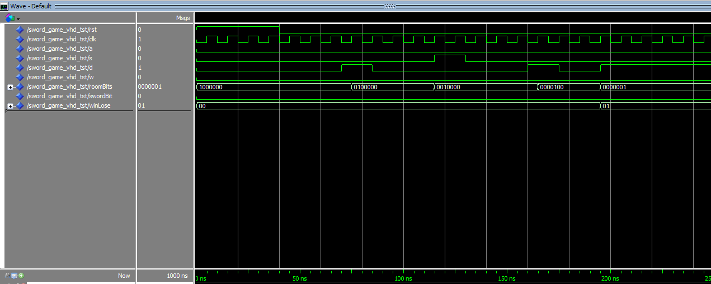

Figure 2 Losing Simulation

# Part 2

## State Transition Diagrams

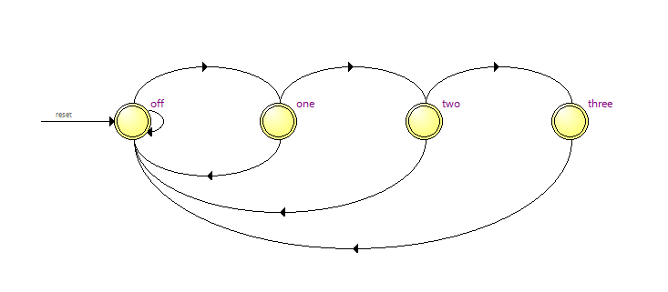

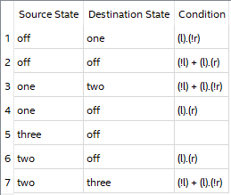

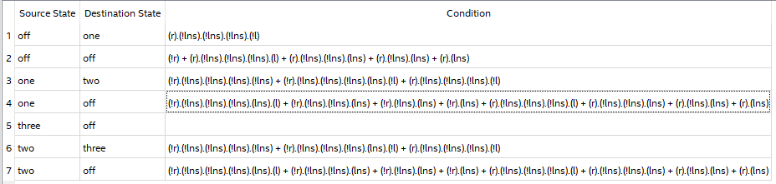

## VHDL Code

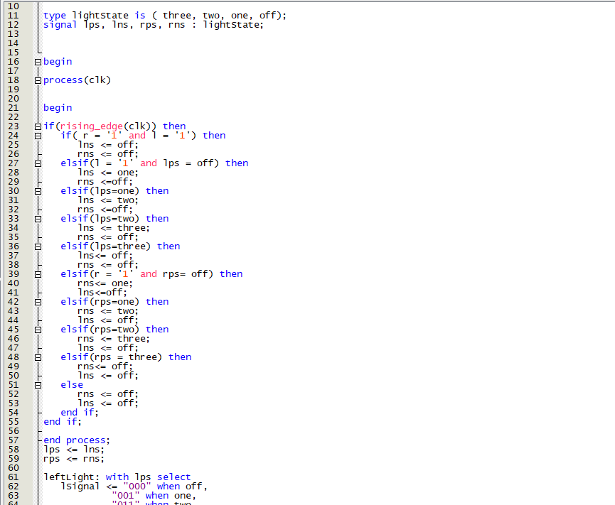

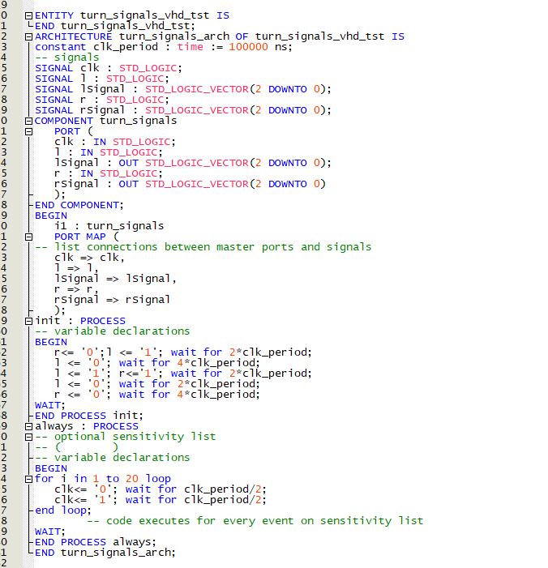

## Simulation Results

