Dustin Kendall

kendalld@pnw.edu

Homework #4

ECE 371 Computer Organization

# Problem 1

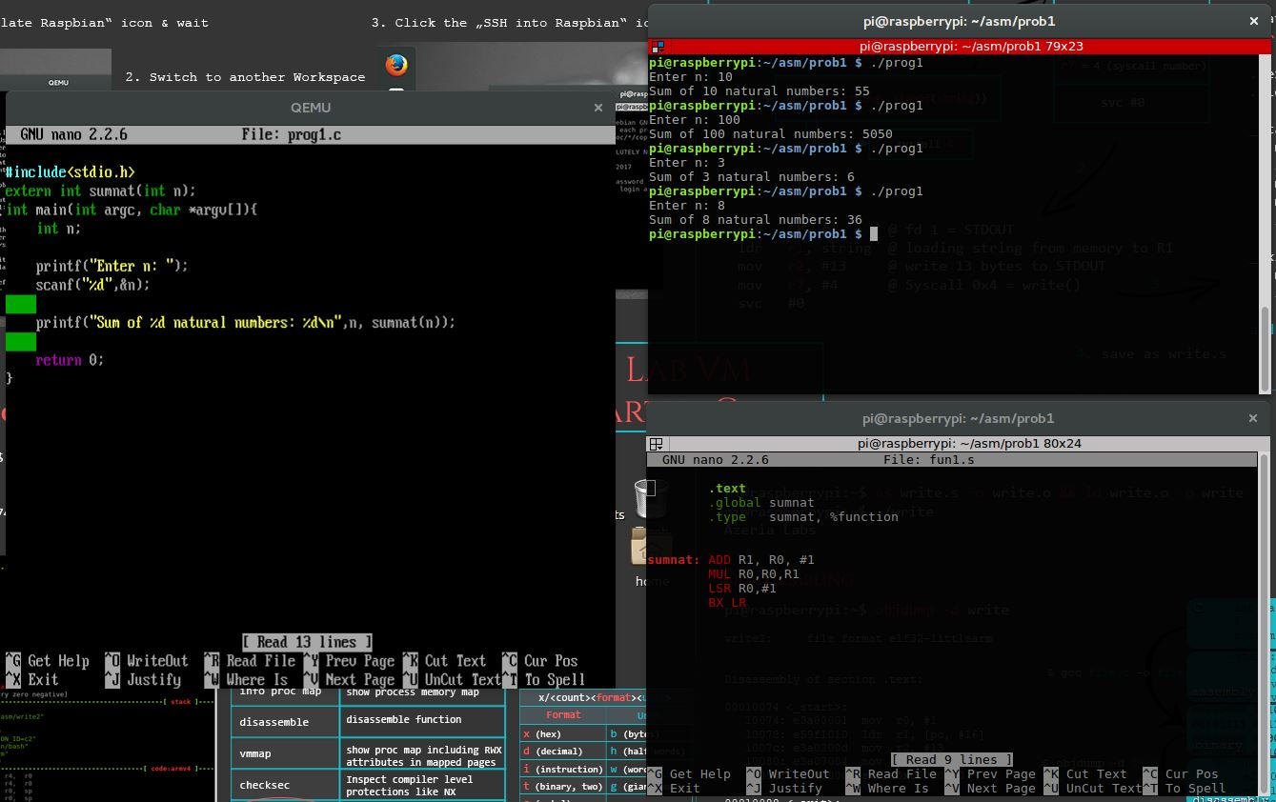

# Problem 2

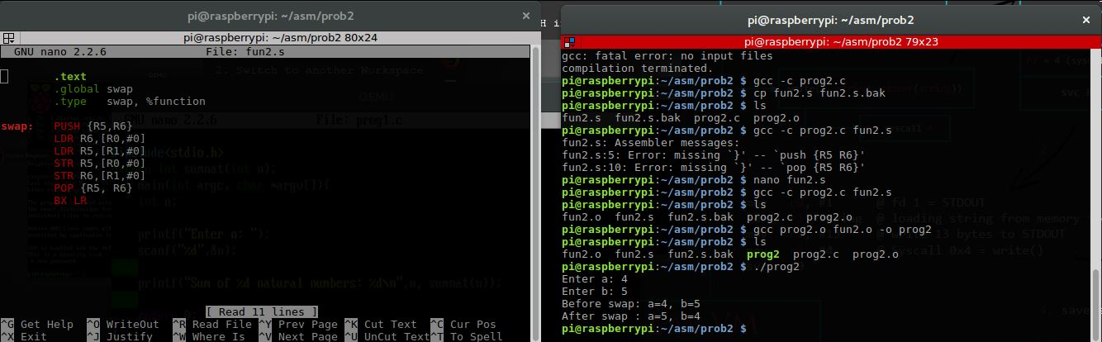

# Problem 3

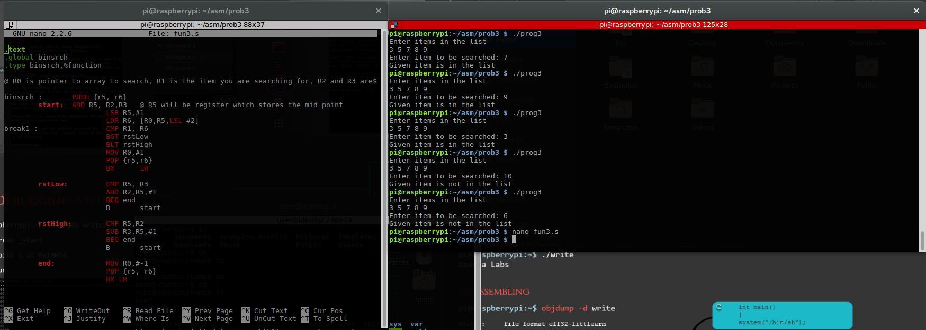

# Problem 4

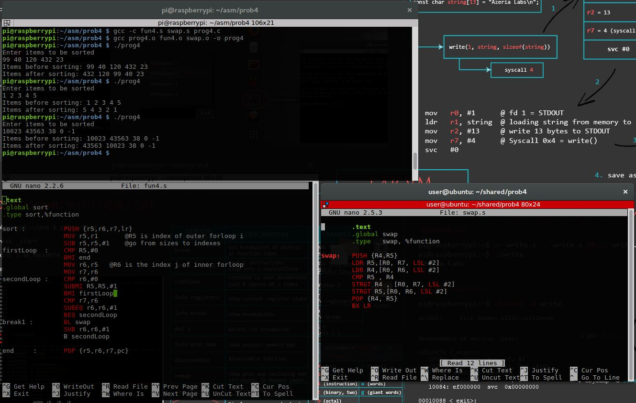

# Problem 5

