# Hands-On Assignment #1

Author: Dustin Kendall

## Task 0 Install and Run Virtual Machine

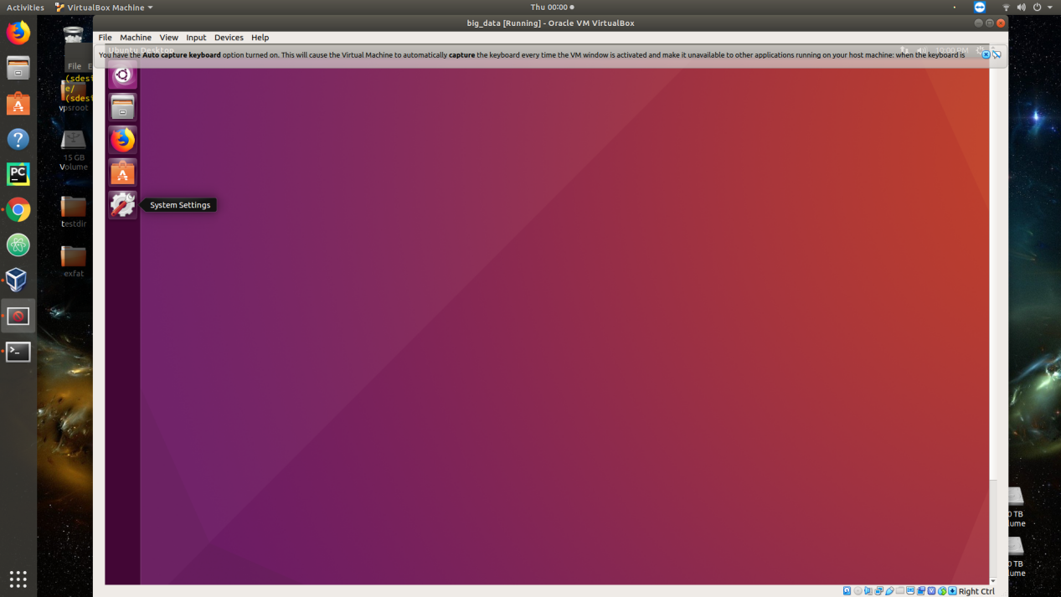

Image 1 Running Ubuntu 16.04 within Ubuntu 18.04

## Task 1 ATM Calculator

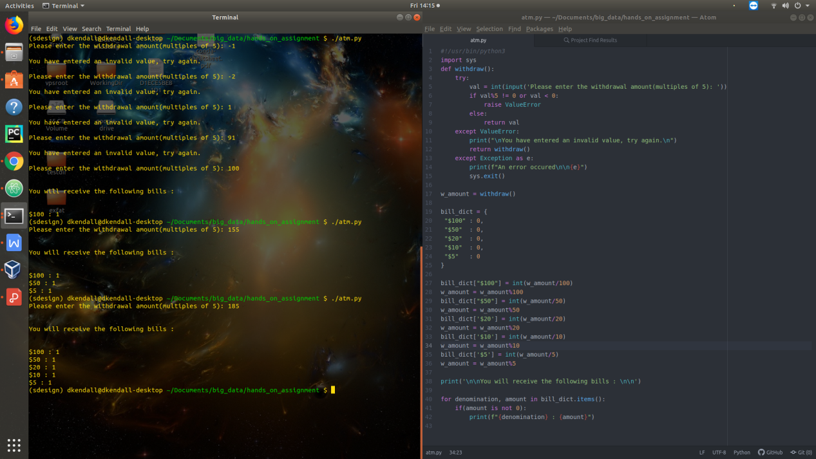

Image 2 Code is in file atm.py

## Task 3

## jps_running_task3

## Task 4

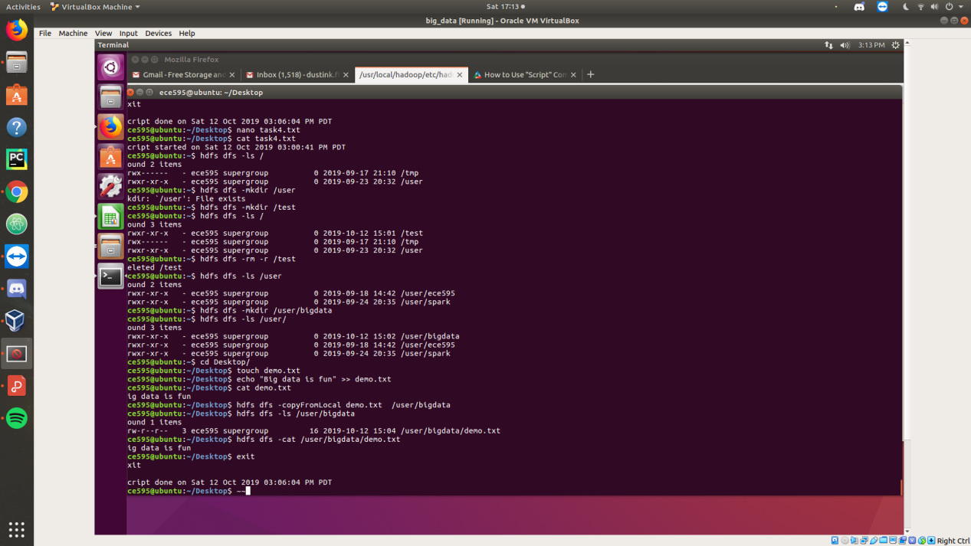

## Task 5

### Part A

#### Code

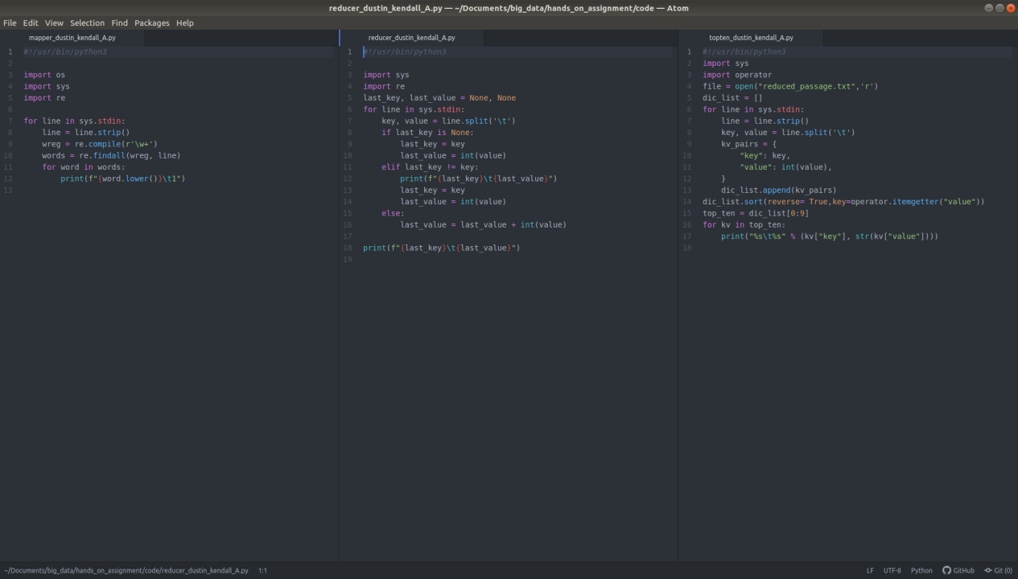

#### Results

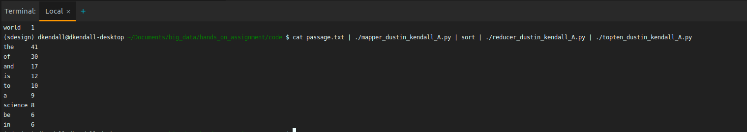

### Part B

#### Code

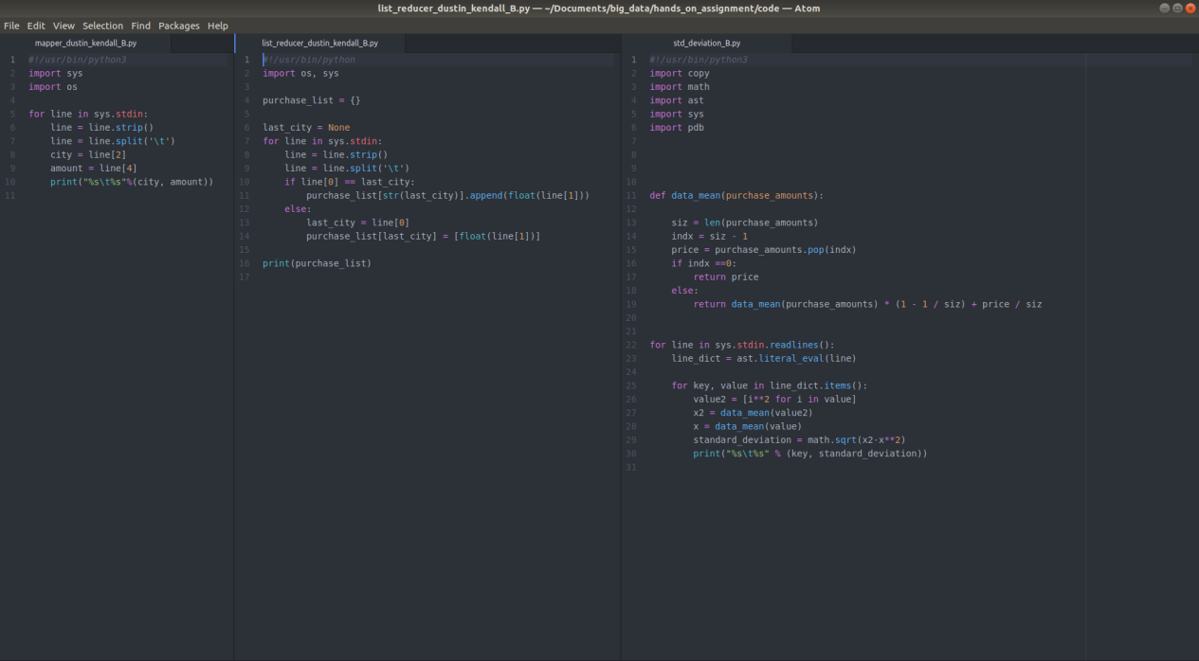

#### Results

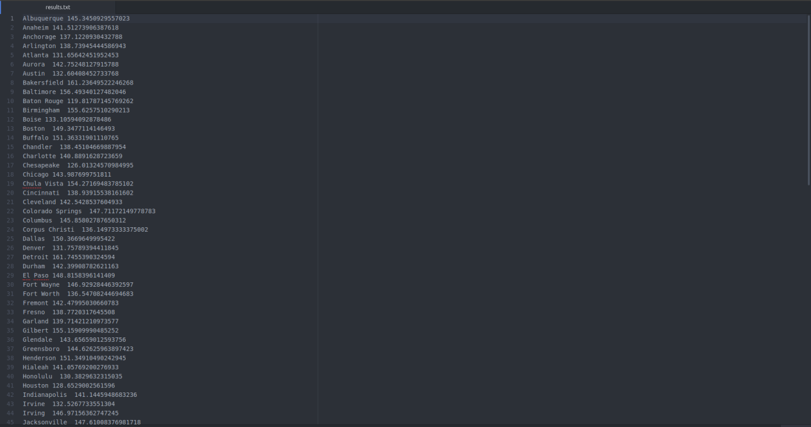

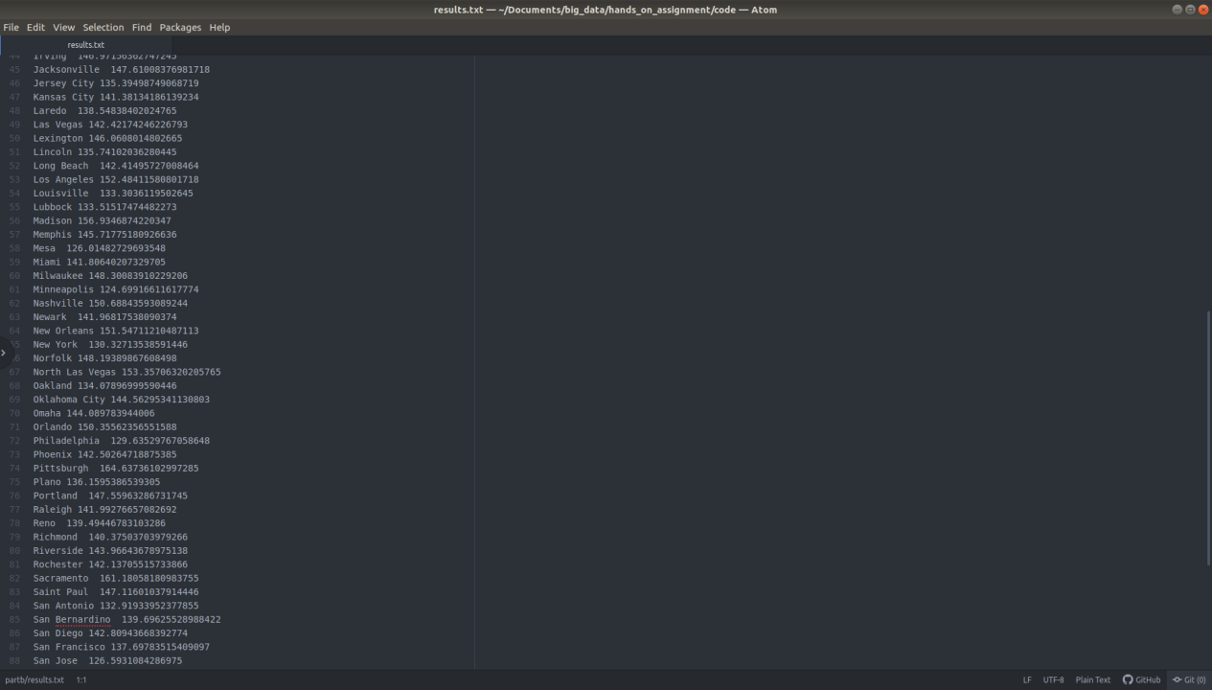

### Part C

#### Code

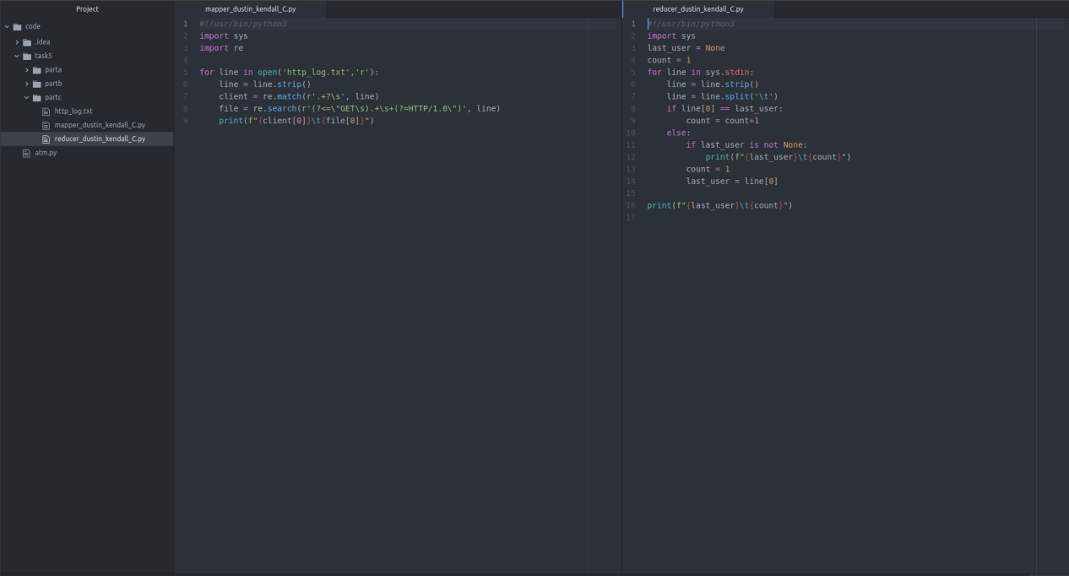

#### Results

