Time-Series Analysis and Forecasting of Renewable Electricity Generation by Source: Midwest Region (U.S. Census)
  - Technical Report | Hydro, wind, solar, biomass and geothermal | U.S. EIA monthly net generation, January 2001 – July 2026

1. Research Objective & Questions

1.1 Objective
To study the temporal behaviour of each renewable resource in the Midwestern U.S. Census region — its trend, seasonality, stationarity, autocorrelation and partial autocorrelation — and to use these results to build, compare and validate separate forecasting models for hydro, solar, biomass and wind. Each resource is analysed separately because each depends on a different natural driver (rainfall and snowmelt, sunlight, fuel supply, wind).

1.2 Research questions
Main research question: How do hydro, solar, biomass, wind and geothermal electricity generation vary over time in the Midwestern U.S. region, and what specific trends, seasonal cycles and temporal dependencies can be isolated to accurately forecast their future contributions?
1. What long-term trend does each resource (hydro, solar, biomass, wind) follow — growth, decline or no trend — and how fast?
2. Does each resource show 12-month seasonality, when does it peak and trough, and is the seasonality additive or multiplicative?
3. Is each series stationary according to the ADF and KPSS tests, and which transformation and differencing orders (d, D) are needed?
4. Which (p, d, q) × (P, D, Q)12 orders are suggested by the ACF and PACF, and are they confirmed by an AIC search?
5. Which model family gives the most accurate 24-month-ahead forecasts (MAE, RMSE, MAPE) for each resource, and does it beat the seasonal-naive baseline?
6. Are the residuals of the selected models white noise (zero mean, no autocorrelation, approximately normal)?
7. What generation is expected from each resource over August 2026 – July 2027?

1.3 Hypotheses
- H1: All four modelled resources show 12-month seasonality: strong for solar and wind, moderate for hydro, and weaker for biomass.
- H2: Seasonal models (SARIMA, Holt-Winters) forecast more accurately than the seasonal-naive baseline for each resource.
- H3: Solar requires a model that captures exponential growth. Trend-free models (naive, seasonal naive, SES) will perform worst for solar.
- H4: Hydro is the hardest resource to forecast in relative terms because it is influenced by unpredictable rainfall and snowmelt.
- H5: Wind's strong trend and seasonality allow seasonal time-series models to outperform simple baseline forecasts.

2. Dataset Description & Regional Selection

2.1 Data source and extraction from the EIA Electricity Data Browser
The data come from the U.S. Energy Information Administration (EIA) Electricity Data Browser (https://www.eia.gov/electricity/data/browser/), which publishes the official monthly net-generation statistics collected on Form EIA-923 (Electric Power Monthly). The steps below describe how the monthly state-level series used in this study are extracted.
1. Open the browser. Go to https://www.eia.gov/electricity/data/browser/. The landing page lists the available electricity data sets.
2. Choose the data set. Select Net generation (electric power generation by fuel type).
3. Select the fuel types. Tick Conventional hydroelectric, Wind, All utility-scale solar, Wood and wood-derived fuels, Other biomass, Geothermal and All fuels (needed for the renewable share). Pumped-storage hydro is excluded, and small-scale (rooftop) solar is not part of these series.
4. Select the geography. Choose the state level and select every state of the Midwest Census region (12 jurisdictions, listed in Table 2.1). The national file used here contains all 50 states and the District of Columbia, so the same steps are repeated for every state.
5. Select the sector. Choose All sectors, so that utilities, independent power producers and commercial and industrial plants are all included.
6. Select frequency and period. Set the frequency to Monthly and the period to January 2001 – July 2026.
7. Check the units. Values are reported in thousand megawatt-hours, which equals gigawatt-hours (GWh); no unit conversion is needed.
8. Download. Use the download option to export each table as CSV (or Excel). Each series corresponds to an EIA series code of the form ELEC.GEN.<FUEL>-<STATE>-99.M (for example ELEC.GEN.WND-TX-99.M is wind, Texas, all sectors, monthly).
9. Combine the downloads. Stack the state files into one table with one row per state per month, and one column per source. Wood and other biomass are added together into a single biomass column.
10. Derive the totals. total_renewable = hydro + wind + solar + biomass + geothermal, and renewable_share_pct = total_renewable ÷ total_generation × 100.
11. Attach the regional classification. Label every row with its official U.S. Census region and division (Northeast, Midwest, South, West; 9 divisions).
12. Save. The final file has 15,657 rows (51 jurisdictions × 307 months) and 11 columns.
Table 2.2 Variables in the dataset
Variable | Description
month | First day of the month of the observation
census_region | U.S. Census region (Northeast, Midwest, South, West)
census_division | U.S. Census division (9 divisions)
hydro, wind, solar, biomass, geothermal | Net generation from each source, in thousand MWh (= GWh)
total_renewable | Sum of the five renewable sources (GWh)
total_generation | Net generation from all sources, renewable and non-renewable (GWh)
renewable_share_pct | total_renewable / total_generation × 100

2.2 Regional selection: the Midwest region
The Midwestern U.S. Census region covers 12 states in two divisions (Table 2.1). Wind dominates the region's renewable output, solar is the fastest growing, hydro comes mainly from the Missouri and upper Mississippi river systems, and the region has no geothermal plants.
Table 2.1 States of the Midwest region
Census division | States
East North Central | IL, IN, MI, OH, WI
West North Central | IA, KS, MN, MO, NE, ND, SD

Only rows with census_region = "Midwest" are kept (3,684 rows = 12 jurisdictions × 307 months). Each month has one row per state, so the rows are added together to give one monthly regional total per resource.
Table 2.3 Summary statistics of the monthly regional series (GWh), Jan 2001 – Jul 2026
Statistic | hydro | solar | biomass | geothermal | wind
count | 307.000 | 307.000 | 307.000 | 307.000 | 307.000
mean | 1290.662 | 381.051 | 552.611 | 0.000 | 6277.193
std | 308.241 | 948.709 | 105.138 | 0.000 | 5825.660
min | 681.270 | 0.000 | 316.106 | 0.000 | 78.287
25% | 1073.893 | 0.000 | 458.563 | 0.000 | 746.505
50% | 1267.102 | 11.839 | 551.017 | 0.000 | 4911.042
75% | 1445.229 | 220.471 | 654.640 | 0.000 | 9966.570
max | 2473.126 | 6301.997 | 761.019 | 0.000 | 21243.116

2.3 Study period for each resource
Table 2.4 Series analysed
Resource | Period used | Monthly observations
Hydro | Jan 2001 – Jul 2026 | 307
Solar | Jan 2012 – Jul 2026 | 175
Biomass | Jan 2001 – Jul 2026 | 307
Wind | Jan 2001 – Jul 2026 | 307
Geothermal | Not modelled (0 GWh in every month) | —

3. Preprocessing and Missing-Value Handling

3.1 Data-quality checks
Table 3.1 Data-quality checks
Check | Result
Full dataset | 15,657 rows × 11 columns; 51 jurisdictions × 307 months; 4 Census regions, 9 divisions
Date range | January 2001 – July 2026, monthly
Regional rows | 3,684 rows, 12 state rows in every month
Missing months in the regional series | 0 (every month present)
Missing values | Only renewable_share_pct has missing values (15 rows nationally, where total generation is 0 so the ratio is undefined). It is not used in modelling; all five generation columns are complete
Duplicate rows | 0
Imputation needed | None: after aggregation every regional series is complete

3.2 Zero-generation months and treatment of each resource
Table 3.2 Months with zero output, Jan 2001 – Jul 2026
Resource | Months with zero generation
Hydro | 0
Solar | 107 (all up to December 2009)
Biomass | 0
Wind | 0
Geothermal | 307 (all months)

Geothermal: no data to analyse
Geothermal generation is 0 GWh in all 307 months (Jan 2001 – Jul 2026), in every Midwestern state. The Midwest has no utility-scale geothermal power plants, so geothermal is reported here and excluded from the time-series modelling. Its forecast is simply 0 GWh.
Wind is by far the Midwest's largest renewable source, averaging 6,277 GWh per month against 1,291 GWh for hydro, and it is modelled alongside hydro, solar and biomass.

Choosing the start of the solar series
Midwestern solar output is exactly zero until December 2009 (107 zero months). It stays below about 4 GWh/month through 2011, and some months fall below 1 GWh (Jan 2010: 0.1 GWh; Jan 2011: 0.6 GWh). From January 2012 onwards, every month is at least 1.2 GWh and the seasonal cycle is clear. Solar is therefore analysed from Jan 2012 (175 monthly observations). Earlier values are too small to carry a usable pattern, and the zeros make a log transform impossible.

3.3 Preparation steps
- The index is converted to a monthly datetime index with frequency MS (month start).
- Geothermal is removed from the modelling, because it is identically zero.
- Solar is analysed from January 2012 onwards.
- Hydro, wind and biomass use the full period, January 2001 – July 2026.

3.4 Transformation: additive or multiplicative?
If the seasonal swings grow as the level rises, the seasonality is multiplicative and the series is log-transformed. This is checked with the correlation between the 12-month rolling mean and the 12-month rolling standard deviation (threshold 0.7).
Table 3.3 Variance check
Resource | Correlation (rolling mean vs rolling std) | Treatment
Hydro | 0.722 | Multiplicative (log scale)
Solar | 0.982 | Multiplicative (log scale)
Biomass | 0.148 | Additive (original scale)
Wind | 0.981 | Multiplicative (log scale)

Additive or multiplicative?
- Solar: the rolling mean and rolling std are almost perfectly correlated (0.982), so the seasonality is multiplicative and a log transform is needed.
- Hydro: the correlation is 0.722, just above the 0.7 threshold. Its swings are larger when the level is higher, so hydro is also treated as multiplicative (log scale).
- Biomass: the correlation is 0.148, so its variability does not depend on the level. Biomass is treated as additive.
- Wind: the correlation is 0.981, so it is treated as multiplicative(log scale).

4. Time-Series Plot, Trend, and Seasonality Analysis

4.1 Time-series plots
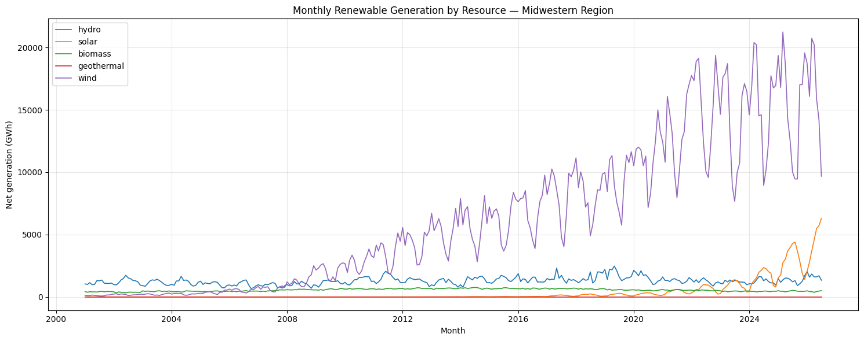
Figure 4.1: Monthly renewable generation by resource, Midwest region
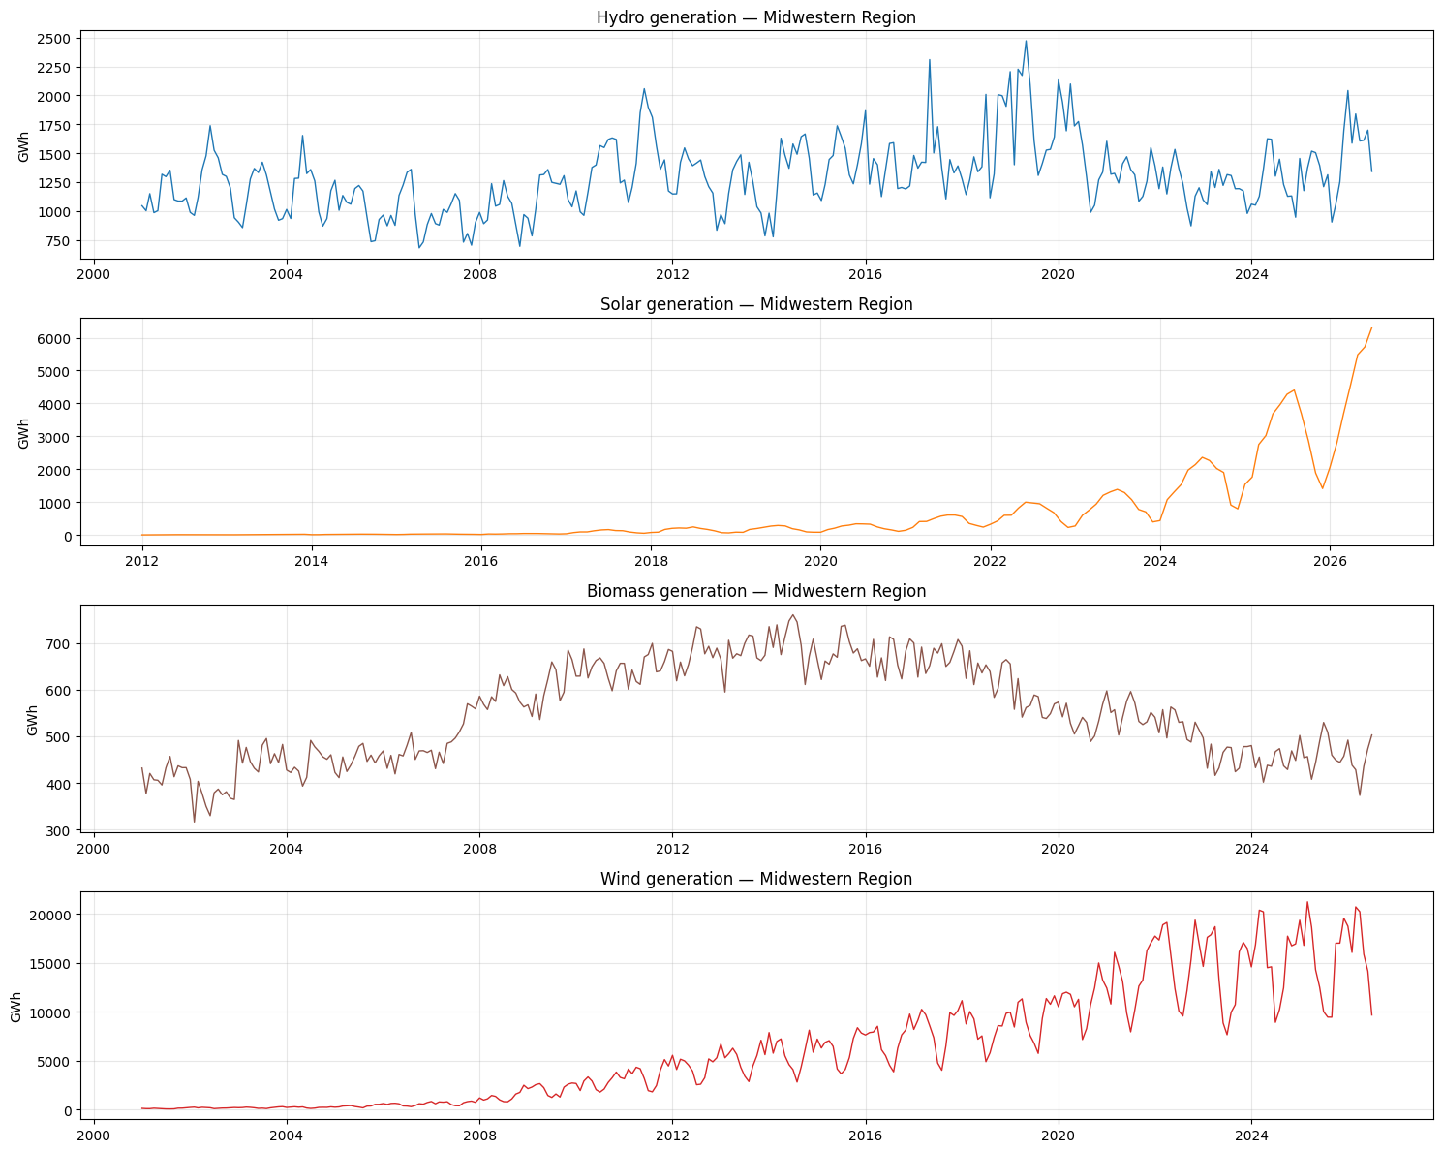
Figure 4.2: Each resource on its own scale

Initial visual observations
1. Hydro moves between roughly 680 and 2,470 GWh per month. It rose gradually to a high period around 2016–2020, with the record of about 2,470 GWh in 2019, and has fallen back since. Each year has a spring/summer high and a winter low. Wet years (2011, 2019) stand out.
2. Solar was negligible until about 2017 and has exploded since 2022, reaching about 6,300 GWh in Jul 2026. Its summer peak and winter dip repeat every year, and the swing becomes much larger as the level grows.
3. Biomass follows a clear hump. It was about 400–500 GWh in 2001–2007, jumped to a plateau of about 650–750 GWh in 2009–2018, and has declined since then to about 450–500 GWh. It has a small seasonal ripple.
4. Geothermal is a flat line at zero.

4.2 Trend analysis
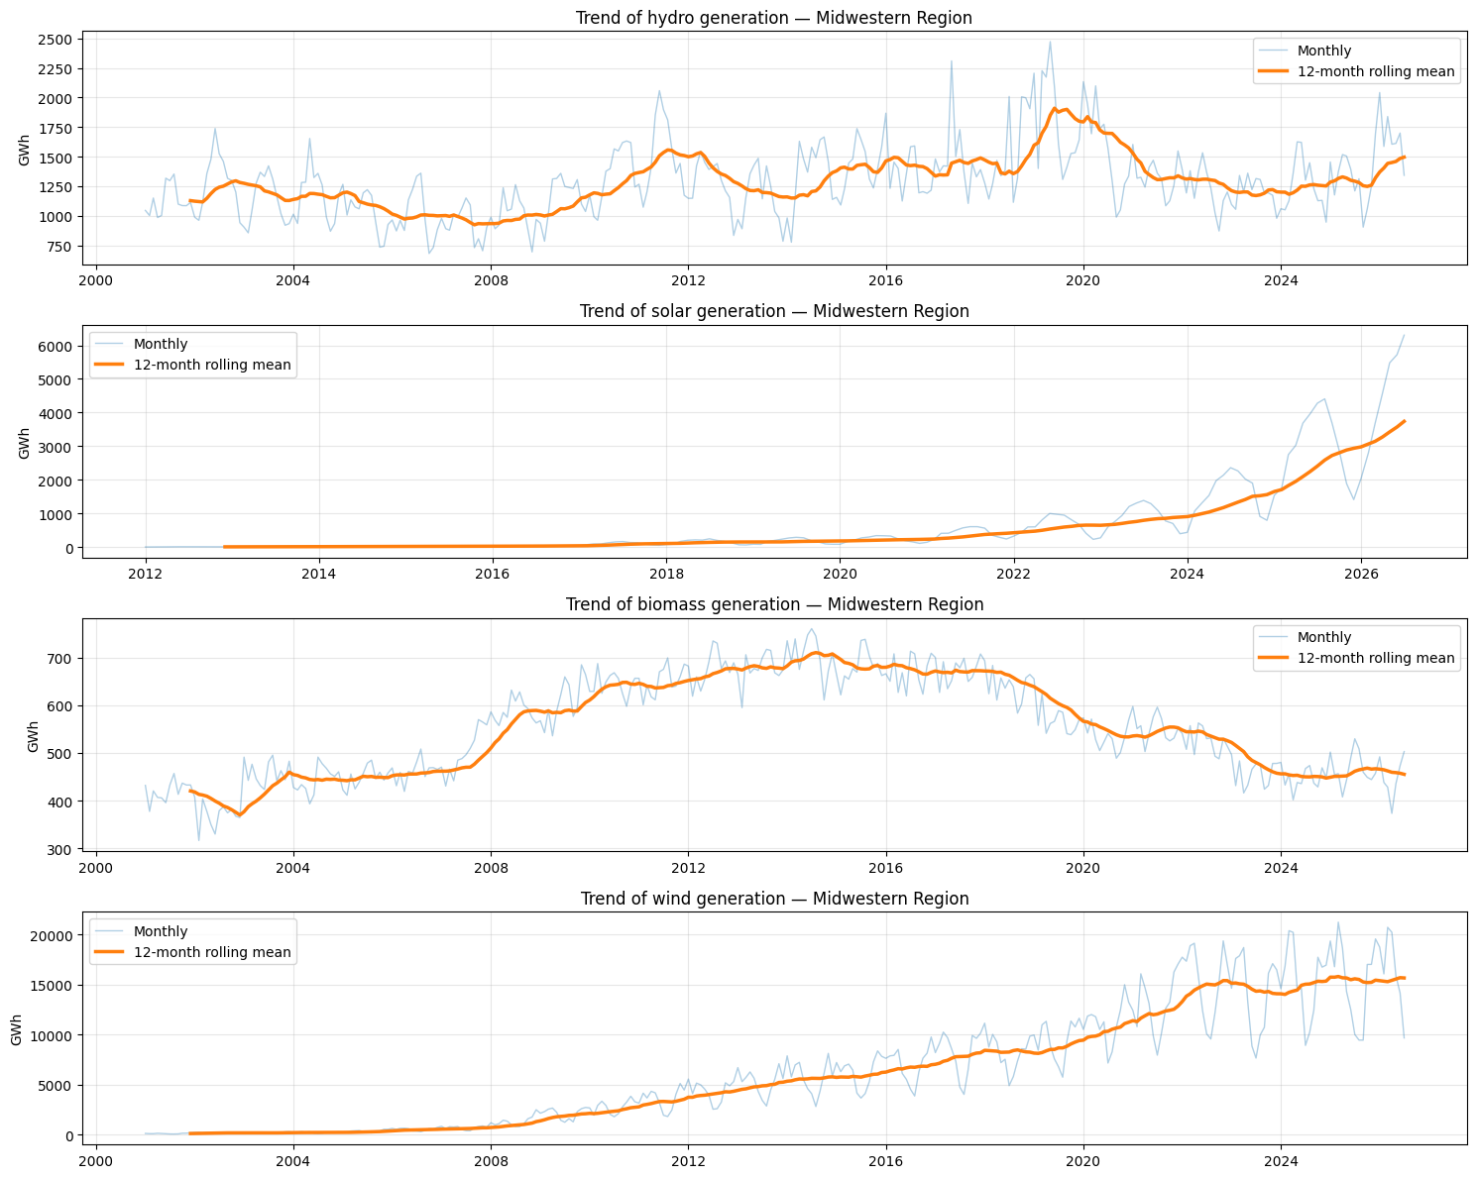
Figure 4.3: Monthly series with 12-month rolling mean (trend)
Table 4.1 Annual generation by resource (GWh), complete calendar years
Year | hydro | solar | biomass | wind
2001 | 13538.000 | — | 5041.000 | 1502.000
2002 | 15382.000 | — | 4435.000 | 2360.000
2003 | 13551.000 | — | 5517.000 | 2585.000
2004 | 14081.000 | — | 5317.000 | 2818.000
2005 | 12478.000 | — | 5379.000 | 4379.000
2006 | 11995.000 | — | 5540.000 | 6517.000
2007 | 11201.000 | — | 6008.000 | 8360.000
2008 | 12138.000 | — | 7072.000 | 15750.000
2009 | 13885.000 | — | 7271.000 | 25226.000
2010 | 16300.000 | — | 7728.000 | 33031.000
2011 | 18114.000 | — | 7801.000 | 42629.000
2012 | 15463.000 | 67.000 | 8131.000 | 52172.000
2013 | 13905.000 | 132.000 | 8123.000 | 63045.000
2014 | 16381.000 | 220.000 | 8496.000 | 69468.000
2015 | 16855.000 | 286.000 | 8157.000 | 74718.000
2016 | 16417.000 | 404.000 | 8031.000 | 83942.000
2017 | 17874.000 | 1200.000 | 8072.000 | 98320.000
2018 | 18236.000 | 1815.000 | 7708.000 | 99088.000
2019 | 21597.000 | 2116.000 | 6878.000 | 112887.000
2020 | 18891.000 | 2719.000 | 6404.000 | 134917.000
2021 | 16060.000 | 4907.000 | 6633.000 | 154319.000
2022 | 14845.000 | 7806.000 | 6309.000 | 184824.000
2023 | 14438.000 | 10691.000 | 5489.000 | 169085.000
2024 | 15027.000 | 18702.000 | 5366.000 | 184249.000
2025 | 15854.000 | 35244.000 | 5602.000 | 185410.000

Table 4.2 Trend measures (linear slope, compound annual growth rate, correlation with time)
Resource | Years | First year (GWh) | Last year (GWh) | Slope (GWh/yr) | CAGR (%) | Corr. with time
hydro | 2001-2025 | 13538.201 | 15853.766 | 172.419 | 0.660 | 0.524
solar | 2012-2025 | 67.453 | 35244.475 | 1836.990 | 61.839 | 0.776
biomass | 2001-2025 | 5041.273 | 5601.559 | 42.529 | 0.440 | 0.255
wind | 2001-2025 | 1501.618 | 185410.342 | 8599.598 | 22.222 | 0.970

Trend interpretation
Resource | Long-term behaviour
Hydro | Weak upward drift with large swings. The slope is +172 GWh/yr (r = 0.52) and the compound growth rate is only 0.66%/yr. Annual output ranges from 11,201 GWh (2007) to 21,597 GWh (2019). It rose until 2019, then fell back to about 15,000–16,000 GWh.
Solar | Explosive, accelerating growth. Output rose from 67 GWh (2012) to 35,244 GWh (2025), about 62%/yr. 2025 was 1.9 times 2024 (18,702 GWh). The trend is exponential.
Biomass | Rise then decline. Output rose from 5,041 GWh (2001) to a peak of 8,496 GWh (2014), then fell back to 5,602 GWh (2025). The linear slope (+43 GWh/yr, r = 0.26) does not describe this hump.
Wind | Rapid, sustained growth. Output rose from 1,502 GWh (2001) to 185,410 GWh (2025), with a linear slope of +8,600 GWh/yr, a CAGR of 22.22%/yr, and a strong positive correlation with time (r = 0.97). Wind shows the strongest linear association with time among the four resources.

Key finding: The four resources follow different trends: hydro exhibits weak upward drift with large fluctuations, solar shows explosive growth, biomass rises and then declines, and wind experiences rapid, sustained growth.

4.3 Seasonality analysis
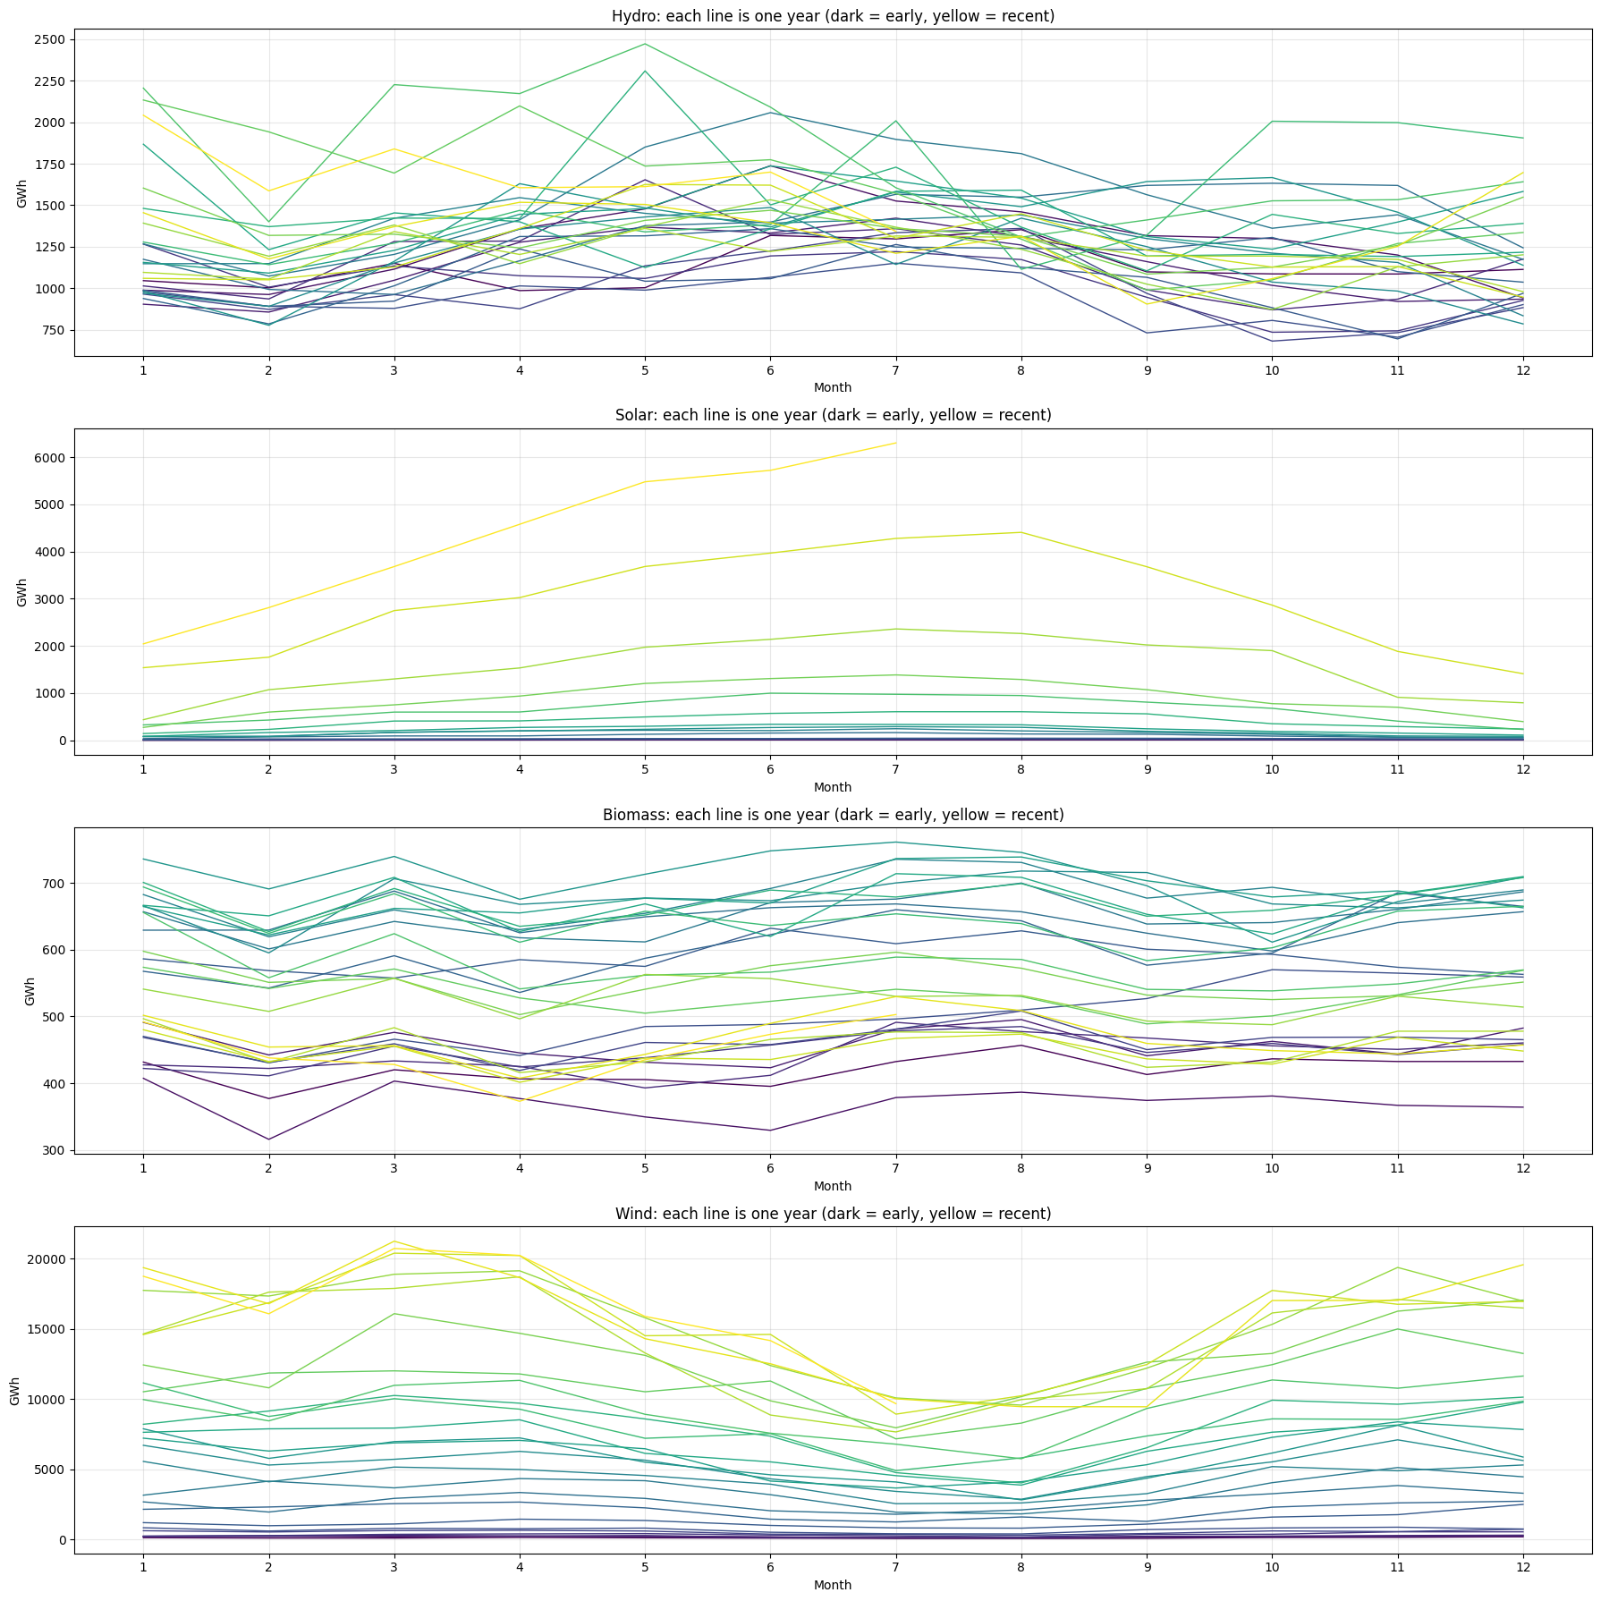
Figure 4.4: Seasonal plot: one line per year
Table 4.3 Average seasonal index (value ÷ centred 12-month moving average; 1.10 = 10% above trend)
Month | hydro | solar | biomass | wind
Jan | 0.989 | 0.525 | 1.030 | 1.175
Feb | 0.852 | 0.750 | 0.945 | 1.095
Mar | 0.972 | 1.017 | 1.020 | 1.239
Apr | 1.070 | 1.104 | 0.942 | 1.252
May | 1.142 | 1.276 | 0.976 | 1.072
Jun | 1.139 | 1.388 | 1.000 | 0.824
Jul | 1.134 | 1.428 | 1.049 | 0.629
Aug | 1.073 | 1.346 | 1.053 | 0.617
Sep | 0.929 | 1.144 | 0.980 | 0.815
Oct | 0.907 | 0.900 | 0.979 | 1.052
Nov | 0.901 | 0.682 | 1.007 | 1.143
Dec | 0.908 | 0.535 | 1.022 | 1.151

- Hydro: peak in May (+14.2% above trend), trough in February (−14.8%)
- Solar: peak in July (+42.8% above trend), trough in January (−47.5%)
- Biomass: peak in August (+5.3% above trend), trough in April (−5.8%)
- Wind: peak in April (+25.2% above trend), trough in August (−38.3%)
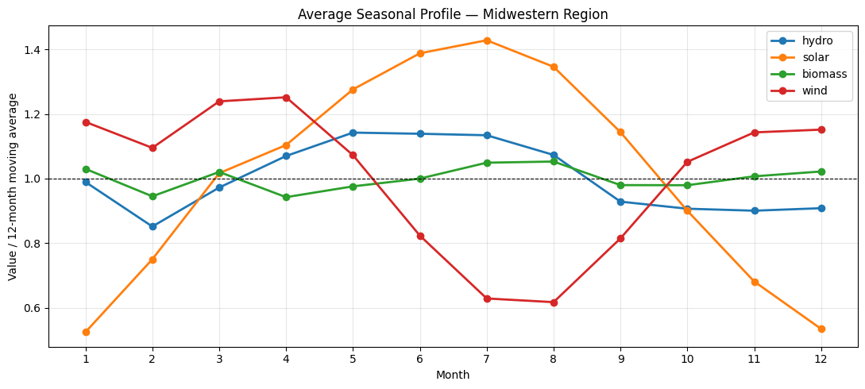
Figure 4.5: Average seasonal profile of each resource

Seasonal pattern
Resource | Peak | Trough | Size | Explanation
Hydro | May (+14.2% above trend) | February (−14.8%) | moderate | April–August are above trend (spring snowmelt and rainfall on the Missouri and upper Mississippi rivers). Late autumn and winter, when rivers are low or frozen, are below trend
Solar | July (+42.8%) | January (−47.5%) | very large | March–September above trend, October–February below. The swing is larger than in the South because of the Midwest's higher latitude (much shorter winter days)
Biomass | August (+5.3%) | April (−5.8%) | small | Slightly higher in mid-summer and mid-winter, lower in spring
Wind | April (+25.2%) | August (−38.3%) | Large | Strongest in spring and weakest in summer(opposite to solar's peak)

Midwestern hydro and solar peak in roughly the same season (May and July). The region's renewable output from these sources is therefore concentrated in spring and summer.
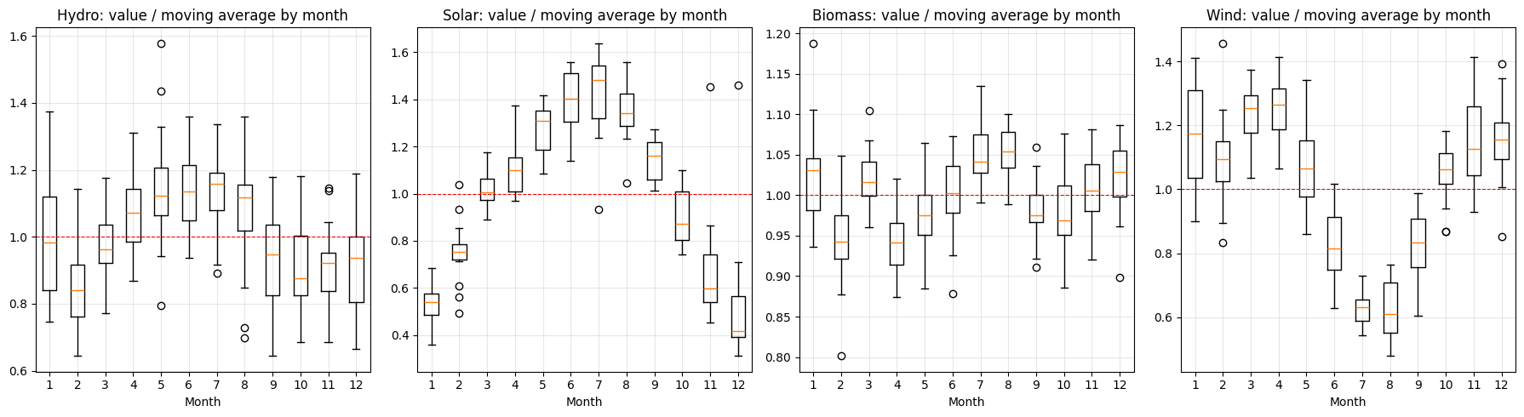
Figure 4.6: Month-of-year boxplots (value ÷ moving average)

4.4 Seasonal decomposition
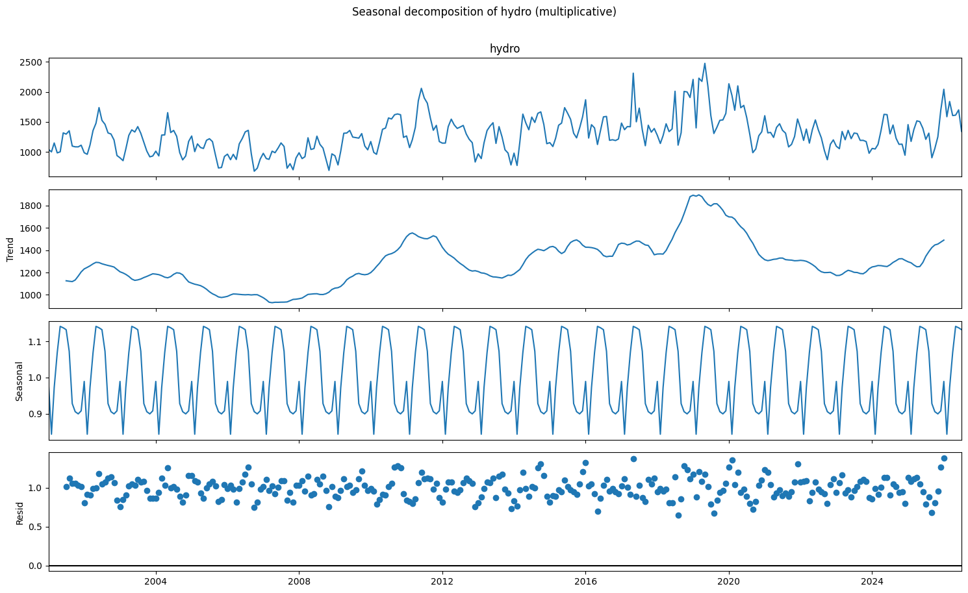
Figure 4.7: Seasonal decomposition of hydro
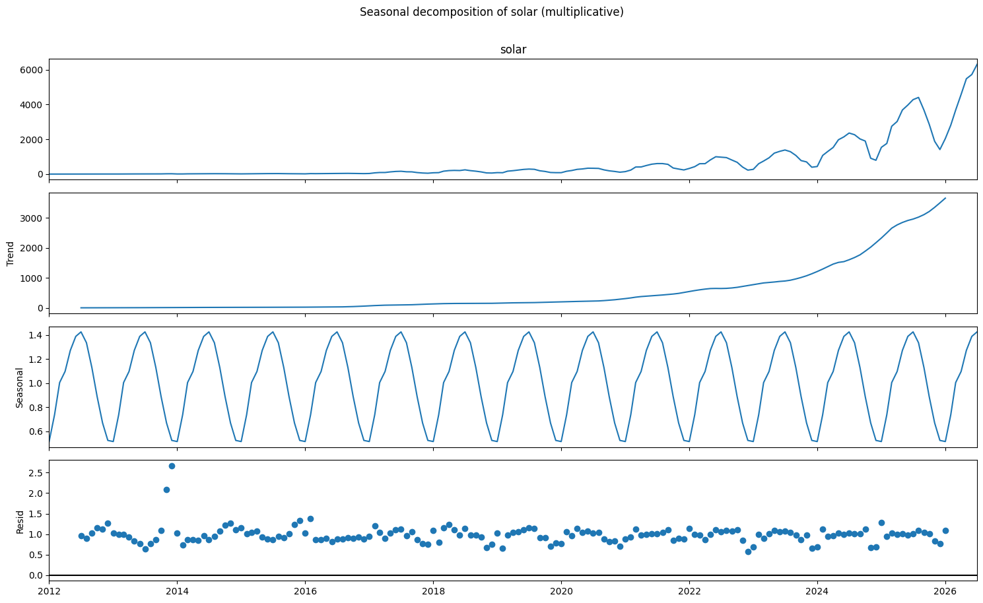
Figure 4.8: Seasonal decomposition of solar
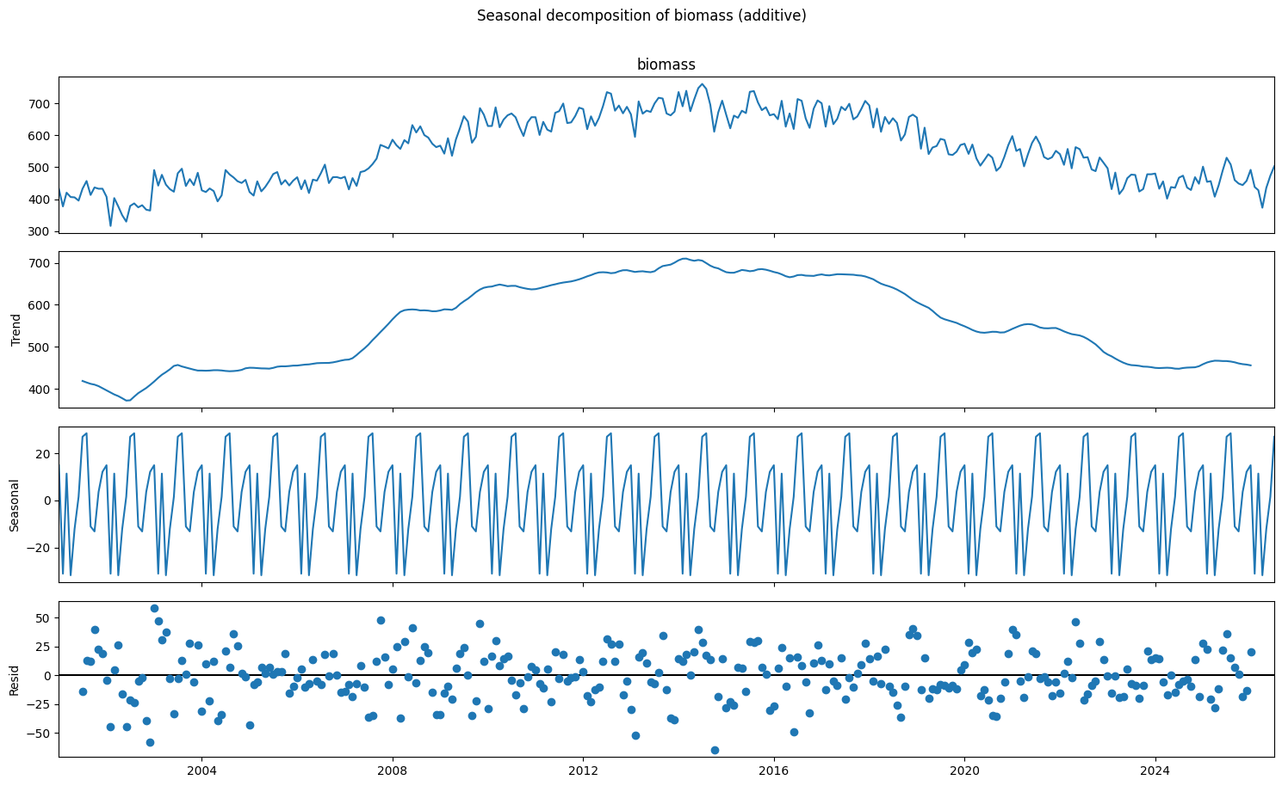
Figure 4.9: Seasonal decomposition of biomass
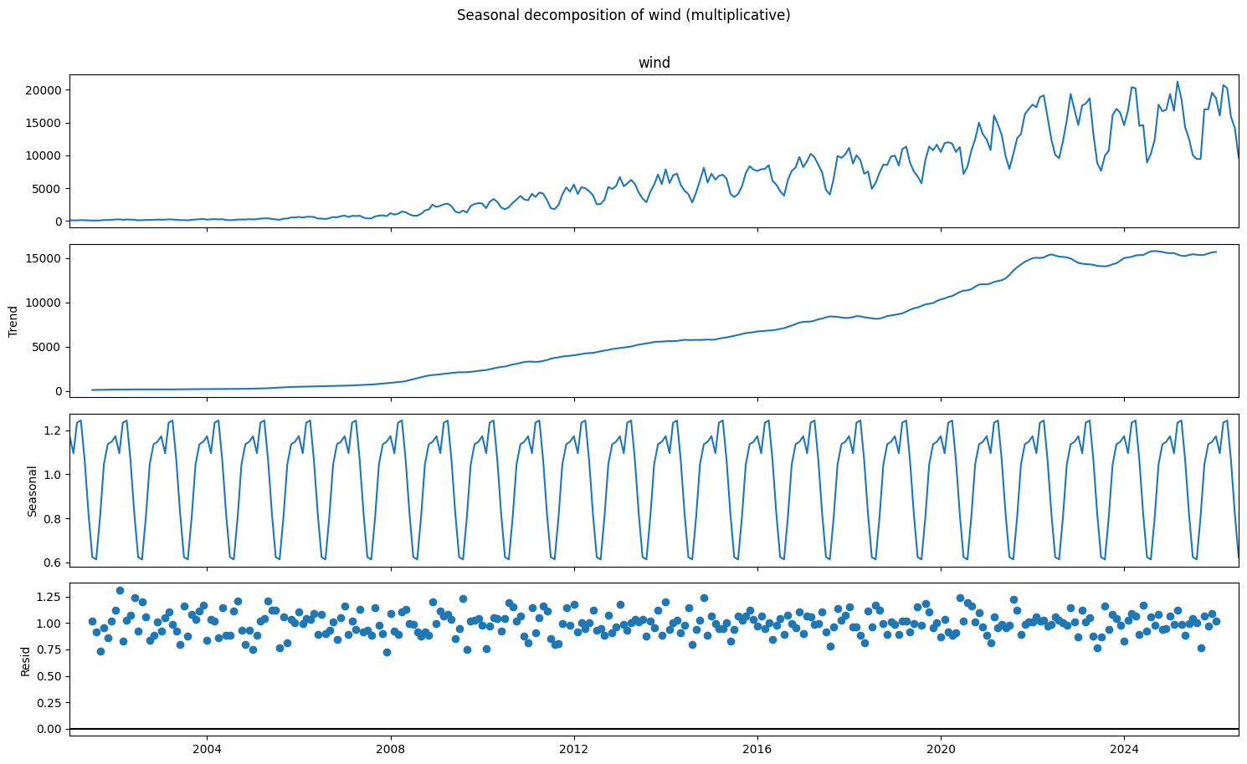
Figure 4.10: Seasonal decomposition of wind
Table 4.4 Seasonal and trend strength (0 = none, 1 = maximum)
Resource | Seasonal strength | Trend strength
hydro | 0.367 | 0.587
solar | 0.802 | 0.989
biomass | 0.457 | 0.957
wind | 0.829 | 0.995

Seasonal decomposition interpretation
- Hydro (multiplicative): seasonal strength 0.37 and trend strength 0.59. The seasonal cycle is real but the irregular component is large, driven by wet and dry years.
- Solar (multiplicative): trend strength 0.99 and seasonal strength 0.80. Solar is almost entirely trend plus a very regular summer cycle.
- Biomass (additive): trend strength 0.96 and seasonal strength 0.46. The slow rise-and-decline trend dominates, with only a modest seasonal component.
- Wind (multiplicative): Trend strength is 1.00 (0.995) and seasonal strength is 0.83. Wind generation is strongly dominated by its long-term trend, with a pronounced seasonal pattern. The relatively high seasonal strength indicates that seasonality explains a substantial part of the variation remaining after accounting for the trend.

5. ADF Stationarity Test (Before and After Differencing)

5.1 Test design
- Augmented Dickey-Fuller (ADF): H0 = the series has a unit root (non-stationary). p < 0.05 means stationary.
- KPSS (confirmatory): H0 = the series is stationary. p < 0.05 means non-stationary. The KPSS p-value is limited by its lookup table to 0.01–0.10.
- A series is called stationary only when both tests agree. The original series are tested with a constant and a trend; transformed series with a constant only.

5.2 Before differencing: visual evidence (ACF of the original series)
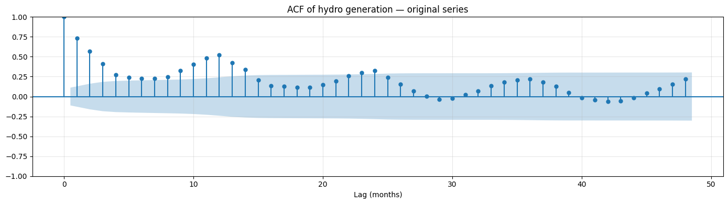
Figure 5.1: ACF of the original hydro series (lags 0–48)
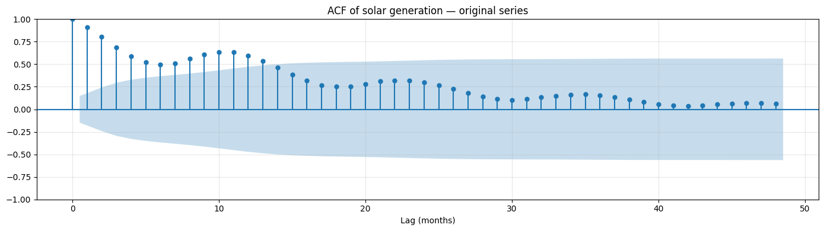
Figure 5.2: ACF of the original solar series (lags 0–48)
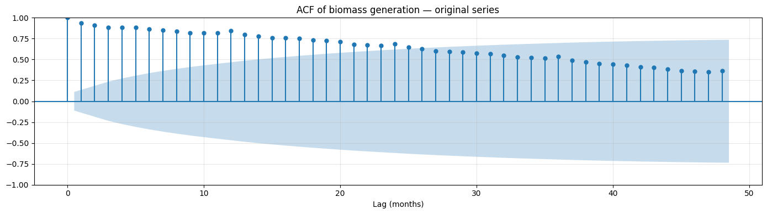
Figure 5.3: ACF of the original biomass series (lags 0–48)
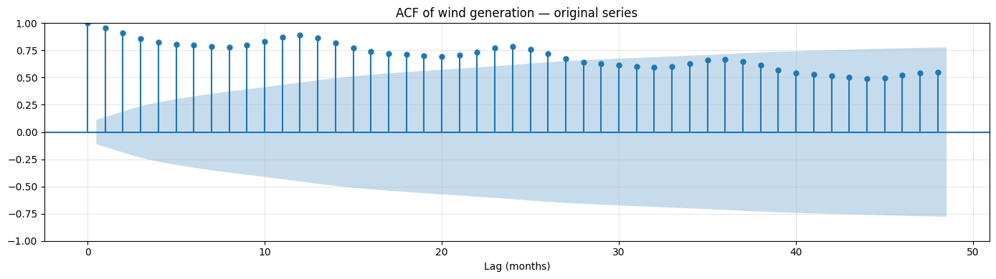
Figure 5.4: ACF of the original wind series (lags 0–48)

ACF interpretation (original series)
- Hydro: The ACF decays from 0.73 (lag 1) to about 0.24 (lag 5), then rises again to 0.52 at lag 12 and 0.33 at lag 24. This shows short-term persistence plus a clear yearly cycle.
- Solar: The ACF decays slowly (0.91 at lag 1, about 0.5 by lag 6) with a bump at lag 12 (0.60). This shows trend plus seasonality.
- Biomass: The ACF stays very high for a long time: 0.93 at lag 1, 0.84 at lag 12 and still 0.54 at lag 36. Such slow decay is the classic signature of a non-stationary, trend-dominated series.
- Wind: The ACF starts at 1.00 at lag 0 and remains strongly positive throughout the 48-month range, declining gradually from about 0.95 at lag 1 to around 0.55 at lag 48. It also shows a mild rise around lags 10–13 and 22–25, suggesting a possible yearly pattern. The slow decay indicates strong persistence and a substantial long-term trend. The repeating bumps are consistent with annual seasonality, though the trend may contribute to the high autocorrelation across many lags.

5.3 Before differencing: ADF and KPSS on the original series
Table 5.1 ADF and KPSS tests on the original series (constant + trend)
# | Series | n | ADF stat | ADF p | KPSS stat | KPSS p | Conclusion
0 | hydro (original) | 307 | -2.681 | 0.244 | 0.184 | 0.022 | Non-stationary
1 | solar (original) | 175 | -2.169 | 0.507 | 0.399 | 0.010 | Non-stationary
2 | biomass (original) | 307 | -0.818 | 0.964 | 0.695 | 0.010 | Non-stationary
3 | wind (original) | 307 | -2.545 | 0.306 | 0.566 | 0.010 | Non-stationary

Stationarity of the original series
Resource | ADF p-value | KPSS p-value | Conclusion
Hydro | 0.244 | 0.022 | Non-stationary
Solar | 0.507 | 0.010 | Non-stationary
Biomass | 0.964 | 0.010 | Non-stationary
Wind | 0.306 | 0.010 | Non-stationary

All four original series are non-stationary, as supported by both the ADF and KPSS tests. For every resource, the ADF p-value is greater than 0.05, so the null hypothesis of a unit root cannot be rejected. The KPSS p-value is at or below 0.05, so the null hypothesis of stationarity is rejected.
Therefore, differencing or another suitable transformation should be considered for all four resources before time-series modelling.

5.4 After transformation and differencing
Table 5.2 ADF and KPSS tests after log transform (multiplicative resources) and differencing
# | Series | n | ADF stat | ADF p | KPSS stat | KPSS p | Conclusion
0 | hydro: level, constant only (no trend term) | 307 | -1.809 | 0.376 | 1.207 | 0.010 | Non-stationary
1 | hydro: decomposition residual | 295 | -7.881 | 0.000 | 0.007 | 0.100 | Stationary
2 | hydro: first difference (d=1) | 306 | -7.819 | 0.000 | 0.027 | 0.100 | Stationary
3 | hydro: seasonal difference (D=1) | 295 | -3.902 | 0.002 | 0.060 | 0.100 | Stationary
4 | hydro: both (d=1, D=1) | 294 | -7.152 | 0.000 | 0.026 | 0.100 | Stationary
5 | solar: level, constant only (no trend term) | 175 | -0.207 | 0.938 | 1.844 | 0.010 | Non-stationary
6 | solar: decomposition residual | 163 | -3.672 | 0.005 | 0.142 | 0.100 | Stationary
7 | solar: first difference (d=1) | 174 | -4.091 | 0.001 | 0.033 | 0.100 | Stationary
8 | solar: seasonal difference (D=1) | 163 | -4.225 | 0.001 | 0.101 | 0.100 | Stationary
9 | solar: both (d=1, D=1) | 162 | -3.856 | 0.002 | 0.065 | 0.100 | Stationary
10 | biomass: level, constant only (no trend term) | 307 | -1.271 | 0.642 | 0.793 | 0.010 | Non-stationary
11 | biomass: decomposition residual | 295 | -7.183 | 0.000 | 0.010 | 0.100 | Stationary
12 | biomass: first difference (d=1) | 306 | -5.634 | 0.000 | 0.272 | 0.100 | Stationary
13 | biomass: seasonal difference (D=1) | 295 | -2.468 | 0.123 | 0.838 | 0.010 | Non-stationary
14 | biomass: both (d=1, D=1) | 294 | -8.525 | 0.000 | 0.500 | 0.042 | Mixed evidence
15 | wind: level, constant only (no trend term) | 307 | -2.059 | 0.261 | 2.691 | 0.010 | Non-stationary
16 | wind: decomposition residual | 295 | -9.750 | 0.000 | 0.191 | 0.100 | Stationary
17 | wind: first difference (d=1) | 306 | -3.809 | 0.003 | 0.315 | 0.100 | Stationary
18 | wind: seasonal difference (D=1) | 295 | -2.233 | 0.194 | 1.260 | 0.010 | Non-stationary
19 | wind: both (d=1, D=1) | 294 | -8.350 | 0.000 | 0.067 | 0.100 | Stationary

Stationarity analysis: final interpretation
- Hydro (log scale): The level is non-stationary (ADF p = 0.376, KPSS p = 0.010). A first difference makes it stationary (ADF p < 0.001, KPSS p ≥ 0.10). The seasonal difference is also stationary, but hydro's seasonal strength is only 0.37, so a seasonal difference is not needed; seasonality can instead be modelled with seasonal AR/MA terms. Use d = 1, D = 0.
- Solar (log scale): A seasonal difference alone makes it stationary (ADF p = 0.001, KPSS p ≥ 0.10). Use d = 0, D = 1. Applying both differences may cause over-differencing.
- Biomass: The level is non-stationary; the seasonal difference alone remains non-stationary (ADF p = 0.123). The first difference is stationary (ADF p < 0.001, KPSS p ≥ 0.10), while applying both differences gives mixed evidence (KPSS p = 0.042), potentially indicating over-differencing. Use d = 1, D = 0.
- Wind (log scale): The level is non-stationary (ADF p = 0.261, KPSS p = 0.010). A first difference makes it stationary (ADF p = 0.003, KPSS p ≥ 0.10). The seasonal difference alone remains non-stationary (ADF p = 0.194, KPSS p = 0.010), while applying both differences produces stationarity (ADF p < 0.001, KPSS p ≥ 0.10). Since first differencing alone is sufficient, start with d = 1, D = 0 and assess whether seasonal AR/MA terms adequately capture the remaining seasonality.
The decomposition residuals of all four resources are stationary according to both tests. This suggests that the decomposition has removed the trend and seasonal structure sufficiently for the residuals to be stationary.

5.5 Differencing orders used for modelling
The same rule is applied to every resource: use a seasonal difference (D = 1) when the seasonal strength exceeds 0.64; then add a first difference (d = 1) if ADF and KPSS do not both confirm stationarity. In the forecasting stage the rule is re-applied to the training data only (January 2001 – July 2024), so the test period does not influence the choice.
Table 5.3 Stationary series selected in the exploratory analysis
Resource | Series used for ACF/PACF (full data)
Hydro | Δ log(hydro)
Solar | Δ12 log(solar)
Biomass | Δ biomass
Wind | Δ Δ12 log(wind)

Table 5.4 Differencing orders chosen on the training data
Resource | Seasonal strength | D | ADF p after D | KPSS p after D | d
hydro | 0.378 | 0 | 0.279 | 0.010 | 1
solar | 0.790 | 1 | 0.003 | 0.100 | 0
biomass | 0.444 | 0 | 0.659 | 0.010 | 1
wind | 0.827 | 1 | 0.093 | 0.010 | 1

6. ACF / PACF Plots and Justification for ARIMA/SARIMA Order Selection

6.1 ACF and PACF of the stationary series
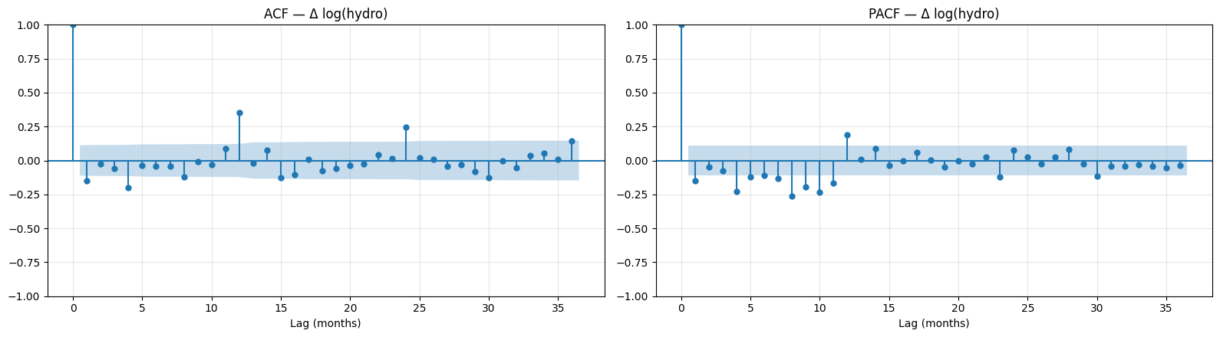
Figure 6.1: ACF and PACF of the stationary hydro series (lags 0–36)
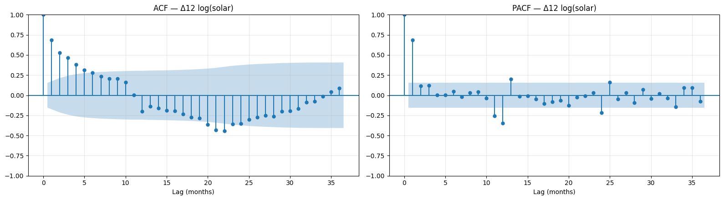
Figure 6.2: ACF and PACF of the stationary solar series (lags 0–36)
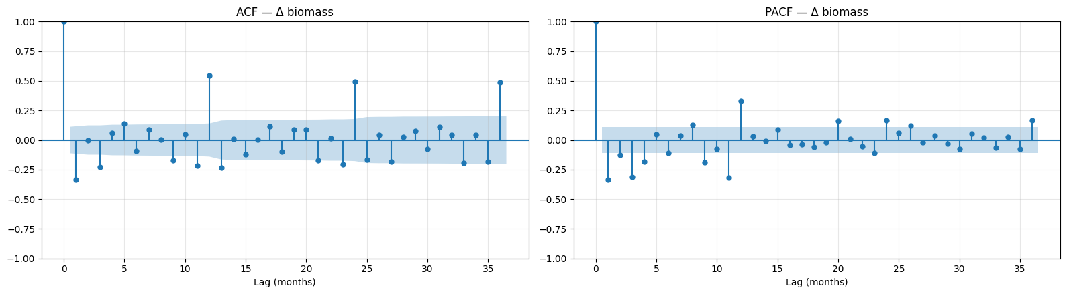
Figure 6.3: ACF and PACF of the stationary biomass series (lags 0–36)
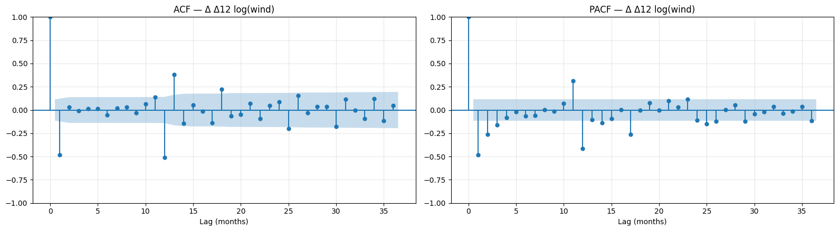
Figure 6.4: ACF and PACF of the stationary wind series (lags 0–36)
Table 6.1 Key ACF / PACF values of the stationary series
Resource | Series | ACF lag 1 | ACF lag 12 | PACF lag 1 | PACF lag 12 | Significant ACF lags (≤13) | Significant PACF lags (≤13) | 95% bound
Hydro | Δ log(hydro) | -0.147 | 0.351 | -0.147 | 0.188 | 1, 4, 8, 12 | 1, 4, 5, 7, 8, 9, 10, 11, 12 | 0.112
Solar | Δ12 log(solar) | 0.684 | -0.199 | 0.684 | -0.345 | 1, 2, 3, 4, 5, 6, 7, 8, 9, 10, 12 | 1, 11, 12, 13 | 0.154
Biomass | Δ biomass | -0.335 | 0.547 | -0.335 | 0.333 | 1, 3, 5, 9, 11, 12, 13 | 1, 2, 3, 4, 8, 9, 11, 12 | 0.112
Wind | Δ Δ12 log(wind) | -0.482 | -0.513 | -0.482 | -0.414 | 1, 11, 12, 13 | 1, 2, 3, 11, 12 | 0.114

6.2 Reading the plots and the suggested orders

ACF / PACF interpretation and suggested models
Resource | Pattern on the stationary series | Suggested model
Hydro (Δ log) | Small negative ACF at lag 1 (−0.15), which is commonly associated with first differencing and suggests an MA(1) term. A positive spike at lag 12 (ACF 0.35, PACF 0.19) indicates that yearly dependence remains, suggesting seasonal AR and/or MA terms. | SARIMA(1,1,1)(1,0,1)12
Solar (Δ12 log) | ACF starts at 0.68 and decays gradually over lags 1–10, while the PACF has its strongest spike at lag 1, suggesting an AR(1) component. The PACF spike at lag 12 (−0.35) also suggests seasonal dependence. | SARIMA(1,0,0)(1,1,1)12 with drift
Biomass (Δ) | ACF at lag 1 (−0.34) suggests an MA(1) component. Strong positive seasonal spikes at lag 12 (ACF 0.55, PACF 0.33) suggest seasonal AR and/or MA terms. | SARIMA(1,1,1)(1,0,1)12
Wind (Δ Δ12 log) | Strong negative ACF spikes at lag 1 (−0.48) and lag 12 (−0.51), with negative PACF values at both lags (−0.48 and −0.41). This indicates substantial short-term and annual dependence remains after both differences. The pattern suggests investigating non-seasonal MA and seasonal MA terms, while checking whether applying both differences has over-differenced the series. | Start by comparing SARIMA(1,1,1)(0,1,1)12 and simpler alternatives using AIC and residual diagnostics.

The ACF/PACF plots provide candidate model orders rather than definitive specifications. The final models should be selected using information criteria such as AIC and validated with residual diagnostics, including residual ACF and the Ljung–Box test.

6.3 Confirmation by AIC grid search
Orders were then searched by AIC on the training data (ARIMA: p, q ≤ 3; SARIMA: p, q ≤ 2 and P, Q ≤ 1 with s = 12; d and D fixed from Section 5). Failed or degenerate fits are rejected.
Table 6.2 Orders selected by AIC (training data)
Resource | Model | Selected order | AIC
Hydro | ARIMA | ARIMA(2,1,3) | -270.1
Hydro | SARIMA | SARIMA(1,1,1)(1,0,1)12 | -301.2
Hydro | SARIMAX (Fourier exog.) | ARIMA(1,1,1) | -293.1
Solar | ARIMA | ARIMA(2,1,2) + drift | -18.4
Solar | SARIMA | SARIMA(1,0,0)(1,1,1)12 + drift | -45.7
Solar | SARIMAX (Fourier exog.) | ARIMA(3,1,3) + drift | -53.9
Biomass | ARIMA | ARIMA(2,1,3) | 2768.1
Biomass | SARIMA | SARIMA(1,1,1)(1,0,1)12 | 2650.9
Biomass | SARIMAX (Fourier exog.) | ARIMA(3,1,3) | 2720.5
Wind | ARIMA | ARIMA(3,1,3) | -102.4
Wind | SARIMA | SARIMA(0,1,1)(0,1,1)12 | -271.1
Wind | SARIMAX (Fourier exog.) | ARIMA(0,1,1) + drift | -302.9

Table 6.3 Top three SARIMA candidates by AIC for each resource
Resource | SARIMA candidate | Trend term | AIC
Hydro | SARIMA(1,1,1)(1,0,1)12 | none | -301.207
Hydro | SARIMA(1,1,2)(1,0,1)12 | none | -299.518
Hydro | SARIMA(2,1,1)(1,0,1)12 | none | -299.475
Solar | SARIMA(1,0,0)(1,1,1)12 | drift | -45.731
Solar | SARIMA(1,0,0)(0,1,1)12 | drift | -45.330
Solar | SARIMA(1,0,1)(0,1,1)12 | drift | -44.100
Biomass | SARIMA(1,1,1)(1,0,1)12 | none | 2650.891
Biomass | SARIMA(0,1,2)(1,0,1)12 | none | 2651.476
Biomass | SARIMA(2,1,1)(1,0,1)12 | none | 2652.823
Wind | SARIMA(0,1,1)(0,1,1)12 | none | -271.105
Wind | SARIMA(0,1,2)(0,1,1)12 | none | -270.594
Wind | SARIMA(1,1,1)(0,1,1)12 | none | -270.511

6.4 Order justification and estimated coefficients
The AIC search confirms the ACF/PACF readings: log-hydro SARIMA(1,1,1)(1,0,1)12, log-solar SARIMA(1,0,0)(1,1,1)12 with drift and biomass SARIMA(1,1,1)(1,0,1)12 are exactly the orders suggested by the plots. For wind, the plots pointed to non-seasonal and seasonal MA terms after both differences; the AIC search selected the simplest such model, the airline model SARIMA(0,1,1)(0,1,1)12 on the log scale.
Table 6.4 Hydro: SARIMA(1,1,1)(1,0,1)12 coefficients (training data)
Parameter | Coefficient | Std. error | z | p-value | 95% CI lower | 95% CI upper
AR(1) φ1 | 0.5978 | 0.064 | 9.409 | 0.000 | 0.473 | 0.722
MA(1) θ1 | -0.9389 | 0.030 | -31.239 | 0.000 | -0.998 | -0.880
Seasonal AR(1) Φ1 | 0.7819 | 0.084 | 9.347 | 0.000 | 0.618 | 0.946
Seasonal MA(1) Θ1 | -0.5001 | 0.113 | -4.421 | 0.000 | -0.722 | -0.278
σ² (error variance) | 0.0192 | 0.001 | 13.043 | 0.000 | 0.016 | 0.022

Table 6.5 Solar: SARIMA(1,0,0)(1,1,1)12 + drift coefficients (training data)
Parameter | Coefficient | Std. error | z | p-value | 95% CI lower | 95% CI upper
Drift (trend) | 0.0389 | 0.002 | 16.086 | 0.000 | 0.034 | 0.044
AR(1) φ1 | 0.7733 | 0.051 | 15.083 | 0.000 | 0.673 | 0.874
Seasonal AR(1) Φ1 | 0.2556 | 0.137 | 1.870 | 0.061 | -0.012 | 0.524
Seasonal MA(1) Θ1 | -0.8322 | 0.149 | -5.604 | 0.000 | -1.123 | -0.541
σ² (error variance) | 0.0365 | 0.004 | 9.181 | 0.000 | 0.029 | 0.044

Table 6.6 Biomass: SARIMA(1,1,1)(1,0,1)12 coefficients (training data)
Parameter | Coefficient | Std. error | z | p-value | 95% CI lower | 95% CI upper
AR(1) φ1 | 0.3233 | 0.136 | 2.375 | 0.018 | 0.057 | 0.590
MA(1) θ1 | -0.6854 | 0.108 | -6.321 | 0.000 | -0.898 | -0.473
Seasonal AR(1) Φ1 | 0.9824 | 0.013 | 74.456 | 0.000 | 0.957 | 1.008
Seasonal MA(1) Θ1 | -0.8214 | 0.056 | -14.577 | 0.000 | -0.932 | -0.711
σ² (error variance) | 649.1225 | 39.735 | 16.336 | 0.000 | 571.244 | 727.001

All hydro coefficients are significant (AR(1) 0.60, MA(1) −0.94, seasonal AR 0.78, seasonal MA −0.50). For solar the drift (0.039 per month on the log scale, about 4% growth per month) and the AR(1) (0.77) are highly significant, and the seasonal MA(1) (−0.83) matches the negative lag-12 PACF; the seasonal AR term is only marginal (p = 0.061). For biomass the seasonal AR coefficient is almost 1 (0.98), so the model effectively repeats last year's pattern.

7. Model Fitting, Selection, and Forecasting Evaluation

7.1 Train / test design
- The split is chronological: the model only ever sees the past. Random shuffling is not used, because it would let models learn from future months.
- Test set = the last 24 months (August 2024 – July 2026): two full seasonal cycles, so each calendar month is tested twice.
- Training set = everything before August 2024 (283 months for hydro, biomass and wind; 151 months for solar).
- Every model forecasts all 24 test months from the end of the training data (multi-step forecasting), as it would be used in practice.
- After evaluation, the best model of each resource is re-fitted on all data and forecasts August 2026 – July 2027.

7.2 Candidate models
Table 7.1 Models compared for every resource
Family | Models
Baseline | Naive (last value), Seasonal Naive (same month last year)
Classical | ARIMA (with differencing), SARIMA, SARIMAX with Fourier (sine/cosine) seasonal terms
Exponential smoothing | SES, Holt (damped), Holt-Winters additive / multiplicative / additive damped
Machine learning | Linear Regression, Random Forest on lagged year-on-year changes (lags 1, 2, 3, 6, 12; rolling means 3/6/12; month sin/cos; quarter)
Neural network | Multi-layer perceptron (16 and 8 hidden units, L2 penalty, early stopping)

- Resources with multiplicative seasonality are modelled on the log scale by ARIMA, SARIMA, SARIMAX and the ML models and converted back with exp().
- SARIMAX regressors are Fourier terms (and a time index when the series is not differenced). They are known in advance for any future month, so there is no data leakage.
- ML and neural-network models predict the change from the same month last year and are applied recursively (each prediction is fed back as a lag). A small MLP is used instead of an LSTM/GRU because each resource has only about 150–280 training months.

7.3 Evaluation metrics
MAE = (1/n) Σ |yₜ − ŷₜ|
RMSE = √[ (1/n) Σ (yₜ − ŷₜ)² ]
MAPE = (100/n) Σ |yₜ − ŷₜ| / yₜ
- MAE and RMSE are in GWh; RMSE penalises large errors more. MAPE is scale-free, so it is used to compare resources.
- MASE (MAE ÷ in-sample seasonal-naive MAE) is also reported; models are ranked by MASE. For fast-growing series (solar), MASE is inflated by the tiny early values, so MAPE is the meaningful comparison.

7.4 Hydro: test-period results
Table 7.2 Hydro: accuracy on the 24 test months (Aug 2024 – Jul 2026), ranked by MASE
Model | MAE (GWh) | RMSE (GWh) | MAPE (%) | MASE | Family
Linear Regression | 211.655 | 319.015 | 13.668 | 0.983 | ML
Holt-Winters multiplicative | 213.422 | 291.613 | 14.276 | 0.991 | Holt-Winters
Holt (damped) | 222.083 | 273.795 | 16.569 | 1.031 | Exponential smoothing
SES | 222.743 | 274.991 | 16.574 | 1.034 | Exponential smoothing
Holt-Winters additive | 223.787 | 307.327 | 14.832 | 1.039 | Holt-Winters
Holt-Winters add. damped | 226.997 | 312.264 | 14.997 | 1.054 | Holt-Winters
ARIMA | 227.147 | 304.834 | 15.162 | 1.055 | ARIMA
Seasonal Naive | 229.979 | 342.347 | 15.087 | 1.068 | Baseline
Naive | 232.922 | 289.304 | 16.493 | 1.081 | Baseline
SARIMAX (Fourier exog) | 239.643 | 326.927 | 15.803 | 1.113 | SARIMAX
SARIMA | 241.307 | 322.164 | 15.843 | 1.120 | SARIMA
Random Forest | 246.901 | 373.679 | 15.643 | 1.146 | ML
Neural Network (MLP) | 280.041 | 388.153 | 18.865 | 1.300 | Neural network

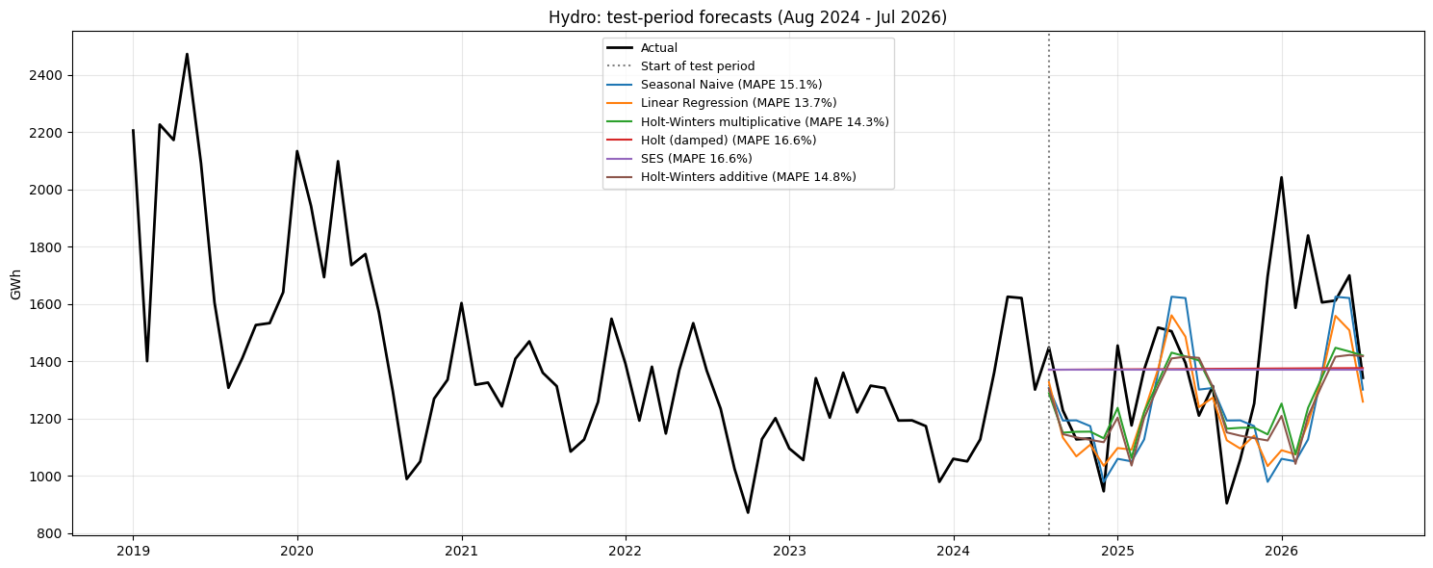
Figure 7.1: Hydro: test-period forecasts of the best models vs actual values

Hydro: model results
- Best model: Linear Regression on lag features of year-on-year log change. MAPE 13.7%, MASE 0.983.
- The gain over the seasonal naive (MAPE 15.1%) is small: an 8% lower MAE. Holt-Winters multiplicative is essentially tied (14.3%, MASE 0.991).
- Most models fall in a narrow 13.7–16.6% band, and SARIMA (15.8%) is no better than the baseline. Hydro has no strong signal beyond its average seasonal shape, and its deviations come from weather that the past cannot predict.
- The neural network is the worst model (18.9%). With fewer than 300 training rows it overfits.

7.5 Solar: test-period results
Table 7.3 Solar: accuracy on the 24 test months (Aug 2024 – Jul 2026), ranked by MASE
Model | MAE (GWh) | RMSE (GWh) | MAPE (%) | MASE | Family
SARIMAX (Fourier exog) | 264.179 | 301.825 | 11.448 | 2.425 | SARIMAX
SARIMA | 292.513 | 363.522 | 11.231 | 2.685 | SARIMA
Random Forest | 365.426 | 425.685 | 15.084 | 3.354 | ML
Linear Regression | 525.964 | 597.499 | 20.162 | 4.828 | ML
ARIMA | 551.134 | 625.316 | 19.211 | 5.059 | ARIMA
Holt-Winters additive | 788.118 | 1004.702 | 25.539 | 7.234 | Holt-Winters
Holt-Winters add. damped | 810.183 | 1046.296 | 25.689 | 7.436 | Holt-Winters
Holt-Winters multiplicative | 899.781 | 1054.277 | 28.642 | 8.259 | Holt-Winters
Neural Network (MLP) | 1082.258 | 1244.929 | 35.064 | 9.934 | Neural network
Holt (damped) | 1162.987 | 1404.686 | 54.241 | 10.675 | Exponential smoothing
Naive | 1302.328 | 1650.301 | 47.195 | 11.953 | Baseline
SES | 1302.328 | 1650.301 | 47.195 | 11.953 | Exponential smoothing
Seasonal Naive | 1819.004 | 2079.520 | 57.612 | 16.696 | Baseline

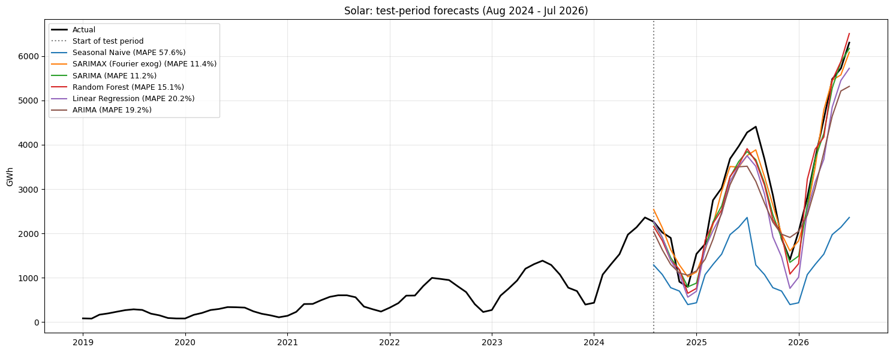
Figure 7.2: Solar: test-period forecasts of the best models vs actual values

Solar: model results
- Best model: SARIMAX, an ARIMA(3,1,3) with drift plus Fourier seasonal terms, on log(solar). MAPE 11.4%, an 85% lower MAE than the seasonal naive. SARIMA(1,0,0)(1,1,1)12 with drift is essentially tied (MAPE 11.2%, which is slightly lower; MASE 2.69 vs 2.43).
- Random Forest is next (15.1%), then ARIMA (19.1%) and linear regression (20.2%).
- Trend-free models fail badly:
- seasonal naive 57.6%;
- naive and SES 47.2%;
- damped Holt 54.2%. This supports H3: solar nearly doubled in 2025, and only models with an explicit growth (drift) term keep up.
- Holt-Winters (25.5–28.6%) and the neural network (35.1%) under-forecast the 2025–26 surge.
- The MASE values for solar are all above 1, because MASE is scaled by in-sample errors from years when solar was tiny. MAPE is the meaningful comparison here.

7.6 Biomass: test-period results
Table 7.4 Biomass: accuracy on the 24 test months (Aug 2024 – Jul 2026), ranked by MASE
Model | MAE (GWh) | RMSE (GWh) | MAPE (%) | MASE | Family
Seasonal Naive | 21.601 | 27.114 | 4.626 | 0.541 | Baseline
Holt-Winters multiplicative | 22.639 | 29.055 | 4.843 | 0.567 | Holt-Winters
Holt-Winters add. damped | 23.148 | 29.276 | 4.943 | 0.580 | Holt-Winters
Holt-Winters additive | 23.172 | 29.306 | 4.948 | 0.581 | Holt-Winters
Neural Network (MLP) | 23.503 | 28.794 | 5.275 | 0.589 | Neural network
Linear Regression | 24.236 | 30.420 | 5.389 | 0.607 | ML
SARIMAX (Fourier exog) | 25.085 | 31.769 | 5.323 | 0.629 | SARIMAX
Random Forest | 25.170 | 31.638 | 5.676 | 0.631 | ML
ARIMA | 26.561 | 35.690 | 5.742 | 0.666 | ARIMA
SES | 26.682 | 35.492 | 5.760 | 0.669 | Exponential smoothing
Holt (damped) | 26.972 | 35.908 | 5.804 | 0.676 | Exponential smoothing
Naive | 28.508 | 35.224 | 6.394 | 0.714 | Baseline
SARIMA | 37.657 | 45.396 | 7.945 | 0.944 | SARIMA

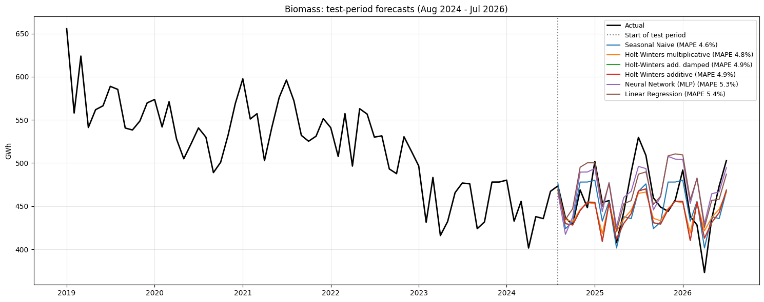
Figure 7.3: Biomass: test-period forecasts of the best models vs actual values

Biomass: model results
- Best model: Seasonal Naive (each month equals the same month last year). MAPE 4.6%, MASE 0.541.
- No model beats it. Holt-Winters multiplicative (4.8%), the neural network (5.3%), SARIMAX (5.3%) and linear regression (5.4%) come close.
- SARIMA is the weakest model (7.9%). Its estimated seasonal AR coefficient is almost 1 (0.98), so it effectively repeats last year, and then its ARMA terms add a downward drift that over-shoots.
- H2 is therefore not supported for biomass. Midwestern biomass is so stable from year to year that the simplest seasonal benchmark is the best forecast.

7.7 Wind: test-period results
Table 7.5 Wind: accuracy on the 24 test months (Aug 2024 – Jul 2026), ranked by MASE
Model | MAE (GWh) | RMSE (GWh) | MAPE (%) | MASE | Family
Holt-Winters multiplicative | 1152.714 | 1500.856 | 8.074 | 1.278 | Holt-Winters
Seasonal Naive | 1196.798 | 1710.383 | 7.720 | 1.327 | Baseline
Holt-Winters additive | 1723.654 | 2112.420 | 12.886 | 1.911 | Holt-Winters
Holt-Winters add. damped | 1787.699 | 2183.828 | 13.381 | 1.982 | Holt-Winters
SARIMA | 2589.414 | 3035.696 | 17.651 | 2.871 | SARIMA
ARIMA | 3406.732 | 4302.045 | 20.370 | 3.777 | ARIMA
SARIMAX (Fourier exog) | 4274.466 | 5045.409 | 28.452 | 4.739 | SARIMAX
Random Forest | 5494.918 | 6058.066 | 37.594 | 6.092 | ML
Holt (damped) | 6547.300 | 7538.311 | 37.781 | 7.259 | Exponential smoothing
SES | 6696.274 | 7669.597 | 38.799 | 7.424 | Exponential smoothing
Naive | 6696.274 | 7669.597 | 38.799 | 7.424 | Baseline
Linear Regression | 8426.592 | 9504.731 | 54.419 | 9.342 | ML
Neural Network (MLP) | 13281.853 | 15678.835 | 86.005 | 14.725 | Neural network

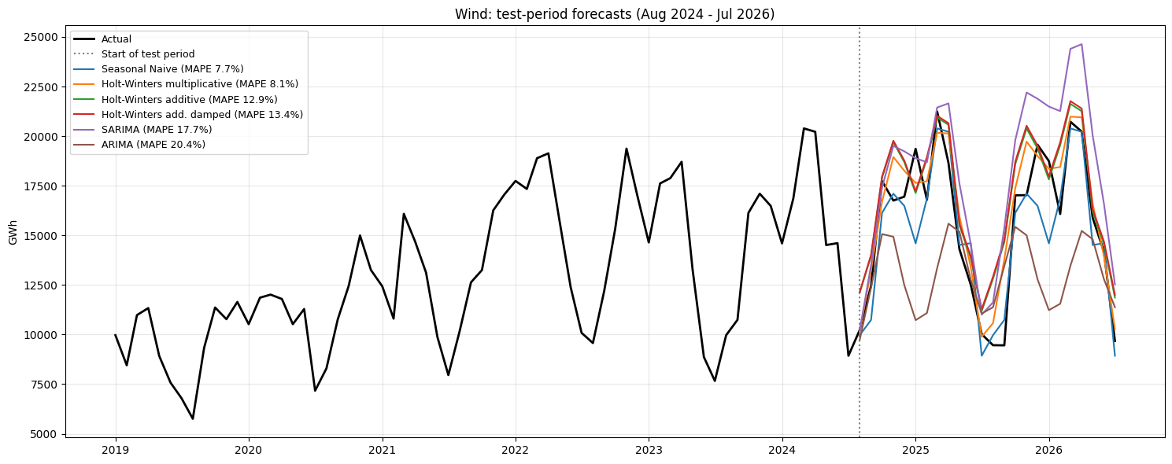
Figure 7.4: Wind: test-period forecasts of the best models vs actual values
- Best model: Holt-Winters multiplicative. MAPE 8.1%, MASE 1.28, with the lowest MAE (1,152.7 GWh) and RMSE (1,500.9 GWh) of all models — a 3.7% lower MAE than the seasonal naive.
- The seasonal naive is essentially tied: its MAPE is slightly lower (7.7%) but its MAE (1,196.8 GWh) and RMSE (1,710.4 GWh) are higher. Wind's spring-peak/summer-lull pattern is so regular that last year's values are already a strong forecast.
- SARIMA (0,1,1)(0,1,1)12 does poorly (17.7%), and ARIMA (20.4%) and SARIMAX (28.5%) are worse still: after both differences they extrapolate the earlier rapid growth, while wind output flattened in 2024–2025.
- Trend-free models without seasonality (naive and SES 38.8%), the ML models (Random Forest 37.6%, Linear Regression 54.4%) and the neural network (86.0%) fail. This supports H5 for Holt-Winters only.

7.8 Model comparison across resources
Table 7.6 MAPE (%) of the best model in each family
Resource | ARIMA | Baseline | Exponential smoothing | Holt-Winters | ML | Neural network | SARIMA | SARIMAX | Best model
Biomass | 5.742 | 4.626 | 5.760 | 4.843 | 5.389 | 5.275 | 7.945 | 5.323 | Seasonal Naive
Hydro | 15.162 | 15.087 | 16.569 | 14.276 | 13.668 | 18.865 | 15.843 | 15.803 | Linear Regression
Solar | 19.211 | 47.195 | 54.241 | 25.539 | 15.084 | 35.064 | 11.231 | 11.448 | SARIMAX (Fourier exog)
Wind | 20.370 | 7.720 | 37.781 | 8.074 | 37.594 | 86.005 | 17.651 | 28.452 | Holt-Winters multiplicative

Table 7.7 MASE of the best model in each family
Resource | ARIMA | Baseline | Exponential smoothing | Holt-Winters | ML | Neural network | SARIMA | SARIMAX
Biomass | 0.666 | 0.541 | 0.669 | 0.567 | 0.607 | 0.589 | 0.944 | 0.629
Hydro | 1.055 | 1.068 | 1.031 | 0.991 | 0.983 | 1.300 | 1.120 | 1.113
Solar | 5.059 | 11.953 | 10.675 | 7.234 | 3.354 | 9.934 | 2.685 | 2.425
Wind | 3.777 | 1.327 | 7.259 | 1.278 | 6.092 | 14.725 | 2.871 | 4.739

Table 7.8 Best model for each resource
Resource | Best model | Best MAPE (%) | Best MASE | Seasonal Naive MAPE (%) | MAE improvement vs Seasonal Naive (%)
Hydro | Linear Regression | 13.668 | 0.983 | 15.087 | 7.968
Solar | SARIMAX (Fourier exog) | 11.448 | 2.425 | 57.612 | 85.477
Biomass | Seasonal Naive | 4.626 | 0.541 | 4.626 | 0.000
Wind | Holt-Winters multiplicative | 8.074 | 1.278 | 7.720 | 3.684

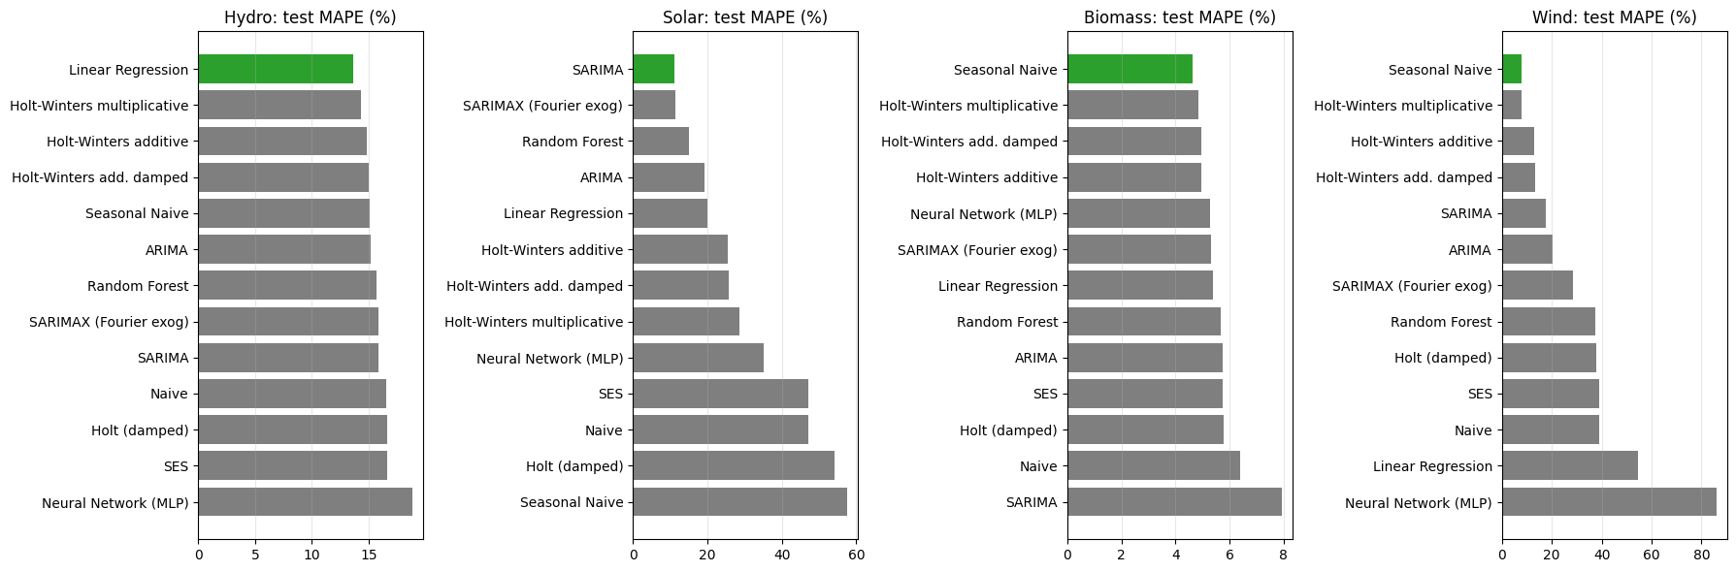
Figure 7.5: Test MAPE of every model, by resource (best model in green)

Model Comparison Across Resources
Resource | Best Model | Best Model MAPE | Seasonal Naive MAPE | Improvement in MAE
Biomass | Seasonal Naive | 4.6% | 4.6% | 0% (the benchmark itself)
Solar | SARIMAX (Fourier exog) | 11.45% | 57.6% | 85.6%
Hydro | Linear Regression | 13.7% | 15.1% | 8.0%
Wind | Holt–Winters multiplicative | 8.07% | 7.72% | 3.7%

*Note: Solar's SARIMAX model has a MAPE of 11.45%, while SARIMA achieves a slightly lower MAPE of 11.23%. SARIMAX is selected based on its lower MAE and RMSE. Wind's Seasonal Naive model has a slightly lower MAPE than Holt–Winters multiplicative.*

Key Findings
- Each resource has a different best-performing model, supporting the need to model each resource separately.
- Difficulty: Biomass is the easiest to forecast in relative terms, with a MAPE of 4.6%. Wind follows at 7.7–8.1%, Solar at approximately 11–12%, and Hydro at approximately 14–15%. These results describe performance on the selected test period rather than inherent forecasting difficulty across all periods.
- H2 — Seasonal models beat the baseline:
- Supported for Solar: SARIMA achieves 11.23% MAPE versus 57.6% for Seasonal Naive.
- Weakly supported for Hydro: Holt–Winters multiplicative achieves 14.28% MAPE versus 15.09% for Seasonal Naive.
- Not supported for Biomass: Seasonal Naive itself is the best-performing model.
- Mixed for Wind: Holt–Winters multiplicative has better MAE and RMSE, but Seasonal Naive has slightly better MAPE.
- H3 — Solar needs growth-aware models: Supported by the results. SARIMA and SARIMAX achieve approximately 11–12% MAPE, substantially better than the trend-free models, which have MAPE values around 19–20% for ARIMA and Linear Regression and higher values for some other methods. This supports the usefulness of seasonal and trend-aware modeling, although it does not isolate growth as the sole cause of improvement.
- H4 — Forecastability differs across resources: The results support differences in forecasting performance across resources. Biomass is easiest in this test period, while Hydro is harder in relative terms than Biomass and Wind. This is consistent with the hypothesis, but the results alone do not prove that weather variability causes Hydro's errors.

Conclusion
No single model performs best for every renewable energy resource. Seasonal Naive is sufficient for Biomass, SARIMAX is strongest for Solar by MAE and RMSE, Linear Regression is strongest for Hydro by MAE, and Holt–Winters multiplicative is strongest for Wind by MAE and RMSE. Model selection should therefore be resource-specific and consider multiple evaluation metrics.

7.9 Forecast for August 2026 – July 2027
The best model of each resource is re-fitted on all data up to July 2026 and forecasts the next 12 months. The band is an approximate 90% range taken from that model's test-period percentage errors.
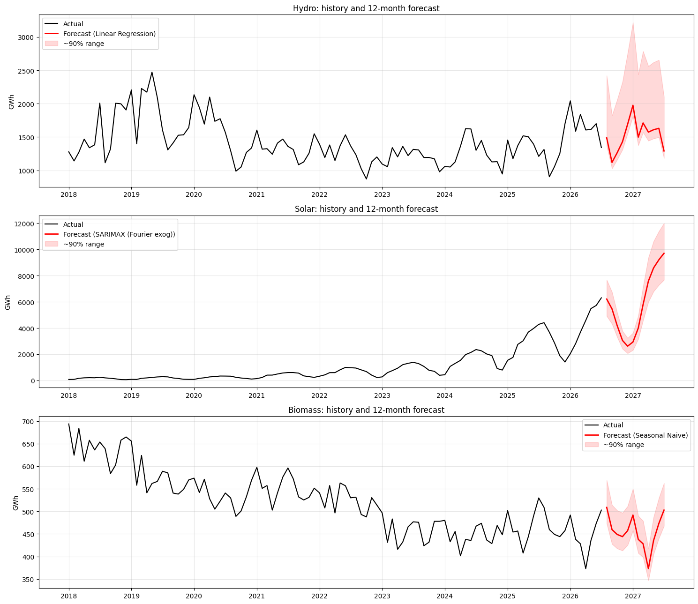
Figure 7.6: History and 12-month forecast of each resource
Table 7.10 Twelve-month outlook
Resource | Best model | Last 12 months (GWh) | Next 12 months (GWh) | Change (%) | Peak month | Lowest month | Share of next 12 months (%)
Hydro | Linear Regression | 17953.450 | 18282.999 | 1.836 | Jan 2027 | Sep 2026 | 6.287
Solar | SARIMAX (Fourier exog) | 44860.454 | 69300.422 | 54.480 | Jul 2027 | Dec 2026 | 23.829
Biomass | Seasonal Naive | 5461.279 | 5461.279 | 0.000 | Aug 2026 | Apr 2027 | 1.878
Wind | Holt-Winters multiplicative | 188025.812 | 197774.952 | 5.185 | Mar 2027 | Aug 2026 | 68.006

Table 7.11 Monthly forecasts (GWh)
Month | hydro | solar | biomass | wind
2026-08 | 1487.100 | 6209.500 | 508.800 | 10205.100
2026-09 | 1120.000 | 5455.600 | 459.600 | 13134.100
2026-10 | 1264.000 | 4191.200 | 448.900 | 17271.200
2026-11 | 1429.300 | 3052.000 | 444.000 | 18661.200
2026-12 | 1692.800 | 2618.600 | 457.300 | 18921.200
2027-01 | 1975.800 | 2931.100 | 491.800 | 18810.200
2027-02 | 1498.600 | 3994.900 | 438.000 | 18220.700
2027-03 | 1711.000 | 5790.900 | 428.100 | 20779.100
2027-04 | 1573.600 | 7577.400 | 373.100 | 20418.000
2027-05 | 1609.200 | 8578.600 | 435.300 | 17002.000
2027-06 | 1630.500 | 9201.900 | 473.300 | 13966.700
2027-07 | 1291.100 | 9698.700 | 502.800 | 10385.400

Forecast for Aug 2026 – Jul 2027
Resource | Last 12 months | Forecast next 12 months | Change | Peak | Low
Solar | 44,860 GWh | 69,300 GWh | +54.5% | Jul 2027 | Dec 2026
Hydro | 17,953 GWh | 18,283 GWh | +1.8% | Jan 2027 | Sep 2026
Biomass | 5,461 GWh | 5,461 GWh | 0.0% | Aug 2026 | Apr 2027
Wind | 188,026 GWh | 197,775 GWh | +5.2% | Mar 2027 | Aug 2026

- Solar continues its steep growth and would supply about 75% of the region's combined hydro + solar + biomass output (wind excluded) next year. The +54.5% comes from extending the recent drift of about 4% per month. If new solar capacity slows, the true growth will be lower.
- Hydro is expected to stay roughly flat (+1.8%).
- Biomass is forecast by the Seasonal Naive model, so it repeats the last 12 months exactly (0% change). Given the residual analysis, a small decline is more likely.
- Wind is forecast to increase by approximately 5.2%, from 188,026 GWh to 197,775 GWh, indicating moderate growth compared with the much steeper projected solar increase.

10. Geothermal
Geothermal generation is 0 GWh in every month from Jan 2001 to Jul 2026 in all 12 Midwestern states. There are no utility-scale geothermal plants in the region, so there is no time-series behaviour to model. Every model would forecast exactly 0. The forecast for geothermal is therefore 0 GWh, unless a new plant is built, which cannot be predicted from this data.

8. Residual Diagnostics and Interpretation

8.1 Method
- Best test model: one-step-ahead errors over the 60 months before the test period, re-estimating the model every month.
- SARIMA (for comparison): in-sample residuals of the AIC-selected SARIMA fitted on the training data (on the model scale: log for multiplicative resources).
- Tests: t-test for mean = 0; Ljung-Box at lags 6 and 12 (H0: no autocorrelation); Shapiro-Wilk (H0: normal). A good model has mean ≈ 0, Ljung-Box p > 0.05 and roughly normal residuals.

8.2 Hydro
Best hydro model on the test period: Linear Regression.
Table 8.1a Hydro: residual tests of the best test model
# | resource | model | n | mean | mean t-test p | std | Ljung-Box p (lag 6) | Ljung-Box p (lag 12) | Shapiro-Wilk p
0 | hydro | Linear Regression | 60 | -48.531 | 0.124 | 240.582 | 0.841 | 0.916 | 0.912

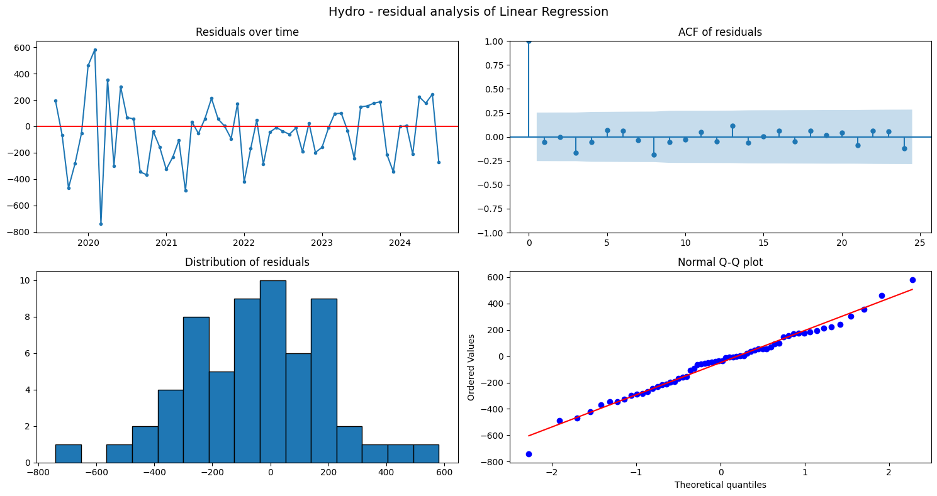
Figure 8.1: Hydro: residual analysis of the best test model (time plot, ACF, histogram, Q-Q plot)
Table 8.1b Hydro: residual tests of SARIMA (in-sample)
# | resource | model | n | mean | mean t-test p | std | Ljung-Box p (lag 6) | Ljung-Box p (lag 12) | Shapiro-Wilk p
0 | hydro | SARIMA (in-sample) | 270 | 0.001 | 0.934 | 0.140 | 0.415 | 0.391 | 0.565

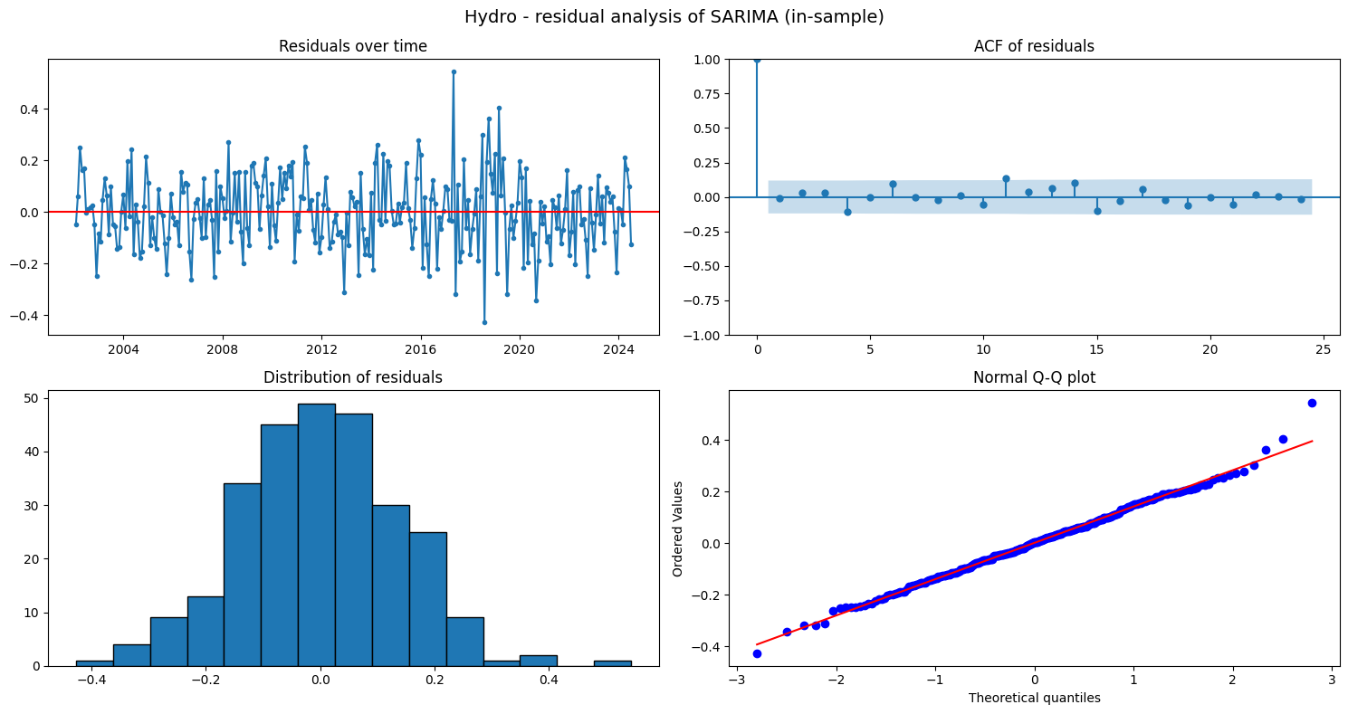
Figure 8.2: Hydro: residual analysis of SARIMA (in-sample)

Hydro: residual interpretation
- Linear Regression: the mean one-step error (−49 GWh) is not significantly different from 0 (p = 0.12). There is no autocorrelation (Ljung-Box p = 0.84 at lag 6, 0.92 at lag 12) and the errors are normal (Shapiro p = 0.91). These are white-noise residuals.
- SARIMA(1,1,1)(1,0,1)12 (log scale): residual mean ≈ 0 (p = 0.93), no autocorrelation (Ljung-Box p = 0.42 and 0.39) and normal (Shapiro p = 0.57). Also white noise.
Both models capture the hydro series' time structure. What remains is unpredictable weather-driven variation, which explains why no model gets much below about 14% error.

8.3 Solar
Best solar model on the test period: SARIMAX (Fourier exog).
Table 8.2a Solar: residual tests of the best test model
# | resource | model | n | mean | mean t-test p | std | Ljung-Box p (lag 6) | Ljung-Box p (lag 12) | Shapiro-Wilk p
0 | solar | SARIMAX (Fourier exog) | 60 | -10.433 | 0.405 | 96.379 | 0.068 | 0.015 | 0.001

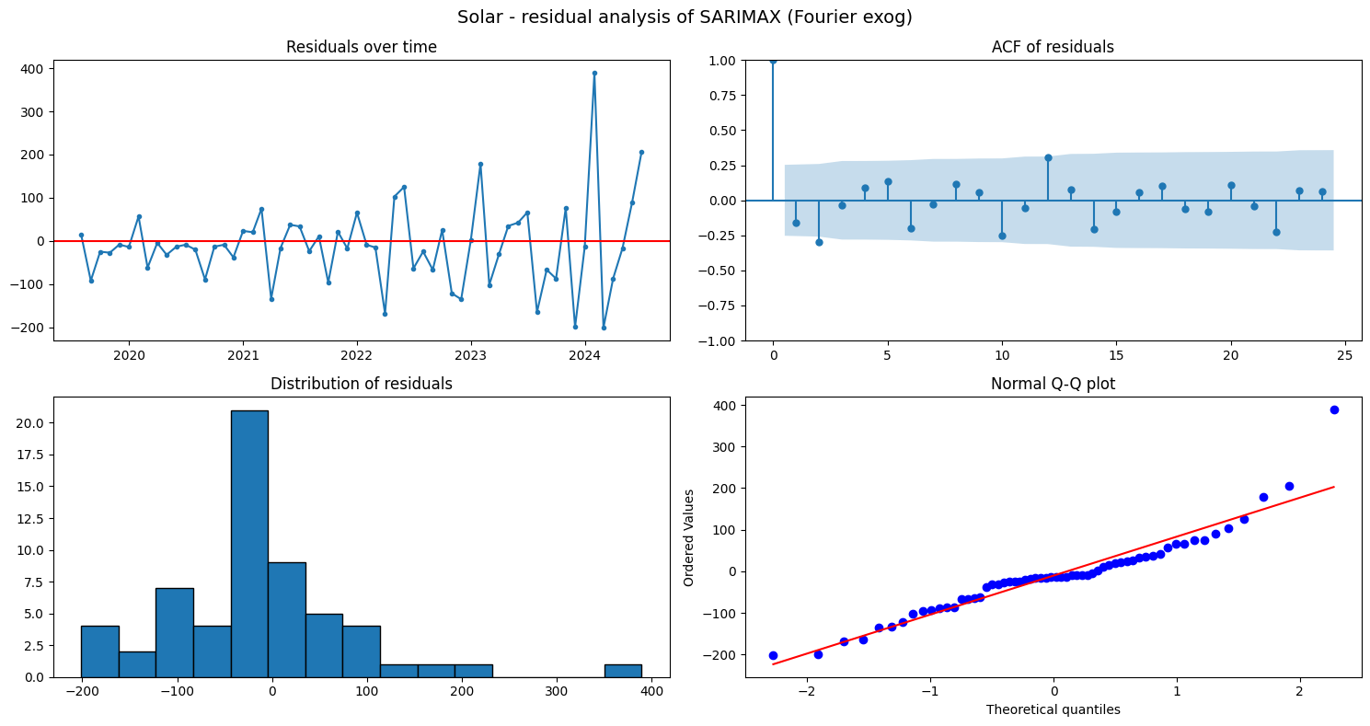
Figure 8.3: Solar: residual analysis of the best test model (time plot, ACF, histogram, Q-Q plot)
Table 8.2b Solar: residual tests of SARIMA (in-sample)
# | resource | model | n | mean | mean t-test p | std | Ljung-Box p (lag 6) | Ljung-Box p (lag 12) | Shapiro-Wilk p
0 | solar | SARIMA (in-sample) | 138 | 0.004 | 0.804 | 0.199 | 0.870 | 0.935 | 0.000

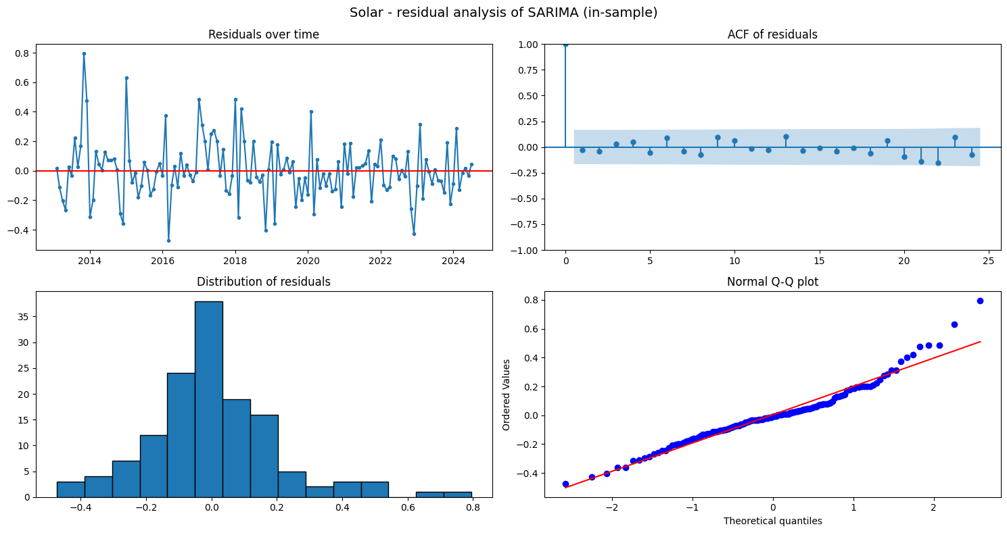
Figure 8.4: Solar: residual analysis of SARIMA (in-sample)

Solar: residual interpretation
- SARIMAX (best on test): the mean one-step error is ≈ 0 (p = 0.41), but Ljung-Box is significant at lag 12 (p = 0.015) and the errors are non-normal (Shapiro p = 0.001). Some seasonal dependence is left over.
- SARIMA(1,0,0)(1,1,1)12 with drift: residual mean ≈ 0 (p = 0.80) and no autocorrelation (Ljung-Box p = 0.87 and 0.94). These are white-noise residuals, non-normal only because of a few unusual months. The drift coefficient (shown as x1, about 0.039 per month on the log scale) corresponds to roughly 4% growth per month, about 59% per year.
SARIMA matches SARIMAX's accuracy and leaves cleaner residuals, so SARIMA is the more reliable solar model.

8.4 Biomass
Best biomass model on the test period: Seasonal Naive.
Table 8.3a Biomass: residual tests of the best test model
# | resource | model | n | mean | mean t-test p | std | Ljung-Box p (lag 6) | Ljung-Box p (lag 12) | Shapiro-Wilk p
0 | biomass | Seasonal Naive | 60 | -30.761 | 0.000 | 39.645 | 0.000 | 0.000 | 0.733

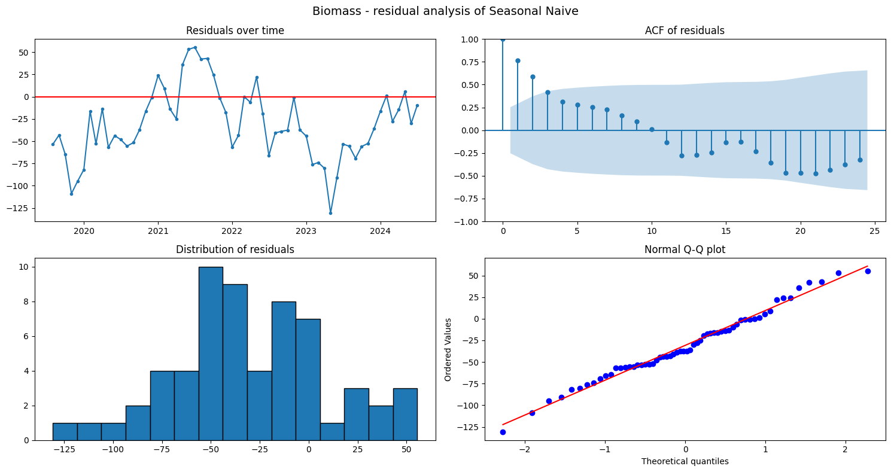
Figure 8.5: Biomass: residual analysis of the best test model (time plot, ACF, histogram, Q-Q plot)
Table 8.3b Biomass: residual tests of SARIMA (in-sample)
# | resource | model | n | mean | mean t-test p | std | Ljung-Box p (lag 6) | Ljung-Box p (lag 12) | Shapiro-Wilk p
0 | biomass | SARIMA (in-sample) | 270 | -0.995 | 0.536 | 26.386 | 0.613 | 0.613 | 0.000

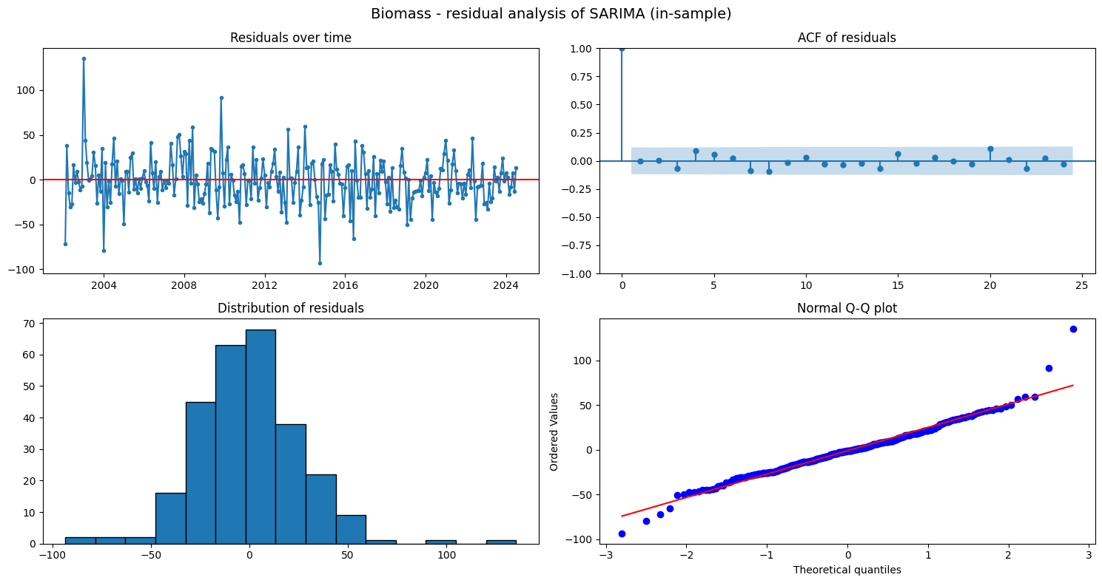
Figure 8.6: Biomass: residual analysis of SARIMA (in-sample)

Biomass: residual interpretation
- Seasonal Naive (best on test): the one-step errors have a significantly negative mean (−31 GWh, p < 0.001). The benchmark over-forecasts, because biomass kept declining while the forecast copies last year's higher values. The errors are also autocorrelated (Ljung-Box p < 0.001) but normal (Shapiro p = 0.73).
- SARIMA(1,1,1)(1,0,1)12 in-sample: residual mean ≈ 0 (p = 0.54) and no autocorrelation (Ljung-Box p = 0.61 at lags 6 and 12). These are white noise in-sample, although the model forecast the test period worse.
The seasonal naive is the most accurate biomass forecast, but its biased, autocorrelated errors show it ignores the ongoing decline. A small downward adjustment would likely improve it.

8.5 Wind
Best wind model on the test period: Holt-Winters multiplicative.
Table 8.4a Wind: residual tests of the best test model
# | resource | model | n | mean | mean t-test p | std | Ljung-Box p (lag 6) | Ljung-Box p (lag 12) | Shapiro-Wilk p
0 | wind | Holt-Winters multiplicative | 60 | 6.258 | 0.975 | 1557.363 | 0.899 | 0.926 | 0.179

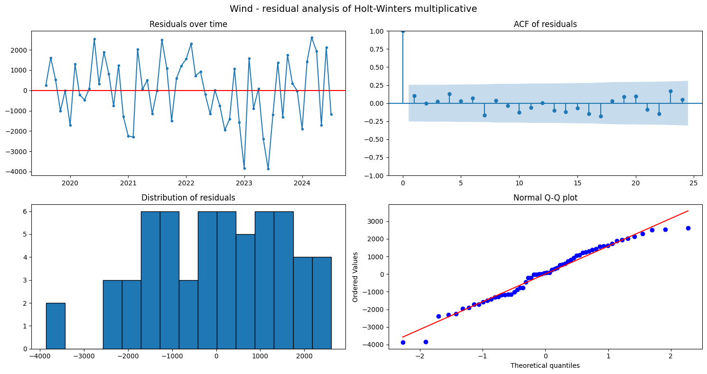
Figure 8.7: Wind: residual analysis of the best test model (time plot, ACF, histogram, Q-Q plot)
- Holt-Winters multiplicative (best on test): the mean one-step error (+6.3 GWh) is essentially 0 (p = 0.98), there is no autocorrelation (Ljung-Box p = 0.90 at lag 6 and 0.93 at lag 12), and the errors are normal (Shapiro p = 0.18).
- These are white-noise residuals: the most accurate wind model is also statistically well specified, so its prediction intervals can be trusted.

8.6 Summary
Table 8.5 Residual analysis summary
Resource – model | n | mean | mean t-test p | std | Ljung-Box p (lag 6) | Ljung-Box p (lag 12) | Shapiro-Wilk p
hydro – Linear Regression | 60 | -48.531 | 0.124 | 240.582 | 0.841 | 0.916 | 0.912
hydro – SARIMA (in-sample) | 270 | 0.001 | 0.934 | 0.140 | 0.415 | 0.391 | 0.565
solar – SARIMAX (Fourier exog) | 60 | -10.433 | 0.405 | 96.379 | 0.068 | 0.015 | 0.001
solar – SARIMA (in-sample) | 138 | 0.004 | 0.804 | 0.199 | 0.870 | 0.935 | 0.000
biomass – Seasonal Naive | 60 | -30.761 | 0.000 | 39.645 | 0.000 | 0.000 | 0.733
biomass – SARIMA (in-sample) | 270 | -0.995 | 0.536 | 26.386 | 0.613 | 0.613 | 0.000
wind – Holt-Winters multiplicative | 60 | 6.258 | 0.975 | 1557.363 | 0.899 | 0.926 | 0.179

Residual analysis summary
- SARIMA leaves white-noise residuals for all three resources (Ljung-Box p > 0.05 at lags 6 and 12, mean ≈ 0), so it captures the time structure of each series.
- The best test model for hydro (Linear Regression) also leaves white-noise, normal residuals.
- The best test models for solar (SARIMAX: autocorrelation at lag 12) and biomass (Seasonal Naive: biased and autocorrelated) leave some structure. For solar, SARIMA is the safer choice. For biomass, the remaining bias reflects the ongoing decline.
- Non-normal residuals for solar and in-sample biomass come from a few unusual months. Point forecasts are unaffected, but prediction intervals that assume normal errors would be too narrow.

Conclusion

Answer to the research question (Midwest)
Hydro, solar, biomass, wind and geothermal behave very differently over time in the Midwestern U.S. region:
- Trend:
- hydro shows weak drift with large wet and dry swings (peak 2019);
- solar shows exponential growth (67 → 35,244 GWh/yr between 2012 and 2025, nearly doubling in 2025);
- biomass rose until 2014 and has declined since;
- wind grew rapidly and steadily (1,502 → 185,410 GWh/yr, about 22%/yr), with growth flattening in 2024–2025;
- geothermal is absent (0 GWh throughout).
- Seasonality: all three active resources follow a 12-month cycle:
- solar's is very strong (July +43%, January −48%);
- hydro's is moderate (May +14%, February −15%);
- biomass's is weak (±6%);
- wind's is strong (April +25%, August −38%). Hydro and solar both peak in the warm season.
- Temporal dependence:
- log-hydro behaves as SARIMA(1,1,1)(1,0,1)12;
- log-solar as SARIMA(1,0,0)(1,1,1)12 with drift;
- biomass as SARIMA(1,1,1)(1,0,1)12. These were identified from the ACF/PACF and confirmed by AIC.
- Forecasting:
- biomass is forecast most accurately (MAPE 4.6%), but by the seasonal naive: no model beats it;
- solar is forecast well only by growth-aware models (SARIMAX/SARIMA, about 11–12%), while trend-free models fail (47–58%);
- hydro is the hardest (13.7%, only 8% better than the baseline), because its variation is driven by weather;
- wind is forecast best by Holt-Winters multiplicative (8.1% MAPE, lowest MAE and RMSE), essentially tied with the seasonal naive (7.7% MAPE).
- Outlook (Aug 2026 – Jul 2027): wind about 197,800 GWh (+5.2%), solar about 69,300 GWh (+54.5%), hydro about 18,300 GWh (+2%), biomass about 5,460 GWh (flat). Wind remains by far the largest source; solar will supply about three-quarters of the combined hydro, solar and biomass output.
Comparison with the South: the conclusions match on solar (growth-aware models needed) and hydro (hardest to forecast). They differ in two ways:
- Midwestern hydro needs a log transform and differencing, while Southern hydro was stationary.
- For Midwestern biomass the simple seasonal naive cannot be beaten, while in the South SARIMA was clearly better.

Limitations:
- The test set is a single 24-month window.
- No weather or capacity data are included.
- Rooftop solar is not in the EIA figures.
Future work: add precipitation and snowpack data for hydro and capacity data for solar as SARIMAX regressors, use rolling-origin evaluation.

