Time-Series Analysis and Forecasting of Renewable Electricity Generation by Source: Northeast Region (U.S. Census)
  - Technical Report | Hydro, wind, solar and biomass | U.S. EIA monthly net generation, study window January 2013 – July 2026

1. Research Objective & Questions

1.1 Objective
The Northeast renewable mix is hydro-led (mostly New York), with fast-growing solar, onshore wind and declining biomass. Each source has a different physical driver, so grid operators need forecasts for each source rather than a single total. The objective of this study is to describe the trend, seasonality and stationarity of each source in the U.S. Census Northeast region, identify suitable ARIMA/SARIMA structures from the ACF and PACF, compare statistical, machine-learning and deep-learning forecasting models for each source, validate them through residual diagnostics, and produce a separate 12-month forecast for each source and for total renewable output.

1.2 Research questions
1. What are each source's trend and seasonal patterns, and which states drive them?
2. Is each series stationary, and which transformations and differencing orders are needed?
3. Which (p, d, q) × (P, D, Q)12 orders are suggested by the ACF and PACF, and are they confirmed by AIC?
4. Which model family forecasts 12 months ahead best for each source — (S)ARIMA(X), Holt-Winters, or machine-learning / deep-learning models — measured by MAE, RMSE and MAPE?
5. Does a system covariate (the rest of electricity generation, a demand proxy) improve on a univariate seasonal model?
6. Are the residuals of the selected models white noise?
7. Which source is the most forecastable, and what is the combined outlook for August 2026 – July 2027?

1.3 Hypotheses
- H1: All four sources show significant 12-month seasonality, with different peak months.
- H2: Seasonal models (SARIMA, Holt-Winters) and growth-aware models forecast more accurately than the seasonal-naive baseline.
- H3: Plain ARIMA without seasonal terms will fail for the strongly seasonal, fast-growing solar series.
- H4: Adding a demand-proxy covariate (SARIMAX) gives little improvement over a univariate seasonal model.

2. Dataset Description & Regional Selection

2.1 Data source and extraction from the EIA Electricity Data Browser
The data come from the U.S. Energy Information Administration (EIA) Electricity Data Browser (https://www.eia.gov/electricity/data/browser/), which publishes the official monthly net-generation statistics collected on Form EIA-923 (Electric Power Monthly). The steps below describe how the monthly state-level series used in this study are extracted.
1. Open the browser. Go to https://www.eia.gov/electricity/data/browser/. The landing page lists the available electricity data sets.
2. Choose the data set. Select Net generation (electric power generation by fuel type).
3. Select the fuel types. Tick Conventional hydroelectric, Wind, All utility-scale solar, Wood and wood-derived fuels, Other biomass, Geothermal and All fuels (needed for the renewable share). Pumped-storage hydro is excluded, and small-scale (rooftop) solar is not part of these series.
4. Select the geography. Choose the state level and select every state of the Northeast Census region (9 jurisdictions, listed in Table 2.1). The national file used here contains all 50 states and the District of Columbia, so the same steps are repeated for every state.
5. Select the sector. Choose All sectors, so that utilities, independent power producers and commercial and industrial plants are all included.
6. Select frequency and period. Set the frequency to Monthly and the period to January 2001 – July 2026.
7. Check the units. Values are reported in thousand megawatt-hours, which equals gigawatt-hours (GWh); no unit conversion is needed.
8. Download. Use the download option to export each table as CSV (or Excel). Each series corresponds to an EIA series code of the form ELEC.GEN.<FUEL>-<STATE>-99.M (for example ELEC.GEN.WND-TX-99.M is wind, Texas, all sectors, monthly).
9. Combine the downloads. Stack the state files into one table with one row per state per month, and one column per source. Wood and other biomass are added together into a single biomass column.
10. Derive the totals. total_renewable = hydro + wind + solar + biomass + geothermal, and renewable_share_pct = total_renewable ÷ total_generation × 100.
11. Attach the regional classification. Label every row with its official U.S. Census region and division (Northeast, Midwest, South, West; 9 divisions).
12. Save. The final file has 15,657 rows (51 jurisdictions × 307 months) and 11 columns.
Table 2.2 Variables in the dataset
Variable | Description
month | First day of the month of the observation
census_region | U.S. Census region (Northeast, Midwest, South, West)
census_division | U.S. Census division (9 divisions)
hydro, wind, solar, biomass, geothermal | Net generation from each source, in thousand MWh (= GWh)
total_renewable | Sum of the five renewable sources (GWh)
total_generation | Net generation from all sources, renewable and non-renewable (GWh)
renewable_share_pct | total_renewable / total_generation × 100

2.2 Regional selection: the Northeast region
Table 2.1 States of the Northeast region
Census division | States
New England | CT, ME, MA, NH, RI, VT
Middle Atlantic | NJ, NY, PA

The national file has 15,657 rows (51 jurisdictions × 307 months) and no state-name column. Rows follow alphabetical postal-code order within each month; this order was verified against the Census divisions for all 307 months, which allowed each Northeast row to be labelled with its state. The Northeast panel has 2,763 rows (9 states × 307 months) from January 2001 to July 2026, with no missing values.
Table 2.3 Which states drive each source
Source | Largest contributing state (share of regional output, Jan 2013 – Jul 2026) | Other main states
Hydro | New York (74%) | Pennsylvania 8%, Maine 8%
Wind | New York (40%) | Pennsylvania 30%, Maine 19%
Solar | New York (27%) | Massachusetts 24%, New Jersey 22%
Biomass | Maine (22%) | Pennsylvania 19%, New York 19%, New Hampshire 11%

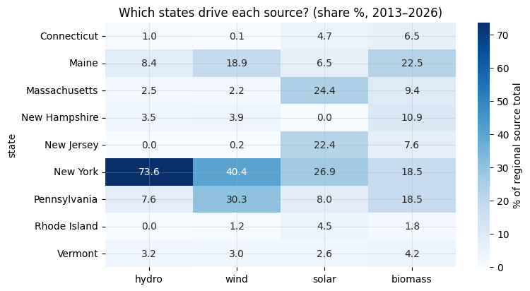
Figure 2.1: Share of each source's regional output by state, 2013–2026

2.3 Study window
Solar output in the Northeast was negligible before 2013 (0 GWh until 2007 and only 423 GWh in 2012), so the study window is January 2013 – July 2026 (163 months) for all four sources. This keeps the four series on the same time axis and avoids near-zero values that would make a log transform impossible. Geothermal generation is 0 in every month in the Northeast, so it is not analysed.
Table 2.4 Regional annual generation before the study window (GWh)
Source | 2001 | 2002 | 2003 | 2004 | 2005 | 2006 | 2007 | 2008 | 2009 | 2010 | 2011 | 2012
Hydro | 30264.0 | 33508.0 | 34957.0 | 34582.0 | 36673.0 | 39612.0 | 34325.0 | 38598.0 | 39423.0 | 35848.0 | 39971.0 | 34265.0
Wind | 44.0 | 150.0 | 164.0 | 436.0 | 402.0 | 1047.0 | 1475.0 | 2157.0 | 3741.0 | 5078.0 | 5503.0 | 6425.0
Solar | 0.0 | 0.0 | 0.0 | 0.0 | 0.0 | 0.0 | 0.0 | 3.0 | 14.0 | 30.0 | 115.0 | 423.0
Biomass | 10777.0 | 11042.0 | 11026.0 | 11141.0 | 11827.0 | 11859.0 | 12301.0 | 12674.0 | 12722.0 | 12823.0 | 12357.0 | 12640.0

Table 2.5 Summary statistics of the monthly regional series in the study window (GWh)
Series | count | mean | std | min | 25% | 50% | 75% | max
Hydro | 163.0 | 3145.0 | 383.7 | 2235.2 | 2904.4 | 3123.6 | 3403.3 | 4009.9
Wind | 163.0 | 957.1 | 306.5 | 367.4 | 707.0 | 979.7 | 1157.9 | 1759.0
Solar | 163.0 | 442.6 | 431.8 | 32.3 | 130.3 | 254.3 | 632.6 | 1929.4
Biomass | 163.0 | 888.0 | 185.3 | 519.6 | 727.3 | 883.4 | 1056.6 | 1201.2
total renewable | 163.0 | 5432.7 | 590.3 | 4065.7 | 4979.5 | 5458.0 | 5825.0 | 6976.7
total generation | 163.0 | 44532.6 | 4750.7 | 34287.1 | 40990.8 | 43810.8 | 46925.3 | 58075.1

3. Preprocessing and Missing-Value Handling

3.1 Data-quality checks
Table 3.1 Data-quality checks
Check | Result
Missing values in the Northeast panel | 0
Negative values in Northeast rows | 0
Geothermal always 0 | Yes, so geothermal is excluded
Rows with renewable share > 100% | 10 (small New England states in some months; a property of net generation, kept)
Sources sum to total_renewable | Yes
Regional series with any zero month in the window | None (hydro 0, wind 0, solar 0, biomass 0)
Imputation needed | None

3.2 Zero and repeated values in individual states
Table 3.2 Zero months by state and source (study window, 163 months)
State | hydro | wind | solar | biomass
Connecticut | 0 | 33 | 12 | 0
Maine | 0 | 0 | 45 | 0
Massachusetts | 0 | 0 | 0 | 8
New Hampshire | 0 | 0 | 97 | 0
New Jersey | 26 | 0 | 0 | 0
New York | 0 | 0 | 0 | 0
Pennsylvania | 0 | 0 | 0 | 0
Rhode Island | 5 | 0 | 1 | 0
Vermont | 0 | 0 | 0 | 0

Table 3.3 Months with exactly the same value as the previous month (possible carried-forward values)
State | hydro | wind | solar | biomass
Connecticut | 0 | 37 | 11 | 0
Maine | 0 | 0 | 47 | 0
Massachusetts | 0 | 0 | 0 | 10
New Hampshire | 0 | 0 | 102 | 0
New Jersey | 21 | 0 | 0 | 0
New York | 0 | 0 | 0 | 0
Pennsylvania | 0 | 0 | 0 | 0
Rhode Island | 6 | 0 | 3 | 0
Vermont | 0 | 0 | 0 | 0

- Zero and repeated values occur only in small contributors (New Hampshire solar, Connecticut wind, New Jersey hydro). They have no visible effect on the regional totals, which are positive in every month, so no correction is applied.
- The nine state rows of each month are summed to give one regional value per source per month.
- The series are indexed by month (month-start frequency) and restricted to January 2013 – July 2026.
- Seasonal swings grow with the level for the growing sources, so all four series are modelled on the log scale (log y); forecasts are transformed back with exp().

4. Time-Series Plot, Trend, and Seasonality Analysis

4.1 Time-series plots
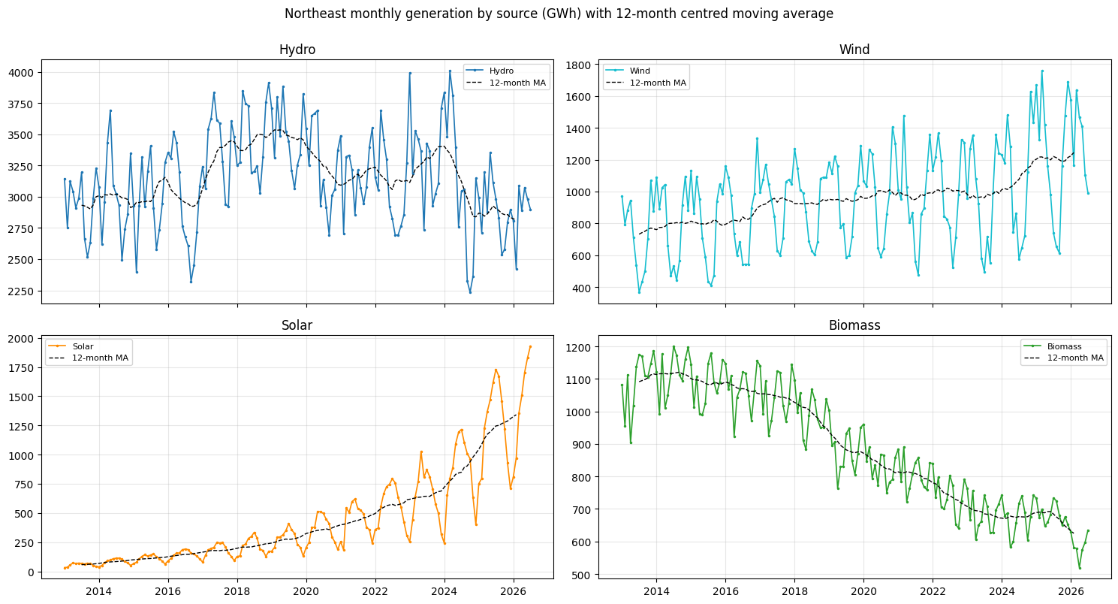
Figure 4.1: Monthly generation by source with 12-month centred moving average
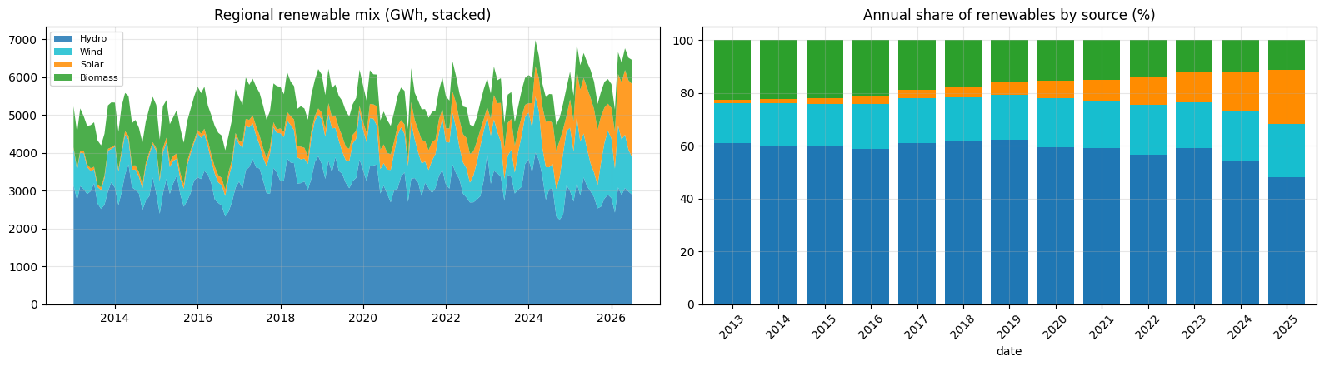
Figure 4.2: Regional renewable mix: stacked monthly generation and annual share of each source
- Hydro is the largest source (about 58% of regional renewables). It moves around a flat level of about 3,100 GWh/month with large month-to-month swings.
- Wind grows slowly from about 700 to about 1,000 GWh/month, with a strong winter/spring maximum and a summer minimum.
- Solar grows rapidly from about 30 GWh/month (2013) to a record of about 1,930 GWh/month (summer 2026), with a summer peak that widens every year.
- Biomass declines steadily from about 1,100 to about 600 GWh/month.

4.2 Trend and seasonality measures
Table 4.1 STL trend and seasonal strength, growth rates and seasonal peaks (log scale, 2013–2026)
Source | Trend strength F_T | Seasonal strength F_S | Log-linear growth (%/yr) | CAGR 2013–2025 (%) | Peak month | Trough month | Peak/trough ratio
Hydro | 0.559 | 0.642 | −0.014 | −0.076 | March | September | 1.287
Wind | 0.704 | 0.907 | 3.493 | 4.351 | March | August | 2.245
Solar | 0.987 | 0.904 | 26.743 | 29.153 | July | December | 2.587
Biomass | 0.979 | 0.816 | −4.899 | −3.815 | December | April | 1.206

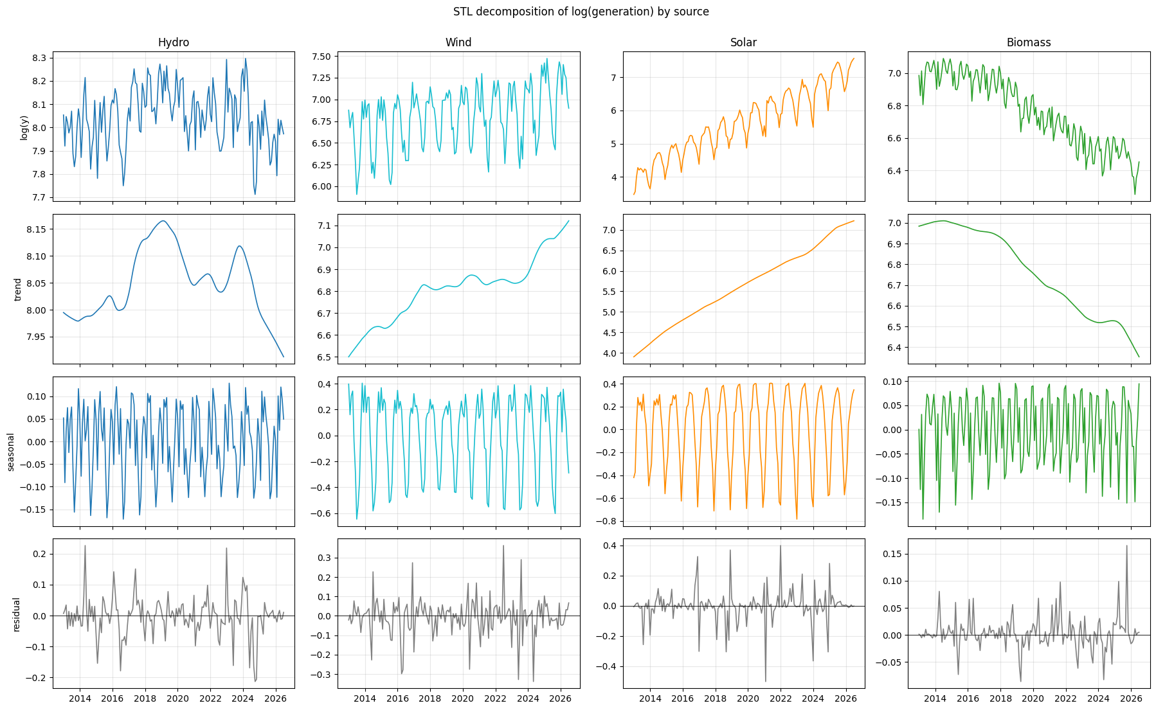
Figure 4.3: STL decomposition of log(generation) by source
- Hydro: no trend (growth ≈ 0%/yr); a March snowmelt peak and a September low; moderate seasonal strength (0.64).
- Wind: slow growth (+3.5%/yr) and the strongest seasonality (F_S = 0.91; March peak, August trough, peak 2.2 times the trough).
- Solar: very strong trend (F_T = 0.99, +26.7%/yr) and strong seasonality (July peak, December trough, ratio 2.6).
- Biomass: steady decline (−4.9%/yr, F_T = 0.98) with a December peak and April trough.

4.3 Seasonal profiles and relationships between sources
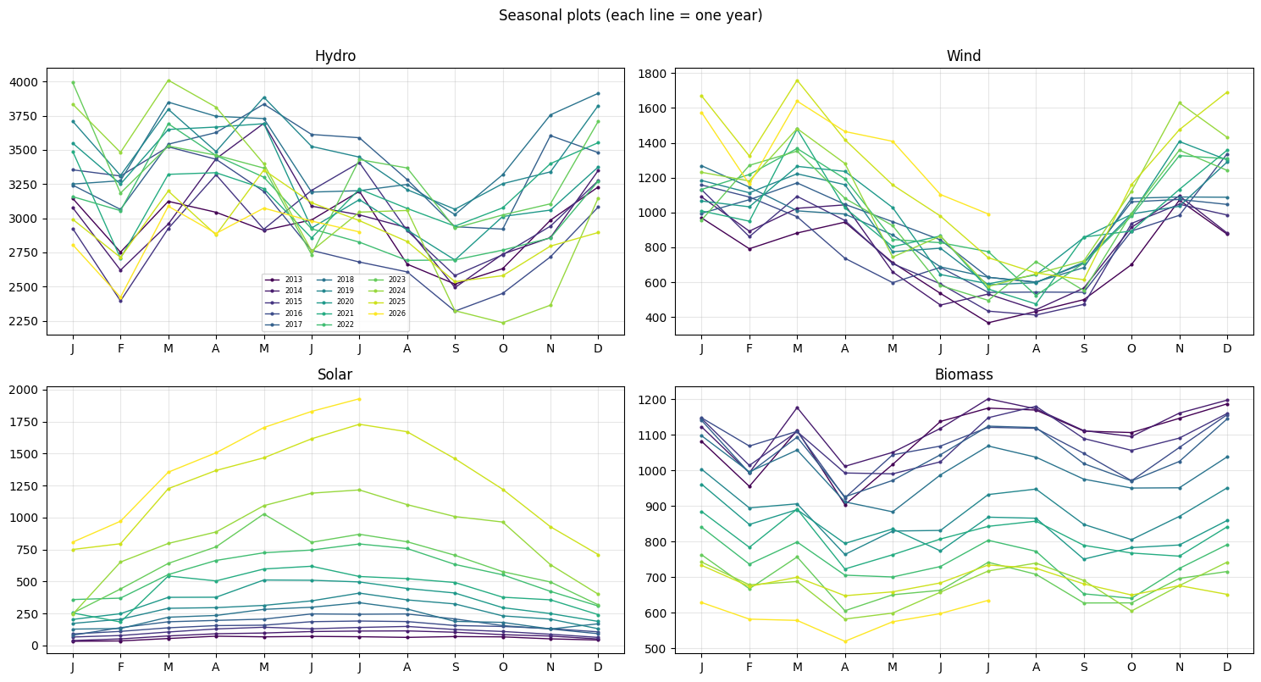
Figure 4.4: Seasonal plots: one line per year for each source
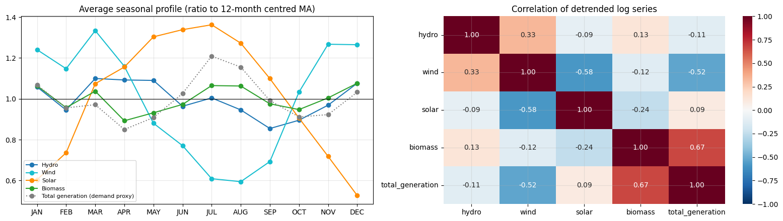
Figure 4.5: Average seasonal profile (ratio to 12-month centred moving average) and correlation of the detrended log series
- The different seasonal peaks (hydro and wind in March, solar in July, biomass in December) smooth the combined renewable output across the year.
- After detrending, solar and wind are negatively correlated (r = −0.58): solar is strong when wind is weak.
- Biomass tracks total generation (r = 0.67), i.e. it follows electricity demand.
- Seasonal swings grow with the level, so all four series are modelled on the log scale. H1 is supported.

5. ADF Stationarity Test (Before and After Differencing)

5.1 Test design
- ADF: H0 = unit root (non-stationary); p < 0.05 means stationary.
- KPSS: H0 = stationary; p < 0.05 means non-stationary (p-values bounded to 0.01–0.10).
- Verdict: Stationary when both tests agree on stationarity, Non-stationary when both reject it, Inconclusive otherwise.
- Five versions of each series are tested: raw y, log(y), Δ log(y) (d = 1), Δ12 log(y) (D = 1) and Δ Δ12 log(y) (d = 1, D = 1).
Table 5.1 ADF and KPSS tests before and after differencing
Source – series | ADF stat | ADF p | KPSS stat | KPSS p | Verdict
Hydro – Raw y | -1.7753 | 0.3928 | 0.2650 | 0.10 | Inconclusive
Hydro – log(y) | -1.8263 | 0.3675 | 0.2636 | 0.10 | Inconclusive
Hydro – Δ log(y) (d=1) | -5.2889 | 0.0000 | 0.1151 | 0.10 | Stationary
Hydro – Δ12 log(y) (D=1) | -2.0910 | 0.2481 | 0.2300 | 0.10 | Inconclusive
Hydro – Δ Δ12 log(y) (d=1,D=1) | -7.0162 | 0.0000 | 0.0285 | 0.10 | Stationary
Wind – Raw y | 0.2248 | 0.9736 | 1.0583 | 0.01 | Non-stationary
Wind – log(y) | -0.3340 | 0.9205 | 0.9614 | 0.01 | Non-stationary
Wind – Δ log(y) (d=1) | -5.0250 | 0.0000 | 0.0108 | 0.10 | Stationary
Wind – Δ12 log(y) (D=1) | -3.8645 | 0.0023 | 0.1024 | 0.10 | Stationary
Wind – Δ Δ12 log(y) (d=1,D=1) | -4.8879 | 0.0000 | 0.0360 | 0.10 | Stationary
Solar – Raw y | 0.9365 | 0.9935 | 1.6568 | 0.01 | Non-stationary
Solar – log(y) | -0.9023 | 0.7872 | 1.8927 | 0.01 | Non-stationary
Solar – Δ log(y) (d=1) | -13.0858 | 0.0000 | 0.0171 | 0.10 | Stationary
Solar – Δ12 log(y) (D=1) | -3.7573 | 0.0034 | 0.1715 | 0.10 | Stationary
Solar – Δ Δ12 log(y) (d=1,D=1) | -3.1068 | 0.0261 | 0.1242 | 0.10 | Stationary
Biomass – Raw y | -0.1268 | 0.9467 | 1.8511 | 0.01 | Non-stationary
Biomass – log(y) | 0.2944 | 0.9771 | 1.8494 | 0.01 | Non-stationary
Biomass – Δ log(y) (d=1) | -3.0778 | 0.0282 | 0.1357 | 0.10 | Stationary
Biomass – Δ12 log(y) (D=1) | -3.0846 | 0.0277 | 0.3358 | 0.10 | Stationary
Biomass – Δ Δ12 log(y) (d=1,D=1) | -3.5986 | 0.0058 | 0.0561 | 0.10 | Stationary

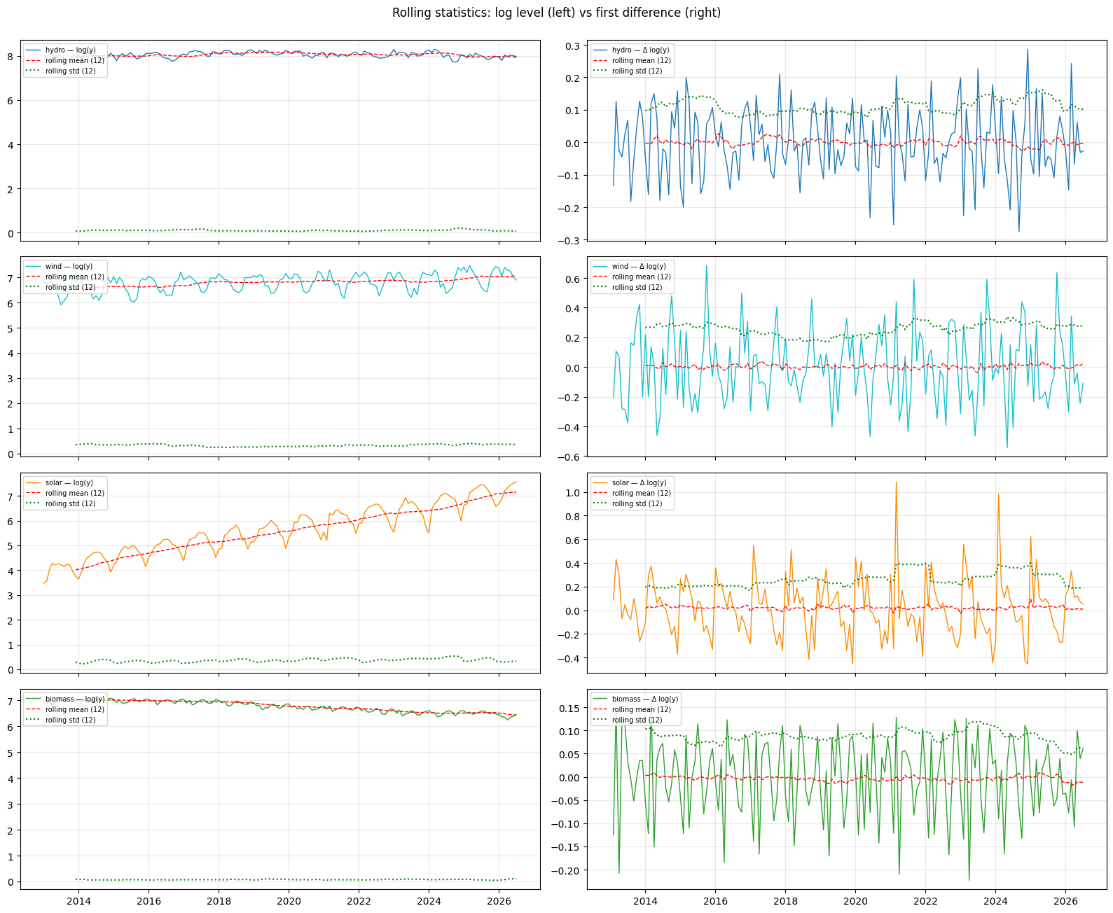
Figure 5.1: Rolling statistics: log level (left) vs first difference (right)

5.2 Interpretation
- Before differencing: wind, solar and biomass are non-stationary in levels and in logs (ADF p ≥ 0.78, KPSS p = 0.01). Hydro is inconclusive (ADF p = 0.37–0.39 but KPSS p = 0.10), consistent with its flat level and large swings.
- After a first difference of the log, all four series are stationary (ADF p ≤ 0.028, KPSS p = 0.10). The rolling mean of Δ log(y) is flat around zero.
- A seasonal difference alone is stationary for wind, solar and biomass but inconclusive for hydro (ADF p = 0.248).
- Decision: log transform + d = 1 for every source. A seasonal difference (D = 1) is not imposed but tested as a model option in Section 6 (SARIMA with D = 0 and D = 1).

6. ACF / PACF Plots and Justification for ARIMA/SARIMA Order Selection
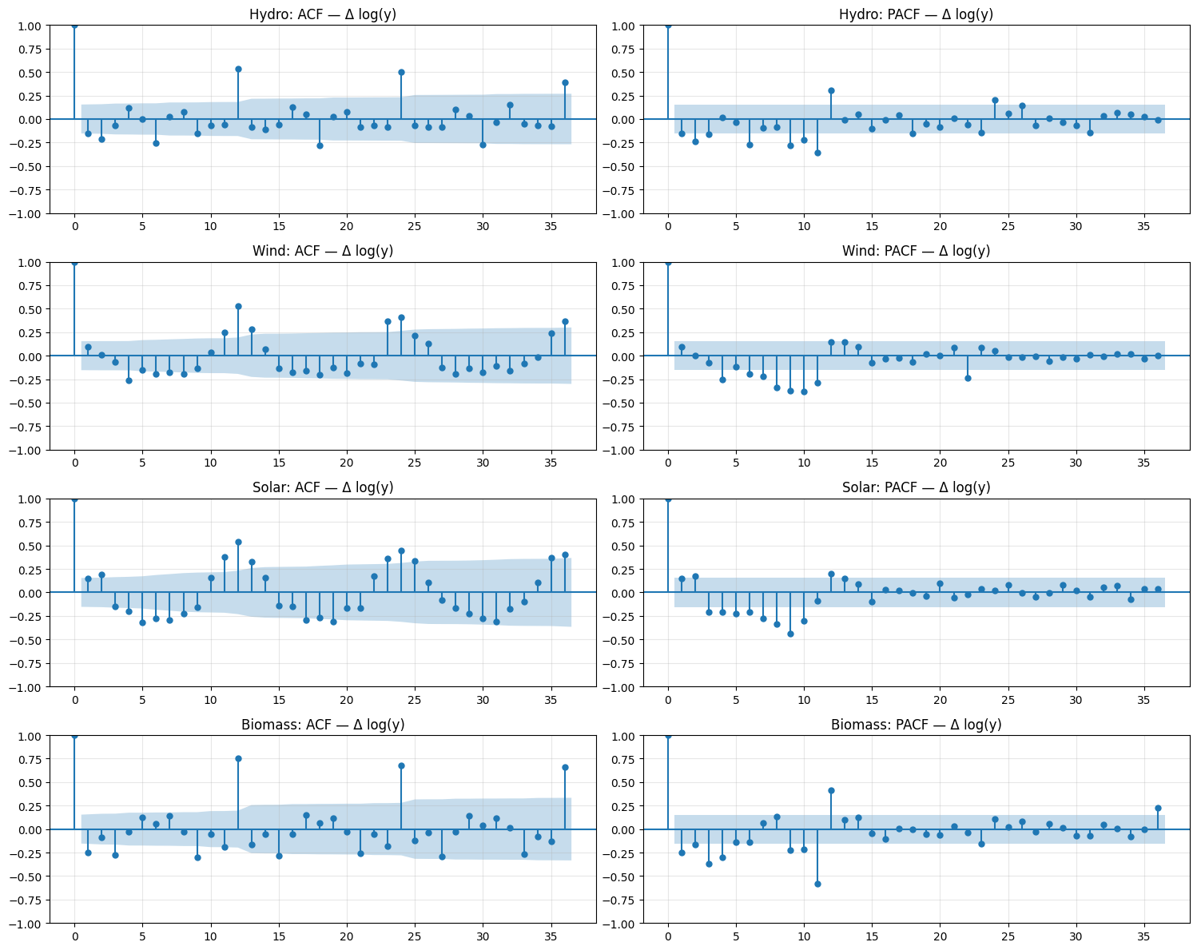
Figure 6.1: ACF and PACF of Δ log(y) for each source (lags 0–36)
Table 6.1 ACF/PACF summary and orders identified from the plots
Source | Series | 95% band | ACF(1) | PACF(1) | ACF(12) | PACF(12) | ACF(24) | Identified model
Hydro | Δ log(y) | ±0.154 | -0.152 | -0.152 | 0.536 | 0.308 | 0.502 | SARIMA(0,1,0)(1,0,0)12
Wind | Δ log(y) | ±0.154 | 0.091 | 0.091 | 0.533 | 0.145 | 0.407 | SARIMA(0,1,0)(1,0,0)12
Solar | Δ log(y) | ±0.154 | 0.146 | 0.146 | 0.539 | 0.201 | 0.448 | SARIMA(0,1,0)(1,0,0)12
Biomass | Δ log(y) | ±0.154 | -0.249 | -0.249 | 0.756 | 0.413 | 0.680 | SARIMA(3,1,1)(1,0,0)12

6.1 Reading the plots
- All four sources show a strong positive spike at lag 12 (ACF 0.53–0.76) and a significant PACF at lag 12 (0.15–0.41) with a slowly decaying pattern at lags 24 and 36. This is the signature of a seasonal AR(1) term (P = 1).
- Hydro, wind and solar have no significant non-seasonal spikes (lag-1 ACF −0.15 to 0.15, inside the ±0.154 band), so p = q = 0: SARIMA(0,1,0)(1,0,0)12.
- Biomass has a significant negative lag-1 spike (ACF and PACF −0.25) and several further PACF lags, giving SARIMA(3,1,1)(1,0,0)12.
- These plot-based orders seed the AIC search below.

6.2 AIC search and comparison with the ACF/PACF choice
All models are fitted on log(y) with d = 1. Orders were chosen by AIC (p, q ≤ 2; P, Q ≤ 1) for four specifications per source: non-seasonal ARIMA, SARIMA with D = 0, SARIMA with D = 1, and SARIMAX with log(rest of generation) as the covariate.
Table 6.2 Orders selected by AIC (training data)
Source | ARIMA | SARIMA (D = 0) | SARIMA (D = 1) | SARIMAX (D = 0)
Hydro | (1,1,1) AIC −258.3 | (0,1,2)(1,0,1)12 AIC −303.4 | (1,1,1)(0,1,1)12 AIC −285.1 | (1,1,1)(1,0,1)12 AIC −314.5
Wind | (2,1,2) AIC −51.4 | (0,1,1)(1,0,1)12 AIC −137.9 | (0,1,1)(0,1,1)12 AIC −128.6 | (0,1,1)(1,0,1)12 AIC −138.0
Solar | (2,1,2) AIC 9.9 | (0,1,1)(1,0,1)12 AIC −124.2 | (0,1,1)(0,1,1)12 AIC −109.2 | (0,1,1)(1,0,1)12 AIC −122.4
Biomass | (2,1,2) AIC −349.7 | (2,1,0)(1,0,1)12 AIC −487.4 | (2,1,0)(1,1,1)12 AIC −450.9 | (2,1,0)(1,0,1)12 AIC −485.9

Table 6.3 ACF/PACF-identified versus AIC-selected SARIMA: fit, residual autocorrelation and test accuracy
Source | Model | AIC | BIC | Ljung-Box p (lag 12) | MAE | RMSE | MAPE (%) | MASE
Hydro | ACF/PACF: SARIMA(0,1,0)(1,0,0)12 | −264.1 | −258.2 | 0.001 | 111.0 | 150.3 | 4.10 | 0.366
Hydro | AIC: SARIMA(0,1,2)(1,0,1)12 | −303.4 | −288.9 | 0.400 | 165.6 | 220.7 | 5.95 | 0.545
Wind | ACF/PACF: SARIMA(0,1,0)(1,0,0)12 | −43.4 | −37.6 | 0.005 | 196.3 | 226.0 | 16.36 | 1.596
Wind | AIC: SARIMA(0,1,1)(1,0,1)12 | −137.9 | −126.2 | 0.543 | 141.2 | 168.8 | 13.57 | 1.148
Solar | ACF/PACF: SARIMA(0,1,0)(1,0,0)12 | −22.9 | −17.0 | 0.000 | 260.3 | 289.1 | 23.11 | 2.802
Solar | AIC: SARIMA(0,1,1)(1,0,1)12 | −124.2 | −112.6 | 0.886 | 182.3 | 228.8 | 12.31 | 1.962
Biomass | ACF/PACF: SARIMA(3,1,1)(1,0,0)12 | −457.1 | −439.7 | 0.000 | 90.3 | 102.4 | 15.13 | 1.852
Biomass | AIC: SARIMA(2,1,0)(1,0,1)12 | −487.4 | −472.8 | 0.005 | 62.8 | 74.4 | 10.50 | 1.288

6.3 Justification of the final orders
- AIC adds a seasonal MA(1) term for every source (P = 1, Q = 1). The plot-based models leave significant residual autocorrelation (Ljung-Box p ≤ 0.005), while the AIC models have white-noise residuals for hydro, wind and solar (p = 0.40–0.89).
- The AIC models also forecast better for wind (MAPE 13.6% vs 16.4%), solar (12.3% vs 23.1%) and biomass (10.5% vs 15.1%). For hydro the simpler plot-based model forecasts better (4.1% vs 5.9%), even though its residuals are autocorrelated.
- The final SARIMA structures are therefore: hydro (0,1,2)(1,0,1)12, wind (0,1,1)(1,0,1)12 / (0,1,1)(0,1,1)12, solar (0,1,1)(1,0,1)12 / (0,1,1)(0,1,1)12 and biomass (2,1,0)(1,0,1)12 / (2,1,0)(1,1,1)12, all on log(y). The D = 1 versions are carried forward where they forecast better (wind, solar, biomass).

7. Model Fitting, Selection, and Forecasting Evaluation

7.1 Design
- Split (per source): training January 2013 – July 2025 (151 months), test August 2025 – July 2026 (12 months). The split is chronological; no shuffling.
- Robustness check: rolling-origin evaluation with refits at July 2023, July 2024 and July 2025, each forecasting 12 months (36 test months per source). The final model of each source is the rolling-origin winner.
- Models: baselines (mean, naive, seasonal naive, drift); ARIMA, SARIMA (D = 0 and D = 1) and SARIMAX on log(y); Holt-Winters additive/multiplicative with and without damping; Random Forest, Gradient Boosting and XGBoost on log-growth with lags 1, 2, 3, 12, month sin/cos and the change in log(rest of generation); and an LSTM (12-month window, 32 units). ML/DL forecasts are recursive over 12 steps.
- SARIMAX covariate: the rest of electricity generation (a demand proxy). In the test it uses observed values (an upper bound on its benefit); in the final forecast it is itself forecast by damped Holt-Winters.
MAE = (1/n) Σ |yₜ − ŷₜ|
RMSE = √[ (1/n) Σ (yₜ − ŷₜ)² ]
MAPE = (100/n) Σ |yₜ − ŷₜ| / yₜ
sMAPE (symmetric MAPE) and MASE (MAE relative to the in-sample seasonal-naive error) are also reported.

7.2 Baseline forecasts
Table 7.1 Baseline accuracy on the test year (Aug 2025 – Jul 2026)
Source – model | MAE | RMSE | MAPE % | sMAPE % | MASE
Hydro – Mean | 354.96 | 406.98 | 13.20 | 12.10 | 1.17
Hydro – Naive | 199.08 | 259.43 | 7.53 | 7.06 | 0.66
Hydro – Seasonal Naive | 213.59 | 241.58 | 7.75 | 7.78 | 0.70
Hydro – Drift | 196.72 | 256.57 | 7.43 | 6.99 | 0.65
Wind – Mean | 410.66 | 464.88 | 32.52 | 36.30 | 3.34
Wind – Naive | 539.55 | 611.19 | 39.59 | 50.62 | 4.39
Wind – Seasonal Naive | 134.39 | 157.17 | 11.02 | 11.36 | 1.09
Wind – Drift | 548.67 | 620.33 | 40.27 | 51.76 | 4.46
Solar – Mean | 970.16 | 1047.43 | 69.35 | 108.03 | 10.44
Solar – Naive | 438.36 | 553.81 | 45.44 | 31.96 | 4.72
Solar – Seasonal Naive | 253.02 | 287.38 | 20.12 | 23.35 | 2.72
Solar – Drift | 472.52 | 597.54 | 49.04 | 33.74 | 5.09
Biomass – Mean | 284.04 | 289.20 | 46.59 | 37.34 | 5.82
Biomass – Naive | 109.19 | 122.00 | 18.39 | 16.42 | 2.24
Biomass – Seasonal Naive | 72.90 | 84.32 | 12.25 | 11.34 | 1.49
Biomass – Drift | 94.13 | 106.05 | 15.88 | 14.36 | 1.93

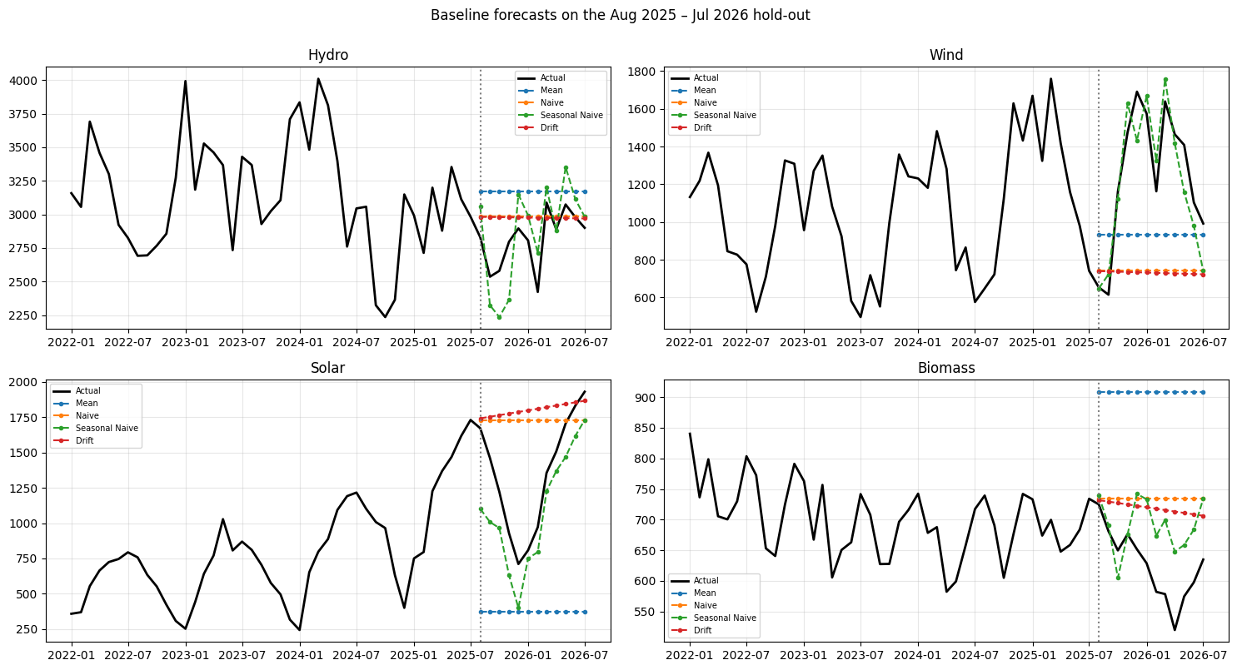
Figure 7.1: Baseline forecasts on the test year
The seasonal naive is the strongest baseline for wind, solar and biomass. For hydro the naive and drift forecasts are slightly better, because hydro has no stable seasonal shape from one year to the next.

7.3 ARIMA, SARIMA and SARIMAX
Table 7.2 ARIMA-family accuracy on the test year
Source – model | MAE | RMSE | MAPE % | sMAPE % | MASE
Hydro – ARIMA | 270.17 | 332.33 | 10.15 | 9.40 | 0.89
Hydro – SARIMA (D=0) | 165.56 | 220.71 | 5.95 | 5.67 | 0.55
Hydro – SARIMA (D=1) | 188.97 | 245.15 | 6.77 | 6.41 | 0.62
Hydro – SARIMAX | 190.62 | 217.38 | 6.79 | 6.51 | 0.63
Wind – ARIMA | 165.96 | 224.19 | 15.89 | 14.37 | 1.35
Wind – SARIMA (D=0) | 141.19 | 168.80 | 13.57 | 13.19 | 1.15
Wind – SARIMA (D=1) | 140.05 | 170.61 | 13.44 | 13.10 | 1.14
Wind – SARIMAX | 144.32 | 168.66 | 13.91 | 13.41 | 1.17
Solar – ARIMA | 859.08 | 970.17 | 79.30 | 51.28 | 9.25
Solar – SARIMA (D=0) | 182.28 | 228.75 | 12.31 | 11.69 | 1.96
Solar – SARIMA (D=1) | 132.85 | 151.59 | 9.26 | 9.10 | 1.43
Solar – SARIMAX | 183.19 | 232.71 | 12.38 | 11.73 | 1.97
Biomass – ARIMA | 68.73 | 84.76 | 11.78 | 10.77 | 1.41
Biomass – SARIMA (D=0) | 62.83 | 74.37 | 10.50 | 9.78 | 1.29
Biomass – SARIMA (D=1) | 57.02 | 68.75 | 9.52 | 8.91 | 1.17
Biomass – SARIMAX | 63.69 | 75.20 | 10.64 | 9.90 | 1.31

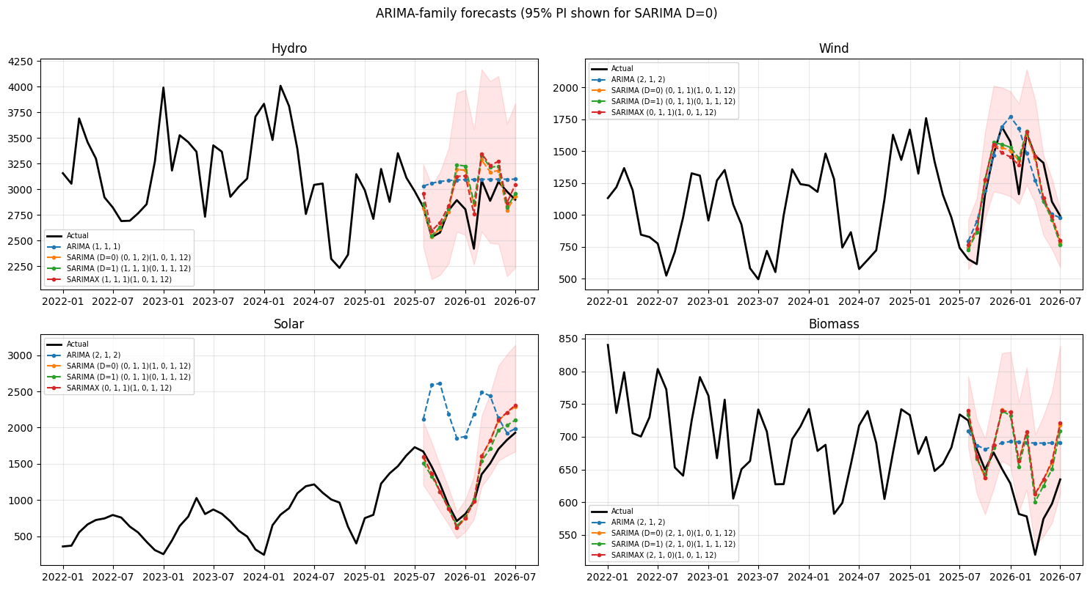
Figure 7.2: ARIMA-family forecasts on the test year (95% prediction interval shown for SARIMA D = 0)
- Plain ARIMA fails on solar (MAPE 79.3%): seasonal terms are essential (H3 supported).
- Best ARIMA-family MAPE: hydro SARIMA D = 0 6.0%, wind SARIMA D = 1 13.4%, solar SARIMA D = 1 9.3%, biomass SARIMA D = 1 9.5%.
- The covariate is significant only for hydro (p < 0.001), and SARIMAX never beats SARIMA out of sample (H4 supported).

7.4 Holt-Winters
Table 7.3 Holt-Winters parameters and test accuracy
Source – model | AIC | α | β | γ | φ | MAE | RMSE | MAPE % | sMAPE % | MASE
Hydro – HW Additive | 1653.113 | 0.644 | 0.000 | 0.000 | — | 227.173 | 276.947 | 8.134 | 7.665 | 0.748
Hydro – HW Additive Damped | 1655.121 | 0.646 | 0.000 | 0.000 | 0.800 | 222.660 | 273.041 | 7.971 | 7.516 | 0.733
Hydro – HW Multiplicative | 1653.711 | 0.644 | 0.000 | 0.000 | — | 238.726 | 285.234 | 8.572 | 8.071 | 0.786
Hydro – HW Multiplicative Damped | 1655.631 | 0.641 | 0.000 | 0.000 | 0.972 | 233.707 | 279.413 | 8.396 | 7.914 | 0.770
Wind – HW Additive | 1461.318 | 0.121 | 0.000 | 0.000 | — | 152.576 | 177.125 | 14.963 | 14.014 | 1.241
Wind – HW Additive Damped | 1464.168 | 0.131 | 0.000 | 0.000 | 0.995 | 159.174 | 181.637 | 15.385 | 14.562 | 1.294
Wind – HW Multiplicative | 1459.086 | 0.115 | 0.000 | 0.000 | — | 141.953 | 171.294 | 13.408 | 13.262 | 1.154
Wind – HW Multiplicative Damped | 1462.265 | 0.135 | 0.000 | 0.000 | 0.995 | 144.899 | 174.001 | 13.612 | 13.533 | 1.178
Solar – HW Additive | 1315.087 | 0.162 | 0.162 | 0.838 | — | 187.763 | 210.000 | 15.765 | 14.341 | 2.021
Solar – HW Additive Damped | 1318.017 | 0.166 | 0.166 | 0.834 | 0.995 | 179.425 | 202.352 | 15.123 | 13.802 | 1.932
Solar – HW Multiplicative | 1240.673 | 0.156 | 0.114 | 0.093 | — | 147.807 | 175.404 | 10.038 | 9.760 | 1.591
Solar – HW Multiplicative Damped | 1243.350 | 0.198 | 0.164 | 0.082 | 0.995 | 151.070 | 190.626 | 9.804 | 9.330 | 1.626
Biomass – HW Additive | 1071.576 | 0.521 | 0.000 | 0.000 | — | 54.844 | 67.268 | 9.008 | 8.450 | 1.125
Biomass – HW Additive Damped | 1074.413 | 0.529 | 0.000 | 0.000 | 0.995 | 61.285 | 74.215 | 10.096 | 9.410 | 1.257
Biomass – HW Multiplicative | 1063.081 | 0.509 | 0.000 | 0.000 | — | 55.042 | 66.638 | 9.201 | 8.616 | 1.129
Biomass – HW Multiplicative Damped | 1062.691 | 0.502 | 0.000 | 0.000 | 0.800 | 71.007 | 83.846 | 11.860 | 10.947 | 1.456

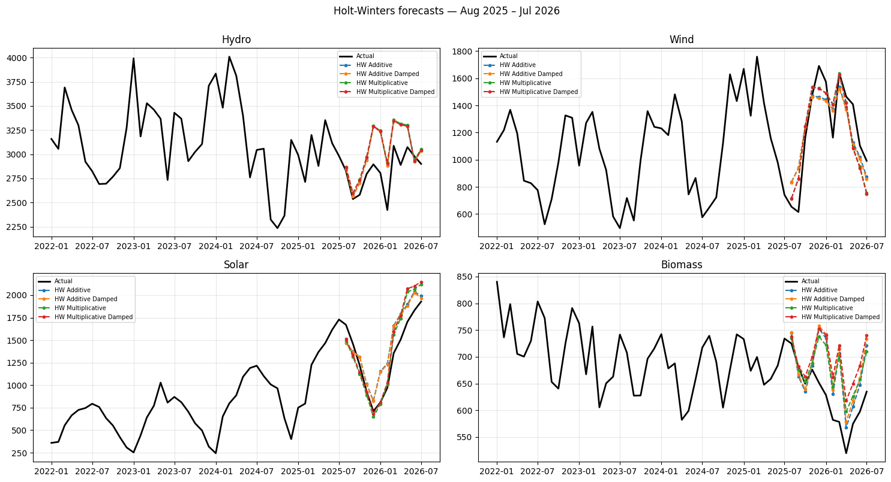
Figure 7.3: Holt-Winters forecasts on the test year
- Multiplicative seasonality is best for solar (MAPE 10.0%), wind (13.4%) and biomass (9.2%); for hydro the additive damped variant is best (8.0%), still worse than SARIMA and the naive forecast.
- β and γ are close to 0 for most sources, i.e. a fixed slope and a fixed seasonal shape; damping did not help.

7.5 Machine learning and deep learning
Table 7.4 Random Forest feature importance (target = log-growth)
Feature | Hydro | Wind | Solar | Biomass
z_lag1 | 0.106 | 0.116 | 0.119 | 0.058
z_lag2 | 0.106 | 0.088 | 0.076 | 0.047
z_lag3 | 0.097 | 0.071 | 0.131 | 0.032
z_lag12 | 0.432 | 0.394 | 0.100 | 0.515
month_sin | 0.051 | 0.046 | 0.424 | 0.035
month_cos | 0.109 | 0.199 | 0.084 | 0.008
d_log_rest | 0.099 | 0.086 | 0.065 | 0.306

Table 7.5 Tree-model accuracy on the test year
Source – model | MAE | RMSE | MAPE % | sMAPE % | MASE
Hydro – Random Forest | 117.64 | 151.92 | 4.28 | 4.24 | 0.39
Hydro – Gradient Boosting | 172.90 | 208.96 | 6.23 | 6.23 | 0.57
Hydro – XGBoost | 179.91 | 224.06 | 6.43 | 6.45 | 0.59
Wind – Random Forest | 161.05 | 181.40 | 14.79 | 14.22 | 1.31
Wind – Gradient Boosting | 206.25 | 225.05 | 19.06 | 18.71 | 1.68
Wind – XGBoost | 193.24 | 222.58 | 18.13 | 17.80 | 1.57
Solar – Random Forest | 59.00 | 64.63 | 4.51 | 4.54 | 0.64
Solar – Gradient Boosting | 102.42 | 151.37 | 6.28 | 5.93 | 1.10
Solar – XGBoost | 134.07 | 166.37 | 9.80 | 9.18 | 1.44
Biomass – Random Forest | 42.25 | 45.89 | 6.95 | 6.75 | 0.87
Biomass – Gradient Boosting | 33.41 | 39.57 | 5.39 | 5.31 | 0.69
Biomass – XGBoost | 34.52 | 39.99 | 5.55 | 5.47 | 0.71

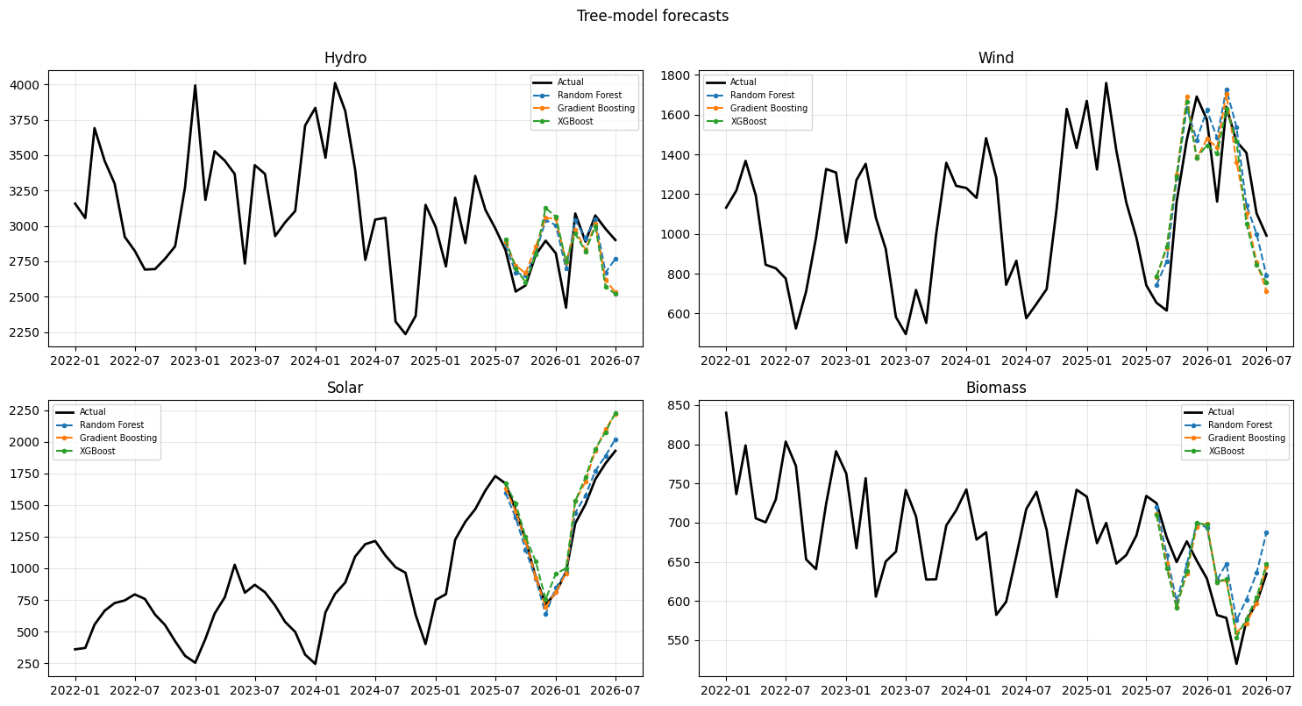
Figure 7.4: Tree-model forecasts on the test year
Table 7.6 LSTM accuracy on the test year (139 training windows per source)
Source – model | MAE | RMSE | MAPE % | sMAPE % | MASE
Hydro – LSTM | 271.45 | 332.15 | 9.82 | 9.33 | 0.89
Wind – LSTM | 214.81 | 273.98 | 15.74 | 17.80 | 1.75
Solar – LSTM | 120.08 | 139.55 | 9.47 | 9.97 | 1.29
Biomass – LSTM | 61.71 | 75.49 | 10.54 | 9.74 | 1.27

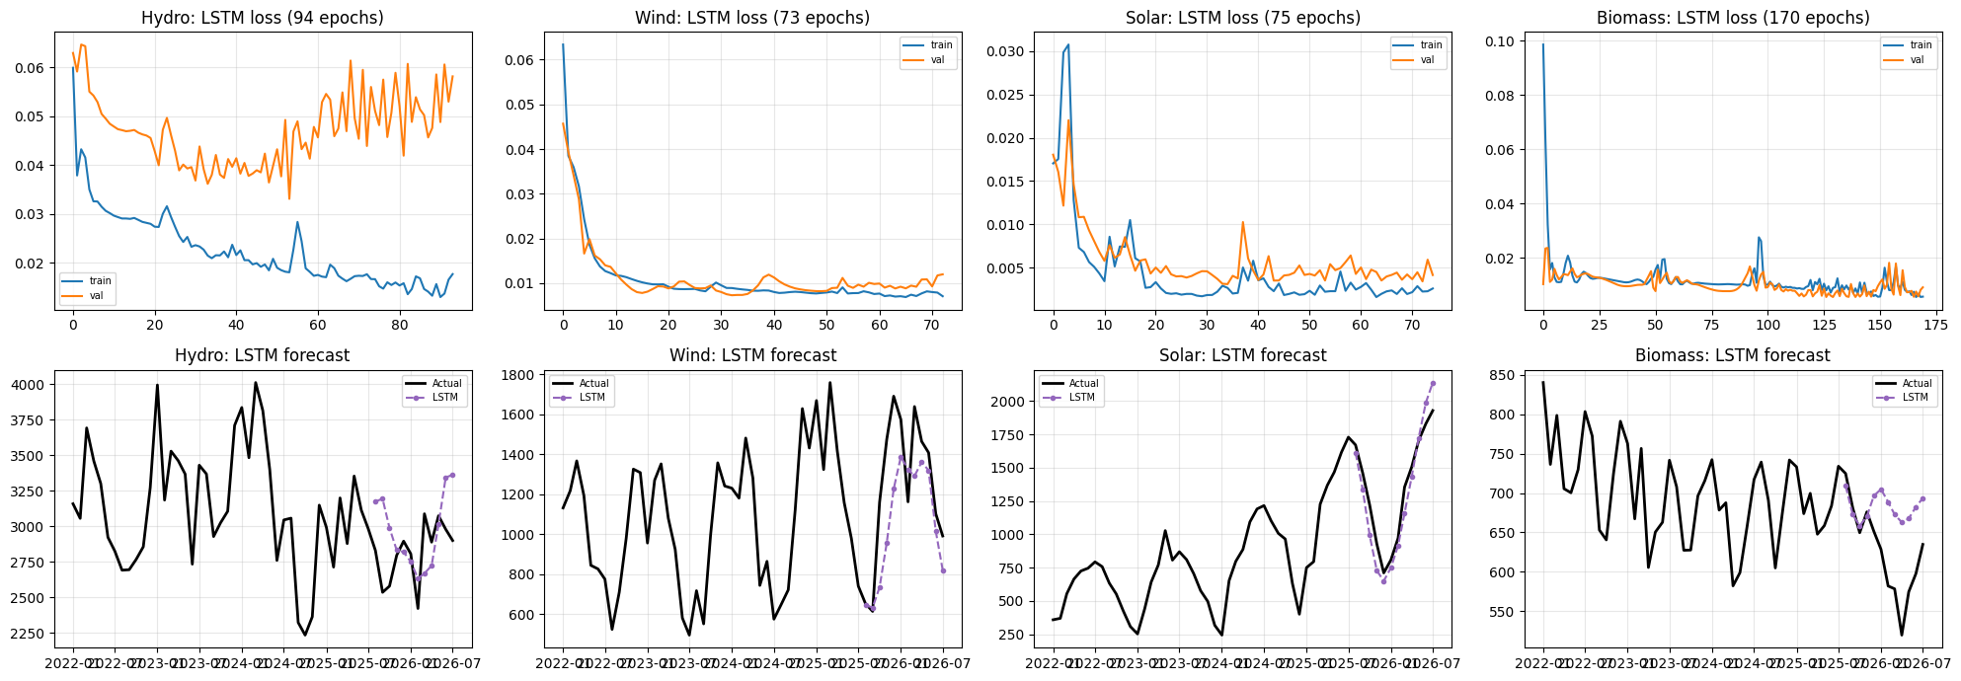
Figure 7.5: LSTM training loss and forecasts
- Tree models win for three sources on the test year: Random Forest for hydro (MAPE 4.3%) and solar (4.5%), Gradient Boosting for biomass (5.4%).
- For wind, every tree model loses to the seasonal naive.
- Lag 12 dominates hydro, wind and biomass; the month terms dominate solar; the demand covariate matters only for biomass (importance about 0.3).
- The LSTM is mid-table: 139 training windows are too few for a recurrent network.

7.6 Forecast accuracy and model selection
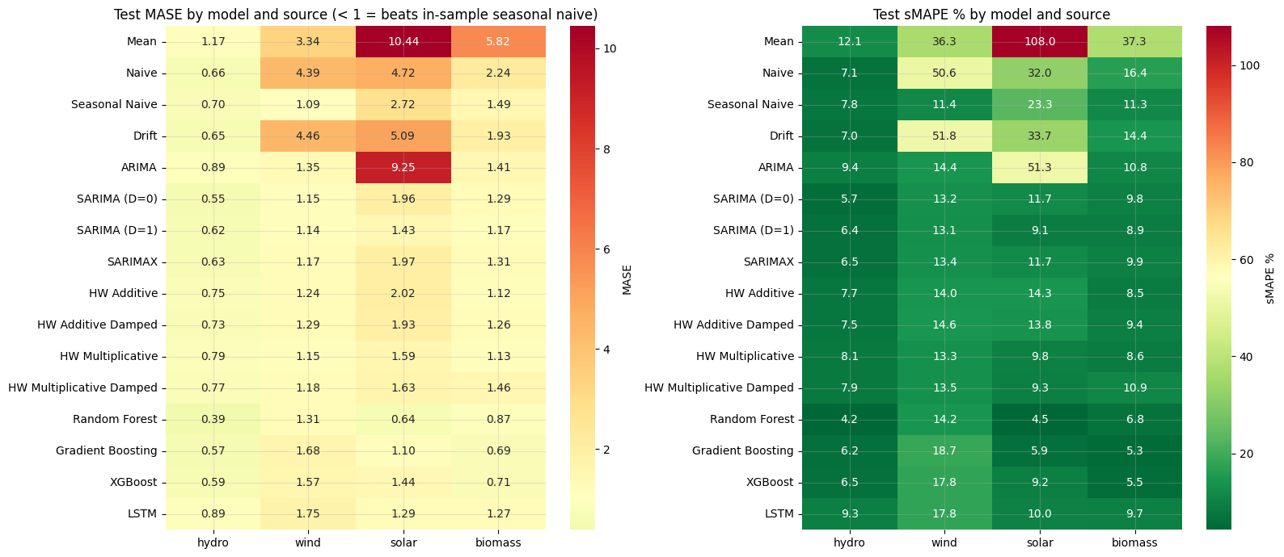
Figure 7.6: Test MASE and sMAPE of every model by source
Table 7.7 Best model of each family on the test year
Source – family | Model | MAE | RMSE | sMAPE % | MASE
Hydro – ML | Random Forest | 117.64 | 151.92 | 4.24 | 0.39
Hydro – ARIMA-family | SARIMA (D=0) | 165.56 | 220.71 | 5.67 | 0.55
Hydro – Baseline | Drift | 196.72 | 256.57 | 6.99 | 0.65
Hydro – Holt-Winters | HW Additive Damped | 222.66 | 273.04 | 7.52 | 0.73
Hydro – DL | LSTM | 271.45 | 332.15 | 9.33 | 0.89
Wind – Baseline | Seasonal Naive | 134.39 | 157.17 | 11.36 | 1.09
Wind – ARIMA-family | SARIMA (D=1) | 140.05 | 170.61 | 13.10 | 1.14
Wind – Holt-Winters | HW Multiplicative | 141.95 | 171.29 | 13.26 | 1.15
Wind – ML | Random Forest | 161.05 | 181.40 | 14.22 | 1.31
Wind – DL | LSTM | 214.81 | 273.98 | 17.80 | 1.75
Solar – ML | Random Forest | 59.00 | 64.63 | 4.54 | 0.64
Solar – DL | LSTM | 120.08 | 139.55 | 9.97 | 1.29
Solar – ARIMA-family | SARIMA (D=1) | 132.85 | 151.59 | 9.10 | 1.43
Solar – Holt-Winters | HW Multiplicative | 147.81 | 175.40 | 9.76 | 1.59
Solar – Baseline | Seasonal Naive | 253.02 | 287.38 | 23.35 | 2.72
Biomass – ML | Gradient Boosting | 33.41 | 39.57 | 5.31 | 0.69
Biomass – Holt-Winters | HW Additive | 54.84 | 67.27 | 8.45 | 1.12
Biomass – ARIMA-family | SARIMA (D=1) | 57.02 | 68.75 | 8.91 | 1.17
Biomass – DL | LSTM | 61.71 | 75.49 | 9.74 | 1.27
Biomass – Baseline | Seasonal Naive | 72.90 | 84.32 | 11.34 | 1.49

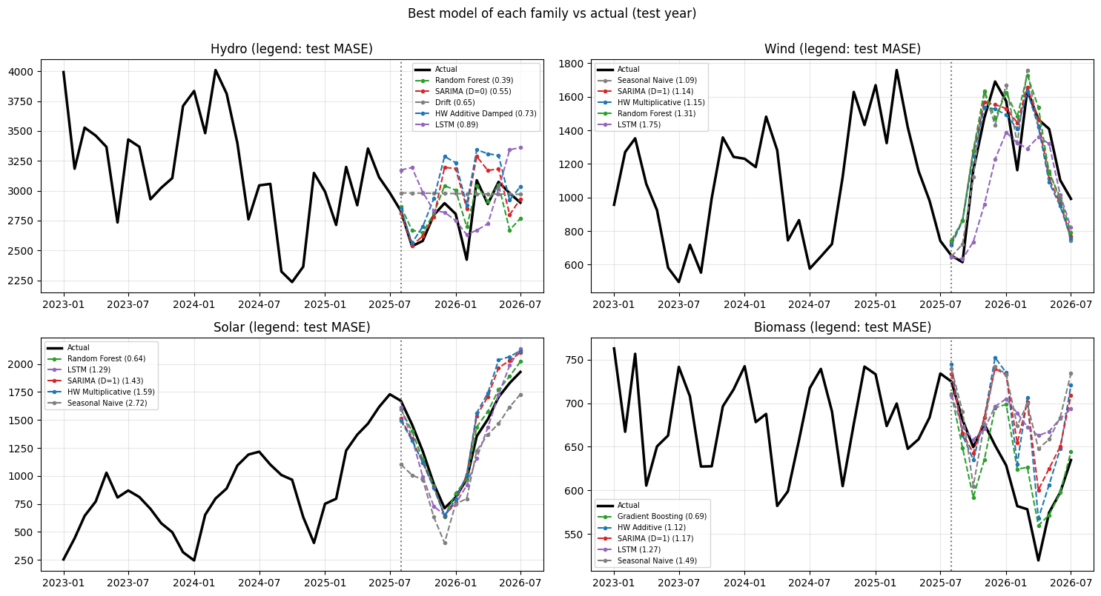
Figure 7.7: Best model of each family versus actual values, test year
Table 7.8 Diebold-Mariano tests: models significantly different from the seasonal naive (5% level); all others not significant
Source | Model | DM statistic | p-value | Versus seasonal naive
Hydro | Mean | 2.240 | 0.047 | significantly worse
Wind | XGBoost | 2.766 | 0.018 | significantly worse
Wind | Gradient Boosting | 3.484 | 0.005 | significantly worse
Wind | Mean | 3.450 | 0.005 | significantly worse
Wind | Naive | 3.848 | 0.003 | significantly worse
Wind | Drift | 3.902 | 0.002 | significantly worse
Solar | Random Forest | -2.925 | 0.014 | significantly better
Solar | LSTM | -2.211 | 0.049 | significantly better
Solar | ARIMA | 4.278 | 0.001 | significantly worse
Solar | Mean | 4.531 | 0.001 | significantly worse
Biomass | Gradient Boosting | -3.509 | 0.005 | significantly better
Biomass | XGBoost | -3.433 | 0.006 | significantly better
Biomass | Random Forest | -3.848 | 0.003 | significantly better
Biomass | HW Multiplicative | -3.023 | 0.012 | significantly better
Biomass | SARIMA (D=1) | -2.679 | 0.021 | significantly better
Biomass | Naive | 2.873 | 0.015 | significantly worse
Biomass | Mean | 9.361 | 0.000 | significantly worse

- Best family on the test year: hydro — ML; wind — baseline ≈ SARIMA ≈ Holt-Winters; solar — ML; biomass — ML.
- Diebold-Mariano: for biomass five models are significantly better than the seasonal naive; for solar, Random Forest and the LSTM; for hydro and wind none (12 test months give little power). For wind, Gradient Boosting and XGBoost are significantly worse.

7.7 Robustness: rolling-origin evaluation (36 test months)
Table 7.9 Rolling-origin winners (refits July 2023, 2024, 2025)
Source | Best model (rolling origin) | Mean MASE | Mean sMAPE (%) | Seasonal Naive mean MASE | Best on single test year
Hydro | Gradient Boosting | 0.780 | 7.556 | 1.275 | Random Forest
Wind | HW Multiplicative | 1.136 | 12.315 | 1.396 | Seasonal Naive
Solar | Gradient Boosting | 1.395 | 11.199 | 3.197 | Random Forest
Biomass | XGBoost | 0.603 | 4.640 | 0.913 | Gradient Boosting

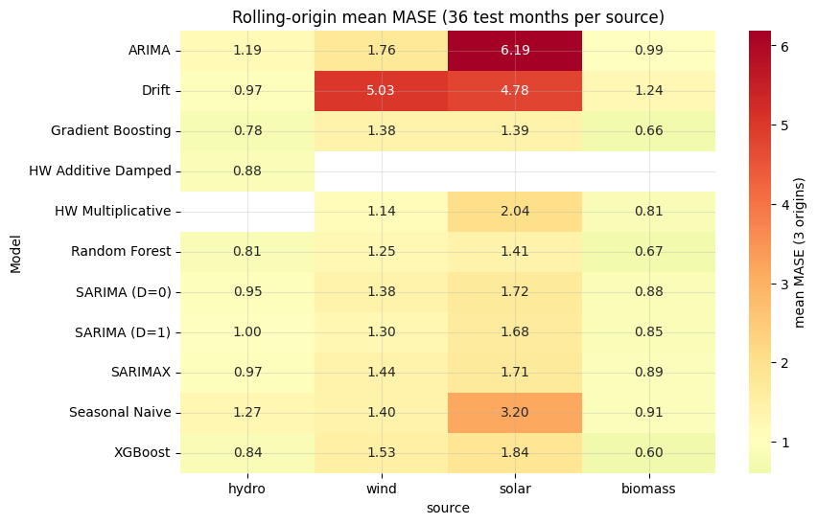
Figure 7.8: Rolling-origin mean MASE of every model by source
- Boosted trees are the most consistent family for hydro (Gradient Boosting, MASE 0.78), solar (Gradient Boosting, 1.39) and biomass (XGBoost, 0.60).
- Wind shows almost no skill beyond repeating last year: Holt-Winters multiplicative (1.14) is only slightly better than the seasonal naive (1.40).
- Forecastability by 3-year sMAPE: biomass (4.6%) > hydro (7.6%) > solar (11.2%) > wind (12.3%).

7.8 Forecast for August 2026 – July 2027
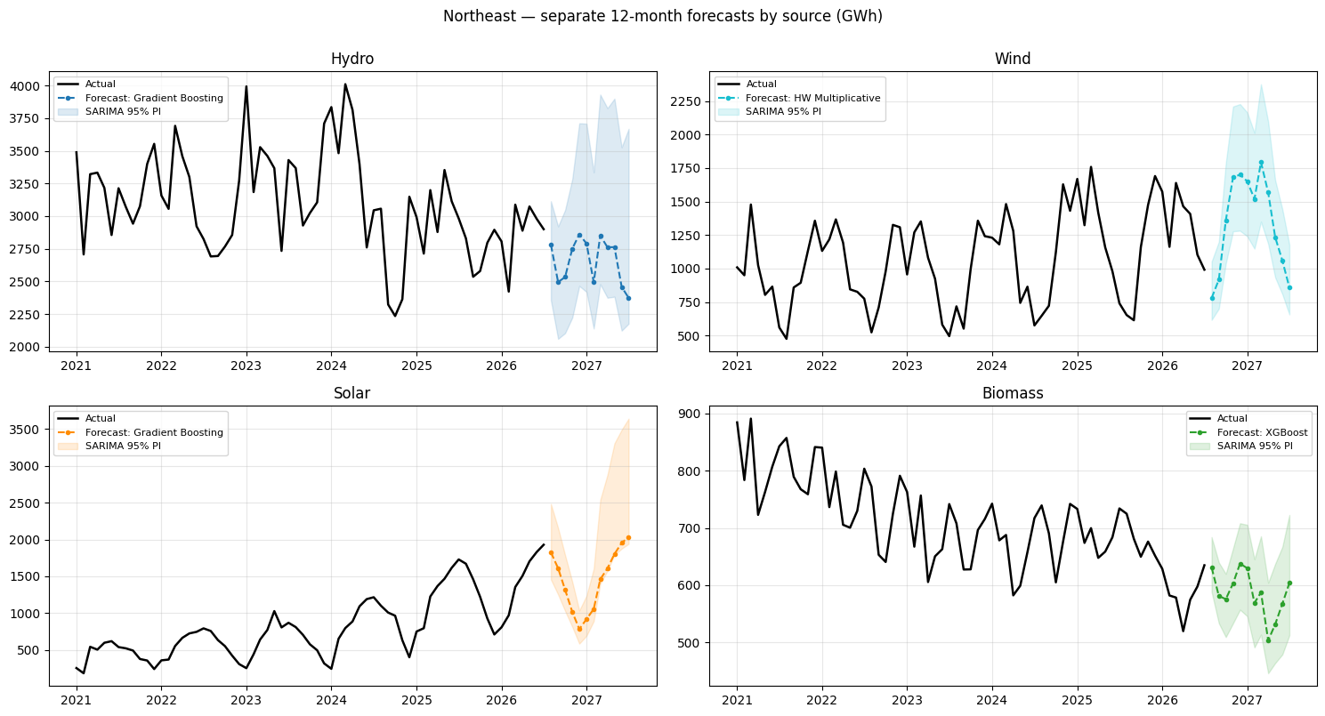
Figure 7.9: Separate 12-month forecasts by source (band = SARIMA 95% prediction interval)
Table 7.10 Twelve-month outlook by source
Source | Model used | Rolling-origin MASE | Last 12 months (GWh) | Next 12 months (GWh) | Change (%) | Share of next 12 months (%)
Hydro | Gradient Boosting | 0.78 | 33794.03 | 31913.22 | -5.57 | 44.05
Wind | HW Multiplicative | 1.14 | 14936.56 | 16123.99 | 7.95 | 22.26
Solar | Gradient Boosting | 1.39 | 16096.50 | 17388.98 | 8.03 | 24.00
Biomass | XGBoost | 0.60 | 7498.14 | 7020.21 | -6.37 | 9.69
Total renewable | sum of sources | — | 72325.24 | 72446.41 | 0.17 | 100.00

Table 7.11 Monthly forecasts (GWh)
Month | hydro | wind | solar | biomass | total renewable
2026-08 | 2781.3 | 779.6 | 1827.0 | 630.8 | 6018.7
2026-09 | 2495.1 | 917.4 | 1609.5 | 581.1 | 5603.0
2026-10 | 2533.6 | 1360.3 | 1318.8 | 575.6 | 5788.3
2026-11 | 2751.3 | 1681.5 | 1015.3 | 603.0 | 6051.0
2026-12 | 2860.3 | 1701.0 | 784.0 | 637.6 | 5982.9
2027-01 | 2790.3 | 1651.1 | 918.5 | 629.6 | 5989.5
2027-02 | 2494.0 | 1519.2 | 1057.1 | 568.9 | 5639.3
2027-03 | 2850.8 | 1794.1 | 1459.4 | 587.4 | 6691.7
2027-04 | 2762.0 | 1567.6 | 1608.5 | 503.4 | 6441.5
2027-05 | 2762.7 | 1234.7 | 1803.2 | 531.5 | 6332.0
2027-06 | 2457.9 | 1058.7 | 1953.9 | 567.7 | 6038.2
2027-07 | 2374.1 | 858.8 | 2033.7 | 603.7 | 5870.3

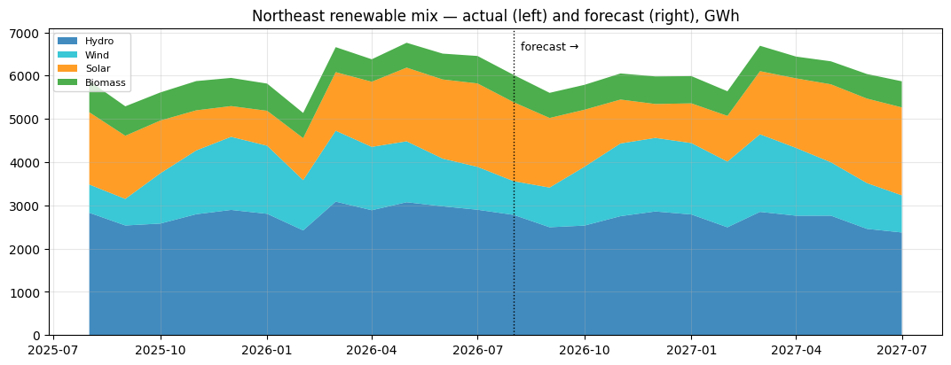
Figure 7.10: Northeast renewable mix: actual (left) and forecast (right)
- Total renewable output is expected to stay flat at about 72,450 GWh (+0.2%): solar (+8.0%) and wind (+8.0%) rise while hydro (−5.6%) and biomass (−6.4%) fall.
- Solar (24%) overtakes wind (22%) as the second-largest source; hydro remains the largest (44%).
- The tree model damps solar growth; SARIMA or Holt-Winters would forecast higher solar output. Wind is the least reliable forecast.

8. Residual Diagnostics and Interpretation
Residuals are tested for zero mean, autocorrelation (Ljung-Box at lags 6 and 12), normality (Shapiro-Wilk and Jarque-Bera) and conditional heteroscedasticity (ARCH-LM). A good model has mean ≈ 0, Ljung-Box p > 0.05, approximately normal errors and no ARCH effect.
Table 8.1 Residual diagnostics of the best models of each family
Source – model | n | mean | std | Ljung-Box p (6) | Ljung-Box p (12) | Shapiro p | Jarque-Bera p | ARCH-LM p | White noise (LB12 p > 0.05) | Final model
hydro – Random Forest | 138.0 | 4.000 | 134.398 | 0.360 | 0.031 | 0.003 | 0.000 | 0.306 | no
hydro – SARIMA (D=0) | 138.0 | -3.694 | 244.183 | 0.844 | 0.400 | 0.157 | 0.093 | 0.211 | yes
hydro – HW Additive Damped | 151.0 | 1.790 | 215.129 | 0.063 | 0.021 | 0.048 | 0.021 | 0.458 | no
hydro – LSTM | 139.0 | 30.098 | 259.091 | 0.448 | 0.128 | 0.936 | 0.892 | 0.188 | yes
hydro – Gradient Boosting | 138.0 | 2.878 | 134.022 | 0.688 | 0.197 | 0.121 | 0.027 | 0.398 | yes | yes
wind – SARIMA (D=1) | 126.0 | 0.206 | 136.557 | 0.497 | 0.553 | 0.427 | 0.901 | 0.061 | yes
wind – HW Multiplicative | 151.0 | -0.377 | 113.156 | 0.297 | 0.699 | 0.499 | 0.644 | 0.091 | yes | yes
wind – Random Forest | 138.0 | 4.434 | 79.928 | 0.004 | 0.045 | 0.208 | 0.231 | 0.071 | no
wind – LSTM | 139.0 | -43.206 | 133.247 | 0.025 | 0.155 | 0.441 | 0.646 | 0.146 | yes
solar – Random Forest | 138.0 | 0.714 | 40.496 | 0.000 | 0.000 | 0.000 | 0.000 | 0.077 | no
solar – LSTM | 139.0 | 21.424 | 71.063 | 0.272 | 0.062 | 0.000 | 0.000 | 0.193 | yes
solar – SARIMA (D=1) | 126.0 | 6.254 | 61.607 | 0.068 | 0.249 | 0.000 | 0.000 | 0.001 | yes
solar – HW Multiplicative | 151.0 | 8.203 | 54.282 | 0.004 | 0.059 | 0.000 | 0.000 | 0.000 | yes
solar – Gradient Boosting | 138.0 | 0.112 | 32.798 | 0.000 | 0.000 | 0.000 | 0.000 | 0.000 | no | yes
biomass – Gradient Boosting | 138.0 | 0.058 | 20.309 | 0.045 | 0.022 | 0.584 | 0.652 | 0.986 | no
biomass – HW Additive | 151.0 | -0.000 | 31.363 | 0.493 | 0.321 | 0.721 | 0.163 | 0.758 | yes
biomass – SARIMA (D=1) | 126.0 | -2.116 | 32.690 | 0.569 | 0.486 | 0.501 | 0.464 | 0.556 | yes
biomass – LSTM | 139.0 | 14.825 | 58.931 | 0.336 | 0.000 | 0.903 | 0.657 | 0.000 | no
biomass – XGBoost | 138.0 | 0.240 | 17.328 | 0.222 | 0.045 | 0.809 | 0.850 | 0.767 | no | yes

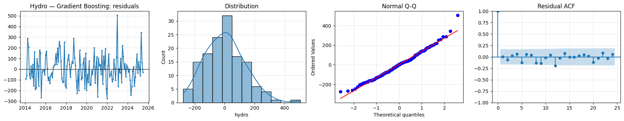
Figure 8.1: Residuals of the final hydro (Gradient Boosting) model: time plot, distribution, Q-Q plot and residual ACF
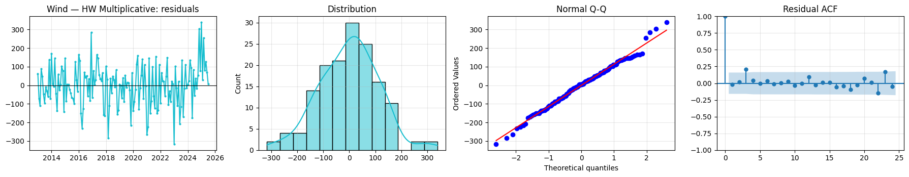
Figure 8.2: Residuals of the final wind (Holt-Winters multiplicative) model: time plot, distribution, Q-Q plot and residual ACF
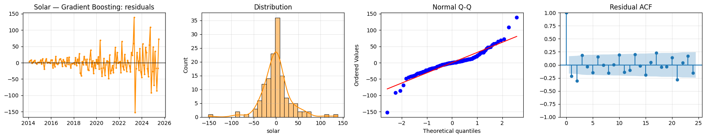
Figure 8.3: Residuals of the final solar (Gradient Boosting) model: time plot, distribution, Q-Q plot and residual ACF
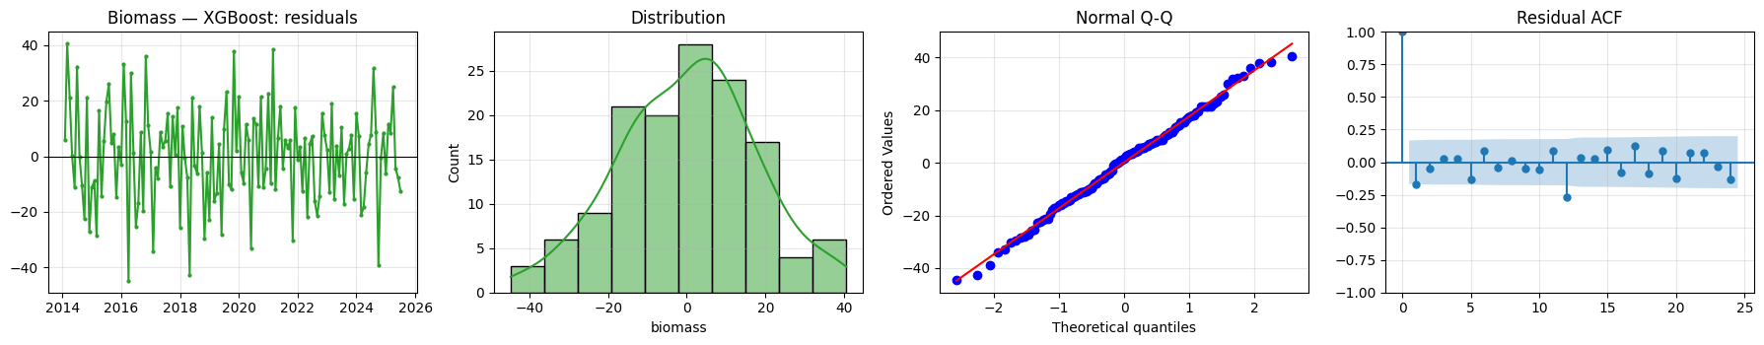
Figure 8.4: Residuals of the final biomass (XGBoost) model: time plot, distribution, Q-Q plot and residual ACF
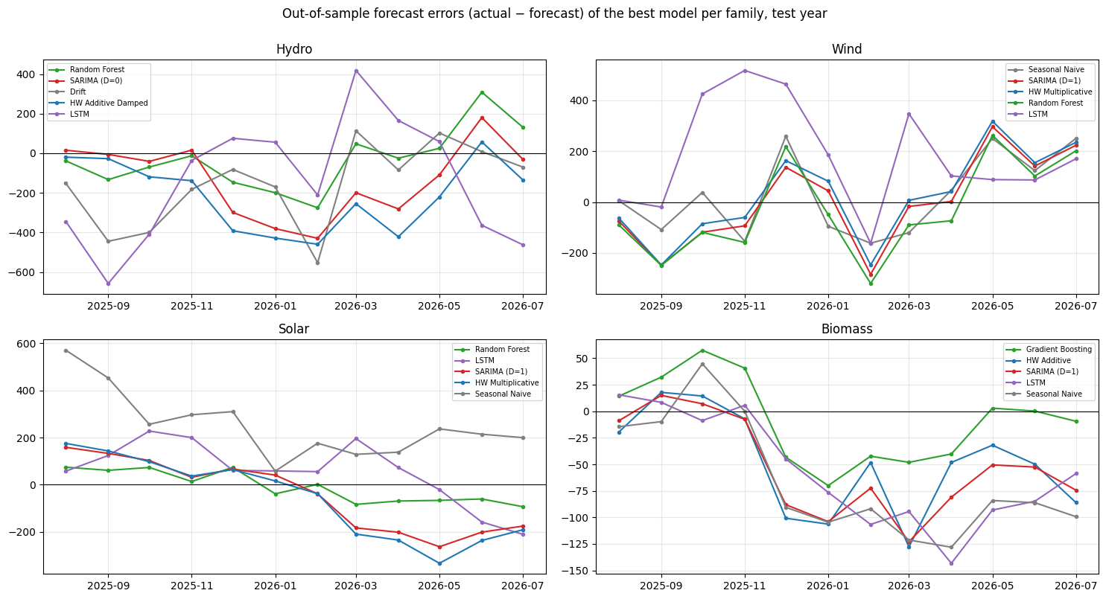
Figure 8.5: Out-of-sample forecast errors of the best model per family, test year
Table 8.2 Summary of residual behaviour
Source | White-noise residuals | Autocorrelated residuals | Note
Hydro | SARIMA D = 0, Gradient Boosting (final), LSTM | Random Forest, Holt-Winters | SARIMA passes all checks, so its intervals are reliable
Wind | SARIMA D = 1, Holt-Winters multiplicative (final), LSTM | Random Forest | Borderline ARCH (p = 0.06–0.09): intervals may be too narrow in volatile winters
Solar | SARIMA D = 1, Holt-Winters multiplicative, LSTM | Random Forest, Gradient Boosting (final) | Non-normal for every model; the spread grows with capacity
Biomass | SARIMA D = 1, Holt-Winters additive | Gradient Boosting, XGBoost (final), LSTM | SARIMA D = 1 passes all checks

- The final models for hydro and wind leave white-noise residuals; the final tree models for solar and biomass leave some autocorrelation, so the SARIMA prediction intervals are used to describe uncertainty in the final forecast.
- SARIMA passes the white-noise test for every source, so its structure captures the time dependence of all four series.

Conclusion
1. Patterns: hydro is flat with a March peak (74% from New York); wind grows +3.5%/yr with the strongest seasonality; solar grows +27%/yr with a July peak; biomass declines −5%/yr with a December peak. The offset peaks smooth total output.
2. Stationarity: a log transform plus one regular difference (d = 1) makes every source stationary; the ACF/PACF show a seasonal AR(1) for all four, and AIC adds a seasonal MA term.
3. Best models (3-year rolling origin): hydro Gradient Boosting, wind Holt-Winters multiplicative, solar Gradient Boosting, biomass XGBoost.
4. Covariate: the demand proxy is significant only for hydro, SARIMAX never beats SARIMA out of sample, and the covariate is useful only inside tree models for biomass.
5. Outlook: about 72.4 TWh in total (+0.2%), with solar and wind up and hydro and biomass down.
6. Limitations: no weather data (rain, snowpack, wind speed, irradiance) — the main improvement to make — and only 12–36 test months.

