Cross-Region Comparison and Overall Conclusions: Renewable Electricity Generation by Source across the Four U.S. Census Regions
  - Technical Report | South, Northeast, Midwest, West | U.S. EIA monthly net generation, January 2001 – July 2026

9. Cross-Region Comparison and Overall Conclusions
This document brings together the four regional reports. In every region each renewable source (hydro, wind, solar, biomass and, where it exists, geothermal) was analysed and forecast separately, using the same steps: trend and seasonality analysis, ADF/KPSS stationarity tests, ACF/PACF identification confirmed by AIC, a comparison of baseline, ARIMA-family, Holt-Winters, machine-learning and neural-network models, residual diagnostics and a 12-month forecast.

9.1 Comparability of the regional studies
Table 9.1 Study design by region
Design element | South, Midwest, West | Northeast
Study window | Jan 2001 – Jul 2026 (solar from 2010 in the South and 2012 in the Midwest; full period in the West) | Jan 2013 – Jul 2026 for all sources
Test period | Last 24 months (Aug 2024 – Jul 2026), one forecast origin | Last 12 months (Aug 2025 – Jul 2026), plus a 3-origin rolling check (36 months)
Transformation | Log scale for multiplicative series; differencing chosen per series by a seasonal-strength + ADF/KPSS rule | Log scale and d = 1 for every source; D = 0 and D = 1 both tested
Model set | Naive, seasonal naive, ARIMA, SARIMA, SARIMAX (Fourier), SES, Holt, Holt-Winters, Linear Regression, Random Forest, MLP | Mean, naive, seasonal naive, drift, ARIMA, SARIMA, SARIMAX (demand proxy), Holt-Winters, Random Forest, Gradient Boosting, XGBoost, LSTM
Sources modelled | South: hydro, wind, solar, biomass · Midwest: hydro, solar, biomass, wind · West: all five including geothermal | Hydro, wind, solar, biomass

Because the Northeast uses a shorter window and a 12-month test, its errors are not strictly comparable with the other three regions; MAPE (a scale-free percentage error) is used for all cross-region comparisons, and the differences in design are kept in mind when ranking regions. Geothermal generation is zero in the South, Midwest and Northeast and is modelled only in the West.

9.2 Side-by-side forecast accuracy: MAE, RMSE and MAPE
Table 9.2 compares the best model of each source in each region. Table 9.3 compares the same two reference models everywhere — SARIMA and the seasonal-naive benchmark — so that the regions can be compared on an equal footing.
Table 9.2 Best model of each source in each region (test period)
Resource | Region | Best model | MAE (GWh) | RMSE (GWh) | MAPE (%)
Hydro | South | ARIMA(3,0,2) + constant | 531.3 | 624.7 | 16.98
Hydro | Northeast | Random Forest | 117.6 | 151.9 | 4.28
Hydro | Midwest | Linear Regression | 211.7 | 319.0 | 13.67
Hydro | West | Holt-Winters multiplicative | 1,474.5 | 2,142.5 | 9.93
Wind | South | Holt-Winters multiplicative | 958.9 | 1,182.2 | 6.98
Wind | Northeast | Seasonal naive | 134.4 | 157.2 | 11.02
Wind | Midwest | Holt-Winters multiplicative | 1,152.7 | 1,500.9 | 8.07
Wind | West | Holt-Winters additive | 609.5 | 792.2 | 7.80
Solar | South | Random Forest | 595.8 | 718.8 | 5.49
Solar | Northeast | Random Forest | 59.0 | 64.6 | 4.51
Solar | Midwest | SARIMAX (Fourier terms) | 264.2 | 301.8 | 11.45
Solar | West | Holt-Winters additive damped | 570.9 | 685.7 | 7.11
Biomass | South | SARIMA(0,1,1)(0,1,1)12 | 77.4 | 89.0 | 4.04
Biomass | Northeast | Gradient Boosting | 33.4 | 39.6 | 5.39
Biomass | Midwest | Seasonal naive | 21.6 | 27.1 | 4.63
Biomass | West | SARIMA(0,1,2)(0,1,1)12 | 32.2 | 40.3 | 5.18
Geothermal | West | SARIMA(1,1,1)(1,0,1)12 | 44.3 | 51.9 | 3.47

Table 9.3 SARIMA (AIC-selected, D = 0 version in the Northeast) and seasonal naive in every region (MAE and RMSE in GWh)
Resource | Region | SARIMA MAE | SARIMA RMSE | SARIMA MAPE (%) | Seasonal naive MAE | Seasonal naive RMSE | Seasonal naive MAPE (%)
Hydro | South | 540.6 | 661.7 | 17.13 | 684.0 | 883.0 | 20.69
Hydro | Northeast | 165.6 | 220.7 | 5.95 | 213.6 | 241.6 | 7.75
Hydro | Midwest | 241.3 | 322.2 | 15.84 | 230.0 | 342.3 | 15.09
Hydro | West | 1,565.3 | 2,204.9 | 10.62 | 1,668.6 | 2,546.4 | 11.11
Wind | South | 2,871.2 | 3,285.7 | 20.04 | 1,496.9 | 1,884.7 | 10.00
Wind | Northeast | 141.2 | 168.8 | 13.57 | 134.4 | 157.2 | 11.02
Wind | Midwest | 2,589.4 | 3,035.7 | 17.65 | 1,196.8 | 1,710.4 | 7.72
Wind | West | 711.6 | 830.2 | 9.28 | 1,180.6 | 1,401.5 | 14.68
Solar | South | 2,190.4 | 2,929.2 | 17.12 | 4,336.6 | 4,724.0 | 36.34
Solar | Northeast | 182.3 | 228.8 | 12.31 | 253.0 | 287.4 | 20.12
Solar | Midwest | 292.5 | 363.5 | 11.23 | 1,819.0 | 2,079.5 | 57.61
Solar | West | 606.1 | 848.3 | 6.39 | 2,191.7 | 2,349.8 | 24.26
Biomass | South | 77.4 | 89.0 | 4.04 | 147.8 | 169.6 | 7.73
Biomass | Northeast | 62.8 | 74.4 | 10.50 | 72.9 | 84.3 | 12.25
Biomass | Midwest | 37.7 | 45.4 | 7.95 | 21.6 | 27.1 | 4.63
Biomass | West | 32.2 | 40.3 | 5.18 | 62.6 | 75.6 | 10.05
Geothermal | West | 44.3 | 51.9 | 3.47 | 68.9 | 83.8 | 5.36

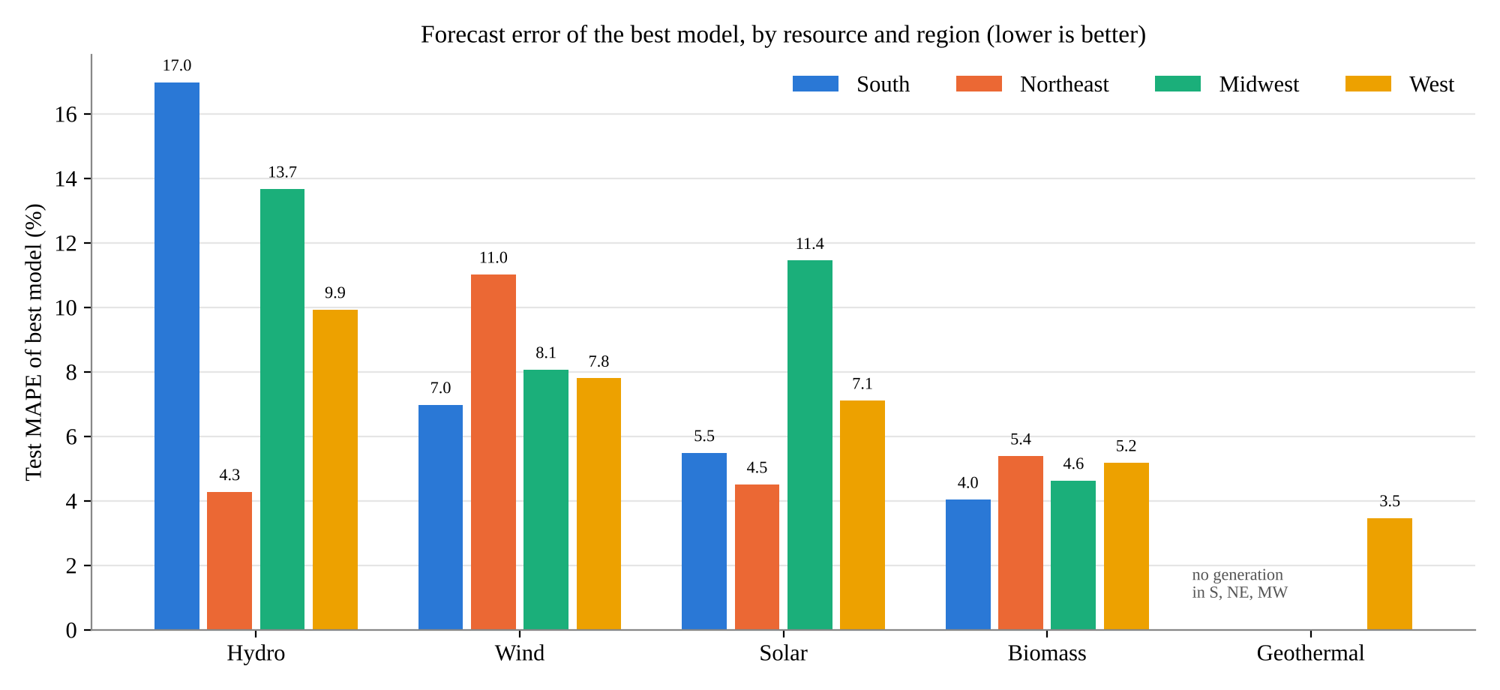
Figure 9.1: MAPE of the best model for each resource in each region (values shown on the bars; see Table 9.2)
- MAE and RMSE scale with the size of each region's output (e.g. Western hydro errors of about 1,500 GWh against Northeastern hydro errors of about 120 GWh), so MAPE is used to compare difficulty across regions.
- No single model wins everywhere. Holt-Winters wins most often for wind (South, Midwest, West); tree models win for solar in the South and Northeast; SARIMA wins for biomass in the South and West and for Western geothermal; the seasonal naive cannot be beaten for Midwestern biomass and Northeastern wind.
- SARIMA is reliable for slowly changing sources but not for wind that has recently slowed down: for Southern and Midwestern wind it over-forecasts (MAPE 20.0% and 17.7%), because its near-unit seasonal AR term carries forward the earlier rapid growth.
- The seasonal naive is a strong benchmark for stable series (Midwestern biomass 4.6%, Midwestern wind 7.7%) and a very poor one for fast-growing solar (24–58%).

9.3 Which sources and regions are hardest to forecast?
Table 9.4 Forecast difficulty ranking within each region
Region | Easiest → hardest (by best-model MAPE)
South | Biomass 4.0% → Solar 5.5% → Wind 7.0% → Hydro 17.0%
Northeast (test year) | Hydro 4.3% → Solar 4.5% → Biomass 5.4% → Wind 11.0%
Northeast (3-year rolling sMAPE) | Biomass 4.6% → Hydro 7.6% → Solar 11.2% → Wind 12.3%
Midwest | Biomass 4.6% → Wind 8.1% → Solar 11.4% → Hydro 13.7%
West | Geothermal 3.5% → Biomass 5.2% → Solar 7.1% → Wind 7.8% → Hydro 9.9%

- Biomass (and Western geothermal) is the easiest source everywhere (MAPE 3.5–5.4%): small, regular seasonal cycles and slow trends.
- Hydro is the hardest source in the South, Midwest and West (9.9–17.0%), because its variation is driven by rainfall and snowpack that the series' own history cannot predict. The Northeast is the exception on its single test year, but its 3-year rolling result again places hydro behind biomass.
- Wind is the hardest Northeastern source and only barely beats the seasonal naive there; in the other regions Holt-Winters forecasts wind to within 7–8%.

9.4 Regional generation profiles: trend comparison
Table 9.5 Compound annual growth rate of each source (2001–2025 unless stated)
Resource | South | Northeast | Midwest | West
Hydro | 0.7%/yr, no meaningful trend (r = 0.25) | −0.1%/yr, flat | 0.7%/yr, weak drift, peak 2019 | 0.5%/yr, no upward trend (slope −695 GWh/yr)
Wind | 23.0%/yr, slowing to 3–4%/yr | 4.4%/yr (2013–2025) | 22.2%/yr, rapid and sustained | 14.0%/yr, slowing to about 4%/yr
Solar | 61.6%/yr (2010–2025) | 29.2%/yr (2013–2025) | 61.8%/yr (2012–2025) | 24.7%/yr (2001–2025), +19% in 2025
Biomass | 0.1%/yr; peak 2017, declining | −3.8%/yr, declining | 0.4%/yr; peak 2014, declining | 0.1%/yr; peak 2014, declining
Geothermal | None | None | None | 0.5%/yr, slow steady rise

Table 9.6 Generation mix, August 2025 – July 2026
Region | Largest renewable source (latest 12 months) | Second largest | Third largest
South | Wind (180.9 TWh) | Solar (157.1 TWh) | Hydro (37.2 TWh)
Northeast | Hydro (33.8 TWh) | Solar (16.1 TWh) | Wind (14.9 TWh)
Midwest | Wind (188.0 TWh) | Solar (44.9 TWh) | Hydro (18.0 TWh)
West | Hydro (171.6 TWh) | Solar (116.6 TWh) | Wind (97.4 TWh)

- Solar is the fastest-growing source in every region; in the South it is about to overtake wind, and in the Northeast and West it has already overtaken wind.
- Wind growth is slowing in the South and West; it remains the backbone of Midwestern renewable output (about 73% of the modelled total).
- Hydro has no meaningful long-term trend anywhere; its level is set by wet and dry years.
- Biomass is declining in every region after peaking in 2014–2017.

9.5 Seasonality strength and timing
Table 9.7 Seasonal peak / trough (deviation from trend) and seasonal strength in brackets
Resource | South | Northeast | Midwest | West
Hydro | Jan +25% / Sep −23% (0.41) | Mar / Sep, ratio 1.29 (0.64) | May +14% / Feb −15% (0.37) | May +29% / Oct −27% (0.77)
Wind | Apr +23% / Sep −24% (0.55) | Mar / Aug, ratio 2.25 (0.91) | Apr +25% / Aug −38% (0.83) | May +22% / Nov −15% (0.52)
Solar | May +24% / Dec −28% (0.71) | Jul / Dec, ratio 2.59 (0.90) | Jul +43% / Jan −48% (0.80) | Jun +54% / Dec −58% (0.67)
Biomass | Jul +6% / Feb −6% (0.65) | Dec / Apr, ratio 1.21 (0.82) | Aug +5% / Apr −6% (0.46) | Aug +8% / Apr −10% (0.68)
Geothermal | — | — | — | Dec +5% / Feb −6% (0.39)

Seasonal strength comes from classical decomposition in the South, Midwest and West and from STL on log values (2013–2026) in the Northeast; the Northeast reports the peak-to-trough ratio instead of percentage deviations.
- Solar has the largest seasonal swing everywhere, and it grows with latitude: ±25% in the South, ±45% in the Midwest, up to ±55% in the West.
- Hydro timing follows the water source: a winter rainfall peak in the South, a March snowmelt peak in the Northeast, and a May–June snowmelt peak in the Midwest and West.
- Wind peaks in spring everywhere (March–May) and is weakest in late summer or autumn.
- Complementarity differs by region: in the South and Northeast the seasonal peaks are spread across the year (hydro in winter/spring, wind in spring, solar in summer), which smooths total output; in the West, hydro, wind and solar all peak in May–June, concentrating output in late spring.

9.6 Stationarity and model structure
Table 9.8 Transformation, differencing and AIC-selected SARIMA order by region
Resource | South | Northeast | Midwest | West
Hydro | level, d = 0, D = 0 → (1,0,0)(1,0,1)12 + c | log, d = 1 → (0,1,2)(1,0,1)12 | log, d = 1, D = 0 → (1,1,1)(1,0,1)12 | log, d = 0, D = 1 → (1,0,2)(0,1,1)12
Wind | log, d = 1, D = 0 → (1,1,1)(1,0,1)12 | log, d = 1 → (0,1,1)(0,1,1)12 | log, d = 1, D = 1 → (0,1,1)(0,1,1)12 | log, d = 1, D = 0 → (1,1,1)(1,0,1)12 + drift
Solar | log, d = 1, D = 1 → (1,1,0)(0,1,1)12 | log, d = 1 → (0,1,1)(0,1,1)12 | log, d = 0, D = 1 → (1,0,0)(1,1,1)12 + drift | log, d = 1, D = 1 → (1,1,1)(1,1,1)12
Biomass | level, d = 1, D = 1 → (0,1,1)(0,1,1)12 | log, d = 1 → (2,1,0)(1,1,1)12 | level, d = 1, D = 0 → (1,1,1)(1,0,1)12 | level, d = 1, D = 1 → (0,1,2)(0,1,1)12
Geothermal | — | — | — | level, d = 1, D = 0 → (1,1,1)(1,0,1)12

- Almost every original series is non-stationary (ADF fails to reject a unit root and/or KPSS rejects stationarity); the exception is hydro in the South and West, which is stationary around its level and needs no regular difference.
- Wind and solar (and Midwestern and Western hydro) have seasonal swings that grow with the level and are modelled on the log scale.
- A seasonal MA(1) term appears in almost every SARIMA, matching the negative lag-12 spike in the ACF after seasonal differencing; where no seasonal difference is taken, a seasonal AR term close to 1 plays the same role.
- SARIMA leaves white-noise residuals for every source in every region, so it is the most reliable common description of the time structure, even where another model forecasts more accurately.

9.7 Twelve-month outlook (August 2026 – July 2027)
Table 9.9 Forecasts by source (TWh, last 12 months → next 12 months)
Region | Hydro | Wind | Solar | Biomass | Geothermal | Total: last 12 months → forecast
South | 37.2 → 42.0 (+12.9%) | 180.9 → 192.4 (+6.3%) | 157.1 → 208.7 (+32.8%) | 23.0 → 22.4 (−2.4%) | — | 398.2 → 465.5 TWh (+16.9%)
Northeast | 33.8 → 31.9 (−5.6%) | 14.9 → 16.1 (+8.0%) | 16.1 → 17.4 (+8.0%) | 7.5 → 7.0 (−6.4%) | — | 72.3 → 72.4 TWh (+0.2%)
Midwest | 18.0 → 18.3 (+1.8%) | 188.0 → 197.8 (+5.2%) | 44.9 → 69.3 (+54.5%) | 5.5 → 5.5 (0.0%) | — | 256.3 → 290.8 TWh (+13.5%)
West | 171.6 → 145.5 (−15.2%) | 97.4 → 102.8 (+5.5%) | 116.6 → 129.0 (+10.7%) | 7.2 → 6.9 (−4.0%) | 15.6 → 16.0 (+2.6%) | 408.4 → 400.3 TWh (−2.0%)

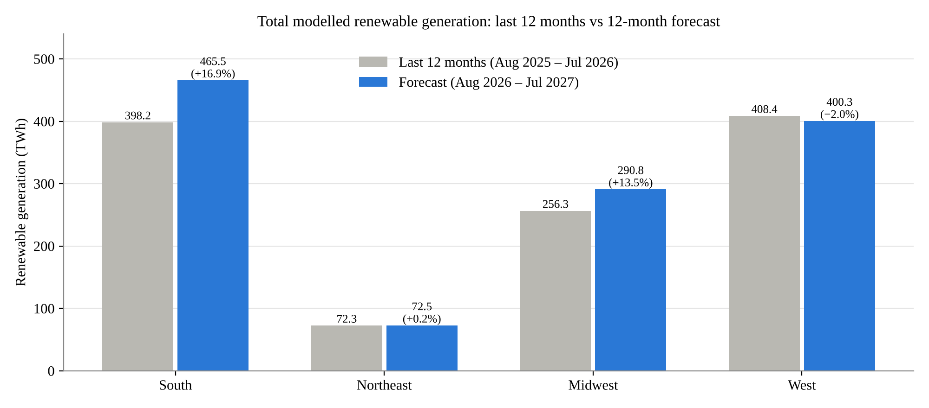
Figure 9.2: Total modelled renewable generation by region, last 12 months versus the 12-month forecast
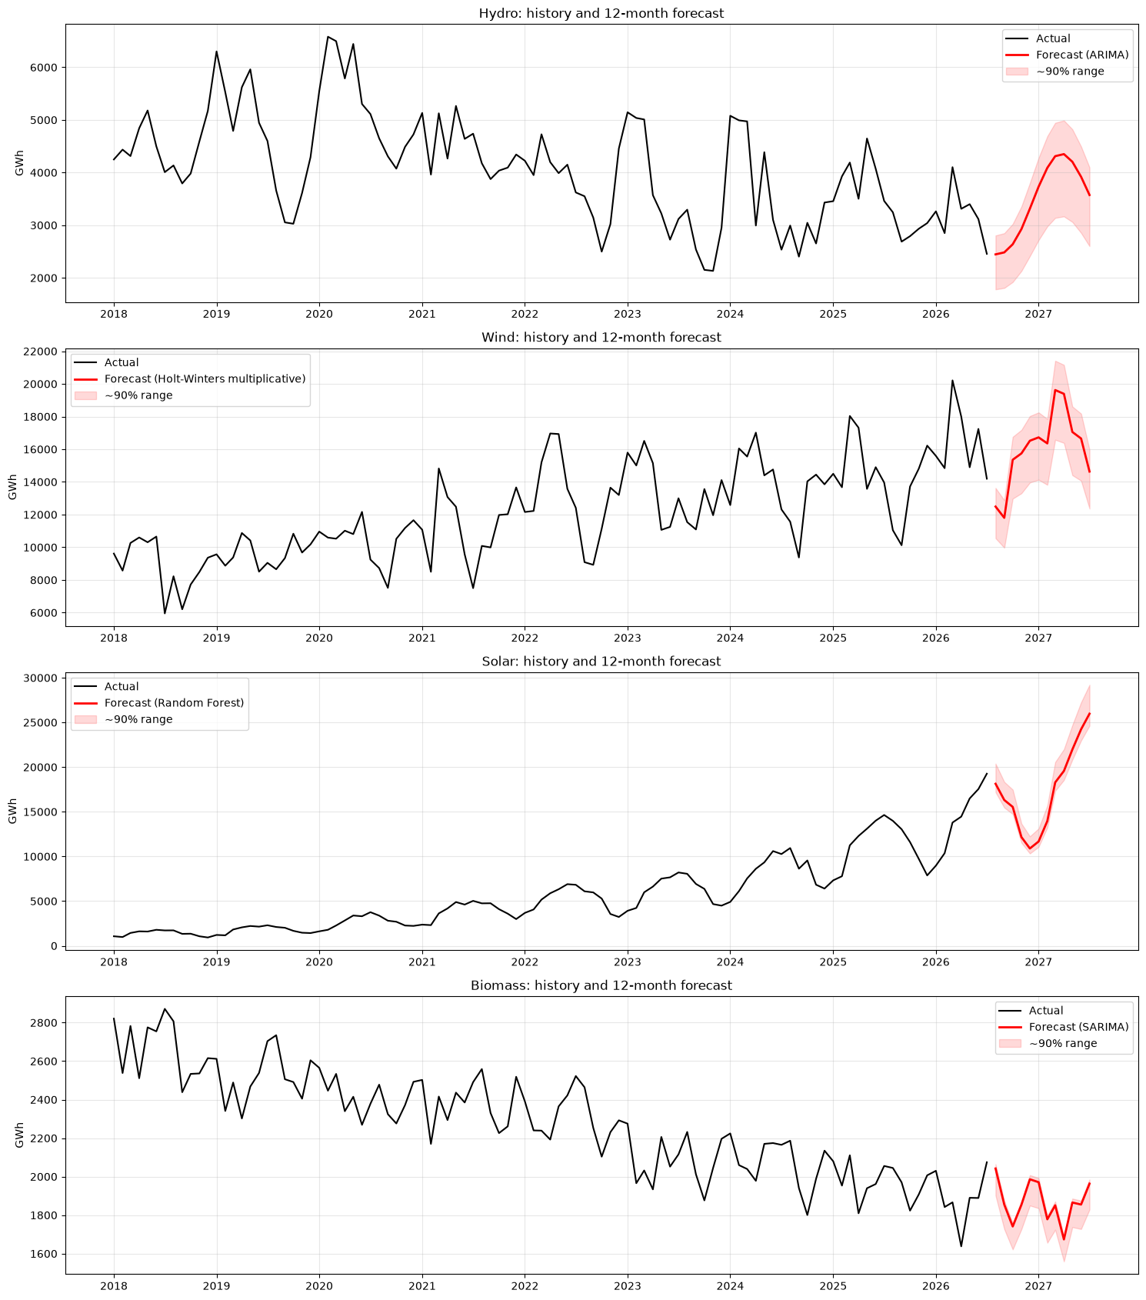
Figure 9.3: South — history and 12-month forecast of each source
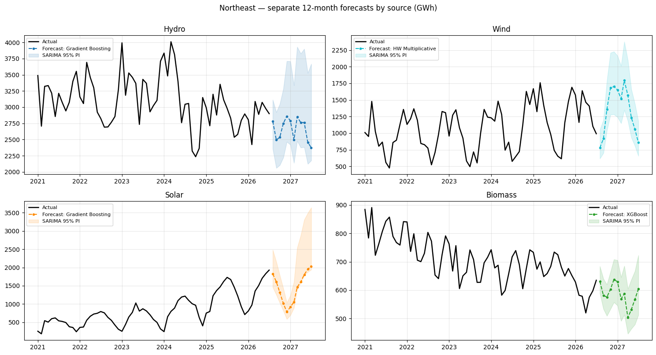
Figure 9.4: Northeast — separate 12-month forecasts by source
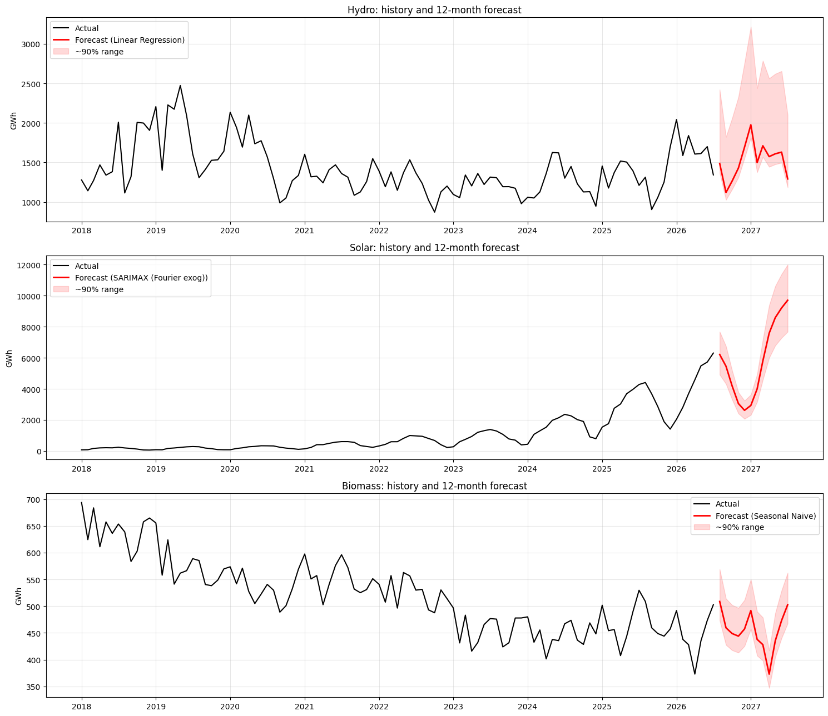
Figure 9.5: Midwest — history and 12-month forecast of each source
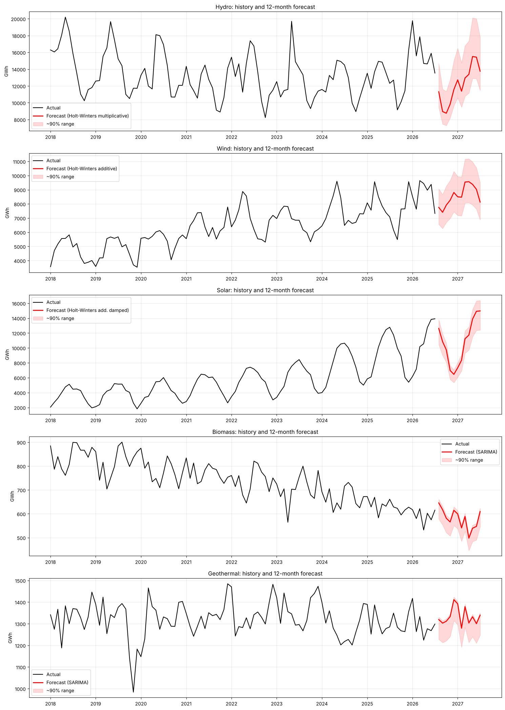
Figure 9.6: West — history and 12-month forecast of each source
- Solar drives growth everywhere: +54.5% in the Midwest, +32.8% in the South, about +10% in the West and Northeast. In the South solar is forecast to overtake wind as the largest source.
- The South is expected to become the largest renewable producer (about 465 TWh), ahead of the West (about 400 TWh).
- The West is forecast to fall slightly (−2.0%) only because hydro is expected to return to normal after a very wet year (−15.2%); its wind and solar keep growing.
- The Northeast stays flat (+0.2%): solar and wind growth offsets declining hydro and biomass.
- Totals cover the modelled sources only, and growth forecasts for solar extend recent trends; they do not know about future capacity additions.

9.8 Hypotheses across regions
Table 9.10 Hypothesis verdicts
Hypothesis | South | Northeast | Midwest | West
Every source shows 12-month seasonality | Supported | Supported | Supported | Supported
Seasonal models beat the seasonal naive | Supported (Holt-Winters or SARIMA beat it for every source) | Partly (hydro, solar and biomass yes on the test year; wind no) | Partly (solar and hydro yes; biomass no; wind tied) | Supported for all five sources
Growing sources need growth-aware models | Supported (solar: trend-free models 25–36%) | Supported (plain ARIMA 79% for solar) | Supported (solar: trend-free models 47–58%) | Supported (solar 38–41%, wind 16–18%)
Hydro is the hardest source | Supported | Not on the test year; partly on rolling origin | Supported | Supported

9.9 Key takeaways
1. Model each source separately. Within every region the best model differs by source, and the same source needs different models in different regions.
2. Forecastability follows the physics of the source: biomass and geothermal (steady, controllable plants) are easiest; hydro (weather-driven) is hardest; wind sits in between and depends on whether its growth is steady or slowing.
3. Holt-Winters is the most successful family for wind; SARIMA for slow, stable series (biomass, geothermal); growth-aware models (tree models on growth rates, SARIMA with drift, Holt-Winters) for solar. Plain naive and SES forecasts fail for every growing source.
4. Simple models remain hard to beat where the seasonal pattern is stable (Midwestern biomass, Northeastern wind).
5. SARIMA is the statistically best-specified model everywhere (white-noise residuals), so its prediction intervals are the most trustworthy even where another model has a lower point error.
6. Solar is reshaping every region's renewable mix and is the main source of expected growth over the next year.

9.10 Limitations and future work
- Single test windows (24 months, or 12 months in the Northeast) limit how firmly the models can be ranked; the Northeast's rolling-origin check shows rankings can change between years.
- No weather (rainfall, snowpack, wind speed, irradiance) or installed-capacity data are used; these are the most promising additions as SARIMAX or ML regressors, especially for hydro and solar.
- Rooftop solar is not included in the EIA series, which understates solar in sunny regions.
- Future work: rolling-origin evaluation for every region, probabilistic (interval) forecasts, and a common study window so that all four regions can be compared exactly.

9.11 Overall conclusion
Renewable generation in the four U.S. Census regions is made of sources that behave very differently over time: flat, weather-driven hydro; fast but slowing wind; explosive solar; declining biomass; and steady geothermal in the West. Each source has its own trend, seasonal timing and SARIMA structure, and each region has its own mix. Forecast accuracy therefore depends far more on the source than on the method: the best models reach 3–6% error for biomass and geothermal, 5–11% for solar and wind, and 10–17% for hydro outside the Northeast. No single model is best everywhere, but SARIMA gives the most reliable statistical description of every series, Holt-Winters is the strongest for wind, and growth-aware models are essential for solar. Over the next year, solar growth is expected to lift total renewable output strongly in the South (+16.9%) and Midwest (+13.5%), while the Northeast stays flat and the West dips slightly as hydro returns to normal.

