Time-Series Analysis and Forecasting of Renewable Electricity Generation by Source: South Region (U.S. Census)
  - Technical Report | Hydro, wind, solar, biomass and geothermal | U.S. EIA monthly net generation, January 2001 – July 2026

1. Research Objective & Questions

1.1 Objective
To study the temporal behaviour of each renewable resource in the Southern U.S. Census region — its trend, seasonality, stationarity, autocorrelation and partial autocorrelation — and to use these results to build, compare and validate separate forecasting models for each resource. Each resource is analysed separately because each depends on a different natural driver (rainfall, wind, sunlight, fuel supply).

1.2 Research questions
Main research question: How do hydro, wind, solar, biomass and geothermal electricity generation vary over time in the Southern U.S. region, and what specific trends, seasonal cycles and temporal dependencies can be isolated to accurately forecast their future contributions?
1. What long-term trend does each resource (hydro, wind, solar, biomass) follow — growth, decline or no trend — and how fast?
2. Does each resource show 12-month seasonality, when does it peak and trough, and is the seasonality additive or multiplicative?
3. Is each series stationary according to the ADF and KPSS tests, and which transformation and differencing orders (d, D) are needed?
4. Which (p, d, q) × (P, D, Q)12 orders are suggested by the ACF and PACF, and are they confirmed by an AIC search?
5. Which model family gives the most accurate 24-month-ahead forecasts (MAE, RMSE, MAPE) for each resource, and does it beat the seasonal-naive baseline?
6. Are the residuals of the selected models white noise (zero mean, no autocorrelation, approximately normal)?
7. What generation is expected from each resource over August 2026 – July 2027?

1.3 Hypotheses
- H1: All four resources show significant 12-month seasonality, with different peak months: winter for hydro, spring for wind, summer for solar.
- H2: Seasonal models (SARIMA, Holt-Winters) forecast more accurately than the seasonal-naive baseline for each resource.
- H3: The growing resources (solar and wind) need models that capture growth. Trend-free models (naive, SES) will perform poorly for them.
- H4: Hydro is the hardest resource to forecast, because its variation is driven by unpredictable rainfall.

2. Dataset Description & Regional Selection

2.1 Data source and extraction from the EIA Electricity Data Browser
The data come from the U.S. Energy Information Administration (EIA) Electricity Data Browser (https://www.eia.gov/electricity/data/browser/), which publishes the official monthly net-generation statistics collected on Form EIA-923 (Electric Power Monthly). The steps below describe how the monthly state-level series used in this study are extracted.
1. Open the browser. Go to https://www.eia.gov/electricity/data/browser/. The landing page lists the available electricity data sets.
2. Choose the data set. Select Net generation (electric power generation by fuel type).
3. Select the fuel types. Tick Conventional hydroelectric, Wind, All utility-scale solar, Wood and wood-derived fuels, Other biomass, Geothermal and All fuels (needed for the renewable share). Pumped-storage hydro is excluded, and small-scale (rooftop) solar is not part of these series.
4. Select the geography. Choose the state level and select every state of the South Census region (17 jurisdictions, listed in Table 2.1). The national file used here contains all 50 states and the District of Columbia, so the same steps are repeated for every state.
5. Select the sector. Choose All sectors, so that utilities, independent power producers and commercial and industrial plants are all included.
6. Select frequency and period. Set the frequency to Monthly and the period to January 2001 – July 2026.
7. Check the units. Values are reported in thousand megawatt-hours, which equals gigawatt-hours (GWh); no unit conversion is needed.
8. Download. Use the download option to export each table as CSV (or Excel). Each series corresponds to an EIA series code of the form ELEC.GEN.<FUEL>-<STATE>-99.M (for example ELEC.GEN.WND-TX-99.M is wind, Texas, all sectors, monthly).
9. Combine the downloads. Stack the state files into one table with one row per state per month, and one column per source. Wood and other biomass are added together into a single biomass column.
10. Derive the totals. total_renewable = hydro + wind + solar + biomass + geothermal, and renewable_share_pct = total_renewable ÷ total_generation × 100.
11. Attach the regional classification. Label every row with its official U.S. Census region and division (Northeast, Midwest, South, West; 9 divisions).
12. Save. The final file has 15,657 rows (51 jurisdictions × 307 months) and 11 columns.
Table 2.2 Variables in the dataset
Variable | Description
month | First day of the month of the observation
census_region | U.S. Census region (Northeast, Midwest, South, West)
census_division | U.S. Census division (9 divisions)
hydro, wind, solar, biomass, geothermal | Net generation from each source, in thousand MWh (= GWh)
total_renewable | Sum of the five renewable sources (GWh)
total_generation | Net generation from all sources, renewable and non-renewable (GWh)
renewable_share_pct | total_renewable / total_generation × 100

2.2 Regional selection: the South region
The Southern U.S. Census region covers 17 jurisdictions in three divisions (Table 2.1). Wind is the South's largest renewable source, solar is the fastest growing, hydro and biomass are long-established, and the region has no geothermal plants.
Table 2.1 States of the South region
Census division | States
South Atlantic | DE, DC, FL, GA, MD, NC, SC, VA, WV
East South Central | AL, KY, MS, TN
West South Central | AR, LA, OK, TX

Only rows with census_region = "South" are kept (5,219 rows = 17 jurisdictions × 307 months). Each month has one row per state, so the rows are added together to give one monthly regional total per resource.
Table 2.3 Summary statistics of the monthly regional series (GWh), Jan 2001 – Jul 2026
Statistic | hydro | solar | biomass | geothermal | wind
count | 307.000 | 307.000 | 307.000 | 307.000 | 307.000
mean | 3726.459 | 2004.067 | 2294.069 | 0.000 | 5779.474
std | 1141.541 | 3621.849 | 243.419 | 0.000 | 5198.765
min | 1296.180 | -0.003 | 1637.675 | 0.000 | 55.825
25% | 2802.652 | 0.068 | 2120.439 | 0.000 | 878.517
50% | 3582.688 | 84.100 | 2270.026 | 0.000 | 4074.036
75% | 4492.564 | 2246.216 | 2455.516 | 0.000 | 10037.591
max | 7391.592 | 19264.384 | 2907.240 | 0.000 | 20212.961

2.3 Study period for each resource
Table 2.4 Series analysed
Resource | Period used | Monthly observations
Hydro | Jan 2001 – Jul 2026 | 307
Wind | Jan 2001 – Jul 2026 | 307
Solar | Jan 2010 – Jul 2026 | 199
Biomass | Jan 2001 – Jul 2026 | 307
Geothermal | Not modelled (0 GWh in every month) | —

3. Preprocessing and Missing-Value Handling

3.1 Data-quality checks
Table 3.1 Data-quality checks
Check | Result
Full dataset | 15,657 rows × 11 columns; 51 jurisdictions × 307 months; 4 Census regions, 9 divisions
Date range | January 2001 – July 2026, monthly
Regional rows | 5,219 rows, 17 state rows in every month
Missing months in the regional series | 0 (every month present)
Missing values | Only renewable_share_pct has missing values (15 rows nationally, where total generation is 0 so the ratio is undefined). It is not used in modelling; all five generation columns are complete
Duplicate rows | 0
Imputation needed | None: after aggregation every regional series is complete

3.2 Zero-generation months and treatment of each resource
Table 3.2 Months with zero output, Jan 2001 – Jul 2026
Resource | Months with zero generation
Hydro | 0
Wind | 0
Solar | 22 (all before 2009)
Biomass | 0
Geothermal | 307 (all months)

Geothermal: no data to analyse
Geothermal generation is 0 GWh in all 307 months (Jan 2001 – Jul 2026), in every Southern state. The South has no utility-scale geothermal power plants, so there is no trend, seasonality or dependence to study. Geothermal is therefore reported here and excluded from the time-series modelling. Its forecast is simply 0 GWh.

Choosing the start of the solar series
Southern solar output was essentially zero until 2008 (0.1 GWh/month or less). It reached only a few GWh/month in 2009 and stays at 3.5 GWh/month or more from January 2010 onwards. The 22 months with exactly zero output all fall before 2009. Earlier values are too small to carry any pattern and make a log transform impossible. Solar is therefore analysed from Jan 2010 (199 monthly observations).

3.3 Preparation steps
- The index is converted to a monthly datetime index with frequency MS (month start).
- Geothermal is removed from the modelling, because it is identically zero.
- Solar is analysed from January 2010 onwards.
- Hydro, wind and biomass use the full period, January 2001 – July 2026.

3.4 Transformation: additive or multiplicative?
If the seasonal swings grow as the level rises, the seasonality is multiplicative and the series is log-transformed. This is checked with the correlation between the 12-month rolling mean and the 12-month rolling standard deviation (threshold 0.7).
Table 3.3 Variance check
Resource | Correlation (rolling mean vs rolling std) | Treatment
Hydro | 0.205 | Additive (original scale)
Wind | 0.953 | Multiplicative (log scale)
Solar | 0.976 | Multiplicative (log scale)
Biomass | 0.314 | Additive (original scale)

Additive or multiplicative?
- Solar (correlation between rolling mean and rolling std = 0.976) and wind (0.953): seasonal swings grow with the level, so both are multiplicative. They are log-transformed and use multiplicative decomposition.
- Hydro (0.205) and biomass (0.314): variability does not depend on the level, so both are additive.

4. Time-Series Plot, Trend, and Seasonality Analysis

4.1 Time-series plots
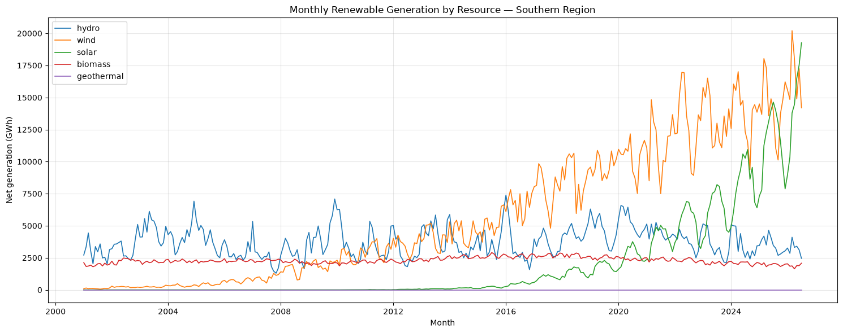
Figure 4.1: Monthly renewable generation by resource, South region
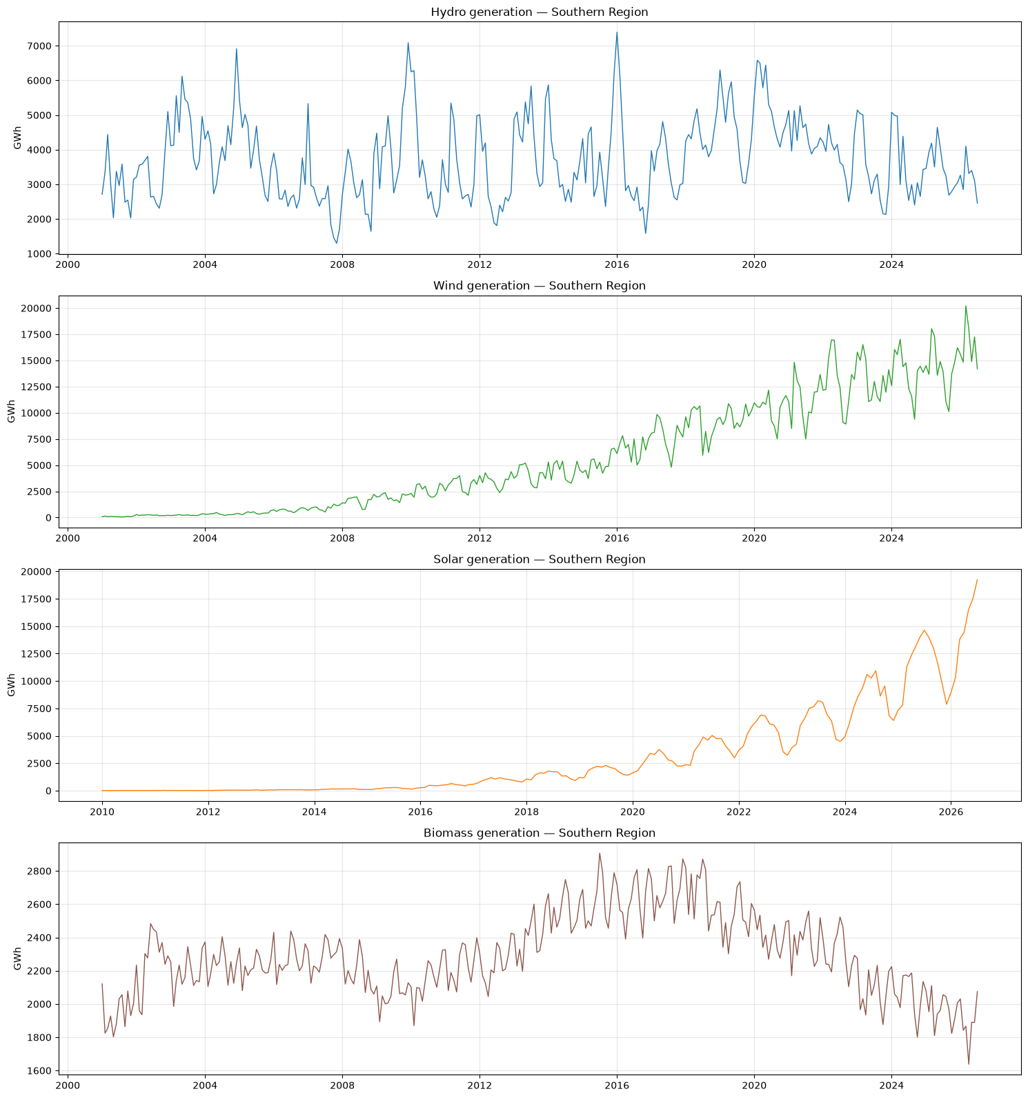
Figure 4.2: Each resource on its own scale

Initial visual observations
1. Hydro has no clear long-term direction. It moves between roughly 1,300 and 7,400 GWh per month, with large spikes in wet periods (2003, 2009–10, early 2016, 2020) and deep lows in dry years (2007–08, 2016–17). Within each year it rises in winter and spring and falls in late summer and autumn.
2. Wind grows steadily from about 100 GWh/month (2001) to about 9,000–20,000 GWh/month in recent years (record 20,213 GWh in Mar 2026), so it is now the South's largest renewable. It has a regular spring peak and late-summer dip, and the swings get larger as the level rises.
3. Solar grows explosively. It was almost invisible before 2016 and reached a record of about 19,300 GWh in Jul 2026, with a summer peak and winter dip whose size grows with the level.
4. Biomass is the most stable resource, at about 1,600–2,900 GWh. It rose to a plateau around 2014–2018 and has declined since.
5. Geothermal is a flat line at zero.

4.2 Trend analysis
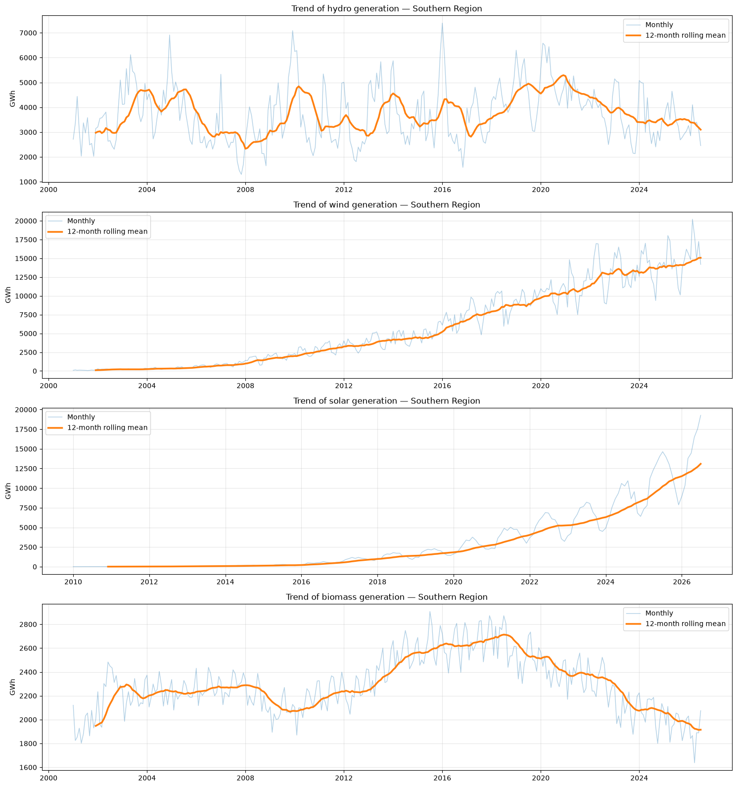
Figure 4.3: Monthly series with 12-month rolling mean (trend)
Table 4.1 Annual generation by resource (GWh), complete calendar years
Year | hydro | wind | solar | biomass
2001 | 35699.000 | 1188.000 | — | 23369.000
2002 | 39638.000 | 2696.000 | — | 27285.000
2003 | 55912.000 | 2798.000 | — | 26186.000
2004 | 51083.000 | 3875.000 | — | 26879.000
2005 | 47540.000 | 5242.000 | — | 26704.000
2006 | 34588.000 | 8611.000 | — | 27344.000
2007 | 30604.000 | 11073.000 | — | 27449.000
2008 | 35016.000 | 19025.000 | — | 26248.000
2009 | 52060.000 | 23518.000 | — | 24881.000
2010 | 43428.000 | 31048.000 | 102.000 | 25616.000
2011 | 41046.000 | 37585.000 | 185.000 | 26845.000
2012 | 34368.000 | 42031.000 | 502.000 | 26874.000
2013 | 53723.000 | 48796.000 | 863.000 | 28777.000
2014 | 41469.000 | 53773.000 | 1554.000 | 30728.000
2015 | 45736.000 | 60726.000 | 2384.000 | 31472.000
2016 | 40518.000 | 79627.000 | 5697.000 | 31456.000
2017 | 42404.000 | 93423.000 | 11319.000 | 32091.000
2018 | 53196.000 | 105968.000 | 16602.000 | 31985.000
2019 | 55387.000 | 115346.000 | 21593.000 | 30195.000
2020 | 63509.000 | 124905.000 | 32328.000 | 28890.000
2021 | 53652.000 | 134753.000 | 47205.000 | 28590.000
2022 | 45529.000 | 155461.000 | 62979.000 | 27716.000
2023 | 40894.000 | 160035.000 | 74644.000 | 24943.000
2024 | 42582.000 | 165944.000 | 99746.000 | 24862.000
2025 | 41949.000 | 171871.000 | 136638.000 | 23662.000

Table 4.2 Trend measures (linear slope, compound annual growth rate, correlation with time)
Resource | Years | First year (GWh) | Last year (GWh) | Slope (GWh/yr) | CAGR (%) | Corr. with time
hydro | 2001-2025 | 35698.892 | 41948.563 | 282.529 | 0.674 | 0.254
wind | 2001-2025 | 1187.510 | 171870.696 | 7826.493 | 23.034 | 0.972
solar | 2010-2025 | 101.694 | 136638.036 | 7704.704 | 61.641 | 0.884
biomass | 2001-2025 | 23369.181 | 23662.322 | 78.843 | 0.052 | 0.228

Trend interpretation
Resource | Long-term behaviour
Hydro | No meaningful trend. The slope is +283 GWh/yr, but the correlation with time is only 0.25 and the compound growth rate 0.67%/yr. Annual output varies from 30,604 GWh (2007) to 63,509 GWh (2020), driven by wet and dry years.
Wind | Strong upward trend that is slowing down. Output rose from 1,188 GWh (2001) to 171,871 GWh (2025), about 23%/yr (r = 0.97). Annual growth fell from 31% (2016) to only about 3–4% in 2023–2025, so wind is maturing.
Solar | Strong, accelerating upward trend. Output rose from 102 GWh (2010) to 136,638 GWh (2025), about 62%/yr, and 2025 was 37% above 2024. The trend is exponential.
Biomass | Rise and decline. Output rose from 23,369 GWh (2001) to a peak of 32,091 GWh (2017), then fell back to 23,662 GWh (2025). A straight-line trend is misleading here.

Key finding: the four resources follow four different trends:
- flat (hydro);
- growth that is slowing (wind);
- exponential growth (solar);
- a rise followed by a decline (biomass).

4.3 Seasonality analysis
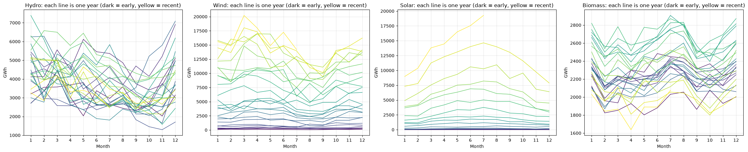
Figure 4.4: Seasonal plot: one line per year
Table 4.3 Average seasonal index (value ÷ centred 12-month moving average; 1.10 = 10% above trend)
Month | hydro | wind | solar | biomass
Jan | 1.247 | 1.072 | 0.763 | 1.040
Feb | 1.127 | 1.002 | 0.792 | 0.942
Mar | 1.195 | 1.191 | 1.119 | 0.986
Apr | 1.044 | 1.225 | 1.143 | 0.958
May | 1.069 | 1.126 | 1.244 | 0.991
Jun | 0.947 | 1.046 | 1.203 | 1.009
Jul | 0.919 | 0.865 | 1.232 | 1.059
Aug | 0.908 | 0.770 | 1.157 | 1.055
Sep | 0.771 | 0.762 | 1.033 | 0.972
Oct | 0.790 | 0.965 | 0.936 | 0.966
Nov | 0.845 | 0.983 | 0.757 | 0.986
Dec | 1.094 | 1.052 | 0.725 | 1.038

- Hydro: peak in January (+24.7% above trend), trough in September (−22.9%)
- Wind: peak in April (+22.5% above trend), trough in September (−23.8%)
- Solar: peak in May (+24.4% above trend), trough in December (−27.5%)
- Biomass: peak in July (+5.9% above trend), trough in February (−5.8%)
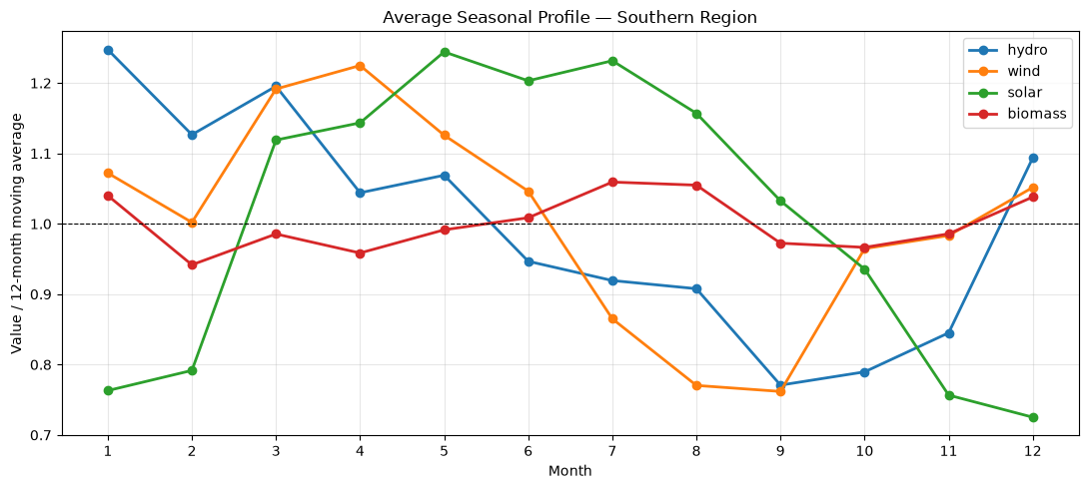
Figure 4.5: Average seasonal profile of each resource

Seasonal pattern
Resource | Peak | Trough | Size | Explanation
Hydro | January (+24.7% above trend) | September (−22.9%) | large | Winter and spring rain and reservoir releases; dry late summer and autumn
Wind | April (+22.5%) | September (−23.8%) | large | Strong spring winds (Mar–May above trend). Calm summer (Jul–Sep about 13–24% below), with a second smaller winter rise
Solar | May (+24.4%) | December (−27.5%) | large | Mar–Sep above trend, following day length and sun angle
Biomass | July (+5.9%) | February (−5.8%) | small | Slightly higher in the summer and winter demand peaks

The cycles complement each other:
- hydro peaks in winter;
- wind peaks in spring;
- solar peaks in late spring and summer.
The South's renewable mix is therefore spread across the year. Wind and solar move in opposite directions in late summer, when wind is lowest and solar is still high.
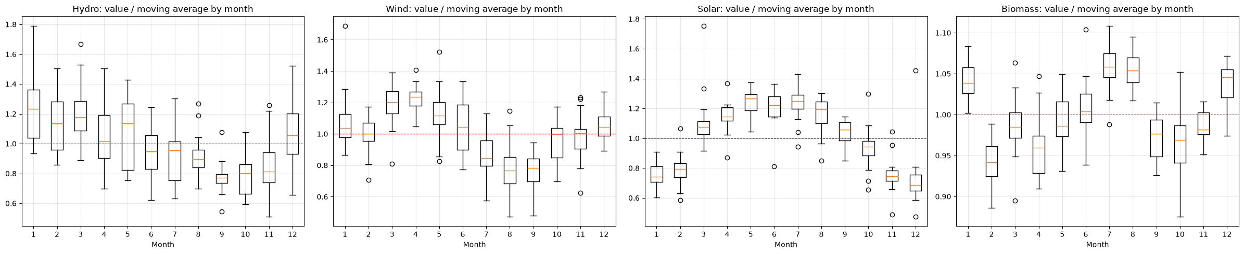
Figure 4.6: Month-of-year boxplots (value ÷ moving average)

4.4 Seasonal decomposition
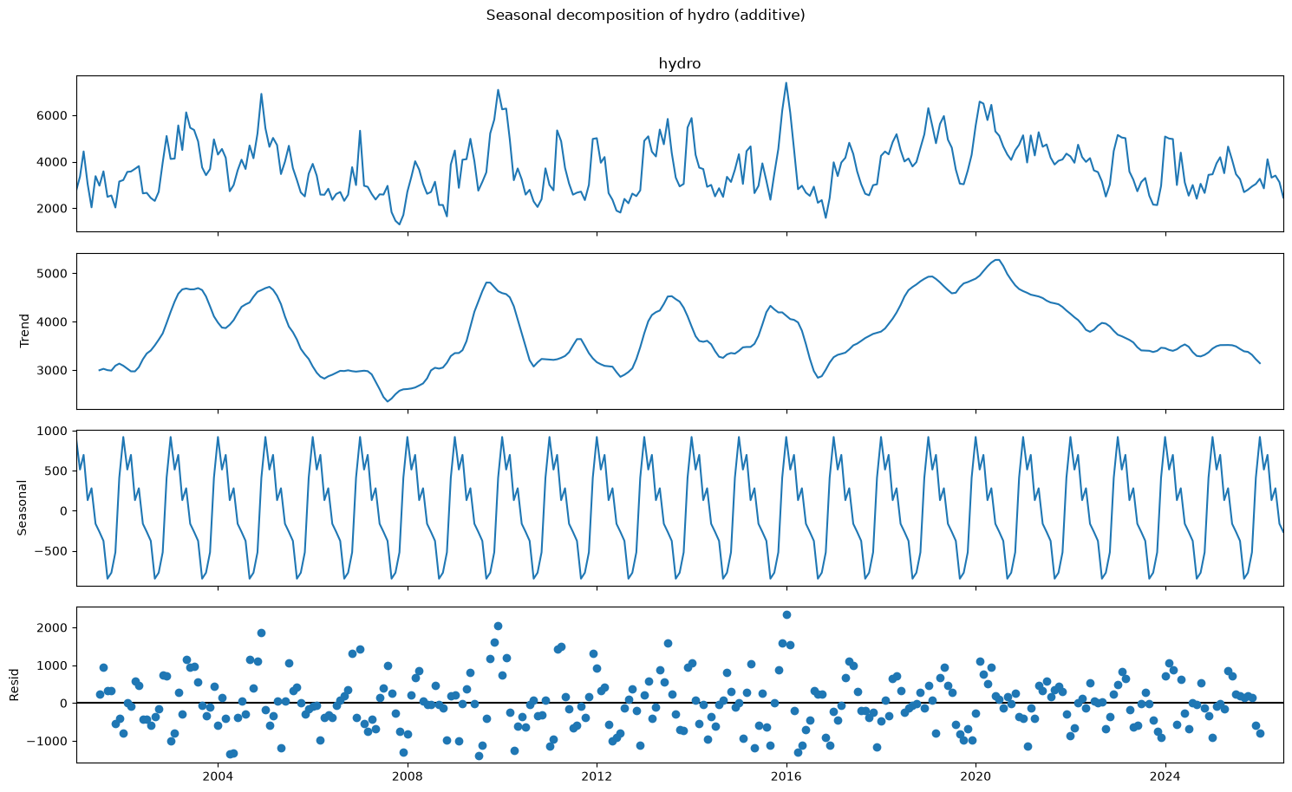
Figure 4.7: Seasonal decomposition of hydro
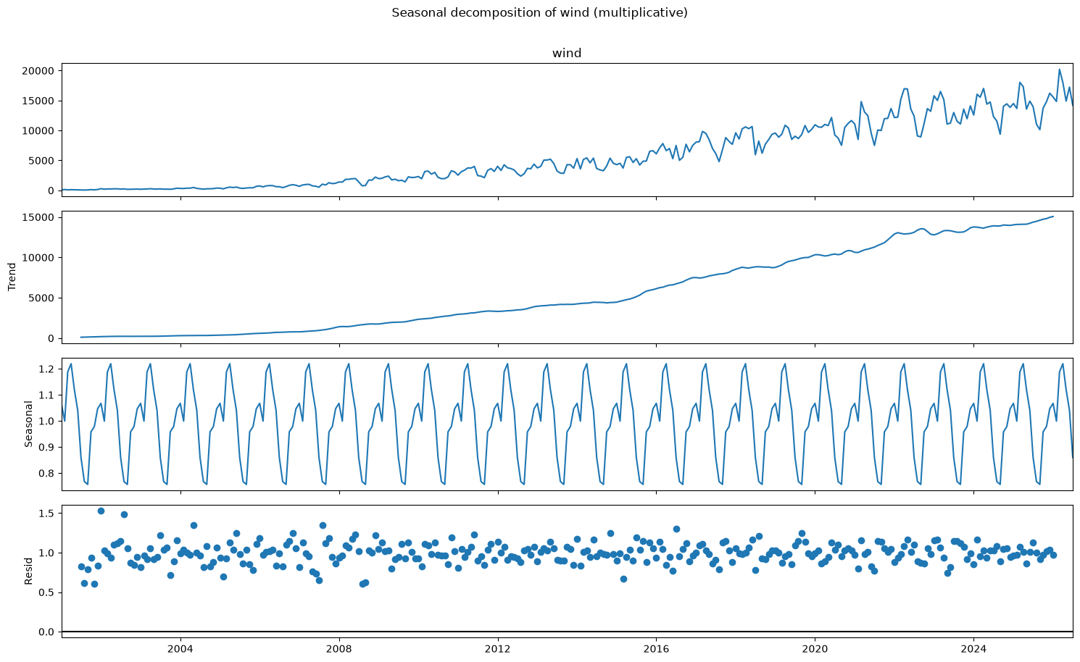
Figure 4.8: Seasonal decomposition of wind
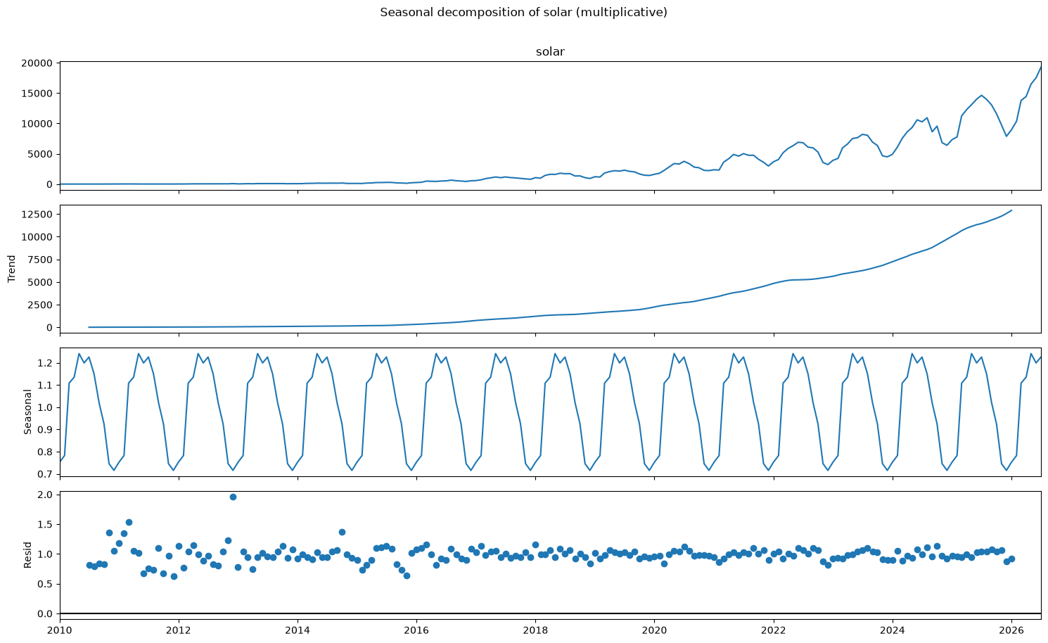
Figure 4.9: Seasonal decomposition of solar
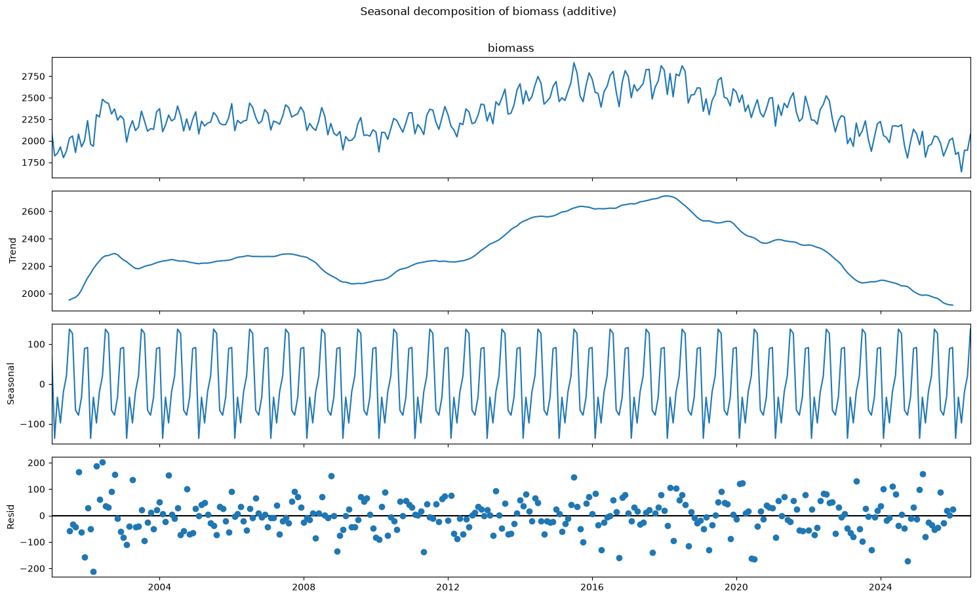
Figure 4.10: Seasonal decomposition of biomass
Table 4.4 Seasonal and trend strength (0 = none, 1 = maximum)
Resource | Seasonal strength | Trend strength
hydro | 0.405 | 0.547
wind | 0.547 | 0.991
solar | 0.706 | 0.996
biomass | 0.650 | 0.910

Seasonal decomposition interpretation
Resource | Decomposition | Seasonal strength | Trend strength | Meaning
Hydro | additive | 0.41 | 0.55 | Real cycle, but a large irregular component (wet and dry years)
Wind | multiplicative | 0.55 | 0.99 | Dominated by the growth trend, with a moderate spring/summer cycle
Solar | multiplicative | 0.71 | 0.996 | Trend plus a clear summer cycle
Biomass | additive | 0.65 | 0.91 | Slow trend, with a small but very regular seasonal ripple

All residual components are centred on zero. Their stationarity is tested in a later step.

5. ADF Stationarity Test (Before and After Differencing)

5.1 Test design
- Augmented Dickey-Fuller (ADF): H0 = the series has a unit root (non-stationary). p < 0.05 means stationary.
- KPSS (confirmatory): H0 = the series is stationary. p < 0.05 means non-stationary. The KPSS p-value is limited by its lookup table to 0.01–0.10.
- A series is called stationary only when both tests agree. The original series are tested with a constant and a trend; transformed series with a constant only.

5.2 Before differencing: visual evidence (ACF of the original series)
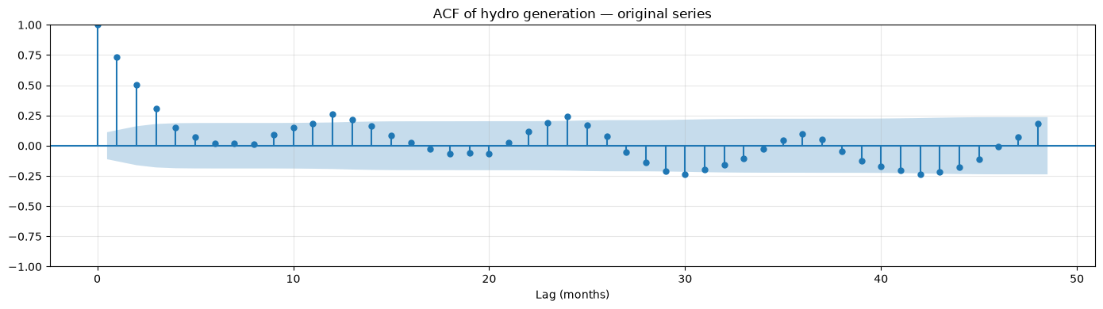
Figure 5.1: ACF of the original hydro series (lags 0–48)
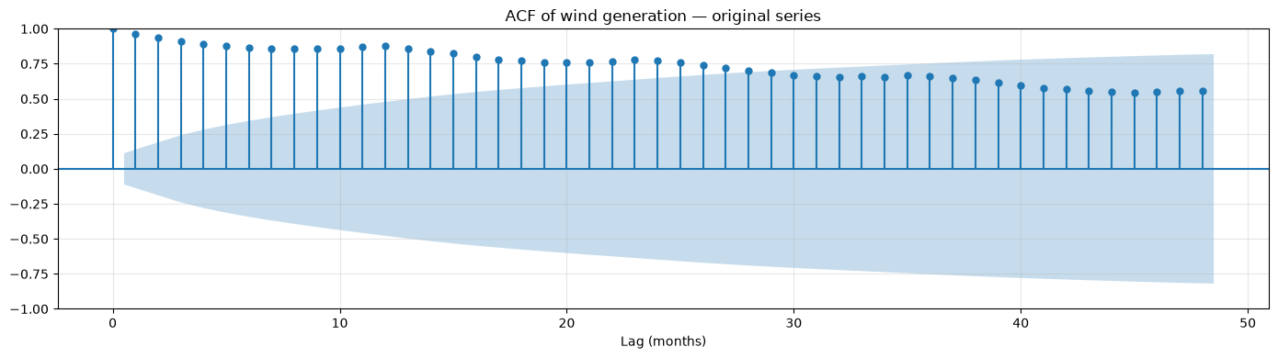
Figure 5.2: ACF of the original wind series (lags 0–48)
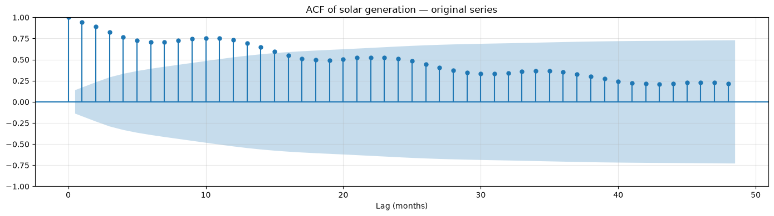
Figure 5.3: ACF of the original solar series (lags 0–48)
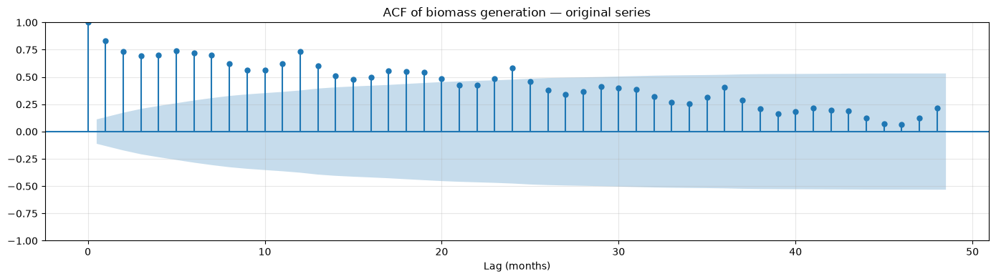
Figure 5.4: ACF of the original biomass series (lags 0–48)

ACF interpretation (original series)
- Hydro: the ACF drops quickly (0.73 at lag 1, about 0 by lag 5), with smaller peaks near lags 12 and 24 (about 0.25). This shows short memory plus a modest yearly cycle.
- Wind: the ACF is very high and decays very slowly (0.96 at lag 1, still 0.56 at lag 48), with bumps at 12, 24 and 36. This is typical of a strongly trending, non-stationary series with yearly seasonality.
- Solar: slow decay (above 0.5 for about 20 lags) with seasonal bumps near 12 and 24, so it is trending and non-stationary.
- Biomass: slow decay with clear peaks at lags 12, 24 and 36, showing a persistent trend plus a yearly cycle.

5.3 Before differencing: ADF and KPSS on the original series
Table 5.1 ADF and KPSS tests on the original series (constant + trend)
# | Series | n | ADF stat | ADF p | KPSS stat | KPSS p | Conclusion
0 | hydro (original) | 307 | -3.247 | 0.075 | 0.103 | 0.100 | Mixed evidence
1 | wind (original) | 307 | -2.098 | 0.547 | 0.697 | 0.010 | Non-stationary
2 | solar (original) | 199 | 1.497 | 1.000 | 0.522 | 0.010 | Non-stationary
3 | biomass (original) | 307 | -1.152 | 0.920 | 0.455 | 0.010 | Non-stationary

Stationarity of the original series
Resource | ADF p | KPSS p | Conclusion
Hydro | 0.075 | 0.10 | Mixed. ADF narrowly fails to reject, while KPSS does not reject stationarity
Wind | 0.547 | 0.01 | Non-stationary
Solar | 1.000 | 0.01 | Non-stationary
Biomass | 0.920 | 0.01 | Non-stationary

Wind, solar and biomass clearly need differencing. Hydro is examined further below.

5.4 After transformation and differencing
Table 5.2 ADF and KPSS tests after log transform (multiplicative resources) and differencing
# | Series | n | ADF stat | ADF p | KPSS stat | KPSS p | Conclusion
0 | hydro: level, constant only (no trend term) | 307 | -3.312 | 0.014 | 0.240 | 0.100 | Stationary
1 | hydro: decomposition residual | 295 | -8.334 | 0.000 | 0.011 | 0.100 | Stationary
2 | hydro: first difference (d=1) | 306 | -7.564 | 0.000 | 0.039 | 0.100 | Stationary
3 | hydro: seasonal difference (D=1) | 295 | -4.737 | 0.000 | 0.063 | 0.100 | Stationary
4 | hydro: both (d=1, D=1) | 294 | -8.812 | 0.000 | 0.026 | 0.100 | Stationary
5 | wind: level, constant only (no trend term) | 307 | -3.993 | 0.001 | 2.711 | 0.010 | Mixed evidence
6 | wind: decomposition residual | 295 | -9.168 | 0.000 | 0.303 | 0.100 | Stationary
7 | wind: first difference (d=1) | 306 | -6.621 | 0.000 | 0.423 | 0.067 | Stationary
8 | wind: seasonal difference (D=1) | 295 | -2.665 | 0.080 | 1.482 | 0.010 | Non-stationary
9 | wind: both (d=1, D=1) | 294 | -8.781 | 0.000 | 0.169 | 0.100 | Stationary
10 | solar: level, constant only (no trend term) | 199 | -4.116 | 0.001 | 2.040 | 0.010 | Mixed evidence
11 | solar: decomposition residual | 187 | -8.736 | 0.000 | 0.107 | 0.100 | Stationary
12 | solar: first difference (d=1) | 198 | -3.338 | 0.013 | 0.114 | 0.100 | Stationary
13 | solar: seasonal difference (D=1) | 187 | -1.514 | 0.526 | 1.168 | 0.010 | Non-stationary
14 | solar: both (d=1, D=1) | 186 | -6.692 | 0.000 | 0.108 | 0.100 | Stationary
15 | biomass: level, constant only (no trend term) | 307 | -1.486 | 0.541 | 0.546 | 0.031 | Non-stationary
16 | biomass: decomposition residual | 295 | -8.270 | 0.000 | 0.008 | 0.100 | Stationary
17 | biomass: first difference (d=1) | 306 | -4.636 | 0.000 | 0.167 | 0.100 | Stationary
18 | biomass: seasonal difference (D=1) | 295 | -2.911 | 0.044 | 0.677 | 0.016 | Mixed evidence
19 | biomass: both (d=1, D=1) | 294 | -6.775 | 0.000 | 0.022 | 0.100 | Stationary

Stationarity analysis: final interpretation
- Hydro: in levels with a constant only, ADF p = 0.014 and KPSS p ≥ 0.10, so hydro is already stationary. No differencing is needed (d = 0, D = 0). Seasonality is handled with seasonal AR/MA terms.
- Wind (log scale):
- the level gives mixed evidence;
- the seasonal difference alone is non-stationary (ADF p = 0.080, KPSS p = 0.01);
- the first difference is stationary (ADF p < 0.001, KPSS p = 0.067).
Wind's seasonal strength is 0.55 (below 0.64), so d = 1, D = 0.
- Solar (log scale): the seasonal difference alone is non-stationary (ADF p = 0.526). With both differences the series is stationary, so d = 1, D = 1.
- Biomass: the seasonal difference alone gives mixed evidence (KPSS p = 0.016). With both differences the series is stationary (ADF p < 0.001, KPSS p ≥ 0.10), so d = 1, D = 1.
- The decomposition residuals of all four resources are stationary by both tests.

5.5 Differencing orders used for modelling
The same rule is applied to every resource: use a seasonal difference (D = 1) when the seasonal strength exceeds 0.64; then add a first difference (d = 1) if ADF and KPSS do not both confirm stationarity. In the forecasting stage the rule is re-applied to the training data only (January 2001 – July 2024), so the test period does not influence the choice.
Table 5.3 Stationary series selected in the exploratory analysis
Resource | Series used for ACF/PACF (full data)
Hydro | hydro (level)
Wind | Δ log(wind)
Solar | Δ Δ12 log(solar)
Biomass | Δ Δ12 biomass

Table 5.4 Differencing orders chosen on the training data
Resource | Seasonal strength | D | ADF p after D | KPSS p after D | d
hydro | 0.406 | 0 | 0.016 | 0.083 | 0
wind | 0.537 | 0 | 0.005 | 0.010 | 1
solar | 0.682 | 1 | 0.615 | 0.010 | 1
biomass | 0.661 | 1 | 0.061 | 0.038 | 1

6. ACF / PACF Plots and Justification for ARIMA/SARIMA Order Selection

6.1 ACF and PACF of the stationary series
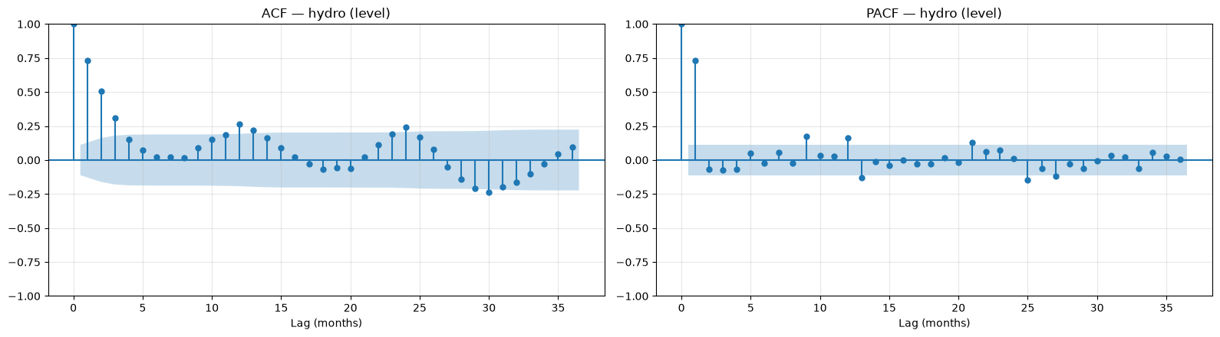
Figure 6.1: ACF and PACF of the stationary hydro series (lags 0–36)
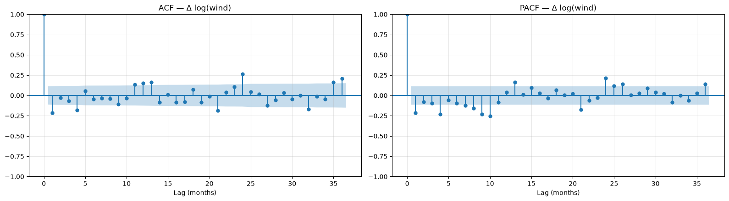
Figure 6.2: ACF and PACF of the stationary wind series (lags 0–36)
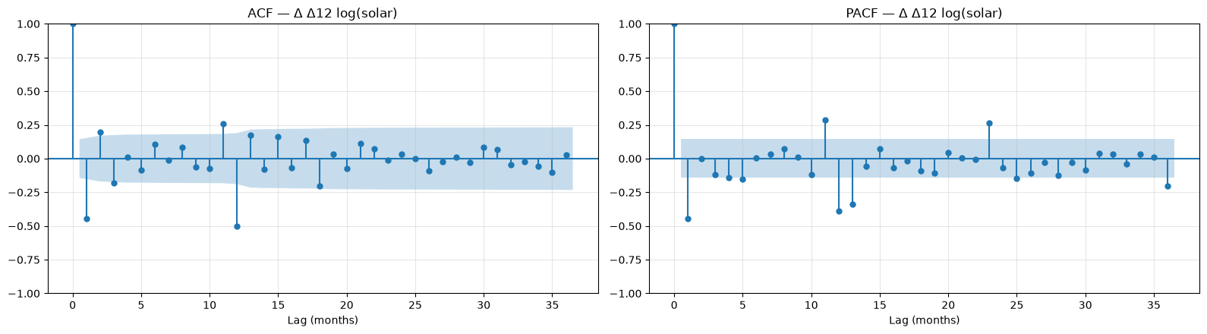
Figure 6.3: ACF and PACF of the stationary solar series (lags 0–36)
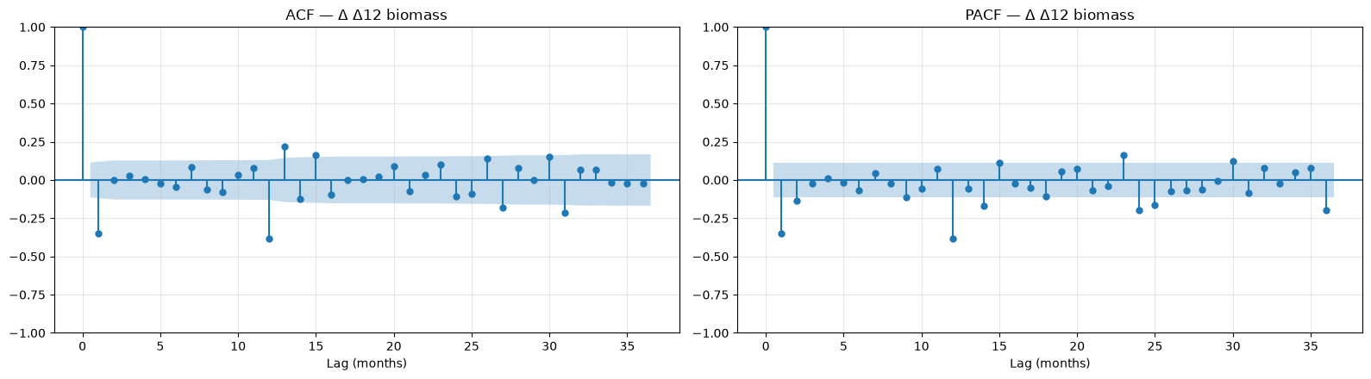
Figure 6.4: ACF and PACF of the stationary biomass series (lags 0–36)
Table 6.1 Key ACF / PACF values of the stationary series
Resource | Series | ACF lag 1 | ACF lag 12 | PACF lag 1 | PACF lag 12 | Significant ACF lags (≤13) | Significant PACF lags (≤13) | 95% bound
Hydro | hydro (level) | 0.733 | 0.264 | 0.733 | 0.162 | 1, 2, 3, 4, 10, 11, 12, 13 | 1, 9, 12, 13 | 0.112
Wind | Δ log(wind) | -0.214 | 0.149 | -0.214 | 0.039 | 1, 4, 11, 12, 13 | 1, 4, 7, 8, 9, 10, 13 | 0.112
Solar | Δ Δ12 log(solar) | -0.447 | -0.501 | -0.447 | -0.390 | 1, 2, 3, 11, 12, 13 | 1, 5, 11, 12, 13 | 0.144
Biomass | Δ Δ12 biomass | -0.349 | -0.384 | -0.349 | -0.383 | 1, 12, 13 | 1, 2, 12 | 0.114

6.2 Reading the plots and the suggested orders

ACF / PACF interpretation and suggested models
Resource | Pattern on the stationary series | Suggested model
Hydro (level) | The ACF decays gradually from 0.73, while the PACF has a single large spike at lag 1 (0.73) and small spikes at 12–13. This indicates an AR(1) plus a seasonal AR term | SARIMA(1,0,0)(1,0,1)12 with a constant
Wind (Δ log) | The ACF is −0.21 at lag 1 (the usual sign after first differencing), which suggests MA(1). A significant ACF at lag 12 (0.15) shows the yearly cycle remains, so seasonal AR/MA terms are needed | SARIMA(1,1,1)(1,0,1)12
Solar (Δ Δ12 log) | ACF and PACF are −0.45 at lag 1, and the ACF is strongly negative at lag 12 (−0.50). This suggests AR(1) plus a seasonal MA(1) | SARIMA(1,1,0)(0,1,1)12
Biomass (Δ Δ12) | The ACF is significant only at lags 1 (−0.35) and 12 (−0.38), the "airline" pattern | SARIMA(0,1,1)(0,1,1)12

In the forecasting stage, the AIC search over all small models selects exactly these four specifications.

6.3 Confirmation by AIC grid search
Orders were then searched by AIC on the training data (ARIMA: p, q ≤ 3; SARIMA: p, q ≤ 2 and P, Q ≤ 1 with s = 12; d and D fixed from Section 5). Failed or degenerate fits are rejected.
Table 6.2 Orders selected by AIC (training data)
Resource | Model | Selected order | AIC
Hydro | ARIMA | ARIMA(3,0,2) + constant | 4570.2
Hydro | SARIMA | SARIMA(1,0,0)(1,0,1)12 + constant | 4543.2
Hydro | SARIMAX (Fourier exog.) | ARIMA(3,0,2) + constant | 4541.9
Wind | ARIMA | ARIMA(3,1,2) + drift | -97.6
Wind | SARIMA | SARIMA(1,1,1)(1,0,1)12 | -160.0
Wind | SARIMAX (Fourier exog.) | ARIMA(0,1,1) + drift | -185.7
Solar | ARIMA | ARIMA(3,1,2) | -74.2
Solar | SARIMA | SARIMA(1,1,0)(0,1,1)12 | -87.6
Solar | SARIMAX (Fourier exog.) | ARIMA(0,1,3) + drift | -115.6
Biomass | ARIMA | ARIMA(2,1,3) | 3449.5
Biomass | SARIMA | SARIMA(0,1,1)(0,1,1)12 | 3127.7
Biomass | SARIMAX (Fourier exog.) | ARIMA(0,1,3) | 3406.5

Table 6.3 Top three SARIMA candidates by AIC for each resource
Resource | SARIMA candidate | Trend term | AIC
Hydro | SARIMA(1,0,0)(1,0,1)12 | constant | 4543.161
Hydro | SARIMA(2,0,0)(1,0,1)12 | constant | 4545.089
Hydro | SARIMA(1,0,1)(1,0,1)12 | constant | 4545.677
Wind | SARIMA(1,1,1)(1,0,1)12 | none | -160.048
Wind | SARIMA(1,1,1)(1,0,1)12 | drift | -160.010
Wind | SARIMA(2,1,1)(1,0,1)12 | drift | -159.560
Solar | SARIMA(1,1,0)(0,1,1)12 | none | -87.594
Solar | SARIMA(1,1,0)(1,1,1)12 | none | -87.417
Solar | SARIMA(2,1,2)(1,1,1)12 | none | -86.412
Biomass | SARIMA(0,1,1)(0,1,1)12 | none | 3127.700
Biomass | SARIMA(0,1,1)(1,1,1)12 | none | 3129.496
Biomass | SARIMA(2,1,0)(0,1,1)12 | none | 3129.544

6.4 Order justification and estimated coefficients
The ACF/PACF readings and the AIC search agree for all four resources: the AIC grid search selected exactly the SARIMA specifications suggested by the plots — hydro (1,0,0)(1,0,1)12 with a constant, wind (1,1,1)(1,0,1)12 on the log scale, solar (1,1,0)(0,1,1)12 on the log scale and the airline model (0,1,1)(0,1,1)12 for biomass. The non-seasonal ARIMA and the SARIMAX with Fourier terms are kept as comparison models.
Table 6.4 Hydro: SARIMA(1,0,0)(1,0,1)12 + constant coefficients (training data)
Parameter | Coefficient | Std. error | z | p-value | 95% CI lower | 95% CI upper
Constant | 3763.2039 | 472.591 | 7.963 | 0.000 | 2836.942 | 4689.466
AR(1) φ1 | 0.7468 | 0.040 | 18.644 | 0.000 | 0.668 | 0.825
Seasonal AR(1) Φ1 | 0.9897 | 0.018 | 53.649 | 0.000 | 0.954 | 1.026
Seasonal MA(1) Θ1 | -0.9214 | 0.070 | -13.180 | 0.000 | -1.058 | -0.784
σ² (error variance) | 5.084e+05 | 4.4e+04 | 11.567 | 0.000 | 4.22e+05 | 5.95e+05

Table 6.5 Wind: SARIMA(1,1,1)(1,0,1)12 coefficients (training data)
Parameter | Coefficient | Std. error | z | p-value | 95% CI lower | 95% CI upper
AR(1) φ1 | 0.1858 | 0.086 | 2.170 | 0.030 | 0.018 | 0.354
MA(1) θ1 | -0.7276 | 0.055 | -13.112 | 0.000 | -0.836 | -0.619
Seasonal AR(1) Φ1 | 0.9971 | 0.008 | 118.955 | 0.000 | 0.981 | 1.013
Seasonal MA(1) Θ1 | -0.9360 | 0.090 | -10.360 | 0.000 | -1.113 | -0.759
σ² (error variance) | 0.0297 | 0.003 | 10.634 | 0.000 | 0.024 | 0.035

Table 6.6 Solar: SARIMA(1,1,0)(0,1,1)12 coefficients (training data)
Parameter | Coefficient | Std. error | z | p-value | 95% CI lower | 95% CI upper
AR(1) φ1 | -0.4548 | 0.052 | -8.698 | 0.000 | -0.557 | -0.352
Seasonal MA(1) Θ1 | -0.8548 | 0.125 | -6.859 | 0.000 | -1.099 | -0.610
σ² (error variance) | 0.0298 | 0.004 | 7.777 | 0.000 | 0.022 | 0.037

Table 6.7 Biomass: SARIMA(0,1,1)(0,1,1)12 coefficients (training data)
Parameter | Coefficient | Std. error | z | p-value | 95% CI lower | 95% CI upper
MA(1) θ1 | -0.4380 | 0.048 | -9.081 | 0.000 | -0.533 | -0.343
Seasonal MA(1) Θ1 | -0.7033 | 0.051 | -13.793 | 0.000 | -0.803 | -0.603
σ² (error variance) | 5954.7357 | 515.034 | 11.562 | 0.000 | 4945.288 | 6964.183

All coefficients are significant at the 5% level. For hydro and wind the seasonal AR coefficient is close to 1 (0.990 and 0.997) with a large negative seasonal MA term, which lets the yearly pattern evolve slowly instead of imposing a fixed seasonal difference. Solar's AR(1) (−0.45) and seasonal MA(1) (−0.85), and biomass's MA(1) (−0.44) and seasonal MA(1) (−0.70), match the negative lag-1 and lag-12 spikes in the ACF.

7. Model Fitting, Selection, and Forecasting Evaluation

7.1 Train / test design
- The split is chronological: the model only ever sees the past. Random shuffling is not used, because it would let models learn from future months.
- Test set = the last 24 months (August 2024 – July 2026): two full seasonal cycles, so each calendar month is tested twice.
- Training set = everything before August 2024 (283 months for hydro, wind and biomass; 175 months for solar).
- Every model forecasts all 24 test months from the end of the training data (multi-step forecasting), as it would be used in practice.
- After evaluation, the best model of each resource is re-fitted on all data and forecasts August 2026 – July 2027.

7.2 Candidate models
Table 7.1 Models compared for every resource
Family | Models
Baseline | Naive (last value), Seasonal Naive (same month last year)
Classical | ARIMA (with differencing), SARIMA, SARIMAX with Fourier (sine/cosine) seasonal terms
Exponential smoothing | SES, Holt (damped), Holt-Winters additive / multiplicative / additive damped
Machine learning | Linear Regression, Random Forest on lagged year-on-year changes (lags 1, 2, 3, 6, 12; rolling means 3/6/12; month sin/cos; quarter)
Neural network | Multi-layer perceptron (16 and 8 hidden units, L2 penalty, early stopping)

- Resources with multiplicative seasonality are modelled on the log scale by ARIMA, SARIMA, SARIMAX and the ML models and converted back with exp().
- SARIMAX regressors are Fourier terms (and a time index when the series is not differenced). They are known in advance for any future month, so there is no data leakage.
- ML and neural-network models predict the change from the same month last year and are applied recursively (each prediction is fed back as a lag). A small MLP is used instead of an LSTM/GRU because each resource has only about 150–280 training months.

7.3 Evaluation metrics
MAE = (1/n) Σ |yₜ − ŷₜ|
RMSE = √[ (1/n) Σ (yₜ − ŷₜ)² ]
MAPE = (100/n) Σ |yₜ − ŷₜ| / yₜ
- MAE and RMSE are in GWh; RMSE penalises large errors more. MAPE is scale-free, so it is used to compare resources.
- MASE (MAE ÷ in-sample seasonal-naive MAE) is also reported; models are ranked by MASE. For fast-growing series (solar), MASE is inflated by the tiny early values, so MAPE is the meaningful comparison.

7.4 Hydro: test-period results
Table 7.2 Hydro: accuracy on the 24 test months (Aug 2024 – Jul 2026), ranked by MASE
Model | MAE (GWh) | RMSE (GWh) | MAPE (%) | MASE | Family
ARIMA | 531.283 | 624.666 | 16.979 | 0.486 | ARIMA
Holt-Winters add. damped | 539.315 | 636.288 | 15.928 | 0.493 | Holt-Winters
SARIMA | 540.580 | 661.664 | 17.129 | 0.494 | SARIMA
Holt-Winters multiplicative | 541.397 | 656.714 | 15.603 | 0.495 | Holt-Winters
Holt-Winters additive | 558.455 | 649.000 | 16.721 | 0.510 | Holt-Winters
Linear Regression | 682.759 | 948.093 | 20.348 | 0.624 | ML
Seasonal Naive | 683.959 | 883.007 | 20.690 | 0.625 | Baseline
Neural Network (MLP) | 684.162 | 882.740 | 20.698 | 0.625 | Neural network
Holt (damped) | 738.989 | 907.922 | 20.520 | 0.675 | Exponential smoothing
SES | 740.710 | 909.547 | 20.571 | 0.677 | Exponential smoothing
SARIMAX (Fourier exog) | 766.704 | 920.898 | 24.468 | 0.701 | SARIMAX
Naive | 773.149 | 940.523 | 21.520 | 0.707 | Baseline
Random Forest | 989.531 | 1113.607 | 31.642 | 0.904 | ML

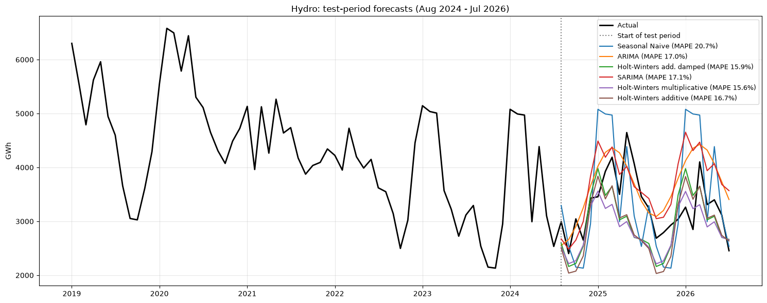
Figure 7.1: Hydro: test-period forecasts of the best models vs actual values

Hydro: model results
- Best model: ARIMA(3,0,2) with a constant. MAPE 17.0%, MASE 0.486, a 22% lower MAE than the seasonal naive (MAPE 20.7%).
- The top four models are essentially tied: ARIMA (MASE 0.486), Holt-Winters additive damped (0.493), SARIMA(1,0,0)(1,0,1)12 (0.494) and Holt-Winters multiplicative (0.495). All four do the same thing: they pull the forecast back toward the long-run average level and add the winter/autumn cycle.
- The tree model (Random Forest, MAPE 31.6%) and SARIMAX with Fourier terms (24.5%) do worst. Hydro has no trend or growth to learn, and its errors come from rainfall that no model can see in advance.
- Even the best hydro error (about 17%) is much larger than for biomass. This supports H4: hydro is hard to forecast because it is driven by the weather.

7.5 Wind: test-period results
Table 7.3 Wind: accuracy on the 24 test months (Aug 2024 – Jul 2026), ranked by MASE
Model | MAE (GWh) | RMSE (GWh) | MAPE (%) | MASE | Family
Holt-Winters multiplicative | 958.893 | 1182.227 | 6.983 | 1.046 | Holt-Winters
Holt-Winters add. damped | 1058.345 | 1362.808 | 7.887 | 1.154 | Holt-Winters
Holt-Winters additive | 1109.892 | 1424.868 | 8.430 | 1.210 | Holt-Winters
Seasonal Naive | 1496.872 | 1884.699 | 10.004 | 1.632 | Baseline
Holt (damped) | 2295.558 | 2827.552 | 15.461 | 2.503 | Exponential smoothing
SES | 2443.110 | 2962.139 | 16.352 | 2.664 | Exponential smoothing
Random Forest | 2746.806 | 3151.948 | 19.236 | 2.996 | ML
Naive | 2868.128 | 3356.238 | 18.828 | 3.128 | Baseline
SARIMA | 2871.235 | 3285.744 | 20.036 | 3.131 | SARIMA
ARIMA | 3757.749 | 4400.502 | 27.980 | 4.098 | ARIMA
SARIMAX (Fourier exog) | 3893.276 | 4559.603 | 26.882 | 4.246 | SARIMAX
Linear Regression | 4335.026 | 4874.034 | 30.138 | 4.728 | ML
Neural Network (MLP) | 5618.372 | 6803.373 | 40.010 | 6.127 | Neural network

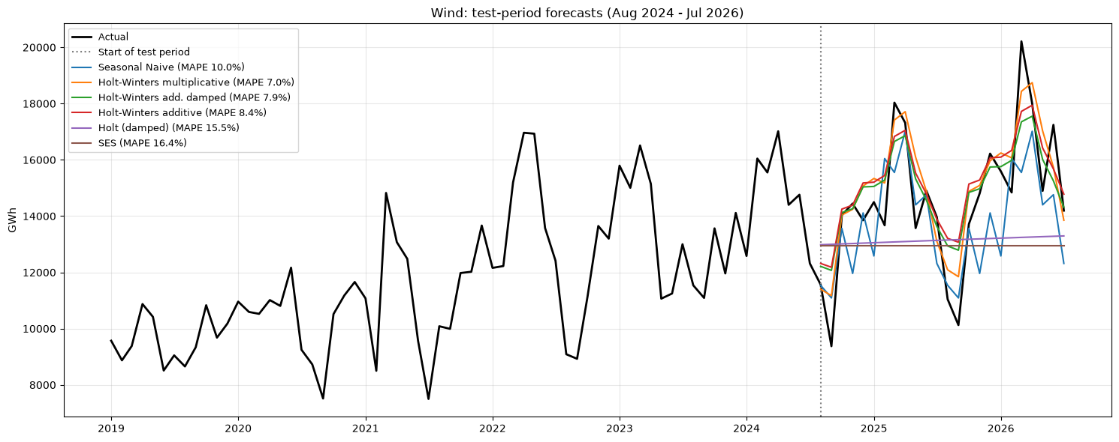
Figure 7.2: Wind: test-period forecasts of the best models vs actual values

Wind: model results
- Best model: Holt-Winters multiplicative. MAPE 7.0%, MASE 1.05, a 36% lower MAE than the seasonal naive (10.0%). The other Holt-Winters variants come next (7.9% and 8.4%).
- Holt-Winters works well because it updates the level and seasonal shape gradually. That suits wind, whose growth has slowed to a few % per year while its spring-peak pattern stays very stable.
- SARIMA performs poorly here (20.0%). Its seasonal AR coefficient is almost exactly 1 (0.997), so it effectively carries forward a growth path from the years when wind grew 15–30% per year, and over-forecasts the recent slowdown.
- ML (Random Forest 19.2%, Linear Regression 30.1%) and the neural network (40.0%) do badly. With growth slowing, past growth rates are a poor guide, and these models extrapolate them.
- Naive and SES (16–19%) ignore seasonality. Their errors confirm that the spring/summer cycle must be modelled (H2 supported for Holt-Winters).

7.6 Solar: test-period results
Table 7.4 Solar: accuracy on the 24 test months (Aug 2024 – Jul 2026), ranked by MASE
Model | MAE (GWh) | RMSE (GWh) | MAPE (%) | MASE | Family
Random Forest | 595.798 | 718.755 | 5.492 | 1.105 | ML
Neural Network (MLP) | 1182.812 | 1783.945 | 9.374 | 2.194 | Neural network
Holt-Winters additive | 1695.592 | 2152.780 | 12.686 | 3.145 | Holt-Winters
Holt-Winters multiplicative | 1736.161 | 1933.365 | 14.445 | 3.220 | Holt-Winters
Holt-Winters add. damped | 1747.140 | 2217.685 | 13.068 | 3.241 | Holt-Winters
SARIMA | 2190.415 | 2929.240 | 17.124 | 4.063 | SARIMA
Holt (damped) | 2964.476 | 3616.451 | 25.450 | 5.499 | Exponential smoothing
SES | 3002.226 | 3679.346 | 25.406 | 5.569 | Exponential smoothing
Naive | 3002.226 | 3679.346 | 25.406 | 5.569 | Baseline
ARIMA | 3713.935 | 4261.895 | 29.699 | 6.889 | ARIMA
SARIMAX (Fourier exog) | 4211.673 | 5421.172 | 33.479 | 7.812 | SARIMAX
Seasonal Naive | 4336.638 | 4723.984 | 36.342 | 8.044 | Baseline
Linear Regression | 4501.987 | 6137.633 | 33.657 | 8.350 | ML

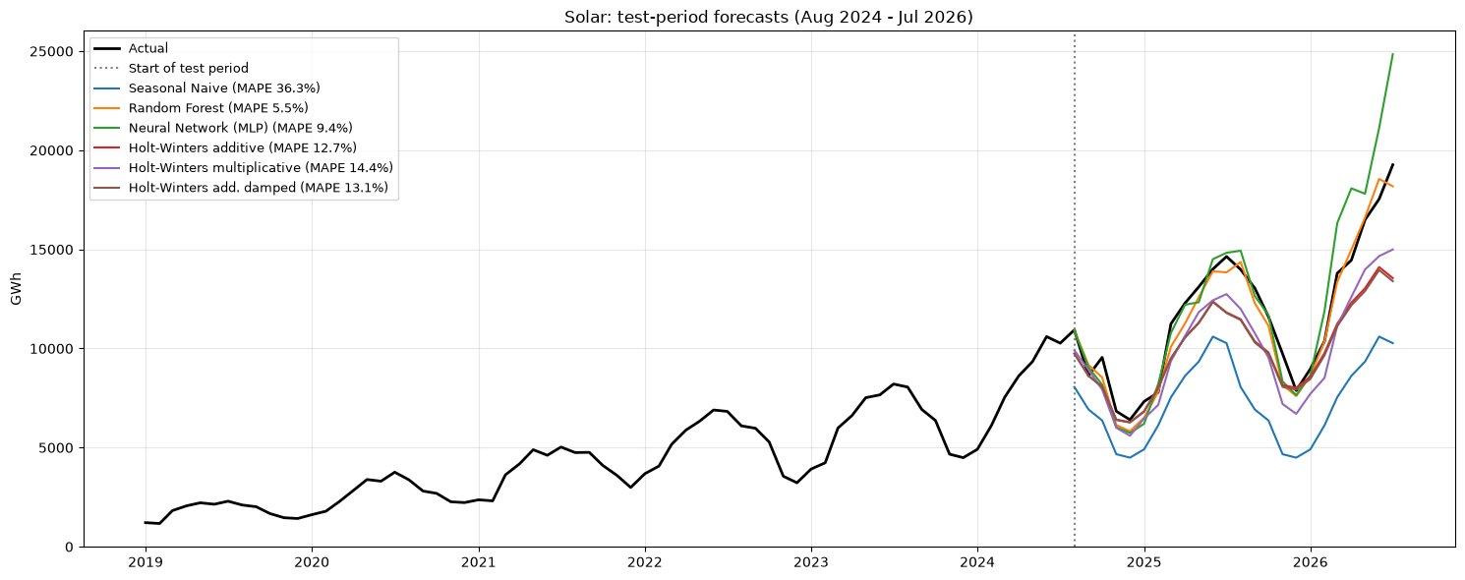
Figure 7.3: Solar: test-period forecasts of the best models vs actual values

Solar: model results
- Best model: Random Forest on lag features of year-on-year log growth. MAPE 5.5%, MASE 1.11, an 86% lower MAE than the seasonal naive.
- The seasonal naive is the worst model (MAPE 36.3%), and naive and SES are also poor (25.4%). They cannot follow growth of about 30–40% per year, which supports H3.
- The neural network (MLP) comes second (9.4%), then Holt-Winters (12.7–14.4%) and SARIMA (17.1%). SARIMA and Holt-Winters under-forecast the 2025–26 jump, when growth accelerated beyond its earlier trend.
- Linear regression on the same features fails (33.7%). Its linear growth extrapolation overshoots over 24 recursive steps.
- Note: the MASE values for solar are all above 1. MASE is scaled by in-sample seasonal-naive errors from years when solar was tiny, so for solar MAPE is the meaningful comparison.

7.7 Biomass: test-period results
Table 7.5 Biomass: accuracy on the 24 test months (Aug 2024 – Jul 2026), ranked by MASE
Model | MAE (GWh) | RMSE (GWh) | MAPE (%) | MASE | Family
SARIMA | 77.442 | 88.995 | 4.035 | 0.694 | SARIMA
Seasonal Naive | 147.784 | 169.555 | 7.730 | 1.325 | Baseline
SARIMAX (Fourier exog) | 148.785 | 167.063 | 7.849 | 1.334 | SARIMAX
Holt-Winters add. damped | 151.113 | 165.429 | 7.883 | 1.355 | Holt-Winters
Holt-Winters additive | 155.820 | 170.571 | 8.128 | 1.397 | Holt-Winters
ARIMA | 157.682 | 176.100 | 8.318 | 1.414 | ARIMA
Holt-Winters multiplicative | 162.178 | 177.048 | 8.486 | 1.454 | Holt-Winters
Holt (damped) | 176.556 | 210.565 | 9.443 | 1.583 | Exponential smoothing
SES | 179.056 | 213.008 | 9.574 | 1.606 | Exponential smoothing
Linear Regression | 186.969 | 200.996 | 9.731 | 1.677 | ML
Neural Network (MLP) | 200.858 | 216.765 | 10.452 | 1.801 | Neural network
Naive | 210.950 | 242.644 | 11.229 | 1.892 | Baseline
Random Forest | 212.946 | 237.243 | 11.115 | 1.910 | ML

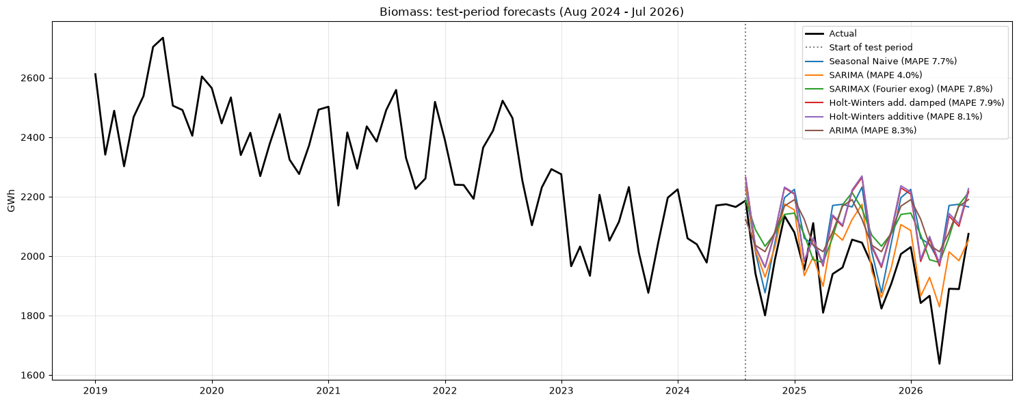
Figure 7.4: Biomass: test-period forecasts of the best models vs actual values

Biomass: model results
- Best model: SARIMA(0,1,1)(0,1,1)12 (the "airline" model). MAPE 4.0%, MASE 0.694, a 48% lower MAE than the seasonal naive (7.7%).
- SARIMA is the only model that is clearly better than the seasonal naive. SARIMAX, Holt-Winters and ARIMA all land at 7.8–8.5%, about the same as the baseline.
- The ML models (9.7–11.1%) and the neural network (10.5%) are worse than the baseline. With a small, regular seasonal ripple and a slowly drifting level, there is little non-linear structure for them to learn.
- Biomass is the easiest resource to forecast. This supports H2 for SARIMA (though not for Holt-Winters).

7.8 Model comparison across resources
Table 7.6 MAPE (%) of the best model in each family
Resource | ARIMA | Baseline | Exponential smoothing | Holt-Winters | ML | Neural network | SARIMA | SARIMAX | Best model
Biomass | 8.318 | 7.730 | 9.443 | 7.883 | 9.731 | 10.452 | 4.035 | 7.849 | SARIMA
Hydro | 16.979 | 20.690 | 20.520 | 15.928 | 20.348 | 20.698 | 17.129 | 24.468 | ARIMA
Solar | 29.699 | 25.406 | 25.450 | 12.686 | 5.492 | 9.374 | 17.124 | 33.479 | Random Forest
Wind | 27.980 | 10.004 | 15.461 | 6.983 | 19.236 | 40.010 | 20.036 | 26.882 | Holt-Winters multiplicative

Table 7.7 MASE of the best model in each family
Resource | ARIMA | Baseline | Exponential smoothing | Holt-Winters | ML | Neural network | SARIMA | SARIMAX
Biomass | 1.414 | 1.325 | 1.583 | 1.355 | 1.677 | 1.801 | 0.694 | 1.334
Hydro | 0.486 | 0.625 | 0.675 | 0.493 | 0.624 | 0.625 | 0.494 | 0.701
Solar | 6.889 | 5.569 | 5.499 | 3.145 | 1.105 | 2.194 | 4.063 | 7.812
Wind | 4.098 | 1.632 | 2.503 | 1.046 | 2.996 | 6.127 | 3.131 | 4.246

Table 7.8 Best model for each resource
Resource | Best model | Best MAPE (%) | Best MASE | Seasonal Naive MAPE (%) | MAE improvement vs Seasonal Naive (%)
Hydro | ARIMA | 16.979 | 0.486 | 20.690 | 22.322
Wind | Holt-Winters multiplicative | 6.983 | 1.046 | 10.004 | 35.940
Solar | Random Forest | 5.492 | 1.105 | 36.342 | 86.261
Biomass | SARIMA | 4.035 | 0.694 | 7.730 | 47.598

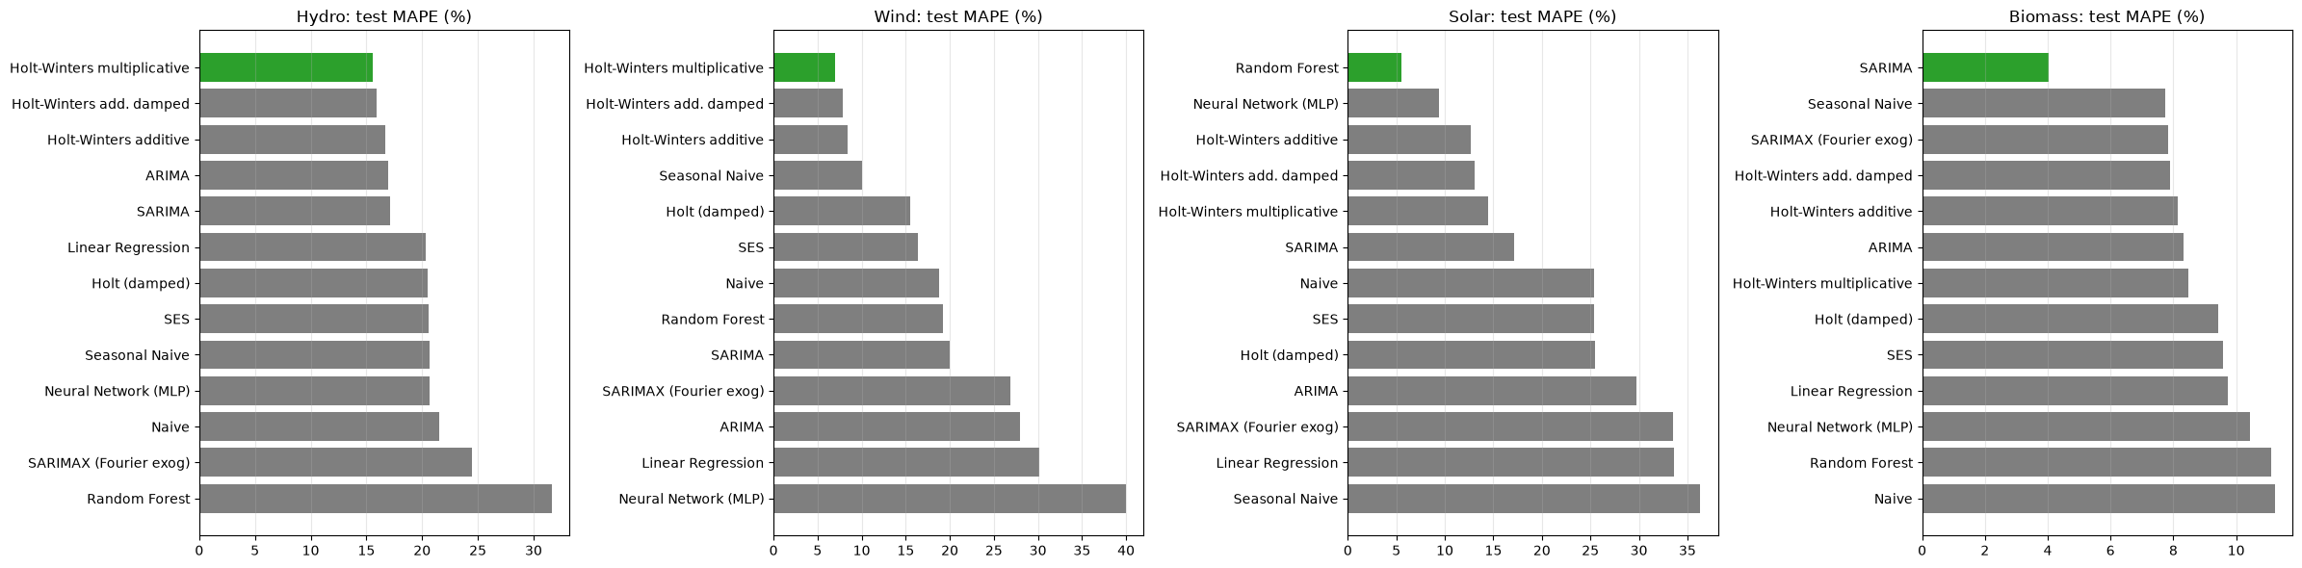
Figure 7.5: Test MAPE of every model, by resource (best model in green)

Model comparison across resources
Resource | Best model | MAPE | Seasonal naive MAPE | Improvement in MAE
Biomass | SARIMA(0,1,1)(0,1,1)12 | 4.0% | 7.7% | 48%
Solar | Random Forest (growth-rate target) | 5.5% | 36.3% | 86%
Wind | Holt-Winters multiplicative | 7.0% | 10.0% | 36%
Hydro | ARIMA(3,0,2) (SARIMA tied, with better residuals) | 17.0% | 20.7% | 22%

- A different model wins for each resource. This confirms that each resource must be modelled separately.
- Difficulty ranking: biomass (easiest) → solar → wind → hydro (hardest). This supports H4.
- H2 (seasonal models beat the baseline):
- supported for hydro, wind (Holt-Winters) and solar (Holt-Winters 12.7% vs 36.3%);
- for biomass, only SARIMA beats the baseline.
- H3 (growing resources need growth-aware models):
- supported for solar: trend-free models score 25–36%;
- for wind, the right model is one that adapts to *slowing* growth (Holt-Winters). Models that extrapolate past high growth (SARIMA, ML) over-forecast.
- Every best model beats the seasonal naive, by 22–86% in MAE.

7.9 Forecast for August 2026 – July 2027
The best model of each resource is re-fitted on all data up to July 2026 and forecasts the next 12 months. The band is an approximate 90% range taken from that model's test-period percentage errors.
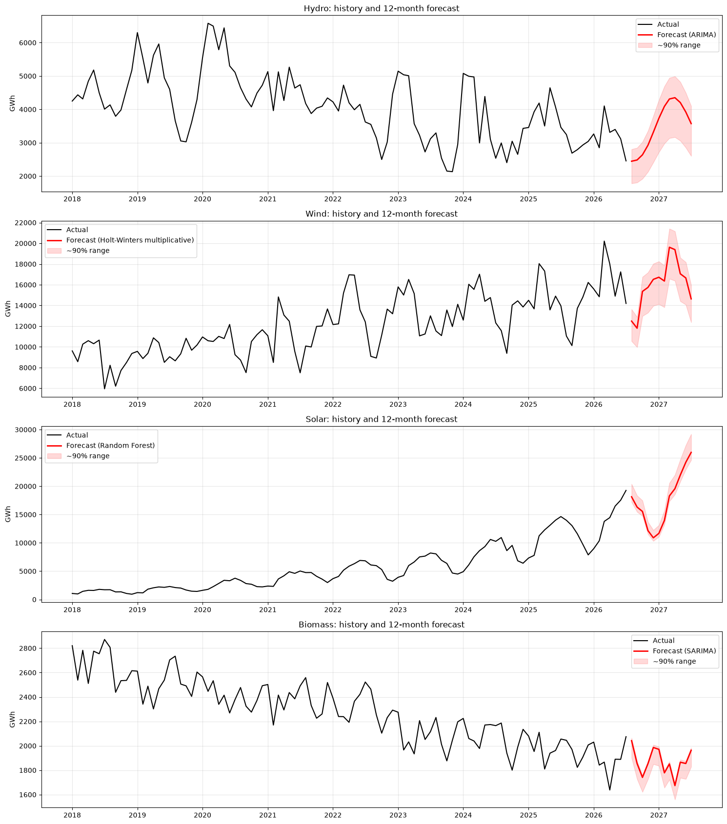
Figure 7.6: History and 12-month forecast of each resource
Table 7.10 Twelve-month outlook
Resource | Best model | Last 12 months (GWh) | Next 12 months (GWh) | Change (%) | Peak month | Lowest month | Share of next 12 months (%)
Hydro | ARIMA | 37190.596 | 41985.347 | 12.892 | Apr 2027 | Aug 2026 | 9.020
Wind | Holt-Winters multiplicative | 180893.248 | 192352.214 | 6.335 | Mar 2027 | Sep 2026 | 41.324
Solar | Random Forest | 157117.392 | 208705.170 | 32.834 | Jul 2027 | Dec 2026 | 44.837
Biomass | SARIMA | 22982.679 | 22435.636 | -2.380 | Aug 2026 | Apr 2027 | 4.820

Table 7.11 Monthly forecasts (GWh)
Month | hydro | wind | solar | biomass
2026-08 | 2445.600 | 12491.200 | 18133.600 | 2042.200
2026-09 | 2482.900 | 11801.900 | 16313.700 | 1854.600
2026-10 | 2637.200 | 15355.500 | 15544.900 | 1741.000
2026-11 | 2925.700 | 15745.000 | 12162.300 | 1853.900
2026-12 | 3314.200 | 16519.700 | 10891.200 | 1986.100
2027-01 | 3731.200 | 16725.000 | 11671.800 | 1971.000
2027-02 | 4089.500 | 16356.500 | 13960.400 | 1778.200
2027-03 | 4311.200 | 19621.000 | 18286.100 | 1850.900
2027-04 | 4350.200 | 19390.700 | 19567.000 | 1673.800
2027-05 | 4204.900 | 17056.100 | 21966.900 | 1865.500
2027-06 | 3919.500 | 16656.000 | 24230.600 | 1855.000
2027-07 | 3573.200 | 14633.500 | 25976.700 | 1963.500

Forecast for Aug 2026 – Jul 2027
Resource | Best model | Last 12 months | Forecast next 12 months | Change | Peak | Low
Solar | Random Forest | 157,117 GWh | 208,705 GWh | +32.8% | Jul 2027 | Dec 2026
Wind | HW multiplicative | 180,893 GWh | 192,352 GWh | +6.3% | Mar 2027 | Sep 2026
Hydro | ARIMA | 37,191 GWh | 41,985 GWh | +12.9% | Apr 2027 | Aug 2026
Biomass | SARIMA | 22,983 GWh | 22,436 GWh | −2.4% | Aug 2026 | Apr 2027

- Solar is forecast to overtake wind as the South's largest renewable source in the next 12 months: about 44.8% of the modelled renewable output vs about 41.3% for wind.
- Wind keeps growing, but slowly (+6.3%).
- Hydro recovers toward its long-run average (about 45,000 GWh/yr) after a below-average year. This is a mean-reversion forecast that depends on rainfall.
- Biomass continues its slow decline.
- Seasonally:
- wind peaks in March;
- solar peaks in July;
- hydro peaks in April;
- Sep–Dec is the weakest period for wind and solar combined.

11. Geothermal
Geothermal generation is 0 GWh in every month from Jan 2001 to Jul 2026 in all 17 Southern jurisdictions. There are no utility-scale geothermal plants in the region, so there is no time-series behaviour to model. Every model would forecast exactly 0. The forecast for geothermal is therefore 0 GWh, unless a new plant is built, which cannot be predicted from this data.

8. Residual Diagnostics and Interpretation

8.1 Method
- Best test model: one-step-ahead errors over the 60 months before the test period, re-estimating the model every month.
- SARIMA (for comparison): in-sample residuals of the AIC-selected SARIMA fitted on the training data (on the model scale: log for multiplicative resources).
- Tests: t-test for mean = 0; Ljung-Box at lags 6 and 12 (H0: no autocorrelation); Shapiro-Wilk (H0: normal). A good model has mean ≈ 0, Ljung-Box p > 0.05 and roughly normal residuals.

8.2 Hydro
Best hydro model on the test period: ARIMA.
Table 8.1a Hydro: residual tests of the best test model
# | resource | model | n | mean | mean t-test p | std | Ljung-Box p (lag 6) | Ljung-Box p (lag 12) | Shapiro-Wilk p
0 | hydro | ARIMA | 60 | 112.267 | 0.240 | 732.970 | 0.075 | 0.007 | 0.341

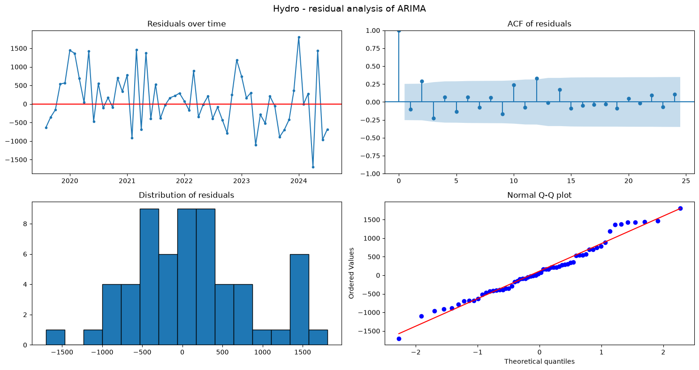
Figure 8.1: Hydro: residual analysis of the best test model (time plot, ACF, histogram, Q-Q plot)
Table 8.1b Hydro: residual tests of SARIMA (in-sample)
# | resource | model | n | mean | mean t-test p | std | Ljung-Box p (lag 6) | Ljung-Box p (lag 12) | Shapiro-Wilk p
0 | hydro | SARIMA (in-sample) | 270 | 35.299 | 0.425 | 725.186 | 0.827 | 0.507 | 0.020

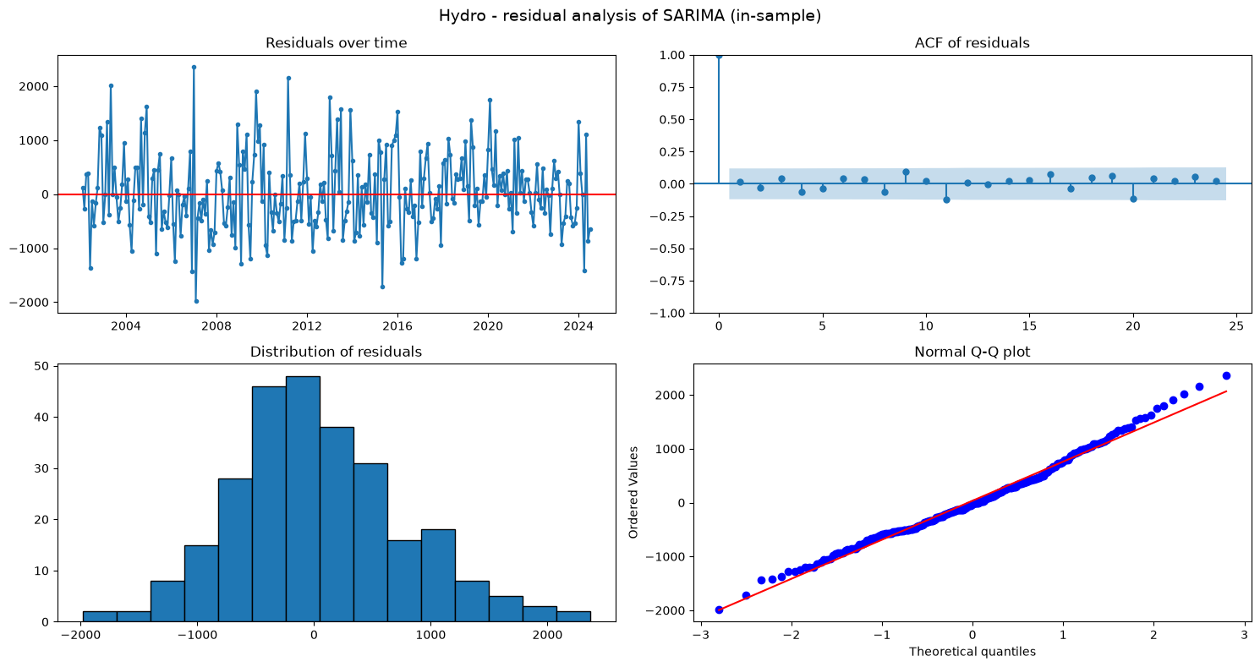
Figure 8.2: Hydro: residual analysis of SARIMA (in-sample)

Hydro: residual interpretation
- ARIMA (best on test): the mean one-step error (+112 GWh) is not significantly different from 0 (p = 0.24) and is roughly normal (Shapiro p = 0.34). However, Ljung-Box is significant at lag 12 (p = 0.007). The non-seasonal ARIMA leaves the yearly pattern in its residuals.
- SARIMA(1,0,0)(1,0,1)12: residual mean ≈ 0 (p = 0.43) and no autocorrelation (Ljung-Box p = 0.83 at lag 6 and 0.51 at lag 12). These are white-noise residuals. They are slightly non-normal (Shapiro p = 0.02) because of extreme wet months.
ARIMA and SARIMA are tied on accuracy (MASE 0.486 vs 0.494), and only SARIMA leaves white-noise residuals. SARIMA is therefore the more reliable hydro model. ARIMA's small edge on the test set does not justify ignoring the seasonal structure it leaves behind.

8.3 Wind
Best wind model on the test period: Holt-Winters multiplicative.
Table 8.2a Wind: residual tests of the best test model
# | resource | model | n | mean | mean t-test p | std | Ljung-Box p (lag 6) | Ljung-Box p (lag 12) | Shapiro-Wilk p
0 | wind | Holt-Winters multiplicative | 60 | 1.785 | 0.993 | 1593.663 | 0.025 | 0.008 | 0.277

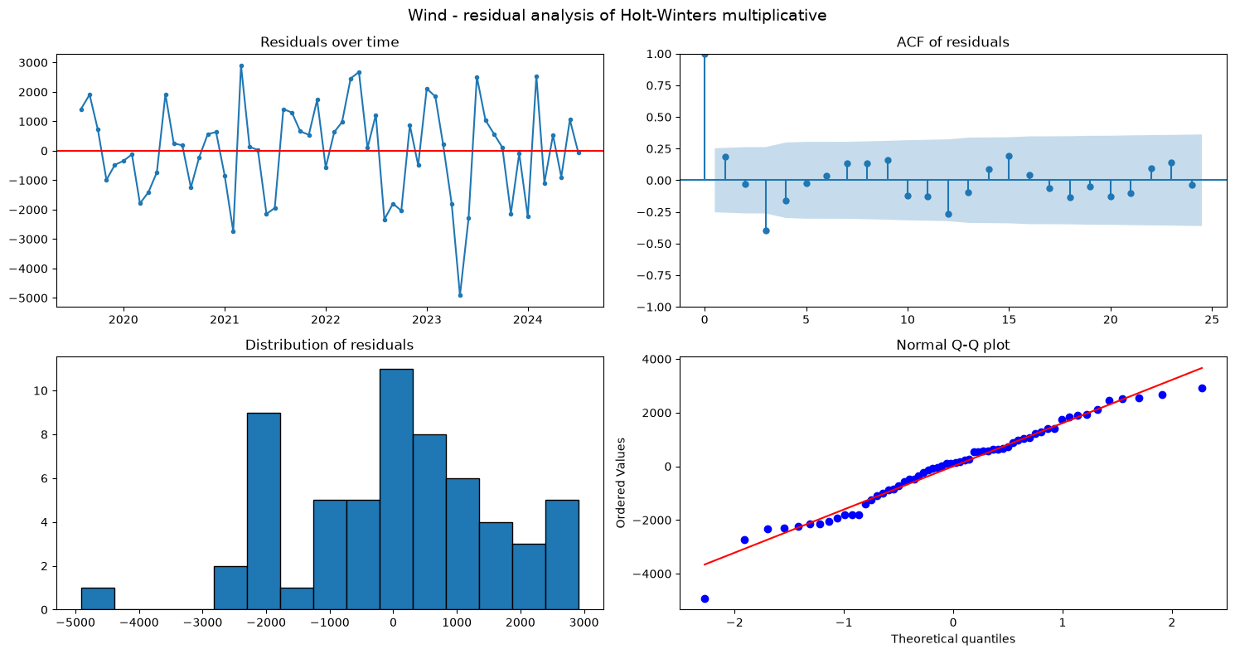
Figure 8.3: Wind: residual analysis of the best test model (time plot, ACF, histogram, Q-Q plot)
Table 8.2b Wind: residual tests of SARIMA (in-sample)
# | resource | model | n | mean | mean t-test p | std | Ljung-Box p (lag 6) | Ljung-Box p (lag 12) | Shapiro-Wilk p
0 | wind | SARIMA (in-sample) | 270 | -0.013 | 0.188 | 0.168 | 0.255 | 0.536 | 0.224

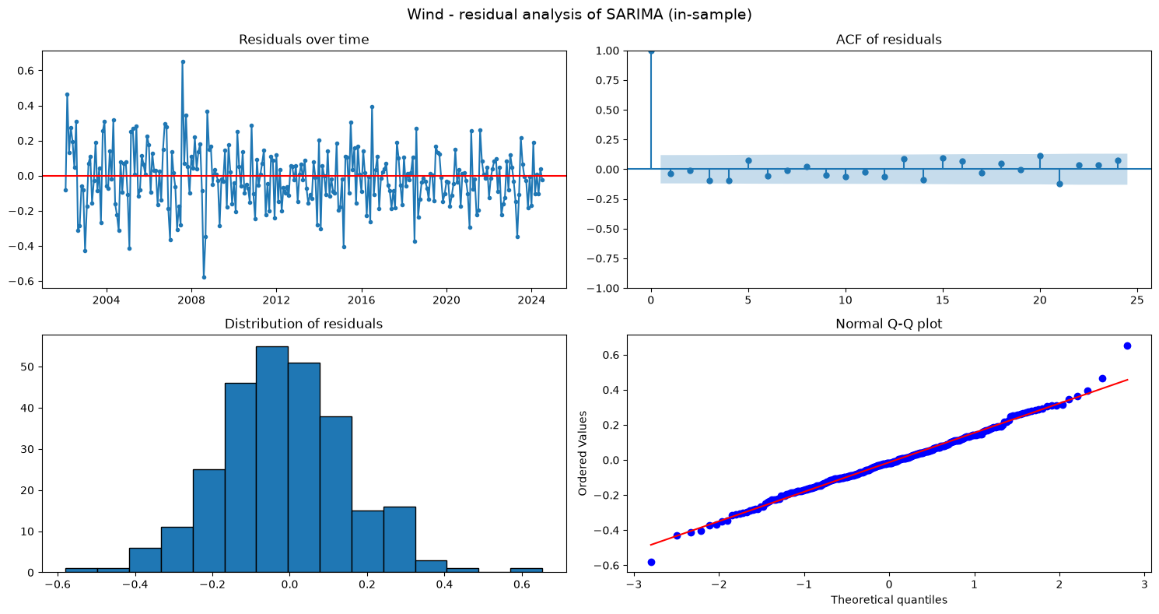
Figure 8.4: Wind: residual analysis of SARIMA (in-sample)

Wind: residual interpretation
- Holt-Winters multiplicative (best on test): the mean one-step error is essentially 0 (+1.8 GWh, p = 0.99) and the errors are normal (Shapiro p = 0.28), so the model is unbiased. However, there is some autocorrelation left (Ljung-Box p = 0.025 at lag 6, 0.008 at lag 12), so a small part of the month-to-month and yearly structure is not captured.
- SARIMA(1,1,1)(1,0,1)12 on log(wind): in-sample residuals are white noise (mean ≈ 0, p = 0.19; Ljung-Box p = 0.26 and 0.54; Shapiro p = 0.22). SARIMA describes the *past* well but forecasts the *recent slowdown* badly.
This illustrates an important point: a model with perfect in-sample residuals is not guaranteed to forecast best when the trend changes. Holt-Winters adapts to the slowdown faster.

8.4 Solar
Best solar model on the test period: Random Forest.
Table 8.3a Solar: residual tests of the best test model
# | resource | model | n | mean | mean t-test p | std | Ljung-Box p (lag 6) | Ljung-Box p (lag 12) | Shapiro-Wilk p
0 | solar | Random Forest | 60 | -181.784 | 0.005 | 484.966 | 0.002 | 0.010 | 0.105

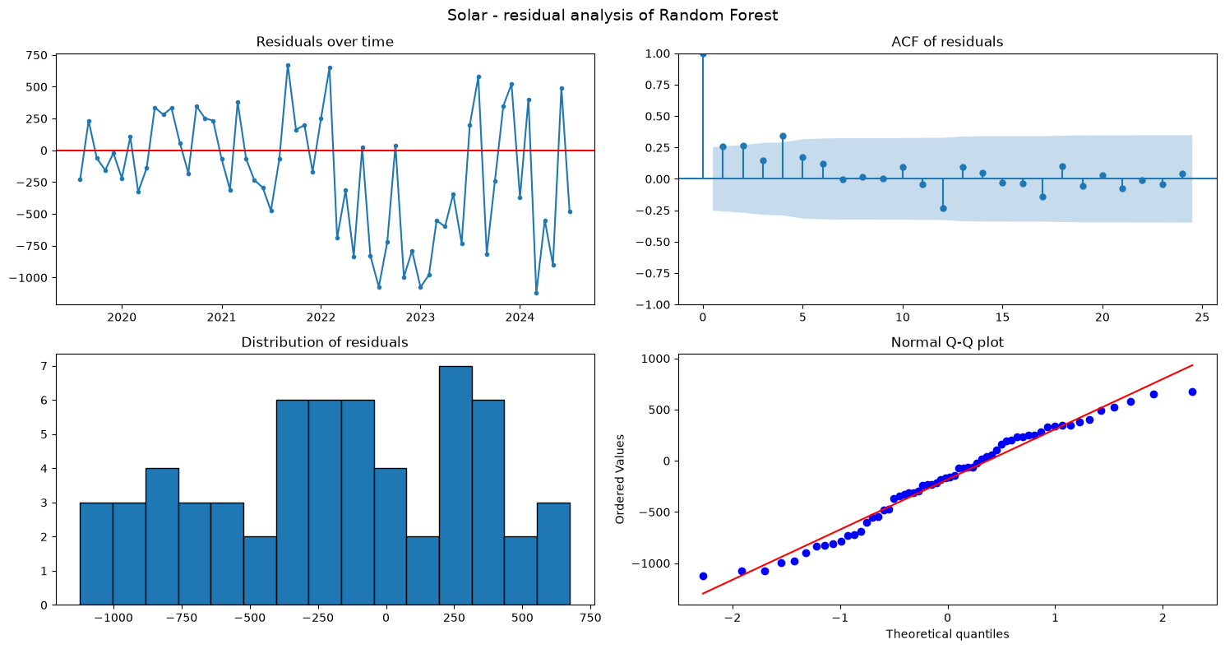
Figure 8.5: Solar: residual analysis of the best test model (time plot, ACF, histogram, Q-Q plot)
Table 8.3b Solar: residual tests of SARIMA (in-sample)
# | resource | model | n | mean | mean t-test p | std | Ljung-Box p (lag 6) | Ljung-Box p (lag 12) | Shapiro-Wilk p
0 | solar | SARIMA (in-sample) | 162 | -0.025 | 0.099 | 0.194 | 0.069 | 0.100 | 0.000

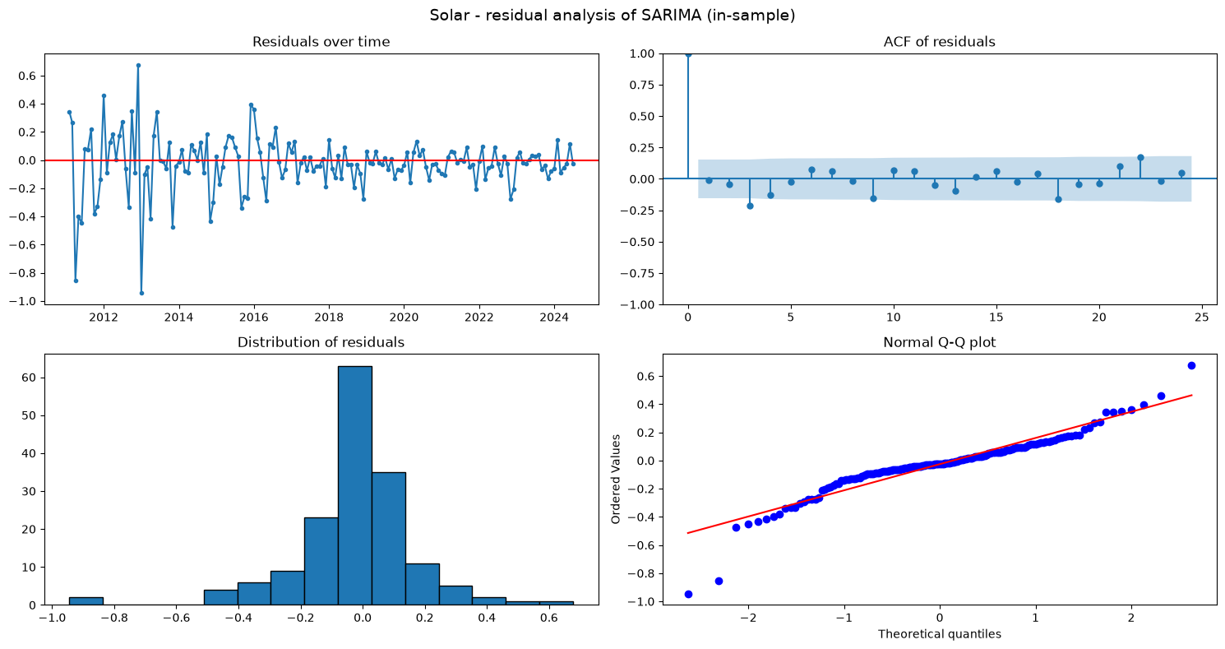
Figure 8.6: Solar: residual analysis of SARIMA (in-sample)

Solar: residual interpretation
- Random Forest: the mean one-step error is −182 GWh and significantly negative (p = 0.005). The model tends to over-forecast month by month. The residuals are also autocorrelated (Ljung-Box p = 0.002 at lag 6). It wins on the 24-month test, but its errors are not white noise. Its 24-month advantage partly reflects how well its growth-rate approach matched the 2025–26 surge.
- SARIMA(1,1,0)(0,1,1)12 on log(solar): residual mean ≈ 0 (p = 0.10) and Ljung-Box p = 0.07 (lag 6) and 0.10 (lag 12). These are white-noise residuals, so the model captures all of the linear time structure. The residuals are non-normal (Shapiro p < 0.001) because of a few unusual months.
Conclusion for solar: Random Forest gives the most accurate forecasts, and SARIMA gives the statistically cleanest description of the series.

8.5 Biomass
Best biomass model on the test period: SARIMA.
Table 8.4a Biomass: residual tests of the best test model
# | resource | model | n | mean | mean t-test p | std | Ljung-Box p (lag 6) | Ljung-Box p (lag 12) | Shapiro-Wilk p
0 | biomass | SARIMA | 60 | -4.463 | 0.681 | 83.557 | 0.571 | 0.171 | 0.164

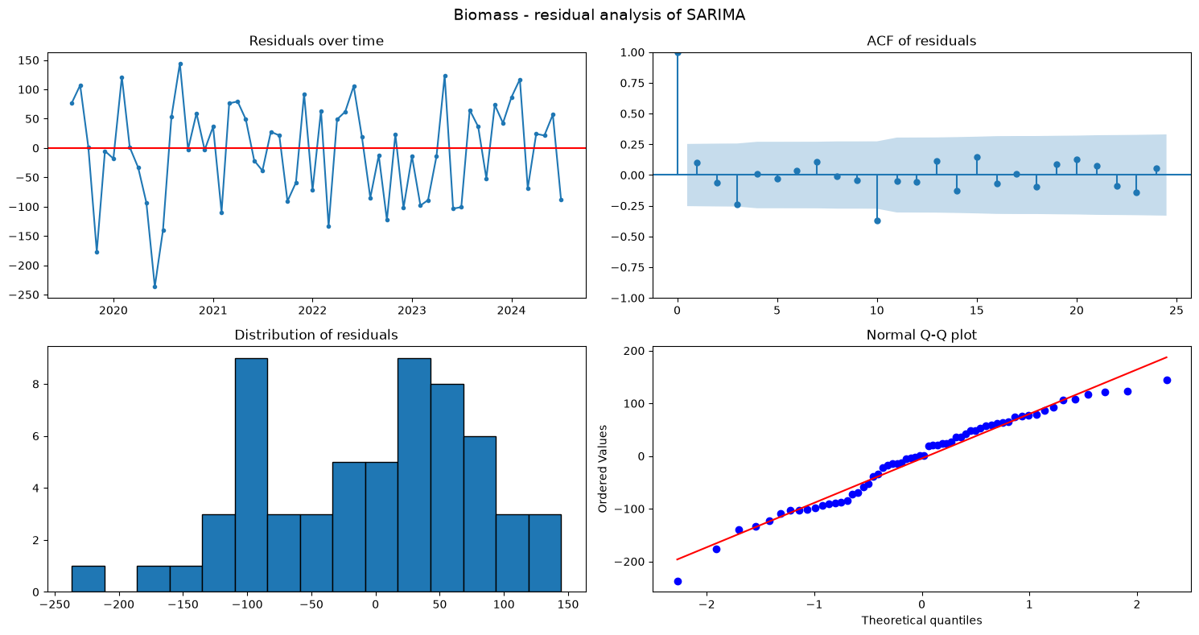
Figure 8.7: Biomass: residual analysis of the best test model (time plot, ACF, histogram, Q-Q plot)
Table 8.4b Biomass: residual tests of SARIMA (in-sample)
# | resource | model | n | mean | mean t-test p | std | Ljung-Box p (lag 6) | Ljung-Box p (lag 12) | Shapiro-Wilk p
0 | biomass | SARIMA (in-sample) | 270 | -3.766 | 0.440 | 80.091 | 0.977 | 0.570 | 0.137

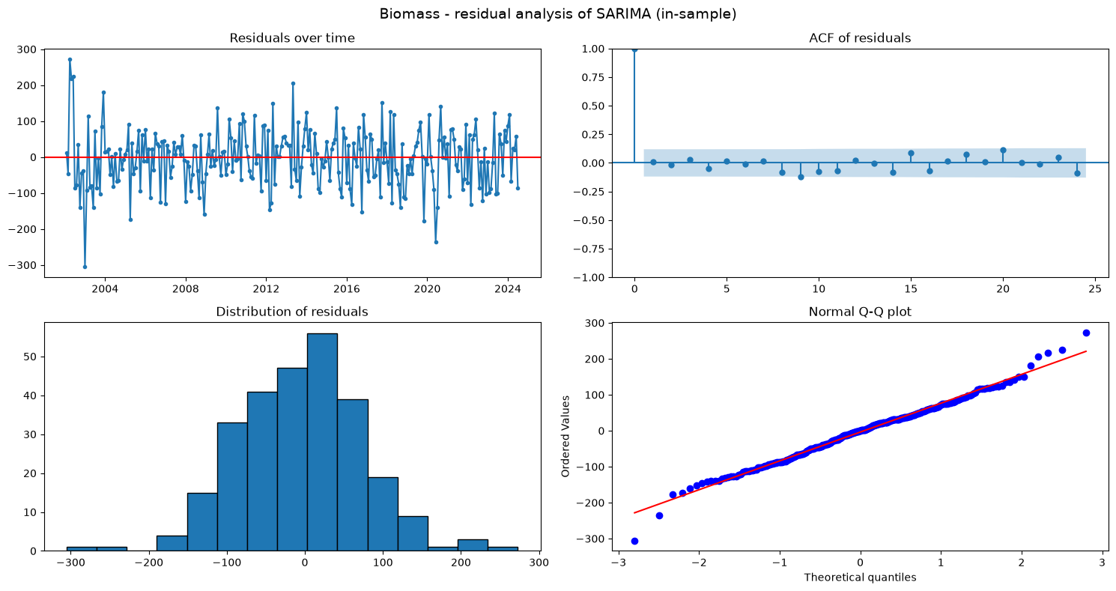
Figure 8.8: Biomass: residual analysis of SARIMA (in-sample)

Biomass: residual interpretation
The SARIMA residuals are white noise by every test, both for the one-step forecast errors and in-sample:
- mean ≈ 0 (p = 0.68 and 0.44);
- no autocorrelation (Ljung-Box p = 0.57 / 0.17 and 0.98 / 0.57);
- normally distributed (Shapiro p = 0.16 and 0.14).
The model has captured all the trend, seasonal and short-term dependence in biomass generation. Its estimated coefficients (MA(1) = −0.44, seasonal MA(1) = −0.70) are highly significant.

8.6 Summary
Table 8.5 Residual analysis summary
Resource – model | n | mean | mean t-test p | std | Ljung-Box p (lag 6) | Ljung-Box p (lag 12) | Shapiro-Wilk p
hydro – ARIMA | 60 | 112.267 | 0.240 | 732.970 | 0.075 | 0.007 | 0.341
hydro – SARIMA (in-sample) | 270 | 35.299 | 0.425 | 725.186 | 0.827 | 0.507 | 0.020
wind – Holt-Winters multiplicative | 60 | 1.785 | 0.993 | 1593.663 | 0.025 | 0.008 | 0.277
wind – SARIMA (in-sample) | 270 | -0.013 | 0.188 | 0.168 | 0.255 | 0.536 | 0.224
solar – Random Forest | 60 | -181.784 | 0.005 | 484.966 | 0.002 | 0.010 | 0.105
solar – SARIMA (in-sample) | 162 | -0.025 | 0.099 | 0.194 | 0.069 | 0.100 | 0.000
biomass – SARIMA | 60 | -4.463 | 0.681 | 83.557 | 0.571 | 0.171 | 0.164
biomass – SARIMA (in-sample) | 270 | -3.766 | 0.440 | 80.091 | 0.977 | 0.570 | 0.137

Residual analysis summary
- SARIMA leaves white-noise residuals for all four resources (Ljung-Box p > 0.05 at lags 6 and 12, mean ≈ 0), so it captures the time structure of every series.
- The best test models for hydro (ARIMA), wind (Holt-Winters) and solar (Random Forest) still leave some autocorrelation. Only biomass (SARIMA) has both the best accuracy and white-noise residuals.
- Lower test error and cleaner residuals do not always come from the same model. For hydro, SARIMA is tied on accuracy and is the more reliable choice. For wind, Holt-Winters is clearly more accurate despite slight autocorrelation.
- Normality is rejected only for some SARIMA residuals (hydro, solar), because of a few extreme months. This affects prediction intervals, not point forecasts.

Conclusion

Answer to the research question
Hydro, wind, solar, biomass and geothermal behave very differently over time in the Southern U.S. region:
- Trend:
- hydro has no trend (stationary in levels);
- wind has strong growth that is now slowing (about 23%/yr long-run, only 3–4%/yr since 2023);
- solar has exponential growth (about 62%/yr);
- biomass rose until 2017 and has declined since;
- geothermal is absent.
- Seasonality: every active resource has a 12-month cycle, but each peaks at a different time:
- hydro in winter (January +25%);
- wind in spring (April +23%);
- solar in late spring and summer (May +24%);
- biomass is nearly flat (±6%). The cycles complement each other across the year.
- Temporal dependence: each has its own SARIMA structure, identified from the ACF/PACF and confirmed by AIC.
Resource | Structure
Hydro | (1,0,0)(1,0,1)12
Wind | (1,1,1)(1,0,1)12 on log
Solar | (1,1,0)(0,1,1)12 on log
Biomass | (0,1,1)(0,1,1)12

- Forecasting:
Resource | Best model | MAPE
Biomass | SARIMA | 4.0%
Solar | Random Forest | 5.5%
Wind | Holt-Winters multiplicative | 7.0%
Hydro | ARIMA/SARIMA | about 17% (hardest)

Every best model beats the seasonal-naive baseline, by 22–86% in MAE.
- Outlook (Aug 2026 – Jul 2027):
- solar about 208,700 GWh (+33%), overtaking wind (about 192,400 GWh, +6%) as the largest source;
- hydro about 42,000 GWh (+13%);
- biomass about 22,400 GWh (−2%).

Limitations
- The test set is a single 24-month window.
- No weather data (rainfall, wind speed, irradiance) or capacity data are included.
- Rooftop solar is not in the EIA figures.

Future work
- Add weather and capacity variables to SARIMAX.
- Use rolling-origin evaluation over several test windows.

