Time-Series Analysis and Forecasting of Renewable Electricity Generation by Source: West Region (U.S. Census)
  - Technical Report | Hydro, wind, solar, biomass and geothermal | U.S. EIA monthly net generation, January 2001 – July 2026

1. Research Objective & Questions

1.1 Objective
To study the temporal behaviour of each renewable resource in the Western U.S. Census region — its trend, seasonality, stationarity, autocorrelation and partial autocorrelation — and to use these results to build, compare and validate separate forecasting models for hydro, wind, solar, biomass and geothermal. Each resource is analysed separately because each depends on a different natural driver (snowpack and rainfall, wind, sunlight, fuel supply, underground heat).

1.2 Research questions
Main research question: How do hydro, wind, solar, biomass and geothermal electricity generation vary over time in the Western U.S. region, and what specific trends, seasonal cycles and temporal dependencies can be isolated to accurately forecast their future contributions?
1. What long-term trend does each resource (hydro, wind, solar, biomass, geothermal) follow — growth, decline or no trend — and how fast?
2. Does each resource show 12-month seasonality, when does it peak and trough, and is the seasonality additive or multiplicative?
3. Is each series stationary according to the ADF and KPSS tests, and which transformation and differencing orders (d, D) are needed?
4. Which (p, d, q) × (P, D, Q)12 orders are suggested by the ACF and PACF, and are they confirmed by an AIC search?
5. Which model family gives the most accurate 24-month-ahead forecasts (MAE, RMSE, MAPE) for each resource, and does it beat the seasonal-naive baseline?
6. Are the residuals of the selected models white noise (zero mean, no autocorrelation, approximately normal)?
7. What generation is expected from each resource over August 2026 – July 2027?

1.3 Hypotheses
- H1: All five resources show 12-month seasonality: strong for hydro and solar, moderate for wind and biomass, weak for geothermal.
- H2: Seasonal models (SARIMA, Holt-Winters) forecast more accurately than the seasonal-naive baseline for each resource.
- H3: The growing resources (solar and wind) need models that capture growth. Trend-free models (naive, SES) will perform poorly for them.
- H4: Hydro is the hardest resource to forecast, because its variation is driven by unpredictable snowpack and rainfall; geothermal, a steady baseload source, is the easiest.

2. Dataset Description & Regional Selection

2.1 Data source and extraction from the EIA Electricity Data Browser
The data come from the U.S. Energy Information Administration (EIA) Electricity Data Browser (https://www.eia.gov/electricity/data/browser/), which publishes the official monthly net-generation statistics collected on Form EIA-923 (Electric Power Monthly). The steps below describe how the monthly state-level series used in this study are extracted.
1. Open the browser. Go to https://www.eia.gov/electricity/data/browser/. The landing page lists the available electricity data sets.
2. Choose the data set. Select Net generation (electric power generation by fuel type).
3. Select the fuel types. Tick Conventional hydroelectric, Wind, All utility-scale solar, Wood and wood-derived fuels, Other biomass, Geothermal and All fuels (needed for the renewable share). Pumped-storage hydro is excluded, and small-scale (rooftop) solar is not part of these series.
4. Select the geography. Choose the state level and select every state of the West Census region (13 jurisdictions, listed in Table 2.1). The national file used here contains all 50 states and the District of Columbia, so the same steps are repeated for every state.
5. Select the sector. Choose All sectors, so that utilities, independent power producers and commercial and industrial plants are all included.
6. Select frequency and period. Set the frequency to Monthly and the period to January 2001 – July 2026.
7. Check the units. Values are reported in thousand megawatt-hours, which equals gigawatt-hours (GWh); no unit conversion is needed.
8. Download. Use the download option to export each table as CSV (or Excel). Each series corresponds to an EIA series code of the form ELEC.GEN.<FUEL>-<STATE>-99.M (for example ELEC.GEN.WND-TX-99.M is wind, Texas, all sectors, monthly).
9. Combine the downloads. Stack the state files into one table with one row per state per month, and one column per source. Wood and other biomass are added together into a single biomass column.
10. Derive the totals. total_renewable = hydro + wind + solar + biomass + geothermal, and renewable_share_pct = total_renewable ÷ total_generation × 100.
11. Attach the regional classification. Label every row with its official U.S. Census region and division (Northeast, Midwest, South, West; 9 divisions).
12. Save. The final file has 15,657 rows (51 jurisdictions × 307 months) and 11 columns.
Table 2.2 Variables in the dataset
Variable | Description
month | First day of the month of the observation
census_region | U.S. Census region (Northeast, Midwest, South, West)
census_division | U.S. Census division (9 divisions)
hydro, wind, solar, biomass, geothermal | Net generation from each source, in thousand MWh (= GWh)
total_renewable | Sum of the five renewable sources (GWh)
total_generation | Net generation from all sources, renewable and non-renewable (GWh)
renewable_share_pct | total_renewable / total_generation × 100

2.2 Regional selection: the West region
The Western U.S. Census region covers 13 jurisdictions in two divisions (Table 2.1). It is the largest renewable producer of the four regions. Hydro from the Rockies, Sierra Nevada and Cascades is the largest source, wind and solar have grown rapidly, and the West is the only region with geothermal generation.
Table 2.1 States of the West region
Census division | States
Mountain | AZ, CO, ID, MT, NV, NM, UT, WY
Pacific | AK, CA, HI, OR, WA

Only rows with census_region = "West" are kept (3,991 rows = 13 jurisdictions × 307 months). Each month has one row per state, so the rows are added together to give one monthly regional total per resource.
Table 2.3 Summary statistics of the monthly regional series (GWh), Jan 2001 – Jul 2026
Statistic | hydro | solar | biomass | geothermal | wind
count | 307.000 | 307.000 | 307.000 | 307.000 | 307.000
mean | 14169.589 | 2378.548 | 758.280 | 1278.813 | 3588.552
std | 3329.523 | 3105.999 | 108.092 | 80.662 | 2533.543
min | 8231.152 | 2.713 | 529.470 | 983.532 | 166.772
25% | 11612.868 | 66.620 | 679.067 | 1227.171 | 1095.031
50% | 13428.174 | 700.834 | 748.068 | 1276.527 | 3551.516
75% | 16391.906 | 4027.226 | 839.450 | 1333.270 | 5526.408
max | 23865.592 | 13913.562 | 1051.114 | 1484.422 | 9641.498

2.3 Study period for each resource
Table 2.4 Series analysed
Resource | Period used | Monthly observations
Hydro | Jan 2001 – Jul 2026 | 307
Wind | Jan 2001 – Jul 2026 | 307
Solar | Jan 2001 – Jul 2026 | 307
Biomass | Jan 2001 – Jul 2026 | 307
Geothermal | Jan 2001 – Jul 2026 | 307

3. Preprocessing and Missing-Value Handling

3.1 Data-quality checks
Table 3.1 Data-quality checks
Check | Result
Full dataset | 15,657 rows × 11 columns; 51 jurisdictions × 307 months; 4 Census regions, 9 divisions
Date range | January 2001 – July 2026, monthly
Regional rows | 3,991 rows, 13 state rows in every month
Missing months in the regional series | 0 (every month present)
Missing values | Only renewable_share_pct has missing values (15 rows nationally, where total generation is 0 so the ratio is undefined). It is not used in modelling; all five generation columns are complete
Duplicate rows | 0
Imputation needed | None: after aggregation every regional series is complete

3.2 Zero-generation months and treatment of each resource
Table 3.2 Months with zero output, Jan 2001 – Jul 2026
Resource | Months with zero generation
Hydro | 0
Wind | 0
Solar | 0 (minimum 2.7 GWh)
Biomass | 0
Geothermal | 0 (983.5 – 1,484.4 GWh every month)

Solar: is the early series usable?
Unlike the South and the Midwest, Western solar output is never zero. Even in 2001–2010 the region produced about 500–1,000 GWh of solar electricity a year (2.7–200 GWh per month), from early solar plants, and these months already show a clear summer peak. Output then grew from 3,324 GWh (2012) to 108,827 GWh (2025). Because every month is positive and the early months already carry the seasonal pattern, solar is analysed over the full period (Jan 2001 – Jul 2026, 307 months), and a log transform is valid.

Geothermal: an active resource in the West
Geothermal generation is between 984 and 1,484 GWh every month (California and Nevada plants), so, unlike the South and Midwest, geothermal is modelled here.

3.3 Preparation steps
- The index is converted to a monthly datetime index with frequency MS (month start).
- All five resources are positive in every month, so all five are modelled and a log transform is possible for each.
- Every resource uses the full period, January 2001 – July 2026.

3.4 Transformation: additive or multiplicative?
If the seasonal swings grow as the level rises, the seasonality is multiplicative and the series is log-transformed. This is checked with the correlation between the 12-month rolling mean and the 12-month rolling standard deviation (threshold 0.7).
Table 3.3 Variance check
Resource | Correlation (rolling mean vs rolling std) | Treatment
Hydro | 0.749 | Multiplicative (log scale)
Wind | 0.938 | Multiplicative (log scale)
Solar | 0.993 | Multiplicative (log scale)
Biomass | 0.326 | Additive (original scale)
Geothermal | 0.184 | Additive (original scale)

Additive or multiplicative?
- Solar (correlation between rolling mean and rolling std = 0.993), wind (0.938) and hydro (0.749): seasonal swings grow with the level, so all three are multiplicative and are log-transformed.
- Biomass (0.326) and geothermal (0.184): variability does not depend on the level, so both are additive.

4. Time-Series Plot, Trend, and Seasonality Analysis

4.1 Time-series plots
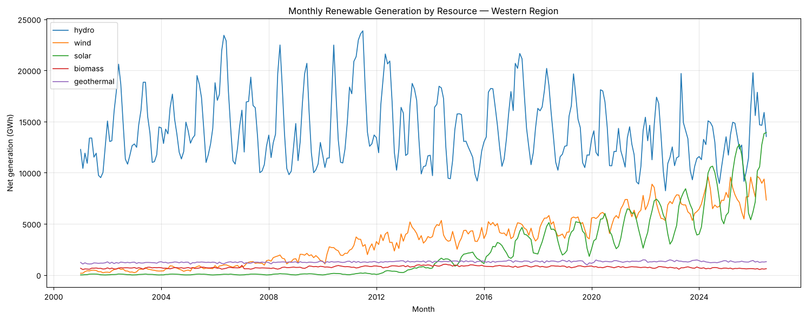
Figure 4.1: Monthly renewable generation by resource, West region
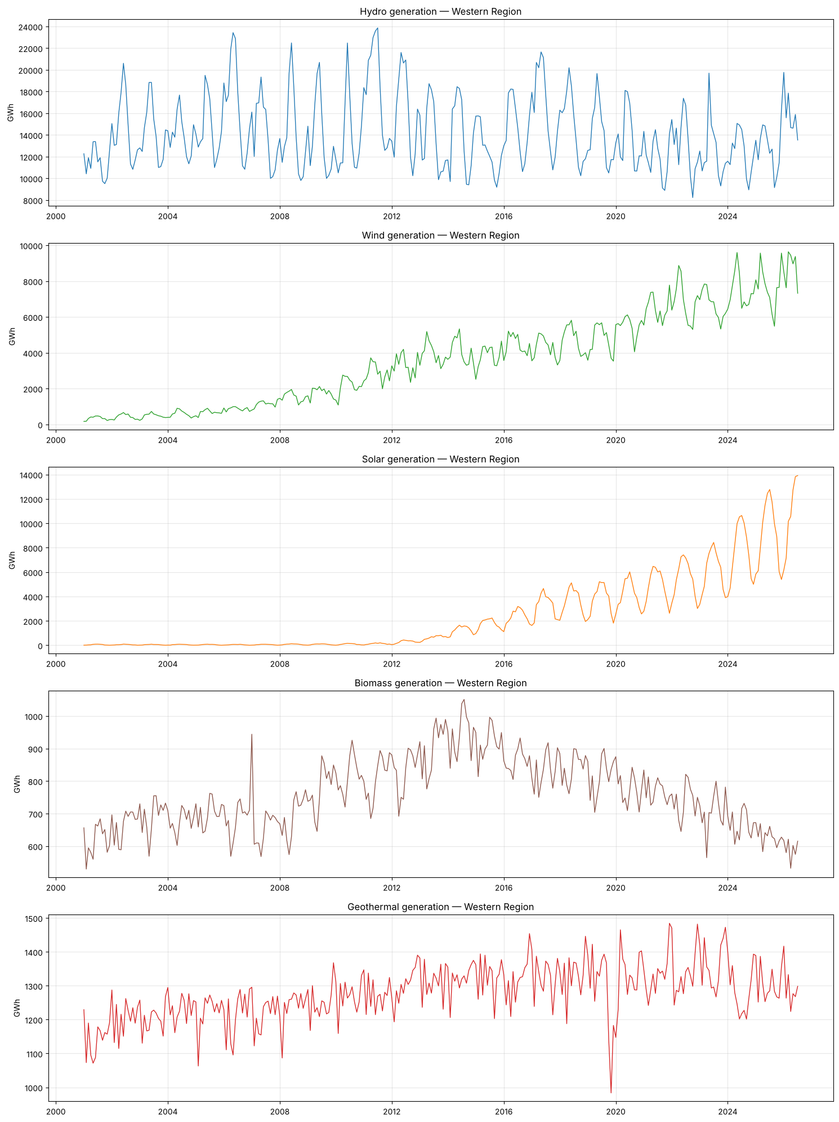
Figure 4.2: Each resource on its own scale

Initial visual observations
1. Hydro is the West's largest renewable source (14,170 GWh/month on average). It has no long-term upward direction: it moves between about 8,200 and 23,900 GWh per month, with very wet years (2006, 2011, 2017 and early 2026) and dry years (2015, 2021–2022). Every year it peaks sharply in late spring when the snowpack melts.
2. Wind grows steadily from about 170 GWh/month (2001) to about 9,600 GWh/month (record in Mar 2026), with a spring peak and the swings widening as the level rises.
3. Solar is almost flat until about 2012 and then grows explosively, reaching a record of about 13,900 GWh in Jul 2026. Its summer peak and winter dip grow with the level.
4. Biomass follows a hump: it rose from about 600–700 GWh/month to a peak of about 1,050 GWh (Aug 2014) and has declined since, to about 600 GWh.
5. Geothermal is very stable (about 1,200–1,450 GWh/month) with a slow upward drift, apart from a sharp one-off drop in late 2019 (minimum Nov 2019).

4.2 Trend analysis
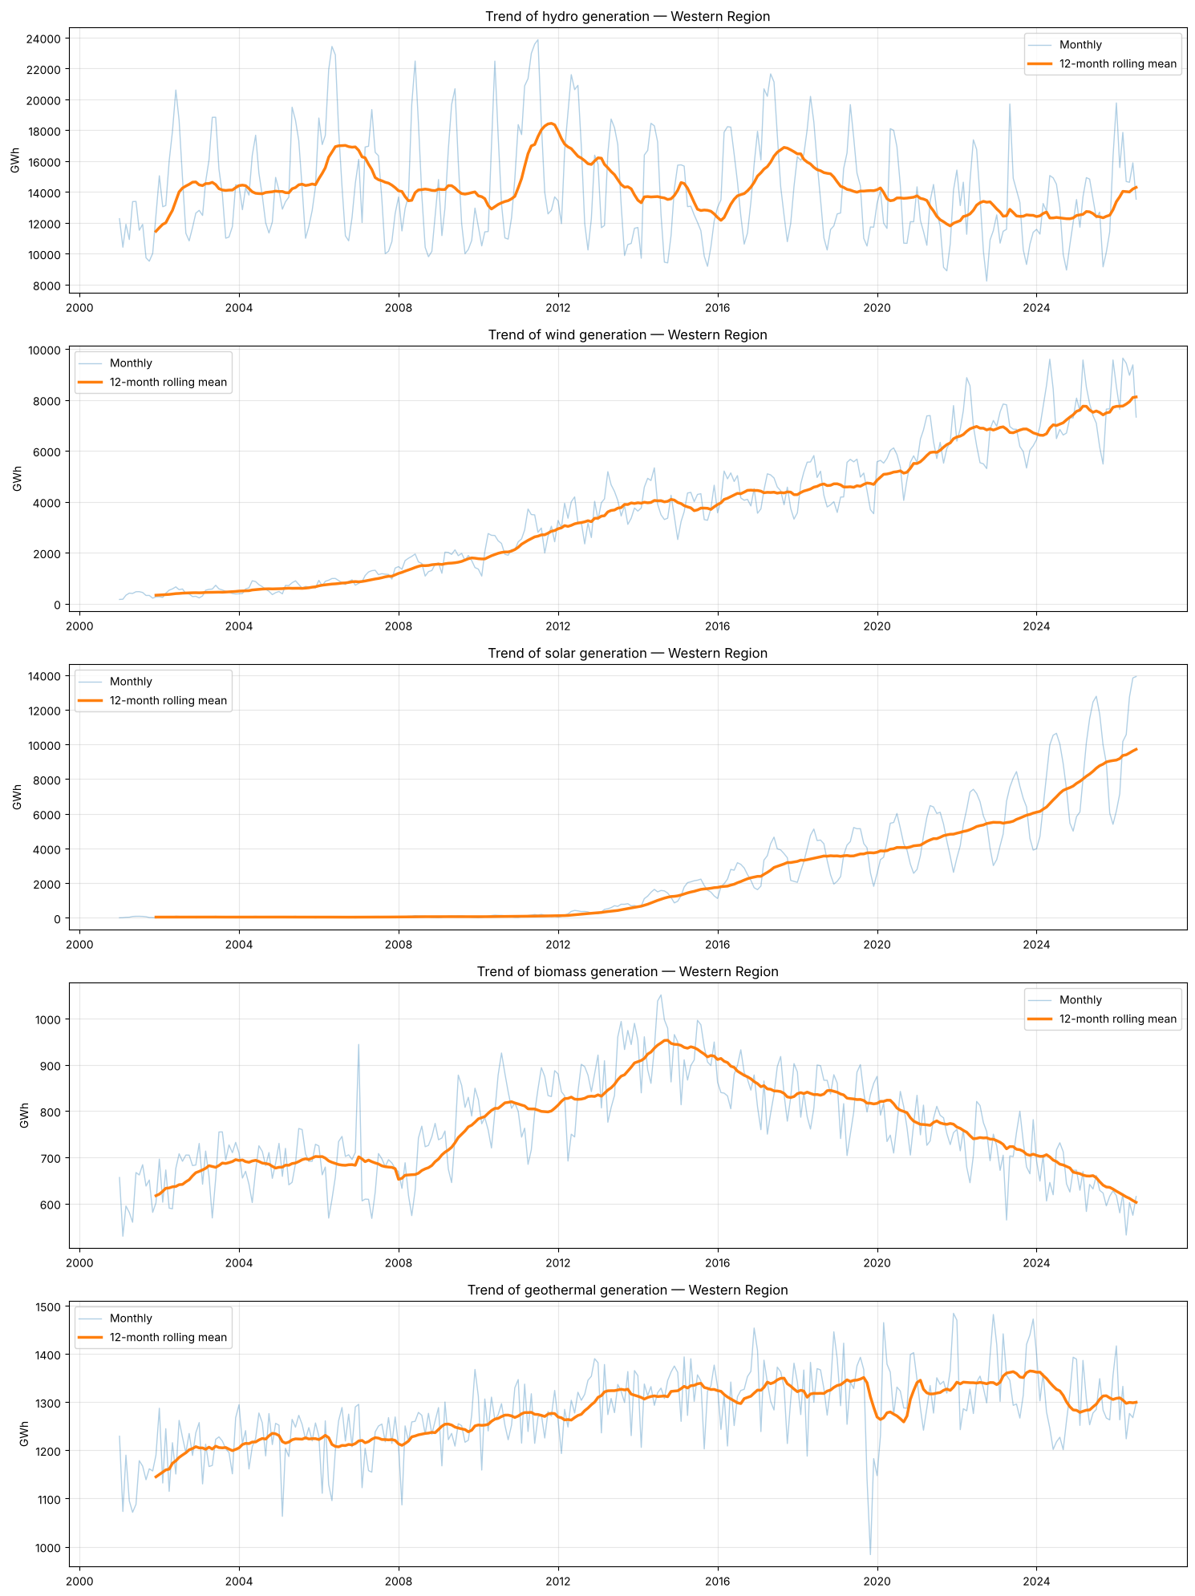
Figure 4.3: Monthly series with 12-month rolling mean (trend)
Table 4.1 Annual generation by resource (GWh), complete calendar years
Year | hydro | wind | solar | biomass | geothermal
2001 | 137460.000 | 4005.000 | 543.000 | 7406.000 | 13741.000
2002 | 175801.000 | 5184.000 | 555.000 | 8002.000 | 14491.000
2003 | 171386.000 | 5769.000 | 534.000 | 8340.000 | 14424.000
2004 | 168672.000 | 7019.000 | 575.000 | 8122.000 | 14811.000
2005 | 173630.000 | 7973.000 | 550.000 | 8423.000 | 14692.000
2006 | 203052.000 | 10418.000 | 508.000 | 8194.000 | 14568.000
2007 | 171381.000 | 13617.000 | 612.000 | 8105.000 | 14648.000
2008 | 169079.000 | 18508.000 | 860.000 | 8287.000 | 14840.000
2009 | 168077.000 | 21437.000 | 863.000 | 9311.000 | 15009.000
2010 | 164628.000 | 25501.000 | 1058.000 | 9811.000 | 15219.000
2011 | 220225.000 | 34460.000 | 1500.000 | 9673.000 | 15316.000
2012 | 192144.000 | 40236.000 | 3324.000 | 9980.000 | 15602.000
2013 | 165750.000 | 47216.000 | 7350.000 | 10849.000 | 15775.000
2014 | 165251.000 | 48803.000 | 14921.000 | 11332.000 | 15877.000
2015 | 150958.000 | 45654.000 | 20906.000 | 11026.000 | 15918.000
2016 | 175444.000 | 53359.000 | 28217.000 | 10366.000 | 15826.000
2017 | 199319.000 | 51367.000 | 38646.000 | 9977.000 | 15927.000
2018 | 179588.000 | 56468.000 | 42830.000 | 10113.000 | 15967.000
2019 | 169034.000 | 56187.000 | 44945.000 | 9786.000 | 15473.000
2020 | 163947.000 | 66070.000 | 49840.000 | 9339.000 | 15890.000
2021 | 143696.000 | 77713.000 | 57915.000 | 9260.000 | 15975.000
2022 | 157723.000 | 81806.000 | 66120.000 | 8869.000 | 16087.000
2023 | 149840.000 | 80495.000 | 72479.000 | 8483.000 | 16367.000
2024 | 147818.000 | 88996.000 | 91197.000 | 8016.000 | 15407.000
2025 | 154215.000 | 92518.000 | 108827.000 | 7578.000 | 15668.000

Table 4.2 Trend measures (linear slope, compound annual growth rate, correlation with time)
Resource | Years | First year (GWh) | Last year (GWh) | Slope (GWh/yr) | CAGR (%) | Corr. with time
hydro | 2001-2025 | 137460.063 | 154215.052 | -695.006 | 0.480 | -0.269
wind | 2001-2025 | 4005.197 | 92517.750 | 3870.290 | 13.977 | 0.987
solar | 2001-2025 | 542.760 | 108827.428 | 3976.112 | 24.716 | 0.901
biomass | 2001-2025 | 7406.009 | 7577.655 | 40.524 | 0.096 | 0.268
geothermal | 2001-2025 | 13740.501 | 15667.651 | 77.839 | 0.548 | 0.863

Trend interpretation
Resource | Long-term behaviour
Hydro | No upward trend. The linear slope is −695 GWh/yr and the correlation with time only −0.27. Annual output ranges from 137,460 GWh (2001) to 220,225 GWh (2011), driven by wet and dry years.
Wind | Strong, steady growth. Output rose from 4,005 GWh (2001) to 92,518 GWh (2025), about 14%/yr, with the strongest correlation with time of all resources (r = 0.99). Growth has slowed to about 4%/yr (2024→2025).
Solar | Strong, accelerating growth. Output rose from 543 GWh (2001) to 108,827 GWh (2025), about 25%/yr overall, with +19% in 2025 alone (r = 0.90). Solar overtook wind in 2024.
Biomass | Rise and decline. Output rose from 7,406 GWh (2001) to a peak of 11,332 GWh (2014), then fell back to 7,578 GWh (2025). A straight-line trend is misleading.
Geothermal | Slow, steady growth. Output rose from 13,741 GWh (2001) to 15,668 GWh (2025), only 0.55%/yr, but very consistently (r = 0.86).

Key finding: the five resources follow five different trends: flat and weather-driven (hydro), steady growth that is slowing (wind), accelerating growth (solar), a rise followed by a decline (biomass), and a slow, almost flat rise (geothermal).

4.3 Seasonality analysis
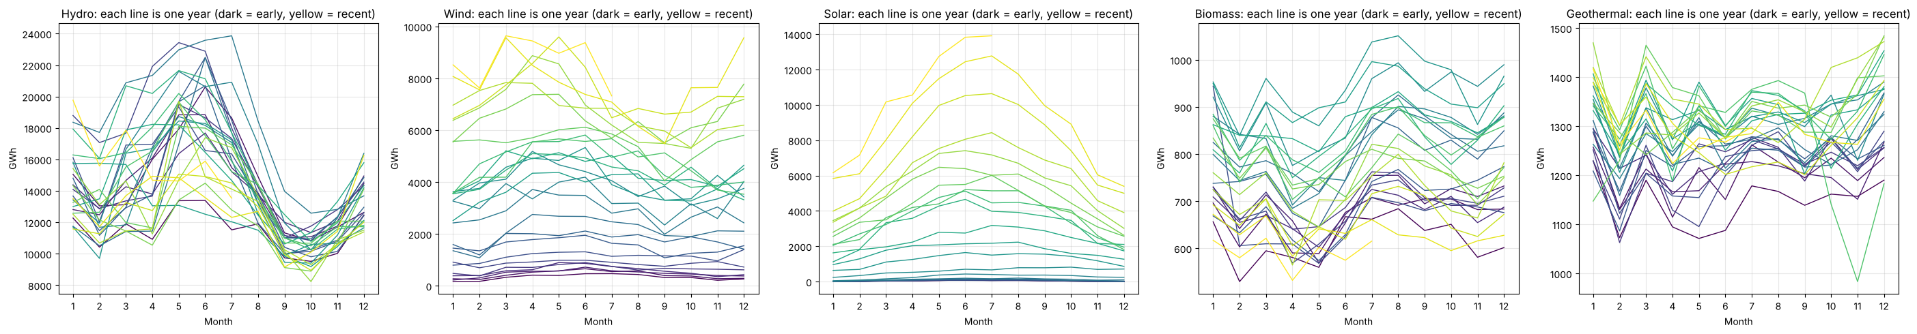
Figure 4.4: Seasonal plot: one line per year
Table 4.3 Average seasonal index (value ÷ centred 12-month moving average; 1.10 = 10% above trend)
Month | hydro | wind | solar | biomass | geothermal
Jan | 1.032 | 0.884 | 0.447 | 1.045 | 1.036
Feb | 0.921 | 0.892 | 0.607 | 0.943 | 0.943
Mar | 1.039 | 1.102 | 0.960 | 1.004 | 1.028
Apr | 1.085 | 1.194 | 1.164 | 0.902 | 0.969
May | 1.293 | 1.219 | 1.397 | 0.910 | 1.000
Jun | 1.289 | 1.210 | 1.536 | 0.967 | 0.979
Jul | 1.148 | 1.073 | 1.451 | 1.068 | 1.014
Aug | 0.968 | 1.007 | 1.413 | 1.084 | 1.013
Sep | 0.756 | 0.864 | 1.192 | 1.034 | 0.987
Oct | 0.728 | 0.881 | 0.890 | 1.015 | 0.996
Nov | 0.811 | 0.855 | 0.597 | 0.986 | 0.994
Dec | 0.946 | 0.894 | 0.418 | 1.038 | 1.049

- Hydro: peak in May (+29.3% above trend), trough in October (−27.2%)
- Wind: peak in May (+21.9% above trend), trough in November (−14.5%)
- Solar: peak in June (+53.6% above trend), trough in December (−58.2%)
- Biomass: peak in August (+8.4% above trend), trough in April (−9.8%)
- Geothermal: peak in December (+4.9% above trend), trough in February (−5.7%)
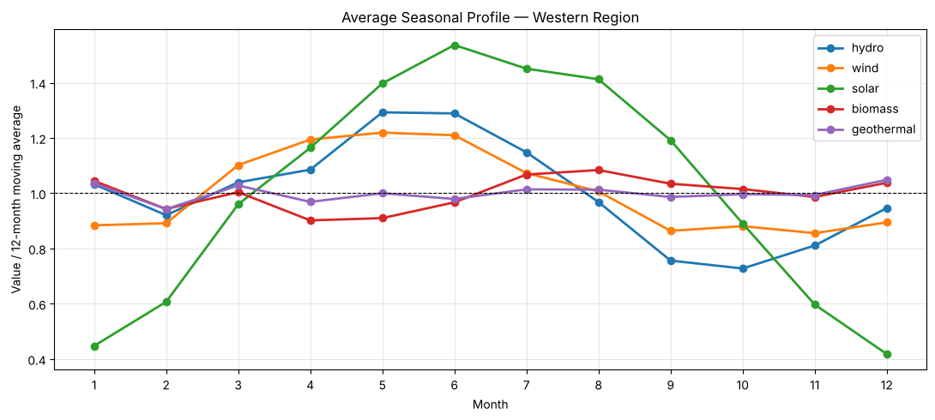
Figure 4.5: Average seasonal profile of each resource

Seasonal pattern
Resource | Peak | Trough | Size | Explanation
Hydro | May (+29.3% above trend) | October (−27.2%) | very large | Snowmelt in the Rockies, Sierra Nevada and Cascades fills rivers in May–June; rivers are lowest in early autumn
Wind | May (+21.9%) | November (−14.5%) | large | Spring winds (March–June above trend); calmer autumn and winter
Solar | June (+53.6%) | December (−58.2%) | very large | Follows day length and sun angle; April–September above trend
Biomass | August (+8.4%) | April (−9.8%) | small | Slightly higher in summer, lower in spring
Geothermal | December (+4.9%) | February (−5.7%) | very small | Baseload plants that run almost constantly all year

Unlike the South, where the cycles complement each other, the West's three largest sources (hydro, wind and solar) all peak in May–June. Western renewable output is therefore concentrated in late spring and early summer, and the autumn months (September–November) are the weakest.
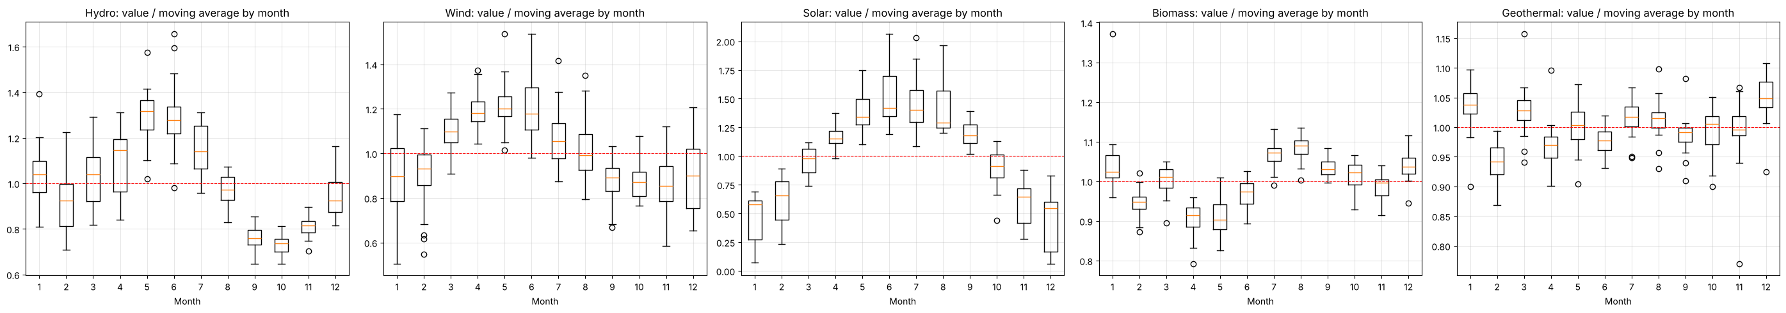
Figure 4.6: Month-of-year boxplots (value ÷ moving average)

4.4 Seasonal decomposition
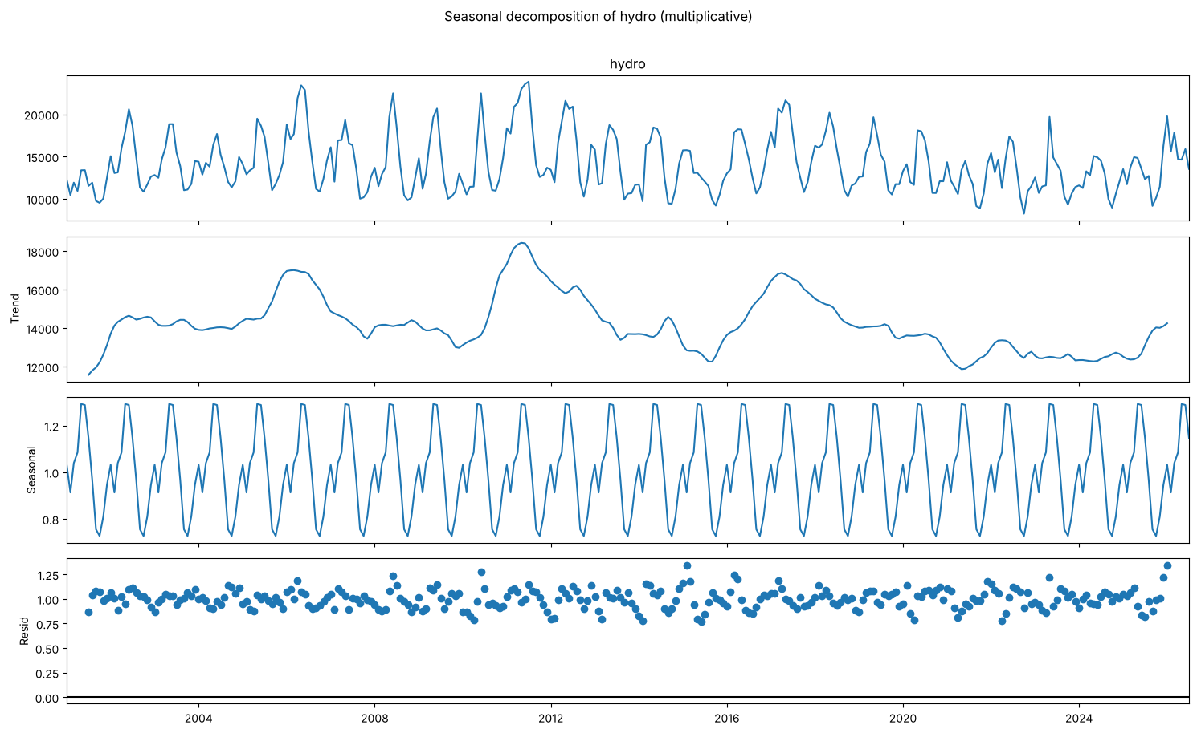
Figure 4.7: Seasonal decomposition of hydro
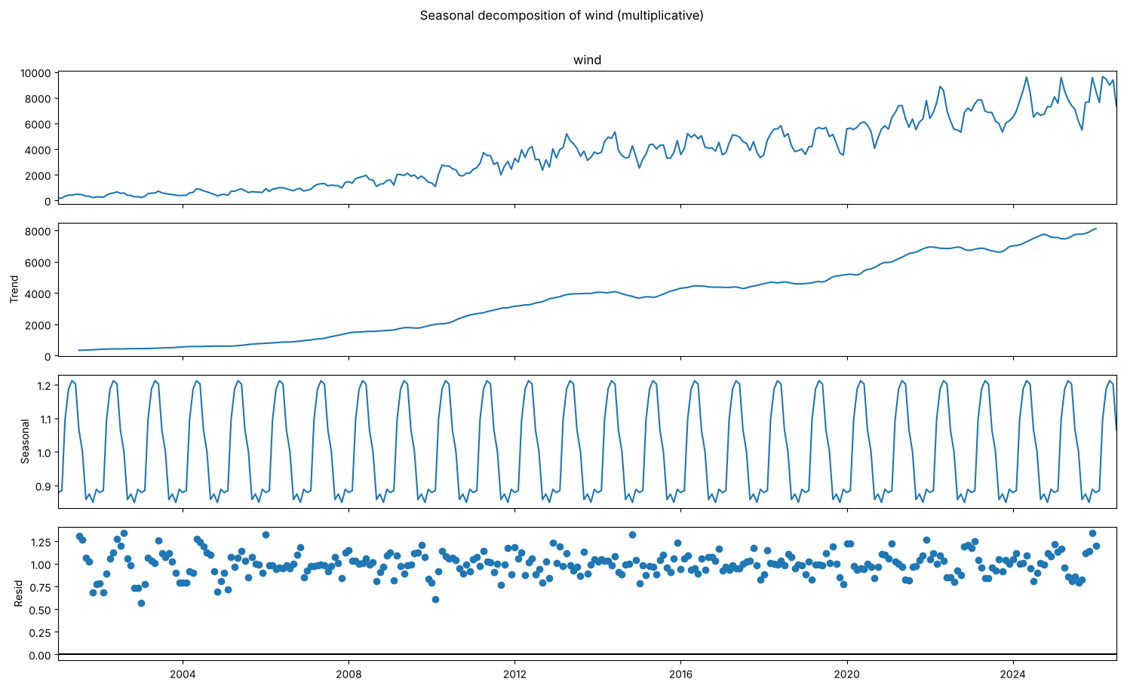
Figure 4.8: Seasonal decomposition of wind
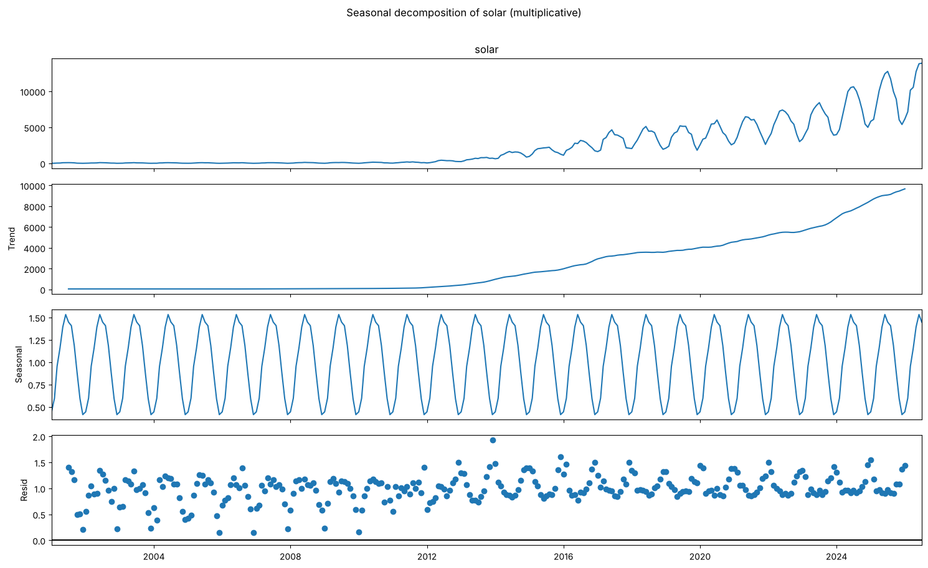
Figure 4.9: Seasonal decomposition of solar
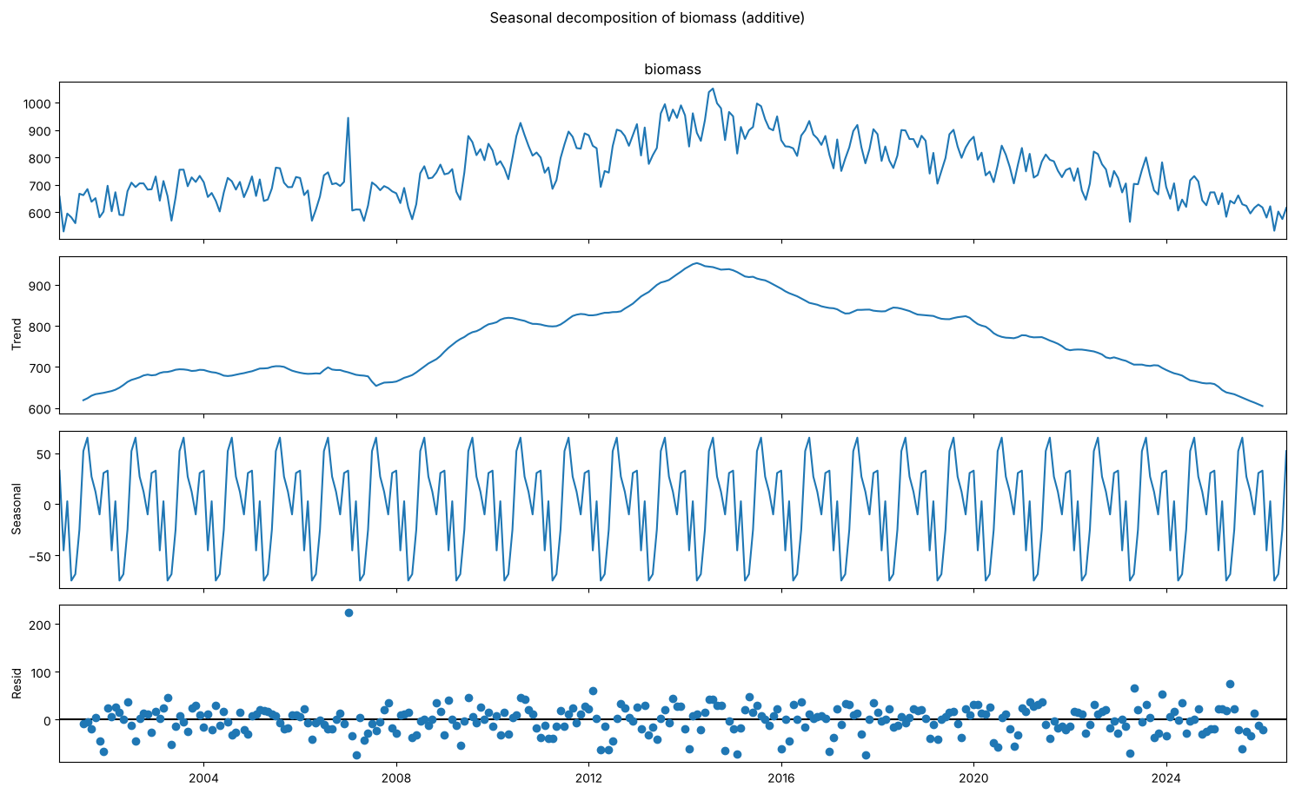
Figure 4.10: Seasonal decomposition of biomass
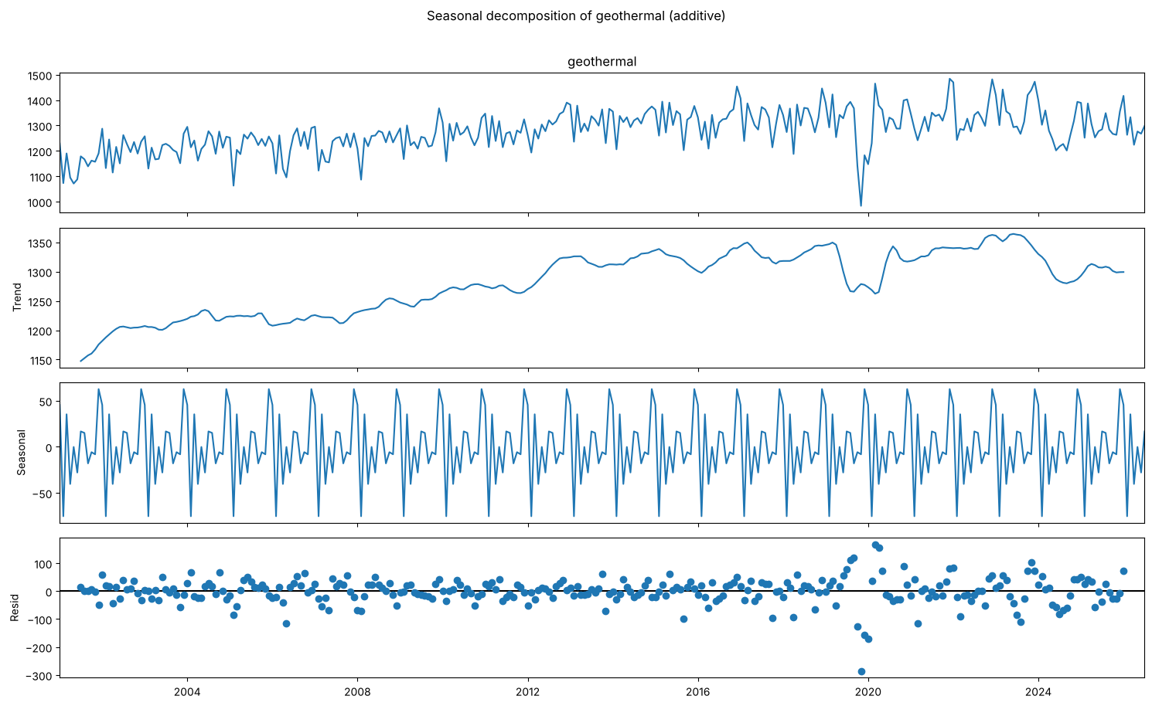
Figure 4.11: Seasonal decomposition of geothermal
Table 4.4 Seasonal and trend strength (0 = none, 1 = maximum)
Resource | Seasonal strength | Trend strength
hydro | 0.769 | 0.523
wind | 0.520 | 0.981
solar | 0.671 | 0.973
biomass | 0.676 | 0.901
geothermal | 0.387 | 0.559

Seasonal decomposition interpretation
Resource | Decomposition | Seasonal strength | Trend strength | Meaning
Hydro | multiplicative | 0.77 | 0.52 | Strong snowmelt cycle, weak trend, large irregular component (wet and dry years)
Wind | multiplicative | 0.52 | 0.98 | Dominated by the growth trend, with a moderate spring cycle
Solar | multiplicative | 0.67 | 0.97 | Growth trend plus a clear summer cycle
Biomass | additive | 0.68 | 0.90 | Rise-and-decline trend with a small but regular seasonal ripple
Geothermal | additive | 0.39 | 0.56 | Weak seasonality and a weak trend; mostly small irregular variation

All residual components are centred on zero. Their stationarity is tested in a later step.

5. ADF Stationarity Test (Before and After Differencing)

5.1 Test design
- Augmented Dickey-Fuller (ADF): H0 = the series has a unit root (non-stationary). p < 0.05 means stationary.
- KPSS (confirmatory): H0 = the series is stationary. p < 0.05 means non-stationary. The KPSS p-value is limited by its lookup table to 0.01–0.10.
- A series is called stationary only when both tests agree. The original series are tested with a constant and a trend; transformed series with a constant only.

5.2 Before differencing: visual evidence (ACF of the original series)
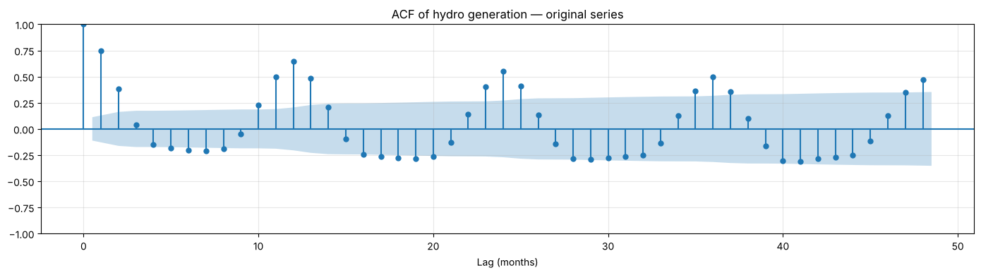
Figure 5.1: ACF of the original hydro series (lags 0–48)
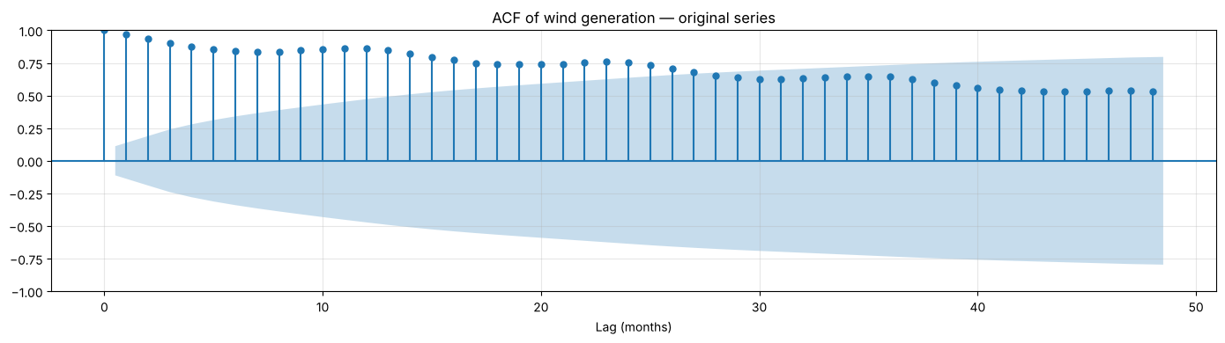
Figure 5.2: ACF of the original wind series (lags 0–48)
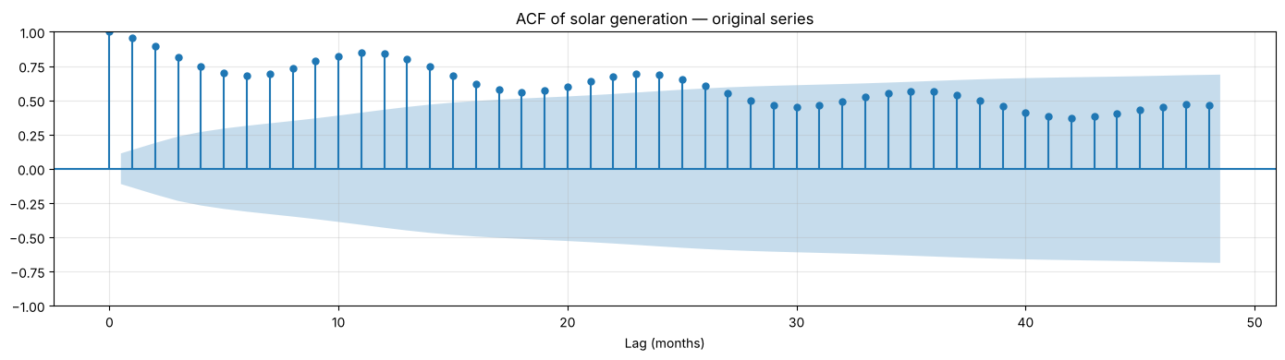
Figure 5.3: ACF of the original solar series (lags 0–48)
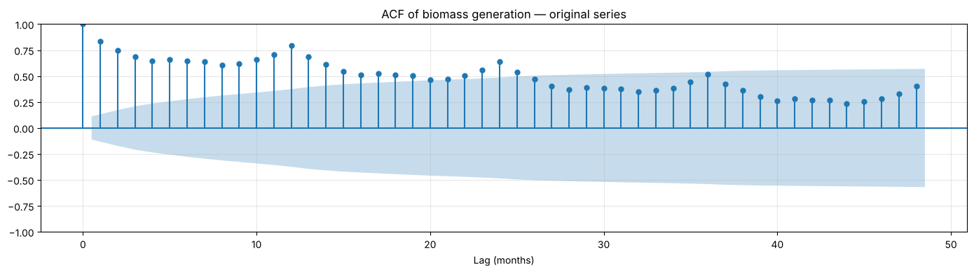
Figure 5.4: ACF of the original biomass series (lags 0–48)
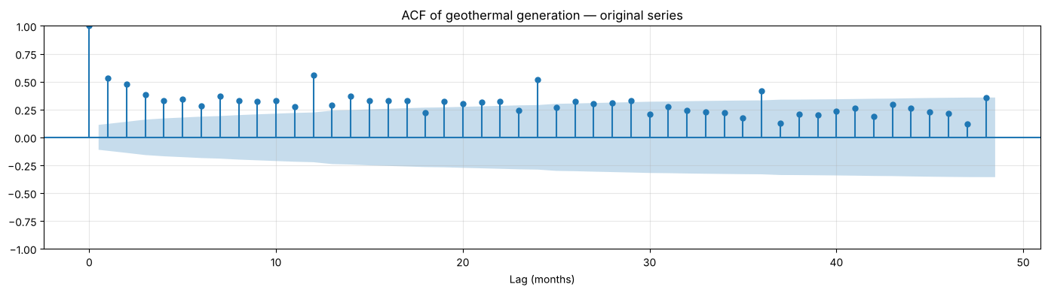
Figure 5.5: ACF of the original geothermal series (lags 0–48)

ACF interpretation (original series)
- Hydro: the ACF drops quickly (0.75 at lag 1, about −0.20 by lag 6) and then rises again to 0.64 at lag 12 and 0.55 at lag 24. This is short memory plus a very strong yearly cycle.
- Wind: the ACF is very high and decays very slowly (0.97 at lag 1, still 0.53 at lag 48), with bumps at 12, 24 and 36: a trending, non-stationary series with yearly seasonality.
- Solar: slow decay (0.96 at lag 1, 0.47 at lag 48) with seasonal bumps at 12 and 24 (0.84 and 0.69): trending and non-stationary.
- Biomass: slow decay (0.83 at lag 1, 0.40 at lag 48) with peaks at lags 12, 24 and 36: a persistent trend plus a yearly cycle.
- Geothermal: moderate autocorrelation (0.53 at lag 1) with peaks at 12 and 24 (0.56 and 0.52): a weak trend and a small yearly cycle.

5.3 Before differencing: ADF and KPSS on the original series
Table 5.1 ADF and KPSS tests on the original series (constant + trend)
# | Series | n | ADF stat | ADF p | KPSS stat | KPSS p | Conclusion
0 | hydro (original) | 307 | -4.189 | 0.005 | 0.142 | 0.058 | Stationary
1 | wind (original) | 307 | -2.347 | 0.408 | 0.265 | 0.010 | Non-stationary
2 | solar (original) | 307 | 0.011 | 0.994 | 0.662 | 0.010 | Non-stationary
3 | biomass (original) | 307 | -0.067 | 0.993 | 0.638 | 0.010 | Non-stationary
4 | geothermal (original) | 307 | -2.938 | 0.150 | 0.397 | 0.010 | Non-stationary

Stationarity of the original series
Resource | ADF p | KPSS p | Conclusion
Hydro | 0.005 | 0.058 | Stationary around a trend (both tests agree)
Wind | 0.408 | 0.01 | Non-stationary
Solar | 0.994 | 0.01 | Non-stationary
Biomass | 0.993 | 0.01 | Non-stationary
Geothermal | 0.150 | 0.01 | Non-stationary

Wind, solar, biomass and geothermal need differencing. Hydro is examined further below.

5.4 After transformation and differencing
Table 5.2 ADF and KPSS tests after log transform (multiplicative resources) and differencing
# | Series | n | ADF stat | ADF p | KPSS stat | KPSS p | Conclusion
0 | hydro: level, constant only (no trend term) | 307 | -3.560 | 0.007 | 0.318 | 0.100 | Stationary
1 | hydro: decomposition residual | 295 | -8.536 | 0.000 | 0.025 | 0.100 | Stationary
2 | hydro: first difference (d=1) | 306 | -5.652 | 0.000 | 0.025 | 0.100 | Stationary
3 | hydro: seasonal difference (D=1) | 295 | -4.270 | 0.001 | 0.094 | 0.100 | Stationary
4 | hydro: both (d=1, D=1) | 294 | -8.066 | 0.000 | 0.050 | 0.100 | Stationary
5 | wind: level, constant only (no trend term) | 307 | -3.940 | 0.002 | 2.703 | 0.010 | Mixed evidence
6 | wind: decomposition residual | 295 | -12.006 | 0.000 | 0.103 | 0.100 | Stationary
7 | wind: first difference (d=1) | 306 | -5.075 | 0.000 | 0.092 | 0.100 | Stationary
8 | wind: seasonal difference (D=1) | 295 | -3.324 | 0.014 | 1.178 | 0.010 | Mixed evidence
9 | wind: both (d=1, D=1) | 294 | -7.208 | 0.000 | 0.179 | 0.100 | Stationary
10 | solar: level, constant only (no trend term) | 307 | -0.553 | 0.881 | 2.809 | 0.010 | Non-stationary
11 | solar: decomposition residual | 295 | -1.520 | 0.524 | 1.514 | 0.010 | Non-stationary
12 | solar: first difference (d=1) | 306 | -2.873 | 0.049 | 0.012 | 0.100 | Stationary
13 | solar: seasonal difference (D=1) | 295 | -2.292 | 0.174 | 0.368 | 0.091 | Mixed evidence
14 | solar: both (d=1, D=1) | 294 | -6.379 | 0.000 | 0.123 | 0.100 | Stationary
15 | biomass: level, constant only (no trend term) | 307 | -0.919 | 0.782 | 0.746 | 0.010 | Non-stationary
16 | biomass: decomposition residual | 295 | -9.538 | 0.000 | 0.010 | 0.100 | Stationary
17 | biomass: first difference (d=1) | 306 | -4.040 | 0.001 | 0.227 | 0.100 | Stationary
18 | biomass: seasonal difference (D=1) | 295 | -2.688 | 0.076 | 1.075 | 0.010 | Non-stationary
19 | biomass: both (d=1, D=1) | 294 | -7.019 | 0.000 | 0.070 | 0.100 | Stationary
20 | geothermal: level, constant only (no trend term) | 307 | -2.398 | 0.142 | 2.324 | 0.010 | Non-stationary
21 | geothermal: decomposition residual | 295 | -9.114 | 0.000 | 0.006 | 0.100 | Stationary
22 | geothermal: first difference (d=1) | 306 | -7.885 | 0.000 | 0.095 | 0.100 | Stationary
23 | geothermal: seasonal difference (D=1) | 295 | -6.183 | 0.000 | 0.194 | 0.100 | Stationary
24 | geothermal: both (d=1, D=1) | 294 | -8.066 | 0.000 | 0.039 | 0.100 | Stationary

Stationarity analysis: final interpretation
- Hydro (log scale): the level with a constant only is already stationary (ADF p = 0.007, KPSS p ≥ 0.10), and so is the seasonal difference (ADF p = 0.001). Because hydro's seasonal strength is high (above 0.64), the rule applies a seasonal difference (d = 0, D = 1).
- Wind (log scale): the level gives mixed evidence and the seasonal difference alone is also mixed (KPSS p = 0.01). The first difference is stationary (ADF p < 0.001, KPSS p ≥ 0.10), and wind's seasonal strength is below 0.64, so d = 1, D = 0.
- Solar (log scale): the seasonal difference alone is not stationary (ADF p = 0.174) and the first difference is only borderline (ADF p = 0.049). With both differences the series is clearly stationary (ADF p < 0.001, KPSS p ≥ 0.10), so d = 1, D = 1.
- Biomass: the seasonal difference alone is non-stationary (ADF p = 0.076, KPSS p = 0.01). With both differences it is stationary (ADF p < 0.001, KPSS p ≥ 0.10), so d = 1, D = 1.
- Geothermal: the first difference is stationary (ADF p < 0.001, KPSS p ≥ 0.10) and its seasonality is weak, so d = 1, D = 0.
- The decomposition residuals of hydro, wind, biomass and geothermal are stationary by both tests. The solar residual is not (ADF p = 0.524), because a centred moving average cannot follow solar's very fast growth; differencing is therefore used for solar instead.

5.5 Differencing orders used for modelling
The same rule is applied to every resource: use a seasonal difference (D = 1) when the seasonal strength exceeds 0.64; then add a first difference (d = 1) if ADF and KPSS do not both confirm stationarity. In the forecasting stage the rule is re-applied to the training data only (January 2001 – July 2024), so the test period does not influence the choice.
Table 5.3 Stationary series selected in the exploratory analysis
Resource | Series used for ACF/PACF (full data)
Hydro | Δ12 log(hydro)
Wind | Δ log(wind)
Solar | Δ Δ12 log(solar)
Biomass | Δ Δ12 biomass
Geothermal | Δ geothermal

Table 5.4 Differencing orders chosen on the training data
Resource | Seasonal strength | D | ADF p after D | KPSS p after D | d
hydro | 0.775 | 1 | 0.001 | 0.100 | 0
wind | 0.554 | 0 | 0.003 | 0.010 | 1
solar | 0.722 | 1 | 0.204 | 0.065 | 1
biomass | 0.689 | 1 | 0.112 | 0.010 | 1
geothermal | 0.386 | 0 | 0.205 | 0.010 | 1

6. ACF / PACF Plots and Justification for ARIMA/SARIMA Order Selection

6.1 ACF and PACF of the stationary series
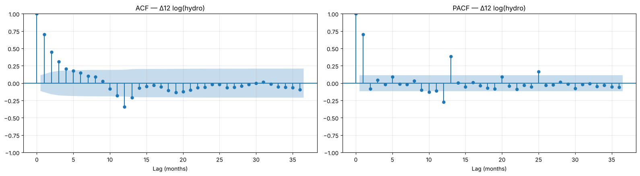
Figure 6.1: ACF and PACF of the stationary hydro series (lags 0–36)
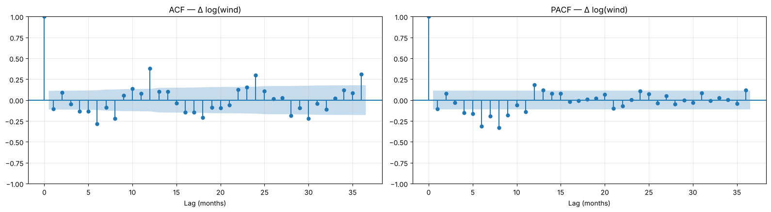
Figure 6.2: ACF and PACF of the stationary wind series (lags 0–36)
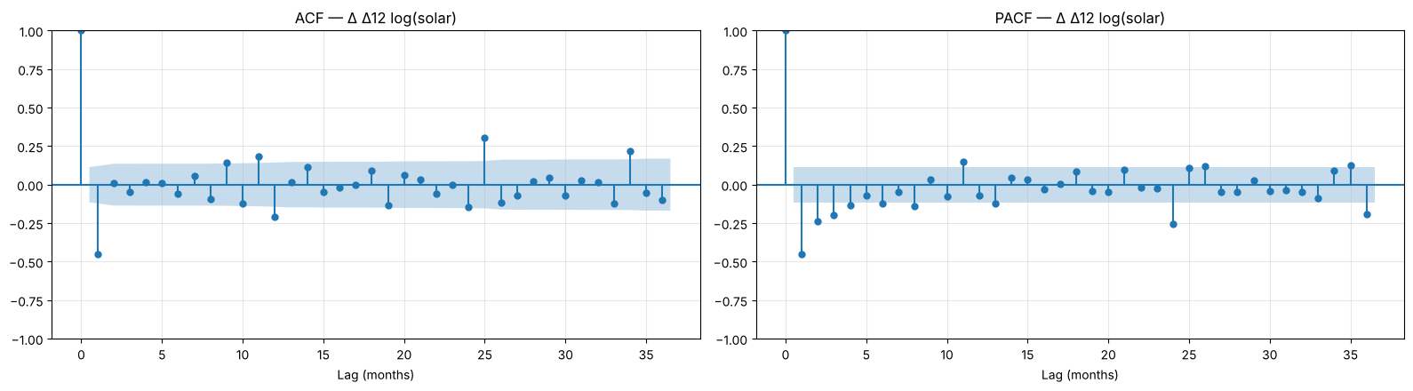
Figure 6.3: ACF and PACF of the stationary solar series (lags 0–36)
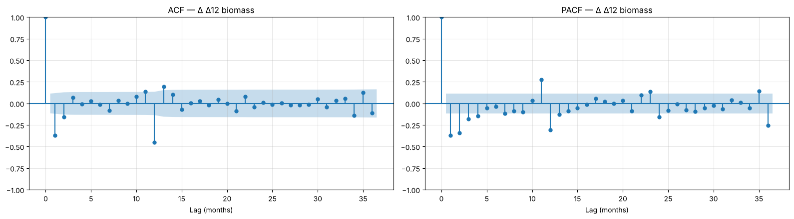
Figure 6.4: ACF and PACF of the stationary biomass series (lags 0–36)
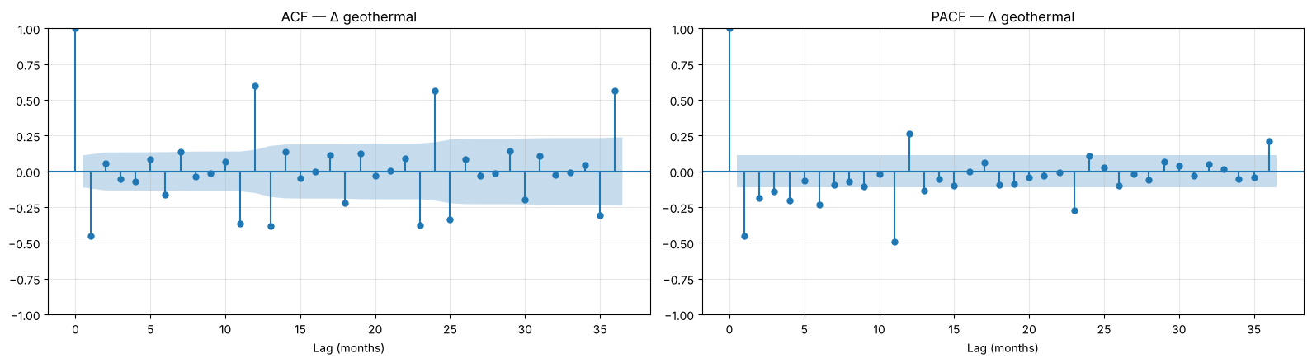
Figure 6.5: ACF and PACF of the stationary geothermal series (lags 0–36)
Table 6.1 Key ACF / PACF values of the stationary series
Resource | Series | ACF lag 1 | ACF lag 12 | PACF lag 1 | PACF lag 12 | Significant ACF lags (≤13) | Significant PACF lags (≤13) | 95% bound
Hydro | Δ12 log(hydro) | 0.701 | -0.339 | 0.701 | -0.272 | 1, 2, 3, 4, 5, 6, 11, 12, 13 | 1, 10, 12, 13 | 0.114
Wind | Δ log(wind) | -0.105 | 0.380 | -0.105 | 0.185 | 4, 5, 6, 8, 10, 12 | 4, 5, 6, 7, 8, 9, 11, 12, 13 | 0.112
Solar | Δ Δ12 log(solar) | -0.452 | -0.206 | -0.452 | -0.070 | 1, 9, 10, 11, 12 | 1, 2, 3, 4, 6, 8, 11, 13 | 0.114
Biomass | Δ Δ12 biomass | -0.371 | -0.453 | -0.371 | -0.307 | 1, 2, 11, 12, 13 | 1, 2, 3, 4, 7, 11, 12, 13 | 0.114
Geothermal | Δ geothermal | -0.452 | 0.597 | -0.452 | 0.267 | 1, 6, 7, 11, 12, 13 | 1, 2, 3, 4, 6, 11, 12, 13 | 0.112

6.2 Reading the plots and the suggested orders

ACF / PACF interpretation and suggested models
Resource | Pattern on the stationary series | Suggested model
Hydro (Δ12 log) | The ACF decays gradually from 0.70 over lags 1–6, while the PACF has a single large spike at lag 1 (0.70): an AR(1). The negative spike at lag 12 (ACF −0.34, PACF −0.27) indicates a seasonal MA(1) | SARIMA(1,0,0)(0,1,1)12
Wind (Δ log) | The lag-1 ACF is small (−0.11). A positive spike at lag 12 (ACF 0.38, PACF 0.19) shows the yearly cycle remains after first differencing, so seasonal AR and MA terms are needed | SARIMA(1,1,1)(1,0,1)12
Solar (Δ Δ12 log) | ACF and PACF are −0.45 at lag 1, which suggests an MA(1) (or AR(1)); the ACF is negative at lag 12 (−0.21), which suggests a seasonal MA(1) | SARIMA(0,1,1)(0,1,1)12
Biomass (Δ Δ12) | The ACF is significant mainly at lags 1 (−0.37) and 12 (−0.45): the "airline" pattern | SARIMA(0,1,1)(0,1,1)12
Geothermal (Δ) | ACF −0.45 at lag 1 suggests MA(1); a strong positive spike at lag 12 (ACF 0.60, PACF 0.27) suggests seasonal AR/MA terms | SARIMA(0,1,1)(1,0,1)12

These orders are checked against an AIC search in Part B.

6.3 Confirmation by AIC grid search
Orders were then searched by AIC on the training data (ARIMA: p, q ≤ 3; SARIMA: p, q ≤ 2 and P, Q ≤ 1 with s = 12; d and D fixed from Section 5). Failed or degenerate fits are rejected.
Table 6.2 Orders selected by AIC (training data)
Resource | Model | Selected order | AIC
Hydro | ARIMA | ARIMA(3,0,3) + constant | -327.7
Hydro | SARIMA | SARIMA(1,0,2)(0,1,1)12 | -463.3
Hydro | SARIMAX (Fourier exog.) | ARIMA(1,0,1) + constant | -451.5
Wind | ARIMA | ARIMA(3,1,2) + drift | -279.0
Wind | SARIMA | SARIMA(1,1,1)(1,0,1)12 + drift | -308.5
Wind | SARIMAX (Fourier exog.) | ARIMA(2,1,1) + drift | -283.7
Solar | ARIMA | ARIMA(2,1,3) + drift | 201.5
Solar | SARIMA | SARIMA(1,1,1)(1,1,1)12 | 8.0
Solar | SARIMAX (Fourier exog.) | ARIMA(3,1,2) + drift | 134.0
Biomass | ARIMA | ARIMA(3,1,3) | 3050.2
Biomass | SARIMA | SARIMA(0,1,2)(0,1,1)12 | 2738.5
Biomass | SARIMAX (Fourier exog.) | ARIMA(2,1,2) | 2937.7
Geothermal | ARIMA | ARIMA(3,1,3) + drift | 3092.5
Geothermal | SARIMA | SARIMA(1,1,1)(1,0,1)12 | 2997.6
Geothermal | SARIMAX (Fourier exog.) | ARIMA(3,1,3) + drift | 3082.8

Table 6.3 Top three SARIMA candidates by AIC for each resource
Resource | SARIMA candidate | Trend term | AIC
Hydro | SARIMA(1,0,2)(0,1,1)12 | none | -463.259
Hydro | SARIMA(2,0,1)(0,1,1)12 | none | -461.868
Hydro | SARIMA(1,0,1)(0,1,1)12 | none | -461.853
Wind | SARIMA(1,1,1)(1,0,1)12 | drift | -308.527
Wind | SARIMA(1,1,1)(1,0,1)12 | none | -308.268
Wind | SARIMA(2,1,1)(1,0,1)12 | drift | -308.074
Solar | SARIMA(1,1,1)(1,1,1)12 | none | 7.965
Solar | SARIMA(0,1,2)(1,1,1)12 | none | 8.609
Solar | SARIMA(2,1,1)(1,1,1)12 | none | 8.688
Biomass | SARIMA(0,1,2)(0,1,1)12 | none | 2738.490
Biomass | SARIMA(1,1,1)(0,1,1)12 | none | 2738.687
Biomass | SARIMA(0,1,1)(0,1,1)12 | none | 2739.239
Geothermal | SARIMA(1,1,1)(1,0,1)12 | none | 2997.647
Geothermal | SARIMA(1,1,2)(1,0,1)12 | drift | 2998.874
Geothermal | SARIMA(1,1,2)(1,0,1)12 | none | 2999.242

6.4 Order justification and estimated coefficients
The ACF/PACF readings were refined, not contradicted, by the AIC search. Hydro: the plots suggest AR(1) plus a seasonal MA(1); AIC adds two small MA terms, (1,0,2)(0,1,1)12, neither of which is significant (MA(1) p = 0.78, MA(2) p = 0.051). Wind: the plots suggest (1,1,1)(1,0,1)12 and AIC selects exactly this order with a drift. Solar: the plots suggest an MA(1) plus a seasonal MA(1); AIC selects (1,1,1)(1,1,1)12, adding significant AR and seasonal AR terms. Biomass: the airline pattern (0,1,1)(0,1,1)12 is refined to (0,1,2)(0,1,1)12 with a small but significant MA(2). Geothermal: the plots suggest (0,1,1)(1,0,1)12 and AIC adds an AR(1), giving (1,1,1)(1,0,1)12.
Table 6.4 Hydro: SARIMA(1,0,2)(0,1,1)12 coefficients (training data)
Parameter | Coefficient | Std. error | z | p-value | 95% CI lower | 95% CI upper
AR(1) φ1 | 0.8118 | 0.070 | 11.643 | 0.000 | 0.675 | 0.949
MA(1) θ1 | 0.0226 | 0.082 | 0.275 | 0.784 | -0.138 | 0.184
MA(2) θ2 | -0.1734 | 0.089 | -1.953 | 0.051 | -0.347 | 0.001
Seasonal MA(1) Θ1 | -0.8445 | 0.047 | -18.153 | 0.000 | -0.936 | -0.753
σ² (error variance) | 0.0096 | 0.001 | 13.942 | 0.000 | 0.008 | 0.011

Table 6.5 Wind: SARIMA(1,1,1)(1,0,1)12 + drift coefficients (training data)
Parameter | Coefficient | Std. error | z | p-value | 95% CI lower | 95% CI upper
Drift (trend) | 0.0115 | 0.007 | 1.650 | 0.099 | -0.002 | 0.025
AR(1) φ1 | 0.4527 | 0.072 | 6.323 | 0.000 | 0.312 | 0.593
MA(1) θ1 | -0.8988 | 0.038 | -23.829 | 0.000 | -0.973 | -0.825
Seasonal AR(1) Φ1 | 0.9616 | 0.017 | 56.023 | 0.000 | 0.928 | 0.995
Seasonal MA(1) Θ1 | -0.6981 | 0.066 | -10.578 | 0.000 | -0.827 | -0.569
σ² (error variance) | 0.0179 | 0.001 | 13.922 | 0.000 | 0.015 | 0.020

Table 6.6 Solar: SARIMA(1,1,1)(1,1,1)12 coefficients (training data)
Parameter | Coefficient | Std. error | z | p-value | 95% CI lower | 95% CI upper
AR(1) φ1 | 0.1591 | 0.069 | 2.290 | 0.022 | 0.023 | 0.295
MA(1) θ1 | -0.7782 | 0.052 | -15.102 | 0.000 | -0.879 | -0.677
Seasonal AR(1) Φ1 | 0.4842 | 0.131 | 3.707 | 0.000 | 0.228 | 0.740
Seasonal MA(1) Θ1 | -0.7109 | 0.113 | -6.282 | 0.000 | -0.933 | -0.489
σ² (error variance) | 0.0576 | 0.003 | 20.122 | 0.000 | 0.052 | 0.063

Table 6.7 Biomass: SARIMA(0,1,2)(0,1,1)12 coefficients (training data)
Parameter | Coefficient | Std. error | z | p-value | 95% CI lower | 95% CI upper
MA(1) θ1 | -0.5716 | 0.039 | -14.762 | 0.000 | -0.647 | -0.496
MA(2) θ2 | -0.1069 | 0.043 | -2.509 | 0.012 | -0.190 | -0.023
Seasonal MA(1) Θ1 | -0.8365 | 0.047 | -17.737 | 0.000 | -0.929 | -0.744
σ² (error variance) | 1365.6047 | 77.003 | 17.734 | 0.000 | 1214.682 | 1516.528

Table 6.8 Geothermal: SARIMA(1,1,1)(1,0,1)12 coefficients (training data)
Parameter | Coefficient | Std. error | z | p-value | 95% CI lower | 95% CI upper
AR(1) φ1 | 0.5265 | 0.040 | 13.209 | 0.000 | 0.448 | 0.605
MA(1) θ1 | -0.9784 | 0.014 | -70.121 | 0.000 | -1.006 | -0.951
Seasonal AR(1) Φ1 | 0.9865 | 0.008 | 123.326 | 0.000 | 0.971 | 1.002
Seasonal MA(1) Θ1 | -0.8244 | 0.037 | -22.130 | 0.000 | -0.897 | -0.751
σ² (error variance) | 2192.9477 | 111.174 | 19.725 | 0.000 | 1975.050 | 2410.845

In every resource the seasonal MA(1) coefficient is large and negative (−0.70 to −0.84), matching the negative lag-12 spikes after seasonal differencing. Wind and geothermal have seasonal AR coefficients close to 1 (0.96 and 0.99), meaning a very persistent yearly pattern; hydro's AR(1) of 0.81 reflects multi-month wet and dry spells.

7. Model Fitting, Selection, and Forecasting Evaluation

7.1 Train / test design
- The split is chronological: the model only ever sees the past. Random shuffling is not used, because it would let models learn from future months.
- Test set = the last 24 months (August 2024 – July 2026): two full seasonal cycles, so each calendar month is tested twice.
- Training set = everything before August 2024 (283 months for every resource).
- Every model forecasts all 24 test months from the end of the training data (multi-step forecasting), as it would be used in practice.
- After evaluation, the best model of each resource is re-fitted on all data and forecasts August 2026 – July 2027.

7.2 Candidate models
Table 7.1 Models compared for every resource
Family | Models
Baseline | Naive (last value), Seasonal Naive (same month last year)
Classical | ARIMA (with differencing), SARIMA, SARIMAX with Fourier (sine/cosine) seasonal terms
Exponential smoothing | SES, Holt (damped), Holt-Winters additive / multiplicative / additive damped
Machine learning | Linear Regression, Random Forest on lagged year-on-year changes (lags 1, 2, 3, 6, 12; rolling means 3/6/12; month sin/cos; quarter)
Neural network | Multi-layer perceptron (16 and 8 hidden units, L2 penalty, early stopping)

- Resources with multiplicative seasonality are modelled on the log scale by ARIMA, SARIMA, SARIMAX and the ML models and converted back with exp().
- SARIMAX regressors are Fourier terms (and a time index when the series is not differenced). They are known in advance for any future month, so there is no data leakage.
- ML and neural-network models predict the change from the same month last year and are applied recursively (each prediction is fed back as a lag). A small MLP is used instead of an LSTM/GRU because each resource has only about 150–280 training months.

7.3 Evaluation metrics
MAE = (1/n) Σ |yₜ − ŷₜ|
RMSE = √[ (1/n) Σ (yₜ − ŷₜ)² ]
MAPE = (100/n) Σ |yₜ − ŷₜ| / yₜ
- MAE and RMSE are in GWh; RMSE penalises large errors more. MAPE is scale-free, so it is used to compare resources.
- MASE (MAE ÷ in-sample seasonal-naive MAE) is also reported; models are ranked by MASE. For fast-growing series (solar), MASE is inflated by the tiny early values, so MAPE is the meaningful comparison.

7.4 Hydro: test-period results
Table 7.2 Hydro: accuracy on the 24 test months (Aug 2024 – Jul 2026), ranked by MASE
Model | MAE (GWh) | RMSE (GWh) | MAPE (%) | MASE | Family
Holt-Winters multiplicative | 1474.519 | 2142.475 | 9.930 | 0.713 | Holt-Winters
SARIMA | 1565.286 | 2204.869 | 10.619 | 0.757 | SARIMA
Seasonal Naive | 1668.619 | 2546.397 | 11.107 | 0.807 | Baseline
SARIMAX (Fourier exog) | 1679.145 | 2388.853 | 11.443 | 0.813 | SARIMAX
Linear Regression | 1882.198 | 2691.351 | 12.628 | 0.911 | ML
Holt-Winters add. damped | 2021.519 | 2709.701 | 13.933 | 0.978 | Holt-Winters
ARIMA | 2150.316 | 2588.256 | 16.874 | 1.041 | ARIMA
Random Forest | 2188.367 | 3193.467 | 14.406 | 1.059 | ML
Holt-Winters additive | 2222.346 | 3033.094 | 15.465 | 1.075 | Holt-Winters
Holt (damped) | 2302.784 | 2870.871 | 19.520 | 1.114 | Exponential smoothing
Naive | 2302.805 | 2870.759 | 19.519 | 1.114 | Baseline
SES | 2302.805 | 2870.759 | 19.519 | 1.114 | Exponential smoothing
Neural Network (MLP) | 3108.838 | 3836.047 | 22.247 | 1.504 | Neural network

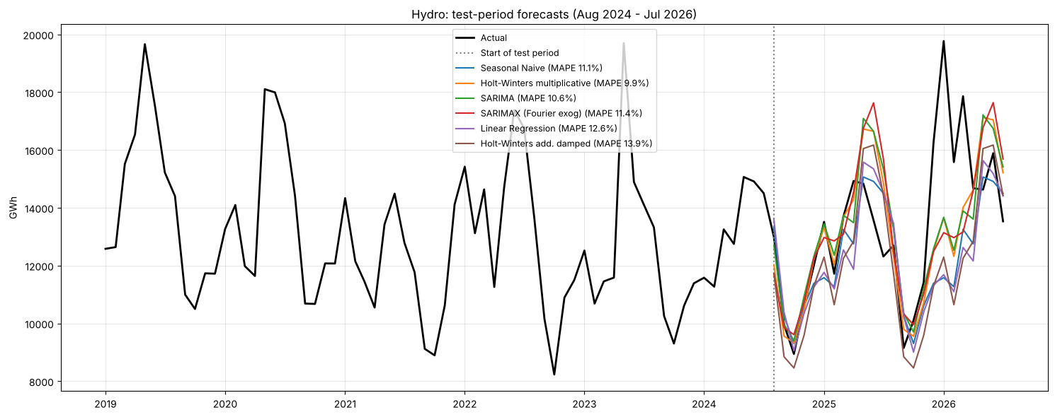
Figure 7.1: Hydro: test-period forecasts of the best models vs actual values

Hydro: model results
- Best model: Holt-Winters multiplicative. MAPE 9.9%, MASE 0.713, an 11.6% lower MAE than the seasonal naive (MAPE 11.1%).
- SARIMA(1,0,2)(0,1,1)12 on log(hydro) is a close second (MAPE 10.6%, MASE 0.757). Both models reproduce the strong snowmelt cycle.
- Trend-free models without seasonality (naive, SES, damped Holt, about 19.5%) and the neural network (22.2%) do worst. Hydro's year-to-year variation comes from snowpack, which no model can see in advance.
- Hydro's error (about 10%) is the largest of the five Western resources, which supports H4.

7.5 Wind: test-period results
Table 7.3 Wind: accuracy on the 24 test months (Aug 2024 – Jul 2026), ranked by MASE
Model | MAE (GWh) | RMSE (GWh) | MAPE (%) | MASE | Family
Holt-Winters additive | 609.526 | 792.155 | 7.800 | 1.257 | Holt-Winters
Holt-Winters add. damped | 636.251 | 855.823 | 7.887 | 1.312 | Holt-Winters
SARIMA | 711.583 | 830.237 | 9.281 | 1.467 | SARIMA
Random Forest | 852.804 | 1047.970 | 11.082 | 1.759 | ML
Holt-Winters multiplicative | 901.511 | 1115.504 | 11.049 | 1.859 | Holt-Winters
ARIMA | 1141.315 | 1269.037 | 14.900 | 2.353 | ARIMA
Seasonal Naive | 1180.613 | 1401.533 | 14.675 | 2.434 | Baseline
Linear Regression | 1186.796 | 1427.820 | 15.349 | 2.447 | ML
Holt (damped) | 1294.740 | 1590.427 | 15.445 | 2.670 | Exponential smoothing
SARIMAX (Fourier exog) | 1363.220 | 1642.509 | 17.713 | 2.811 | SARIMAX
Neural Network (MLP) | 1376.320 | 1718.212 | 17.823 | 2.838 | Neural network
SES | 1379.081 | 1682.014 | 16.422 | 2.844 | Exponential smoothing
Naive | 1470.317 | 1764.896 | 17.533 | 3.032 | Baseline

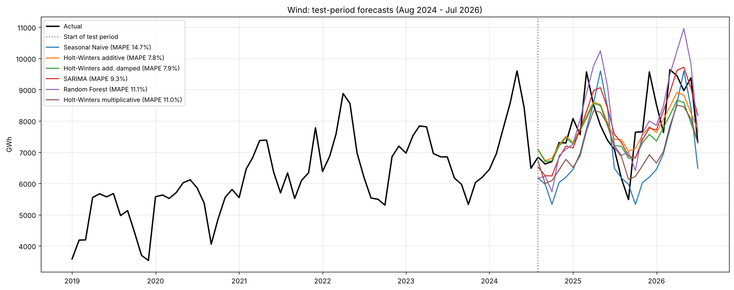
Figure 7.2: Wind: test-period forecasts of the best models vs actual values

Wind: model results
- Best model: Holt-Winters additive. MAPE 7.8%, MASE 1.26, a 48% lower MAE than the seasonal naive (14.7%). The damped variant is almost tied (7.9%).
- SARIMA(1,1,1)(1,0,1)12 with drift on log(wind) comes next (9.3%), then Random Forest (11.1%) and Holt-Winters multiplicative (11.0%).
- Naive and SES (16–18%) ignore seasonality, and the seasonal naive (14.7%) ignores growth: both components must be modelled (H2 and H3 supported).
- The neural network (17.8%) and linear regression (15.3%) do poorly: with growth slowing, past growth rates are a poor guide.

7.6 Solar: test-period results
Table 7.4 Solar: accuracy on the 24 test months (Aug 2024 – Jul 2026), ranked by MASE
Model | MAE (GWh) | RMSE (GWh) | MAPE (%) | MASE | Family
Holt-Winters add. damped | 570.908 | 685.656 | 7.106 | 1.757 | Holt-Winters
Holt-Winters additive | 572.972 | 686.701 | 6.972 | 1.763 | Holt-Winters
Holt-Winters multiplicative | 597.997 | 718.876 | 6.860 | 1.840 | Holt-Winters
SARIMA | 606.102 | 848.341 | 6.392 | 1.865 | SARIMA
ARIMA | 794.226 | 996.204 | 9.271 | 2.444 | ARIMA
Linear Regression | 1257.156 | 1634.965 | 13.855 | 3.869 | ML
Neural Network (MLP) | 1462.751 | 1823.290 | 15.165 | 4.502 | Neural network
Random Forest | 1798.554 | 2280.939 | 19.326 | 5.535 | ML
Seasonal Naive | 2191.716 | 2349.845 | 24.261 | 6.745 | Baseline
SARIMAX (Fourier exog) | 2441.980 | 3068.364 | 24.247 | 7.515 | SARIMAX
SES | 2672.009 | 3180.520 | 37.859 | 8.223 | Exponential smoothing
Naive | 2672.009 | 3180.520 | 37.859 | 8.223 | Baseline
Holt (damped) | 2808.518 | 3363.623 | 40.540 | 8.643 | Exponential smoothing

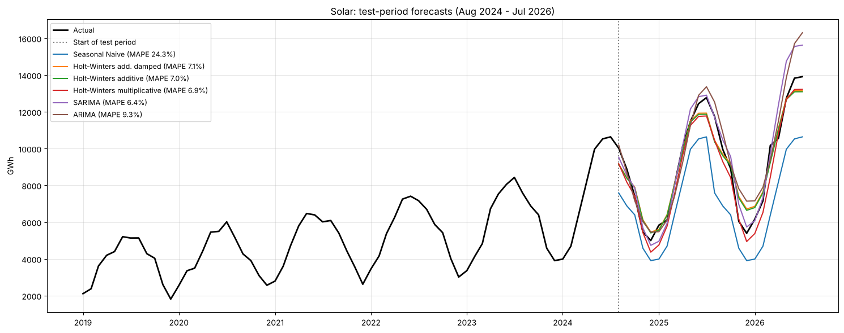
Figure 7.3: Solar: test-period forecasts of the best models vs actual values

Solar: model results
- Best model (lowest MASE): Holt-Winters additive damped. MAPE 7.1%, MASE 1.76, a 74% lower MAE than the seasonal naive (24.3%). The other Holt-Winters variants are essentially tied (6.9–7.0% MAPE).
- SARIMA(1,1,1)(1,1,1)12 on log(solar) has the lowest MAPE (6.4%) but a higher MAE (606 vs 571 GWh) and RMSE (848 vs 686 GWh): it is more accurate in the small winter months and less accurate in the large summer months.
- Trend-free models fail badly: naive and SES 37.9%, damped Holt 40.5%, seasonal naive 24.3%. This supports H3.
- The ML models (13.9–19.3%) and the neural network (15.2%) extrapolate past growth rates poorly.
- As in the South and Midwest, solar's MASE values are all above 1, because MASE is scaled by in-sample errors from years when solar was tiny; MAPE is the meaningful comparison.

7.7 Biomass: test-period results
Table 7.5 Biomass: accuracy on the 24 test months (Aug 2024 – Jul 2026), ranked by MASE
Model | MAE (GWh) | RMSE (GWh) | MAPE (%) | MASE | Family
SARIMA | 32.179 | 40.320 | 5.178 | 0.726 | SARIMA
Holt-Winters multiplicative | 32.743 | 38.598 | 5.305 | 0.738 | Holt-Winters
Holt-Winters additive | 36.235 | 43.519 | 5.841 | 0.817 | Holt-Winters
Neural Network (MLP) | 45.494 | 57.152 | 7.310 | 1.026 | Neural network
Holt-Winters add. damped | 49.966 | 60.231 | 8.111 | 1.127 | Holt-Winters
Linear Regression | 52.022 | 64.752 | 8.386 | 1.173 | ML
SES | 53.080 | 62.075 | 8.759 | 1.197 | Exponential smoothing
Holt (damped) | 53.257 | 62.314 | 8.789 | 1.201 | Exponential smoothing
SARIMAX (Fourier exog) | 53.700 | 62.816 | 8.757 | 1.211 | SARIMAX
Random Forest | 54.312 | 69.105 | 8.740 | 1.225 | ML
Seasonal Naive | 62.635 | 75.609 | 10.046 | 1.413 | Baseline
ARIMA | 68.729 | 75.693 | 11.281 | 1.550 | ARIMA
Naive | 87.946 | 96.535 | 14.464 | 1.983 | Baseline

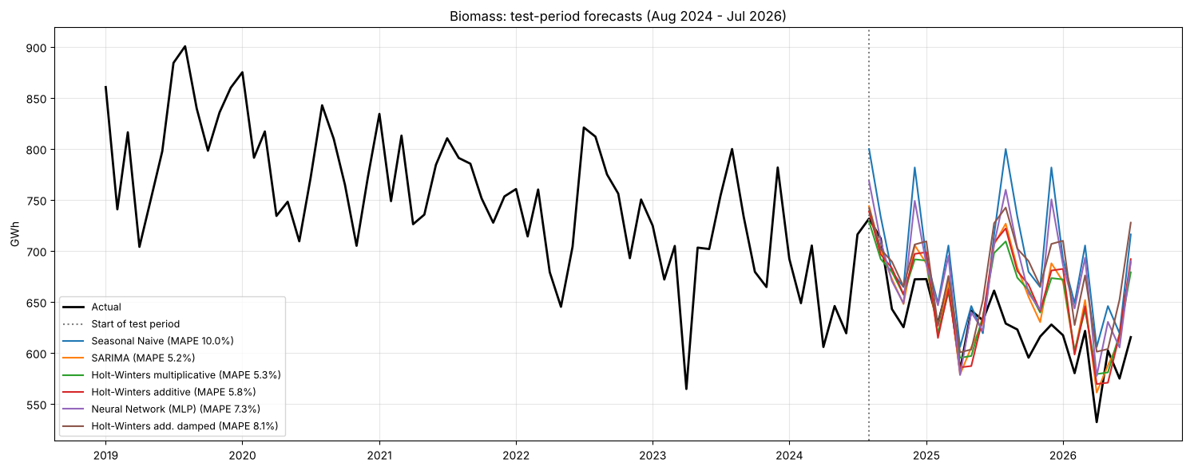
Figure 7.4: Biomass: test-period forecasts of the best models vs actual values

Biomass: model results
- Best model: SARIMA(0,1,2)(0,1,1)12. MAPE 5.2%, MASE 0.726, a 49% lower MAE than the seasonal naive (10.0%).
- Holt-Winters multiplicative is essentially tied (5.3%, and a slightly lower RMSE of 38.6 vs 40.3 GWh).
- The neural network (7.3%), ML models (8.4–8.7%) and SARIMAX (8.8%) are clearly worse. The seasonal naive (10.0%) over-forecasts because biomass keeps declining.
- H2 is supported for biomass: both seasonal models beat the baseline.

7.8 Geothermal: test-period results
Table 7.6 Geothermal: accuracy on the 24 test months (Aug 2024 – Jul 2026), ranked by MASE
Model | MAE (GWh) | RMSE (GWh) | MAPE (%) | MASE | Family
SARIMA | 44.260 | 51.895 | 3.471 | 0.905 | SARIMA
SES | 53.786 | 60.830 | 4.174 | 1.099 | Exponential smoothing
Holt (damped) | 63.823 | 71.670 | 5.004 | 1.304 | Exponential smoothing
Neural Network (MLP) | 67.739 | 82.269 | 5.266 | 1.384 | Neural network
Seasonal Naive | 68.898 | 83.826 | 5.358 | 1.408 | Baseline
Random Forest | 71.202 | 88.506 | 5.559 | 1.455 | ML
Linear Regression | 71.656 | 86.788 | 5.581 | 1.464 | ML
SARIMAX (Fourier exog) | 72.455 | 82.871 | 5.705 | 1.481 | SARIMAX
ARIMA | 75.727 | 85.969 | 5.956 | 1.548 | ARIMA
Holt-Winters multiplicative | 81.083 | 90.814 | 6.151 | 1.657 | Holt-Winters
Naive | 81.647 | 98.445 | 6.122 | 1.669 | Baseline
Holt-Winters additive | 83.316 | 92.879 | 6.326 | 1.703 | Holt-Winters
Holt-Winters add. damped | 85.366 | 94.850 | 6.484 | 1.745 | Holt-Winters

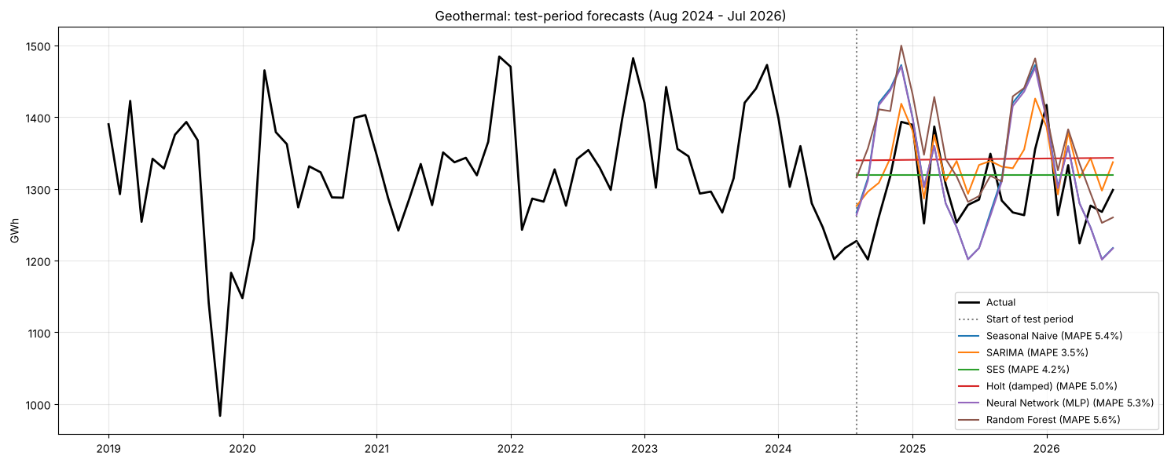
Figure 7.5: Geothermal: test-period forecasts of the best models vs actual values

Geothermal: model results
- Best model: SARIMA(1,1,1)(1,0,1)12. MAPE 3.5%, MASE 0.905, a 36% lower MAE than the seasonal naive (5.4%).
- SES comes second (4.2%): geothermal is a stable baseload source, so a smoothed level is already a good forecast.
- Holt-Winters is the weakest family here (6.2–6.5%): its seasonal component amplifies a cycle that is very weak in geothermal output.
- Geothermal is the easiest Western resource to forecast, which supports the second part of H4.

7.9 Model comparison across resources
Table 7.7 MAPE (%) of the best model in each family
Resource | ARIMA | Baseline | Exponential smoothing | Holt-Winters | ML | Neural network | SARIMA | SARIMAX | Best model
Biomass | 11.281 | 10.046 | 8.759 | 5.305 | 8.386 | 7.310 | 5.178 | 8.757 | SARIMA
Geothermal | 5.956 | 5.358 | 4.174 | 6.151 | 5.559 | 5.266 | 3.471 | 5.705 | SARIMA
Hydro | 16.874 | 11.107 | 19.520 | 9.930 | 12.628 | 22.247 | 10.619 | 11.443 | Holt-Winters multiplicative
Solar | 9.271 | 24.261 | 37.859 | 7.106 | 13.855 | 15.165 | 6.392 | 24.247 | Holt-Winters add. damped
Wind | 14.900 | 14.675 | 15.445 | 7.800 | 11.082 | 17.823 | 9.281 | 17.713 | Holt-Winters additive

Table 7.8 MASE of the best model in each family
Resource | ARIMA | Baseline | Exponential smoothing | Holt-Winters | ML | Neural network | SARIMA | SARIMAX
Biomass | 1.550 | 1.413 | 1.197 | 0.738 | 1.173 | 1.026 | 0.726 | 1.211
Geothermal | 1.548 | 1.408 | 1.099 | 1.657 | 1.455 | 1.384 | 0.905 | 1.481
Hydro | 1.041 | 0.807 | 1.114 | 0.713 | 0.911 | 1.504 | 0.757 | 0.813
Solar | 2.444 | 6.745 | 8.223 | 1.757 | 3.869 | 4.502 | 1.865 | 7.515
Wind | 2.353 | 2.434 | 2.670 | 1.257 | 1.759 | 2.838 | 1.467 | 2.811

Table 7.9 Best model for each resource
Resource | Best model | Best MAPE (%) | Best MASE | Seasonal Naive MAPE (%) | MAE improvement vs Seasonal Naive (%)
Hydro | Holt-Winters multiplicative | 9.930 | 0.713 | 11.107 | 11.632
Wind | Holt-Winters additive | 7.800 | 1.257 | 14.675 | 48.372
Solar | Holt-Winters add. damped | 7.106 | 1.757 | 24.261 | 73.952
Biomass | SARIMA | 5.178 | 0.726 | 10.046 | 48.624
Geothermal | SARIMA | 3.471 | 0.905 | 5.358 | 35.761

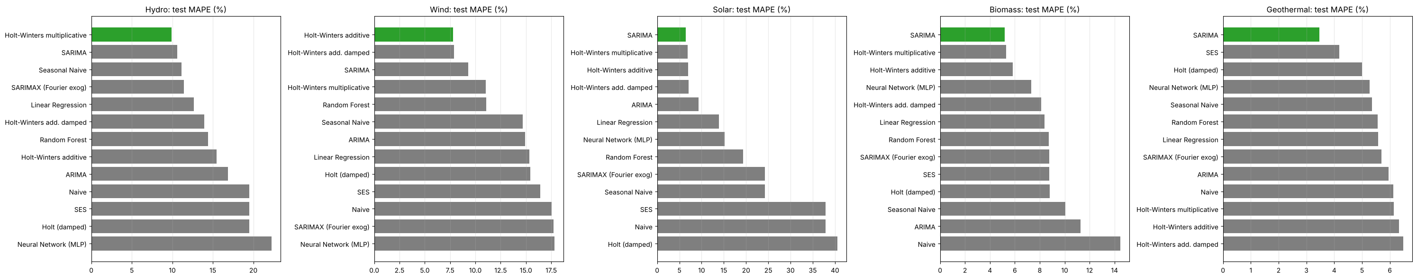
Figure 7.6: Test MAPE of every model, by resource (best model in green)

Model comparison across resources
Resource | Best model | MAPE | Seasonal naive MAPE | Improvement in MAE
Geothermal | SARIMA(1,1,1)(1,0,1)12 | 3.5% | 5.4% | 36%
Biomass | SARIMA(0,1,2)(0,1,1)12 | 5.2% | 10.0% | 49%
Solar | Holt-Winters additive damped | 7.1% | 24.3% | 74%
Wind | Holt-Winters additive | 7.8% | 14.7% | 48%
Hydro | Holt-Winters multiplicative | 9.9% | 11.1% | 12%

- Only two families win in the West: SARIMA and Holt-Winters. Unlike the South (Random Forest for solar) and the Northeast (boosted trees), the ML models and the neural network never win.
- Difficulty ranking: geothermal (easiest) → biomass → solar → wind → hydro (hardest). This supports H4.
- H2 (seasonal models beat the baseline) is supported for all five resources: every best model is a seasonal model and beats the seasonal naive, by 12–74% in MAE.
- H3 (growing resources need growth-aware models) is supported: trend-free models score 38–41% for solar and 16–18% for wind.

7.10 Forecast for August 2026 – July 2027
The best model of each resource is re-fitted on all data up to July 2026 and forecasts the next 12 months. The band is an approximate 90% range taken from that model's test-period percentage errors.
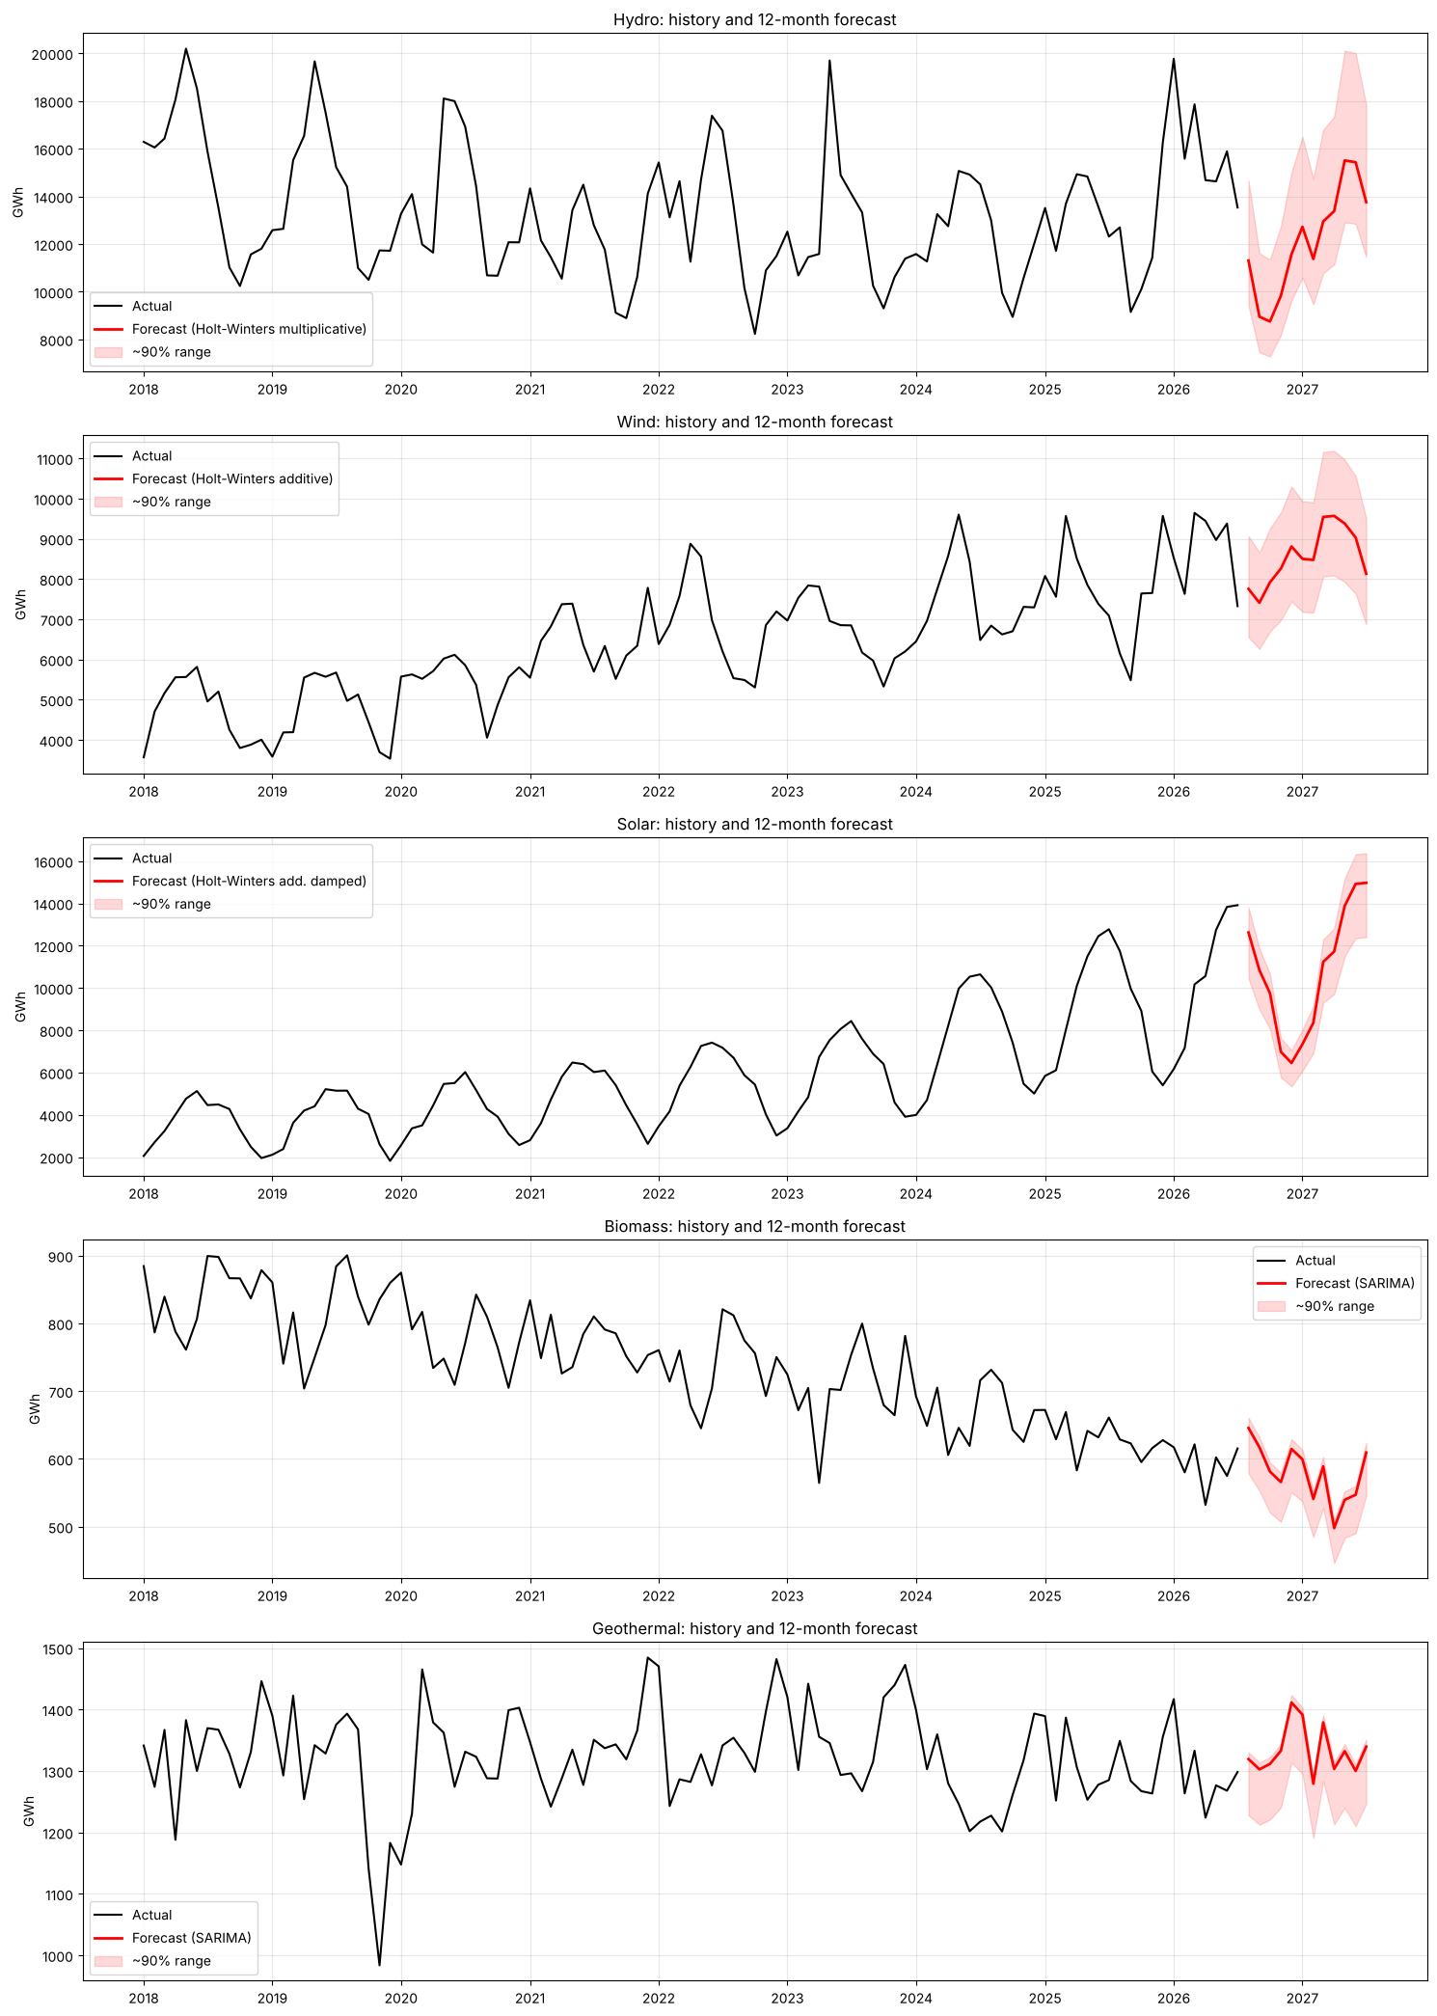
Figure 7.7: History and 12-month forecast of each resource
Table 7.11 Twelve-month outlook
Resource | Best model | Last 12 months (GWh) | Next 12 months (GWh) | Change (%) | Peak month | Lowest month | Share of next 12 months (%)
Hydro | Holt-Winters multiplicative | 171592.166 | 145548.194 | -15.178 | May 2027 | Oct 2026 | 36.359
Wind | Holt-Winters additive | 97397.414 | 102769.293 | 5.515 | Apr 2027 | Sep 2026 | 25.673
Solar | Holt-Winters add. damped | 116602.120 | 129041.935 | 10.669 | Jul 2027 | Dec 2026 | 32.236
Biomass | SARIMA | 7233.331 | 6947.012 | -3.958 | Aug 2026 | Apr 2027 | 1.735
Geothermal | SARIMA | 15597.879 | 16001.967 | 2.591 | Dec 2026 | Feb 2027 | 3.997

Table 7.12 Monthly forecasts (GWh)
Month | hydro | wind | solar | biomass | geothermal
2026-08 | 11308.800 | 7753.500 | 12621.800 | 645.600 | 1319.300
2026-09 | 8955.200 | 7408.500 | 10840.300 | 617.100 | 1302.600
2026-10 | 8751.100 | 7918.900 | 9745.700 | 581.100 | 1311.300
2026-11 | 9839.000 | 8259.300 | 6974.000 | 565.700 | 1332.900
2026-12 | 11570.500 | 8808.200 | 6448.600 | 614.600 | 1411.300
2027-01 | 12724.900 | 8500.800 | 7336.500 | 599.400 | 1391.600
2027-02 | 11373.100 | 8473.200 | 8353.400 | 540.800 | 1279.200
2027-03 | 12948.100 | 9542.000 | 11232.100 | 588.900 | 1379.000
2027-04 | 13380.700 | 9567.500 | 11720.100 | 497.800 | 1303.200
2027-05 | 15507.300 | 9378.400 | 13879.300 | 539.600 | 1332.100
2027-06 | 15432.400 | 9030.400 | 14919.600 | 547.000 | 1300.000
2027-07 | 13757.100 | 8128.600 | 14970.500 | 609.400 | 1339.500

Forecast for Aug 2026 – Jul 2027
Resource | Best model | Last 12 months | Forecast next 12 months | Change | Peak | Low
Hydro | HW multiplicative | 171,592 GWh | 145,548 GWh | −15.2% | May 2027 | Oct 2026
Solar | HW additive damped | 116,602 GWh | 129,042 GWh | +10.7% | Jul 2027 | Dec 2026
Wind | HW additive | 97,397 GWh | 102,769 GWh | +5.5% | Apr 2027 | Sep 2026
Geothermal | SARIMA | 15,598 GWh | 16,002 GWh | +2.6% | Dec 2026 | Feb 2027
Biomass | SARIMA | 7,233 GWh | 6,947 GWh | −4.0% | Aug 2026 | Apr 2027
Total | sum | 408,423 GWh | 400,308 GWh | −2.0%

- Hydro is expected to fall back from an unusually wet year (171.6 TWh in the last 12 months, against 154.2 TWh in calendar 2025). This is a return to normal snowpack, not a loss of capacity, and it depends entirely on next winter's weather.
- Solar keeps growing (+10.7%) and would supply about 32% of the West's renewable output, close to hydro (36%) and ahead of wind (26%).
- Wind grows moderately (+5.5%), geothermal stays stable (+2.6%) and biomass continues its slow decline (−4.0%).
- Seasonally, hydro peaks in May, wind in April and solar in July; October–December is the weakest period for the region as a whole.

8. Residual Diagnostics and Interpretation

8.1 Method
- Best test model: one-step-ahead errors over the 60 months before the test period, re-estimating the model every month.
- SARIMA (for comparison): in-sample residuals of the AIC-selected SARIMA fitted on the training data (on the model scale: log for multiplicative resources).
- Tests: t-test for mean = 0; Ljung-Box at lags 6 and 12 (H0: no autocorrelation); Shapiro-Wilk (H0: normal). A good model has mean ≈ 0, Ljung-Box p > 0.05 and roughly normal residuals.

8.2 Hydro
Best hydro model on the test period: Holt-Winters multiplicative.
Table 8.1a Hydro: residual tests of the best test model
# | resource | model | n | mean | mean t-test p | std | Ljung-Box p (lag 6) | Ljung-Box p (lag 12) | Shapiro-Wilk p
0 | hydro | Holt-Winters multiplicative | 60 | 15.581 | 0.948 | 1833.166 | 0.018 | 0.021 | 0.003

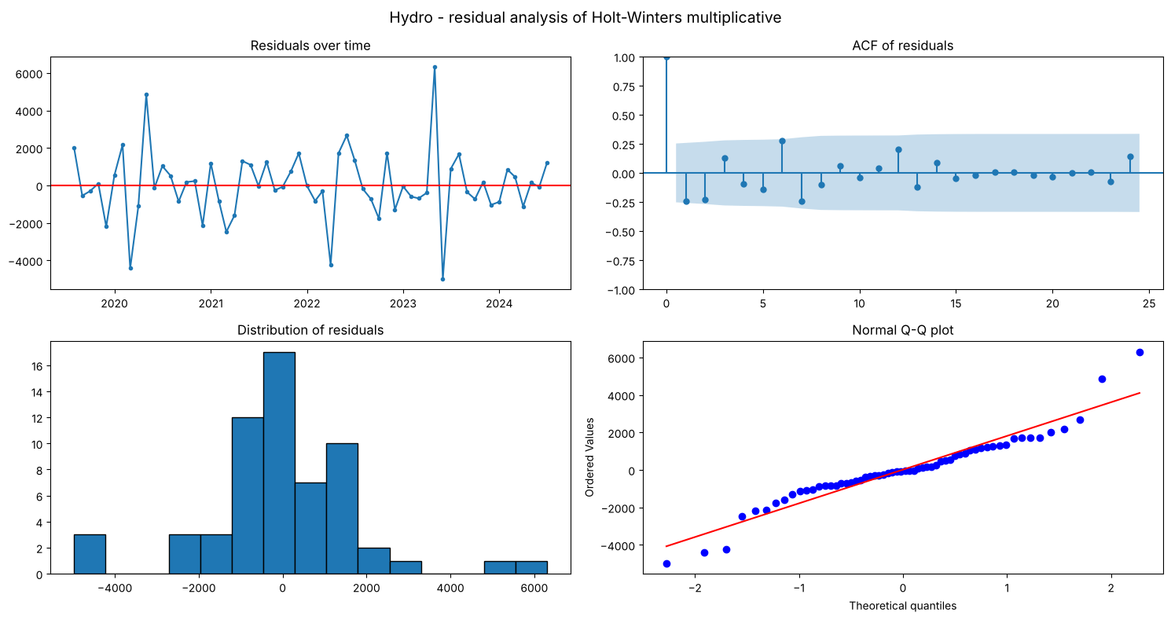
Figure 8.1: Hydro: residual analysis of the best test model (time plot, ACF, histogram, Q-Q plot)
Table 8.1b Hydro: residual tests of SARIMA (in-sample)
# | resource | model | n | mean | mean t-test p | std | Ljung-Box p (lag 6) | Ljung-Box p (lag 12) | Shapiro-Wilk p
0 | hydro | SARIMA (in-sample) | 270 | 0.002 | 0.712 | 0.101 | 0.883 | 0.644 | 0.005

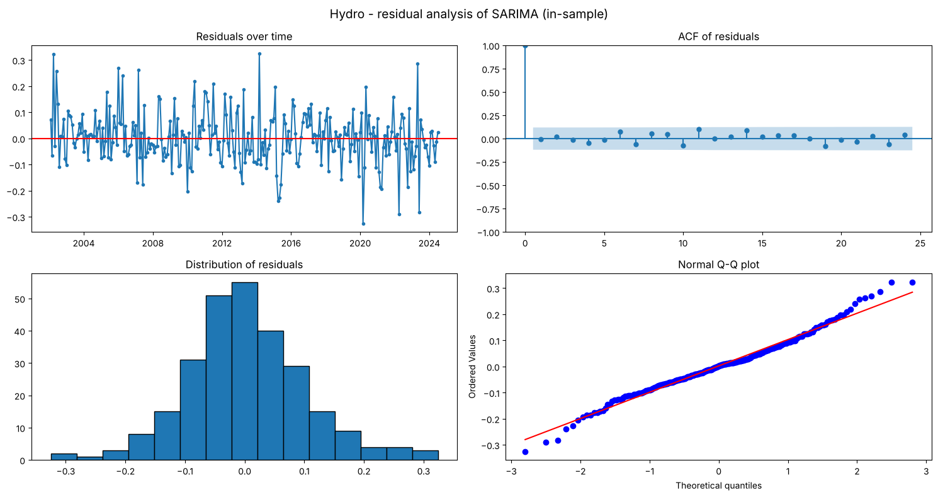
Figure 8.2: Hydro: residual analysis of SARIMA (in-sample)

Hydro: residual interpretation
- Holt-Winters multiplicative (best on test): the mean one-step error (+16 GWh) is not significantly different from 0 (p = 0.95), so the model is unbiased. However, Ljung-Box is significant (p = 0.018 at lag 6, 0.021 at lag 12) and the errors are not normal (Shapiro p = 0.003): some structure from wet and dry spells is left over.
- SARIMA(1,0,2)(0,1,1)12: residual mean ≈ 0 (p = 0.71) and no autocorrelation (Ljung-Box p = 0.88 at lag 6 and 0.64 at lag 12). These are white-noise residuals, slightly non-normal (Shapiro p = 0.005) because of extreme wet months. The AR(1) coefficient (0.81) and seasonal MA coefficient (−0.84) are highly significant.
Holt-Winters is slightly more accurate, but only SARIMA leaves white-noise residuals, so SARIMA is the statistically more reliable hydro model.

8.3 Wind
Best wind model on the test period: Holt-Winters additive.
Table 8.2a Wind: residual tests of the best test model
# | resource | model | n | mean | mean t-test p | std | Ljung-Box p (lag 6) | Ljung-Box p (lag 12) | Shapiro-Wilk p
0 | wind | Holt-Winters additive | 60 | 66.953 | 0.495 | 755.360 | 0.016 | 0.068 | 0.874

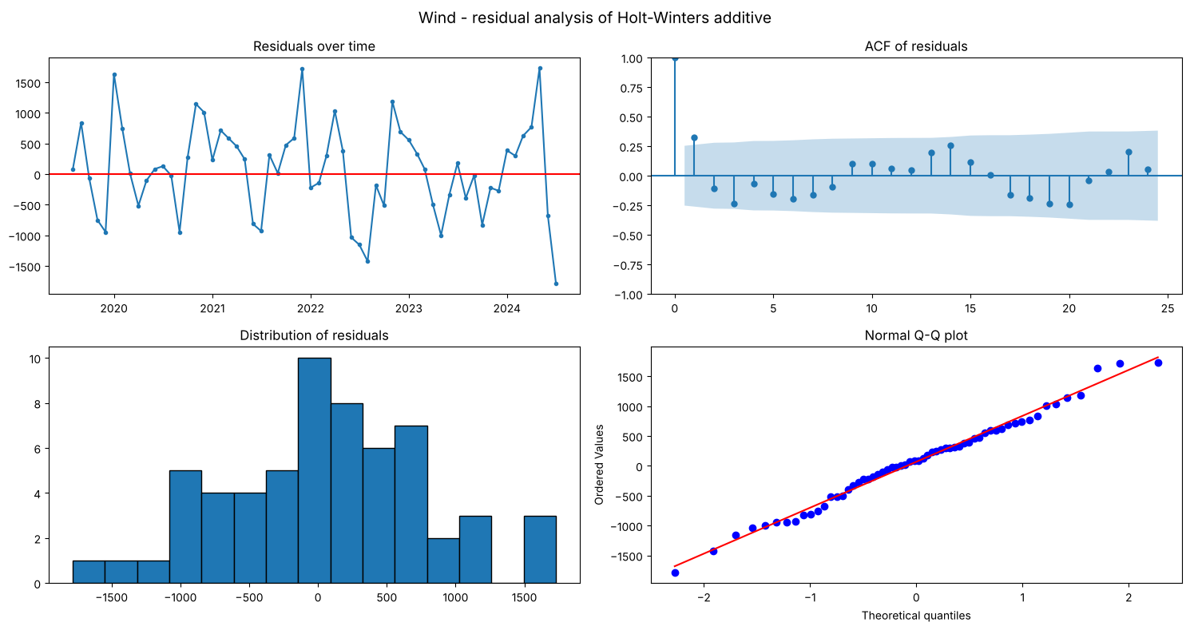
Figure 8.3: Wind: residual analysis of the best test model (time plot, ACF, histogram, Q-Q plot)
Table 8.2b Wind: residual tests of SARIMA (in-sample)
# | resource | model | n | mean | mean t-test p | std | Ljung-Box p (lag 6) | Ljung-Box p (lag 12) | Shapiro-Wilk p
0 | wind | SARIMA (in-sample) | 270 | -0.008 | 0.322 | 0.131 | 0.246 | 0.127 | 0.006

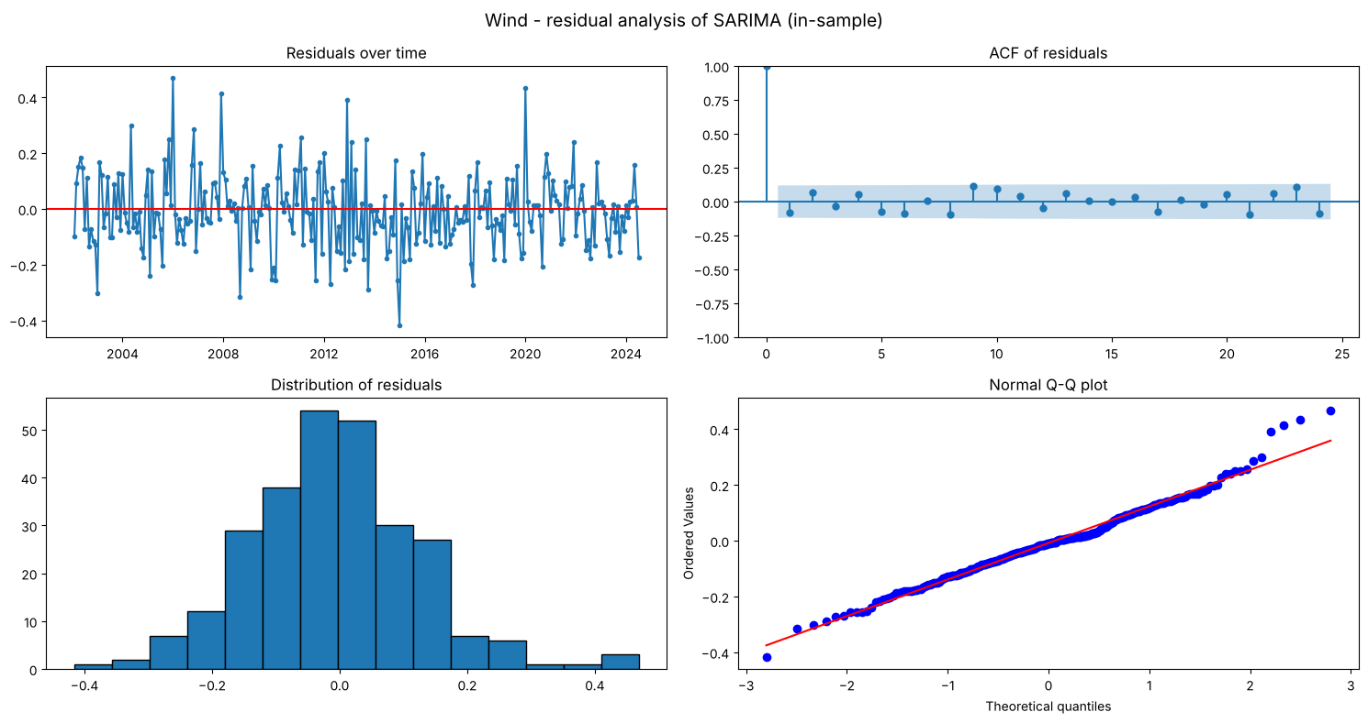
Figure 8.4: Wind: residual analysis of SARIMA (in-sample)

Wind: residual interpretation
- Holt-Winters additive (best on test): the mean one-step error (+67 GWh) is not significantly different from 0 (p = 0.50) and the errors are normal (Shapiro p = 0.87). There is some autocorrelation at lag 6 (Ljung-Box p = 0.016), but not at lag 12 (p = 0.068).
- SARIMA(1,1,1)(1,0,1)12 with drift (log scale): in-sample residuals are white noise (mean ≈ 0, p = 0.32; Ljung-Box p = 0.25 and 0.13), slightly non-normal (Shapiro p = 0.006). The seasonal AR coefficient is 0.96, so the yearly pattern is very persistent.
Holt-Winters is clearly more accurate; SARIMA describes the series' time structure most cleanly.

8.4 Solar
Best solar model on the test period: Holt-Winters add. damped.
Table 8.3a Solar: residual tests of the best test model
# | resource | model | n | mean | mean t-test p | std | Ljung-Box p (lag 6) | Ljung-Box p (lag 12) | Shapiro-Wilk p
0 | solar | Holt-Winters add. damped | 60 | 152.668 | 0.027 | 521.208 | 0.002 | 0.001 | 0.912

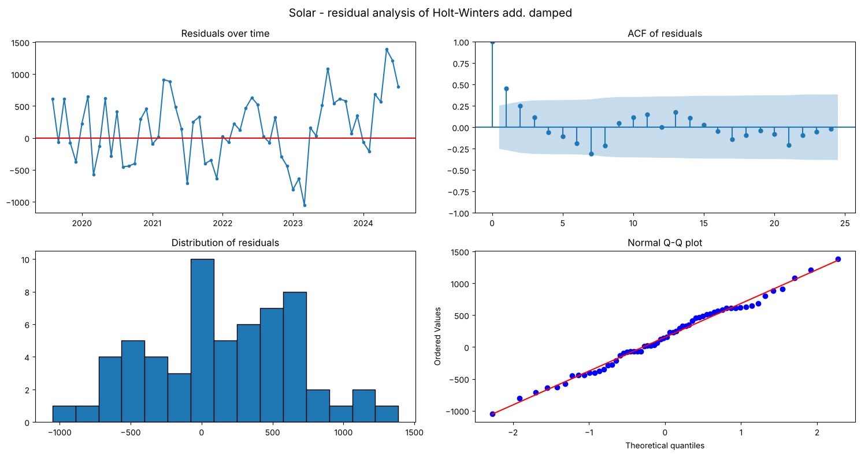
Figure 8.5: Solar: residual analysis of the best test model (time plot, ACF, histogram, Q-Q plot)
Table 8.3b Solar: residual tests of SARIMA (in-sample)
# | resource | model | n | mean | mean t-test p | std | Ljung-Box p (lag 6) | Ljung-Box p (lag 12) | Shapiro-Wilk p
0 | solar | SARIMA (in-sample) | 270 | -0.004 | 0.761 | 0.242 | 0.814 | 0.507 | 0.000

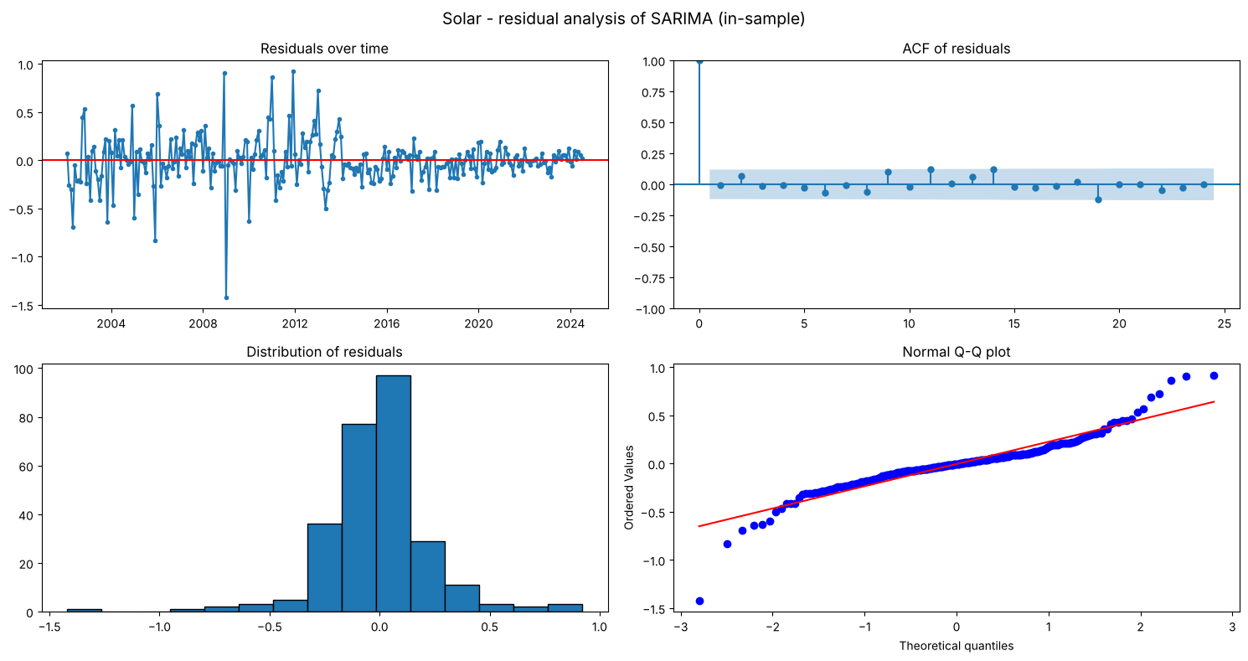
Figure 8.6: Solar: residual analysis of SARIMA (in-sample)

Solar: residual interpretation
- Holt-Winters additive damped (best on test): the mean one-step error is +153 GWh and significant (p = 0.027): the model tends to under-forecast month by month, because solar keeps growing faster than a damped trend expects. The errors are autocorrelated (Ljung-Box p = 0.002 and 0.001) but normal (Shapiro p = 0.91).
- SARIMA(1,1,1)(1,1,1)12 (log scale): residual mean ≈ 0 (p = 0.76) and no autocorrelation (Ljung-Box p = 0.81 and 0.51). These are white-noise residuals, non-normal (Shapiro p < 0.001) because of a few unusual months.
Conclusion for solar: Holt-Winters gives the smallest errors in GWh; SARIMA gives the lowest percentage error and the statistically cleanest residuals.

8.5 Biomass
Best biomass model on the test period: SARIMA.
Table 8.4a Biomass: residual tests of the best test model
# | resource | model | n | mean | mean t-test p | std | Ljung-Box p (lag 6) | Ljung-Box p (lag 12) | Shapiro-Wilk p
0 | biomass | SARIMA | 60 | -5.479 | 0.225 | 34.600 | 0.375 | 0.473 | 0.494

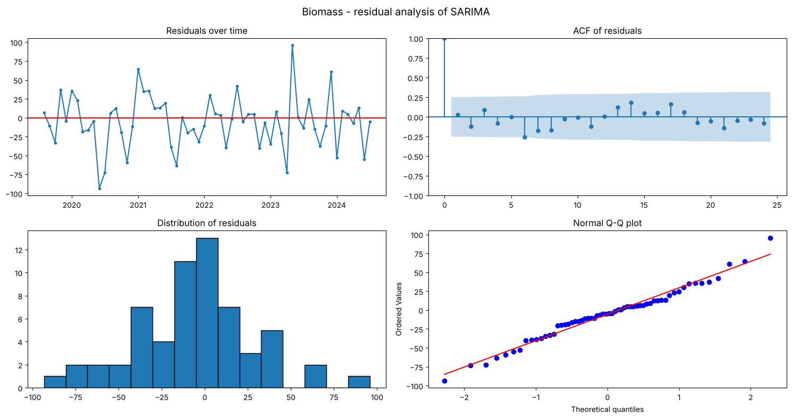
Figure 8.7: Biomass: residual analysis of the best test model (time plot, ACF, histogram, Q-Q plot)
Table 8.4b Biomass: residual tests of SARIMA (in-sample)
# | resource | model | n | mean | mean t-test p | std | Ljung-Box p (lag 6) | Ljung-Box p (lag 12) | Shapiro-Wilk p
0 | biomass | SARIMA (in-sample) | 270 | -3.283 | 0.154 | 37.755 | 0.699 | 0.743 | 0.000

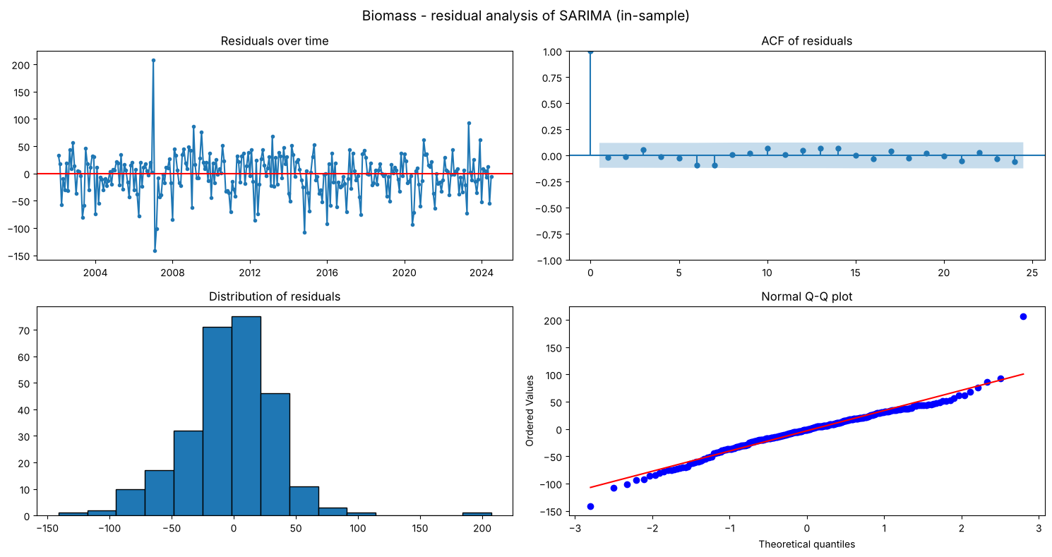
Figure 8.8: Biomass: residual analysis of SARIMA (in-sample)

Biomass: residual interpretation
The SARIMA residuals are white noise for the one-step forecast errors: mean ≈ 0 (p = 0.23), no autocorrelation (Ljung-Box p = 0.38 and 0.47) and normal (Shapiro p = 0.49). In-sample they are also uncorrelated (Ljung-Box p = 0.70 and 0.74) with mean ≈ 0 (p = 0.15), although not normal (Shapiro p < 0.001) because of a few outlying months (for example early 2007). All three MA coefficients (MA(1) = −0.57, MA(2) = −0.11, seasonal MA(1) = −0.84) are significant. The model has captured the trend, seasonal and short-term dependence of biomass.

8.6 Geothermal
Best geothermal model on the test period: SARIMA.
Table 8.5a Geothermal: residual tests of the best test model
# | resource | model | n | mean | mean t-test p | std | Ljung-Box p (lag 6) | Ljung-Box p (lag 12) | Shapiro-Wilk p
0 | geothermal | SARIMA | 59 | -7.487 | 0.445 | 74.748 | 0.054 | 0.275 | 0.001

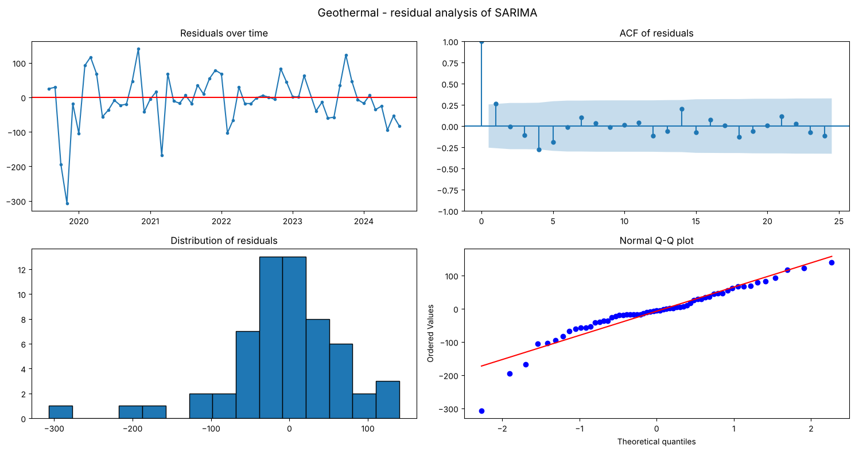
Figure 8.9: Geothermal: residual analysis of the best test model (time plot, ACF, histogram, Q-Q plot)
Table 8.5b Geothermal: residual tests of SARIMA (in-sample)
# | resource | model | n | mean | mean t-test p | std | Ljung-Box p (lag 6) | Ljung-Box p (lag 12) | Shapiro-Wilk p
0 | geothermal | SARIMA (in-sample) | 270 | 0.900 | 0.756 | 47.526 | 0.096 | 0.483 | 0.000

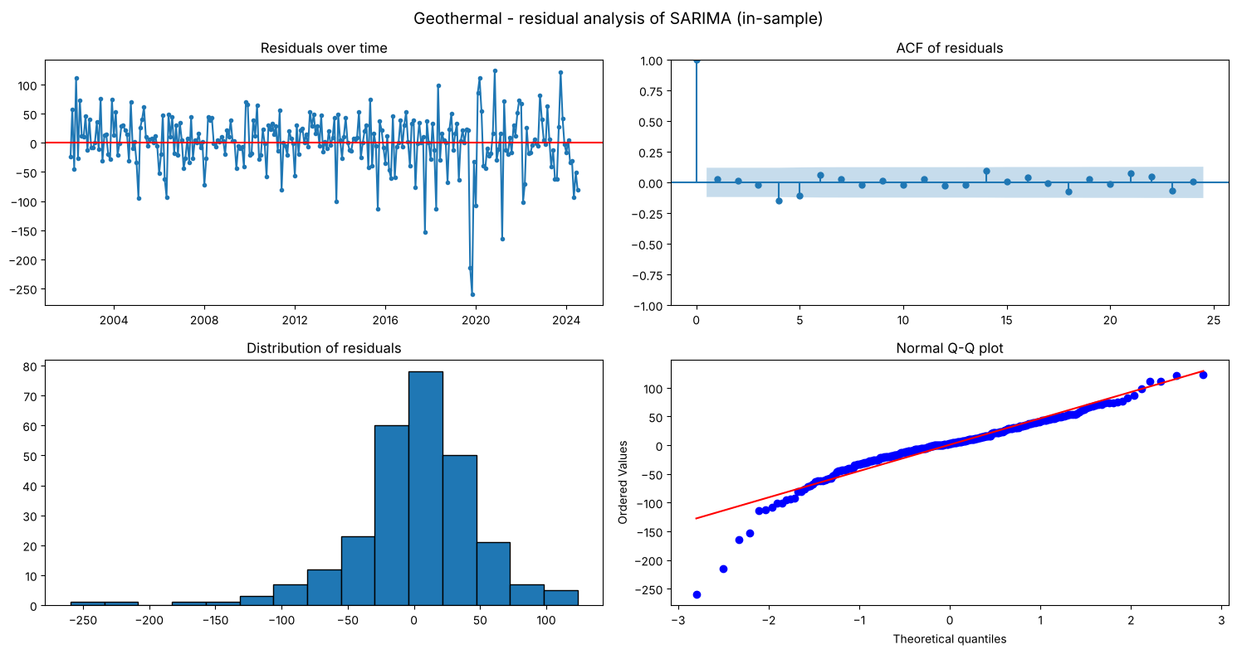
Figure 8.10: Geothermal: residual analysis of SARIMA (in-sample)

Geothermal: residual interpretation
- SARIMA one-step errors (59 of 60 re-fits; one window failed numerically and was skipped): mean ≈ 0 (−7.5 GWh, p = 0.45) and no significant autocorrelation (Ljung-Box p = 0.054 at lag 6, 0.275 at lag 12). The errors are not normal (Shapiro p = 0.001), because of a few unusual months.
- In-sample SARIMA residuals: mean ≈ 0 (p = 0.76), no autocorrelation (Ljung-Box p = 0.10 and 0.48), non-normal (Shapiro p < 0.001). The sharp drop in late 2019 is the main outlier.
Geothermal's SARIMA is both the most accurate model and statistically well specified.

8.7 Summary
Table 8.6 Residual analysis summary
Resource – model | n | mean | mean t-test p | std | Ljung-Box p (lag 6) | Ljung-Box p (lag 12) | Shapiro-Wilk p
hydro – Holt-Winters multiplicative | 60 | 15.581 | 0.948 | 1833.166 | 0.018 | 0.021 | 0.003
hydro – SARIMA (in-sample) | 270 | 0.002 | 0.712 | 0.101 | 0.883 | 0.644 | 0.005
wind – Holt-Winters additive | 60 | 66.953 | 0.495 | 755.360 | 0.016 | 0.068 | 0.874
wind – SARIMA (in-sample) | 270 | -0.008 | 0.322 | 0.131 | 0.246 | 0.127 | 0.006
solar – Holt-Winters add. damped | 60 | 152.668 | 0.027 | 521.208 | 0.002 | 0.001 | 0.912
solar – SARIMA (in-sample) | 270 | -0.004 | 0.761 | 0.242 | 0.814 | 0.507 | 0.000
biomass – SARIMA | 60 | -5.479 | 0.225 | 34.600 | 0.375 | 0.473 | 0.494
biomass – SARIMA (in-sample) | 270 | -3.283 | 0.154 | 37.755 | 0.699 | 0.743 | 0.000
geothermal – SARIMA | 59 | -7.487 | 0.445 | 74.748 | 0.054 | 0.275 | 0.001
geothermal – SARIMA (in-sample) | 270 | 0.900 | 0.756 | 47.526 | 0.096 | 0.483 | 0.000

Residual analysis summary
- SARIMA leaves white-noise residuals for all five resources (Ljung-Box p > 0.05 at lags 6 and 12, mean ≈ 0), so it captures the time structure of every series.
- For biomass and geothermal, the best test model *is* SARIMA, so the most accurate model is also statistically well specified.
- The best test models for hydro (Holt-Winters multiplicative) and solar (Holt-Winters damped) leave some autocorrelation, and the solar model has a significant under-forecasting bias. Wind's Holt-Winters is unbiased with only mild autocorrelation at lag 6.
- Normality is rejected for several SARIMA residuals because of a few extreme months (wet hydro years, geothermal outages). This affects prediction intervals, not point forecasts.

Conclusion

22. Research Conclusion

Answer to the research question
Hydro, wind, solar, biomass and geothermal behave very differently over time in the Western U.S. region:
- Trend:
- hydro has no upward trend and is driven by wet and dry years;
- wind has strong growth that is now slowing (about 14%/yr long-run, about 4% in 2025);
- solar has accelerating growth (about 25%/yr; it overtook wind in 2024);
- biomass rose until 2014 and has declined since;
- geothermal grows slowly and steadily (about 0.5%/yr).
- Seasonality: every resource has a 12-month cycle, but of very different strength:
- solar (June +54%, December −58%) and hydro (May +29%, October −27%) are strongest;
- wind peaks in May (+22%);
- biomass (±10%) and geothermal (±5%) are nearly flat. Unlike the South, hydro, wind and solar all peak in late spring and early summer.
- Temporal dependence: each has its own SARIMA structure, identified from the ACF/PACF and refined by AIC:
Resource | Structure (AIC)
Hydro | (1,0,2)(0,1,1)12 on log
Wind | (1,1,1)(1,0,1)12 with drift on log
Solar | (1,1,1)(1,1,1)12 on log
Biomass | (0,1,2)(0,1,1)12
Geothermal | (1,1,1)(1,0,1)12

- Forecasting:
Resource | Best model | MAPE
Geothermal | SARIMA | 3.5%
Biomass | SARIMA | 5.2%
Solar | Holt-Winters additive damped | 7.1%
Wind | Holt-Winters additive | 7.8%
Hydro | Holt-Winters multiplicative | 9.9% (hardest)

Every best model beats the seasonal-naive baseline, by 12–74% in MAE.
- Outlook (Aug 2026 – Jul 2027): total renewable output about 400,300 GWh (−2.0%): hydro falls back about 15% from a wet year, solar grows about 11% and wind about 6%.

Limitations
- The test set is a single 24-month window.
- No weather data (snowpack, precipitation, wind speed, irradiance) or capacity data are included; hydro forecasts in particular depend on next winter's snowpack.
- Rooftop solar is not in the EIA figures.

Future work
- Add snowpack and capacity variables to SARIMAX.
- Use rolling-origin evaluation over several test windows.

