**Concept Proposal Submitted to the Potato Research Consortium**

**Title:** Comparison of potato yields, soil health, and pathogen loads in virgin and non-virgin soils.

**Year Initiated: 2021-22. Current Year: 2021-22. Terminating Year: 2022.**

**Personnel & Cooperators:**

PIs involved include David Linnard Wheeler, Deirdre Griffin LaHue, and Cynthia Gleason from Washington State University and Kenneth Frost from Oregon State University. Sudha G.C. Upadhaya serves as a research associate in the first PI’s lab. Teal Potter serves as a postdoctoral scholar in the second PI’s lab. All PIs will request funding.

**Funding Request for 2021-22: $72,329**

**Introduction: Problem Statement, Research Question(s) & Justification:**

Since potatoes were first grown on a commercial scale, growers have noticed that the history of a field influences both yield and quality. Fields previously planted with potatoes generally yield less than potatoes on soils not previously farmed (virgin soils) or fields never planted with potatoes. Recent conversations with growers indicated 14-26% greater yields from virgin soils compared to nearby non-virgin soils. Researchers have observed the same effect at least since the 1990s (Powelson and Rowe 1993). The purpose of this proposal is to determine what is responsible for these observations.

To identify factors associated with the greater yields observed when potatoes are grown in virgin soil, we propose to conduct a common garden experiment with virgin and non-virgin soils collected from the Northwest. To capture the physical, chemical, and biological factors often associated with changes in land-management practices (Chen et al. 2020; Gómez-Acata et al. 2014; Zhang et al. 2018), we have assembled a team of soil scientists and plant pathologists.

**Goal(s), Hypothesis, & Objectives**:

The objective of this research is to test the null hypotheses (i) there is no difference in potato yield, pathogen inoculum, and disease expression between virgin soils and non-virgin soils and (ii) there are no differences in soil properties between virgin soils and non-virgin soils that are associated with differences in potato performance.

To test these hypotheses, we will first collect soil samples and cropping history records from a total of 15 paired fields (n=30) with virgin and non-virgin soil in Washington, Oregon, and Idaho (**Figure 1.A**).Each soil will then be characterized for physical, chemical and biological properties following the Comprehensive Assessment of Soil Health (CASH; Moebius-Clune et al., 2017), as well as free living and plant-parasitic nematodes, soilborne potato pathogen presence and abundance, and bacterial and fungal community structure (using 16S rRNA and ITS amplicon sequencing, respectively) (**Figure 1.B**). Russet Burbank potatoes will be planted in common garden microplots containing the sampled soil. Disease expression will be assessed throughout the growing season. Yields will be quantified for each treatment (**Figure 1.C**). Associations between virgin and non-virgin soils and soil properties will be visualized (**Figure 1.D**) and differences between soil properties, potato yields, and disease expression will be investigated with standard statistical procedures (**Figure 1.D**).

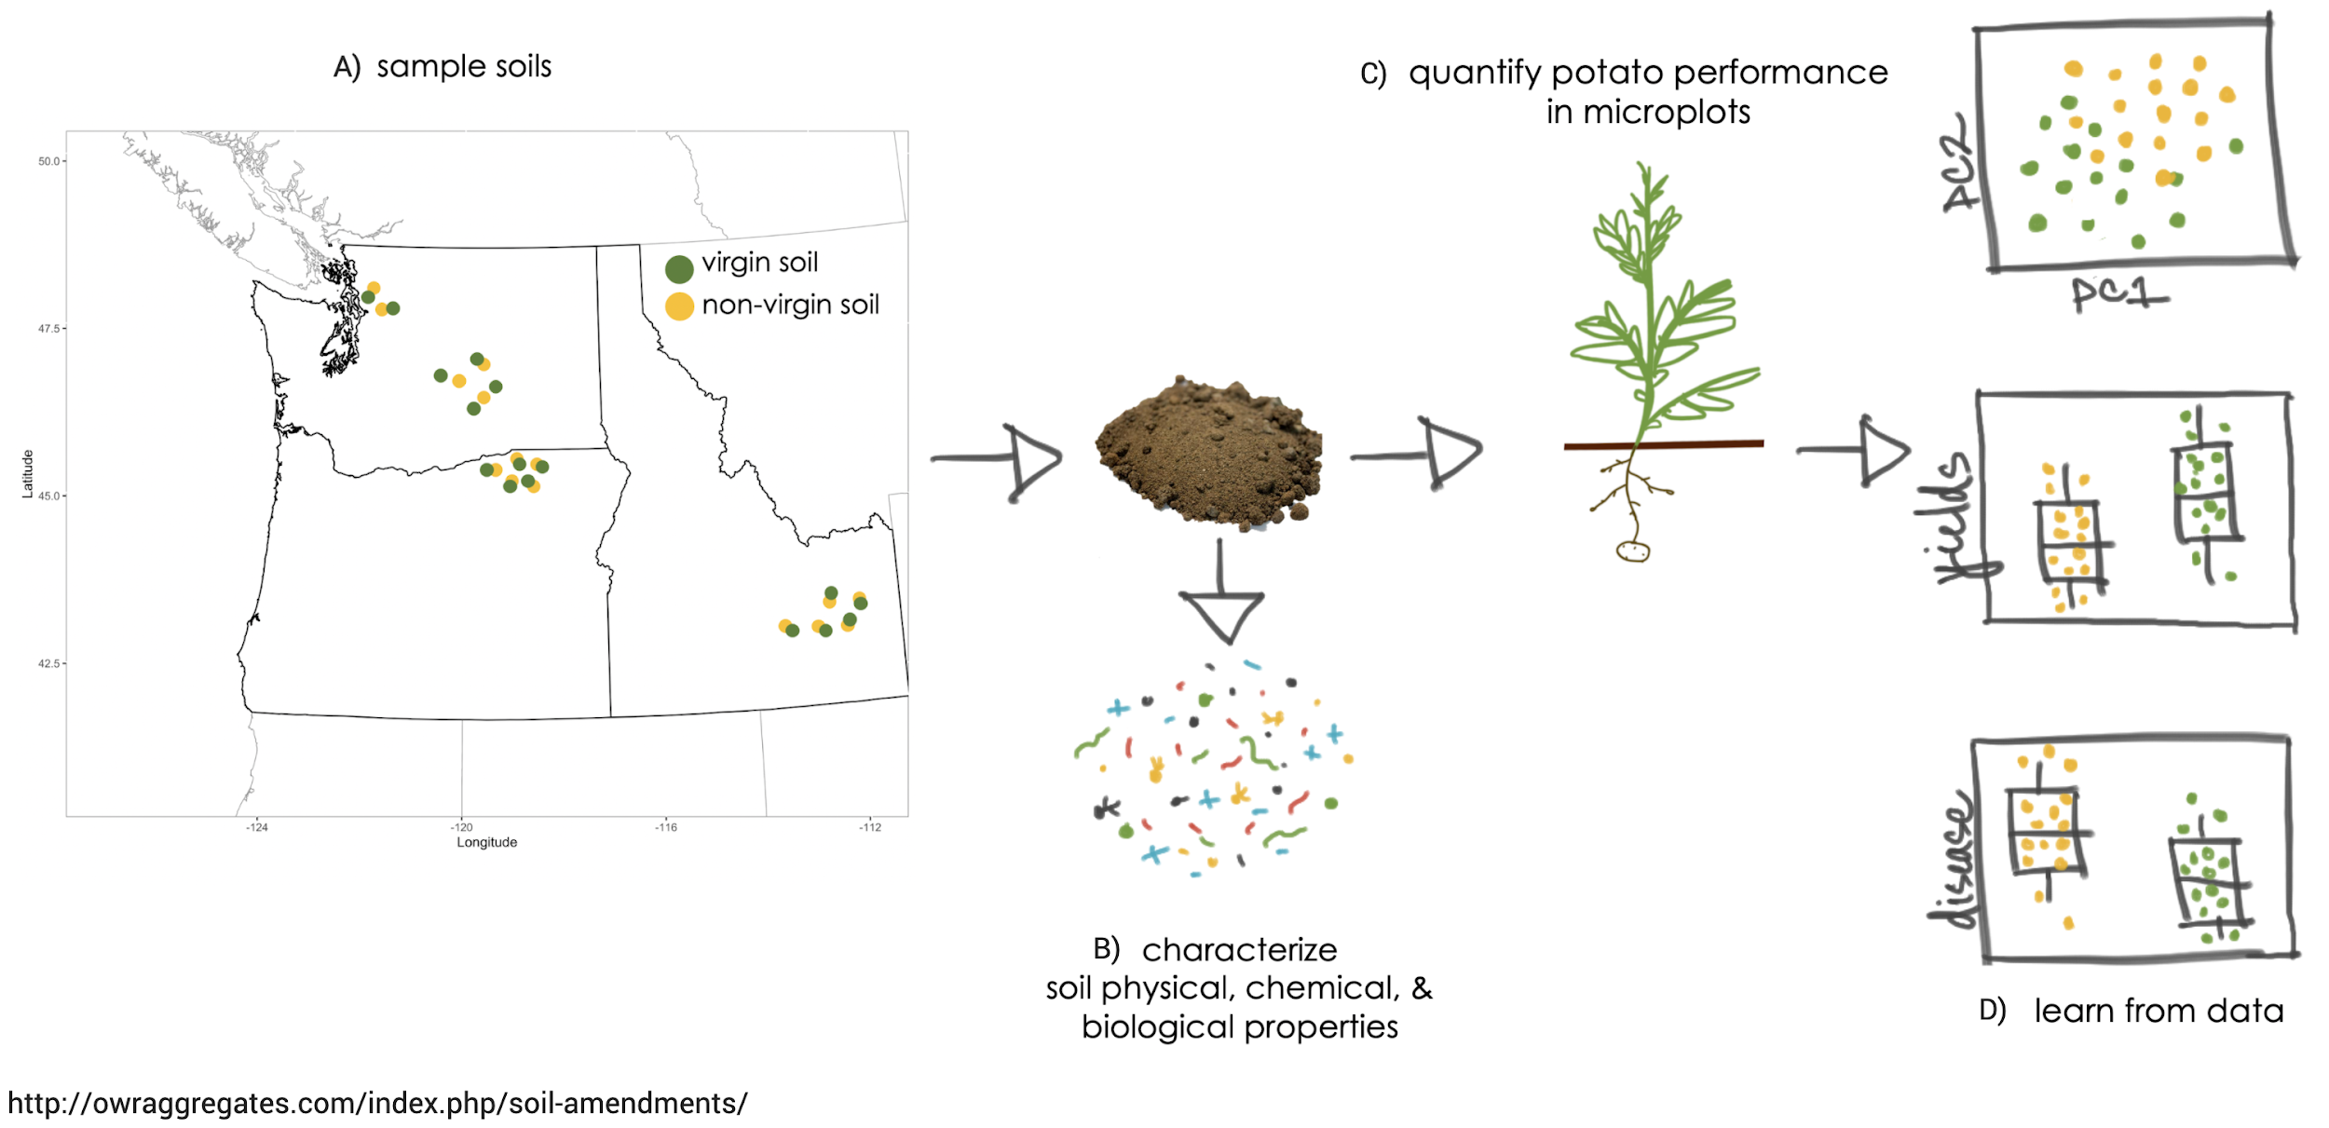



**Figure 1.** Flow chart of experiment

Anticipated outcomes of this research include (i) determination of the differences in soil properties (including meso- and microorganisms) between virgin soil and non-virgin soil (ii) estimates of the effects of virgin soils on tuber yields and disease expression relative to non-virgin soils. Ultimately this information should reveal differences between virgin and non-virgin soils that can be exploited to improve yields. Further studies can subsequently be designed to confirm the beneficial effects of virgin soils on potato yields and design management tactics to reproduce such effects in the Northwest.

**Collaboration:** DL Wheeler and S GC Upadhaya will collect soils, establish microplots, collect yield and disease data, and analyze data. D Griffin LaHue and T Potter will conduct analyses of soil physical, chemical, and biological properties with support from M Kleber and D Myrold. K Frost will quantify soilborne pathogens from soils. C Gleason will conduct the nematode community analysis.

**Additional grant funding:** This project will serve to generate preliminary data for larger grants, like USDA Sustainable Agriculture Research and Education and Specialty Crop Block Grants.

**References:**

Chen LF, He ZB, Zhao WZ, Liu JL, Zhou H, Li J, Meng YY, and Wang LS. 2020. Soil structure and nutrient supply drive changes in soil microbial communities during conversion of virgin desert soil to irrigated Cropland. Eur J Soil Sci. 71:768–781. <https://doi.org/10.1111/ejss.12901>

Gómez-Acata ES, Valencia-Becerril I, Valenzuela-Encinas C, Velásquez-Rodríguez AS, Navarro-Noya YE, Montoya-Ciriaco N, Suárez‐Arriaga MC, Rojas‐Valdez A, Reyes‐Reyes BG, Luna‐Guido M, and Dendooven L. 2014. Deforestation and cultivation with maize (*Zea mays* L.) has a profound effect on the bacterial community structure in soil. Land Degrad. Devel*.* 27:1122–1130. https://doi:10.1002/ldr.2328

Moebius-Clune, BN, Moebius-Clune DJ, Gugino BK, Idowu OJ, Schindelbeck RR, Ristow AJ, van Es HM, Thies JE, Shayler HA, McBride MB, Kurtz KSM, Wolfe DW, Abawi, GS. 2017. Comprehensive Assessment of Soil Health: The Cornell Framework, 3rd Ed. <http://www.css.cornell.edu/extension/soil-health/manual.pdf>

Powelson ML, and Rowe RC. 1993. Biology and management of early dying of potatoes. Annu Rev Phytopathol. 31:111-126.

Zhang H, Zhang S, Meng X, Li M, Mu L, Lei J, and Sui X. 2018. Conversion from natural wetlands to forestland and farmland alters the composition of soil fungal communities in Sanjiang Plain, Northeast China. Biotechnol. Biotechnol. Equip. 32:951-960. https://doi:10.1080/13102818.2018.1459208