**Annual Progress Report / Final Report**

**Title:** Comparison of potato yields, soil health, and pathogen loads in virgin and non-virgin soils

**Personnel:** PIs involved include David Linnard Wheeler ([david.wheeler@wsu.edu](mailto:david.wheeler@wsu.edu); 215-880-3024), Deirdre Griffin LaHue ([d.griffin@wsu.edu](mailto:d.griffin@wsu.edu); 360-848-6127), and Cynthia Gleason ([cynthia.gleason@wsu.edu](mailto:cynthia.gleason@wsu.edu); 509-335-3742) from Washington State University and Kenneth Frost ([kenneth.frost@oregonstate.edu](mailto:kenneth.frost@oregonstate.edu); 608-556-9637) from Oregon State University. Sudha G.C. Upadhaya ([sudha.gcupadhaya@wsu.edu](mailto:sudha.gcupadhaya@wsu.edu); 701-303-0630) is a graduate student in the first PI’s lab. Teal Potter serves as a postdoctoral scholar in the second PI’s lab. All PIs will request funding.

**Reporting Period:** Year Initiated: 2021; Terminating Year: 2022.

**Summary of accomplishments & progress toward long-term goals:**

The goal of this project is to identify the soil physical, chemical, and biological properties that contribute towards increased potato yields in virgin soils. To accomplish this goal, we first collected soil samples from virgin and non-virgin fields within the Columbia Basin and Skagit Valley. Next, we characterized the soils and estimated the impact of each soil type on potato performance with microplot experiments. Major soil-borne pathogens like *Fusarium* spp, *Pythium* spp, fungicide resistant strains of *Pythium* spp, *Verticillium dahliae*, and Colletotrichum coccodes were detected using soil plating methods. Interestingly, soil-borne pathogens were observed in both virgin and non-virgin fields. Moreover, there was no difference in the abundance of these organisms between virgin and non-virgin fields. Also, no difference in potato plant senescence, tuber yield, count, and pathogen loads were detected between virgin and non-virgin fields in the microplot study conducted in Pullman, WA. Soil physical, chemical, and additional biological properties are forthcoming. All data for year 1 will be obtained and analyzed by Spring 2022. So far, the obtained results support the hypothesis that soil-borne pathogens are not the only factors responsible for the lower yields in the non-virgin fields. However, results from soil physical and chemical properties and biological diversity in the soil will provide better insights in future. These results are from a single-year study. We will have to support or refute the obtained results by repeating the experiment for at least one more year. In the future, the results obtained from this project will contribute towards establishing the soil health indicators for potato production in the Pacific Northwest region. In long run, this research will inform future efforts to reproduce and maintain the benefits of virgin soils on potato yield and quality at commercial scales. Identification of factors associated with increased yields in virgin soils will help inform management strategies and ideally help growers reproduce these effects in commercial non-virgin potato fields.

**Activities or experiments conducted:**

**Objective 1: Sample soils from virgin and non-virgin fields:**

A total of 22 fields (n=11 pairs) of virgin and non-virgin soils were sampled from the Columbia Basin (n=7) and Skagit Valley (n=4) (**Fig 1**) during May 2021. Soil samples were collected from multiple sites within a field and mixed into one composite sample per field. The cropping history of each field was obtained from the growers. The collected soil was thoroughly mixed and used to characterize soil physical, chemical, and biological properties. Potato performance in virgin and non-virgin soils was evaluated in microplots and with yield data collected from growers who grew potatoes in each field.

**Objective 2: Characterize soil physical, chemical, and biological properties:**

The presence and abundance of major soil-borne pathogens of potato were studied with culture dependent and amplicon sequence-based methods. Several putative soil-borne pathogens including *Fusarium*, spp, *Pythium* spp, fungicide-resistant strains of *Pythium* spp, *Verticillium dahliae*, and *Colletotrichum coccodes* were quantified. Propagules numbers were averaged across four replications for *Fusarium*, spp., *Pythium* spp and summed across five replications for *Verticillium dahliae* and *Colletotrichum coccodes*. Obtained propagule count data was converted to the number of propagules per gram of soil for each pathogen.

Data on soil-borne pathogens were visualized using boxplots. A series of paired t-tests were conducted to detect differences in soil-borne pathogens propagules between virgin and non-virgin soils. Since multiple tests were required, a Bonferroni correction was applied to adjust *P*-values.

DNA was extracted from all samples using PowerSoil Pro DNA extraction kits, and DNA samples have been sent to the Oregon State University Genomics Core lab for library preparation and Illumina sequencing of bacterial and fungal soil communities. Sequencing data is estimated to be returned by April-May 2022 and will be analyzed by Dr. Teal Potter.

Analysis of additional soil properties, including soil texture, active carbon (i.e., permanganate-oxidizable C), potentially mineralizable C, soil protein content, plant-available nutrients, pH, and electrical conductivity are underway with data expected in early spring 2022.

**Objective 3: Quantify potato performance in microplots:**

Potato disease expression and yields in soils collected from virgin and non-virgin fields were quantified in a microplot study. Microplots were established in Pullman, WA, during the spring of 2021 (**Fig 2**). The pots were arranged in a randomized complete block design along the predominant environmental gradient at the site. Each pair of fields were assigned randomly to the block. Pots were filled with soil and Russet Burbank potatoes were planted in each pot during the fourth week of May. Before planting, seed tubers were assayed on semi-selective media for the presence of the *V. dahliae and C. coccodes*. Seed tubers free of *V. dahliae* and *C. coccodes* were used for planting. Plants were watered regularly, and plots were weeded as needed. Plant senescence was estimated as a percentage a total of eight times throughout the growing season. Plants were harvested in mid-October. Potato tuber yield and tuber count were recorded for each microplot. Further, soil-borne pathogen loads in tubers and stems were quantified on semi-selective media. Briefly, all tubers were thoroughly cleaned, and a thin layer of stolon end was excised from each tuber. Excised tuber pieces were surface sterilized in 0.5% NaOCl for 2 minutes, rinsed in deionized water, and plated on the semi-selective NP-10 media (Kabir et al. 2005). Similarly, *V. dahliae* and *C. coccodes* were detected from basal ends of plant stems with semi-selective media. Plates were incubated in the dark for two weeks at 22°C and examined under a dissecting microscope for the presence of *V. dahliae* and *C. coccodes* colonies.

Plant senescence data were used to calculate the area under the senescence progress curve (AUSPC). High values of AUSPC reflect high values of plant senescence and likewise for lower values of AUSPC. All data were visualized using boxplots. Three independent paired t-tests were conducted in AUSPC, tuber yield, and tuber count data to detect differences between virgin and non-virgin fields. Normality and homogeneity of variances assumptions were assessed using Q-Q plots, boxplots, and residual versus fitted values plots. *P*-values were adjusted for multiple t-tests using the Bonferroni correction method.

Nematodes were extracted from 100 g of each soil sample by decanting and sieving, followed by sucrose flotation. DNA was extracted from these samples using the DNeasy PowerLyzer PowerSoil Kit. The samples were sent to the University of Minnesota Genomics Center for sequencing using the 18S ribosomal DNA primers NF-1 and 18Sr2b. We obtained sequence information for 18 samples.  Taxonomic classification was performed using bioinformatics package Mothur and the NemaTaxa database (**Fig 5**).

**Results and Discussion:**

Soil-borne pathogens propagules were detected in both virgin and non-virgin fields (**Fig** 3). The most abundant and potentially plant pathogenic fungi detected were *Fusarium* spp had followed by the *Pythium* spp. Fungicide resistant *Pythium* spp were also detected in both virgin and non-virgin fields (**Fig. 3**). *V. dahliae* was observed in soil collected from three virgin and four non-virgin fields, whereas *C. coccodes* was observed in just one virgin field and no non-virgin fields. There was no significant difference (*P* < 0.05) in *Fusarium*, *Pythium*, *V. dahlia*e, and *C. coccodes* populations between virgin and non-virgin soil (**Fig 3**).

The relatively high abundance of both *Fusarium* and *Pythium* in both virgin and non-virgin fields supports the hypothesis that the hosts/substrates supporting these pathogens were present in both types of fields. However, further characterization is needed to determine if the *Fusarium* spp observed in this study are pathogenic towards potatoes.

No significant differences in potato senescence were observed between virgin and non-virgin fields (**Fig 4A**). Similarly, there was no significant difference between virgin and non-virgin fields in yield and tuber number (**Fig 4B and 4C).** In addition, *V. dahliae* and *C. coccodes* were only detected at low levels in tubers grown in soils from a few virgin and non-virgin soils. The low abundance of *V. dahliae* and *C. coccodes* in tubers is reflected in the soil inoculum estimates from the soil plating results. There was a lot of nematode diversity between samples in the virgin and non-virgin sites. Many of the identified genera contained free-living nematodes. *Ditylenchus*, a genera of plant parasitic nematodes, was found in both virgin and non-virgin soil samples (**Fig. 5**). Similar abundance of soil-borne pathogens in both types of fields supports the hypothesis that soil-borne pathogens are not the only limiting factors for yield in non-virgin fields.

**Publications:**

**Presentations & Reports:**

**Figure 1.** Soil sampling locations in WA and OR, 2021. Soil was collected from total 11 pairs of fields, including seven and four pairs from Columbia basin and Skagit valley, respectively.

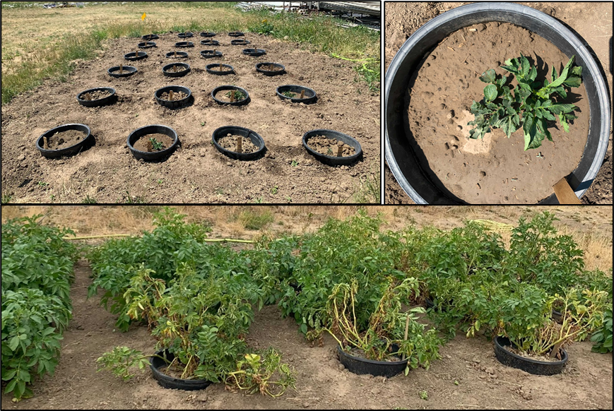

**Figure 2.** Microplots in Pullman, WA.

**Figure 3.** Abundance of soil-borne pathogens including (a) Pythium spp, (b) fungicide-resistant Pythium spp, (c) Fusarium spp, (d) Verticillium dahliae, and (e) Colletotrichum coccodes in the soil collected from virgin and non-virgin fields. Average propagules per gram of soil were recorded for Fusarium spp and Pythium spp, whereas a total number of propagules per gram of soil was recorded for the V. dahliae and C. coccodes.

**Figure 4.** Potato performance in microplots. The differences in (a) wilt symptoms expressed as area under the senescence progress curve (AUSPC), (b) total tuber weight (grams), and (b) the total number of potato tubers recovered from plants grown in virgin and non-virgin soil.

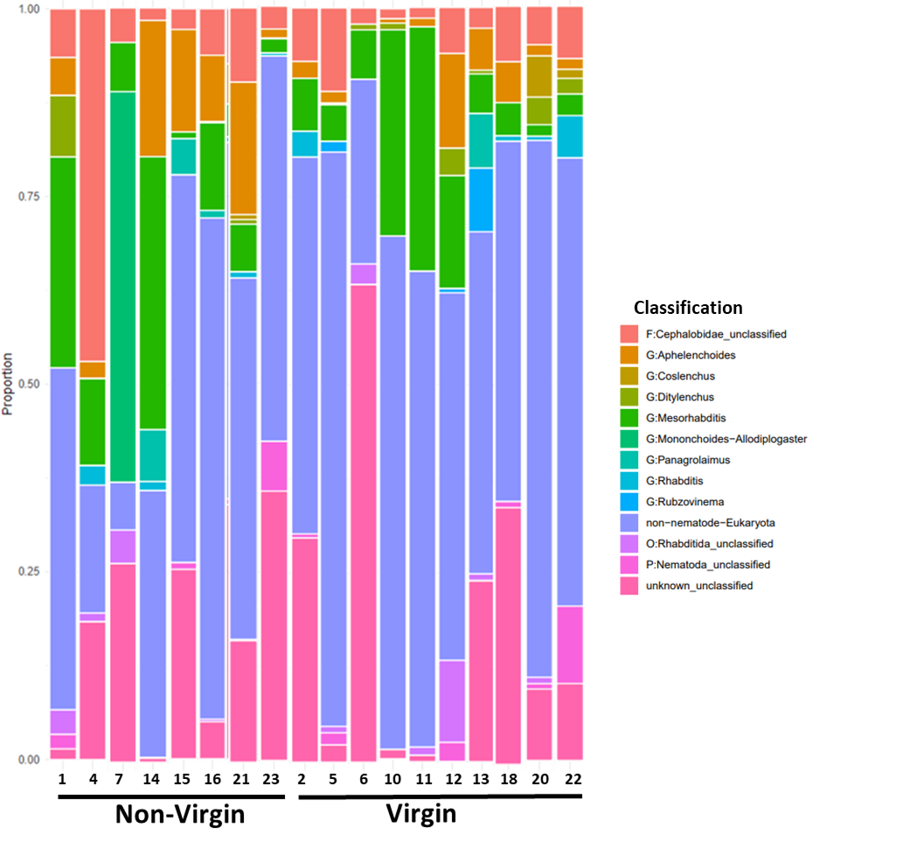

**Figure 5.** Classification of nematodes to the taxonomic level of phylum (P), order (O), family (F), or genus (G) in non-virgin and virgin fields.

**References:**

Kabir, Z., Bhat, R.G. and Subbarao, K. 2004. Comparison of media for recovery of *Verticillium dahliae* from soil. Plant Dis. 88:49-55.