Trigger box documentation

# Trigger box specifications

The format of a timing trigger sent by a PC running stimulus presentation can mismatch with the format accepted by a different unit running data acquisition. The trigger box is designed to relay and change the format of a trigger between the stimulation PC and the acquisition unit.

Sections 1.1 and 1.2 describe the basic functionality of this trigger box. Sections 1.3 and 1.4 describe the hardware of the box, and Sections 1.5 and 1.6 the software. Any basic installation using the Biosemi ActiveTwo acquisition system should find the first two sections sufficient. Modifications to the functionality described in previous sections can be made by referring to their corresponding sections (1.5 to 1.6).

Section 2 shows some tests run with the box to demonstrate proper functionality.

## Operation summary

The trigger input of the box needs to be a single voltage waveform. The box triggers off an input that rises above a voltage threshold, set with the dial on top of the box, in the range of 0 to 5V. The serial input is connected to the stimulation PC via USB, which provides power and allows serial communication. Serial input to the box specifies the box’s output trigger. Serial feedback from the box to the PC gives information about the output.

The output consists of eight simultaneous voltage waveforms. Each represents a binary bit in an eight bit integer, which is the format accepted by the BioSemi ActiveTwo system. When representing a numbered trigger, for example trigger number 5, a 0000 0101 is sent: only the sixth and eighth waveforms will be active. To represent a binary one, the waveform is an upward going 5V square pulse of 2ms in length. A binary zero is a zero voltage waveform.

This trigger information is sent via the stimulation PC’s serial communication before the actual trigger is sent. For the example above, the PC would have sent a numerical 5 over the serial before sending the trigger to the box. If no trigger number was specified, the box sends the default trigger, programmed to be 133. The box is programmed so that it can only trigger once every 100ms.

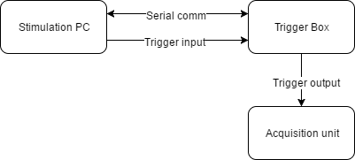

Figure 1‑1: block diagram showing data flow of the trigger box

## Installation instructions

Ensure that you have administrator privileges for the acquisition PC so that program installations are not blocked by the system.

The components that should already exist are:

* Acquisition PC
* Acquisition hardware unit and software (In this document, Biosemi ActiveTwo and ActiView respectively)
* Stimulation PC
* Soundcard for stimulus and trigger delivery
* Software for stimulus and trigger presentation (In this document, Matlab is used)

Required external components:

* Trigger box (to create this box, see Section 1.4, Components list)
* ¼ inch mono jack plug to plug audio cable (connects soundcard to trigger box)
* DB-37 male to DB-25 male cable (for ActiveTwo USB receiver to trigger box. Different cable needed if acquisition system is different)

Step 1: Install The Arduino software. The latest version can be downloaded from <https://www.arduino.cc/en/Main/Software>.

Step 2: Install Teensyduino software, which enables the Arduino software to be compatible with the Teensy 2.0++ board. The latest version is at <https://www.pjrc.com/teensy/td_download.html>.

Step 3: Connect the box to the soundcard and acquisition unit with the two cables. See Figure 2.

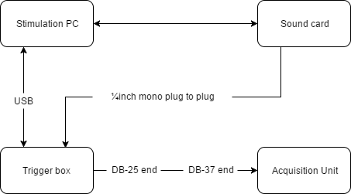

Figure 1‑2: Block diagram showing the physical connections of the trigger box

Step 4: Run the Arduino software and copy the Teensy code into a sketch (see Section 3). Select correct parameters in the Arduino software on the dropdown menus: Board - Teensy 2.0++, CPU clock 16MHz, communication type - Serial, COM port: COMx (choose whichever is available). Compile and upload the sketch (top left button), making sure the pop-up box says “Upload OK”.

Step 5: Open Matlab and copy the Matlab code into a script (see Section 3). In the code, change the third line’s serial port to COMx instead of the default COM9, depending on what you chose in Step 4.

Step 5 alternate: Open stimulation program and prepare stimulus. Make sure trigger and stimulus channels are correct.

Step 6: Test trigger output from soundcard and ensure the voltage from potentiometer is right.

Step 7: begin stimulation by running the Matlab code while the acquisition computer is acquiring data. See 2.2 for an example of some expected output.

Although this is more advanced and requires some knowledge of how the box works, it is recommended to get technical expertise to ensure the proper functioning of the trigger box. These things should be tested (refer to later Section 2 for details on how it is done).

* The voltage threshold dial is set at a reasonable level with respect to the input trigger. Check this by using an oscilloscope and looking at potentiometer and input voltage (Section 2.1).
* The delay between input and output trigger (both mean and range) is acceptable for the user’s application Check this by using an oscilloscope and probing input and output voltage (Section 2.1).
* The output trigger is saved by the acquisition system correctly (Section 2.2).

## Trigger box circuit diagram

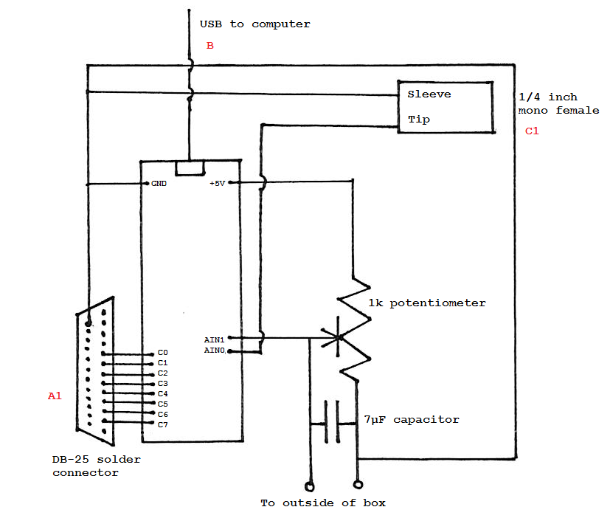

Figure 1‑3: Circuit diagram of the trigger box with individual components

## Components list

* 1kΩ linear potentiometer; a log-scale potentiometer or one with different resistance is fine too, as long as it allows reliable control over the output voltage.
* 7µF capacitor; any capacitance is fine as long as it is not too large (approximately below the µF range is fine).[1]
* A Teensy 2.0++ microcontroller board[2], the documentation can be found at <https://www.pjrc.com/store/teensypp.html> and <http://www.atmel.com/images/doc7593.pdf>.
* Project box that will fit all internal components
* DB-25 female solder connector **(A1, see label on Figure 1‑3)**
* USB type A to Mini B cable **(B)**
* ¼ inch mono jack (female) **(C1)**

And two cables already mentioned in Section 1.2:

* ¼ inch mono jack male to male plug audio cable **(C2)**
* DB-37 male to DB-25 male converter cable **(A2)**

**A: USB receiver to trigger box connection:**

The BioSemi USB receiver documentation can be found at: <http://www.biosemi.com/receiver.htm>.

USB receiver end: DB-37 female. Pins 1-8 are the trigger channels used

Trigger box end: DB-25 female. Pins 2-9 are connected to microcontroller output C0 to C7 respectively. **(A1)**

Connecting cable: DB-37 male to DB-25 male cable, connects pins 1-8 of DB-37 to pins 2-9 of DB-25. Pin 37 is also connected to pin 25 (GND). **(A2)**

**B: Computer to trigger box:**

Computer end: USB serial, COM port varies.

Trigger box: inbuilt USB mini connection.

Connecting cable: USB type A to Mini B cable **(B).** The computer and microcontroller use a COM port by default to communicate. This COM port needs be set in the Arduino software, and be reflected in the stimulating PC’s serial communications (See Step 4 of Section 1.2).

**C: Input trigger to trigger box:**

Trigger box: ¼ inch mono jack (female), where sleeve is grounded and tip is connected to AIN0 on the Teensy board **(C1);**

Connecting cable: Both ends are expected to be mono; the sound card end plays the trigger through the cable’s tip connection **(C2).**

## Input

The input waveform is designed to be a positive going square pulse of less than 100 milliseconds in width, and exceeding a set voltage threshold triggers an output.

The threshold voltage above which the box will trigger on the input can be anywhere between 0 and 5 volts, and can be adjusted by turning the dial on top of the box. It is recommended that this voltage is at least above 1V in case of noise.

To change the maximum length of the input waveform, change the wait length in the interrupt service routine (See attached code).

To change input triggering on a rising edge to falling edge or both (toggle), change ACIS bits of the ACSR register in the setup function.

Table 1: ACIS bits that will alter trigger shape. From http://www.atmel.com/Images/doc7593.pdf

|  |  |  |
| --- | --- | --- |
| **ACIS1** | **ACIS0** | **Interrupt mode** |
| 0 | 0 | Comparator Interrupt on Input Toggle |
| 0 | 1 | Reserved |
| 1 | 0 | Comparator Interrupt on Falling Input Edge |
| 1 | 1 | Comparator Interrupt on Rising Input Edge |

## Output

The output of the box is compliant with the documentation supplied by BioSemi. See <http://www.biosemi.com/faq/trigger_signals.htm> for details.

The length of the output trigger and the delay before another trigger can be activated can both be customised in the code. Note that to create these delays, you must use the delaymicroseconds function and not delay. The reason for this is that Delay uses a timer (which doesn’t work inside an interrupt service routine) whereas delaymicroseconds uses CPU cycles to produce the delay. This can be seen in C:\Program Files (x86)\Arduino\hardware\arduino\avr\cores\arduino\wiring.c.

# Characterising input and output waveforms

## Trigger box waveforms

The purpose of this section is to view the input and output waveforms of the trigger box. Here, the input waveform is a sound file which has a positive going rectangular pulse of 0.9 amplitude and 2ms length sampled at 44.1kHz created in Audacity. This is sent via the RME FireFace soundcard to the box. The box was programmed to trigger on a rising edge when the comparator voltage is exceeded, which is set to approximately 3V with the potentiometer. The output is the default 2-millisecond positive going 5V rectangular pulse.

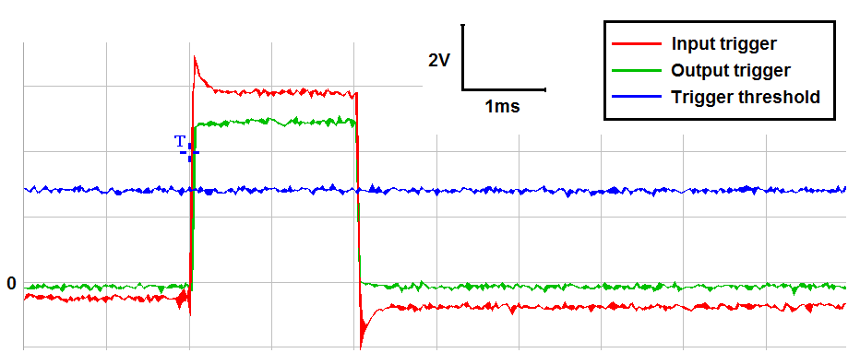

Figure 2‑1: Full waveform of trigger box input and output. This plot and all plots below are triggered on the oscilloscope on the rising edge of the output from the trigger box (green).

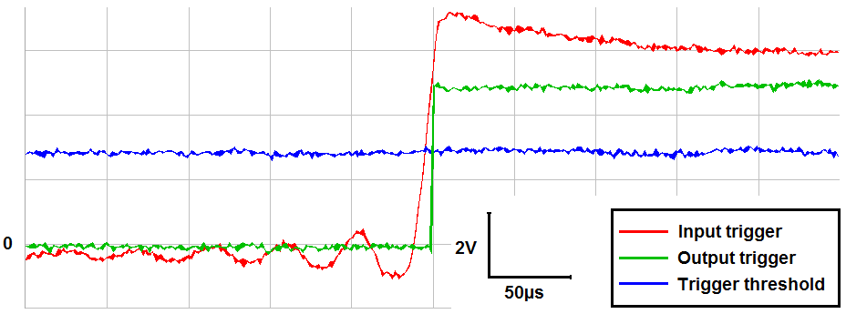

Figure 2‑2: Zoomed in waveform of trigger box input and output, showing input waveform ripples. Comparator voltage must be set to trigger on the upward slope and not any of the ripples.

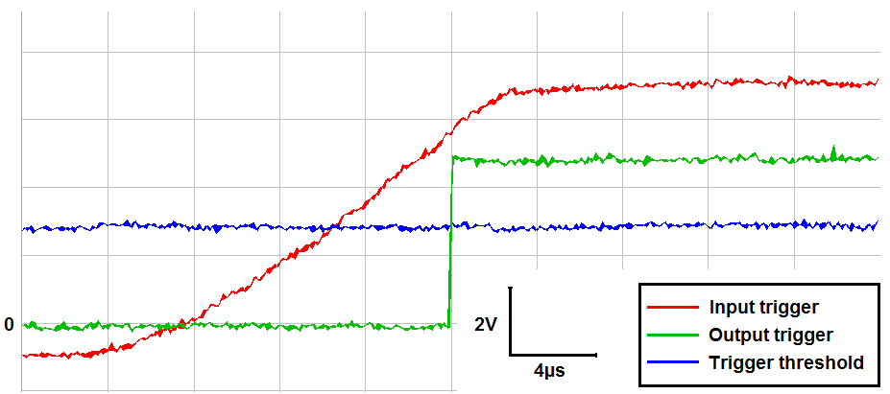

Figure 2‑3: Further zoomed in waveform of trigger box input and output, showing input vs output delay. Delay between input and output is approximately 6µs.

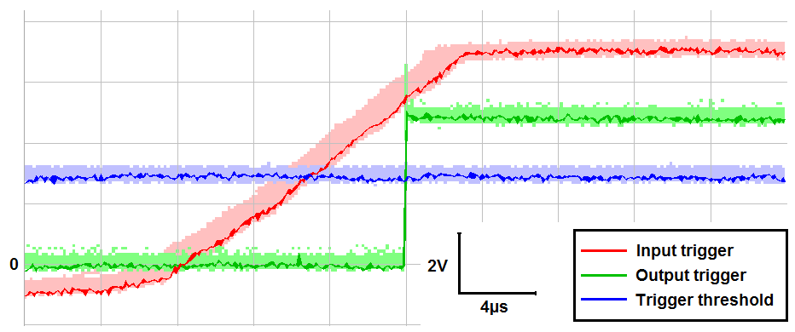

Figure 2‑4: Accumulation of 700 trials of trigger box input and output, showing the jitter of the input relative to the output, and the comparator voltage jitter. Maximum difference of about max 4µs

It is found that the output trigger fires after a 6±4µs delay.

## EEG acquisition waveforms

Tested with triggerbox_demo_tester.wav, see attached code.



Figure 2‑5: 1000 presentations of simulated response and triggers, as extracted from BDF file.



Figure 2‑6: Zoomed in plot showing the maximum deviation between timings is one sample.

For reference, the sampling rate of the EEG will be at 2048 = 488µs between two samples; sound card 44.1 kHz = 22.7 µs between two samples. We expect all variance to be within one sample because the sampling rate of the EEG is much lower than that of the soundcard. This means that the start of the sound can be anywhere between two samples of the EEG, but can never be outside those two samples, otherwise the trigger box is not relaying the trigger properly.

1. The potentiometer and the capacitor together will have a time constant in which the voltage will settle to its steady state when the potentiometer resistance is changed. If the time taken to reach a constant voltage is too long, reduce the resistance of the potentiometer or the capacitance of the capacitor.
2. A different microcontroller can be used but the software would need different programming.