Final Lecture: Infinite Relational Model
Jesse Mu
2016-11-02
Table of contents

1. The Infinite Relational Model
What happens when you want to cluster your data, but the number of clusters is unknown? While some approaches involve fitting several models with a varying number of clusters to your data and comparing model fit statistics, the Bayesian approach is to specify a model which is allowed to dynamically grow the number of clusters as the complexity of the data warrants.
The Infinite Relational Model is the prototypical example of such a model (Kemp et al. 2006).
For this last project, a simple version of Charles Kemp’s Infinite Relational Model (IRM) was coded in irm.R to co-cluster rows and columns of a simple 2-dimensional binary relation.

1.1 Demo
source('irm.R')

1.1.1 Sanity check
As a sanity check, the toy matrix from the original paper is used:
R = rbind(
c(0, 0, 1, 0, 1, 0, 0, 1, 0),
c(0, 0, 0, 0, 0, 0, 1, 0, 1),
c(0, 0, 1, 0, 0, 0, 1, 0, 1),
c(0, 1, 1, 0, 0, 0, 0, 1, 1),
c(0, 0, 0, 0, 0, 0, 1, 0, 1),
c(0, 1, 1, 0, 1, 0, 0, 1, 0),
c(1, 0, 0, 0, 0, 1, 0, 0, 0),
c(0, 0, 0, 0, 0, 1, 1, 0, 1),
c(1, 0, 0, 1, 0, 1, 0, 0, 0)
)
plot.R(R)
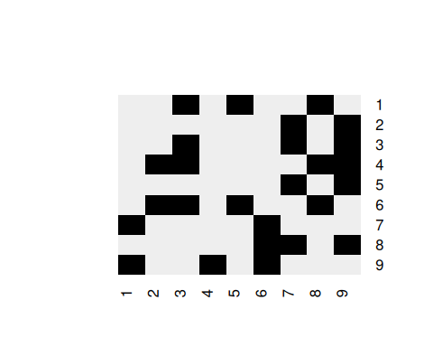
Z = irm(R, sweeps = 1000)
top.n(Z)
#> 122121323 122121324 123121424 122123424 122321424 122323424 122123425 123121434
#> 854 72 16 15 14 11 5 4
#> 112121323 122121343
#> 2 2
plot.R(R, mode.irm(Z))
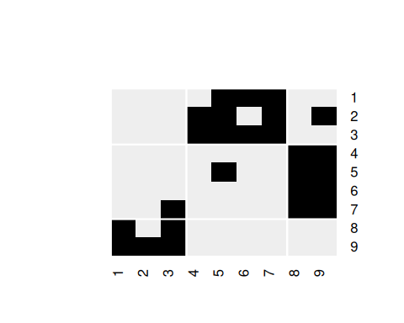
This successfully finds the clusters of rows and columns that correspond to the original paper.
Kemp, Charles, Joshua B. Tenenbaum, Thomas L. Griffiths, Takeshi Yamada, and Naonori Ueda. 2006. “Learning Systems of Concepts with an Infinite Relational Model.” Proceedings of the National Conference on Artificial Intelligence (AAAI) 21: 381–88. http://web.mit.edu/cocosci/archive/Papers/Kemp-etal-AAAI06.pdf.

