Chapter 10: Nonconjugate priors and Metropolis-Hastings algorithms
Jesse Mu
2016-12-08
Table of contents

1. Generalized linear models
Poisson + logistic. No conjugate priors.

2. Metropolis algorithm
s2 = 1; t2 = 10; mu = 5
y = c(9.37, 10.18, 9.16, 11.60, 10.33)
theta = 0
delta2 = 2
S = 10000
THETA = rep(NA, S)
set.seed(1)
# theta - current sample
# theta.star - proposed sample according to proposal distribution
# log.r - acceptance ratio
for (s in 1:S) {
theta.star = rnorm(1, theta, sqrt(delta2))
log.r = (sum(dnorm(y, theta.star, sqrt(s2), log = TRUE)) +
dnorm(theta.star, mu, sqrt(t2), log = TRUE)) -
(sum(dnorm(y, theta, sqrt(s2), log = TRUE)) +
dnorm(theta, mu, sqrt(t2), log = TRUE))
if (log(runif(1)) < log.r) theta = theta.star
THETA[s] = theta
}
theta.df = data.frame(
iteration = 1:S,
theta = THETA
)
ggplot(theta.df, aes(x = iteration, y = theta)) +
geom_line()
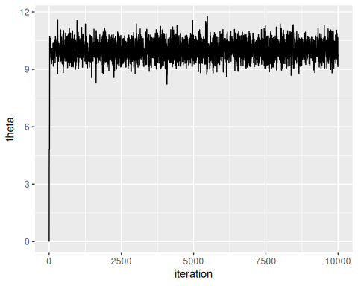
Interestingly, the effective sample sizes is quite low, only in the low thousands:
library(coda)
effectiveSize(THETA)
#> var1
#> 1427.451
acf(THETA)
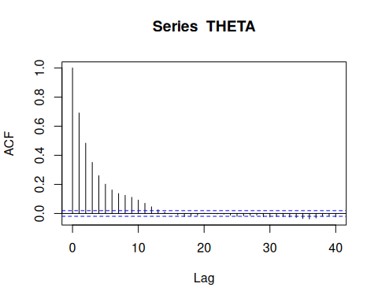
real.df = data.frame(
theta = seq(8, 12, length = 500),
density = dnorm(seq(8, 12, length = 500), 10.03, .44)
)
ggplot(theta.df) +
geom_histogram(aes(x = theta, y = ..density..), bins = 60) +
geom_line(data = real.df, mapping = aes(x = theta, y = density))
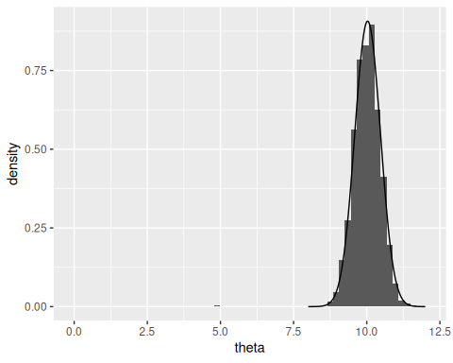
# outs[, 4]
# distribution looks different if we include 25000 vs ... 1000

2.0.1 Output of the Metropolis algorithm
Need to run until stationarity
Different proposal distributions. Delta as a tradeoff between rate of approach towards the HPD region versus overshooting (like learning rate in gradient descent, etc)
Acceptance rate of between 20 and 50% is good. Control length

2.1 Combining Metropolis and Gibbs algorithms
Since proposal distributions for different parameters can all be different - could use Gibbs for some parameters (where Gibbs is just a special case of Metropolis-Hastings)

2.1.1 A regression model with correlated errors
This section explores running multiple independent MCMC chains and combining the data (which is theoretically OK). The approach in icecore_parallel.R is to take the MH algorithm for analyzing the icecore data and distribute it across multiple cores with parallel::mclapply. That file creates icecore_mcmc which is analyzed here.
if (!file.exists('./icecore_mcmc')) {
stop("Run icecore_parallel.R first to get MCMC data")
}
load('./icecore_mcmc')
# Should have "outs" now
# TODO: put colnames in icecore_parallel
colnames(outs) = c('b1', 'b2', 's2', 'phi')
plot(density(outs[seq(1, 80000), 'phi']))
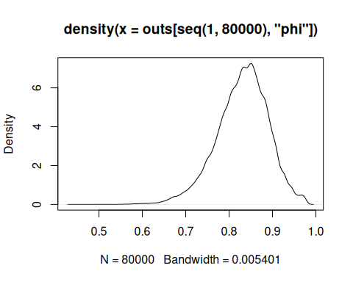
plot(density(outs[seq(1, 80000, by = 25), 'phi']))
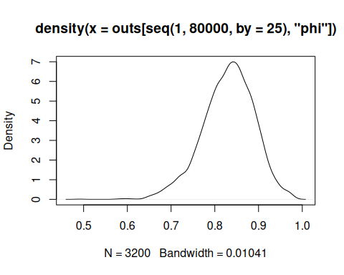
outs.df = data.frame(outs)
outs.df$iteration = 1:nrow(outs.df)
message(nrow(outs.df), " samples in ./icecore_mcmc")
ggplot(outs.df, aes(x = iteration, y = phi)) +
geom_line()
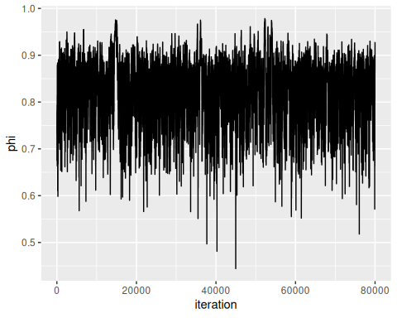
effectiveSize(outs.df$phi)
#> var1
#> 1084.922

3. Exercises

3.1 10.2
msparrownest = read.table('Exercises/msparrownest.dat')
For convenience let $θ_{i}=P\left(Y_{i}=1∣α,β,x_{i}\right)$. Now we solve for $θ_{i}$ in our model
$$\begin{matrix} & log\left(\frac{θ_{i}}{1−θ_{i}}\right)=α+βx_{i} \\ ⟹ & \frac{θ_{i}}{1−θ_{i}}=exp\left(α+βx_{i}\right) \\ ⟹ & θ_{i}=exp\left(α+βx_{i}\right)−θ_{i}exp\left(α+βx_{i}\right) \\ ⟹ & θ_{i}=\frac{exp\left(a+βx_{i}\right)}{1+exp\left(α+βx_{i}\right)}\end{matrix}$$
So we know $Y_{i}∼\text{Bernoulli}\left(p_{i}\right)$ where $p_{i}=\frac{exp\left(a+βx_{i}\right)}{1+exp\left(a+βx_{i}\right)}$ and thus
$$p\left(y_{i}∣α,β,x_{i}\right)=p_{i}^{y_{i}}{\left(1−p_{i}\right)}^{1−y_{i}}$$

3.1.1 a
Let $z_{i}=exp\left(α+βx_{i}\right)$ for simplicity.
$$\begin{matrix}p\left(y∣α,β,x_{i}\right) & =\prod_{i=1}^{n}{p}\left(y_{i}∣α,β,x_{i}\right) \\ & =\prod_{i=1}^{n}{p_{i}^{y_{i}}}{\left(1−p_{i}\right)}^{1−y_{i}} \\ & =\prod_{i=1}^{n}{{\left(\frac{z_{i}}{1+z_{i}}\right)}^{y_{i}}}{\left(1−\frac{z_{i}}{1+z_{i}}\right)}^{1−y_{i}} \\ & =\prod_{i=1}^{n}{{\left(\frac{z_{i}}{1+z_{i}}\right)}^{y_{i}}}{\left(\frac{1+z_{i}}{1+z_{i}}−\frac{z_{i}}{1+z_{i}}\right)}^{1−y_{i}} \\ & =\prod_{i=1}^{n}{{\left(\frac{z_{i}}{1+z_{i}}\right)}^{y_{i}}}{\left(\frac{1}{1+z_{i}}\right)}^{1−y_{i}} \\ & =\prod_{i=1}^{n}{\frac{z_{i}^{y_{i}}}{{\left(1+z_{i}\right)}^{y_{i}}}}\frac{1}{{\left(1+z_{i}\right)}^{1−y_{i}}} \\ & =\prod_{i=1}^{n}{\frac{z_{i}^{y_{i}}}{1+z_{i}}} \\ & =\prod_{i=1}^{n}{\frac{exp\left(y_{i}\left(α+βx_{i}\right)\right)}{1+exp\left(α+βx_{i}\right)}} \\ \end{matrix}$$
and this cannot be simplified further.

3.1.2 b
It’s helpful to think about this in terms of the log-odds, i.e., $\text{log-odds}\left(θ_{i}\right)=a+βx_{i}$. With an uninformative prior where no interaction between wingspan $x_{i}$ and nesting is assumed by default, the prior for $β$ should be centered around 0. To also be uninformative about the prior proportion of nesting birds regardless of wingspan, the prior for $α$ should be centered around 0 as well, so the prior expectation regardless of $x_{i}$ is $\text{log-odds}\left(θ_{i}\right)=0+0x_{i}=0$ (thus not favoring nesting or not).
The question is what to use for a prior distribution and how diffuse to make the priors. Priors for $α$ and $β$ should be symmetric, so normal distributions for both make sense. For an uninformative prior, the variance of these normals should be set high.
If $α$ is always 0, then as $x$ moves from 10 to 15, the possible values of $β$ should allow for a change in the log-odds ratio from approximately 0 to 1. Note the log-odds ratio of some sufficiently small number e.g. 1e-5 is -11.5129155 which is roughly 10. Since $x$ at a minimum is 10, it makes sense to have most of the prior on $β$ in the range $\left[−10/10,10/10\right]=\left[−1,1\right]$, so the standard deviation of the $β$ prior is set to 0.5 and the variance to 0.25.
Similarly, the standard deviation of the $α$ prior to be 5 and the variance 25, so that, if $β=0$, the most of the $α$ prior falls in the log-odds interval $\left[−10,10\right]$.
So
$$\begin{matrix}α & ∼N\left(0,25\right) \\ β & ∼N\left(0,0.25\right) \\ \end{matrix}$$

3.1.3 c
library(MASS)
inv = solve
# In this sampling scheme, when we sample, we keep the values together
# ($\theta$). But when I store the values, I split them (ALPHA, BETA).
S = 10000
burnin = 5000
y = msparrownest[, 1]
n = length(y)
# Use linear regression format, where column 1 is 1 (for alpha) and column 2 is
# the wingspan
x = cbind(rep(1, n), msparrownest[, 2])
# Start with X^T X but increase until acceptance ratio between 30% - 50%
var.prop = 7 * inv(t(x) %*% x)
# Prior parameters
pmn.theta = c(0, 0)
psd.theta = sqrt(c(25, 0.25))
# Where to store values
ALPHA = numeric(S + burnin)
BETA = numeric(S + burnin)
# Acceptances
acs = 0
# Initial estimates
theta = c(0, 0)
# For calculating likelihood ratio
log.p.y = function(x, y, theta) {
exp_term = exp(x %*% theta)
p = exp_term / (1 + exp_term)
sum(dbinom(y, 1, p, log = TRUE))
}
p.theta = function(theta) {
sum(dnorm(theta, pmn.theta, psd.theta, log = TRUE))
}
for (s in 1:(S + burnin)) {
theta.star = mvrnorm(1, theta, var.prop)
lhr = log.p.y(x, y, theta.star) +
p.theta(theta.star) -
log.p.y(x, y, theta) -
p.theta(theta)
if (log(runif(1)) < lhr) {
theta = theta.star
if (s > burnin) {
acs = acs + 1
}
}
ALPHA[s] = theta[1]
BETA[s] = theta[2]
}
ALPHA = ALPHA[burnin:length(ALPHA)]
BETA = BETA[burnin:length(BETA)]
message("Acceptance ratio: ", acs / S) # Good to go
c(effectiveSize(ALPHA), effectiveSize(BETA))
#> var1 var1
#> 1569.255 1549.445

3.1.4 d
alpha_prior = data.frame(
val = seq(-10, 10, length.out = 1000),
density = dnorm(seq(-10, 10, length.out = 1000), 0, 5),
var = 'alpha',
dist = 'prior'
)
beta_prior = data.frame(
val = seq(-1, 1, length.out = 1000),
density = dnorm(seq(-1, 1, length.out = 1000), 0, 0.5),
var = 'beta',
dist = 'prior'
)
prior_df = rbind(alpha_prior, beta_prior)
alpha_post = data.frame(
val = ALPHA,
var = 'alpha',
dist = 'posterior'
)
beta_post = data.frame(
val = BETA,
var = 'beta',
dist = 'posterior'
)
post_df = rbind(alpha_post, beta_post)
ggplot(prior_df, aes(x = val, y = density, color = dist)) +
geom_line() +
geom_density(data = post_df, mapping = aes(x = val, y = ..density..)) +
facet_wrap(~ var, scales = 'free')
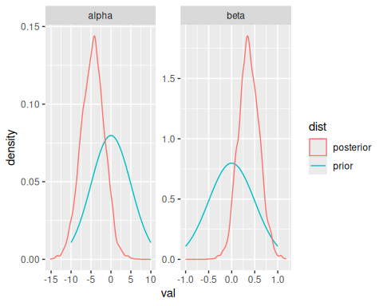

3.1.5 e
Using the samples of $α$ and $β$, simply compute a distribution on $f_{αβ}\left(x\right)$. Confidence intervals can then be constructed around this distribution. However, this needs to be done for many $x$ values:
x_seq = seq(10, 15, length = 100)
quantiles = sapply(x_seq, function(x) {
exp_term = exp(ALPHA + BETA * x)
fab = exp_term / (1 + exp_term)
quantile(fab, probs = c(0.025, 0.5, 0.975))
})
fab_df = data.frame(
wingspan = x_seq,
ymin = quantiles[1, ],
fpred = quantiles[2, ],
ymax = quantiles[3, ]
)
ggplot(fab_df, aes(x = wingspan, y = fpred, ymin = ymin, ymax = ymax)) +
geom_line() +
geom_ribbon(fill = 'grey', alpha = 0.5)
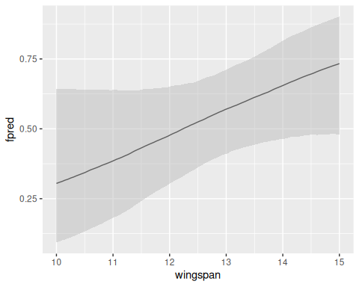
This is the logistic regressions’ approximate probability of nesting based on wingspan, although the confidence intervals are quite wide.

