Linear (Gaussian) Models
Table of contents

Configuring R
Functions from these packages will be used throughout this document:
library(conflicted) # check for conflicting function definitions
# library(printr) # inserts help-file output into markdown output
library(rmarkdown) # Convert R Markdown documents into a variety of formats.
library(pander) # format tables for markdown
library(ggplot2) # graphics
library(ggfortify) # help with graphics
library(dplyr) # manipulate data
library(tibble) # `tibble`s extend `data.frame`s
library(magrittr) # `%>%` and other additional piping tools
library(haven) # import Stata files
library(knitr) # format R output for markdown
library(tidyr) # Tools to help to create tidy data
library(plotly) # interactive graphics
library(dobson) # datasets from Dobson and Barnett 2018
library(parameters) # format model output tables for markdown
library(haven) # import Stata files
library(latex2exp) # use LaTeX in R code (for figures and tables)
library(fs) # filesystem path manipulations
library(survival) # survival analysis
library(survminer) # survival analysis graphics
library(KMsurv) # datasets from Klein and Moeschberger
library(parameters) # format model output tables for
library(webshot2) # convert interactive content to static for pdf
library(forcats) # functions for categorical variables ("factors")
library(stringr) # functions for dealing with strings
library(lubridate) # functions for dealing with dates and times
library(broom) # Summarizes key information about statistical objects in tidy tibbles
library(broom.helpers) # Provides suite of functions to work with regression model 'broom::tidy()' tibbles
Here are some R settings I use in this document:
rm(list = ls()) # delete any data that's already loaded into R
conflicts_prefer(dplyr::filter)
ggplot2::theme_set(
ggplot2::theme_bw() +
# ggplot2::labs(col = "") +
ggplot2::theme(
legend.position = "bottom",
text = ggplot2::element_text(size = 12, family = "serif")))
knitr::opts_chunk$set(message = FALSE)
options('digits' = 6)
panderOptions("big.mark", ",")
pander::panderOptions("table.emphasize.rownames", FALSE)
pander::panderOptions("table.split.table", Inf)
conflicts_prefer(dplyr::filter) # use the `filter()` function from dplyr() by default
legend_text_size = 9
run_graphs = TRUE
include_reference_lines <- FALSE

 Note
This content is adapted from:
- Dobson and Barnett (2018), Chapters 2-6
- Dunn and Smyth (2018), Chapters 2-3
- Vittinghoff et al. (2012), Chapter 4
There are numerous textbooks specifically for linear regression, including:
- Kutner et al. (2005): used for UCLA Biostatistics MS level linear models class
- Chatterjee and Hadi (2015): used for Stanford MS-level linear models class
- Seber and Lee (2012): used for UCLA Biostatistics PhD level linear models class and UC Davis STA 108.
- Kleinbaum et al. (2014): same first author as Kleinbaum and Klein (2010) and Kleinbaum and Klein (2012)
- Linear Models with R (Faraway 2025)
- Applied Linear Regression by Sanford Weisberg (Weisberg 2005)
For more recommendations, see the discussion on Reddit.
- see also https://web.stanford.edu/class/stats191

1. Overview

1.1 Why this course includes linear regression
- This course is about generalized linear models (for non-Gaussian outcomes)
- UC Davis STA 108 (“Applied Statistical Methods: Regression Analysis”) is a prerequisite for this course, so everyone here should have some understanding of linear regression already.
- We will review linear regression to:
- make sure everyone is caught up
- provide an epidemiological perspective on model interpretation.

1.2 Chapter overview
- Section 2: how to interpret linear regression models
- Section 3: how to estimate linear regression models
- Section 4: how to tell if your model is insufficiently complex
- Section 5: how to quantify uncertainty about our estimates and generate predictions

2. Understanding Gaussian Linear Regression Models

2.1 General form of a Gaussian linear regression model
Definition 1 (General form of a Gaussian linear regression model) A Gaussian linear regression model has two components:
- The random part
- (the outcome distribution model):
$$Y_{i}|{\tilde{x}}_{i} ∼_{⟂​​​⟂} N(μ_{i},σ^{2})$$
- Here ${\tilde{x}}_{i}$ is the observed covariate vector for unit $i$. Here $∼_{⟂​​​⟂}$ means independently distributed. Conditional on ${\tilde{x}}_{1},…,{\tilde{x}}_{n}$, the responses are independent across units, and each $Y_{i}|{\tilde{x}}_{i}$ follows the same conditional distributional form with common variance $σ^{2}$ while allowing $μ_{i}$ to vary by observation.
- The systematic part
- (the linear predictor component):
$$\begin{aligned}μ_{i}&=\tilde{β}⋅{\tilde{x}}_{i} \\ &=β_{0}+β_{1}x_{i1}+⋯+β_{p}x_{ip}\end{aligned}$$
For the systematic part of the model, here $\tilde{β}\overset{\text{def}}{=}(β_{0},β_{1},…,β_{p})$ is the coefficient vector.
Here $p$ is the number of covariates excluding the intercept. The vector ${\tilde{x}}_{i}$ includes an intercept entry equal to 1, so ${\tilde{x}}_{i}$ has length $p+1$.
Terminology varies across texts. (Dobson and Barnett 2018, 36) uses this two-part formulation explicitly (probability distribution + mean/link equation/linear component). (Vittinghoff et al. 2012, 72–73) uses the labels systematic part and random part. (Dunn and Smyth 2018, 11) uses the labels random component and systematic component.

2.2 Motivating example: birthweights and gestational age
Suppose we want to learn about the distributions of birthweights (outcome $Y$) for (human) babies born at different gestational ages (covariate $A$) and with different chromosomal sexes (covariate $S$) (Dobson and Barnett (2018) Example 2.2.2).

2.3 Dobson birthweight data

2.3.1 Data as table
Table 1: birthweight data (Dobson and Barnett (2018) Example 2.2.2)
library(dobson)
data("birthweight", package = "dobson")
birthweight
#> # A tibble: 12 × 4
#> `boys gestational age` `boys weight` `girls gestational age` `girls weight`
#> <dbl> <dbl> <dbl> <dbl>
#> 1 40 2968 40 3317
#> 2 38 2795 36 2729
#> 3 40 3163 40 2935
#> 4 35 2925 38 2754
#> 5 36 2625 42 3210
#> 6 37 2847 39 2817
#> 7 41 3292 40 3126
#> 8 40 3473 37 2539
#> 9 37 2628 36 2412
#> 10 38 3176 38 2991
#> 11 40 3421 39 2875
#> 12 38 2975 40 3231

2.3.2 Reshape data for graphing
Table 2: birthweight data reshaped
library(tidyverse)
bw <-
birthweight |>
pivot_longer(
cols = everything(),
names_to = c("sex", ".value"),
names_sep = "s "
) |>
rename(age = `gestational age`) |>
mutate(
id = row_number(),
sex = sex |>
case_match(
"boy" ~ "male",
"girl" ~ "female"
) |>
factor(levels = c("female", "male")),
male = sex == "male",
female = sex == "female"
)
bw
#> # A tibble: 24 × 6
#> sex age weight id male female
#> <fct> <dbl> <dbl> <int> <lgl> <lgl>
#> 1 male 40 2968 1 TRUE FALSE
#> 2 female 40 3317 2 FALSE TRUE
#> 3 male 38 2795 3 TRUE FALSE
#> 4 female 36 2729 4 FALSE TRUE
#> 5 male 40 3163 5 TRUE FALSE
#> 6 female 40 2935 6 FALSE TRUE
#> 7 male 35 2925 7 TRUE FALSE
#> 8 female 38 2754 8 FALSE TRUE
#> 9 male 36 2625 9 TRUE FALSE
#> 10 female 42 3210 10 FALSE TRUE
#> # ℹ 14 more rows

2.3.3 Data as graph
plot1 <- bw |>
ggplot(aes(
x = age,
y = weight,
shape = sex,
col = sex
)) +
theme_bw() +
xlab("Gestational age (weeks)") +
ylab("Birthweight (grams)") +
theme(legend.position = "bottom") +
# expand_limits(y = 0, x = 0) +
geom_point(alpha = .7)
print(plot1 + facet_wrap(~sex))
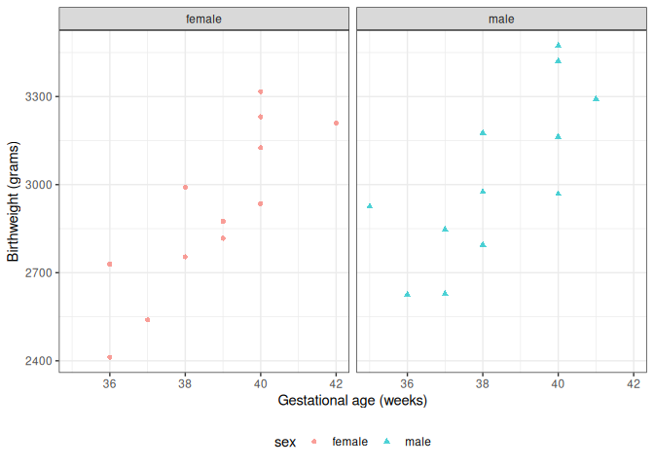
Figure 1: birthweight data (Dobson and Barnett (2018) Example 2.2.2)

2.3.4 Data notation
Let’s define some notation to represent this data:
- $Y$: birthweight (measured in grams)
- $S$: chromosomal sex: “male” (XY) or “female” (XX)
- $M$: indicator variable for $S$ = “male”
  - $M=0$ if $S$ = “female”
  - $M=1$ if $S$ = “male”
- $F$: indicator variable for $S$ = “female”
  - $F=1$ if $S$ = “female”
  - $F=0$ if $S$ = “male”
- $A$: estimated gestational age at birth (measured in weeks).
Female is the reference level for the categorical variable $S$ (chromosomal sex) and corresponding indicator variable $M$ . The choice of a reference level is arbitrary and does not limit what we can do with the resulting model; it only makes it more computationally convenient to make inferences about comparisons involving that reference group.
$M$ and $F$ are called dummy variables; together, they are a numeric representation of the categorical variable $S$. Dummy variables with values 0 and 1 are also called indicator variables. There are other ways to construct dummy variables, such as using the values -1 and 1 (see Dobson and Barnett (2018) §2.4 for details).

2.4 Parallel lines regression
c.f. Dunn and Smyth (2018) §2.10.3.
We don’t have enough data to model the distribution of birth weight separately for each combination of gestational age and sex, so let’s instead consider a (relatively) simple model for how that distribution varies with gestational age and sex:
$$\begin{aligned}Y|M,A& ∼_{ciid} N(μ(M,A),σ^{2}) \\ μ(m,a)&=β_{0}+β_{M}m+β_{A}a\end{aligned} (1)$$
Table 3 shows the parameter estimates from R. Figure 2 shows the estimated model, superimposed on the data.
Table 3: Regression parameter estimates for Model 1 of birthweight data
bw_lm1 <- lm(
formula = weight ~ sex + age,
data = bw
)
library(parameters)
bw_lm1 |>
parameters::parameters() |>
parameters::print_md(
include_reference = include_reference_lines,
select = "{estimate}"
)
Parameter | Coefficient
(Intercept) | -1773.32
sex (male) | 163.04
age | 120.89

bw <-
bw |>
mutate(`E[Y|X=x]` = fitted(bw_lm1)) |>
arrange(sex, age)
plot2 <-
plot1 %+% bw +
geom_line(aes(y = `E[Y|X=x]`))
print(plot2)
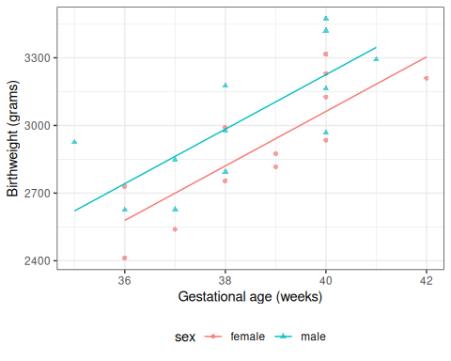
Figure 2: Graph of Model 1 for birthweight data

2.4.1 Model assumptions and predictions
To learn what this model is assuming, let’s plug in a few values.

Exercise 1 What’s the mean birthweight for a female born at 36 weeks?
Estimated coefficients for model 1
Parameter | Coefficient
(Intercept) | -1773.32
sex (male) | 163.04
age | 120.89

Solution
Solution.
Estimated coefficients for model 1
Parameter | Coefficient
(Intercept) | -1773.32
sex (male) | 163.04
age | 120.89
pred_female <- coef(bw_lm1)["(Intercept)"] + coef(bw_lm1)["age"] * 36
## or using built-in prediction:
pred_female_alt <- predict(bw_lm1, newdata = tibble(sex = "female", age = 36))
$$\begin{aligned}E[Y|M=0,A=36]&=β_{0}+​\left(β_{M}⋅0\right)​+​\left(β_{A}⋅36\right)​ \\ &=−1773.321839+​\left(163.039303⋅0\right)​+​\left(120.894327⋅36\right)​ \\ &=2578.873934\end{aligned}$$

Exercise 2 What’s the mean birthweight for a male born at 36 weeks?
Estimated coefficients for model 1
Parameter | Coefficient
(Intercept) | -1773.32
sex (male) | 163.04
age | 120.89

Solution
Solution.
Estimated coefficients for model 1
Parameter | Coefficient
(Intercept) | -1773.32
sex (male) | 163.04
age | 120.89
pred_male <-
coef(bw_lm1)["(Intercept)"] +
coef(bw_lm1)["sexmale"] +
coef(bw_lm1)["age"] * 36
$$\begin{aligned}E[Y|M=1,A=36]&=β_{0}+β_{M}⋅1+β_{A}⋅36 \\ &=2741.913237\end{aligned}$$

Exercise 3 What’s the difference in mean birthweights between males born at 36 weeks and females born at 36 weeks?
coef(bw_lm1)
#> (Intercept) sexmale age
#> -1773.322 163.039 120.894

Solution
Solution.
$$\begin{aligned}&E[Y|M=1,A=36]−E[Y|M=0,A=36] \\ &=2741.913237−2578.873934 \\ &=163.039303\end{aligned}$$
Shortcut:
$$\begin{aligned}&E[Y|M=1,A=36]−E[Y|M=0,A=36] \\ &=(β_{0}+β_{M}⋅1+β_{A}⋅36)−(β_{0}+β_{M}⋅0+β_{A}⋅36) \\ &=β_{M} \\ &=163.039303\end{aligned}$$

Age cancels out in this difference. In other words, according to this model, the difference between females and males with the same gestational age is the same for every age.
This characteristic is an assumption of the model specified by Equation 1. It’s hardwired into the parametric model structure, even before we estimated values for those parameters.

2.4.2 Coefficient Interpretation
Recall Model 1:
$$E[Y|M=m,A=a]=μ(m,a)=β_{0}+β_{M}m+β_{A}a$$
Slope (of the mean with respect to age) for males:
$$\begin{aligned}\frac{d}{da}μ(1,a)&=\frac{d}{da}(β_{0}+β_{M}⋅1+β_{A}⋅a) \\ &=\left(\frac{d}{da}β_{0}+\frac{d}{da}β_{M}⋅1+\frac{d}{da}(β_{A}⋅a)\right) \\ &=(0+0+β_{A}) \\ &=β_{A}\end{aligned}$$
Slope for females:
$$\begin{aligned}\frac{d}{da}μ(0,a)&=\frac{d}{da}(β_{0}+β_{M}⋅0+β_{A}⋅a) \\ &=\left(\frac{d}{da}β_{0}+\frac{d}{da}β_{M}⋅0+\frac{d}{da}(β_{A}⋅a)\right) \\ &=(0+0+β_{A}) \\ &=β_{A}\end{aligned}$$

Exercise 4 What is the interpretation of $β_{A}$ in Model 1?

Solution
Solution.
$$\begin{aligned}\frac{d}{da}μ(m,a)&=\frac{d}{da}(β_{0}+β_{M}⋅m+β_{A}⋅a) \\ &=\left(\frac{d}{da}β_{0}+\frac{d}{da}β_{M}⋅m+\frac{d}{da}(β_{A}⋅a)\right) \\ &=(0+0+β_{A}) \\ &=β_{A}\end{aligned}$$
Conclusion:
$$β_{A}=\frac{d}{da}μ(m,a)$$

$β_{A}$ is the slope of mean birthweight with respect to gestational age, adjusting for sex.
Or we can plug in the definition of slope:
$$β_{A}=E[Y|M=m,A=a+1]−E[Y|M=m,A=a]$$
Exchangeability and consistency have not been assessed; so we are not discussing potential outcomes (causality), only observed outcomes.

Exercise 5 What is the interpretation of $β_{M}$ in Model 1?

Solution
Solution.
More precisely written:
$$E​\left[Y|M=m,A=a\right]​=μ(m,a)=\{\begin{matrix}β_{0}+β_{M}m+β_{A}a, & \text{for }m∈​\left\{0,1\right\}​ \\ \text{undefined}, & \text{for }m∉​\left\{0,1\right\}​\end{matrix}$$
The model is undefined for $m∉​\left\{0,1\right\}​$, so the derivative with respect to $m$ doesn’t exist.
$$\begin{aligned}E[Y|M=1,A=a]&=β_{0}+β_{M}1+β_{A}a \\ &=β_{0}+β_{M}+β_{A}a \\ E[Y|M=0,A=a]&=β_{0}+β_{M}0+β_{A}a \\ &=β_{0}+β_{A}a\end{aligned}$$
So:
$$\begin{aligned}E[Y|M=1,A=a]−E[Y|M=0,A=a]&=(β_{0}+β_{M}+β_{A}a)−(β_{0}+β_{A}a) \\ &=β_{M}\end{aligned}$$
Therefore:
$$\begin{aligned}β_{M}&=E[Y|M=1,A=a]−E[Y|M=0,A=a] \\ &=μ(1,a)−μ(0,a) \\ \end{aligned}$$
In words: $β_{M}$ is the difference in mean birthweight between males and females adjusting for age.

Exercise 6 $β_{0}=?$

Solution
Solution.
$$\begin{aligned}E​\left[Y|M=0,A=0\right]​&=μ(0,0) \\ &=β_{0}+β_{M}0+β_{A}0 \\ &=β_{0} \\ β_{0}&=E​\left[Y|M=0,A=0\right]​=μ(0,0)\end{aligned}$$
$β_{0}$ is the mean birthweight for a female with gestational age 0 weeks.

2.5 Interactions
What if we don’t like that parallel lines assumption?
Then we need to allow an “interaction” between age $A$ and sex $S$:
$$E[Y|S=s,A=a]=β_{0}+β_{A}a+β_{M}m+β_{AM}(a⋅m) (2)$$
Now, the slope of mean birthweight $E[Y|A,S]$ with respect to gestational age $A$ depends on the value of sex $S$.
bw_lm2 <- lm(weight ~ sex + age + sex:age, data = bw)
bw_lm2 |>
parameters() |>
parameters::print_md(
include_reference = include_reference_lines,
select = "{estimate}"
)
Table 4: Birthweight model with interaction term
Parameter | Coefficient
(Intercept) | -2141.67
sex (male) | 872.99
age | 130.40
sex (male) × age | -18.42

bw <-
bw |>
mutate(
predlm2 = predict(bw_lm2)
) |>
arrange(sex, age)
plot1_interact <-
plot1 %+% bw +
geom_line(aes(y = predlm2))
print(plot1_interact)
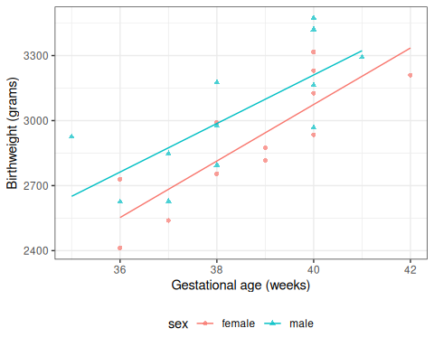
Figure 3: Birthweight model with interaction term
Now we can see that the lines aren’t parallel.

Here’s another way we could rewrite this model (by collecting terms involving $S$):
$$E[Y|M,A]=β_{0}+β_{M}M+(β_{A}+β_{AM}M)A$$
If you want to understand a coefficient in a model with interactions, collect terms for the corresponding variable, and you will see which other covariates interact with the variable whose coefficient you are interested in. In this case, the association between $A$ (age) varies between males and females (that is, by sex $S$). So the slope of $Y$ with respect to $A$ depends on the value of $M$. According to this model, there is no such thing as “the slope of birthweight with respect to age”. There are two slopes, one for each sex. We can only talk about “the slope of birthweight with respect to age among males” and “the slope of birthweight with respect to age among females”. Then: each non-interaction slope coefficient is the difference in means per unit difference in its corresponding variable, when all interacting variables are set to 0.

To learn what this model is assuming, let’s plug in a few values.
Exercise 7 According to this model, what’s the mean birthweight for a female born at 36 weeks?
Parameter | Coefficient
(Intercept) | -2141.67
sex (male) | 872.99
age | 130.40
sex (male) × age | -18.42

Solution
Solution.
Parameter | Coefficient
(Intercept) | -2141.67
sex (male) | 872.99
age | 130.40
sex (male) × age | -18.42
pred_female <- coef(bw_lm2)["(Intercept)"] + coef(bw_lm2)["age"] * 36
$$E[Y|M=0,A=36]=β_{0}+β_{M}⋅0+β_{A}⋅36+β_{AM}⋅(0*36)=2552.733333$$

Exercise 8 What’s the mean birthweight for a male born at 36 weeks?
Parameter | Coefficient
(Intercept) | -2141.67
sex (male) | 872.99
age | 130.40
sex (male) × age | -18.42

Solution
Solution.
Parameter | Coefficient
(Intercept) | -2141.67
sex (male) | 872.99
age | 130.40
sex (male) × age | -18.42
pred_male <-
coef(bw_lm2)["(Intercept)"] +
coef(bw_lm2)["sexmale"] +
coef(bw_lm2)["age"] * 36 +
coef(bw_lm2)["sexmale:age"] * 36
$$\begin{aligned}E[Y|M=1,A=36]&=β_{0}+β_{M}⋅1+β_{A}⋅36+β_{AM}⋅1⋅36 \\ &=2762.706897\end{aligned}$$

Exercise 9 What’s the difference in mean birthweights between males born at 36 weeks and females born at 36 weeks?

Solution
Solution.
$$\begin{aligned}&E[Y|M=1,A=36]−E[Y|M=0,A=36] \\ &=(β_{0}+β_{M}⋅1+β_{A}⋅36+β_{AM}⋅1⋅36) \\ & −(β_{0}+β_{M}⋅0+β_{A}⋅36+β_{AM}⋅0⋅36) \\ &=β_{M}+β_{AM}⋅36 \\ &=209.973563\end{aligned}$$

Note that age now does show up in the difference: in other words, according to this model, the difference in mean birthweights between females and males with the same gestational age can vary by gestational age.
That’s how the lines in the graph ended up non-parallel.

2.5.1 Coefficient Interpretation
Exercise 10 What is the interpretation of $β_{M}$ in Model 2?

Solution
Solution.
Mean birthweight among males with gestational age 0 weeks:
$$\begin{aligned}μ(1,0)&=E​\left[Y|M=1,A=0\right]​ \\ &=β_{0}+β_{M}⋅1+β_{A}⋅0+β_{AM}⋅1⋅0 \\ &=β_{0}+β_{M}\end{aligned}$$
Mean birthweight among females with gestational age 0 weeks:
$$\begin{aligned}μ(0,0)&=E​\left[Y|M=0,A=0\right]​ \\ &=β_{0}+β_{M}⋅0+β_{A}⋅0+β_{AM}⋅0⋅0 \\ &=β_{0}\end{aligned}$$
$$\begin{aligned}β_{M}&=μ(1,0)−μ(0,0) \\ &=E​\left[Y|M=1,A=0\right]​−E​\left[Y|M=0,A=0\right]​\end{aligned}$$
$β_{M}$ is the difference in mean birthweight between males with gestational age 0 weeks and females with gestational age 0 weeks.

Exercise 11 What is the interpretation of $β_{AM}$ in Model 2?

Solution
Solution.
Slope among males:
$$\begin{aligned}\frac{∂}{∂a}μ(1,a)&=\frac{∂}{∂a}\left(β_{0}+β_{M}⋅1+β_{A}⋅a+β_{AM}⋅1⋅a\right) \\ &=\frac{∂}{∂a}\left(β_{0}+β_{M}+β_{A}⋅a+β_{AM}⋅a\right) \\ &=β_{A}+β_{AM}\end{aligned}$$
or
$$\begin{aligned}E[Y|1,a+1]−E[Y|1,a]=&β_{0}+β_{M}⋅1+β_{A}⋅(a+1)+β_{AM}⋅1⋅(a+1) \\ &−(β_{0}+β_{M}⋅1+β_{A}⋅a+β_{AM}⋅1⋅a) \\ =&β_{A}+β_{AM}\end{aligned}$$
Slope among females:
$$\begin{aligned}\frac{∂}{∂a}μ(0,a)&=\frac{∂}{∂a}\left(β_{0}+β_{M}⋅0+β_{A}⋅a+β_{AM}⋅0⋅a\right) \\ &=\frac{∂}{∂a}\left(β_{0}+β_{A}⋅a\right) \\ &=β_{A} \\ \end{aligned}$$
or
$$\begin{aligned}E[Y|0,a+1]−E[Y|0,a]=&β_{0}+β_{M}⋅0+β_{A}⋅(a+1)+β_{AM}⋅0⋅(a+1) \\ &−(β_{0}+β_{M}⋅0+β_{A}⋅a+β_{AM}⋅0⋅a) \\ =&β_{0}+β_{A}⋅(a+1)−(β_{0}+β_{A}⋅a) \\ =&β_{A}\end{aligned}$$
Difference in slopes:
$$\begin{aligned}\frac{∂}{∂a}μ(1,a)−\frac{∂}{∂a}μ(0,a)&=β_{A}+β_{AM}−β_{A} \\ &=β_{AM}\end{aligned}$$
or
$$\begin{aligned}(E[Y|1,a+1]−E[Y|1,a])−(E[Y|0,a+1]−E[Y|0,a])&=β_{A}+β_{AM}−β_{A} \\ &=β_{AM}\end{aligned}$$
Therefore
$$\begin{aligned}β_{AM}=&\frac{∂}{∂a}μ(1,a)−\frac{∂}{∂a}μ(0,a) \\ =&(E[Y|M=1,A=a+1]−E[Y|M=1,A=a]) \\ &−(E[Y|M=0,A=a+1]−E[Y|M=0,A=a])\end{aligned}$$
$β_{AM}$ is the difference in slope of mean birthweight with respect to gestational age between males and females.

2.5.2 Compare coefficient interpretations
Table 5: Coefficient interpretations, by model structure
$μ(m,a)$​ | $β_{0}+β_{M}m+β_{A}a$​ | $β_{0}+β_{M}m+β_{A}a+β_{AM}ma$​
$β_{0}$​ | $μ(0,0)$​ | $μ(0,0)$​
$β_{A}$​ | $\frac{∂}{∂a}μ(m,a)$​ | $\frac{∂}{∂a}μ(0,a)$​
$β_{M}$​ | $μ(1,a)−μ(0,a)$​ | $μ(1,0)−μ(0,0)$​
$β_{AM}$​ |  | $\frac{∂}{∂a}μ(1,a)−\frac{∂}{∂a}μ(0,a)$​

In the model with an interaction term multiplying $A×M$, the interpretation of $β_{A}$ involves the reference level of $M$, and interpretation of $β_{M}$ involves the reference level of $A$ (Table 5).

2.5.3 General procedure for interpreting coefficients
Definition 2 (General procedure for interpreting a regression coefficient) To derive the interpretation of coefficient $β_{j}$ in a model with linear predictor $η(\tilde{x})=η(x_{1},…,x_{p})$:
- Write down the linear predictor $η(x_{1},…,x_{p})$.
- Differentiate or difference $η$ with respect to $x_{j}$:
  - If $x_{j}$ is continuous: compute the partial derivative $\frac{∂}{∂x_{j}}η(\tilde{x})$.
  - If $x_{j}$ is discrete: compute the one-unit difference $η(\tilde{x})|_{x_{j}=a+1}−η(\tilde{x})|_{x_{j}=a}$.
- For an interaction coefficient $β_{jk}$ (multiplying the product $x_{j}⋅x_{k}$), apply this step twice in sequence: first differentiate or difference $η$ with respect to $x_{j}$ to obtain the slope of $x_{j}$ as a function of $x_{k}$; then differentiate or difference that slope with respect to $x_{k}$ (choosing continuous/discrete as appropriate for $x_{k}$) to obtain the change in slopes, which equals $β_{jk}$.
- If any covariates remain, set them to their reference levels. If covariates other than the one(s) used in step 2 still appear in the resulting expression, substitute each covariate’s reference level for it. This substitution eliminates the corresponding interaction terms and isolates $β_{j}$ alone on the right-hand side.
- Identify $β_{j}$: the expression from the previous steps equals $β_{j}$; write $β_{j}=⋯$ to state the interpretation explicitly.
Special case — intercept ($β_{0}$): If the coefficient of interest is the intercept $β_{0}$, skip step 2. Apply step 3 directly by setting all covariates to their reference levels: $β_{0}=η(\text{reference pattern})$.
This procedure gives the interpretation on the linear predictor scale. For Gaussian linear regression (identity link), $η(\tilde{x})=E​\left[Y|\tilde{x}\right]​$, so the resulting interpretation is directly on the mean outcome scale. For other GLMs and for proportional hazards models, the linear predictor is a transformed version of the mean (e.g., the log-odds for logistic regression, the log-rate for Poisson regression, or the log-hazard for Cox models), so an additional step — applying the inverse link or exponentiating — translates the interpretation to the scale of the outcome.
The reference covariate pattern used in step 3 is not arbitrary: setting remaining covariates to $0$ is correct when $0$ is their reference level (as coded in the model). If the reference level for some covariate is not $0$, substitute the actual reference value instead.
Exm
Example 1 (Applying the procedure to Model 1) For the birthweight parallel-lines model
$$E​\left[Y|M=m,A=a\right]​=β_{0}+β_{M}m+β_{A}a,$$
where $M∈\{0,1\}$ (sex; $1$ = male, $0$ = female) and $A$ is gestational age (weeks):
$β_{A}$ (gestational age, continuous): $\frac{∂}{∂a}η(m,a)=β_{A}$, so $β_{A}=\frac{∂}{∂a}E​\left[Y|M=m,A=a\right]​$. (Step 3 not needed: no remaining covariates appear after differentiating.)
$β_{M}$ (sex, discrete):
$$\begin{aligned}η(m,a)|_{m=1}−η(m,a)|_{m=0}&=(β_{0}+β_{M}+β_{A}a)−(β_{0}+β_{A}a) \\ &=β_{M},\end{aligned}$$
so $β_{M}=E​\left[Y|M=1,A=a\right]​−E​\left[Y|M=0,A=a\right]​$. (Step 3 not needed: $a$ cancels in the differencing, so the result holds for all values of $A$.)
$β_{0}$ (intercept, special case): Skip step 2; set $m=0$ and $a=0$ (the reference levels) in step 3: $β_{0}=η(0,0)=E​\left[Y|M=0,A=0\right]​$.

2.6 Stratified regression
We could re-write the interaction model as a stratified model, with a slope and intercept for each sex:
$$E​\left[Y|A=a,S=s\right]​=β_{M}m+β_{AM}(a⋅m)+β_{F}f+β_{AF}(a⋅f) (3)$$
Compare this stratified model (Equation 3) with our interaction model, Equation 2:
$$E​\left[Y|A=a,S=s\right]​=β_{0}+β_{A}a+β_{M}m+β_{AM}(a⋅m)$$
In the stratified model, the intercept term $β_{0}$ has been relabeled as $β_{F}$.
bw_lm2 <- lm(weight ~ sex + age + sex:age, data = bw)
bw_lm2 |>
parameters() |>
print_md(
include_reference = include_reference_lines,
select = "{estimate}"
)
Table 6: Birthweight model with interaction term
Parameter | Coefficient
(Intercept) | -2141.67
sex (male) | 872.99
age | 130.40
sex (male) × age | -18.42

bw_lm_strat <-
bw |>
lm(
formula = weight ~ sex + sex:age - 1,
data = _
)
bw_lm_strat |>
parameters() |>
print_md(
select = "{estimate}"
)
Table 7: Birthweight model - stratified betas
Parameter | Coefficient
sex (female) | -2141.67
sex (male) | -1268.67
sex (female) × age | 130.40
sex (male) × age | 111.98

2.7 Curved-line regression
If we transform some of our covariates ($X$s) and plot the resulting model on the original covariate scale, we end up with curved regression lines:
bw_lm3 <- lm(weight ~ sex:log(age) - 1, data = bw)
ggbw <-
bw |>
ggplot(
aes(x = age, y = weight)
) +
geom_point() +
xlab("Gestational Age (weeks)") +
ylab("Birth Weight (g)")
ggbw2 <- ggbw +
stat_smooth(
method = "lm",
formula = y ~ log(x),
geom = "smooth"
) +
xlab("Gestational Age (weeks)") +
ylab("Birth Weight (g)")
ggbw2 |> print()
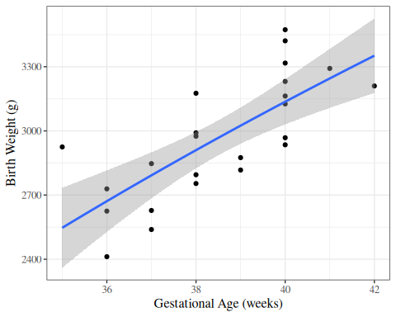
Figure 4: birthweight model with age entering on log scale

Figure 5 displays an example with a slightly more obvious curve.
library(palmerpenguins)
ggpenguins <-
palmerpenguins::penguins |>
dplyr::filter(species == "Adelie") |>
ggplot(
aes(x = bill_length_mm, y = body_mass_g)
) +
geom_point() +
xlab("Bill length (mm)") +
ylab("Body mass (g)")
ggpenguins2 <- ggpenguins +
stat_smooth(
method = "lm",
formula = y ~ log(x),
geom = "smooth"
) +
xlab("Bill length (mm)") +
ylab("Body mass (g)")
ggpenguins2 |> print()
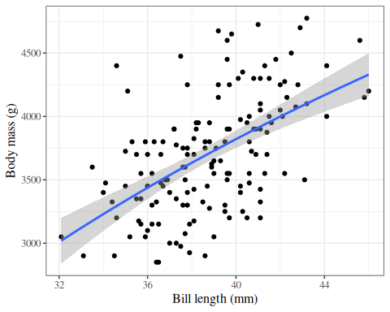
Figure 5: palmerpenguins model with bill_length entering on log scale

2.8 Rescaling
Centering covariates (subtracting a constant from them) can make coefficient interpretations more meaningful, particularly for the intercept and main effect terms in models with interactions.

2.8.1 Rescale age
For example, the intercept $β_{0}$ in our interaction model represents the mean birthweight for females at age = 0 weeks, which is not a biologically plausible scenario. If we center age at 36 weeks instead, $β_{0}$ will represent the mean birthweight for females at 36 weeks, which is more interpretable.

Exercise 12 Let $A^{*}=A−32$ weeks.
Consider a new version of Model 2, with $A^{*}$ in place of $A$:
$$E​\left[Y|M=m,A^{*}=a^{*}\right]​=γ_{0}+γ_{M}m+γ_{A^{*}}a^{*}+γ_{A^{*}M}(m⋅a^{*}) (4)$$
Let the coefficients of this model be $γ$s instead of $β$s.
What are the interpretations of the $γ$s? How do they relate to the $β$s in Model 2? Which have the same interpretation? Which are different, and how do they differ? What is the pattern?

Solution
Solution. Interpretation of $γ_{0}$:
From Model 4, $γ_{0}$ is the mean birthweight among females ($M=0$) with $A^{*}=0$ (i.e., $A=32$ weeks):
$$γ_{0}=E​\left[Y|M=0,A^{*}=0\right]​=E​\left[Y|M=0,A=32\right]​$$
Substituting into Model 2:
$$\begin{aligned}γ_{0}&=β_{0}+β_{M}⋅0+β_{A}⋅32+β_{AM}⋅0⋅32 \\ &=β_{0}+32β_{A}\end{aligned}$$
This centered intercept parameter differs from $β_{0}=E​\left[Y|M=0,A=0\right]​$, which is the mean birthweight among females at $A=0$ weeks.
Interpretation of $γ_{M}$:
From Model 4, $γ_{M}$ is the sex difference in mean birthweight at $A^{*}=0$ (i.e., $A=32$ weeks):
$$\begin{aligned}γ_{M}&=E​\left[Y|M=1,A^{*}=0\right]​−E​\left[Y|M=0,A^{*}=0\right]​ \\ &=E​\left[Y|M=1,A=32\right]​−E​\left[Y|M=0,A=32\right]​\end{aligned}$$
Substituting into Model 2:
$$\begin{aligned}γ_{M}&=(β_{0}+β_{M}+β_{A}⋅32+β_{AM}⋅32)−(β_{0}+β_{A}⋅32) \\ &=β_{M}+32β_{AM}\end{aligned}$$
This male main-effect parameter differs from $β_{M}$, which is the sex difference at $A=0$ weeks.
Interpretation of $γ_{A^{*}}$:
From Model 4, $γ_{A^{*}}$ is the slope of mean birthweight with respect to $A^{*}$ among females ($M=0$):
$$\begin{aligned}γ_{A^{*}}&=\frac{d}{da^{*}}E​\left[Y|M=0,A^{*}=a^{*}\right]​ \\ &=\frac{d}{da^{*}}E​\left[Y|M=0,A=a^{*}+32\right]​ \\ &=\frac{d}{da}E​\left[Y|M=0,A=a\right]​\end{aligned}$$
Substituting into Model 2:
$$\begin{aligned}γ_{A^{*}}&=\frac{d}{da}\left(β_{0}+β_{A}⋅a\right) \\ &=β_{A}\end{aligned}$$
Since shifting $A$ by a constant does not change the slope, $γ_{A^{*}}=β_{A}$: these two coefficients have the same value and interpretation.
Interpretation of $γ_{A^{*}M}$:
From Model 4, $γ_{A^{*}M}$ is the difference in slope with respect to $A^{*}$ between males and females:
$$\begin{aligned}γ_{A^{*}M}&=\frac{d}{da^{*}}E​\left[Y|M=1,A^{*}=a^{*}\right]​−\frac{d}{da^{*}}E​\left[Y|M=0,A^{*}=a^{*}\right]​ \\ &=\frac{d}{da}E​\left[Y|M=1,A=a\right]​−\frac{d}{da}E​\left[Y|M=0,A=a\right]​\end{aligned}$$
Substituting into Model 2:
$$\begin{aligned}γ_{A^{*}M}&=(β_{A}+β_{AM})−β_{A} \\ &=β_{AM}\end{aligned}$$
Since shifting $A$ by a constant does not change slopes, $γ_{A^{*}M}=β_{AM}$: these two coefficients have the same value and interpretation.
The pattern:
Slope coefficients ($γ_{A^{*}}$ and $γ_{A^{*}M}$) are unchanged by rescaling: they have the same values and interpretations as the corresponding $β$s.
Coefficients change only for variables that have interactions with the rescaled variable $A$. This set of modified coefficients includes the intercept (which can be viewed as the main effect of a variable that interacts with $A$ via $β_{A}$), and the main effect of $M$ (which interacts with $A$ via $β_{AM}$). Shifting $A$ by 32 weeks changes the reference point from $A=0$ to $A=32$, so these coefficients now represent quantities evaluated at $A=32$ weeks rather than at $A=0$ weeks.

Exercise 13 Using R, fit the rescaled interaction model with $A^{*}=A−36$ weeks in place of $A$ in Model 2. Compare the coefficient estimates with those from the original model. Which coefficients change, and which remain the same?

Solution
Solution.
bw <-
bw |>
mutate(
`age - mean` = age - mean(age),
`age - 36wks` = age - 36
)
lm1_c <- lm(weight ~ sex + `age - 36wks`, data = bw)
lm2_c <- lm(weight ~ sex + `age - 36wks` + sex:`age - 36wks`, data = bw)
parameters(lm2_c, ci_method = "wald") |> print_md()
Parameter | Coefficient | SE | 95% CI | t(20) | p
(Intercept) | 2552.73 | 97.59 | (2349.16, 2756.30) | 26.16 | < .001
sex (male) | 209.97 | 129.75 | (-60.68, 480.63) | 1.62 | 0.121
age - 36wks | 130.40 | 30.00 | (67.82, 192.98) | 4.35 | < .001
sex (male) × age - 36wks | -18.42 | 41.76 | (-105.52, 68.68) | -0.44 | 0.664
Compare with what we got without rescaling:
parameters(bw_lm2, ci_method = "wald") |> print_md()
Parameter | Coefficient | SE | 95% CI | t(20) | p
(Intercept) | -2141.67 | 1163.60 | (-4568.90, 285.56) | -1.84 | 0.081
sex (male) | 872.99 | 1611.33 | (-2488.18, 4234.17) | 0.54 | 0.594
age | 130.40 | 30.00 | (67.82, 192.98) | 4.35 | < .001
sex (male) × age | -18.42 | 41.76 | (-105.52, 68.68) | -0.44 | 0.664
Notice that the slope coefficients (age - 36wks and sexmale:age - 36wks) remain the same, but the intercept and sexmale coefficient have changed to reflect means at age = 36 weeks rather than age = 0 weeks.

2.8.2 Centering gestational age does not change predictions
Centering gestational age changes the coefficient parameterization, but it does not change fitted values, confidence bands, or prediction bands.
The next output reports maximum absolute differences between the uncentered and centered models. All values should be near zero (up to floating-point rounding), which confirms that centering changes parameterization only.
bw_centered <-
bw |>
dplyr::mutate(
age_mean_centered = age - mean(age)
)
bw_lm2_centered <-
lm(
weight ~ sex + age_mean_centered + sex:age_mean_centered,
data = bw_centered
)
pred_uncentered_ci <-
predict(
bw_lm2,
newdata = bw_centered,
interval = "confidence"
) |>
tibble::as_tibble()
pred_centered_ci <-
predict(
bw_lm2_centered,
newdata = bw_centered,
interval = "confidence"
) |>
tibble::as_tibble()
pred_uncentered_pi <-
predict(
bw_lm2,
newdata = bw_centered,
interval = "predict"
) |>
tibble::as_tibble()
pred_centered_pi <-
predict(
bw_lm2_centered,
newdata = bw_centered,
interval = "predict"
) |>
tibble::as_tibble()
tibble::tibble(
fitted_max_abs_diff = max(abs(pred_uncentered_ci$fit - pred_centered_ci$fit)),
ci_lwr_max_abs_diff = max(abs(pred_uncentered_ci$lwr - pred_centered_ci$lwr)),
ci_upr_max_abs_diff = max(abs(pred_uncentered_ci$upr - pred_centered_ci$upr)),
pi_lwr_max_abs_diff = max(abs(pred_uncentered_pi$lwr - pred_centered_pi$lwr)),
pi_upr_max_abs_diff = max(abs(pred_uncentered_pi$upr - pred_centered_pi$upr))
)
#> # A tibble: 1 × 5
#> fitted_max_abs_diff ci_lwr_max_abs_diff ci_upr_max_abs_diff
#> <dbl> <dbl> <dbl>
#> 1 4.09e-12 5.00e-12 3.18e-12
#> # ℹ 2 more variables: pi_lwr_max_abs_diff <dbl>, pi_upr_max_abs_diff <dbl>
comparison_plot_data <-
dplyr::bind_rows(
bw_centered |>
dplyr::bind_cols(
pred_uncentered_ci |>
dplyr::transmute(
fit,
ci_lwr = lwr,
ci_upr = upr
),
pred_uncentered_pi |>
dplyr::transmute(
pred_lwr = lwr,
pred_upr = upr
)
) |>
dplyr::transmute(
age,
weight,
sex,
model = "Without centering age",
fit,
ci_lwr,
ci_upr,
pred_lwr,
pred_upr
),
bw_centered |>
dplyr::bind_cols(
pred_centered_ci |>
dplyr::transmute(
fit,
ci_lwr = lwr,
ci_upr = upr
),
pred_centered_pi |>
dplyr::transmute(
pred_lwr = lwr,
pred_upr = upr
)
) |>
dplyr::transmute(
age,
weight,
sex,
model = "With centered age",
fit,
ci_lwr,
ci_upr,
pred_lwr,
pred_upr
)
) |>
dplyr::mutate(
model = factor(
model,
levels = c("Without centering age", "With centered age")
)
)
comparison_plot_data |>
ggplot2::ggplot(
ggplot2::aes(
x = age,
y = weight,
col = sex,
fill = sex,
group = sex
)
) +
ggplot2::geom_point(alpha = 0.5) +
ggplot2::geom_ribbon(
ggplot2::aes(
ymin = pred_lwr,
ymax = pred_upr
),
alpha = 0.15,
col = NA
) +
ggplot2::geom_ribbon(
ggplot2::aes(
ymin = ci_lwr,
ymax = ci_upr
),
alpha = 0.3,
col = NA
) +
ggplot2::geom_line(
ggplot2::aes(y = fit)
) +
ggplot2::facet_wrap(~model) +
ggplot2::theme_bw() +
ggplot2::theme(legend.position = "bottom") +
ggplot2::labs(
x = "Gestational age (weeks)",
y = "Birthweight (grams)",
col = "Sex",
fill = "Sex"
)
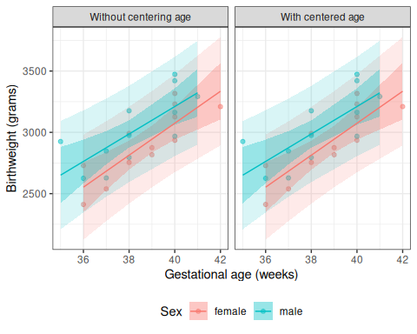
Figure 6: Two-panel comparison of the fitted birthweight model bw_lm2 with and without centering gestational age, showing identical fitted values, confidence bands, and prediction bands in both panels.

2.9 Categorical covariates with more than two levels

2.9.1 Example: birthweight
In the birthweight example, the variable sex had only two observed values:
unique(bw$sex)
#> [1] female male
#> Levels: female male
If there are more than two observed values, we can’t just use a single variable with 0s and 1s.

2.9.2 Example: iris
For example, Table 8 shows the (in)famous iris data (Anderson (1935)), and Table 9 provides summary statistics. The data include three species: “setosa”, “versicolor”, and “virginica”.
Table 8: The iris data
head(iris)
#> # A tibble: 6 × 5
#> Sepal.Length Sepal.Width Petal.Length Petal.Width Species
#> <dbl> <dbl> <dbl> <dbl> <fct>
#> 1 5.1 3.5 1.4 0.2 setosa
#> 2 4.9 3 1.4 0.2 setosa
#> 3 4.7 3.2 1.3 0.2 setosa
#> 4 4.6 3.1 1.5 0.2 setosa
#> 5 5 3.6 1.4 0.2 setosa
#> 6 5.4 3.9 1.7 0.4 setosa

Table 9: Summary statistics for the iris data
library(table1)
table1(
x = ~ . | Species,
data = iris,
overall = FALSE
)
#> # A tibble: 13 × 4
#> ` ` setosa versicolor virginica
#> <chr> <chr> <chr> <chr>
#> 1 "" "(N=50)" "(N=50)" "(N=50)"
#> 2 "Sepal.Length" "" "" ""
#> 3 " Mean (SD)" "5.01 (0.352)" "5.94 (0.516)" "6.59 (0.63…
#> 4 " Median [Min, Max]" "5.00 [4.30, 5.80]" "5.90 [4.90, 7.00]" "6.50 [4.90…
#> 5 "Sepal.Width" "" "" ""
#> 6 " Mean (SD)" "3.43 (0.379)" "2.77 (0.314)" "2.97 (0.32…
#> 7 " Median [Min, Max]" "3.40 [2.30, 4.40]" "2.80 [2.00, 3.40]" "3.00 [2.20…
#> 8 "Petal.Length" "" "" ""
#> 9 " Mean (SD)" "1.46 (0.174)" "4.26 (0.470)" "5.55 (0.55…
#> 10 " Median [Min, Max]" "1.50 [1.00, 1.90]" "4.35 [3.00, 5.10]" "5.55 [4.50…
#> 11 "Petal.Width" "" "" ""
#> 12 " Mean (SD)" "0.246 (0.105)" "1.33 (0.198)" "2.03 (0.27…
#> 13 " Median [Min, Max]" "0.200 [0.100, 0.600]" "1.30 [1.00, 1.80]" "2.00 [1.40…

If we want to model Sepal.Length by species, we could create a variable $X$ that represents “setosa” as $X=1$, “virginica” as $X=2$, and “versicolor” as $X=3$.
Table 10: iris data with numeric coding of species
data(iris) # this step is not always necessary, but ensures you're starting
# from the original version of a dataset stored in a loaded package
iris <-
iris |>
tibble() |>
mutate(
X = case_when(
Species == "setosa" ~ 1,
Species == "virginica" ~ 2,
Species == "versicolor" ~ 3
)
)
iris |>
distinct(Species, X)
#> # A tibble: 3 × 2
#> Species X
#> <fct> <dbl>
#> 1 setosa 1
#> 2 versicolor 3
#> 3 virginica 2
Then we could fit a model like:
iris_lm1 <- lm(Sepal.Length ~ X, data = iris)
iris_lm1 |>
parameters() |>
print_md()
Table 11: Model of iris data with numeric coding of Species
Parameter | Coefficient | SE | 95% CI | t(148) | p
(Intercept) | 4.91 | 0.16 | (4.60, 5.23) | 30.83 | < .001
X | 0.46 | 0.07 | (0.32, 0.61) | 6.30 | < .001

Let’s see how that model looks:
iris_plot1 <- iris |>
ggplot(
aes(
x = X,
y = Sepal.Length
)
) +
geom_point(alpha = .1) +
geom_abline(
intercept = coef(iris_lm1)[1],
slope = coef(iris_lm1)[2]
) +
theme_bw(base_size = 18)
print(iris_plot1)
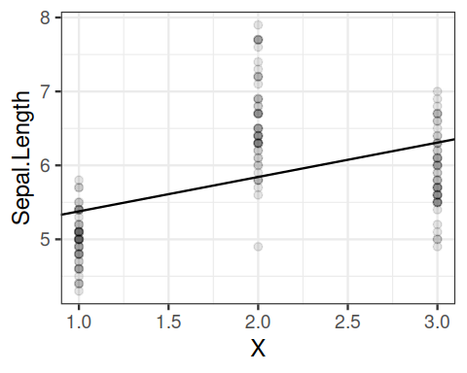
Figure 7: Model of iris data with numeric coding of Species
We have forced the model to use a straight line for the three estimated means. Maybe not a good idea?

2.9.3 Let’s see what R does with categorical variables by default:
iris_lm2 <- lm(Sepal.Length ~ Species, data = iris)
iris_lm2 |>
parameters() |>
print_md()
Table 12: Model of iris data with Species as a categorical variable
Parameter | Coefficient | SE | 95% CI | t(147) | p
(Intercept) | 5.01 | 0.07 | (4.86, 5.15) | 68.76 | < .001
Species (versicolor) | 0.93 | 0.10 | (0.73, 1.13) | 9.03 | < .001
Species (virginica) | 1.58 | 0.10 | (1.38, 1.79) | 15.37 | < .001

2.9.4 Re-parametrize with no intercept
If you don’t want the default and offset option, you can use “-1” like we’ve seen previously:
iris_lm2_no_int <- lm(Sepal.Length ~ Species - 1, data = iris)
iris_lm2_no_int |>
parameters() |>
print_md()
Table 13
Parameter | Coefficient | SE | 95% CI | t(147) | p
Species (setosa) | 5.01 | 0.07 | (4.86, 5.15) | 68.76 | < .001
Species (versicolor) | 5.94 | 0.07 | (5.79, 6.08) | 81.54 | < .001
Species (virginica) | 6.59 | 0.07 | (6.44, 6.73) | 90.49 | < .001

2.9.5 Let’s see what these new models look like:
iris_plot2 <-
iris |>
mutate(
predlm2 = predict(iris_lm2)
) |>
arrange(X) |>
ggplot(aes(x = X, y = Sepal.Length)) +
geom_point(alpha = .1) +
geom_line(aes(y = predlm2), col = "red") +
geom_abline(
intercept = coef(iris_lm1)[1],
slope = coef(iris_lm1)[2]
) +
theme_bw(base_size = 18)
print(iris_plot2)
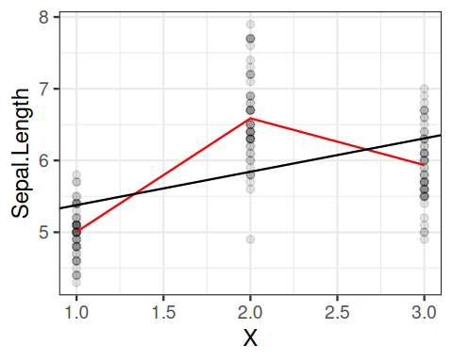
Figure 8

2.9.6 Let’s see how R did that:
Table 14
formula(iris_lm2)
#> Sepal.Length ~ Species
model.matrix(iris_lm2) |>
as_tibble() |>
unique()
#> # A tibble: 3 × 3
#> `(Intercept)` Speciesversicolor Speciesvirginica
#> <dbl> <dbl> <dbl>
#> 1 1 0 0
#> 2 1 1 0
#> 3 1 0 1
This format is called a “corner point parametrization” (e.g., in Dobson and Barnett (2018)) or “treatment coding” (e.g., in Dunn and Smyth (2018)).
The default contrasts are controlled by options("contrasts"):
options("contrasts")
#> $contrasts
#> unordered ordered
#> "contr.treatment" "contr.poly"
See ?options for more details.

Table 15
formula(iris_lm2_no_int)
#> Sepal.Length ~ Species - 1
model.matrix(iris_lm2_no_int) |>
as_tibble() |>
unique()
#> # A tibble: 3 × 3
#> Speciessetosa Speciesversicolor Speciesvirginica
#> <dbl> <dbl> <dbl>
#> 1 1 0 0
#> 2 0 1 0
#> 3 0 0 1
This format is called a “group point parametrization” (e.g., in Dobson and Barnett (2018)).
There are more options; see Dobson and Barnett (2018) §6.4.1 and the codingMatrices package vignette (Venables (2023)).

2.10 Ordinal covariates
(c.f. Dobson and Barnett (2018) §2.4.4)

We can create ordinal variables in R using the ordered() function.
Exm
Example 2 The hers data (Vittinghoff et al. 2012) is available in the rmb package:
hers <- rmb::hers |> haven::zap_labels()
Table 16: HERS data
hers |> head()
#> # A tibble: 6 × 37
#> HT age raceth nonwhite smoking drinkany exercise physact globrat poorfair
#> <dbl> <dbl> <dbl> <dbl> <dbl> <dbl> <dbl> <dbl> <dbl> <dbl>
#> 1 0 70 2 1 0 0 0 5 3 0
#> 2 0 62 2 1 0 0 0 1 3 0
#> 3 1 69 1 0 0 0 0 3 3 0
#> 4 0 64 1 0 1 1 0 1 3 0
#> 5 0 65 1 0 0 0 0 2 3 0
#> 6 1 68 2 1 0 1 0 3 3 0
#> # ℹ 27 more variables: medcond <dbl>, htnmeds <dbl>, statins <dbl>,
#> # diabetes <dbl>, dmpills <dbl>, insulin <dbl>, weight <dbl>, BMI <dbl>,
#> # waist <dbl>, WHR <dbl>, glucose <dbl>, weight1 <dbl>, BMI1 <dbl>,
#> # waist1 <dbl>, WHR1 <dbl>, glucose1 <dbl>, tchol <dbl>, LDL <dbl>,
#> # HDL <dbl>, TG <dbl>, tchol1 <dbl>, LDL1 <dbl>, HDL1 <dbl>, TG1 <dbl>,
#> # SBP <dbl>, DBP <dbl>, age10 <dbl>
The physact variable records each participant’s self-reported physical activity, relative to other women her age, on an ordered five-level scale (1 = much less active, …, 5 = much more active). We make it an ordered factor so that lm() uses polynomial contrasts, which respect the ordering, instead of the default treatment contrasts:
hers <- hers |>
dplyr::mutate(physact_ord = ordered(physact))
lm_physact <- lm(LDL ~ physact_ord, data = hers)
Table 17: Mean LDL by physical-activity level, using polynomial contrasts
lm_physact |>
parameters::model_parameters() |>
parameters::print_md()
Parameter | Coefficient | SE | 95% CI | t(2747) | p
(Intercept) | 144.71 | 0.85 | (143.05, 146.38) | 170.10 | < .001
physact ord (linear) | -0.31 | 2.29 | (-4.80, 4.18) | -0.14 | 0.892
physact ord (quadratic) | -1.86 | 2.05 | (-5.88, 2.15) | -0.91 | 0.363
physact ord (cubic) | 0.47 | 1.74 | (-2.94, 3.89) | 0.27 | 0.785
physact ord (4th degree) | -0.58 | 1.42 | (-3.36, 2.21) | -0.40 | 0.686

With polynomial contrasts, each coefficient summarizes a trend component across the ordered levels: the linear term measures the strength and direction of a straight-line (monotone) trend in mean LDL across the levels, and the quadratic and higher terms capture curvature. The contrasts are orthonormal, so the linear coefficient is scaled by the contrast normalization; it is not the raw change in mean LDL per level. Here the linear-trend coefficient is small and not statistically significant, so these data show little evidence of a monotone association between physical-activity level and mean LDL cholesterol.

For ordinal variables, we might want to use contrasts that respect the ordering of the categories. The default treatment contrasts don’t account for ordering.
Working with ordinal variables
When working with ordinal covariates in linear models:
- Use ordered() or factor(ordered = TRUE) to create the variable
- Consider using polynomial contrasts (contr.poly) which respect ordering
- Alternatively, treat the ordinal variable as numeric if equal spacing is reasonable
- Check ?codingMatrices::contr.diff for additional contrast options
See Dobson and Barnett (2018) §2.4.4 for more details on contrasts for ordinal variables.

3. Fitting linear models
In EPI 203 and our review of MLEs, we learned how to fit outcome-only models of the form $p(X=x|θ)$ to iid data $\tilde{x}=(x_{1},…,x_{n})$ using maximum likelihood estimation.
Now, we apply the same procedure to linear regression models:

3.1 Likelihood
$$\begin{aligned}L_{i}&\overset{\text{def}}{=}p(Y_{i}=y_{i}|{\tilde{X}}_{i}={\tilde{x}}_{i})&&\text{(conditional likelihood for observation }i\text{)} \\ &=(2πσ^{2})^{−1/2}exp​\left\{−\frac{1}{2σ^{2}}ε_{i}^{2}\right\}​&&\text{(Gaussian density evaluation)} \\ ε_{i}&\overset{\text{def}}{=}y_{i}−μ_{i}&&\text{(definition of residual)} \\ μ_{i}&\overset{\text{def}}{=}μ({\tilde{x}}_{i})&&\text{(conditional expectation function)} \\ &={\tilde{x}}_{i}⋅\tilde{β}&&\text{(linear predictor structure)}\end{aligned}$$

$$\begin{aligned}L&\overset{\text{def}}{=}L(\tilde{y}∣x,\tilde{β},σ^{2})&&\text{(definition of joint likelihood)} \\ &\overset{\text{def}}{=}p(\tilde{Y}=\tilde{y}∣X=x)&&\text{(definition via joint density)} \\ &=\prod_{i=1}^{n}{L_{i}}&&\text{(product over independent observations)}\end{aligned} (5)$$

3.2 Log-likelihood
$$\begin{aligned}ℓ_{i}&\overset{\text{def}}{=}log​\left\{L_{i}\right\}​&&\text{(definition of individual log-likelihood)} \\ &=log​\left\{(2πσ^{2})^{−1/2}exp​\left\{−\frac{1}{2σ^{2}}ε_{i}^{2}\right\}​\right\}​&&\text{(substitute individual density)} \\ &=−\frac{1}{2}log​\left\{2πσ^{2}\right\}​−\frac{1}{2σ^{2}}ε_{i}^{2}&&\text{(logarithm product rule)}\end{aligned}$$

$$\begin{aligned}ℓ&\overset{\text{def}}{=}ℓ(\tilde{y}∣x,\tilde{β},σ^{2})&&\text{(definition of total log-likelihood)} \\ &\overset{\text{def}}{=}log​\left\{L(\tilde{y}∣x,\tilde{β},σ^{2})\right\}​&&\text{(logarithm of likelihood function)} \\ &=log​\left\{\prod_{i=1}^{n}{L_{i}}\right\}​&&\text{(substitute product likelihood)} \\ &=\sum_{i=1}^{n}{log}​\left\{L_{i}\right\}​&&\text{(logarithm of product is sum of logs)} \\ &=\sum_{i=1}^{n}{ℓ_{i}}&&\text{(substitute individual log-likelihood symbol)} \\ &=\sum_{i=1}^{n}{​}\left(−\frac{1}{2}log​\left\{2πσ^{2}\right\}​−\frac{1}{2σ^{2}}ε_{i}^{2}\right)​&&\text{(substitute explicit log-likelihood form)} \\ &=−\frac{n}{2}log​\left\{2πσ^{2}\right\}​−\frac{1}{2σ^{2}}\sum_{i=1}^{n}{ε_{i}^{2}}&&\text{(distribute summation)} \\ &=−\frac{n}{2}log​\left\{2πσ^{2}\right\}​−\frac{1}{2σ^{2}}​\left(\tilde{ε}⋅\tilde{ε}\right)​&&\text{(express sum of squared residuals as dot product)} \\ &=−\frac{n}{2}log​\left\{2πσ^{2}\right\}​−\frac{1}{2σ^{2}}​\left((\tilde{y}−\tilde{μ})⋅(\tilde{y}−\tilde{μ})\right)​&&\text{(substitute residual vector }\tilde{ε}=\tilde{y}−\tilde{μ}\text{)} \\ &=−\frac{n}{2}log​\left\{2πσ^{2}\right\}​−\frac{1}{2σ^{2}}​\left((\tilde{y}−X\tilde{β})⋅(\tilde{y}−X\tilde{β})\right)​&&\text{(substitute mean vector }\tilde{μ}=X\tilde{β}\text{)} \\ &=−\frac{n}{2}log​\left\{2πσ^{2}\right\}​−\frac{1}{2σ^{2}}\sum_{i=1}^{n}{​}\left(y_{i}−​\left({\tilde{x}}_{i}⋅\tilde{β}\right)​\right)​^{2}&&\text{(return to scalar summation form)}\end{aligned} (6)$$

3.3 Score function
$$\begin{aligned}μ_{i}^{′}&\overset{\text{def}}{=}\frac{∂}{∂\tilde{β}}μ_{i}&&\text{(gradient of conditional mean w.r.t. }\tilde{β}\text{)} \\ &=\frac{∂}{∂\tilde{β}}​\left({\tilde{x}}_{i}⋅\tilde{β}\right)​&&\text{(substitute }μ_{i}={\tilde{x}}_{i}⋅\tilde{β}\text{)} \\ &=​\left(\frac{∂}{∂\tilde{β}}\tilde{β}\right)​{\tilde{x}}_{i}&&\text{(apply matrix calculus rule)} \\ &=\underset{(p+1)×(p+1)}{\underset{⏟}{I}}\underset{(p+1)×1}{\underset{⏟}{{\tilde{x}}_{i}}}&&\text{(derivative of vector w.r.t. itself is identity matrix)} \\ &=\underset{(p+1)×1}{\underset{⏟}{{\tilde{x}}_{i}}}&&\text{(identity matrix multiplication)}\end{aligned}$$

$$\begin{aligned}ε_{i}^{′}&\overset{\text{def}}{=}\frac{∂}{∂\tilde{β}}ε_{i}&&\text{(gradient of residual w.r.t. }\tilde{β}\text{)} \\ &=\frac{∂}{∂\tilde{β}}(y_{i}−μ_{i})&&\text{(substitute definition of residual)} \\ &=\frac{∂}{∂\tilde{β}}y_{i}−\frac{∂}{∂\tilde{β}}μ_{i}&&\text{(linearity of differentiation)} \\ &=0_{(p+1)×1}−{\tilde{x}}_{i}&&\text{(outcome }y_{i}\text{ does not depend on }\tilde{β}\text{)} \\ &=−{\tilde{x}}_{i}&&\text{(subtract zero vector)}\end{aligned}$$

$$\begin{aligned}ℓ_{i}^{′}&\overset{\text{def}}{=}\frac{∂}{∂\tilde{β}}ℓ_{i}&&\text{(individual score function w.r.t. }\tilde{β}\text{)} \\ &=\frac{∂}{∂\tilde{β}}​\left(−\frac{1}{2}log​\left\{2πσ^{2}\right\}​−\frac{1}{2σ^{2}}ε_{i}^{2}\right)​&&\text{(substitute individual log-likelihood)} \\ &=\frac{∂}{∂\tilde{β}}​\left(−\frac{1}{2}log​\left\{2πσ^{2}\right\}​\right)​−\frac{∂}{∂\tilde{β}}\frac{1}{2σ^{2}}ε_{i}^{2}&&\text{(linearity of differentiation)} \\ &=0_{(p+1)×1}−\frac{1}{2σ^{2}}\frac{∂}{∂\tilde{β}}ε_{i}^{2}&&\text{(constant term derivative vanishes)} \\ &=−\frac{1}{2σ^{2}}⋅2​\left(ε_{i}^{′}\right)​ε_{i}&&\text{(chain rule for scalar squared term)} \\ &=−\frac{1}{σ^{2}}​\left(−{\tilde{x}}_{i}ε_{i}\right)​&&\text{(substitute }ε_{i}^{′}=−{\tilde{x}}_{i}\text{)} \\ &=\frac{1}{σ^{2}}{\tilde{x}}_{i}ε_{i}&&\text{(simplify double negative)}\end{aligned}$$

$$\begin{aligned}ℓ_{\tilde{β}}^{′}&\overset{\text{def}}{=}\frac{∂}{∂\tilde{β}}ℓ&&\text{(total log-likelihood score vector w.r.t. }\tilde{β}\text{)} \\ &=\frac{∂}{∂\tilde{β}}\sum_{i=1}^{n}{ℓ_{i}}&&\text{(substitute total log-likelihood sum)} \\ &=\sum_{i=1}^{n}{\frac{∂}{∂\tilde{β}}}ℓ_{i}&&\text{(exchange summation and derivative)} \\ &=\sum_{i=1}^{n}{ℓ_{i}^{′}}&&\text{(substitute individual score symbol)} \\ &=\sum_{i=1}^{n}{\frac{1}{σ^{2}}}{\tilde{x}}_{i}ε_{i}&&\text{(substitute individual score expression)} \\ &=\frac{1}{σ^{2}}\sum_{i=1}^{n}{{\tilde{x}}_{i}}ε_{i}&&\text{(factor out constant scalar }\frac{1}{σ^{2}}\text{)} \\ &=\frac{1}{σ^{2}}\underset{(p+1)×n}{\underset{⏟}{X^{⊤}}}\underset{n×1}{\underset{⏟}{\tilde{ε}}}&&\text{(matrix-vector formulation of the weighted sum)}\end{aligned}$$

3.4 Solving the score equation
To find the maximum likelihood estimator (MLE), we set the score vector equal to the zero vector. The score equation for $\tilde{β}$ is:
$$ℓ_{\tilde{β}}^{′}=0_{(p+1)×1}$$
Since $σ^{2}>0$, multiplying by $σ^{2}$ gives the equivalent condition:
$$\sum_{i=1}^{n}{{\tilde{x}}_{i}}ε_{i}=0_{(p+1)×1}$$
Substituting $ε_{i}=y_{i}−({\tilde{x}}_{i}⋅\tilde{β})$:
$$\begin{aligned}0_{(p+1)×1}&=\sum_{i=1}^{n}{{\tilde{x}}_{i}}​\left(y_{i}−({\tilde{x}}_{i}⋅\tilde{β})\right)​&&\text{(substitute explicit residual expression)} \\ &=\sum_{i=1}^{n}{{\tilde{x}}_{i}}y_{i}−\sum_{i=1}^{n}{{\tilde{x}}_{i}}({\tilde{x}}_{i}⋅\tilde{β})&&\text{(distribute summation across terms)}\end{aligned}$$
So the vector score equation becomes:
$$\sum_{i=1}^{n}{{\tilde{x}}_{i}}({\tilde{x}}_{i}⋅\tilde{β})=\sum_{i=1}^{n}{{\tilde{x}}_{i}}y_{i}$$
Assume the design matrix $X$ has full column rank $p+1$. This rank condition implies that $\sum_{i=1}^{n}{{\tilde{x}}_{i}}{{\tilde{x}}_{i}}^{⊤}=X^{⊤}X$ is an invertible $(p+1)×(p+1)$ matrix. To solve for $\tilde{β}$, use the identity ${\tilde{x}}_{i}({\tilde{x}}_{i}⋅\tilde{β})=({\tilde{x}}_{i}{{\tilde{x}}_{i}}^{⊤})\tilde{β}$:
$$\begin{aligned}​\left(\sum_{i=1}^{n}{{\tilde{x}}_{i}}{{\tilde{x}}_{i}}^{⊤}\right)​\tilde{β}&=\sum_{i=1}^{n}{{\tilde{x}}_{i}}y_{i}&&\text{(factor out vector }\tilde{β}\text{)} \\ \tilde{β}&=​\left(\sum_{i=1}^{n}{{\tilde{x}}_{i}}{{\tilde{x}}_{i}}^{⊤}\right)​^{−1}\sum_{i=1}^{n}{{\tilde{x}}_{i}}y_{i}&&\text{(multiply by inverse matrix)} \\ \hat{\tilde{β}}&=​\left(\underset{(p+1)×n}{\underset{⏟}{X^{⊤}}}\underset{n×(p+1)}{\underset{⏟}{X}}\right)​^{−1}\underset{(p+1)×n}{\underset{⏟}{X^{⊤}}}\underset{n×1}{\underset{⏟}{\tilde{y}}}&&\text{(matrix formulation of ordinary least squares / MLE vector)}\end{aligned}$$

3.5 Hessian
$$\begin{aligned}ℓ_{i}^{″}&\overset{\text{def}}{=}\frac{∂}{∂{\tilde{β}}^{⊤}}\frac{∂}{∂\tilde{β}}ℓ_{i}&&\text{(individual Hessian matrix definition)} \\ &=\frac{∂}{∂{\tilde{β}}^{⊤}}ℓ_{i}^{′}&&\text{(derivative of individual score vector)} \\ &=\frac{∂}{∂{\tilde{β}}^{⊤}}​\left(\frac{1}{σ^{2}}{\tilde{x}}_{i}ε_{i}\right)​&&\text{(substitute individual score)} \\ &=\frac{1}{σ^{2}}{\tilde{x}}_{i}\frac{∂}{∂{\tilde{β}}^{⊤}}ε_{i}&&\text{(factor out constant vector term }{\tilde{x}}_{i}\text{)} \\ &=\frac{1}{σ^{2}}{\tilde{x}}_{i}(−{{\tilde{x}}_{i}}^{⊤})&&\text{(substitute transpose derivative }\frac{∂}{∂{\tilde{β}}^{⊤}}ε_{i}=−{{\tilde{x}}_{i}}^{⊤}\text{)} \\ &=−\frac{1}{σ^{2}}{\tilde{x}}_{i}{{\tilde{x}}_{i}}^{⊤}&&\text{(simplify outer product term)}\end{aligned}$$

$$\begin{aligned}ℓ^{″}&\overset{\text{def}}{=}\frac{∂}{∂{\tilde{β}}^{⊤}}\frac{∂}{∂\tilde{β}}ℓ&&\text{(total Hessian matrix definition)} \\ &=\frac{∂}{∂{\tilde{β}}^{⊤}}ℓ^{′}&&\text{(derivative of total score vector)} \\ &=\frac{∂}{∂{\tilde{β}}^{⊤}}\sum_{i=1}^{n}{ℓ_{i}^{′}}&&\text{(substitute sum of individual scores)} \\ &=\sum_{i=1}^{n}{\frac{∂}{∂{\tilde{β}}^{⊤}}}ℓ_{i}^{′}&&\text{(exchange summation and derivative)} \\ &=\sum_{i=1}^{n}{ℓ_{i}^{″}}&&\text{(substitute individual Hessian symbol)} \\ &=\sum_{i=1}^{n}{​}\left(−\frac{1}{σ^{2}}{\tilde{x}}_{i}{{\tilde{x}}_{i}}^{⊤}\right)​&&\text{(substitute individual Hessian expression)} \\ &=−\frac{1}{σ^{2}}\sum_{i=1}^{n}{{\tilde{x}}_{i}}{{\tilde{x}}_{i}}^{⊤}&&\text{(factor out constant scalar }−\frac{1}{σ^{2}}\text{)} \\ &=−\frac{1}{σ^{2}}\underset{(p+1)×n}{\underset{⏟}{X^{⊤}}}\underset{n×(p+1)}{\underset{⏟}{X}}&&\text{(express summation as matrix product)}\end{aligned}$$
Expressed as a summation, the Hessian matrix is given by:
$$ℓ^{″}=−\frac{1}{σ^{2}}\sum_{i=1}^{n}{{\tilde{x}}_{i}}{{\tilde{x}}_{i}}^{⊤} (7)$$

3.6 Alternative approach using matrix derivatives
We can obtain the score function and Hessian directly in matrix-vector form without differentiating and summing term-by-term for each observation.
The total log-likelihood gradient with respect to $\tilde{β}$ is:
$$\begin{aligned}ℓ_{\tilde{β}}^{′}(\tilde{y}∣x,\tilde{β},σ^{2})&\overset{\text{def}}{=}\frac{∂}{∂\tilde{β}}ℓ(\tilde{y}∣x,\tilde{β},σ^{2})&&\text{(definition of score vector)} \\ &=−\frac{1}{2σ^{2}}\frac{∂}{∂\tilde{β}}​\left(\sum_{i=1}^{n}{​}\left(y_{i}−​\left({\tilde{x}}_{i}⋅\tilde{β}\right)​\right)​^{2}\right)​&&\text{(substitute scalar sum of squares)}\end{aligned} (8)$$

Let’s switch to matrix-vector notation:
The sum of squared residuals can be rewritten in vector notation using the inner product:
$$\sum_{i=1}^{n}{(}y_{i}−{{\tilde{x}}_{i}}^{⊤}\tilde{β})^{2}=(\tilde{y}−X\tilde{β})⋅(\tilde{y}−X\tilde{β})={(\tilde{y}−X\tilde{β})}^{⊤}(\tilde{y}−X\tilde{β})$$

Expanding this quadratic vector form gives:
$$\begin{aligned}{(\tilde{y}−X\tilde{β})}^{⊤}(\tilde{y}−X\tilde{β})&=​\left({\tilde{y}}^{⊤}−{\tilde{β}}^{⊤}X^{⊤}\right)​(\tilde{y}−X\tilde{β})&&\text{(transpose of difference)} \\ &={\tilde{y}}^{⊤}\tilde{y}−{\tilde{β}}^{⊤}X^{⊤}\tilde{y}−{\tilde{y}}^{⊤}X\tilde{β}+{\tilde{β}}^{⊤}X^{⊤}X\tilde{β}&&\text{(expand matrix product)} \\ &={\tilde{y}}^{⊤}\tilde{y}−2{\tilde{y}}^{⊤}X\tilde{β}+{\tilde{β}}^{⊤}X^{⊤}X\tilde{β}&&\text{(combine scalar transpose terms }{\tilde{β}}^{⊤}X^{⊤}\tilde{y}={\tilde{y}}^{⊤}X\tilde{β}\text{)}\end{aligned}$$

We will use some results from vector calculus:
Differentiating each term in the expanded sum-of-squared-residuals quadratic form with respect to $\tilde{β}$:
$$\begin{aligned}\frac{∂}{∂\tilde{β}}​\left(\sum_{i=1}^{n}{(}y_{i}−{{\tilde{x}}_{i}}^{⊤}\tilde{β})^{2}\right)​&=\frac{∂}{∂\tilde{β}}{(\tilde{y}−X\tilde{β})}^{⊤}(\tilde{y}−X\tilde{β})&&\text{(express in matrix vector form)} \\ &=\frac{∂}{∂\tilde{β}}​\left({\tilde{y}}^{⊤}\tilde{y}−2{\tilde{y}}^{⊤}X\tilde{β}+{\tilde{β}}^{⊤}X^{⊤}X\tilde{β}\right)​&&\text{(substitute expanded form)} \\ &=0_{(p+1)×1}−2X^{⊤}\tilde{y}+2X^{⊤}X\tilde{β}&&\text{(matrix derivatives w.r.t. }\tilde{β}\text{)} \\ &=−2X^{⊤}(\tilde{y}−X\tilde{β})&&\text{(factor out }−2X^{⊤}\text{)} \\ &=−2X^{⊤}(\tilde{y}−E​\left[\tilde{Y}∣X\right]​)&&\text{(substitute conditional mean }E​\left[\tilde{Y}∣X\right]​=X\tilde{β}\text{)} \\ &=−2X^{⊤}\tilde{ε}&&\text{(substitute residual vector }\tilde{ε}=\tilde{y}−X\tilde{β}\text{)}\end{aligned} (9)$$
Multiplying the sum-of-squared-residuals gradient by the scalar factor $−\frac{1}{2σ^{2}}$ yields the full log-likelihood score vector $ℓ_{\tilde{β}}^{′}$:
$$\begin{aligned}ℓ_{\tilde{β}}^{′}&=−\frac{1}{2σ^{2}}​\left(−2X^{⊤}\tilde{ε}\right)​&&\text{(scale gradient by log-likelihood factor)} \\ &=\frac{1}{σ^{2}}X^{⊤}\tilde{ε}&&\text{(simplify factor }−\frac{1}{2σ^{2}}⋅(−2)=\frac{1}{σ^{2}}\text{)}\end{aligned}$$

Setting the log-likelihood score vector equal to the zero vector:
$$\begin{aligned}0_{(p+1)×1}&=\frac{1}{σ^{2}}X^{⊤}(\tilde{y}−X\tilde{β})&&\text{(set score vector to zero vector)} \\ 0_{(p+1)×1}&=X^{⊤}(\tilde{y}−X\tilde{β})&&\text{(multiply by }σ^{2}>0\text{)} \\ 0_{(p+1)×1}&=X^{⊤}\tilde{y}−X^{⊤}X\tilde{β}&&\text{(distribute }X^{⊤}\text{ across difference)} \\ X^{⊤}\tilde{y}&=X^{⊤}X\tilde{β}&&\text{(rearrange terms)} \\ \hat{\tilde{β}}&=(X^{⊤}X)^{−1}X^{⊤}\tilde{y}&&\text{(multiply by inverse matrix }(X^{⊤}X)^{−1}\text{)}\end{aligned}$$

3.6.1 Hessian
The Hessian (second derivative matrix) using matrix calculus is:
$$\begin{aligned}ℓ_{\tilde{β},{\tilde{β}}^{⊤}}^{″}(\tilde{y}∣x,\tilde{β},σ^{2})&\overset{\text{def}}{=}\frac{∂}{∂{\tilde{β}}^{⊤}}​\left(\frac{1}{σ^{2}}X^{⊤}(\tilde{y}−X\tilde{β})\right)​&&\text{(differentiate score vector w.r.t. }{\tilde{β}}^{⊤}\text{)} \\ &=−\frac{1}{σ^{2}}X^{⊤}X&&\text{(matrix derivative of linear term w.r.t. }{\tilde{β}}^{⊤}\text{)}\end{aligned}$$
The Hessian matrix $−\frac{1}{σ^{2}}X^{⊤}X$ is negative definite when $X$ has full column rank $p+1$, confirming that $\hat{\tilde{β}}=(X^{⊤}X)^{−1}X^{⊤}\tilde{y}$ uniquely maximizes the log-likelihood and is the maximum likelihood estimator for $\tilde{β}$.

Similarly (not shown):
$${\hat{σ}}_{\text{ML}}^{2}=\frac{1}{n}{(\tilde{y}−X\hat{\tilde{β}})}^{⊤}(\tilde{y}−X\hat{\tilde{β}})$$

3.7 Residual Standard Deviation
$\hat{σ}$ represents an estimate of the Residual Standard Deviation parameter, $σ$. We can extract $\hat{σ}$ from the fitted model, using the sigma() function:
sigma(bw_lm2)
#> [1] 180.613

3.7.1 $σ$ is NOT “Residual standard error”
In the summary.lm() output, this estimate is labeled as "Residual standard error":
summary(bw_lm2)
#>
#> Call:
#> lm(formula = weight ~ sex + age + sex:age, data = bw)
#>
#> Residuals:
#> Min 1Q Median 3Q Max
#> -246.7 -138.1 -39.1 176.6 274.3
#>
#> Coefficients:
#> Estimate Std. Error t value Pr(>|t|)
#> (Intercept) -2141.7 1163.6 -1.84 0.08057 .
#> sexmale 873.0 1611.3 0.54 0.59395
#> age 130.4 30.0 4.35 0.00031 ***
#> sexmale:age -18.4 41.8 -0.44 0.66389
#> ---
#> Signif. codes: 0 '***' 0.001 '**' 0.01 '*' 0.05 '.' 0.1 ' ' 1
#>
#> Residual standard error: 181 on 20 degrees of freedom
#> Multiple R-squared: 0.643, Adjusted R-squared: 0.59
#> F-statistic: 12 on 3 and 20 DF, p-value: 0.000101
However, this label is a misnomer: see note in ?stats::sigma

3.8 Predicted and fitted values
Definition 3 (Predicted value) In a regression model $p(y|\tilde{x})$, the predicted value of $y$ given $\tilde{x}$ is the estimated mean of $Y$ given $\tilde{X}=\tilde{x}$:
$$\hat{y}\overset{\text{def}}{=}​\left[Y|\tilde{X}=\tilde{x}\right]​$$

For linear models, the predicted value can be straightforwardly calculated by multiplying each predictor value $x_{j}$ by its corresponding coefficient $β_{j}$ and adding up the results:
$$\begin{aligned}\hat{y}&=​\left[Y|\tilde{X}=\tilde{x}\right]​ \\ &={\tilde{x}}^{⊤}\hat{β} \\ &={\hat{β}}_{0}⋅1+{\hat{β}}_{1}x_{1}+...+{\hat{β}}_{p}x_{p}\end{aligned}$$

Definition 4 (Fitted value) For a given dataset $(\tilde{Y},X)$ and corresponding fitted model $p_{\hat{β}}(\tilde{y}|x)$, the fitted value of $y_{i}$ is the predicted value (see Definition 3) of $y$ when $\tilde{X}={\tilde{x}}_{i}$ using the estimated parameters $\hat{β}$:
$${\hat{y}}_{i}\overset{\text{def}}{=}​\left[Y_{i}|\tilde{X}={\tilde{x}}_{i}\right]​={{\tilde{x}}_{i}}^{⊤}\hat{β}$$

Example: prediction for the birthweight data
x <- c(1, 1, 40)
sum(x * coef(bw_lm1))
#> [1] 3225.49
R has built-in functions for prediction:
x <- tibble(age = 40, sex = "male")
bw_lm1 |> predict(newdata = x)
#> 1
#> 3225.49
If you don’t provide newdata, R will use the covariate values from the original dataset:
predict(bw_lm1)
#> 1 2 3 4 5 6 7 8 9 10
#> 3225.49 3062.45 2983.70 2578.87 3225.49 3062.45 2621.02 2820.66 2741.91 3304.24
#> 11 12 13 14 15 16 17 18 19 20
#> 2862.81 2941.56 3346.38 3062.45 3225.49 2699.77 2862.81 2578.87 2983.70 2820.66
#> 21 22 23 24
#> 3225.49 2941.56 2983.70 3062.45
These special predictions are called the fitted values of the dataset (see Definition 4).
R has an extra function to get these values:
fitted(bw_lm1)
#> 1 2 3 4 5 6 7 8 9 10
#> 3225.49 3062.45 2983.70 2578.87 3225.49 3062.45 2621.02 2820.66 2741.91 3304.24
#> 11 12 13 14 15 16 17 18 19 20
#> 2862.81 2941.56 3346.38 3062.45 3225.49 2699.77 2862.81 2578.87 2983.70 2820.66
#> 21 22 23 24
#> 3225.49 2941.56 2983.70 3062.45

4. Assessing model fit

4.1 Goodness of fit

4.1.1 AIC and BIC
This section is adapted from Vittinghoff et al. (2012, sec. 4.5) and Kleinbaum et al. (2014, sec. 15).
When we use likelihood ratio tests, we are comparing how well different models fit the data.
Likelihood ratio tests require nested models: one must be a special case of the other.
AIC and BIC can be used to compare both nested and non-nested models.

4.1.2 Formulas
Definition 5 (Akaike Information Criterion (AIC))
$$\text{AIC}=−2ℓ(\hat{θ})+2p$$
where $ℓ(\hat{θ})$ is the log-likelihood evaluated at the maximum-likelihood estimates $\hat{θ}$, $p$ is the number of estimated parameters (including ${\hat{σ}}^{2}$ for Gaussian models), and $n$ is the number of observations.

Definition 6 (Bayesian Information Criterion (BIC))
$$\text{BIC}=−2ℓ(\hat{θ})+plog(n)$$
where $ℓ(\hat{θ})$, $p$, and $n$ are defined as in Definition 5.

4.1.3 Conceptual basis
Each criterion has two components:
- Fit term ($−2ℓ(\hat{θ})$): measures lack of fit — lower is better. A model with more parameters will always achieve a higher (or equal) log-likelihood on the observed data.
- Penalty term ($2p$ for AIC; $plog(n)$ for BIC): penalizes model complexity to guard against overfitting.
Together, they balance goodness of fit against parsimony.
The AIC was introduced by Akaike (1974) and is grounded in information theory (specifically, the Kullback-Leibler divergence). The BIC was introduced by Schwarz (1978) as an approximation to the Bayes factor for model comparison.

4.1.4 AIC vs. BIC
Criterion | Penalty per parameter | Tends to select
AIC | $2$​ | larger models
BIC | $log(n)$​ | smaller models
The BIC penalty exceeds the AIC penalty whenever $log(n)>2$, i.e., when $n>e^{2}≈7.4$. In practice, BIC almost always penalizes additional parameters more heavily than AIC and therefore tends to select simpler (more parsimonious) models (Vittinghoff et al. 2012; Kleinbaum et al. 2014).

AIC in R
-2 * logLik(bw_lm2) |> as.numeric() +
2 * (length(coef(bw_lm2)) + 1) # sigma counts as a parameter here
#> [1] 323.159
AIC(bw_lm2)
#> [1] 323.159

BIC in R
-2 * logLik(bw_lm2) |> as.numeric() +
(length(coef(bw_lm2)) + 1) * log(nobs(bw_lm2))
#> [1] 329.049
BIC(bw_lm2)
#> [1] 329.049

4.1.5 Interpretation
- Lower values are better. There are no hypothesis tests or p-values associated with these criteria.
- To compare models, calculate the criterion for each model and choose the model with the smallest value.
- Differences of less than 2 units are generally considered negligible; differences greater than 10 are considered strong evidence in favor of the lower-criterion model.
- BIC tends to favor simpler models than AIC, especially when the sample size is large.

4.1.6 (Residual) Deviance
Let $q$ be the number of distinct covariate combinations in a data set.
bw_X_unique <-
bw |>
count(sex, age)
n_unique_bw <- nrow(bw_X_unique)
For example, in the birthweight data, there are $q=12$ unique patterns (Table 18).
Table 18: Unique covariate combinations in the birthweight data, with replicate counts
bw_X_unique
#> # A tibble: 12 × 3
#> sex age n
#> <fct> <dbl> <int>
#> 1 female 36 2
#> 2 female 37 1
#> 3 female 38 2
#> 4 female 39 2
#> 5 female 40 4
#> 6 female 42 1
#> 7 male 35 1
#> 8 male 36 1
#> 9 male 37 2
#> 10 male 38 3
#> 11 male 40 4
#> 12 male 41 1

Definition 7 (Replicates) If a given covariate pattern has more than one observation in a dataset, those observations are called replicates.

Exm
Example 3 (Replicates in the birthweight data) In the birthweight dataset, there are 2 replicates of the combination “female, age 36” (Table 18).

Exercise 14 (Replicates in the birthweight data) Which covariate pattern(s) in the birthweight data has the most replicates?

Solution (Replicates in the birthweight data)
Solution 1 (Replicates in the birthweight data). Two covariate patterns are tied for most replicates: males at age 40 weeks and females at age 40 weeks. 40 weeks is the usual length for human pregnancy (Polin et al. (2011)), so this result makes sense.
bw_X_unique |> dplyr::filter(n == max(n))
#> # A tibble: 2 × 3
#> sex age n
#> <fct> <dbl> <int>
#> 1 female 40 4
#> 2 male 40 4

Saturated models
The most complicated model we could fit would have one parameter (a mean) for each covariate pattern, plus a variance parameter:
lm_max <-
bw |>
mutate(age = factor(age)) |>
lm(
formula = weight ~ sex:age - 1,
data = _
)
lm_max |>
parameters() |>
print_md()
Table 19: Saturated model for the birthweight data
Parameter | Coefficient | SE | 95% CI | t(12) | p
sex (male) × age35 | 2925.00 | 187.92 | (2515.55, 3334.45) | 15.56 | < .001
sex (female) × age36 | 2570.50 | 132.88 | (2280.98, 2860.02) | 19.34 | < .001
sex (male) × age36 | 2625.00 | 187.92 | (2215.55, 3034.45) | 13.97 | < .001
sex (female) × age37 | 2539.00 | 187.92 | (2129.55, 2948.45) | 13.51 | < .001
sex (male) × age37 | 2737.50 | 132.88 | (2447.98, 3027.02) | 20.60 | < .001
sex (female) × age38 | 2872.50 | 132.88 | (2582.98, 3162.02) | 21.62 | < .001
sex (male) × age38 | 2982.00 | 108.50 | (2745.60, 3218.40) | 27.48 | < .001
sex (female) × age39 | 2846.00 | 132.88 | (2556.48, 3135.52) | 21.42 | < .001
sex (female) × age40 | 3152.25 | 93.96 | (2947.52, 3356.98) | 33.55 | < .001
sex (male) × age40 | 3256.25 | 93.96 | (3051.52, 3460.98) | 34.66 | < .001
sex (male) × age41 | 3292.00 | 187.92 | (2882.55, 3701.45) | 17.52 | < .001
sex (female) × age42 | 3210.00 | 187.92 | (2800.55, 3619.45) | 17.08 | < .001

We call this model the full, maximal, or saturated model for this dataset.

plot_PIs_and_CIs(bw, bw_lm2)
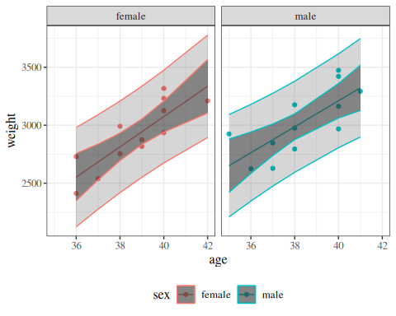
(a) Model 2 (linear with age:sex interaction)

plot_PIs_and_CIs(bw |> mutate(age = factor(age)), lm_max)
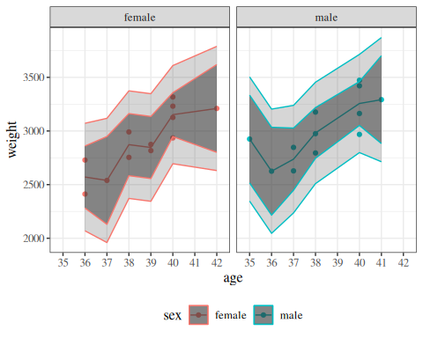
(b) Saturated model

Figure 9: Model 2 and saturated model for birthweight data, with confidence and prediction intervals

We can calculate the log-likelihood of this model as usual:
logLik(lm_max)
#> 'log Lik.' -151.402 (df=13)
We can compare this model to our other models using chi-square tests, as usual:
library(lmtest)
lrtest(lm_max, bw_lm2)
#> # A tibble: 2 × 5
#> `#Df` LogLik Df Chisq `Pr(>Chisq)`
#> <dbl> <dbl> <dbl> <dbl> <dbl>
#> 1 13 -151. NA NA NA
#> 2 5 -157. -8 10.4 0.241
The likelihood ratio statistic for this test is
$$λ=2*(ℓ_{\text{full}}−ℓ)=10.355374$$
where:
- $ℓ_{\text{full}}$ is the log-likelihood of the full model: -151.401601
- $ℓ$ is the log-likelihood of our comparison model (two slopes, two intercepts): -156.579288
This statistic is called the deviance or residual deviance for our two-slopes and two-intercepts model; it tells us how much the likelihood of that model deviates from the likelihood of the maximal model.
The corresponding p-value tells us whether there we have enough evidence to detect that our two-slopes, two-intercepts model is a worse fit for the data than the maximal model; in other words, it tells us if there’s evidence that we missed any important patterns. (Remember, a nonsignificant p-value could mean that we didn’t miss anything and a more complicated model is unnecessary, or it could mean we just don’t have enough data to tell the difference between these models.)

4.1.7 Null Deviance
Similarly, the least complicated model we could fit would have only one mean parameter, an intercept:
$$E​\left[Y|X=x\right]​=β_{0}$$
We can fit this model in R like so:
lm0 <- lm(weight ~ 1, data = bw)
lm0 |>
parameters() |>
print_md()
Parameter | Coefficient | SE | 95% CI | t(23) | p
(Intercept) | 2967.67 | 57.58 | (2848.56, 3086.77) | 51.54 | < .001

plot_PIs_and_CIs(bw, lm0)
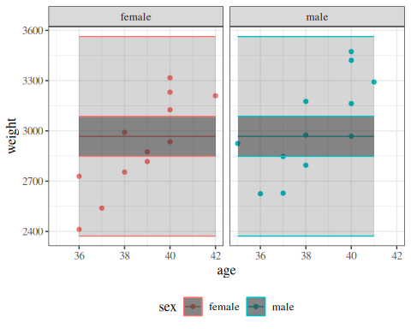
(a) Null model

plot_PIs_and_CIs(bw, bw_lm2)
(b) Model 2 (linear with age:sex interaction)

Figure 10: Null model and model 2 for birthweight data, with 95% confidence and prediction intervals.

This model also has a likelihood:
logLik(lm0)
#> 'log Lik.' -168.955 (df=2)
And we can compare it to more complicated models using a likelihood ratio test:
lrtest(bw_lm2, lm0)
#> # A tibble: 2 × 5
#> `#Df` LogLik Df Chisq `Pr(>Chisq)`
#> <dbl> <dbl> <dbl> <dbl> <dbl>
#> 1 5 -157. NA NA NA
#> 2 2 -169. -3 24.8 0.0000174
The likelihood ratio statistic for the test comparing the null model to the maximal model is
$$λ=2*(ℓ_{\text{full}}−ℓ_{0})=35.106732$$
where:
- $ℓ_{\text{0}}$ is the log-likelihood of the null model: -168.954967
- $ℓ_{\text{full}}$ is the log-likelihood of the maximal model: -151.401601
In R, this test is:
lrtest(lm_max, lm0)
#> # A tibble: 2 × 5
#> `#Df` LogLik Df Chisq `Pr(>Chisq)`
#> <dbl> <dbl> <dbl> <dbl> <dbl>
#> 1 13 -151. NA NA NA
#> 2 2 -169. -11 35.1 0.000238
This log-likelihood ratio statistic is called the null deviance. It tells us whether we have enough data to detect a difference between the null and full models.

plot_PIs_and_CIs(bw, lm0)
(a) Null model

plot_PIs_and_CIs(bw, bw_lm1)
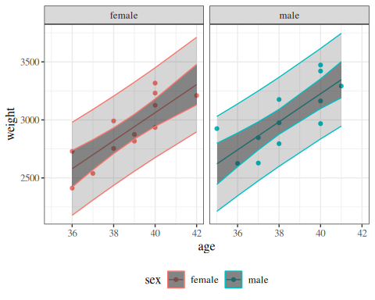
(b) No-interactions model (parallel slopes)

plot_PIs_and_CIs(bw, bw_lm2)
(c) Model 2 (linear with age:sex interaction)

plot_PIs_and_CIs(bw |> mutate(age = factor(age)), lm_max)
(d) Saturated model

Figure 11: Four models for birthweight data, with 95% confidence and prediction intervals. The spectrum from null to saturated includes many other possible models, such as quadratic polynomial models (with or without interactions) and generalized additive models (GAMs).

4.1.8 Gaussian Deviance vs. GLM Deviance
The residual deviance is a general concept that applies to all GLMs, including Gaussian linear regression. For any GLM, the residual deviance is:
$$D=2(ℓ_{\text{sat}}−ℓ(\hat{β})) (10)$$
where $ℓ_{\text{sat}}$ is the log-likelihood of the saturated model and $ℓ(\hat{β})$ is the log-likelihood of the fitted model. However, this formula simplifies differently depending on the distribution family, and the resulting test statistics have different null distributions.

Gaussian linear regression deviance
From Equation 6, the Gaussian log-likelihood is:
$$ℓ(\hat{β},{\hat{σ}}^{2})=−\frac{n}{2}log(2π{\hat{σ}}^{2})−\frac{1}{2{\hat{σ}}^{2}}\sum_{i=1}^{n}{(}y_{i}−{\hat{y}}_{i})^{2}$$
The saturated model has one free mean parameter per distinct covariate pattern. When there are no replicates (each covariate pattern appears exactly once), it sets ${\hat{μ}}_{i}=y_{i}$ for every observation, so its residual sum of squares is zero:
$$ℓ_{\text{sat}}({\hat{σ}}^{2})=−\frac{n}{2}log(2π{\hat{σ}}^{2})$$
Substituting into Equation 10, the Gaussian deviance simplifies to the residual sum of squares (RSS), scaled by ${\hat{σ}}^{2}$:
$$D=2(ℓ_{\text{sat}}−ℓ(\hat{β}))=\frac{\sum_{i=1}^{n}{(}y_{i}−{\hat{y}}_{i})^{2}}{{\hat{σ}}^{2}}=\frac{\text{RSS}}{{\hat{σ}}^{2}}$$
Because $σ^{2}$ is unknown and must be estimated, comparing deviances between two nested Gaussian models uses an F-test, which is exact under Gaussian assumptions. Substituting $D=\text{RSS}/{\hat{σ}}^{2}$, the ${\hat{σ}}^{2}$ factors cancel:
$$F=\frac{(D_{1}−D_{2})/(p_{2}−p_{1})}{D_{2}/(n−p_{2})}=\frac{({\text{RSS}}_{1}−{\text{RSS}}_{2})/(p_{2}−p_{1})}{{\text{RSS}}_{2}/(n−p_{2})} ∼ F_{p_{2}−p_{1}, n−p_{2}}$$
In R, deviance() applied to an lm object returns RSS (the unscaled deviance):
deviance(bw_lm2)
#> [1] 652425
sum(residuals(bw_lm2)^2)
#> [1] 652425
The two expressions return the same value.
The Gaussian linear regression model can equivalently be fit as a GLM with family = gaussian, which also returns RSS as the deviance:
bw_glm2 <- glm(
weight ~ sex + age + sex:age,
data = bw,
family = gaussian
)
deviance(bw_lm2)
#> [1] 652425
deviance(bw_glm2)
#> [1] 652425
deviance(bw_lm2) and deviance(bw_glm2) return the same value, confirming that Gaussian linear regression is a special case of the GLM framework where the deviance equals RSS.

Non-Gaussian GLM deviance
For non-Gaussian GLMs, the deviance does not simplify to RSS. The formula depends on the distribution family:
Poisson:
$$D=2\sum_{i=1}^{n}{\left[y_{i}log​\left(\frac{y_{i}}{{\hat{μ}}_{i}}\right)−(y_{i}−{\hat{μ}}_{i})\right]}$$
Binomial:
$$D=2\sum_{i=1}^{n}{\left[y_{i}log​\left(\frac{y_{i}}{{\hat{π}}_{i}}\right)+(n_{i}−y_{i})log​\left(\frac{n_{i}−y_{i}}{n_{i}−{\hat{π}}_{i}}\right)\right]}$$
For Poisson and Binomial models, the dispersion parameter $ϕ=1$ is fixed rather than estimated. Consequently, the difference in deviances between two nested models follows an approximate $χ^{2}$ distribution:
$$D_{1}−D_{2} \dot{∼} χ_{p_{2}−p_{1}}^{2}$$
This asymptotic result replaces the exact F-test used for Gaussian models.

Saturated vs. fully parametrized models with replicates
When some covariate patterns appear more than once (i.e., when there are replicates), it is important to distinguish between two special models:
- The saturated model has one free mean parameter per distinct covariate pattern ($q$ parameters, where $q≤n$ is the number of unique patterns).
- The fully parametrized model has one free mean parameter per observation ($n$ parameters).
When there are no replicates ($q=n$), these two coincide. When there are replicates ($q<n$), the saturated model constrains all observations sharing a covariate pattern to have the same mean, but places no constraint on means across different patterns. See Kleinbaum and Klein (2010) for further discussion of this distinction.
Deviance is always measured relative to the saturated model, not the fully parametrized model.

Gaussian deviance with replicates
When covariate pattern $k$ has $n_{k}$ replicates with sample mean ${\overset{‾}{y}}_{k}$, the saturated model fits ${\hat{μ}}_{k}={\overset{‾}{y}}_{k}$ for each pattern $k$, so its residual sum of squares equals the within-group (pure error) SS:
RSSsat=k=1qi:xi=xk​(yi−yk)2
This within-group residual sum of squares is nonzero whenever any covariate pattern has replicates with different response values. The Gaussian deviance relative to the saturated model is therefore:
$$D=2(ℓ_{\text{sat}}−ℓ(\hat{β}))=\frac{\text{RSS}−{\text{RSS}}_{\text{sat}}}{{\hat{σ}}^{2}}$$
Note
R’s deviance() applied to an lm object returns the total fitted-model RSS, not the deviance relative to the saturated model. To compute the deviance relative to the saturated model, subtract the saturated model’s RSS: deviance(lm_fit) - deviance(lm_saturated).

For the birthweight data, we can verify this directly using bw_lm2 (the interaction model) and lm_max (the saturated model):
deviance(bw_lm2) # total RSS of fitted model
#> [1] 652425
deviance(lm_max) # within-group (pure error) SS
#> [1] 423783
deviance(bw_lm2) - deviance(lm_max) # lack-of-fit SS (deviance vs. saturated)
#> [1] 228642
The lack-of-fit SS (deviance(bw_lm2) - deviance(lm_max)) measures how much additional unexplained variation remains after accounting for pure measurement error within covariate patterns.

GLM deviance with replicates
For a Binomial GLM fit to data grouped by covariate pattern (with $y_{k}$ events and $n_{k}$ observations for pattern $k$), the saturated model sets ${\hat{π}}_{k}^{\text{sat}}=y_{k}/n_{k}$ for each pattern $k$. R’s deviance() correctly computes $2(ℓ_{\text{sat}}−ℓ(\hat{β}))$ using this grouping:
$$D=2\sum_{k=1}^{q}{\left[y_{k}log​\left(\frac{y_{k}/n_{k}}{{\hat{π}}_{k}}\right)+(n_{k}−y_{k})log​\left(\frac{1−y_{k}/n_{k}}{1−{\hat{π}}_{k}}\right)\right]}$$
By convention, terms with $y_{k}=0$ or $y_{k}=n_{k}$ contribute zero to the sum, since $0log(0)=0$ in the limit.
When binomial data is ungrouped (individual Bernoulli observations, $n_{i}=1$), R uses the fully parametrized model as its reference — assigning ${\hat{π}}_{i}=y_{i}∈\{0,1\}$ to each individual observation. Since each predicted probability is exactly 0 or 1, every Bernoulli likelihood contribution equals 1, and hence $ℓ_{\text{fp}}=0$. Thus R’s deviance() returns $−2ℓ(\hat{β})$.
We can verify this directly: observations are ungrouped Bernoulli with repeated covariate patterns ($x∈\{0,1\}$ appears three times each).
set.seed(42)
x_ug <- rep(0:1, each = 3)
y_ug <- c(0L, 1L, 0L, 1L, 1L, 0L)
fit_ug <- glm(y_ug ~ x_ug, family = binomial)
deviance(fit_ug) # R's deviance
#> [1] 7.63817
-2 * as.numeric(logLik(fit_ug)) # -2 * log-likelihood (using ell_fp = 0)
#> [1] 7.63817
The two values are equal, confirming that R uses $ℓ_{\text{fp}}=0$ as its reference when data are ungrouped.
Note
This reference model is the fully parametrized model (one parameter per observation), not the saturated model (one parameter per distinct covariate pattern). They coincide only when there are no repeated covariate patterns ($q=n$). When patterns do repeat ($q<n$), the saturated model sets ${\hat{π}}_{k}=y_{k}/n_{k}$ per pattern, giving $ℓ_{\text{sat}}<0$.
deviance() for ungrouped data cannot be used as a goodness-of-fit test against the $χ^{2}$ distribution when $q<n$. The correct GOF statistic is $2(ℓ_{\text{sat}}−ℓ(\hat{β}))$, but R’s deviance() for ungrouped data returns $−2ℓ(\hat{β})$ (using $ℓ_{\text{fp}}=0$). These two quantities differ by $−2ℓ_{\text{sat}}>0$ whenever $q<n$. Even if each covariate pattern has many replicates (large $n_{k}$), R’s ungrouped deviance is the wrong statistic to compare against $χ^{2}(q−p)$. To obtain a valid GOF test when patterns repeat, fit the model using grouped data (one row per pattern with $y_{k}$ and $n_{k}$), so that R uses the saturated model as its reference.
For further discussion, see Dunn and Smyth (2018, chap. 9) and this Stats Stack Exchange thread.

Summary
Feature | Gaussian linear regression | Non-Gaussian GLMs (e.g., Poisson, Binomial)
Deviance formula | $(\text{RSS}−{\text{RSS}}_{\text{sat}})/{\hat{σ}}^{2}$​ | $2(ℓ_{\text{sat}}−ℓ(\hat{β}))$​
deviance() in R | Returns total RSS | Returns $2(ℓ_{\text{sat}}−ℓ(\hat{β}))$
Saturated model reference | Per covariate pattern | Per covariate pattern (grouped) or per observation (ungrouped)
Dispersion $ϕ$ | Unknown; estimated as $s^{2}=\text{RSS}/(n−p)$ | Fixed ($ϕ=1$)
Test for nested models | F-test (exact) | $χ^{2}$-test (asymptotic)

4.2 Diagnostics
 Tip
This section is adapted from Dobson and Barnett (2018, secs. 6.2–6.3) and Dunn and Smyth (2018) Chapter 3.

4.2.1 Assumptions in linear regression models
$$Y_{i}|{\tilde{X}}_{i}∼_{⟂​​​⟂}N(μ_{i},σ^{2})$$
$$μ_{i}=\tilde{x}⋅\tilde{β}$$
- Normality
The model assumes that the distribution conditional on a given $X$ value is Gaussian.
- Correct Functional Form of Conditional Mean Structure (Linear Component)
The model assumes that the conditional means have the structure:
$$E​\left[Y|\tilde{X}=\tilde{x}\right]​={\tilde{x}}^{⊤}\tilde{β}$$
- Homoskedasticity
The model assumes that variance $σ^{2}$ is constant (with respect to $\tilde{x}$).
- Independence
The model assumes that the observations are statistically independent.

4.2.2 Direct visualization
The most direct way to examine the fit of a model is to compare it to the raw observed data.
bw <-
bw |>
mutate(
predlm2 = predict(bw_lm2)
) |>
arrange(sex, age)
plot1_interact <-
plot1 %+% bw +
geom_line(aes(y = predlm2))
print(plot1_interact)
Figure 12: Birthweight model with interaction term
It’s not easy to assess these assumptions from this model. If there are multiple continuous covariates, it becomes even harder to visualize the raw data.

Fitted model for hers data
Consider the hers data from Vittinghoff et al. (2012).
The “heart and estrogen/progestin study” (HERS) was a clinical trial of hormone therapy for prevention of recurrent heart attacks and death among 2,763 post-menopausal women with existing coronary heart disease (CHD) (Hulley et al. 1998).
The trial was conducted at 20 US clinical centers. Participants were randomized to receive either conjugated equine estrogens (0.625 mg/day) plus medroxyprogesterone acetate (2.5 mg/day) or a matching placebo (Hulley et al. 1998). Women were followed for an average of 4.1 years (Hulley et al. 1998).
The primary outcome was nonfatal myocardial infarction or CHD death (Hulley et al. 1998).

Table 20: hers data
hers <- rmb::hers |> haven::zap_labels()
hers
#> # A tibble: 2,763 × 37
#> HT age raceth nonwhite smoking drinkany exercise physact globrat
#> <dbl> <dbl> <dbl> <dbl> <dbl> <dbl> <dbl> <dbl> <dbl>
#> 1 0 70 2 1 0 0 0 5 3
#> 2 0 62 2 1 0 0 0 1 3
#> 3 1 69 1 0 0 0 0 3 3
#> 4 0 64 1 0 1 1 0 1 3
#> 5 0 65 1 0 0 0 0 2 3
#> 6 1 68 2 1 0 1 0 3 3
#> 7 0 70 1 0 0 0 0 3 2
#> 8 1 69 1 0 0 0 1 5 4
#> 9 1 61 1 0 0 1 1 3 4
#> 10 1 62 1 0 1 1 0 2 3
#> # ℹ 2,753 more rows
#> # ℹ 28 more variables: poorfair <dbl>, medcond <dbl>, htnmeds <dbl>,
#> # statins <dbl>, diabetes <dbl>, dmpills <dbl>, insulin <dbl>, weight <dbl>,
#> # BMI <dbl>, waist <dbl>, WHR <dbl>, glucose <dbl>, weight1 <dbl>,
#> # BMI1 <dbl>, waist1 <dbl>, WHR1 <dbl>, glucose1 <dbl>, tchol <dbl>,
#> # LDL <dbl>, HDL <dbl>, TG <dbl>, tchol1 <dbl>, LDL1 <dbl>, HDL1 <dbl>,
#> # TG1 <dbl>, SBP <dbl>, DBP <dbl>, age10 <dbl>

Suppose we consider models with and without intercept terms (i.e., possibly forcing the intercept to go through 0):
hers_lm_with_int <- lm(
na.action = na.exclude,
LDL ~ smoking * age, data = hers
)
library(equatiomatic)
equatiomatic::extract_eq(hers_lm_with_int)
$$LDL=α+β_{1}(smoking)+β_{2}(age)+β_{3}(smoking×age)+ϵ$$
hers_lm_no_int <- lm(
na.action = na.exclude,
LDL ~ age + smoking:age - 1, data = hers
)
library(equatiomatic)
equatiomatic::extract_eq(hers_lm_no_int)
$$LDL=β_{1}(age)+β_{2}(age×{age}_{smoking})+ϵ$$

(a) With intercept
library(gtsummary)
hers_lm_with_int |>
tbl_regression(intercept = TRUE)
Characteristic | Beta | 95% CI | p-value
(Intercept) | 154 | 138, 170 | <0.001
current smoker | 54 | 15, 94 | 0.007
age in years | -0.14 | -0.38, 0.09 | 0.2
current smoker * age in years | -0.79 | -1.4, -0.17 | 0.012
Abbreviation: CI = Confidence Interval

(b) No intercept
hers_lm_no_int |>
tbl_regression(intercept = TRUE)
Characteristic | Beta | 95% CI | p-value
age in years | 2.1 | 2.1, 2.2 | <0.001
age in years * current smoker | 0.19 | 0.12, 0.26 | <0.001
Abbreviation: CI = Confidence Interval

Table 21: hers data models with and without intercepts

library(sjPlot)
hers_plot1 <- hers_lm_no_int |>
sjPlot::plot_model(
type = "pred",
terms = c("age", "smoking"),
show.data = TRUE
) +
facet_wrap(~group_col, ncol = 1) +
expand_limits(y = 0) +
theme(legend.position = "bottom")
hers_plot1
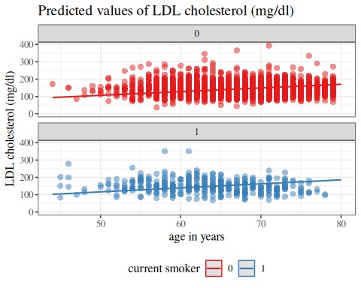
(a) No intercept

library(sjPlot)
hers_plot2 <- hers_lm_with_int |>
sjPlot::plot_model(
type = "pred",
terms = c("age", "smoking"),
show.data = TRUE
) +
facet_wrap(~group_col, ncol = 1) +
expand_limits(y = 0) +
theme(legend.position = "bottom")
hers_plot2
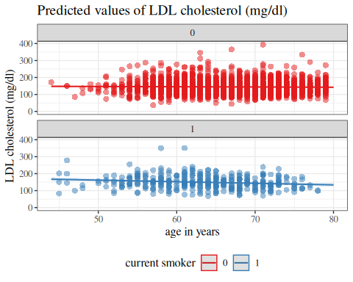
(b) With intercept

Figure 13: hers data models with and without intercepts

4.2.3 Residuals
Maybe we can transform the data and model in some way to make it easier to inspect.
Definition 8 (Deviation of an observation from its subpopulation mean) The deviation of an observation from its subpopulation mean in a probabilistic model $p(Y∣X)$, is the difference between an observed value and its model-implied mean given covariates:
$$e(y_{i})\overset{\text{def}}{=}y_{i}−E​\left[Y_{i}∣X_{i}\right]​ (11)$$
Many sources call deviations “error” or “noise.” The model-implied mean can be viewed as an estimate of $Y_{i}$, before $y_{i}$ is observed. However, an estimation error is defined as an estimate minus its estimand (see estimation error), and deviation is the observed value minus its estimand, so the deviation is actually the negative of the estimation error of the mean $E​\left[Y_{i}∣X_{i}\right]​$ with respect to its estimand $Y_{i}$:
$$e(y_{i})=−​\left(E​\left[Y_{i}∣X_{i}\right]​−y_{i}\right)​$$
On the other hand, each observation $y_{i}$ can be viewed as a nonparametric estimate of $μ_{i}=E​\left[Y_{i}∣X_{i}\right]​$ (albeit an imprecise one, individually, since $n=1$):
$$y_{i}={\hat{μ}}_{i}^{(NP)}$$
where ${\hat{μ}}_{i}^{(NP)}$ denotes the nonparametric estimate from a single observed value $y_{i}$.
Thus, the deviation can be interpreted as the estimation error of $y_{i}$ with respect to $E​\left[Y_{i}∣X_{i}\right]​$:
$$\begin{aligned}e(y_{i})&=y_{i}−μ_{i} \\ &={\hat{μ}}_{i}^{(NP)}−μ_{i} \\ &=ε​\left({\hat{μ}}_{i}^{(NP)}\right)​\end{aligned}$$

We can rearrange Equation 11 to view $y_{i}$ as the sum of its mean plus the deviation (often called error/noise):
$$y_{i}=E​\left[Y_{i}∣X_{i}\right]​+e(y_{i})$$
Definition 9 (Signal (statistical sense)) In statistical modeling, the signal is the deterministic part of the model. For mean-based models, the signal is the model-implied mean function, for example $E​\left[Y∣X\right]​$ (or $E​\left[Y\right]​$ when there are no covariates).

Theorem 1 (Deviations in Gaussian models) If $Y$ has a Gaussian distribution, then $e(Y)$ also has a Gaussian distribution, and vice versa.

Proof
Proof. By Definition 8, $e(Y∣X=x)=Y−E​\left[Y∣X=x\right]​$. Let $μ(x)=E​\left[Y∣X=x\right]​$. Since $e(Y∣X=x)=Y−μ(x)$ is an affine function of $Y$, and Gaussian distributions are closed under affine transformations, if $Y∣X=x∼N(μ(x),σ^{2})$, then:
$$e(Y∣X=x)=Y−μ(x)∼N(μ(x)−μ(x),σ^{2})=N(0,σ^{2})$$
Conversely, since $Y=E​\left[Y∣X=x\right]​+e(Y∣X=x)=μ(x)+e(Y∣X=x)$, if $e(Y∣X=x)∼N(0,σ^{2})$, then $Y∣X=x=μ(x)+e(Y∣X=x)∼N(μ(x),σ^{2})$.

Definition 10 (Residuals) A residual is the difference between an observed value and its corresponding fitted value, $\hat{y}$:
$$\begin{aligned}r&\overset{\text{def}}{=}y−\hat{y}\end{aligned}$$
For indexed observations, the residual is defined as:
$$r_{i}\overset{\text{def}}{=}y_{i}−{\hat{y}}_{i}$$
For a particular fitted model, each residual $r_{i}$ is tied to its corresponding fitted value ${\hat{y}}_{i}$. The fitted value ${\hat{y}}_{i}$ is often a sample mean or fitted conditional mean, but not always.

Exm
Example 4 (Residuals in birthweight data)
plot1_interact +
facet_wrap(~sex) +
geom_segment(
aes(
x = age,
y = predlm2,
xend = age,
yend = weight,
col = sex,
group = id
),
linetype = "dotted"
)
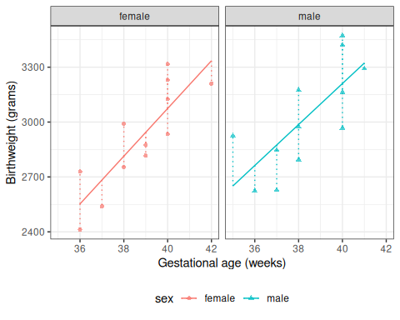
Figure 14: Fitted values and residuals for interaction model for birthweight data

4.3 Residuals of fitted values vs subpopulation-mean deviations
The residual is a plug-in estimate of the deviation of an observation from its subpopulation mean:
$$\begin{aligned}e(y_{i})&=y_{i}−E​\left[Y_{i}∣X_{i}\right]​ \\ \hat{e(y_{i})}&=y_{i}−{\hat{y}}_{i} \\ &=r_{i}\end{aligned}$$
Different sources are not fully consistent about these terms. For terminology in this course, we use:
- deviation for deviation of an observation from its population mean (typically conditional on covariates). This quantity is often called error in other sources, even though it doesn’t directly involve an estimate; cf., https://en.wikipedia.org/wiki/Errors_and_residuals;
- estimation error for deviation of an estimate from its estimand;
- residual for deviation of an observed value from a fitted value.

4.4 General characteristics of residuals
Definition 11 (Hat matrix) For an ordinary least squares linear model with design matrix $X$, the hat matrix is
$$H=X(X^{⊤}X)^{−1}X^{⊤}$$
so the fitted values satisfy
$$\hat{\tilde{Y}}=H\tilde{Y}$$

Theorem 2 (Mean and variance of residuals) For an ordinary least squares linear model with fitted values ${\hat{y}}_{i}={\tilde{x}}_{i}⋅\tilde{β}$ (and fitted-value vector $\hat{\tilde{Y}}$), if the conditional mean is correctly specified so that:
$$E​\left[\tilde{Y}∣X\right]​=Xβ$$
equivalently:
$$E​\left[\hat{\tilde{Y}}∣X\right]​=E​\left[\tilde{Y}∣X\right]​$$
and if the errors are homoskedastic so that $Var​\left(\tilde{Y}∣X\right)​=σ^{2}I_{n}$ where $I_{n}$ is the $n×n$ identity matrix, then, treating $X$ as fixed in this derivation, the residual moments are:
$$E​\left[\tilde{r}∣X\right]​=0 (12)$$
$$Var​\left(r_{i}∣X\right)​=σ^{2}(1−h_{ii}) (13)$$
The conditional mean result (Equation 12) uses unbiasedness of fitted values. The conditional variance result (Equation 13) uses the homoskedasticity condition with the OLS hat-matrix representation.
When leverage is roughly uniform, $h_{ii}≈k/n$, where $k=rank(X)$ (so $k=p+1$ for a full-rank model with an intercept and $p$ predictors), so $Var​\left(r_{i}\right)​≈σ^{2}$ as $n$ grows.

Proof
Proof. Equation 12:
$$\begin{aligned}E​\left[\tilde{r}∣X\right]​&=E​\left[\tilde{Y}−\hat{\tilde{Y}}∣X\right]​ \\ &=E​\left[\tilde{Y}∣X\right]​−E​\left[\hat{\tilde{Y}}∣X\right]​ \\ &=E​\left[\tilde{Y}∣X\right]​−E​\left[H\tilde{Y}∣X\right]​ \\ &=E​\left[\tilde{Y}∣X\right]​−HE​\left[\tilde{Y}∣X\right]​ \\ &=E​\left[\tilde{Y}∣X\right]​−HXβ \\ &=Xβ−HXβ \\ &=Xβ−Xβ \\ &=\tilde{0}\end{aligned}$$
Equation 13:
$$\begin{aligned}\tilde{r}&=(I_{n}−H)\tilde{Y} \\ Var​\left(\tilde{r}∣X\right)​&=Var​\left((I_{n}−H)\tilde{Y}∣X\right)​ \\ &=(I_{n}−H)Var​\left(\tilde{Y}∣X\right)​{(I_{n}−H)}^{⊤} \\ &=(I_{n}−H)σ^{2}I_{n}{(I_{n}−H)}^{⊤} \\ &=σ^{2}(I_{n}−H){(I_{n}−H)}^{⊤} \\ &=σ^{2}(I_{n}−H)^{2} \\ &=σ^{2}(I_{n}−2H+H^{2}) \\ &=σ^{2}(I_{n}−H) (\text{since }H^{2}=H) \\ Var​\left(r_{i}∣X\right)​&={\left[Var​\left(\tilde{r}∣X\right)​\right]}_{ii} \\ &={\left[σ^{2}(I_{n}−H)\right]}_{ii} \\ &=σ^{2}(1−h_{ii})\end{aligned}$$

Theorem 3 (Conditional distribution of residuals in Gaussian models) In a Gaussian linear regression model, the residuals $r_{i}$, conditional on the design matrix $X$, are normally distributed:
$$r_{i}∣X∼N​\left(0, σ^{2}(1−h_{ii})\right)​ (14)$$
where $h_{ii}$ is the $i$-th diagonal element of the hat matrix (Definition 11). When leverage is roughly uniform, $σ^{2}(1−h_{ii})≈σ^{2}$ for large $n$; replacing the unknown $σ^{2}$ with its estimate ${\hat{σ}}^{2}$ gives:
$$r_{i}≈N(0,{\hat{σ}}^{2}) (15)$$

Proof
Proof. Using the hat matrix (Definition 11), the residual vector is $\tilde{r}=(I−H)\tilde{Y}$, so the $i$-th residual is a linear combination of the observations:
$$r_{i}=[(I−H)\tilde{Y}]_{i}=\sum_{j=1}^{n}{(}δ_{ij}−h_{ij}) Y_{j}$$
where $δ_{ij}$ is the Kronecker delta ($δ_{ij}=1$ if $i=j$, else $δ_{ij}=0$).
Given $X$, the random variables $Y_{1},…,Y_{n}$ are conditionally independent Gaussians by the Gaussian model assumption. Therefore, conditional on $X$, the residual $r_{i}$ is a linear combination of independent Gaussians, so $r_{i}$ is Gaussian.
The mean and variance follow from Theorem 2:
$$\begin{aligned}E​\left[r_{i}∣X\right]​&=0 \\ Var​\left(r_{i}∣X\right)​&=σ^{2}(1−h_{ii})\end{aligned}$$
Therefore $r_{i}∣X∼N(0,σ^{2}(1−h_{ii}))$.

4.5 Computing residuals in R
R provides a function for residuals:
resid(bw_lm2)
#> 1 2 3 4 5 6 7 8
#> 176.2667 -140.7333 -144.1333 -59.5333 177.4667 -126.9333 -68.9333 242.6667
#> 9 10 11 12 13 14 15 16
#> -139.3333 51.6667 156.6667 -125.1333 274.2759 -137.7069 -27.6897 -246.6897
#> 17 18 19 20 21 22 23 24
#> -191.6724 189.3276 -11.6724 -242.6379 -47.6379 262.3621 210.3621 -30.6207

Exercise 15 Check R’s output by computing the residuals directly.

Solution
Solution.
bw$weight - fitted(bw_lm2)
#> 1 2 3 4 5 6 7 8
#> 176.2667 -140.7333 -144.1333 -59.5333 177.4667 -126.9333 -68.9333 242.6667
#> 9 10 11 12 13 14 15 16
#> -139.3333 51.6667 156.6667 -125.1333 274.2759 -137.7069 -27.6897 -246.6897
#> 17 18 19 20 21 22 23 24
#> -191.6724 189.3276 -11.6724 -242.6379 -47.6379 262.3621 210.3621 -30.6207
This manually calculated vector matches R’s output!

4.6 Graphing the residuals
plot1_interact +
facet_wrap(~sex) +
geom_segment(
aes(
x = age,
y = predlm2,
xend = age,
yend = weight,
col = sex,
group = id
),
linetype = "dotted"
)
(a) fitted values

bw <- bw |>
mutate(
resids_intxn =
weight - fitted(bw_lm2)
)
plot_bw_resid <-
bw |>
ggplot(aes(
x = age,
y = resids_intxn,
linetype = sex,
shape = sex,
col = sex
)) +
theme_bw() +
xlab("Gestational age (weeks)") +
ylab("residuals (grams)") +
theme(legend.position = "bottom") +
geom_hline(aes(
yintercept = 0,
col = sex
)) +
geom_segment(
aes(yend = 0),
linetype = "dotted"
) +
geom_point(alpha = .7)
# expand_limits(y = 0, x = 0)
print(plot_bw_resid + facet_wrap(~sex))
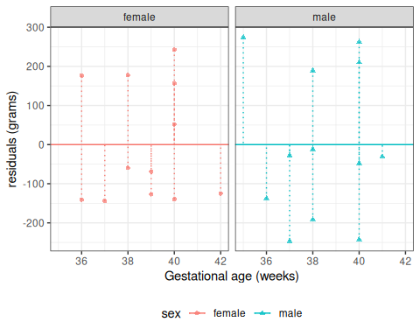
(b) Residuals

Figure 15: Fitted values and residuals for interaction model for birthweight data

4.7 Residuals versus predictors
hers <- hers |>
mutate(
resids_no_intcpt =
LDL - fitted(hers_lm_no_int),
resids_with_intcpt =
LDL - fitted(hers_lm_with_int)
)
hers |>
arrange(age) |>
ggplot() +
aes(x = age, y = resids_no_intcpt, col = factor(smoking)) +
geom_point() +
geom_hline(aes(yintercept = 0, col = factor(smoking))) +
facet_wrap(~smoking, labeller = "label_both") +
theme(legend.position = "bottom") +
geom_smooth(col = "blue")
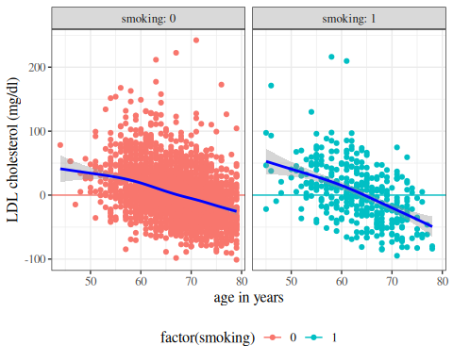
(a) no intercept

hers |>
arrange(age) |>
ggplot() +
aes(x = age, y = resids_with_intcpt, col = factor(smoking)) +
geom_point() +
geom_hline(aes(yintercept = 0, col = factor(smoking))) +
facet_wrap(~smoking, labeller = "label_both") +
theme(legend.position = "bottom") +
geom_smooth(col = "blue")
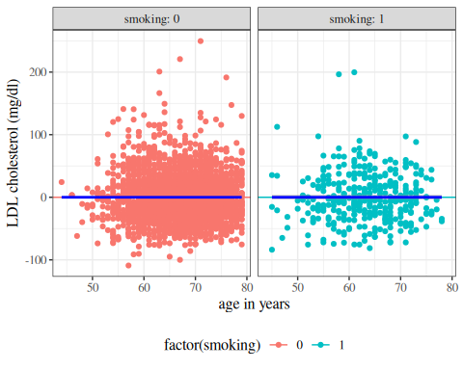
(b) with intercept

Figure 16: Residuals of hers data vs predictors

4.8 Residuals versus fitted values
If the model contains multiple continuous covariates, how do we check for errors in the mean structure assumption?
library(ggfortify)
hers_lm_no_int |>
update(na.action = na.omit) |>
autoplot(
which = 1,
ncol = 1,
smooth.colour = NA
) +
geom_hline(yintercept = 0, col = "red")
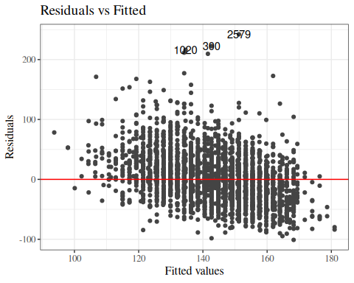
Figure 17: Residuals of interaction model for hers data

We can add a LOESS smooth to visualize where the residual mean is nonzero:
library(ggfortify)
hers_lm_no_int |>
update(na.action = na.omit) |>
autoplot(
which = 1,
ncol = 1
) +
geom_hline(yintercept = 0, col = "red")
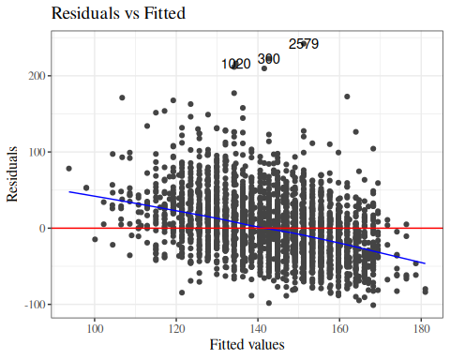
Figure 18: Residuals of interaction model for hers data, no intercept term

library(ggfortify)
hers_lm_no_int |>
update(na.action = na.omit) |>
autoplot(
which = 1,
ncol = 1
) +
geom_hline(yintercept = 0, col = "red")
(a) no intercept term

hers_lm_with_int |>
update(na.action = na.omit) |>
autoplot(
which = 1,
ncol = 1
) +
geom_hline(yintercept = 0, col = "red")
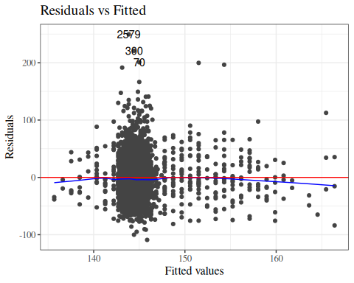
(b) with intercept term

Figure 19: Residuals of interaction model for hers data, with and without intercept term

Definition 12 (Standardized residuals) For an ordinary linear model, the estimated standard deviation of the $i$th residual is
$$​\left(r_{i}\right)​=\hat{σ}\sqrt{1−h_{ii}}$$
so the standardized residual is
$$r_{i}^{′}=\frac{r_{i}}{​\left(r_{i}\right)​}=\frac{r_{i}}{\hat{σ}\sqrt{1−h_{ii}}}$$
Hence, with enough data and a correct model, each standardized residual has an approximately standard Gaussian marginal distribution; that is,
$$r_{i}^{′} \dot{∼} N(0,1)$$
but they are not independent. If $H$ is the hat matrix with entries $h_{ij}$, then
$$Cov​\left(r_{i},r_{j}∣X\right)​=\left\{\begin{matrix}σ^{2}(1−h_{ii}), & i=j, \\ −σ^{2}h_{ij}, & i≠j,\end{matrix}\right.$$
and therefore
$$Cov​\left(r_{i}^{′},r_{j}^{′}∣X\right)​≈\left\{\begin{matrix}1, & i=j, \\ \frac{−h_{ij}}{\sqrt{(1−h_{ii})(1−h_{jj})}}, & i≠j,\end{matrix}\right.$$
In particular, for $i≠j$, these covariances are generally nonzero.

4.8.1 Marginal distributions of residuals
To look for problems with our model, we can check whether the residuals $r_{i}$ and standardized residuals $r_{i}^{′}$ look like they have the distributions that they are supposed to have, according to the model.

Standardized residuals in R
h_ii <- hatvalues(bw_lm2)
manual_std_resid <- resid(bw_lm2) / (sigma(bw_lm2) * sqrt(1 - h_ii))
manual_std_resid
#> 1 2 3 4 5 6 7
#> 1.1598166 -0.9260109 -0.8747917 -0.3472255 1.0350665 -0.7347315 -0.3990086
#> 8 9 10 11 12 13 14
#> 1.4375164 -0.8253872 0.3060646 0.9280669 -0.8761592 1.9142780 -0.8655921
#> 15 16 17 18 19 20 21
#> -0.1642993 -1.4637574 -1.1101599 1.0965787 -0.0676062 -1.4615865 -0.2869582
#> 22 23 24
#> 1.5803994 1.2671652 -0.1980543
rstandard(bw_lm2)
#> 1 2 3 4 5 6 7
#> 1.1598166 -0.9260109 -0.8747917 -0.3472255 1.0350665 -0.7347315 -0.3990086
#> 8 9 10 11 12 13 14
#> 1.4375164 -0.8253872 0.3060646 0.9280669 -0.8761592 1.9142780 -0.8655921
#> 15 16 17 18 19 20 21
#> -0.1642993 -1.4637574 -1.1101599 1.0965787 -0.0676062 -1.4615865 -0.2869582
#> 22 23 24
#> 1.5803994 1.2671652 -0.1980543
These residual vectors are nearly identical. Any differences are from numerical rounding.

rstandard_compare_plot <-
tibble(
x = resid(bw_lm2) / (sigma(bw_lm2) * sqrt(1 - h_ii)),
y = rstandard(bw_lm2)
) |>
ggplot(aes(x = x, y = y)) +
geom_point() +
theme_bw() +
coord_equal() +
xlab("resid(bw_lm2)/(sigma(bw_lm2)*sqrt(1-h_ii))") +
ylab("rstandard(bw_lm2)") +
geom_abline(
aes(
intercept = 0,
slope = 1,
col = "x=y"
)
) +
labs(colour = "") +
scale_colour_manual(values = "red")
print(rstandard_compare_plot)
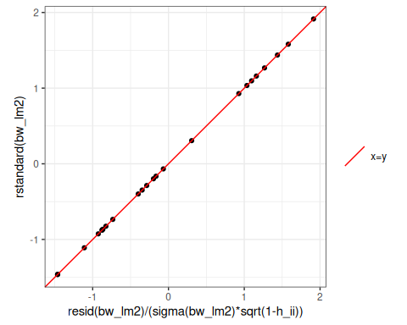

Let’s add these residuals to the tibble of our dataset:
bw <-
bw |>
mutate(
fitted_lm2 = fitted(bw_lm2),
resid_lm2 = resid(bw_lm2),
resid_lm2_alt = weight - fitted_lm2,
std_resid_lm2 = rstandard(bw_lm2),
std_resid_lm2_alt =
resid_lm2 / (sigma(bw_lm2) * sqrt(1 - h_ii))
)
bw |>
select(
sex,
age,
weight,
fitted_lm2,
resid_lm2,
std_resid_lm2
)
#> # A tibble: 24 × 6
#> sex age weight fitted_lm2 resid_lm2 std_resid_lm2
#> <fct> <dbl> <dbl> <dbl> <dbl> <dbl>
#> 1 female 36 2729 2553. 176. 1.16
#> 2 female 36 2412 2553. -141. -0.926
#> 3 female 37 2539 2683. -144. -0.875
#> 4 female 38 2754 2814. -59.5 -0.347
#> 5 female 38 2991 2814. 177. 1.04
#> 6 female 39 2817 2944. -127. -0.735
#> 7 female 39 2875 2944. -68.9 -0.399
#> 8 female 40 3317 3074. 243. 1.44
#> 9 female 40 2935 3074. -139. -0.825
#> 10 female 40 3126 3074. 51.7 0.306
#> # ℹ 14 more rows

Now let’s build histograms:
resid_marginal_hist <-
bw |>
ggplot(aes(x = resid_lm2)) +
geom_histogram()
print(resid_marginal_hist)
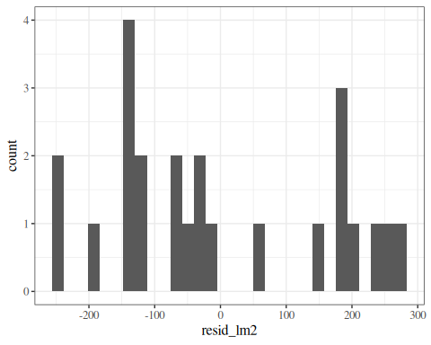
Figure 20: Marginal distribution of (nonstandardized) residuals
Hard to tell with this small amount of data, but I’m a bit concerned that the histogram doesn’t show a bell-curve shape.

std_resid_marginal_hist <-
bw |>
ggplot(aes(x = std_resid_lm2)) +
geom_histogram()
print(std_resid_marginal_hist)
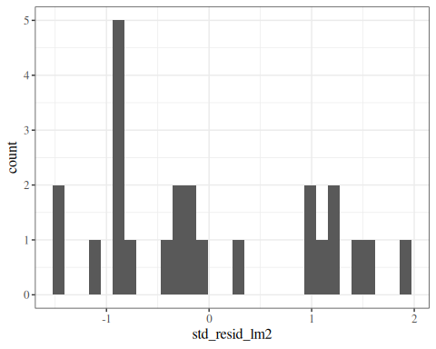
Figure 21: Marginal distribution of standardized residuals
This standardized residual histogram looks similar, although the scale of the x-axis got narrower, because we divided by $\hat{σ}$ (roughly speaking).
Still hard to tell if the distribution is Gaussian.

4.8.2 QQ plot of standardized residuals
Another way to assess whether the standardized residuals follow a standard normal distribution is a quantile-quantile (QQ) plot.
A QQ plot compares the empirical distribution of a dataset to a theoretical reference distribution. Each point corresponds to one observation:
- The x-axis (Theoretical Quantiles) shows the $N(0,1)$ quantile corresponding to the plotting position $p_{i}$ used for the $i$th ordered residual. In R, qqnorm() obtains these plotting positions from ppoints(n).
- The y-axis (Standardized Residuals) shows the observed standardized residuals, plotted in increasing order as $r_{(1)}≤⋯≤r_{(n)}$. In QQ-plot terminology, these ordered values are sample quantiles. The QQ plot uses points
$$\left(Φ^{−1}(p_{i}), r_{(i)}\right), i=1,…,n,$$
- where $p_{i}$ denotes the plotting positions returned by ppoints(n). For the common midpoint choice $p_{i}=(i−0.5)/n$, the sample quantile at $p_{i}$ equals $r_{(i)}$. More generally, qqnorm() pairs the $i$th ordered residual with the corresponding theoretical quantile computed from its plotting position. So both labels are correct: qqnorm() emphasizes the quantile role (“Sample Quantiles”), while autoplot.lm() emphasizes the underlying ordered values (“Standardized residuals”).
If the standardized residuals approximately follow $N(0,1)$, the points should fall approximately on a straight line.
library(ggfortify)
# needed to make ggplot2::autoplot() work for `lm` objects
qqplot_lm2_auto <-
bw_lm2 |>
autoplot(
which = 2, # options are 1:6; can do multiple at once
ncol = 1
) +
theme_classic()
print(qqplot_lm2_auto)
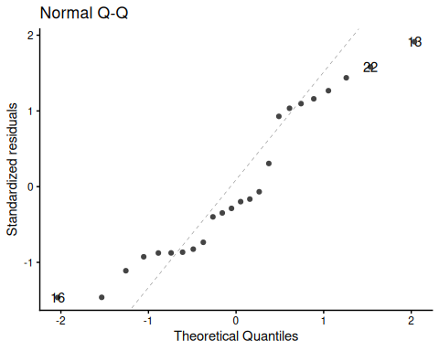
If the Gaussian model were correct, the points should fall approximately on the reference line.
The reference line passes through the pairs of theoretical and empirical quantiles at probabilities 0.25 and 0.75: it connects $(Φ^{−1}(0.25), {\hat{Q}}_{0.25})$ and $(Φ^{−1}(0.75), {\hat{Q}}_{0.75})$, where $Φ^{−1}$ is the standard normal quantile function and ${\hat{Q}}_{p}$ is the $p$-th sample quantile of the standardized residuals. If the standardized residuals are approximately $N(0,1)$, this line should be close to the identity line $y=x$, and the points should fall roughly along a straight line.
Systematic deviations from the line suggest departures from normality:
- S-shaped curves: heavier or lighter tails than the normal distribution
- Concave or convex curves: skewness
- Individual points far from the line: potential outliers
Fig 2.4 panel (c) in Dobson and Barnett (2018) is a little different; they didn’t specify how they produced it, but other statistical analysis systems do things differently from R.
See also Dunn and Smyth (2018) §3.5.4.

QQ plot: typical patterns
set.seed(36) # seed chosen for Fig. 3.6 reproduction
n <- 150 # sample size as in @dunn2018generalized Fig. 3.6
sims <- list(
"Right skewed" = rchisq(n, df = 3),
"Left skewed" = -rchisq(n, df = 3),
"Tails too heavy" = rt(n, df = 3),
"Tails too light" = runif(n, -sqrt(3), sqrt(3)),
"True normal" = rnorm(n),
"Bimodal" = c(rnorm(n / 2, -2.5), rnorm(n / 2, 2.5))
)
old_par <- par(
mfcol = c(2, 6),
mar = c(3, 3, 2, 0.5),
oma = c(0, 0, 0, 0)
)
for (nm in names(sims)) {
qqnorm(
sims[[nm]],
main = nm,
xlab = "Theoretical Quantiles",
ylab = "Sample Quantiles",
pch = 1,
cex = 0.6
)
qqline(sims[[nm]])
hist(
sims[[nm]],
main = "",
xlab = "Residuals",
ylab = "Frequency",
col = "grey70",
border = "white",
breaks = 15
)
}
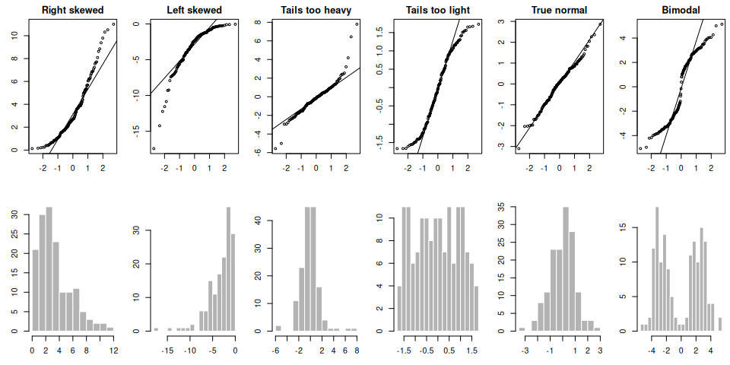
par(old_par)
Figure 22: Typical QQ-plot patterns for six types of residual distribution. Adapted from Dunn and Smyth (2018, fig. 3.6), with thanks to the authors; reproduced here using simulated data ($n=150$). Each column shows one distribution scenario: a QQ plot (top) paired with a histogram of the simulated data (bottom).

4.8.3 QQ plot - how it’s built
To construct a QQ plot by hand:
- Assign each standardized residual a plotting position $p_{i}$ based on its rank among the $n$ observations. R’s default formula for $n>10$ is:
$$p_{i}=\frac{{\text{rank}}_{i}−0.5}{n}$$
- Compute the theoretical quantile: $q_{i}=Φ^{−1}(p_{i})$, the value from $N(0,1)$ that corresponds to probability $p_{i}$.
- Plot $(q_{i},r_{i}^{′})$ — theoretical quantile $q_{i}$ on the x-axis, observed standardized residual $r_{i}^{′}$ (see Definition 12) on the y-axis.
- Add the reference line through the pairs of theoretical and empirical quantiles at probabilities 0.25 and 0.75.
bw <- bw |>
mutate(
# plotting position: (rank - 0.5) / n
p = (rank(std_resid_lm2) - 1 / 2) / n(),
expected_quantiles_lm2 = qnorm(p)
)
qqplot_lm2 <-
bw |>
ggplot(
aes(
x = expected_quantiles_lm2,
y = std_resid_lm2,
col = sex,
shape = sex
)
) +
geom_point() +
theme_classic() +
theme(legend.position = "none") + # removing the plot legend
ggtitle("Normal Q-Q") +
xlab("Theoretical Quantiles") +
ylab("Standardized residuals")
# find the reference line through the (theoretical, empirical) quantile pairs
# at probabilities 0.25 and 0.75:
ps <- c(.25, .75) # reference probabilities
a <- quantile(rstandard(bw_lm2), ps) # empirical quantiles
b <- qnorm(ps) # theoretical quantiles
qq_slope <- diff(a) / diff(b)
qq_intcpt <- a[1] - b[1] * qq_slope
qqplot_lm2 <-
qqplot_lm2 +
geom_abline(slope = qq_slope, intercept = qq_intcpt)
  print(qqplot_lm2)
  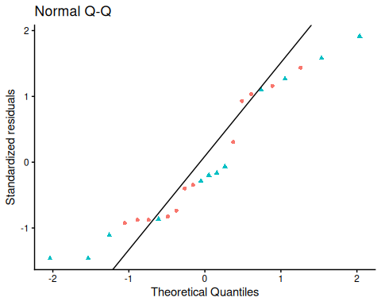
  (a) ggplot2 (manual construction)
  std_resid_lm2 <- rstandard(bw_lm2)
  qqnorm(
  std_resid_lm2,
  main = "Normal Q-Q",
  xlab = "Theoretical Quantiles",
  ylab = "Standardized residuals"
  )
  qqline(std_resid_lm2)
  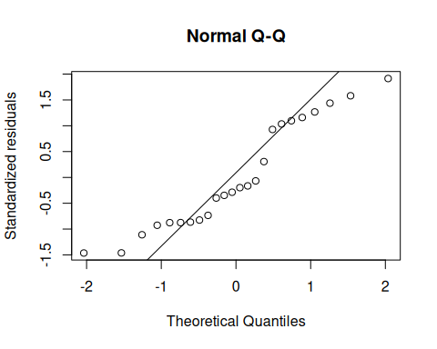
  (b) base R (qqnorm + qqline)

library(ggfortify)
autoplot(
bw_lm2,
which = 2,
ncol = 1
) +
theme_classic()
(c) ggfortify::autoplot()

Figure 23: Three equivalent ways to produce a QQ plot of the standardized residuals for the birthweight model (Equation 2). All three plots show the same data and reference line.

4.8.4 Formal diagnostic tests for linear regression assumptions
Graphical diagnostics are usually the first step, but formal tests can provide numerical summaries.
For linear regression residuals, three common tests are:
- fligner.test() for equal variances across groups (the Fligner–Killeen test).
- Levene / Brown–Forsythe test (a median-centered Levene variant, where standard Levene centers on group means, and Brown–Forsythe centers on group medians for more robustness; e.g., via car::leveneTest(..., center = median) or equivalent code).
- shapiro.test() / Shapiro–Wilk test for normality.

Fligner–Killeen test (homoskedasticity across groups)
Suppose residuals are split into groups ($g=1,…,G$), for example by a categorical predictor.
The test starts from absolute deviations from each group median:
$$d_{gi}=|e_{gi}−\text{median}(e_{g1},…,e_{g,n_{g}})|.$$
After ranking the pooled $d_{gi}$ values, the Fligner–Killeen statistic is built from normal scores of those ranks.
Under the null hypothesis of equal variances, the test statistic is approximately $χ_{G−1}^{2}$. Small p-values suggest heteroskedasticity.

Levene / Brown–Forsythe test (homoskedasticity across groups)
Levene’s test transforms residuals to within-group absolute deviations:
$$z_{gi}=|e_{gi}−c_{g}|,$$
where $c_{g}$ is the group center.
Classical Levene uses the group mean for $c_{g}$. Brown–Forsythe uses the group median, which is more robust.
Then run a one-way ANOVA on $z_{gi}$ by group:
$$F=\frac{{\text{MS}}_{\text{between}}}{{\text{MS}}_{\text{within}}}∼F_{G−1,N−G} \text{under }H_{0}.$$
Small p-values suggest unequal residual variance.
For simple linear regression, Kutner et al. (2005, 116–17) describes the Brown–Forsythe test by splitting observations into two $X$-level groups (low versus high), computing absolute deviations from each group median, and applying a two-sample pooled-variance t test: let
$$z_{ij}=|e_{ij}−{\tilde{e}}_{i}|,$$
where $j$ indexes observations within group $i$, and ${\tilde{e}}_{i}$ is the median residual in group $i$. Then:
$$t_{\text{BF}}=\frac{{\overset{‾}{z}}_{1}−{\overset{‾}{z}}_{2}}{s_{p}\sqrt{1/n_{1}+1/n_{2}}}, t_{\text{BF}}≈t_{n_{1}+n_{2}−2}\text{ under }H_{0}.$$
Here, ${\overset{‾}{z}}_{1}$ and ${\overset{‾}{z}}_{2}$ are the means of the $z_{ij}$ values in groups $i=1$ and $i=2$, $s_{p}$ is their pooled standard deviation, and $n_{1},n_{2}$ are the two group sample sizes. Large $|t_{\text{BF}}|$ indicates nonconstant residual variance.

Shapiro–Wilk test (normality of standardized residuals)
For ordered standardized residuals $r_{(1)}≤⋯≤r_{(n)}$, the Shapiro–Wilk statistic is:
$$W=\frac{{\left(\sum_{i=1}^{n}{a_{i}}r_{(i)}\right)}^{2}}{\sum_{i=1}^{n}{(}r_{i}−\overset{‾}{r})^{2}},$$
where $a_{i}$ are constants from normal-order-statistic moments. The numerator uses ordered residuals $r_{(i)}$, while the denominator uses the original (unordered) residuals.
If residuals are Gaussian, $W$ tends to be close to 1. Small $W$ (and small p-value) indicates departure from normality.

Numerical example (birthweight interaction model)
diag_bw <-
broom::augment(bw_lm2, data = bw) |>
transmute(
sex,
resid_lm2 = .resid,
std_resid_lm2 = .std.resid
)
fligner_bw <- fligner.test(resid_lm2 ~ sex, data = diag_bw)
levene_bw <-
diag_bw |>
group_by(sex) |>
mutate(
med_resid = median(resid_lm2),
abs_dev = abs(resid_lm2 - med_resid)
) |>
ungroup()
levene_fit <- aov(abs_dev ~ sex, data = levene_bw)
levene_tab <- summary(levene_fit)[[1]]
levene_F <- unname(levene_tab[1, "F value"])
levene_p <- unname(levene_tab[1, "Pr(>F)"])
shapiro_bw <- shapiro.test(diag_bw$std_resid_lm2)
tibble(
test = c(
"Fligner--Killeen: equal variance by sex",
"Levene/Brown--Forsythe: equal variance by sex",
"Shapiro--Wilk: normality of standardized residuals"
),
statistic = c(
unname(fligner_bw$statistic),
levene_F,
unname(shapiro_bw$statistic)
),
p_value = c(
fligner_bw$p.value,
levene_p,
shapiro_bw$p.value
)
) |>
mutate(
statistic = signif(statistic, 4),
p_value = signif(p_value, 4)
)
#> # A tibble: 3 × 3
#> test statistic p_value
#> <chr> <dbl> <dbl>
#> 1 Fligner--Killeen: equal variance by sex 0.00240 0.961
#> 2 Levene/Brown--Forsythe: equal variance by sex 0.326 0.574
#> 3 Shapiro--Wilk: normality of standardized residuals 0.919 0.0548
Interpretation rule: for all three tests, a small p-value is evidence against the corresponding model assumption.
Compared with visual diagnostics:
- Fligner–Killeen / Levene summarizes the same heteroskedasticity signal that we inspect in residuals-vs-fitted (Figure 24) and scale-location (Figure 32) plots.
- Shapiro–Wilk summarizes the same normality signal that we inspect in QQ plots (Figure 23 (c)) and standardized-residual histograms (Figure 21).
- Use tests and plots together: the tests provide a single numerical summary, while the plots show the shape and practical size of departures.

4.8.5 Conditional distributions of residuals
If our Gaussian linear regression model is correct, the residuals $r_{i}$ and standardized residuals $r_{i}^{′}$ should have:
- an approximately Gaussian distribution, with:
- a mean of 0
- a constant variance
This mean and variance structure should be true for every value of $x$.

If we didn’t correctly guess the functional form of the linear component of the mean, for covariate vector $x=(x_{1},…,x_{p})$,
$$E​\left[Y∣X=x\right]​=β_{0}+β_{1}x_{1}+⋯+β_{p}x_{p}$$
Then the residuals might have nonzero mean.
Regardless of whether we guessed the mean function correctly, the variance of the residuals might differ between values of $x$.

Residuals versus fitted values
To look for these issues, we can plot the residuals $r_{i}$ against the fitted values ${\hat{y}}_{i}$ (Figure 24).
autoplot(bw_lm2, which = 1, ncol = 1) |> print()
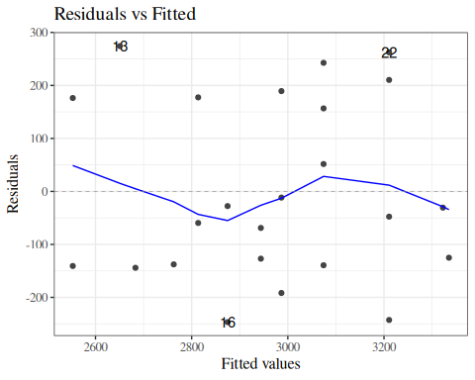
Figure 24: birthweight model (Equation 2): residuals versus fitted values
If the model is correct, the blue line should stay flat and close to 0, and the cloud of dots should have the same vertical spread regardless of the fitted value.
If not, we probably need to change the functional form of the linear component of the mean,
$$E​\left[Y∣X=x\right]​=β_{0}+β_{1}x_{1}+⋯+β_{p}x_{p}$$

Example: PLOS Medicine title length data
(Adapted from Dobson and Barnett (2018), §6.7.1)
data(PLOS, package = "dobson")
library(ggplot2)
fig1 =
PLOS |>
ggplot(
aes(x = authors,
y = nchar)
) +
geom_point() +
theme(legend.position = "bottom") +
labs(col = "") +
guides(col=guide_legend(ncol=3))
fig1
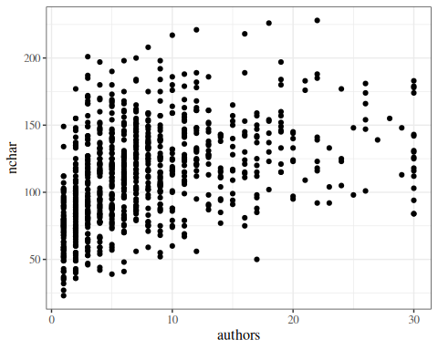
Figure 25: Number of authors versus title length in PLOS Medicine articles

Linear fit
lm_PLOS_linear = lm(
formula = nchar ~ authors,
data = PLOS)
fig2 = fig1 +
geom_smooth(
method = "lm",
fullrange = TRUE,
aes(col = "lm(y ~ x)"))
fig2
library(ggfortify)
autoplot(lm_PLOS_linear, which = 1, ncol = 1)
  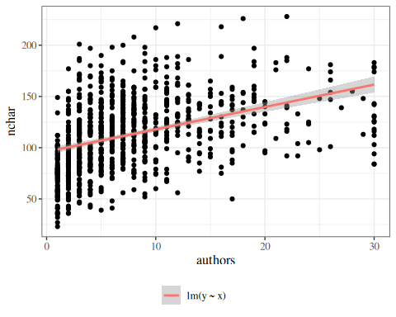
  (a) Data and fit
  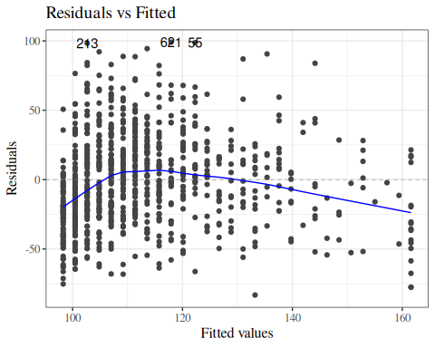
  (b) Residuals vs fitted
Figure 26: Number of authors versus title length in PLOS Medicine, with linear model fit

Quadratic fit
lm_PLOS_quad = lm(
formula = nchar ~ authors + I(authors^2),
data = PLOS)
fig3 =
fig2 +
geom_smooth(
method = "lm",
fullrange = TRUE,
formula = y ~ x + I(x ^ 2),
aes(col = "lm(y ~ x + I(x^2))")
)
fig3
autoplot(lm_PLOS_quad, which = 1, ncol = 1)
  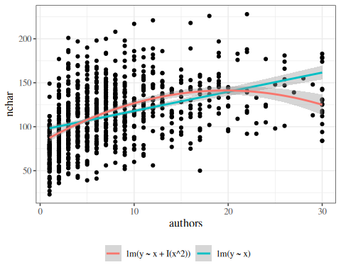
  (a) Data and fit
  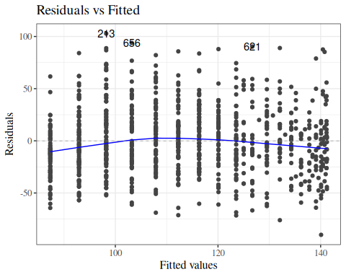
  (b) Residuals vs fitted
Figure 27: Number of authors versus title length in PLOS Medicine, with quadratic model fit

Linear versus quadratic fits
library(ggfortify)
autoplot(lm_PLOS_linear, which = 1, ncol = 1)
autoplot(lm_PLOS_quad, which = 1, ncol = 1)
  (a) Linear
  (b) Quadratic
Figure 28: Residuals versus fitted plot for linear and quadratic fits to PLOS data

Cubic fit
lm_PLOS_cub = lm(
formula = nchar ~ authors + I(authors^2) + I(authors^3),
data = PLOS)
fig4 =
fig3 +
geom_smooth(
method = "lm",
fullrange = TRUE,
formula = y ~ x + I(x ^ 2) + I(x ^ 3),
aes(col = "lm(y ~ x + I(x^2) + I(x ^ 3))")
)
fig4
autoplot(lm_PLOS_cub, which = 1, ncol = 1)
  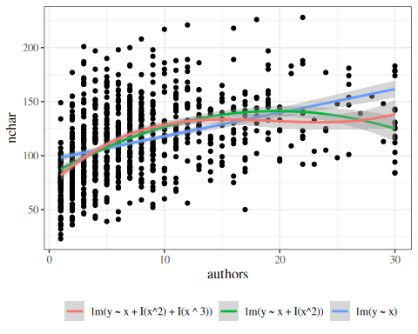
  (a) Data and fit
  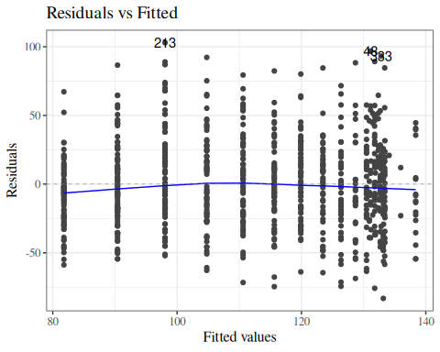
  (b) Residuals vs fitted
Figure 29: Number of authors versus title length in PLOS Medicine, with cubic model fit

Logarithmic fit
lm_PLOS_log = lm(nchar ~ log(authors), data = PLOS)
fig5 = fig4 +
geom_smooth(
method = "lm",
fullrange = TRUE,
formula = y ~ log(x),
aes(col = "lm(y ~ log(x))")
)
fig5
autoplot(lm_PLOS_log, which = 1, ncol = 1)
  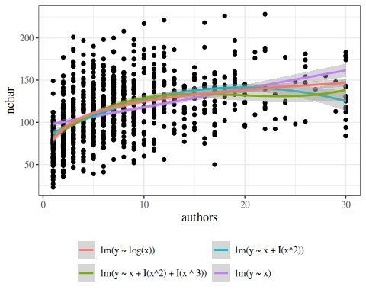
  (a) Data and fit
  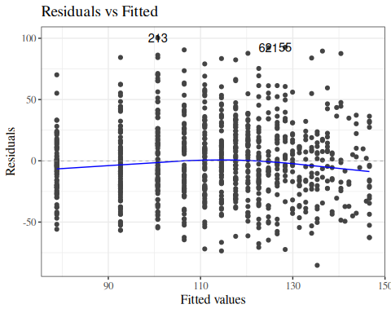
  (b) Residuals vs fitted
Figure 30: logarithmic fit

Model selection
Table 22: linear vs quadratic
anova(lm_PLOS_linear, lm_PLOS_quad)
#> # A tibble: 2 × 6
#> Res.Df RSS Df `Sum of Sq` F `Pr(>F)`
#> <dbl> <dbl> <dbl> <dbl> <dbl> <dbl>
#> 1 876 947502. NA NA NA NA
#> 2 875 880950. 1 66552. 66.1 1.46e-15

Table 23: quadratic vs cubic
anova(lm_PLOS_quad, lm_PLOS_cub)
#> # A tibble: 2 × 6
#> Res.Df RSS Df `Sum of Sq` F `Pr(>F)`
#> <dbl> <dbl> <dbl> <dbl> <dbl> <dbl>
#> 1 875 880950. NA NA NA NA
#> 2 874 865933. 1 15018. 15.2 0.000106

AIC/BIC
AIC(lm_PLOS_quad)
#> [1] 8567.61
AIC(lm_PLOS_cub)
#> [1] 8554.51
AIC(lm_PLOS_cub)
#> [1] 8554.51
AIC(lm_PLOS_log)
#> [1] 8543.63
BIC(lm_PLOS_cub)
#> [1] 8578.4
BIC(lm_PLOS_log)
#> [1] 8557.97

Extrapolation is dangerous
fig_all = fig5 +
xlim(0, 60)
fig_all
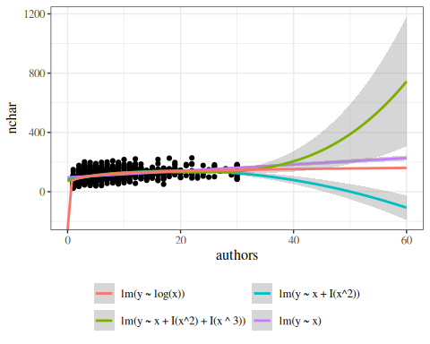
Figure 31: Number of authors versus title length in PLOS Medicine

Scale-location plot
We can also plot the square roots of the absolute values of the standardized residuals against the fitted values (Figure 32).
autoplot(bw_lm2, which = 3, ncol = 1) |> print()
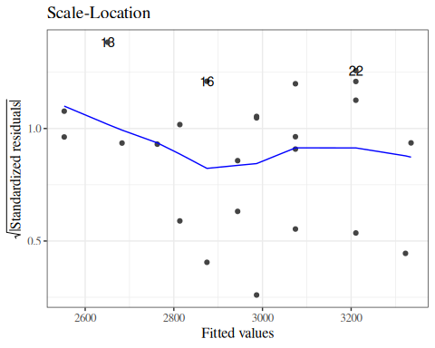
Figure 32: Scale-location plot of birthweight data
Here, the blue line doesn’t need to be near 0, but it should be flat. If not, the residual variance $σ^{2}$ might not be constant, and we might need to transform our outcome $Y$ (or use a model that allows non-constant variance).

Residuals versus leverage
We can also plot our standardized residuals against “leverage”, which roughly speaking is a measure of how unusual each $x_{i}$ value is. Very unusual $x_{i}$ values can have extreme effects on the model fit, so we might want to remove those observations as outliers, particularly if they have large residuals.
autoplot(bw_lm2, which = 5, ncol = 1) |> print()
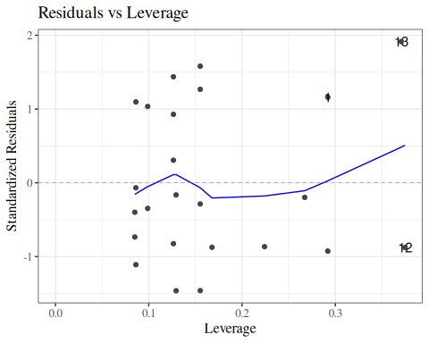
Figure 33: birthweight model with interactions (Equation 2): residuals versus leverage
The blue line should be relatively flat and close to 0 here. The curved dashed contour lines show where Cook’s distance equals 0.5 and 1; observations near or beyond those contours have substantial influence on the fit (see Section 4.8.6).

4.8.6 Cook’s distance
Tip
This section is adapted from Dobson and Barnett (2018, sec. 6.3).

Residuals and leverage each capture one aspect of an observation’s influence on the model fit. Cook’s distance (Cook 1977) combines them into a single diagnostic.
Definition 13 (Cook’s distance) For ordinary least squares with $p$ parameters, the Cook’s distance for observation $i$ is
$$D_{i}\overset{\text{def}}{=}\frac{{({\hat{\tilde{β}}}_{(−i)}−\hat{\tilde{β}})}^{⊤}X^{⊤}X({\hat{\tilde{β}}}_{(−i)}−\hat{\tilde{β}})}{p {\hat{σ}}^{2}} (16)$$
where ${\hat{\tilde{β}}}_{(−i)}$ is the least-squares estimate obtained after deleting observation $i$.
Because refitting the model $n$ times is expensive, Equation 16 has an equivalent closed-form expression that uses only quantities from the full-data fit:
$$D_{i}=\frac{(r_{i}^{′})^{2}}{p}⋅\frac{h_{ii}}{1−h_{ii}} (17)$$
where $r_{i}^{′}$ is the standardized residual (Definition 12) and $h_{ii}$ is the leverage (diagonal of the hat matrix, Definition 11).
Exm
Example 5 Consider a regression with $p=2$ parameters. Suppose observation $i$ has standardized residual $r_{i}^{′}=2$ and leverage $h_{ii}=0.3$. Applying Equation 17,
$$D_{i}=\frac{(2)^{2}}{2}⋅\frac{0.3}{1−0.3}=2⋅0.43≈0.86.$$

Equation 17 shows that influence has two ingredients:
- Residual size ($(r_{i}^{′})^{2}$): a poorly fitted observation pushes $D_{i}$ up regardless of its leverage.
- Leverage ($h_{ii}/(1−h_{ii})$): high leverage amplifies the effect of even a moderate residual.
An observation must be both unusual in its predictor values and poorly fitted to have a large Cook’s distance.

Cook’s distance plot
We can visualize Cook’s distances for all observations using autoplot with which = 4 (Figure 34).
autoplot(bw_lm2, which = 4, ncol = 1) |> print()
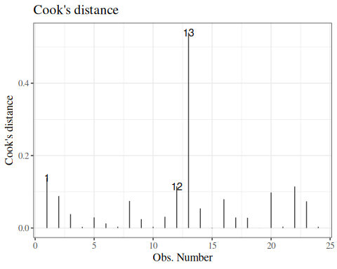
Figure 34: Cook’s distance for birthweight model with interactions (Equation 2)
A commonly cited rule of thumb (Dobson and Barnett 2018, sec. 6.3) flags observation $i$ as influential if
$$D_{i}>1$$
A more conservative threshold is $D_{i}>4/n$ (Bollen and Jackman 1990).
Observations exceeding either threshold warrant closer inspection: check whether they represent genuine data or recording errors, and consider refitting the model with and without them to assess sensitivity.
The residuals-versus-leverage plot (Figure 33) also displays Cook’s distance contours as curved dashed lines. An observation lying near or beyond a contour line has substantial influence on the fit.
Computing Cook’s distances in R:
cooks.distance(bw_lm2)
#> 1 2 3 4 5 6
#> 0.138666533 0.088394496 0.038580119 0.003306326 0.029380480 0.012546308
#> 7 8 9 10 11 12
#> 0.003700182 0.074772987 0.024651000 0.003389576 0.031165758 0.115007141
#> 13 14 15 16 17 18
#> 0.539629434 0.054112479 0.001002262 0.079551451 0.029067335 0.028360493
#> 19 20 21 22 23 24
#> 0.000107797 0.098092422 0.003781150 0.114688577 0.073731478 0.003576445
Exercise 16 Verify Equation 17 for the observations in bw_lm2: compute $D_{i}$ using the standardized residuals and leverage values, and check that the result matches cooks.distance(bw_lm2).

Solution
Solution.
r_prime <- rstandard(bw_lm2)
h <- hatvalues(bw_lm2)
p <- length(coef(bw_lm2))
D_manual <- (r_prime^2 / p) * (h / (1 - h))
cbind(manual = D_manual, builtin = cooks.distance(bw_lm2)) |> head(3)
#> manual builtin
#> 1 0.1386665 0.1386665
#> 2 0.0883945 0.0883945
#> 3 0.0385801 0.0385801

4.8.7 Diagnostics constructed by hand
bw <-
bw |>
mutate(
predlm2 = predict(bw_lm2),
residlm2 = weight - predlm2,
std_resid = residlm2 / sigma(bw_lm2),
# std_resid_builtin = rstandard(bw_lm2), # uses leverage
sqrt_abs_std_resid = std_resid |> abs() |> sqrt()
)

Residuals vs fitted
resid_vs_fit <- bw |>
ggplot(
aes(x = predlm2, y = residlm2, col = sex, shape = sex)
) +
geom_point() +
theme_classic() +
geom_hline(yintercept = 0)
print(resid_vs_fit)
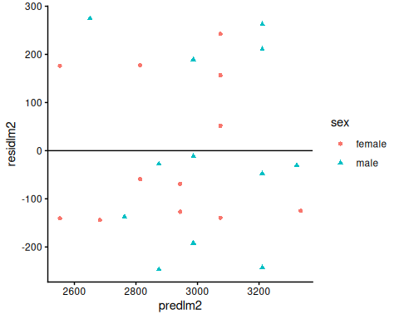

Standardized residuals vs fitted
bw |>
ggplot(
aes(x = predlm2, y = std_resid, col = sex, shape = sex)
) +
geom_point() +
theme_classic() +
geom_hline(yintercept = 0)
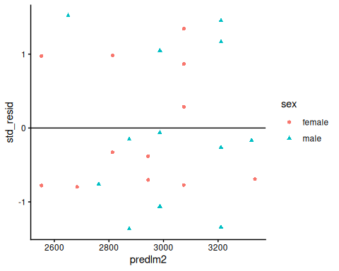

Standardized residuals vs gestational age
bw |>
ggplot(
aes(x = age, y = std_resid, col = sex, shape = sex)
) +
geom_point() +
theme_classic() +
geom_hline(yintercept = 0)
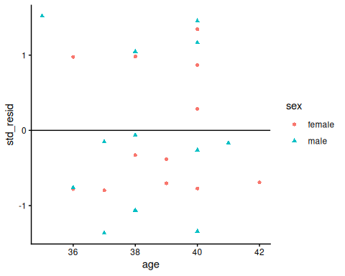

sqrt(abs(std_resid)) vs fitted
Compare with autoplot(bw_lm2, 3) (note: autoplot uses leverage-adjusted rstandard())
bw |>
ggplot(
aes(x = predlm2, y = sqrt_abs_std_resid, col = sex, shape = sex)
) +
geom_point() +
theme_classic() +
geom_hline(yintercept = 0)
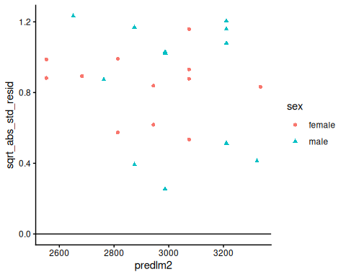

4.8.8 Diagnostics for the independence assumption
The independence assumption means that the model errors are independent, or at least uncorrelated, across observations after conditioning on the predictors in the model. Because those errors are unobserved, we usually assess this assumption using residual-based plots and formal tests.
For data with a natural ordering (for example, time, spatial location, or clinic visit sequence), we usually assess independence with both plots and formal tests (Kutner et al. 2005, chap. 12; Chatterjee and Hadi 2015, chap. 6).
Definition 14 (Common diagnostics for independence)
- Residuals versus observation order (or time) plots: patterns, runs, or drifts can indicate dependence (Kutner et al. 2005, chap. 12).
- Correlograms: plot the sample autocorrelation function (ACF), and often the partial autocorrelation function (PACF), to look for serial structure (Chatterjee and Hadi 2015, chap. 6).
- Durbin-Watson test: tests for first-order serial correlation in regression residuals (Chatterjee and Hadi 2015, chap. 9; Kutner et al. 2005, chap. 12).
- Breusch-Godfrey test: tests for higher-order serial correlation, and is more flexible than Durbin-Watson in many regression settings (Chatterjee and Hadi 2015, chap. 9; Kutner et al. 2005, chap. 12).

Mathematical details for Durbin-Watson and Breusch-Godfrey
Suppose the observations have a meaningful order, indexed by $t=1,…,n$. Let $e_{t}$ denote the OLS residual from a fitted regression model.
Definition 15 (Durbin-Watson diagnostic) The test statistic is
$$\begin{aligned}d&=\frac{\sum_{t=2}^{n}{(}e_{t}−e_{t−1})^{2}}{\sum_{t=1}^{n}{e_{t}^{2}}}\end{aligned}$$
which is approximately $2(1−{\hat{r}}_{1})$, where ${\hat{r}}_{1}$ is the sample lag-1 residual autocorrelation (Kutner et al. 2005, chap. 12; Chatterjee and Hadi 2015, chap. 6). This approximation is most useful in standard large-sample linear-model settings, and is less straightforward in models with lagged outcomes (Kutner et al. 2005, chap. 12).
The null and alternatives are typically framed through an AR(1) error model:
$$ε_{t}=ρε_{t−1}+u_{t}.$$
Here, $ε_{t}$ is the autocorrelated regression error process, and $u_{t}$ is a white-noise innovation term. The null is $H_{0}:ρ=0$, and alternatives can be one-sided or two-sided, depending on whether we suspect positive, negative, or any serial correlation (Kutner et al. 2005, chap. 12).

Definition 16 (Breusch-Godfrey diagnostic) For a test of order $p$, we run an auxiliary regression of residuals on: the original regressors, and lagged residuals $e_{t−1},…,e_{t−p}$. If $R_{\text{aux}}^{2}$ is from that auxiliary model, the LM statistic is
$$\text{LM}=(n−p)R_{\text{aux}}^{2},$$
and under $H_{0}:ρ_{1}=⋯=ρ_{p}=0$, it is asymptotically $χ_{p}^{2}$ (Chatterjee and Hadi 2015, chap. 6; Draper and Smith 2014, chap. 11).

Exm
Example 6 (Simulated example for independence diagnostics) The following simulation generates ordered data with positively autocorrelated errors. This serial correlation creates a setting where independence should fail. We generate the error term from an AR(1) process with coefficient 0.7, matching the notation in the mathematical details section.
set.seed(204)
n_obs <- 120
x <- seq(-1, 1, length.out = n_obs)
ar_errors <- as.numeric(arima.sim(model = list(ar = 0.7), n = n_obs, sd = 1))
y <- 2 + 1.5 * x + ar_errors
serial_dep_exm <- tibble::tibble(
time_index = seq_len(n_obs),
x = x,
y = y
)
serial_dep_exm_lm <- lm(y ~ x, data = serial_dep_exm)
summary(serial_dep_exm_lm)
#>
#> Call:
#> lm(formula = y ~ x, data = serial_dep_exm)
#>
#> Residuals:
#> Min 1Q Median 3Q Max
#> -2.6747 -0.9128 -0.0552 1.0087 2.5022
#>
#> Coefficients:
#> Estimate Std. Error t value Pr(>|t|)
#> (Intercept) 1.998 0.110 18.13 < 2e-16 ***
#> x 1.773 0.189 9.37 6.4e-16 ***
#> ---
#> Signif. codes: 0 '***' 0.001 '**' 0.01 '*' 0.05 '.' 0.1 ' ' 1
#>
#> Residual standard error: 1.21 on 118 degrees of freedom
#> Multiple R-squared: 0.426, Adjusted R-squared: 0.422
#> F-statistic: 87.7 on 1 and 118 DF, p-value: 6.36e-16
Residuals versus order:
serial_dep_exm |>
dplyr::mutate(resid = resid(serial_dep_exm_lm)) |>
ggplot(aes(x = time_index, y = resid)) +
geom_hline(yintercept = 0, linetype = "dashed", color = "gray50") +
geom_line(color = "steelblue") +
theme_classic() +
labs(
x = "Observation order",
y = "Residual"
)
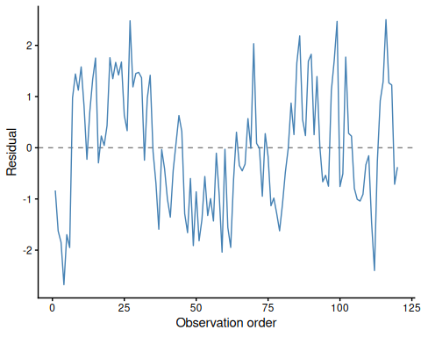
Figure 35: Residuals versus observation order for simulated data
Correlogram diagnostics:
local({
op <- par(no.readonly = TRUE)
on.exit(par(op), add = TRUE)
par(mfrow = c(1, 2))
acf(
resid(serial_dep_exm_lm),
main = "Residual ACF"
)
pacf(
resid(serial_dep_exm_lm),
main = "Residual PACF"
)
})
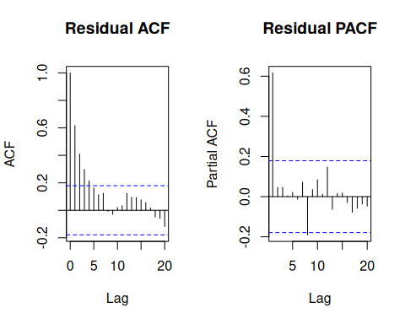
Figure 36: Residual ACF and PACF for simulated data
Durbin-Watson and Breusch-Godfrey tests:
lmtest::dwtest(serial_dep_exm_lm, alternative = "two.sided")
#>
#> Durbin-Watson test
#>
#> data: serial_dep_exm_lm
#> DW = 0.7623, p-value = 4.16e-12
#> alternative hypothesis: true autocorrelation is not 0
lmtest::bgtest(serial_dep_exm_lm, order = 4)
#>
#> Breusch-Godfrey test for serial correlation of order up to 4
#>
#> data: serial_dep_exm_lm
#> LM test = 45.94, df = 4, p-value = 2.53e-09
In this example, the residual-order plot and correlogram suggest serial dependence, and both formal tests reject independence.

Exm
Example 7 (Real-data examples for independence diagnostics) We can also run the same diagnostics on real ordered data sets.

Nile annual river flow
nile_df <- tibble::tibble(
year = as.numeric(time(datasets::Nile)),
flow = as.numeric(datasets::Nile)
)
nile_lm <- lm(flow ~ year, data = nile_df)
summary(nile_lm)
#>
#> Call:
#> lm(formula = flow ~ year, data = nile_df)
#>
#> Residuals:
#> Min 1Q Median 3Q Max
#> -483.7 -98.2 -23.2 111.4 368.7
#>
#> Coefficients:
#> Estimate Std. Error t value Pr(>|t|)
#> (Intercept) 6132.174 1001.758 6.12 1.9e-08 ***
#> year -2.714 0.522 -5.20 1.1e-06 ***
#> ---
#> Signif. codes: 0 '***' 0.001 '**' 0.01 '*' 0.05 '.' 0.1 ' ' 1
#>
#> Residual standard error: 151 on 98 degrees of freedom
#> Multiple R-squared: 0.217, Adjusted R-squared: 0.209
#> F-statistic: 27.1 on 1 and 98 DF, p-value: 1.07e-06
lmtest::dwtest(nile_lm, alternative = "two.sided")
#>
#> Durbin-Watson test
#>
#> data: nile_lm
#> DW = 1.247, p-value = 9.37e-05
#> alternative hypothesis: true autocorrelation is not 0
lmtest::bgtest(nile_lm, order = 4)
#>
#> Breusch-Godfrey test for serial correlation of order up to 4
#>
#> data: nile_lm
#> LM test = 15.94, df = 4, p-value = 0.0031
nile_df |>
dplyr::mutate(resid = resid(nile_lm)) |>
ggplot(aes(x = year, y = resid)) +
geom_hline(yintercept = 0, linetype = "dashed", color = "gray50") +
geom_line(color = "steelblue") +
theme_classic() +
labs(
x = "Year",
y = "Residual"
)
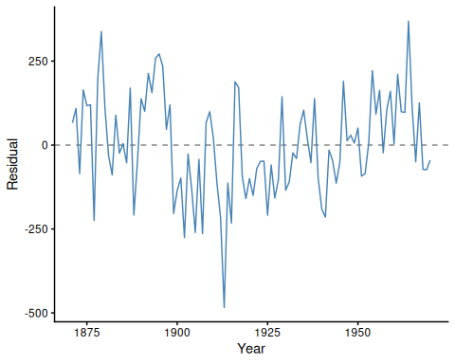
Figure 37: Residuals versus year for Nile flow model

Mauna Loa atmospheric carbon dioxide (co2)
co2_df <- tibble::tibble(
decimal_year = as.numeric(time(datasets::co2)),
co2_ppm = as.numeric(datasets::co2)
)
co2_lm <- lm(co2_ppm ~ decimal_year, data = co2_df)
summary(co2_lm)
#>
#> Call:
#> lm(formula = co2_ppm ~ decimal_year, data = co2_df)
#>
#> Residuals:
#> Min 1Q Median 3Q Max
#> -6.040 -1.948 -0.002 1.911 6.515
#>
#> Coefficients:
#> Estimate Std. Error t value Pr(>|t|)
#> (Intercept) -2.25e+03 2.13e+01 -106 <2e-16 ***
#> decimal_year 1.31e+00 1.07e-02 122 <2e-16 ***
#> ---
#> Signif. codes: 0 '***' 0.001 '**' 0.01 '*' 0.05 '.' 0.1 ' ' 1
#>
#> Residual standard error: 2.62 on 466 degrees of freedom
#> Multiple R-squared: 0.969, Adjusted R-squared: 0.969
#> F-statistic: 1.48e+04 on 1 and 466 DF, p-value: <2e-16
lmtest::dwtest(co2_lm, alternative = "two.sided")
#>
#> Durbin-Watson test
#>
#> data: co2_lm
#> DW = 0.2124, p-value <2e-16
#> alternative hypothesis: true autocorrelation is not 0
lmtest::bgtest(co2_lm, order = 12)
#>
#> Breusch-Godfrey test for serial correlation of order up to 12
#>
#> data: co2_lm
#> LM test = 453.9, df = 12, p-value <2e-16
For both real-data examples, the diagnostics indicate residual dependence, consistent with their time-ordered structure.

No single diagnostic is definitive. In practice, we combine visual and formal diagnostics, and interpret them in the context of study design (Kutner et al. 2005, chap. 12; Draper and Smith 2014, chap. 11).

4.9 Model selection
(adapted from Dobson and Barnett (2018) §6.3.3; for more information on prediction, see James et al. (2013) and Harrell (2015)).
If we have a lot of covariates in our dataset, we might want to choose a small subset to use in our model.
There are a few possible metrics to consider for choosing a “best” model.

4.9.1 DAGs for variable selection
For explanatory models, variable inclusion should not rely on automated algorithms alone. Directed acyclic graphs (DAGs) can help us encode substantive assumptions about which variables are confounders, mediators, or colliders.
In a Dobson-style workflow, we use the DAG first to decide a defensible adjustment set, then compare candidate regression models within that set using predictive or likelihood-based criteria. This approach keeps model selection aligned with study design, rather than only with numerical fit.
In this workflow, the DAG encodes hypothesized time ordering and causal pathways. This structure helps us decide which variables belong in the candidate model set before we run stepwise, subset, or penalized selection methods. The key point is that a variable can improve apparent fit while still distorting the effect we care about if it sits on a causal pathway or induces collider bias (Dobson and Barnett 2018, sec. 6.3.3).
Exm
Example 8 (high temperatures and mortality) Suppose the research question is: “What is the effect of high temperatures on deaths?”
A plausible DAG includes: high temperatures $→$ deaths, high temperatures $→$ blackouts, high temperatures $→$ forest fires, blackouts $→$ deaths, forest fires $→$ air pollution, and both forest fires and air pollution $→$ deaths (Dobson and Barnett 2018, sec. 6.3.3).
dag_heat_deaths <- ggdag::dagify(
D ~ T + B + F + P,
B ~ T,
F ~ T,
P ~ F,
exposure = "T",
outcome = "D",
labels = c(
T = "High temperatures",
D = "Deaths",
B = "Blackouts",
F = "Forest fires",
P = "Air pollution"
)
)
dag_heat_deaths |>
ggdag::ggdag(use_labels = "label") +
ggdag::theme_dag()
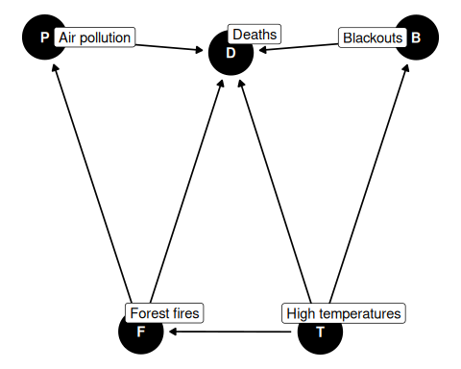
Figure 38: DAG for the high temperatures and mortality example.
If our estimand is the total effect of high temperatures on deaths, then blackouts, forest fires, and air pollution are mediators on downstream pathways. Adjusting for them would remove part of the effect we are trying to estimate.
But if the estimand changes to the effect of blackouts on deaths, then high temperatures become a confounder because they are a common cause of both blackouts and deaths. So the same variable can be “adjust for” or “do not adjust for” depending on the causal question.

Exm
Example 9 (salmonellosis and weather) For daily salmonellosis counts, a plausible DAG has temperature and rainfall as direct causes of risk, with both variables also affecting humidity. If humidity has no direct arrow to salmonellosis, then humidity is not a causal driver; it mainly reflects shared variation from temperature and rainfall. Including humidity in the regression is therefore usually unnecessary for estimating the weather effects, and it may reduce interpretability because humidity is a collider of temperature and rainfall. Conditioning on humidity can induce misleading associations and bias weather-effect estimates when that conditioning opens a path between temperature and rainfall that is not otherwise blocked (Dobson and Barnett 2018, sec. 6.3.3).
dag_salmonellosis_weather <- ggdag::dagify(
S ~ T + R + C,
H ~ T + R,
T ~ Se,
R ~ Se,
labels = c(
S = "Salmonellosis",
T = "Temperature",
R = "Rainfall",
H = "Humidity",
C = "Test change",
Se = "Season"
)
)
dag_salmonellosis_weather |>
ggdag::ggdag(use_labels = "label") +
ggdag::theme_dag()
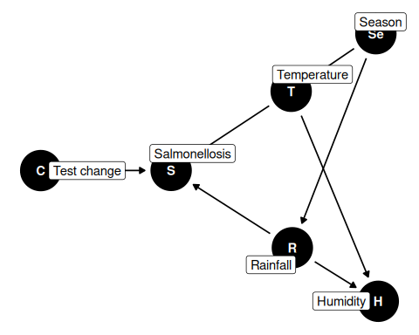
Figure 39: DAG for the salmonellosis and weather example.
The same DAG can include a “change in test” indicator when surveillance switched to a more sensitive diagnostic test. That variable can improve predictive accuracy and face validity, but omitting it does not invalidate causal interpretation for temperature and rainfall effects if it is not on their causal paths (Dobson and Barnett 2018, sec. 6.3.3).
Likewise, season may cause both temperature and rainfall, but if season has no direct path to salmonellosis beyond those weather variables, including season can obscure interpretation of the proximal weather effects (Dobson and Barnett 2018, sec. 6.3.3).
Finally, DAG-informed variable definitions matter. In one intensive-care example, a “nutrition score” looked highly predictive of mortality until investigators clarified that people near death were often coded as zero because no assessment was completed. So the recorded variable combined nutrition with prognosis, and naive selection would overstate its scientific meaning (Dobson and Barnett 2018, sec. 6.3.3).

4.9.2 Mean squared error
We might want to minimize the mean squared error, $E​\left[(y−\hat{y})^{2}\right]​$, for new observations that weren’t in our data set when we fit the model.
Unfortunately,
$$\frac{1}{n}\sum_{i=1}^{n}{(}y_{i}−{\hat{y}}_{i})^{2}$$
gives a biased estimate of $E​\left[(y−\hat{y})^{2}\right]​$ for new data. If we want an unbiased estimate, we will have to be clever.
This optimism in sample fit is one reason that $R^{2}$ is not enough for model selection. $R^{2}$ does not decrease as we add explanatory variables, even when those variables do not improve out-of-sample prediction. Selecting a model by maximizing $R^{2}$ alone can lead to overfitting, since $R^{2}$ does not penalize this non-decreasing property.
With a training/test split, we estimate coefficients in the training data and compute prediction error in held-out data:
$${\hat{β}}_{\text{train}}=({X_{\text{train}}}^{⊤}X_{\text{train}})^{−1}{X_{\text{train}}}^{⊤}y_{\text{train}}$$
$${\hat{e}}_{i,\text{test}}=y_{\text{test},i}−​\left\{{\hat{β}}_{0,\text{train}}+\sum_{j=1}^{p}{{\hat{β}}_{j,\text{train}}}x_{\text{test},ij}\right\}​, i∈\text{test set}$$
RMSE=1ntesti∈test set​(ei,test)2

4.10 Train/validation/test splits
In many applications, we split the data into training, validation, and test sets. This validation approach extends the basic train/test split by separating model tuning from final model assessment. This framework follows (James et al. 2021, 198–201).
- Use the training set to estimate model parameters.
- Use the validation set to compare candidate models, choose transformations, or tune hyperparameters.
- Use the test set once at the end to estimate final out-of-sample performance.
Keeping the test set untouched during model building helps avoid optimistic bias from repeatedly trying many models. If data are limited, $k$-fold cross-validation can replace a single validation split for more stable tuning.
Exm
Example 10 (Numerical example) The following example (Example 10) uses R’s built-in mtcars dataset ($n=32$ cars) to predict fuel efficiency (mpg) from vehicle weight (wt). It uses one random split to compare linear, quadratic, cubic, and quartic models (mpg ~ wt, mpg ~ wt + I(wt^2), mpg ~ wt + I(wt^2) + I(wt^3), and mpg ~ wt + I(wt^2) + I(wt^3) + I(wt^4)) on a validation set, then reports the chosen model’s test RMSE on untouched test data (James et al. 2021, 213).
set.seed(108)
n <- nrow(mtcars)
n_train <- floor(0.6 * n)
n_valid <- floor(0.2 * n)
idx_train <- sample.int(n, size = n_train)
idx_remaining <- setdiff(seq_len(n), idx_train)
idx_valid <- sample(idx_remaining, size = n_valid)
idx_test <- setdiff(idx_remaining, idx_valid)
split_sizes <- tibble::tibble(
split = c("training", "validation", "test"),
n = c(length(idx_train), length(idx_valid), length(idx_test))
)
Table 24: Sizes of the training, validation, and test splits
split_sizes
#> # A tibble: 3 × 2
#> split n
#> <chr> <int>
#> 1 training 19
#> 2 validation 6
#> 3 test 7
train_dat <- mtcars[idx_train, ]
valid_dat <- mtcars[idx_valid, ]
test_dat <- mtcars[idx_test, ]
model_linear <- lm(mpg ~ wt, data = train_dat)
model_quadratic <- lm(mpg ~ wt + I(wt^2), data = train_dat)
model_cubic <- lm(mpg ~ wt + I(wt^2) + I(wt^3), data = train_dat)
model_quartic <- lm(
mpg ~ wt + I(wt^2) + I(wt^3) + I(wt^4),
data = train_dat
)
compute_rmse <- function(model, data) {
sqrt(mean((data$mpg - predict(model, newdata = data))^2))
}
candidate_models <- list(
linear = model_linear,
quadratic = model_quadratic,
cubic = model_cubic,
quartic = model_quartic
)
validation_results <- tibble::tibble(
model = names(candidate_models)
) |>
dplyr::mutate(
training_RMSE = purrr::map_dbl(
model,
\(model_name) compute_rmse(candidate_models[[model_name]], train_dat)
),
validation_RMSE = purrr::map_dbl(
model,
\(model_name) compute_rmse(candidate_models[[model_name]], valid_dat)
)
)
model_labels <- c(
linear = "linear model",
quadratic = "quadratic model",
cubic = "cubic model",
quartic = "quartic model"
)
chosen_model_name <-
validation_results |>
dplyr::arrange(validation_RMSE) |>
dplyr::slice(1) |>
dplyr::pull(model)
chosen_model_label <- model_labels[[chosen_model_name]]
chosen_model <- candidate_models[[chosen_model_name]]
chosen_model_validation_rmse <- compute_rmse(chosen_model, valid_dat)
performance_comparison <- tibble::tibble(
split = c("validation", "test"),
model = chosen_model_name,
RMSE = c(
chosen_model_validation_rmse,
compute_rmse(chosen_model, test_dat)
)
)
partition_colors <- c(
training = "#1b9e77",
validation = "#d95f02",
test = "#7570b3"
)
partition_shapes <- c(
training = 16,
validation = 17,
test = 15
)
wt_range <- range(c(train_dat$wt, valid_dat$wt, test_dat$wt))
mpg_range <- range(c(train_dat$mpg, valid_dat$mpg, test_dat$mpg))
wt_grid <- seq(wt_range[1], wt_range[2], length.out = 200)
plot(
train_dat$wt,
train_dat$mpg,
xlab = "wt",
ylab = "mpg",
pch = partition_shapes[["training"]],
xlim = wt_range,
ylim = mpg_range,
col = partition_colors[["training"]]
)
points(
valid_dat$wt,
valid_dat$mpg,
pch = partition_shapes[["validation"]],
col = partition_colors[["validation"]]
)
points(
test_dat$wt,
test_dat$mpg,
pch = partition_shapes[["test"]],
col = partition_colors[["test"]]
)
abline(model_linear, col = "blue", lwd = 2)
legend(
"topright",
legend = c("training", "validation", "test", "linear fit"),
col = c(unname(partition_colors), "blue"),
pch = c(unname(partition_shapes), NA),
lty = c(NA, NA, NA, 1),
lwd = c(NA, NA, NA, 2),
bty = "n"
)
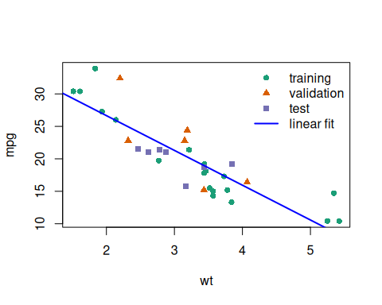
Figure 40: Linear model fit superimposed on data partitions
plot(
train_dat$wt,
train_dat$mpg,
xlab = "wt",
ylab = "mpg",
pch = partition_shapes[["training"]],
xlim = wt_range,
ylim = mpg_range,
col = partition_colors[["training"]]
)
points(
valid_dat$wt,
valid_dat$mpg,
pch = partition_shapes[["validation"]],
col = partition_colors[["validation"]]
)
points(
test_dat$wt,
test_dat$mpg,
pch = partition_shapes[["test"]],
col = partition_colors[["test"]]
)
quadratic_pred <- predict(
model_quadratic,
newdata = data.frame(wt = wt_grid)
)
lines(wt_grid, quadratic_pred, col = "blue", lwd = 2)
legend(
"topright",
legend = c("training", "validation", "test", "quadratic fit"),
col = c(unname(partition_colors), "blue"),
pch = c(unname(partition_shapes), NA),
lty = c(NA, NA, NA, 1),
lwd = c(NA, NA, NA, 2),
bty = "n"
)

Figure 41: Quadratic model fit superimposed on data partitions
plot(
train_dat$wt,
train_dat$mpg,
xlab = "wt",
ylab = "mpg",
pch = partition_shapes[["training"]],
xlim = wt_range,
ylim = mpg_range,
col = partition_colors[["training"]]
)
points(
valid_dat$wt,
valid_dat$mpg,
pch = partition_shapes[["validation"]],
col = partition_colors[["validation"]]
)
points(
test_dat$wt,
test_dat$mpg,
pch = partition_shapes[["test"]],
col = partition_colors[["test"]]
)
cubic_pred <- predict(
model_cubic,
newdata = data.frame(wt = wt_grid)
)
lines(wt_grid, cubic_pred, col = "blue", lwd = 2)
legend(
"topright",
legend = c("training", "validation", "test", "cubic fit"),
col = c(unname(partition_colors), "blue"),
pch = c(unname(partition_shapes), NA),
lty = c(NA, NA, NA, 1),
lwd = c(NA, NA, NA, 2),
bty = "n"
)

Figure 42: Cubic model fit superimposed on data partitions
plot(
train_dat$wt,
train_dat$mpg,
xlab = "wt",
ylab = "mpg",
pch = partition_shapes[["training"]],
xlim = wt_range,
ylim = mpg_range,
col = partition_colors[["training"]]
)
points(
valid_dat$wt,
valid_dat$mpg,
pch = partition_shapes[["validation"]],
col = partition_colors[["validation"]]
)
points(
test_dat$wt,
test_dat$mpg,
pch = partition_shapes[["test"]],
col = partition_colors[["test"]]
)
quartic_pred <- predict(
model_quartic,
newdata = data.frame(wt = wt_grid)
)
lines(wt_grid, quartic_pred, col = "blue", lwd = 2)
legend(
"topright",
legend = c("training", "validation", "test", "quartic fit"),
col = c(unname(partition_colors), "blue"),
pch = c(unname(partition_shapes), NA),
lty = c(NA, NA, NA, 1),
lwd = c(NA, NA, NA, 2),
bty = "n"
)

Figure 43: Quartic model fit superimposed on data partitions
Table 25: Training and validation RMSE for candidate models
validation_results
#> # A tibble: 4 × 3
#> model training_RMSE validation_RMSE
#> <chr> <dbl> <dbl>
#> 1 linear 2.80 3.84
#> 2 quadratic 1.96 4.16
#> 3 cubic 1.91 3.98
#> 4 quartic 1.90 3.97
The chosen model is the linear model, because it has the lower validation RMSE.
Table 26: Validation and test RMSE for the chosen model
performance_comparison
#> # A tibble: 2 × 3
#> split model RMSE
#> <chr> <chr> <dbl>
#> 1 validation linear 3.84
#> 2 test linear 2.44

4.11 Cross-validation
Rather than one arbitrary split, $k$-fold cross-validation repeatedly partitions the data into training and test folds. For each split we compute prediction error, then summarize errors across folds and replications. The preferred model has lower prediction error, with simpler models favored when errors are similar.
When the number of candidate explanatory variables is small, we can compare all possible subsets ($2^{p}$ models) using the same cross-validation metric.
data("carbohydrate", package = "dobson")
library(cvTools)
full_model <- lm(carbohydrate ~ ., data = carbohydrate)
cv_full <-
full_model |> cvFit(
data = carbohydrate, K = 5, R = 10,
y = carbohydrate$carbohydrate
)
reduced_model <- full_model |> update(formula = ~ . - age)
cv_reduced <-
reduced_model |> cvFit(
data = carbohydrate, K = 5, R = 10,
y = carbohydrate$carbohydrate
)

results_reduced <-
tibble(
model = "wgt+protein",
errs = cv_reduced$reps[]
)
results_full <-
tibble(
model = "wgt+age+protein",
errs = cv_full$reps[]
)
cv_results <-
bind_rows(results_reduced, results_full)
cv_results |>
ggplot(aes(y = model, x = errs)) +
geom_boxplot()
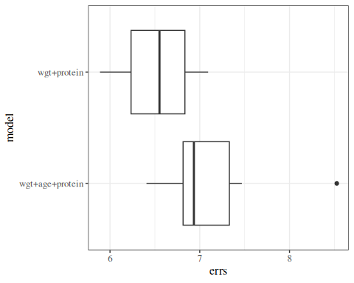

4.11.1 comparing metrics
compare_results <- tribble(
~model, ~cvRMSE, ~r.squared, ~adj.r.squared, ~trainRMSE, ~loglik,
"full",
cv_full$cv,
summary(full_model)$r.squared,
summary(full_model)$adj.r.squared,
sigma(full_model),
logLik(full_model) |> as.numeric(),
"reduced",
cv_reduced$cv,
summary(reduced_model)$r.squared,
summary(reduced_model)$adj.r.squared,
sigma(reduced_model),
logLik(reduced_model) |> as.numeric()
)
compare_results
#> # A tibble: 2 × 6
#> model cvRMSE r.squared adj.r.squared trainRMSE loglik
#> <chr> <dbl> <dbl> <dbl> <dbl> <dbl>
#> 1 full 7.13 0.481 0.383 5.96 -61.8
#> 2 reduced 6.53 0.445 0.380 5.97 -62.5

anova(full_model, reduced_model)
#> # A tibble: 2 × 6
#> Res.Df RSS Df `Sum of Sq` F `Pr(>F)`
#> <dbl> <dbl> <dbl> <dbl> <dbl> <dbl>
#> 1 16 568. NA NA NA NA
#> 2 17 606. -1 -38.4 1.08 0.314

4.12 Best subset selection
When the number of candidate predictors is modest, we can use best subset selection. For each model size $k=0,1,…,p$, we fit all $\left({p \atop k}\right)$ models and keep the best model of size $k$ (e.g., by lowest RSS in the training data).
Best subset selection yields at most $p+1$ candidate models to compare across model sizes, using criteria such as cross-validated prediction error, $C_{p}$, AIC/BIC, or adjusted $R^{2}$. In that sense, best subset selection is more exhaustive than one-path methods like forward or backward stepwise selection.
For a full algorithmic treatment, including validation and criterion-based comparison across model size, see the ISLR treatment of best subset selection (James et al. 2013).
hers_subset <- rmb::hers |> haven::zap_labels() |>
dplyr::select(LDL, age, weight, BMI, HDL, TG, SBP) |>
tidyr::drop_na()
hers_lm_subset <- lm(
LDL ~ age + weight + BMI + HDL + TG + SBP,
data = hers_subset
)
hers_best_subset <- olsrr::ols_step_best_subset(hers_lm_subset)
hers_best_subset$metrics |>
dplyr::arrange(dplyr::desc(adjr)) |>
dplyr::slice_head(n = 5)
#> # A tibble: 5 × 14
#> mindex n predictors rsquare adjr predrsq cp aic sbic sbc
#> <int> <int> <chr> <dbl> <dbl> <dbl> <dbl> <dbl> <dbl> <dbl>
#> 1 5 5 age BMI HDL T… 0.0131 0.0113 0.00868 5.04 27730. 19934. 27771.
#> 2 4 4 age BMI TG SBP 0.0127 0.0112 0.00900 4.27 27729. 19933. 27764.
#> 3 6 6 age weight BM… 0.0131 0.0110 0.00802 7 27732. 19936. 27779.
#> 4 3 3 age TG SBP 0.0113 0.0103 0.00839 5.91 27730. 19935. 27760.
#> 5 2 2 age TG 0.00825 0.00752 0.00602 12.5 27737. 19941. 27761.
#> # ℹ 4 more variables: msep <dbl>, fpe <dbl>, apc <dbl>, hsp <dbl>

4.13 Stepwise regression
Stepwise methods are another common approach. Forward selection adds variables one at a time. Backward selection starts with the full model and removes variables sequentially. Both approaches can select different models from the same data.
 Caution about stepwise selection
Stepwise regression has several known problems:
- It tends to select too many variables (overfitting)
- P-values and confidence intervals are biased after selection
- It ignores model uncertainty
- Results can be unstable across different samples
Consider using cross-validation, penalized methods (like Lasso), or subject-matter knowledge instead. See Harrell (2015) and Heinze et al. (2018) for more discussion.

olsrr::ols_step_both_aic(full_model)
#>
#>
#> Stepwise Summary
#> -------------------------------------------------------------------------
#> Step Variable AIC SBC SBIC R2 Adj. R2
#> -------------------------------------------------------------------------
#> 0 Base Model 140.773 142.764 83.068 0.00000 0.00000
#> 1 protein (+) 137.950 140.937 80.438 0.21427 0.17061
#> 2 weight (+) 132.981 136.964 77.191 0.44544 0.38020
#> -------------------------------------------------------------------------
#>
#> Final Model Output
#> ------------------
#>
#> Model Summary
#> ---------------------------------------------------------------
#> R 0.667 RMSE 5.505
#> R-Squared 0.445 MSE 30.301
#> Adj. R-Squared 0.380 Coef. Var 15.879
#> Pred R-Squared 0.236 AIC 132.981
#> MAE 4.593 SBC 136.964
#> ---------------------------------------------------------------
#> RMSE: Root Mean Square Error
#> MSE: Mean Square Error
#> MAE: Mean Absolute Error
#> AIC: Akaike Information Criteria
#> SBC: Schwarz Bayesian Criteria
#>
#> ANOVA
#> -------------------------------------------------------------------
#> Sum of
#> Squares DF Mean Square F Sig.
#> -------------------------------------------------------------------
#> Regression 486.778 2 243.389 6.827 0.0067
#> Residual 606.022 17 35.648
#> Total 1092.800 19
#> -------------------------------------------------------------------
#>
#> Parameter Estimates
#> ----------------------------------------------------------------------------------------
#> model Beta Std. Error Std. Beta t Sig lower upper
#> ----------------------------------------------------------------------------------------
#> (Intercept) 33.130 12.572 2.635 0.017 6.607 59.654
#> protein 1.824 0.623 0.534 2.927 0.009 0.509 3.139
#> weight -0.222 0.083 -0.486 -2.662 0.016 -0.397 -0.046
#> ----------------------------------------------------------------------------------------

4.14 Lasso
Lasso is a penalized regression method that shrinks coefficient estimates toward zero. It adds an $L_{1}$ penalty term to the objective function, creating a trade-off between model fit and parsimony. The intercept is not penalized.
As the tuning parameter $λ$ increases, more coefficients are shrunken strongly, and some become exactly zero. So lasso both regularizes the model and performs variable selection. In practice, $λ$ is usually chosen by cross-validation to minimize prediction error.
For Gaussian linear models, the penalized least-squares forms are:
$${\hat{β}}^{\text{lasso}}=arg\min_{β_{0},…,β_{p}}​\left\{\sum_{i=1}^{n}{​}\left\{y_{i}−β_{0}−\sum_{j=1}^{p}{β_{j}}x_{ij}\right\}​^{2}+λ\sum_{j=1}^{p}{|}β_{j}|\right\}​$$
$${\hat{β}}^{\text{ridge}}=arg\min_{β_{0},…,β_{p}}​\left\{\sum_{i=1}^{n}{​}\left\{y_{i}−β_{0}−\sum_{j=1}^{p}{β_{j}}x_{ij}\right\}​^{2}+λ\sum_{j=1}^{p}{β_{j}^{2}}\right\}​$$
$${\hat{β}}^{\text{elastic-net}}=arg\min_{β_{0},…,β_{p}}​\left\{\sum_{i=1}^{n}{​}\left\{y_{i}−β_{0}−\sum_{j=1}^{p}{β_{j}}x_{ij}\right\}​^{2}+λ​\left\{α\sum_{j=1}^{p}{|}β_{j}|+\frac{1−α}{2}\sum_{j=1}^{p}{β_{j}^{2}}\right\}​\right\}​$$
library(glmnet)
y <- carbohydrate$carbohydrate
x <- carbohydrate |>
select(age, weight, protein) |>
as.matrix()
fit <- glmnet(x, y)

autoplot(fit, xvar = "lambda")
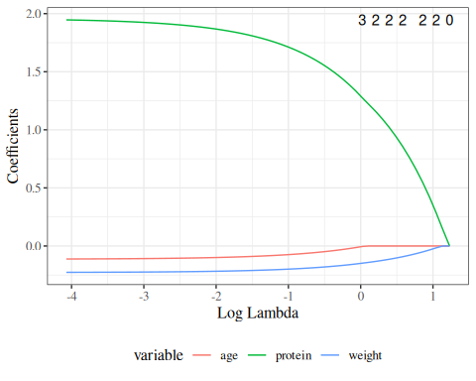
Figure 44: Lasso selection

cvfit <- cv.glmnet(x, y)
plot(cvfit)
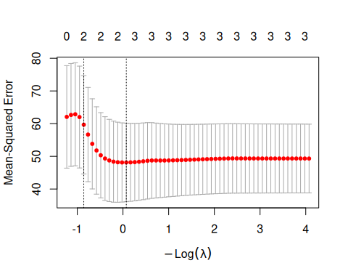

coef(cvfit, s = "lambda.1se")
#> 4 x 1 sparse Matrix of class "dgCMatrix"
#> lambda.1se
#> (Intercept) 34.5502388
#> age .
#> weight -0.0510494
#> protein 0.5472281

4.14.1 Likelihood ratio test for nested models
For a general MLE-focused discussion of likelihood-ratio tests, see Likelihood ratio tests for MLEs.
A likelihood ratio test (LRT) compares two nested models by computing twice the difference in their log-likelihoods:
$$2(ℓ_{1}−ℓ_{0})\dot{∼}χ_{q}^{2} \text{(asymptotically under }H_{0}\text{)}$$
where $q=p_{2}−p_{1}$ is the number of extra parameters in the full model.

logLik(bw_lm2)
#> 'log Lik.' -156.579 (df=5)
logLik(bw_lm1)
#> 'log Lik.' -156.695 (df=4)
log_LR <- (logLik(bw_lm2) - logLik(bw_lm1)) |> as.numeric()
delta_df <- (bw_lm1$df.residual - df.residual(bw_lm2))
x_max <- 1

d_log_LR <- function(x, df = delta_df) dchisq(x, df = df)
chisq_plot <-
ggplot() +
geom_function(fun = d_log_LR) +
stat_function(
fun = d_log_LR,
xlim = c(2 * log_LR, x_max),
geom = "area",
fill = "gray"
) +
geom_segment(
aes(
x = 2 * log_LR,
xend = 2 * log_LR,
y = 0,
yend = d_log_LR(2 * log_LR)
),
col = "red"
) +
xlim(0.0001, x_max) +
ylim(0, 4) +
ylab("p(X=x)") +
xlab("Likelihood-ratio test statistic [x] = 2 * log(likelihood ratio)") +
theme_classic()
chisq_plot |> print()
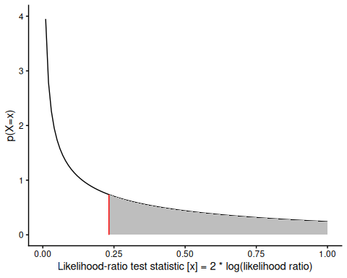
Figure 45: Chi-square distribution

Now we can get the p-value:
pchisq(
q = 2 * log_LR,
df = delta_df,
lower = FALSE
) |>
print()
#> [1] 0.629806

In practice you don’t have to do this by hand; there are functions to do it for you:
# built in
lmtest::lrtest(bw_lm2, bw_lm1)
#> # A tibble: 2 × 5
#> `#Df` LogLik Df Chisq `Pr(>Chisq)`
#> <dbl> <dbl> <dbl> <dbl> <dbl>
#> 1 5 -157. NA NA NA
#> 2 4 -157. -1 0.232 0.630

4.14.2 Partial F-test for nested linear models
See Vittinghoff et al. (2012, sec. 4.3) and Dobson and Barnett (2018, sec. 6.3) for further discussion.

Setup
Suppose we have two nested linear regression models:
Definition 17 (Nested linear models)
$$E​\left[Y∣\tilde{x}\right]​={\tilde{x}}^{⊤}\tilde{β}=β_{0}+β_{1}x_{1}+⋯+β_{p_{1}−1}x_{p_{1}−1} (18)$$
$$E​\left[Y∣\tilde{x},\tilde{z}\right]​={\tilde{x}}^{⊤}\tilde{β}+{\tilde{z}}^{⊤}\tilde{γ}=β_{0}+β_{1}x_{1}+⋯+β_{p_{1}−1}x_{p_{1}−1}+γ_{1}z_{1}+⋯+γ_{q}z_{q} (19)$$
The reduced model (Equation 18) has $p_{1}$ parameters. The full model (Equation 19) adds $q$ extra predictors and has $p_{2}=p_{1}+q$ parameters. The reduced model is a special case of the full model with the constraint $\tilde{γ}=\tilde{0}$.

The null and alternative hypotheses are:
$$H_{0}:\tilde{γ}=\tilde{0} \text{(reduced model)}$$
$$H_{A}:\tilde{γ}≠\tilde{0} \text{(full model)}$$

Exm
Example 11 (Nested models: birthweight data) In the birthweight example, the reduced model has $p_{1}=3$ parameters:
$$E​\left[\text{weight}∣\text{sex},\text{age}\right]​=β_{0}+β_{\text{sex}}⋅\text{sex}+β_{A}⋅\text{age}$$
The full model adds an interaction term ($q=1$ extra parameter, $p_{2}=4$):
$$E​\left[\text{weight}∣\text{sex},\text{age}\right]​=β_{0}+β_{\text{sex}}⋅\text{sex}+β_{A}⋅\text{age}+β_{AM}⋅\text{sex}⋅\text{age}$$
$H_{0}:β_{AM}=0$ vs. $H_{A}:β_{AM}≠0$.

F-statistic
Definition 18 (Partial F-statistic) Let ${\text{RSS}}_{0}$ and ${\text{RSS}}_{1}$ denote the residual sums of squares from the reduced and full models, respectively. The partial F-statistic is:
$$F=\frac{({\text{RSS}}_{0}−{\text{RSS}}_{1}) / q}{{\text{RSS}}_{1} / (n−p_{2})} (20)$$
where:
- ${\text{RSS}}_{0}=\sum_{i=1}^{n}{(}y_{i}−{\hat{y}}_{i}^{(0)})^{2}$ is the residual SS under $H_{0}$
- ${\text{RSS}}_{1}=\sum_{i=1}^{n}{(}y_{i}−{\hat{y}}_{i}^{(1)})^{2}$ is the residual SS under $H_{A}$
- $q=p_{2}−p_{1}$ is the number of constraints (extra parameters in the full model)
- $n−p_{2}$ is the residual degrees of freedom of the full model

Theorem 4 (Null distribution of the partial F-statistic) Under $H_{0}$ and the Gaussian linear regression assumptions,
$$F ∼ F_{q, n−p_{2}} (21)$$
This exact distribution is non-asymptotic: it holds for any sample size $n$ when the errors $ϵ_{i} ∼_{iid} N(0,σ^{2})$.

Proof
Proof. Under $H_{0}$, the extra predictors $\tilde{z}$ contribute nothing, so the numerator ${\text{RSS}}_{0}−{\text{RSS}}_{1} ∼ σ^{2}χ_{q}^{2}$ and the denominator ${\text{RSS}}_{1} ∼ σ^{2}χ_{n−p_{2}}^{2}$ are independent chi-squared random variables (this follows from the Gauss-Markov theorem and the properties of projections in the column spaces of the design matrices). Therefore,
$$F=\frac{({\text{RSS}}_{0}−{\text{RSS}}_{1})/q}{{\text{RSS}}_{1}/(n−p_{2})}=\frac{χ_{q}^{2}/q}{χ_{n−p_{2}}^{2}/(n−p_{2})} ∼ F_{q, n−p_{2}}.$$

Connection to deviance
From Section 4.1.8, the Gaussian deviance of model $k$ is $D_{k}={\text{RSS}}_{k}/{\hat{σ}}^{2}$, where ${\hat{σ}}^{2}$ is an estimate of $σ^{2}$. Because ${\hat{σ}}^{2}$ appears in both the numerator and denominator of Equation 20, it cancels:
$$F=\frac{(D_{0}−D_{1}) / q}{D_{1} / (n−p_{2})}=\frac{({\text{RSS}}_{0}−{\text{RSS}}_{1}) / q}{{\text{RSS}}_{1} / (n−p_{2})} (22)$$
The denominator $s^{2}\overset{\text{def}}{=}{\text{RSS}}_{1}/(n−p_{2})$ is an unbiased estimator of $σ^{2}$ under both $H_{0}$ and $H_{A}$.

Connection to the likelihood ratio test
The approximate likelihood ratio test (LRT) for MLEs (see the table of Gaussian vs. MLE-based tests and Section 4.1.8) uses the statistic:
$$λ=2(ℓ_{1}−ℓ_{0})\dot{∼}χ_{q}^{2} \text{under }H_{0}\text{ (asymptotically)} (23)$$
For Gaussian linear regression, the MLE of $σ^{2}$ under model $k$ is ${\hat{σ}}_{k}^{2}={\text{RSS}}_{k}/n$, so the log-likelihood at the MLE is:
$$\begin{aligned}ℓ_{k}&=−\frac{n}{2}log(2π{\hat{σ}}_{k}^{2})−\frac{n}{2} \\ &=−\frac{n}{2}log​​\left(\frac{2π {\text{RSS}}_{k}}{n}\right)​−\frac{n}{2}\end{aligned} (24)$$
Substituting into Equation 23:
$$\begin{aligned}λ&=2(ℓ_{1}−ℓ_{0}) \\ &=2\left[−\frac{n}{2}log​​\left(\frac{{\text{RSS}}_{1}}{n}\right)​+\frac{n}{2}log​​\left(\frac{{\text{RSS}}_{0}}{n}\right)​\right] \\ &=nlog​​\left(\frac{{\text{RSS}}_{0}}{{\text{RSS}}_{1}}\right)​\end{aligned} (25)$$

Asymptotic equivalence of F-test and LRT
For large $n$, $F$ and $λ$ are approximately related by:
$$λ≈q⋅F (26)$$
This approximation follows because when $H_{0}$ is true and $n$ is large, $({\text{RSS}}_{0}−{\text{RSS}}_{1})/{\text{RSS}}_{1}$ is small, and:
$$\begin{aligned}λ&=nlog​​\left(\frac{{\text{RSS}}_{0}}{{\text{RSS}}_{1}}\right)​ \\ &=nlog​​\left(1+\frac{{\text{RSS}}_{0}−{\text{RSS}}_{1}}{{\text{RSS}}_{1}}\right)​ \\ &≈n⋅\frac{{\text{RSS}}_{0}−{\text{RSS}}_{1}}{{\text{RSS}}_{1}}\end{aligned}$$
$$\begin{aligned}q⋅F&=q⋅\frac{({\text{RSS}}_{0}−{\text{RSS}}_{1})/q}{{\text{RSS}}_{1}/(n−p_{2})} \\ &=(n−p_{2})⋅\frac{{\text{RSS}}_{0}−{\text{RSS}}_{1}}{{\text{RSS}}_{1}} \\ &≈n⋅\frac{{\text{RSS}}_{0}−{\text{RSS}}_{1}}{{\text{RSS}}_{1}}\end{aligned}$$
So $λ≈q⋅F$ for large $n$, and both statistics have the same asymptotic null distribution $χ_{q}^{2}$ (since $q⋅F_{q,n−p_{2}}\dot{∼}χ_{q}^{2}$ as $n→∞$).

Why use the F-test instead of the LRT?
For Gaussian linear regression:
- The F-test is exact — it has the correct $F_{q,n−p_{2}}$ null distribution for any sample size $n$, provided the errors are Gaussian. It accounts for the estimation of $σ^{2}$ via the residual degrees of freedom.
- The LRT is approximate — it relies on the asymptotic $χ_{q}^{2}$ distribution, which requires large $n$ and treats $σ^{2}$ as known (fixed at its MLE).
Both tests give similar p-values for large $n$. For small to moderate $n$, the F-test is preferred because it is exact.
For non-Gaussian GLMs (Poisson, Binomial), the F-test is not applicable; the LRT (or Wald test) is the standard approach.

In R
In R, the partial F-test for two nested lm models is performed with anova():
Table 27
anova(bw_lm1, bw_lm2)
#> # A tibble: 2 × 6
#> Res.Df RSS Df `Sum of Sq` F `Pr(>F)`
#> <dbl> <dbl> <dbl> <dbl> <dbl> <dbl>
#> 1 21 658771. NA NA NA NA
#> 2 20 652425. 1 6346. 0.195 0.664
anova(bw_lm1, bw_lm2) performs the partial F-test comparing the reduced model bw_lm1 (parallel slopes, no interaction) against the full model bw_lm2 (with sex-age interaction). The output shows the RSS for each model, the difference, the F-statistic, and the p-value.

For comparison, the approximate likelihood ratio test using the lmtest package:
Table 28
lmtest::lrtest(bw_lm1, bw_lm2)
#> # A tibble: 2 × 5
#> `#Df` LogLik Df Chisq `Pr(>Chisq)`
#> <dbl> <dbl> <dbl> <dbl> <dbl>
#> 1 4 -157. NA NA NA
#> 2 5 -157. 1 0.232 0.630
Compare the p-values from anova() (exact F-test) and lmtest::lrtest() (approximate LRT). They are similar but not identical: the F-test uses the $F_{1,n−4}$ distribution, while the LRT uses the asymptotic $χ_{1}^{2}$ distribution. For large $n$, these p-values converge.

Extracting F-test components by hand
To understand the computation, we can replicate the F-statistic manually:
Table 29
rss0 <- deviance(bw_lm1) # RSS of reduced model
rss1 <- deviance(bw_lm2) # RSS of full model
n <- nobs(bw_lm2)
p2 <- length(coef(bw_lm2))
q <- length(coef(bw_lm2)) - length(coef(bw_lm1))
s2 <- rss1 / (n - p2) # residual variance estimate from full model
F_stat <- ((rss0 - rss1) / q) / s2
p_val <- pf(F_stat, df1 = q, df2 = n - p2, lower.tail = FALSE)
cat("RSS_0 =", rss0, "\n")
#> RSS_0 = 658771
cat("RSS_1 =", rss1, "\n")
#> RSS_1 = 652425
cat("q =", q, "\n")
#> q = 1
cat("s^2 =", s2, "\n")
#> s^2 = 32621.2
cat("F =", F_stat, "\n")
#> F = 0.194543
cat("p-val =", p_val, "\n")
#> p-val = 0.663893
The LRT statistic $λ=nlog({\text{RSS}}_{0}/{\text{RSS}}_{1})≈q⋅F$ for large $n$.
Table 30
lambda <- n * log(rss0 / rss1)
cat("LRT statistic lambda =", lambda, "\n")
#> LRT statistic lambda = 0.232323
cat("q * F =", q * F_stat, "\n")
#> q * F = 0.194543
cat("LRT p-val (chi^2) =", pchisq(lambda, df = q, lower.tail = FALSE), "\n")
#> LRT p-val (chi^2) = 0.629806
The LRT statistic $λ$ and $q⋅F$ are close in value, illustrating the asymptotic equivalence Equation 26.

5. Inference about Gaussian Linear Regression Models

5.1 Motivating example: birthweight data
Research question: is there really an interaction between sex and age?
$H_{0}:β_{AM}=0$​
$H_{A}:β_{AM}≠0$​
$P(|{\hat{β}}_{AM}|>|−18.417241|∣H_{0})$ = ?

5.2 Inference for individual predictor coefficients

5.2.1 Sampling distribution of $\hat{β}$
The Fisher information for $β$ is:
$$\begin{aligned}I_{β}&=E​\left[−ℓ_{β,β^{′}}^{″}(Y|X,β,σ^{2})\right]​ \\ &=\frac{1}{σ^{2}}X^{′}X\end{aligned}$$

Therefore:
$$Var​\left(\hat{β}\right)​≈(I_{β})^{−1}=σ^{2}(X^{′}X)^{−1}$$
and
$$\hat{β}\dot{∼}N(β,I_{β}^{−1})$$
These distribution properties are all results you have hopefully seen before.

In the Gaussian linear regression case, we also have exact results. To test $H_{0}:β_{j}=β_{j,0}$ (typically $β_{j,0}=0$):
$$\frac{{\hat{β}}_{j}−β_{j,0}}{​\left({\hat{β}}_{j}\right)​} ∼ t_{n−p}$$

5.2.2 Estimated covariance matrix and standard errors

Interpreting the layout of the covariance matrix
The covariance matrix $\hat{Cov}(\hat{\tilde{β}})$ is a $p×p$ symmetric matrix, where $p$ is the number of regression coefficients (including the intercept, if present). Its rows and columns correspond to those $p$ coefficient estimates. When an intercept is included, the coefficients are typically written ${\hat{β}}_{0},{\hat{β}}_{1},…$, with ${\hat{β}}_{0}$ denoting the intercept. The matrix entries themselves are still indexed by position, so matrix row/column index $1$ corresponds to the intercept term when one is included.
The general layout is:
$$\hat{Cov}(\hat{\tilde{β}})=\begin{matrix} & {\hat{β}}_{0} & {\hat{β}}_{1} & ⋯ & {\hat{β}}_{p−1} \\ {\hat{β}}_{0} & Var​\left({\hat{β}}_{0}\right)​ & Cov​\left({\hat{β}}_{0},{\hat{β}}_{1}\right)​ & ⋯ & Cov​\left({\hat{β}}_{0},{\hat{β}}_{p−1}\right)​ \\ {\hat{β}}_{1} & Cov​\left({\hat{β}}_{1},{\hat{β}}_{0}\right)​ & Var​\left({\hat{β}}_{1}\right)​ & ⋯ & Cov​\left({\hat{β}}_{1},{\hat{β}}_{p−1}\right)​ \\ ⋮ & ⋮ & ⋮ & ⋱ & ⋮ \\ {\hat{β}}_{p−1} & Cov​\left({\hat{β}}_{p−1},{\hat{β}}_{0}\right)​ & Cov​\left({\hat{β}}_{p−1},{\hat{β}}_{1}\right)​ & ⋯ & Var​\left({\hat{β}}_{p−1}\right)​\end{matrix}$$
Specifically, the matrix entries represent:
- The diagonal entries are the variances of the individual coefficient estimates: the entry in matrix position $(j+1,j+1)$ is $Var​\left({\hat{β}}_{j}\right)​$, for $j=0,1,…,p−1$.
- The off-diagonal entries are the covariances between pairs of coefficient estimates: the entry in matrix position $(i+1,j+1)$ is $Cov​\left({\hat{β}}_{i},{\hat{β}}_{j}\right)​$, for $i≠j$.
- The matrix is symmetric: $Cov​\left({\hat{β}}_{i},{\hat{β}}_{j}\right)​=Cov​\left({\hat{β}}_{j},{\hat{β}}_{i}\right)​$.
Exm
Example 12 For model 2, which has four coefficients $({\hat{β}}_{0},{\hat{β}}_{M},{\hat{β}}_{A},{\hat{β}}_{AM})$, the covariance matrix has the following layout:
$$Cov(\hat{\tilde{β}})=\begin{matrix} & {\hat{β}}_{0} & {\hat{β}}_{M} & {\hat{β}}_{A} & {\hat{β}}_{AM} \\ {\hat{β}}_{0} & Var​\left({\hat{β}}_{0}\right)​ & Cov​\left({\hat{β}}_{0},{\hat{β}}_{M}\right)​ & Cov​\left({\hat{β}}_{0},{\hat{β}}_{A}\right)​ & Cov​\left({\hat{β}}_{0},{\hat{β}}_{AM}\right)​ \\ {\hat{β}}_{M} & Cov​\left({\hat{β}}_{M},{\hat{β}}_{0}\right)​ & Var​\left({\hat{β}}_{M}\right)​ & Cov​\left({\hat{β}}_{M},{\hat{β}}_{A}\right)​ & Cov​\left({\hat{β}}_{M},{\hat{β}}_{AM}\right)​ \\ {\hat{β}}_{A} & Cov​\left({\hat{β}}_{A},{\hat{β}}_{0}\right)​ & Cov​\left({\hat{β}}_{A},{\hat{β}}_{M}\right)​ & Var​\left({\hat{β}}_{A}\right)​ & Cov​\left({\hat{β}}_{A},{\hat{β}}_{AM}\right)​ \\ {\hat{β}}_{AM} & Cov​\left({\hat{β}}_{AM},{\hat{β}}_{0}\right)​ & Cov​\left({\hat{β}}_{AM},{\hat{β}}_{M}\right)​ & Cov​\left({\hat{β}}_{AM},{\hat{β}}_{A}\right)​ & Var​\left({\hat{β}}_{AM}\right)​\end{matrix}$$
The estimate of that matrix, $\hat{Cov}​\left(\hat{β}\right)​$ is in Table 31.
Table 31: Covariance matrix of $\hat{\tilde{β}}$ for birthweight model 2 (with interaction term)
bw_lm2 |> vcov()
#> (Intercept) sexmale age sexmale:age
#> (Intercept) 1353968 -1353968 -34870.966 34870.966
#> sexmale -1353968 2596387 34870.966 -67210.974
#> age -34871 34871 899.896 -899.896
#> sexmale:age 34871 -67211 -899.896 1743.548
The square roots of the diagonal entries give the standard errors of the coefficient estimates:
bw_lm2 |>
vcov() |>
diag() |>
sqrt()
#> (Intercept) sexmale age sexmale:age
#> 1163.6015 1611.3309 29.9983 41.7558
bw_lm2 |>
parameters() |>
print_md()
Table 32: Estimated model for birthweight data with interaction term
Parameter | Coefficient | SE | 95% CI | t(20) | p
(Intercept) | -2141.67 | 1163.60 | (-4568.90, 285.56) | -1.84 | 0.081
sex (male) | 872.99 | 1611.33 | (-2488.18, 4234.17) | 0.54 | 0.594
age | 130.40 | 30.00 | (67.82, 192.98) | 4.35 | < .001
sex (male) × age | -18.42 | 41.76 | (-105.52, 68.68) | -0.44 | 0.664

So we can do confidence intervals, hypothesis tests, and p-values exactly as in the one-variable case we looked at previously.

5.2.3 Wald tests and confidence intervals
For Gaussian linear regression, the ordinary least squares (OLS) estimates ${\hat{β}}_{k}$ are exactly Gaussian when the error terms $ϵ_{i}$ are Gaussian, for any sample size. See also the table of Gaussian vs. MLE-based tests.

Wald test statistic
To test $H_{0}:β_{k}=β_{k,0}$ (typically $β_{k,0}=0$):
$$t_{k}=\frac{{\hat{β}}_{k}−β_{k,0}}{\hat{SE}({\hat{β}}_{k})}$$
Under $H_{0}$, $t_{k}∼t_{n−p}$ exactly when errors are Gaussian.

Confidence intervals for regression coefficients
A 95% confidence interval for $β_{k}$ is:
$${\hat{β}}_{k}±t_{n−p}(0.975)⋅\hat{SE}({\hat{β}}_{k})$$

In R
In R, parameters() from the parameters package automatically computes Wald tests and confidence intervals for linear regression model coefficients:
bw_lm2 |>
parameters() |>
print_md(
include_reference = TRUE
)
Table 33: Wald tests and 95% CIs for birthweight linear regression
Parameter | Coefficient | SE | 95% CI | t(20) | p
(Intercept) | -2141.67 | 1163.60 | (-4568.90, 285.56) | -1.84 | 0.081
sex (female) | 0.00
sex (male) | 872.99 | 1611.33 | (-2488.18, 4234.17) | 0.54 | 0.594
age | 130.40 | 30.00 | (67.82, 192.98) | 4.35 | < .001
sex (male) × age | -18.42 | 41.76 | (-105.52, 68.68) | -0.44 | 0.664

To understand what’s happening, let’s replicate these results by hand for the interaction term.

P-values
bw_lm2 |>
parameters(keep = "sexmale:age") |>
print_md(
include_reference = TRUE
)
Parameter | Coefficient | SE | 95% CI | t(20) | p
sex (male) × age | -18.42 | 41.76 | (-105.52, 68.68) | -0.44 | 0.664
beta_hat <- coef(summary(bw_lm2))["sexmale:age", "Estimate"]
se_hat <- coef(summary(bw_lm2))["sexmale:age", "Std. Error"]
dfresid <- bw_lm2$df.residual
t_stat <- abs(beta_hat) / se_hat
pval_t <-
pt(-t_stat, df = dfresid, lower.tail = TRUE) +
pt(t_stat, df = dfresid, lower.tail = FALSE)
$$\begin{aligned}&P​\left(|{\hat{β}}_{AM}|>|−18.417241| | H_{0}\right)​ \\ &=Pr​\left(​\left|\frac{{\hat{β}}_{AM}}{\hat{SE}({\hat{β}}_{AM})}\right|​>​\left|\frac{−18.417241}{41.755817}\right|​ | H_{0}\right)​ \\ &=Pr​\left(​\left|T_{20}\right|​>0.44107|H_{0}\right)​ \\ &=0.663893\end{aligned}$$
This manual calculation matches the result in Table 33.

Confidence intervals
q_t_upper <- qt(
p = 0.975,
df = dfresid,
lower.tail = TRUE
)
q_t_lower <- qt(
p = 0.025,
df = dfresid,
lower.tail = TRUE
)
confint_radius_t <-
se_hat * q_t_upper
confint_t <- beta_hat + c(-1, 1) * confint_radius_t
print(confint_t)
#> [1] -105.5184 68.6839
This calculated confidence interval also matches.

Gaussian approximations
For large samples, the t-distribution is well-approximated by the standard Gaussian:
pval_z <- pnorm(abs(t_stat), lower.tail = FALSE) * 2
print(pval_z)
#> [1] 0.659162
confint_radius_z <- se_hat * qnorm(0.975, lower.tail = TRUE)
confint_z <-
beta_hat + c(-1, 1) * confint_radius_z
print(confint_z)
#> [1] -100.2571 63.4227

5.3 Inference for predicted means
Exercise 17 Given a maximum likelihood estimate $\hat{\tilde{β}}$ and a corresponding estimated covariance matrix $\hat{Σ}\overset{\text{def}}{=}\hat{Cov}(\hat{\tilde{β}})$, calculate a 95% confidence interval for the predicted mean $μ(\tilde{x})=E​\left[Y|\tilde{X}=\tilde{x}\right]​$.

Solution
Solution 2.
By the Gauss-Markov theorem, the OLS estimate $\hat{\tilde{β}}$ is the best linear unbiased estimator of $\tilde{β}$. A 95% confidence interval for $μ(\tilde{x})$ can be constructed directly on the original scale:
$$\hat{μ}(\tilde{x})±t_{n−p}(0.975)⋅​\left(\hat{μ}(\tilde{x})\right)​$$
where $\hat{μ}(\tilde{x})={\tilde{x}}^{′}\hat{\tilde{β}}$.
Unlike in logistic regression, no transformation is needed; the confidence interval is constructed directly on the mean scale.
$$μ(\tilde{x})∈​\left(\hat{μ}(\tilde{x})±t_{n−p}(0.975)⋅​\left(\hat{μ}(\tilde{x})\right)​\right)​$$

Exercise 18
How can we estimate the standard error of $\hat{μ}(\tilde{x})$?
$$​\left(\hat{μ}(\tilde{x})\right)​=?$$

Solution
Solution 3.
$$SE​\left(\hat{μ}(\tilde{x})\right)​=\sqrt{Var​\left(\hat{μ}(\tilde{x})\right)​} (27)$$
By the definition $\hat{μ}(\tilde{x})={\tilde{x}}^{′}\hat{\tilde{β}}$ and the variance of a linear combination:
$$\begin{aligned}Var​\left(\hat{μ}(\tilde{x})\right)​&=Var​\left({\tilde{x}}^{′}\hat{\tilde{β}}\right)​ \\ &={\tilde{x}}^{′}Cov​\left(\hat{\tilde{β}}\right)​\tilde{x} \\ &={\tilde{x}}^{⊤}Σ\tilde{x}\end{aligned} (28)$$
where $Σ\overset{\text{def}}{=}Cov(\hat{\tilde{β}})$.

Expanding Equation 28 out of matrix-vector notation, we have:
$$\begin{aligned}{\tilde{x}}^{⊤}Σ\tilde{x}&=\sum_{i=1}^{p}{\sum_{j=1}^{p}{x_{i}}}Σ_{ij}x_{j} \\ &=\sum_{i=1}^{p}{\sum_{j=1}^{p}{x_{i}}}Cov({\hat{\tilde{β}}}_{i},{\hat{\tilde{β}}}_{j})x_{j}\end{aligned}$$

Combining Equation 28 and the Gauss-Markov theorem:
Theorem 5 (Estimated variance and standard error of predicted mean)
$$​\left(\hat{μ}(\tilde{x})\right)​={\tilde{x}}^{⊤}\hat{Σ}\tilde{x} (29)$$
$$​\left(\hat{μ}(\tilde{x})\right)​=\sqrt{{\tilde{x}}^{⊤}\hat{Σ}\tilde{x}} (30)$$
Note: on the RHS, we have plugged in $\hat{Σ}$, our estimate of $Σ$.

In R
In R, predict() with se.fit = TRUE computes the estimated mean $\hat{μ}(\tilde{x})={\tilde{x}}^{′}\hat{\tilde{β}}$ and its estimated standard error for each covariate pattern:
library(dplyr)
new_data <- tibble(
age = c(36, 38, 40),
sex = "male"
)
pred_mean <-
bw_lm2 |>
predict(
newdata = new_data,
se.fit = TRUE
)
new_data |>
mutate(
mu_hat = pred_mean$fit,
se = pred_mean$se.fit,
ci_lower = mu_hat - qt(0.975, df = bw_lm2$df.residual) * se,
ci_upper = mu_hat + qt(0.975, df = bw_lm2$df.residual) * se
) |>
knitr::kable(digits = 3)
Table 34: Predicted means and 95% CI for birthweight linear regression
age | sex | mu_hat | se | ci_lower | ci_upper
36 | male | 2762.71 | 85.508 | 2584.34 | 2941.07
38 | male | 2986.67 | 53.030 | 2876.05 | 3097.29
40 | male | 3210.64 | 71.147 | 3062.23 | 3359.05

Alternatively, predict() with interval = "confidence" gives the same result:
bw_lm2 |>
predict(
newdata = new_data,
interval = "confidence"
) |>
cbind(new_data) |>
knitr::kable(digits = 3)
Table 35: Predicted means and 95% CI using interval = 'confidence'
fit | lwr | upr | age | sex
2762.71 | 2584.34 | 2941.07 | 36 | male
2986.67 | 2876.05 | 3097.29 | 38 | male
3210.64 | 3062.23 | 3359.05 | 40 | male

library(sjPlot)
bw_lm2 |>
plot_model(type = "pred", terms = c("age", "sex"), show.data = TRUE) +
theme_sjplot() +
theme(legend.position = "bottom")
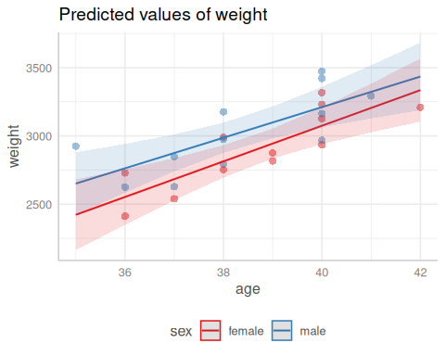
Figure 46: Predicted values and confidence bands for the birthweight model with interaction term

5.3.1 Why are confidence bands narrower near the center of the data?
The confidence bands in Figure 46 are visibly narrower near the center of the gestational age range. To understand why, consider a simple linear regression with one predictor $a$ (gestational age) and an intercept. The covariate vector for a new observation at age $a$ is $\tilde{x}={(1,a)}^{⊤}$, and the general variance formula for the predicted mean specializes to:
$$\begin{aligned}Var​\left(\hat{μ}(a)\right)​&=σ^{2} {\tilde{x}}^{⊤}(X^{⊤}X)^{−1}\tilde{x} \\ &=σ^{2}\left(\frac{1}{n}+\frac{(a−\overset{‾}{a})^{2}}{S_{AA}}\right)\end{aligned} (31)$$
where $\overset{‾}{a}=\frac{1}{n}\sum_{i=1}^{n}{a_{i}}$ is the mean gestational age and $S_{AA}=\sum_{i=1}^{n}{(}a_{i}−\overset{‾}{a})^{2}$ is the total variation in gestational age.
To derive Equation 31, first note that for $n$ observations with design matrix rows $(1,a_{i})$:
$$X^{⊤}X=\left(\begin{matrix}n & n\overset{‾}{a} \\ n\overset{‾}{a} & \sum_{i=1}^{n}{a_{i}^{2}}\end{matrix}\right)$$
The determinant of $X^{⊤}X$ is:
$$\begin{aligned}det(X^{⊤}X)&=n⋅\sum_{i=1}^{n}{a_{i}^{2}}−(n\overset{‾}{a})^{2} \\ &=n\left(\sum_{i=1}^{n}{a_{i}^{2}}−n{\overset{‾}{a}}^{2}\right) \\ &=n S_{AA}\end{aligned}$$
so its inverse is:
$$(X^{⊤}X)^{−1}=\frac{1}{n S_{AA}}\left(\begin{matrix}\sum_{i=1}^{n}{a_{i}^{2}} & −n\overset{‾}{a} \\ −n\overset{‾}{a} & n\end{matrix}\right)$$
Substituting $\tilde{x}={(1,a)}^{⊤}$ into the quadratic form:
$$\begin{aligned}{\tilde{x}}^{⊤}(X^{⊤}X)^{−1}\tilde{x}&=\frac{1}{n S_{AA}}(1, a)\left(\begin{matrix}\sum_{i=1}^{n}{a_{i}^{2}} & −n\overset{‾}{a} \\ −n\overset{‾}{a} & n\end{matrix}\right)\left(\begin{matrix}1 \\ a\end{matrix}\right) \\ &=\frac{\sum_{i=1}^{n}{a_{i}^{2}}−2n\overset{‾}{a} a+n a^{2}}{n S_{AA}} \\ &=\frac{\left(\sum_{i=1}^{n}{a_{i}^{2}}−n{\overset{‾}{a}}^{2}\right)+n(a−\overset{‾}{a})^{2}}{n S_{AA}} \\ &=\frac{S_{AA}+n(a−\overset{‾}{a})^{2}}{n S_{AA}} \\ &=\frac{1}{n}+\frac{(a−\overset{‾}{a})^{2}}{S_{AA}}\end{aligned}$$
Therefore the estimated standard error of the predicted mean at age $a$ is:
$$​\left(\hat{μ}(a)\right)​=\hat{σ}\sqrt{\frac{1}{n}+\frac{(a−\overset{‾}{a})^{2}}{S_{AA}}} (32)$$
Since $(a−\overset{‾}{a})^{2}≥0$ and equals zero when $a=\overset{‾}{a}$, the standard error is minimized at the mean gestational age $\overset{‾}{a}$ and increases as $a$ moves away from $\overset{‾}{a}$ in either direction. Consequently, confidence intervals are narrowest at $\overset{‾}{a}$ and widen toward the extremes of the gestational age range.
Intuitively, the fitted line is “anchored” at the center of the data: in simple linear regression with an intercept, the OLS fitted line passes exactly through the sample mean point $(\overset{‾}{a},\overset{‾}{y})$, so the estimated mean at $\overset{‾}{a}$ is relatively stable across different samples. Moving away from $\overset{‾}{a}$, small changes in the estimated slope cause the fitted line to “pivot” around that anchor, producing larger changes in the predicted mean the further $a$ is from $\overset{‾}{a}$.
Additionally, there is typically more nearby data near the center of the covariate range, so we have more information about the true mean response there. Near the edges of the covariate range, there is less nearby data, leaving us less confident in our estimate of the mean response at those values.

5.4 Inference for differences in means
Exercise 19 Given a maximum likelihood estimate $\hat{\tilde{β}}$ and a corresponding estimated covariance matrix $\hat{Σ}\overset{\text{def}}{=}\hat{Cov}(\hat{\tilde{β}})$, calculate a 95% confidence interval for the difference in means comparing covariate patterns $\tilde{x}$ and ${\tilde{x}}^{*}$:
$$Δμ\overset{\text{def}}{=}μ(\tilde{x})−μ({\tilde{x}}^{*})$$

Solution
Solution 4.
We can construct the confidence interval directly:
$$Δμ∈\hat{Δμ}±t_{n−p}(0.975)⋅​\left(\hat{Δμ}\right)​$$

Exercise 20 Express the difference in means $Δμ\overset{\text{def}}{=}μ(\tilde{x})−μ({\tilde{x}}^{*})$ as a linear function of $\tilde{β}$.

Solution
Solution 5.
$$\begin{aligned}Δμ&=μ(\tilde{x})−μ({\tilde{x}}^{*}) \\ &=\tilde{x}⋅\tilde{β}−({\tilde{x}}^{*})⋅\tilde{β} \\ &=(\tilde{x}−{\tilde{x}}^{*})⋅\tilde{β} \\ &=Δ\tilde{x}⋅\tilde{β}\end{aligned} (33)$$
where $Δ\tilde{x}\overset{\text{def}}{=}\tilde{x}−{\tilde{x}}^{*}$.

Exercise 21
How can we estimate the standard error of $\hat{Δμ}$?
$$​\left(\hat{Δμ}\right)​=?$$

Solution
Solution 6.
$$SE​\left(\hat{Δμ}\right)​=\sqrt{Var​\left(\hat{Δμ}\right)​} (34)$$
By Solution 5 and the variance of a linear combination:
$$\begin{aligned}Var​\left(\hat{Δμ}\right)​&=Var​\left(Δ\tilde{x}⋅\hat{\tilde{β}}\right)​ \\ &=​\left(Δ\tilde{x}\right)​^{⊤}Cov​\left(\hat{\tilde{β}}\right)​(Δ\tilde{x}) \\ &=​\left(Δ\tilde{x}\right)​^{⊤}Σ(Δ\tilde{x})\end{aligned} (35)$$
where $Σ\overset{\text{def}}{=}Cov(\hat{\tilde{β}})$.

Expanding Equation 35 out of matrix-vector notation, we have:
$$\begin{aligned}​\left(Δ\tilde{x}\right)​^{⊤}Σ(Δ\tilde{x})&=\sum_{i=1}^{p}{\sum_{j=1}^{p}{(}}Δ\tilde{x})_{i}Σ_{ij}(Δ\tilde{x})_{j} \\ &=\sum_{i=1}^{p}{\sum_{j=1}^{p}{(}}Δx_{i})Σ_{ij}(Δx_{j}) \\ &=\sum_{i=1}^{p}{\sum_{j=1}^{p}{(}}x_{i}−x_{i}^{*})Cov({\hat{\tilde{β}}}_{i},{\hat{\tilde{β}}}_{j})(x_{j}−x_{j}^{*})\end{aligned}$$

Combining Equation 35 and the Gauss-Markov theorem:
Theorem 6 (Estimated variance and standard error of difference in means)
$$​\left(\hat{Δμ}\right)​={Δ\tilde{x}}^{⊤}\hat{Σ}(Δ\tilde{x}) (36)$$
$$​\left(\hat{Δμ}\right)​=\sqrt{{Δ\tilde{x}}^{⊤}\hat{Σ}(Δ\tilde{x})} (37)$$
Note: on the RHS, we have plugged in $\hat{Σ}$, our estimate of $Σ$.
Compare this result with the formula for inference for predicted means: the only change is to replace $\tilde{x}$ with $Δ\tilde{x}=\tilde{x}−{\tilde{x}}^{*}$.

In R, we can compute the CI for the difference in means by computing the predicted means for both covariate patterns and applying the variance formula directly:
library(dplyr)
new_data_pair <- tibble(
sex = factor(c("female", "male"), levels = levels(bw$sex)),
age = c(40, 40)
)
pred_pair <-
bw_lm2 |>
predict(
newdata = new_data_pair,
se.fit = TRUE
)
design_mat <- model.matrix(delete.response(terms(bw_lm2)), new_data_pair)
delta_x <- design_mat[2, ] - design_mat[1, ]
sigma_hat <- vcov(bw_lm2)
diff_mean_hat <- diff(pred_pair$fit)
se_diff <- sqrt(t(delta_x) %*% sigma_hat %*% delta_x)
t_crit <- qt(0.975, df = bw_lm2$df.residual)
tibble(
diff_mean = diff_mean_hat,
se = as.numeric(se_diff),
ci_lower = diff_mean_hat - t_crit * se,
ci_upper = diff_mean_hat + t_crit * se
) |>
knitr::kable(digits = 3)
Table 36: 95% CI for difference in birthweight means (male vs. female)
diff_mean | se | ci_lower | ci_upper
136.305 | 95.846 | -63.626 | 336.236

5.5 Prediction
We can also construct prediction intervals for the value of a new observation $Y^{*}$, given a covariate pattern ${\tilde{x}}^{*}$.
A new observation $Y^{*}$ at ${\tilde{x}}^{*}$ follows the same linear model as the training data:
$$Y^{*}={({\tilde{x}}^{*})}^{⊤}\tilde{β}+ε^{*}$$
where $ε^{*}∼N​\left(0,σ^{2}\right)​$ is independent of the training data (and therefore independent of $\hat{β}$).
The predicted value of $Y^{*}$ is:
$${\hat{Y}}^{*}\overset{\text{def}}{=}\hat{μ}({\tilde{x}}^{*})={({\tilde{x}}^{*})}^{⊤}\hat{β}$$
We base the prediction interval on the prediction error $Y^{*}−{\hat{Y}}^{*}$:
$$\begin{aligned}Y^{*}−{\hat{Y}}^{*}&={({\tilde{x}}^{*})}^{⊤}\tilde{β}+ε^{*}−{({\tilde{x}}^{*})}^{⊤}\hat{β} \\ &=ε^{*}−{({\tilde{x}}^{*})}^{⊤}(\hat{β}−\tilde{β})\end{aligned}$$
Assuming the model is correctly specified, the predictions will be unbiased:
$$\begin{aligned}E​\left[Y^{*}−{\hat{Y}}^{*}\right]​&=E​\left[ε^{*}\right]​−{({\tilde{x}}^{*})}^{⊤}E​\left[\hat{β}−\tilde{β}\right]​ \\ &=0−{({\tilde{x}}^{*})}^{⊤}⋅0 \\ &=0\end{aligned}$$
The variance of the prediction error is:
$$\begin{aligned}Var​\left(Y^{*}−{\hat{Y}}^{*}\right)​&=Var​\left(ε^{*}−{({\tilde{x}}^{*})}^{⊤}(\hat{β}−\tilde{β})\right)​ \\ &=Var​\left(ε^{*}\right)​+Var​\left({({\tilde{x}}^{*})}^{⊤}\hat{β}\right)​ \text{(since }ε^{*}⟂​​​⟂\hat{β}\text{)} \\ &=σ^{2}+{({\tilde{x}}^{*})}^{⊤}Var​\left(\hat{β}\right)​{\tilde{x}}^{*} \\ &=σ^{2}+{({\tilde{x}}^{*})}^{⊤}​\left(σ^{2}(X^{′}X)^{−1}\right)​{\tilde{x}}^{*} \\ &=σ^{2}+σ^{2}{({\tilde{x}}^{*})}^{⊤}(X^{′}X)^{−1}{\tilde{x}}^{*} \\ &=σ^{2}​\left(1+{({\tilde{x}}^{*})}^{⊤}(X^{′}X)^{−1}{\tilde{x}}^{*}\right)​\end{aligned} (38)$$
See Hogg et al. (2015) §7.6 (p. 340).
The variance (Equation 38) has two components:
- $Var​\left(ε^{*}\right)​=σ^{2}$: the variance of the future observation’s own noise, which is irreducible.
- $Var​\left({\tilde{x}}^{*}⋅\hat{β}\right)​={({\tilde{x}}^{*})}^{⊤}Var​\left(\hat{β}\right)​{\tilde{x}}^{*}$: the variance due to estimating the mean ${\tilde{x}}^{*}⋅\tilde{β}$ from the data.
The first component is not present in the confidence interval for $\hat{μ}({\tilde{x}}^{*})$, which only accounts for estimation uncertainty. This extra variance component is why prediction intervals are always wider than the corresponding confidence intervals: a prediction interval must additionally account for the irreducible noise $ε^{*}$ in a new observation.
The standard error of the prediction error is the square root of its variance:
$$SE​\left(Y^{*}−{\hat{Y}}^{*}\right)​=\sqrt{Var​\left(Y^{*}−{\hat{Y}}^{*}\right)​}=σ\sqrt{1+{({\tilde{x}}^{*})}^{⊤}(X^{′}X)^{−1}{\tilde{x}}^{*}}$$
Replacing $σ$ with the residual standard error $\hat{σ}$ gives the estimated standard error:
$$​\left(Y^{*}−{\hat{Y}}^{*}\right)​=\hat{σ}\sqrt{1+{({\tilde{x}}^{*})}^{⊤}(X^{′}X)^{−1}{\tilde{x}}^{*}} (39)$$
Since $ε^{*}∼N​\left(0,σ^{2}\right)​$ and $\hat{β}∼N​\left(\tilde{β},σ^{2}(X^{′}X)^{−1}\right)​$ are both normally distributed, and since $ε^{*}⟂​​​⟂\hat{β}$ (by independence of the new error term and parameter estimates), their difference $Y^{*}−{\hat{Y}}^{*}=ε^{*}−{({\tilde{x}}^{*})}^{⊤}(\hat{β}−\tilde{β})$ is also normally distributed, with mean 0 and variance given by Equation 38. Standardizing by dividing by $σ\sqrt{1+{({\tilde{x}}^{*})}^{⊤}(X^{′}X)^{−1}{\tilde{x}}^{*}}$ yields a standard normal random variable. Replacing $σ$ with $\hat{σ}$, which is estimated with $n−p$ degrees of freedom and is independent of $Y^{*}−{\hat{Y}}^{*}$, the standardized prediction error follows a $t$ distribution:
$$\frac{Y^{*}−{\hat{Y}}^{*}}{​\left(Y^{*}−{\hat{Y}}^{*}\right)​}∼t_{n−p}$$
Therefore, a $(1−α)$ prediction interval for $Y^{*}$ is:
$$Y^{*}∈​\left({\hat{Y}}^{*}±t_{n−p}​\left(1−\frac{α}{2}\right)​⋅​\left(Y^{*}−{\hat{Y}}^{*}\right)​\right)​ (40)$$
x <- tibble(age = 40, sex = "male")
bw_lm2 |>
predict(newdata = x, interval = "predict")
#> fit lwr upr
#> 1 3210.64 2805.71 3615.57

If you don’t specify newdata, you get a warning:
bw_lm2 |>
predict(interval = "predict") |>
head()
#> Warning in predict.lm(bw_lm2, interval = "predict"): predictions on current data refer to _future_ responses
#> fit lwr upr
#> 1 2552.73 2124.50 2980.97
#> 2 2552.73 2124.50 2980.97
#> 3 2683.13 2275.99 3090.27
#> 4 2813.53 2418.60 3208.47
#> 5 2813.53 2418.60 3208.47
#> 6 2943.93 2551.48 3336.38
The warning from the last command is: “predictions on current data refer to future responses” (since you already know what happened to the current data, and thus don’t need to predict it).
See ?predict.lm for more.

plot_PIs_and_CIs(bw, bw_lm2)
Figure 47: Confidence and prediction intervals for birthweight model 2

6. Multiple linear regression: the HERS study
The birthweight example carried a single continuous predictor (gestational age) alongside a binary group (sex), so every fitted model was a line — or a pair of lines — in a plane.
To see how the same ideas extend to several continuous predictors at once, we now work through a larger example: data from the Heart and Estrogen/Progestin Replacement Study (HERS).
We reuse the sequence of ideas developed on birthweight — parallel slopes, interactions, and stratification — but now with two continuous predictors (age and BMI), so the fitted models are surfaces in three dimensions rather than lines in a plane; the figures in the following subsections are interactive plots you can rotate. We then assess and compare these models with the goodness-of-fit, diagnostic, and model-selection tools from Section 4.

6.1 The hers data
Note
This section is based on (Vittinghoff et al. 2012, chap. 4).

The “heart and estrogen/progestin study” (HERS) was a clinical trial of hormone therapy for prevention of recurrent heart attacks and death among 2,763 post-menopausal women with existing coronary heart disease (CHD) (Hulley et al. 1998).
The trial was conducted at 20 US clinical centers. Participants were randomized to receive either conjugated equine estrogens (0.625 mg/day) plus medroxyprogesterone acetate (2.5 mg/day) or a matching placebo (Hulley et al. 1998). Women were followed for an average of 4.1 years (Hulley et al. 1998).
The primary outcome was nonfatal myocardial infarction or CHD death (Hulley et al. 1998).
library(haven)
hers <- haven::read_dta(
paste0(
"https://regression.ucsf.edu/sites/g/files",
"/tkssra6706/f/wysiwyg/home/data/hersdata.dta"
)
)

6.1.1 Data as table
Table 37: hers data
hers |> head()
#> # A tibble: 6 × 37
#> HT age raceth nonwhite smoking drinkany exercise physact globrat
#> <fct> <dbl> <dbl+l> <dbl+lb> <dbl+l> <dbl+lb> <dbl+lb> <dbl+l> <dbl+l>
#> 1 placebo 70 2 [Afr… 1 [yes] 0 [no] 0 [no] 0 [no] 5 [muc… 3 [goo…
#> 2 placebo 62 2 [Afr… 1 [yes] 0 [no] 0 [no] 0 [no] 1 [muc… 3 [goo…
#> 3 hormone ther… 69 1 [Whi… 0 [no] 0 [no] 0 [no] 0 [no] 3 [abo… 3 [goo…
#> 4 placebo 64 1 [Whi… 0 [no] 1 [yes] 1 [yes] 0 [no] 1 [muc… 3 [goo…
#> 5 placebo 65 1 [Whi… 0 [no] 0 [no] 0 [no] 0 [no] 2 [som… 3 [goo…
#> 6 hormone ther… 68 2 [Afr… 1 [yes] 0 [no] 1 [yes] 0 [no] 3 [abo… 3 [goo…
#> # ℹ 28 more variables: poorfair <dbl+lbl>, medcond <dbl>, htnmeds <dbl+lbl>,
#> # statins <fct>, diabetes <dbl+lbl>, dmpills <dbl+lbl>, insulin <dbl+lbl>,
#> # weight <dbl>, BMI <dbl>, waist <dbl>, WHR <dbl>, glucose <dbl>,
#> # weight1 <dbl>, BMI1 <dbl>, waist1 <dbl>, WHR1 <dbl>, glucose1 <dbl>,
#> # tchol <dbl>, LDL <dbl>, HDL <dbl>, TG <dbl>, tchol1 <dbl>, LDL1 <dbl>,
#> # HDL1 <dbl>, TG1 <dbl>, SBP <dbl>, DBP <dbl>, age10 <dbl>

6.1.2 Data as graph
hers_scatter_data <- hers |>
dplyr::filter(!is.na(age), !is.na(BMI), !is.na(LDL), !is.na(statins))
hers_scatter_no <- hers_scatter_data |> dplyr::filter(statins == "no")
hers_scatter_yes <- hers_scatter_data |> dplyr::filter(statins == "yes")
hers_scatter_axes <- list(
xaxis = list(title = "Age (yr)"),
yaxis = list(title = "BMI (kg/m²)"),
zaxis = list(title = "LDL (mg/dL)")
)
plotly::plot_ly() |>
plotly::add_trace(
data = hers_scatter_no,
x = ~age, y = ~BMI, z = ~LDL,
type = "scatter3d", mode = "markers",
name = "No statins", scene = "scene",
marker = list(size = 3, opacity = 0.5, color = "steelblue")
) |>
plotly::add_trace(
data = hers_scatter_yes,
x = ~age, y = ~BMI, z = ~LDL,
type = "scatter3d", mode = "markers",
name = "Yes statins", scene = "scene2",
marker = list(size = 3, opacity = 0.5, color = "darkorange")
) |>
plotly::layout(
annotations = list(
list(
text = "No statins", x = 0.22, y = 0.95,
xref = "paper", yref = "paper", showarrow = FALSE
),
list(
text = "Yes statins", x = 0.78, y = 0.95,
xref = "paper", yref = "paper", showarrow = FALSE
)
),
scene = c(
hers_scatter_axes,
list(domain = list(x = c(0, 0.48), y = c(0, 1)))
),
scene2 = c(
hers_scatter_axes,
list(domain = list(x = c(0.52, 1), y = c(0, 1)))
)
)
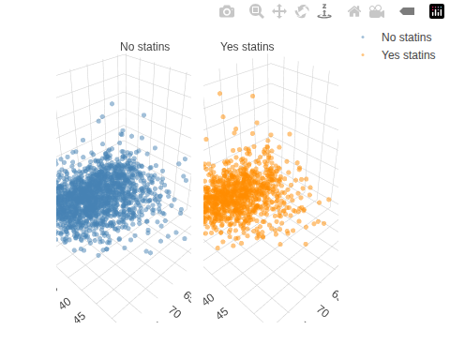
Figure 48: hers data (Vittinghoff et al. (2012)): age (years) and BMI (kg/m²) vs. baseline LDL (mg/dL), split by statin use (left: no statins; right: statins).

6.1.3 Key variables
library(GGally)
hers |>
dplyr::select(LDL, HT, BMI, statins, age) |>
ggpairs(
mapping = aes(col = statins),
lower = list(continuous = GGally::wrap("points", alpha = 0.3)),
columnLabels = c(
"LDL (mg/dL)",
"HT",
"BMI (kg/m²)",
"Statins",
"Age (yr)"
)
) +
theme_bw() +
theme(legend.position = "bottom")
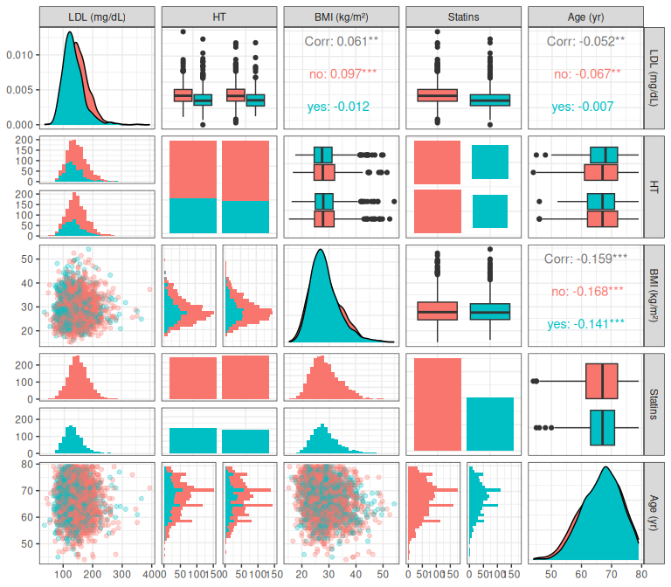
Figure 49: Key variables in hers data: outcome (LDL), treatment (HT), and covariates (BMI, statins, age)

6.1.4 Data notation
Let’s define some notation to represent this data:
- $Y$: LDL cholesterol (mg/dL)
- $A$: age (years)
- $B$: BMI (kg/m²)
- $T$: hormone therapy treatment assignment (“placebo” or “hormone therapy”)
- $H$: indicator variable for $T$ = “hormone therapy”
  - $H=0$ if $T$ = “placebo”
  - $H=1$ if $T$ = “hormone therapy”
- $U$: statin use (“no” or “yes”)
- $V$: indicator variable for $U$ = “yes”
  - $V=0$ if $U$ = “no”
  - $V=1$ if $U$ = “yes”
“Placebo” is the reference level for the categorical variable $T$, and “no” is the reference level for statin use $U$. The choice of reference level is arbitrary; it only affects the interpretation of the intercept and corresponding indicator coefficients.
Since LDL is measured at baseline (before the hormone therapy was administered), $H$ is not included as a predictor in our regression models for LDL. We instead focus on statin use $U$ (and its indicator $V$) as the key grouping variable.

6.2 Parallel-planes model
Just as the birthweight parallel-lines model assumes that sex shifts the intercept but not the age slope (parallel lines in 2D), the parallel-planes model for the HERS data assumes a flat regression surface over the age-BMI space: the slope of mean LDL with respect to BMI is the same at every age, and the slope with respect to age is the same at every BMI.
We use age ($A$) and BMI ($B$) as predictors—not hormone therapy ($H$)—because LDL is measured at baseline, before treatment was administered.
$$\begin{aligned}Y|A,B& ∼_{ciid} N(μ(A,B),σ^{2}) \\ μ(a,b)&=β_{0}+β_{A}a+β_{B}b\end{aligned} (41)$$
Table 38: Regression parameter estimates for Model 41
hers_lm1 <- lm(
formula = LDL ~ age + BMI,
data = hers,
na.action = na.exclude
)
hers_plot_data <- hers |>
dplyr::filter(!is.na(age), !is.na(BMI), !is.na(LDL))
hers_lm1 |>
parameters::parameters() |>
parameters::print_md(
select = "{estimate}"
)
Parameter | Coefficient
(Intercept) | 151.44
age | -0.25
BMI | 0.37

Statins: No
hers_no <- hers_plot_data |> dplyr::filter(statins == "no")
plotly::plot_ly(
x = hers_no[["age"]],
y = hers_no[["BMI"]],
z = hers_no[["LDL"]],
type = "scatter3d",
mode = "markers",
name = "No statins",
marker = list(size = 3, opacity = 0.3, color = "steelblue")
) |>
regress3d::add_3d_surface(
model = hers_lm1,
data = hers_plot_data,
showlegend = TRUE
) |>
plotly::layout(
scene = list(
xaxis = list(title = "Age (yr)"),
yaxis = list(title = "BMI (kg/m\u00b2)"),
zaxis = list(title = "LDL (mg/dL)")
)
)
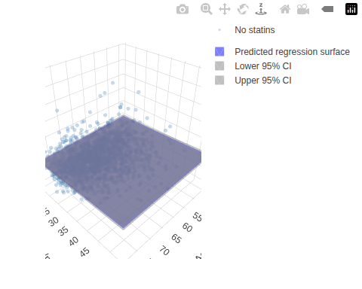
Figure 50: Fitted regression surface from Model 41 (patients not taking statins)

Statins: Yes
hers_yes <- hers_plot_data |> dplyr::filter(statins == "yes")
plotly::plot_ly(
x = hers_yes[["age"]],
y = hers_yes[["BMI"]],
z = hers_yes[["LDL"]],
type = "scatter3d",
mode = "markers",
name = "Yes statins",
marker = list(size = 3, opacity = 0.3, color = "darkorange")
) |>
regress3d::add_3d_surface(
model = hers_lm1,
data = hers_plot_data,
showlegend = TRUE
) |>
plotly::layout(
scene = list(
xaxis = list(title = "Age (yr)"),
yaxis = list(title = "BMI (kg/m\u00b2)"),
zaxis = list(title = "LDL (mg/dL)")
)
)
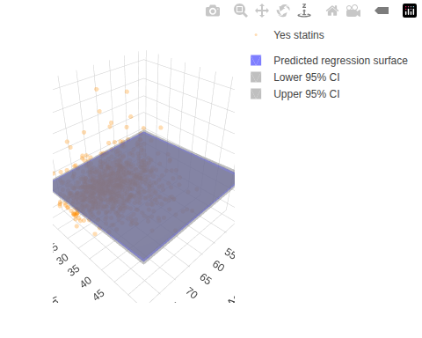
Figure 51: Fitted regression surface from Model 41 (patients taking statins)
The coefficient estimates in Table 38 quantify the shape of these surfaces. Both tabs display the same fitted flat plane: the parallel-planes model constrains the age and BMI slopes to be the same regardless of statin use. The statins-yes tab reveals that patients taking statins tend to have lower LDL values on average — a shift the parallel-planes model cannot capture, because it does not include statin use as a predictor.

6.3 Interaction model
In the parallel-planes model, the BMI slope is the same regardless of age. Just as we added a sex-age interaction to the birthweight model to allow the age slope to differ between males and females, we now add an age-BMI interaction to allow the BMI slope to vary with age.
$$\begin{aligned}Y|A,B& ∼_{ciid} N(μ(A,B),σ^{2}) \\ μ(a,b)&=β_{0}+β_{A}a+β_{B}b+β_{AB}(a⋅b)\end{aligned} (42)$$
The slope of mean LDL with respect to BMI now depends on age:
$$\begin{aligned}\frac{∂}{∂b}μ(A=0,B=b)&=β_{B}+β_{AB}⋅0=β_{B} \\ \frac{∂}{∂b}μ(A=a,B=b)&=β_{B}+β_{AB}a\end{aligned}$$
So the slope of LDL with respect to BMI changes by $β_{AB}$ for each one-year increase in age.
Table 39: Regression parameter estimates for Model 42
hers_lm2 <- lm(
LDL ~ age + BMI + age:BMI,
data = hers,
na.action = na.exclude
)
hers_lm2 |>
parameters::parameters() |>
parameters::print_md(
select = "{estimate}"
)
Parameter | Coefficient
(Intercept) | 194.29
age | -0.90
BMI | -1.13
age × BMI | 0.02

Statins: No
plotly::plot_ly(
x = hers_no[["age"]],
y = hers_no[["BMI"]],
z = hers_no[["LDL"]],
type = "scatter3d",
mode = "markers",
name = "No statins",
marker = list(size = 3, opacity = 0.3, color = "steelblue")
) |>
regress3d::add_3d_surface(
model = hers_lm2,
data = hers_plot_data,
showlegend = TRUE
) |>
plotly::layout(
scene = list(
xaxis = list(title = "Age (yr)"),
yaxis = list(title = "BMI (kg/m\u00b2)"),
zaxis = list(title = "LDL (mg/dL)")
)
)
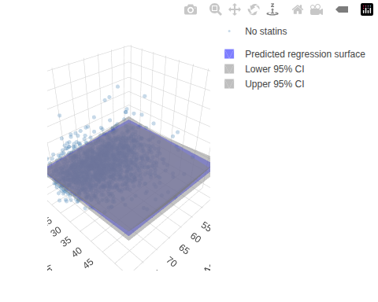
Figure 52: Fitted regression surface from Model 42 (patients not taking statins)

Statins: Yes
plotly::plot_ly(
x = hers_yes[["age"]],
y = hers_yes[["BMI"]],
z = hers_yes[["LDL"]],
type = "scatter3d",
mode = "markers",
name = "Yes statins",
marker = list(size = 3, opacity = 0.3, color = "darkorange")
) |>
regress3d::add_3d_surface(
model = hers_lm2,
data = hers_plot_data,
showlegend = TRUE
) |>
plotly::layout(
scene = list(
xaxis = list(title = "Age (yr)"),
yaxis = list(title = "BMI (kg/m\u00b2)"),
zaxis = list(title = "LDL (mg/dL)")
)
)
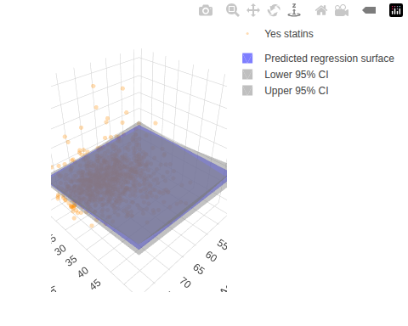
Figure 53: Fitted regression surface from Model 42 (patients taking statins)
Unlike the flat parallel-planes surface, the interaction model produces a twisted regression surface. The BMI slope changes with age: at any given age, the BMI slope equals the base BMI coefficient plus the interaction coefficient times that age. Both tabs plot the same interaction-model surface; statin use is used only to partition the observed data points for visual clarity.

6.4 Stratified model
Until now, statin use ($U$) has appeared only as the color grouping in our HERS plots; here it finally enters the model, as the stratifying variable.
As an alternative to the age–BMI models fit previously, we can model LDL as a function of BMI, stratifying by statin use (i.e., fitting a separate intercept and BMI slope for each statin group). We omit age from this stratified specification to keep it simple and focus on how the BMI–LDL relationship differs by statin use; age could be added back as an additional covariate if desired.
$$E​\left[LDL|B=b,V=v\right]​=β_{no}(1−v)+β_{no,B} b(1−v)+β_{yes}v+β_{yes,B} bv (43)$$
Equivalently, we can fit the same model using reference (indicator) coding, with an overall intercept, a main effect for statin use, a BMI slope, and a statin–BMI interaction:
$$E​\left[LDL|B=b,V=v\right]​=β_{0}+β_{V} v+β_{B} b+β_{VB} (v⋅b) (44)$$
Table 40: Stratified regression estimates for hers data (Model 43)
hers_lm_strat <-
hers |>
lm(
formula = LDL ~ statins + statins:BMI - 1,
data = _,
na.action = na.exclude
)
hers_lm_strat |>
parameters::parameters() |>
parameters::print_md(
select = "{estimate}"
)
Parameter | Coefficient
statins (no) | 132.81
statins (yes) | 136.69
statins (no) × BMI | 0.64
statins (yes) × BMI | -0.08

Table 41: Regression parameter estimates for Model 44
hers_lm_statins_interact <- lm(
LDL ~ statins + BMI + statins:BMI,
data = hers,
na.action = na.exclude
)
hers_lm_statins_interact |>
parameters::parameters() |>
parameters::print_md(
select = "{estimate}"
)
Parameter | Coefficient
(Intercept) | 132.81
statins (yes) | 3.87
BMI | 0.64
statins (yes) × BMI | -0.72

6.5 Goodness of fit
We compare the parallel-planes model (hers_lm1: LDL ~ age + BMI) and the interaction model (hers_lm2: LDL ~ age + BMI + age:BMI) using AIC, BIC, and deviance. Lower AIC and BIC values indicate a better trade-off between fit and complexity; lower deviance indicates a better-fitting model (at the cost of more parameters).

6.5.1 AIC and BIC for hers models
Table 42: AIC and BIC for the hers parallel-planes (hers_lm1) and interaction (hers_lm2) models
aic <- AIC(hers_lm1, hers_lm2)
bic <- BIC(hers_lm1, hers_lm2)
data.frame(
df = aic$df,
AIC = aic$AIC,
BIC = bic$BIC,
row.names = rownames(aic)
) |>
knitr::kable()
 | df | AIC | BIC
hers_lm1 | 4 | 27744.4 | 27768.0
hers_lm2 | 5 | 27745.0 | 27774.6

Both AIC and BIC are slightly lower for the parallel-planes model (Table 42): adding the age-BMI interaction does not improve either criterion, so both favor the simpler parallel-planes specification — BIC, which penalizes extra parameters more heavily, by the wider margin.

6.5.2 Deviance for hers models
Table 43: Deviance for the hers parallel-planes (hers_lm1) and interaction (hers_lm2) models
data.frame(
deviance = c(deviance(hers_lm1), deviance(hers_lm2)),
row.names = c("hers_lm1", "hers_lm2")
) |>
knitr::kable()
 | deviance
hers_lm1 | 3903361
hers_lm2 | 3901412

The interaction model has marginally lower deviance (Table 43) — as it must, since adding a parameter can only reduce the residual sum of squares — but the reduction is tiny relative to the total. The likelihood ratio test in Table 44 formally tests whether that improvement is larger than we would expect by chance from one extra parameter.

6.6 Diagnostics

6.6.1 Parallel-planes model
We check whether the assumptions of the parallel-planes model (hers_lm1, Equation 41, fitted in Table 38) hold by examining residuals vs. fitted values (to assess linearity and constant variance) and a QQ plot (to assess normality of residuals). Plots are faceted by statin use to check for group-level residual patterns.

Residuals vs fitted for hers_lm1
hers_diag <- hers_lm_data |>
dplyr::mutate(
.fitted = fitted(hers_lm1),
.resid = residuals(hers_lm1)
)
ggplot(hers_diag, aes(x = .fitted, y = .resid)) +
geom_point(alpha = 0.3) +
geom_hline(yintercept = 0, linetype = "dashed") +
facet_wrap(~statins, labeller = label_both) +
xlab("Fitted values") +
ylab("Residuals") +
theme_bw()
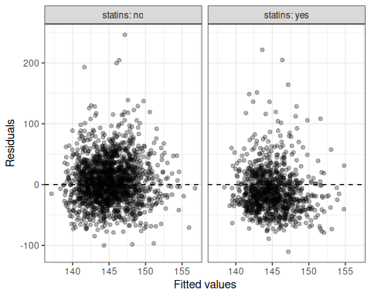
Figure 54: Residuals vs fitted values for hers_lm1 (parallel planes model)

QQ plot for hers_lm1
ggplot(hers_diag, aes(sample = .resid)) +
stat_qq() +
stat_qq_line() +
facet_wrap(~statins, labeller = label_both) +
theme_bw()
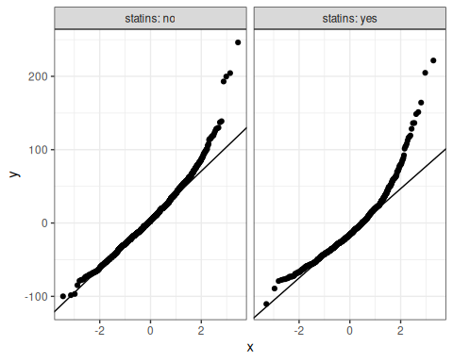
Figure 55: QQ plot of residuals for hers_lm1 (parallel planes model)
The residuals scatter around zero with no clear curve (Figure 54), so the linearity assumption looks reasonable; their spread grows only slightly at higher fitted values, indicating at most mild non-constant variance. The QQ plot (Figure 55) bends above the reference line in the upper tail, reflecting the right skew of LDL — a mild departure from normality. With several thousand observations, the central limit theorem makes inference about the model coefficients robust to this mild non-normality. Both statin groups show the same pattern.

6.6.2 Interaction model
We repeat the same checks for the interaction model (hers_lm2, Equation 42, fitted in Table 39).

Residuals vs fitted for hers_lm2
hers_diag2 <- hers_lm_data |>
dplyr::mutate(
.fitted = fitted(hers_lm2),
.resid = residuals(hers_lm2)
)
ggplot(hers_diag2, aes(x = .fitted, y = .resid)) +
geom_point(alpha = 0.3) +
geom_hline(yintercept = 0, linetype = "dashed") +
facet_wrap(~statins, labeller = label_both) +
xlab("Fitted values") +
ylab("Residuals") +
theme_bw()
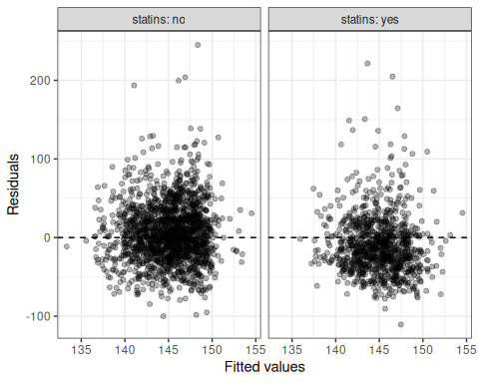
Figure 56: Residuals vs fitted values for hers_lm2 (interaction model)

QQ plot for hers_lm2
ggplot(hers_diag2, aes(sample = .resid)) +
stat_qq() +
stat_qq_line() +
facet_wrap(~statins, labeller = label_both) +
theme_bw()
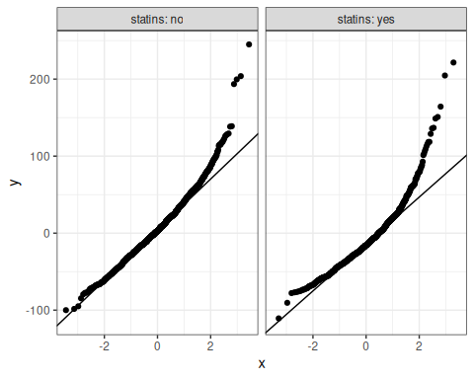
Figure 57: QQ plot of residuals for hers_lm2 (interaction model)
The residual and QQ plots for the interaction model (Figure 56, Figure 57) look essentially identical to those for the parallel-planes model: adding the age-BMI interaction barely changes the residual structure. This similarity previews the model-selection result — the likelihood ratio test (Table 44) shows the interaction does not improve the fit enough to justify the extra parameter.

6.7 Model selection
We compare the parallel-planes model (hers_lm1: LDL ~ age + BMI) and the interaction model (hers_lm2: LDL ~ age + BMI + age:BMI) using a likelihood ratio test (LRT). A small p-value indicates that the interaction term significantly improves model fit.

6.7.1 Comparing HERS models using LRT
Table 44: Likelihood ratio test comparing the hers parallel-planes (hers_lm1) and interaction (hers_lm2) models
hers_lrt <- lmtest::lrtest(hers_lm1, hers_lm2)
hers_lrt
#> # A tibble: 2 × 5
#> `#Df` LogLik Df Chisq `Pr(>Chisq)`
#> <dbl> <dbl> <dbl> <dbl> <dbl>
#> 1 4 -13868. NA NA NA
#> 2 5 -13867. 1 1.37 0.241
Here, the likelihood ratio test is not statistically significant (Table 44: $χ_{1}^{2}≈1.4$, $p≈0.24$): the age-BMI interaction does not fit the data meaningfully better than we would expect from adding one parameter by chance. So we prefer the simpler parallel-planes model (hers_lm1, Equation 41) on parsimony grounds, consistent with the AIC and BIC comparison in Table 42.

7. End-of-chapter exercises
These paper-and-pencil exercises use actual datasets. No numerical computation is required.
Exercise 22 Main-effects model interpretation.
Adapted from the main-effects interpretation exercise in (Vittinghoff et al. 2012, chap. 4).
Dataset summary: The ToothGrowth dataset contains one row per guinea pig. Variable definitions:
- $Y$: tooth length (len)
- $X$: dose (dose)
- $Z$: supplement indicator (supp) with $Z=1$ for VC and $Z=0$ for OJ
Consider the additive model
$$E​\left[Y|X=x,Z=z\right]​=β_{0}+β_{X}x+β_{Z}z.$$
State the interpretation of $β_{0}$, $β_{X}$, and $β_{Z}$. Which interpretations depend on the reference level OJ?
eoc_tg <-
ToothGrowth |>
as_tibble() |>
mutate(supp = relevel(supp, ref = "OJ"))
eoc_tg
#> # A tibble: 60 × 3
#> len supp dose
#> <dbl> <fct> <dbl>
#> 1 4.2 VC 0.5
#> 2 11.5 VC 0.5
#> 3 7.3 VC 0.5
#> 4 5.8 VC 0.5
#> 5 6.4 VC 0.5
#> 6 10 VC 0.5
#> 7 11.2 VC 0.5
#> 8 11.2 VC 0.5
#> 9 5.2 VC 0.5
#> 10 7 VC 0.5
#> # ℹ 50 more rows
glimpse(eoc_tg)
#> Rows: 60
#> Columns: 3
#> $ len <dbl> 4.2, 11.5, 7.3, 5.8, 6.4, 10.0, 11.2, 11.2, 5.2, 7.0, 16.5, 16.5,…
#> $ supp <fct> VC, VC, VC, VC, VC, VC, VC, VC, VC, VC, VC, VC, VC, VC, VC, VC, V…
#> $ dose <dbl> 0.5, 0.5, 0.5, 0.5, 0.5, 0.5, 0.5, 0.5, 0.5, 0.5, 1.0, 1.0, 1.0, …
eoc_tg_add <-
lm(len ~ dose + supp, data = eoc_tg)
eoc_tg_grid <-
expand_grid(
dose = seq(min(eoc_tg$dose), max(eoc_tg$dose), length.out = 100),
supp = levels(eoc_tg$supp)
)
eoc_tg_grid <-
eoc_tg_grid |>
mutate(len_hat = predict(eoc_tg_add, newdata = eoc_tg_grid))
ggplot(eoc_tg, aes(x = dose, y = len, color = supp)) +
geom_point(alpha = 0.7) +
geom_line(
data = eoc_tg_grid,
aes(y = len_hat)
) +
labs(color = "supplement")
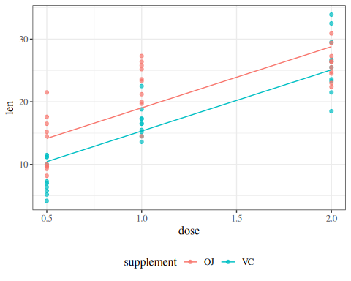
Figure 58: ToothGrowth data with additive (parallel-lines) fit
Solution
Solution.
$β_{0}$ is the mean tooth length for guinea pigs given OJ at dose 0.
$β_{X}$ is the change in mean tooth length for each one-unit increase in dose. In this additive model, that dose effect is the same for OJ and VC.
$β_{Z}$ is the mean tooth-length difference between VC and OJ at the same dose. The interpretations that depend on OJ as the reference level are $β_{0}$ and $β_{Z}$.

Exercise 23 Interaction interpretation.
Adapted from the interaction-slope interpretation example in (Dobson and Barnett 2018, sec. 6.7.1).
Use ToothGrowth as introduced in Exercise 22. Variable definitions:
- $Y$: tooth length (len)
- $X$: dose (dose)
- $Z$: supplement indicator (supp) with $Z=1$ for VC and $Z=0$ for OJ
Consider the interaction model
$$E​\left[Y|X=x,Z=z\right]​=β_{0}+β_{X}x+β_{Z}z+β_{XZ}(x⋅z).$$
Using the plot, write the slope with respect to $X$ for OJ and for VC. Then interpret $β_{XZ}$.
eoc_tg_int <-
lm(len ~ dose * supp, data = eoc_tg)
eoc_tg_grid2 <-
expand_grid(
dose = seq(min(eoc_tg$dose), max(eoc_tg$dose), length.out = 100),
supp = levels(eoc_tg$supp)
)
eoc_tg_grid2 <-
eoc_tg_grid2 |>
mutate(len_hat = predict(eoc_tg_int, newdata = eoc_tg_grid2))
ggplot(eoc_tg, aes(x = dose, y = len, color = supp)) +
geom_point(alpha = 0.7) +
geom_line(
data = eoc_tg_grid2,
aes(y = len_hat)
) +
labs(color = "supplement")
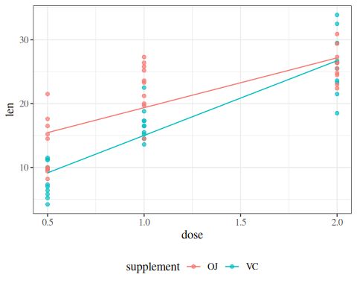
Figure 59: ToothGrowth data with interaction (non-parallel-lines) fit
Solution
Solution.
For OJ, the dose slope is $β_{X}$.
For VC, the dose slope is $β_{X}+β_{XZ}$.
Therefore, $β_{XZ}$ is the difference in dose slopes between VC and OJ.

Exercise 24 Centering and coefficient changes.
Adapted from the centering/reparameterization exercise in (Kleinbaum et al. 2014, chap. 14).
Dataset summary: The PLOS dataset contains one row per paper. Variable definitions:
- $Y$: title length (nchar)
- $X$: number of authors (authors)
- $X^{*}$: centered author count (authors_centered), constructed from authors, defined as $X^{*}=X−10$
Start from
$$E​\left[Y|X=x\right]​=β_{0}+β_{X}x.$$
Rewrite the model in terms of $X^{*}$. Express $γ_{0}$ and $γ_{X}$ in terms of $β_{0}$ and $β_{X}$.
data(PLOS, package = "dobson")
eoc_plos <-
PLOS |>
as_tibble() |>
mutate(authors_centered = authors - 10)
eoc_plos
#> # A tibble: 878 × 3
#> nchar authors authors_centered
#> <int> <dbl> <dbl>
#> 1 150 6 -4
#> 2 88 17 7
#> 3 64 3 -7
#> 4 126 30 20
#> 5 87 9 -1
#> 6 115 3 -7
#> 7 186 10 0
#> 8 58 1 -9
#> 9 75 1 -9
#> 10 80 3 -7
#> # ℹ 868 more rows
glimpse(eoc_plos)
#> Rows: 878
#> Columns: 3
#> $ nchar <int> 150, 88, 64, 126, 87, 115, 186, 58, 75, 80, 81, 74, 7…
#> $ authors <dbl> 6, 17, 3, 30, 9, 3, 10, 1, 1, 3, 3, 3, 1, 30, 6, 11, …
#> $ authors_centered <dbl> -4, 7, -7, 20, -1, -7, 0, -9, -9, -7, -7, -7, -9, 20,…
eoc_plos_orig <-
lm(nchar ~ authors, data = eoc_plos)
eoc_plos_cent <-
lm(nchar ~ authors_centered, data = eoc_plos)
eoc_plos_grid <-
tibble(
authors = seq(
min(eoc_plos$authors),
max(eoc_plos$authors),
length.out = 100
)
) |>
mutate(authors_centered = authors - 10)
eoc_plos_grid <-
eoc_plos_grid |>
mutate(
fit_original = predict(eoc_plos_orig, newdata = eoc_plos_grid),
fit_centered = predict(eoc_plos_cent, newdata = eoc_plos_grid)
)
ggplot(eoc_plos, aes(x = authors, y = nchar)) +
geom_point(alpha = 0.7) +
geom_line(
data = eoc_plos_grid,
aes(y = fit_original, color = "original parameterization")
) +
geom_line(
data = eoc_plos_grid,
aes(y = fit_centered, color = "centered parameterization"),
linetype = 2
) +
labs(color = "")
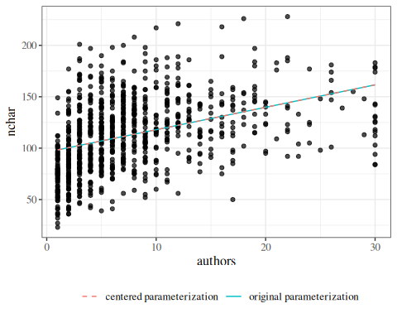
Figure 60: PLOS data with original and centered parameterizations
Solution
Solution.
Since $x=x^{*}+10$:
$$\begin{aligned}E​\left[Y|X^{*}=x^{*}\right]​&=β_{0}+β_{X}(x^{*}+10) \\ &=(β_{0}+10β_{X})+β_{X}x^{*}.\end{aligned}$$
So
$$γ_{0}=β_{0}+10β_{X}, γ_{X}=β_{X}.$$
Centering shifts the intercept, but does not change the slope.

Exercise 25 Diagnostics from observed residual patterns.
Adapted from the residual-diagnostics example in (Dunn and Smyth 2018, chap. 3).
Dataset summary: The mtcars dataset contains one row per car model. Variable definitions:
- $Y$: fuel economy (mpg)
- $X$: vehicle weight (wt)
- $H$: horsepower (hp)
Consider the model
$$E​\left[Y|X=x,H=h\right]​=β_{0}+β_{X}x+β_{H}h.$$
Based on the residual-vs-fitted and Q-Q plots, which assumptions look most questionable? State one practical follow-up step.
eoc_mtcars <-
mtcars |>
as_tibble()
eoc_mtcars
#> # A tibble: 32 × 11
#> mpg cyl disp hp drat wt qsec vs am gear carb
#> <dbl> <dbl> <dbl> <dbl> <dbl> <dbl> <dbl> <dbl> <dbl> <dbl> <dbl>
#> 1 21 6 160 110 3.9 2.62 16.5 0 1 4 4
#> 2 21 6 160 110 3.9 2.88 17.0 0 1 4 4
#> 3 22.8 4 108 93 3.85 2.32 18.6 1 1 4 1
#> 4 21.4 6 258 110 3.08 3.22 19.4 1 0 3 1
#> 5 18.7 8 360 175 3.15 3.44 17.0 0 0 3 2
#> 6 18.1 6 225 105 2.76 3.46 20.2 1 0 3 1
#> 7 14.3 8 360 245 3.21 3.57 15.8 0 0 3 4
#> 8 24.4 4 147. 62 3.69 3.19 20 1 0 4 2
#> 9 22.8 4 141. 95 3.92 3.15 22.9 1 0 4 2
#> 10 19.2 6 168. 123 3.92 3.44 18.3 1 0 4 4
#> # ℹ 22 more rows
glimpse(eoc_mtcars)
#> Rows: 32
#> Columns: 11
#> $ mpg <dbl> 21.0, 21.0, 22.8, 21.4, 18.7, 18.1, 14.3, 24.4, 22.8, 19.2, 17.8,…
#> $ cyl <dbl> 6, 6, 4, 6, 8, 6, 8, 4, 4, 6, 6, 8, 8, 8, 8, 8, 8, 4, 4, 4, 4, 8,…
#> $ disp <dbl> 160.0, 160.0, 108.0, 258.0, 360.0, 225.0, 360.0, 146.7, 140.8, 16…
#> $ hp <dbl> 110, 110, 93, 110, 175, 105, 245, 62, 95, 123, 123, 180, 180, 180…
#> $ drat <dbl> 3.90, 3.90, 3.85, 3.08, 3.15, 2.76, 3.21, 3.69, 3.92, 3.92, 3.92,…
#> $ wt <dbl> 2.620, 2.875, 2.320, 3.215, 3.440, 3.460, 3.570, 3.190, 3.150, 3.…
#> $ qsec <dbl> 16.46, 17.02, 18.61, 19.44, 17.02, 20.22, 15.84, 20.00, 22.90, 18…
#> $ vs <dbl> 0, 0, 1, 1, 0, 1, 0, 1, 1, 1, 1, 0, 0, 0, 0, 0, 0, 1, 1, 1, 1, 0,…
#> $ am <dbl> 1, 1, 1, 0, 0, 0, 0, 0, 0, 0, 0, 0, 0, 0, 0, 0, 0, 1, 1, 1, 0, 0,…
#> $ gear <dbl> 4, 4, 4, 3, 3, 3, 3, 4, 4, 4, 4, 3, 3, 3, 3, 3, 3, 4, 4, 4, 3, 3,…
#> $ carb <dbl> 4, 4, 1, 1, 2, 1, 4, 2, 2, 4, 4, 3, 3, 3, 4, 4, 4, 1, 2, 1, 1, 2,…
eoc_mtcars_fit <-
lm(mpg ~ wt + hp, data = eoc_mtcars)
autoplot(eoc_mtcars_fit, which = 1, ncol = 1)
autoplot(eoc_mtcars_fit, which = 2, ncol = 1)
  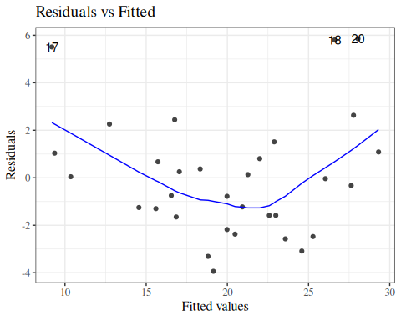
  (a) Residuals versus fitted
  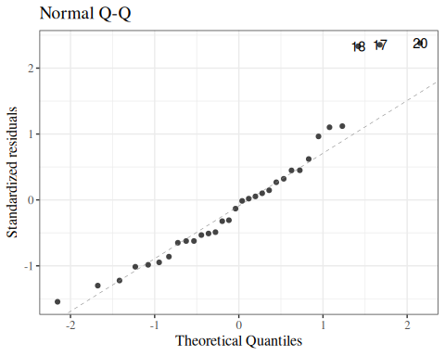
  (b) Normal Q-Q
Figure 61: Diagnostic plots for linear model fit to mtcars data

Solution
Solution.
The residual-vs-fitted plot shows nonlinearity and non-constant spread. The Q-Q plot shows mild tail departures from normality.
The correct conclusion is that linearity and constant-variance assumptions are the most questionable here. A practical next step is to fit a model with a nonlinear weight term (for example, a spline or polynomial in wt) and then re-check diagnostics.

Exercises
Exercise 26 (Likelihood for simple linear regression) (adapted from Kleinbaum et al. (2014), Chapter 6, and Dobson and Barnett (2018), Chapter 6)
Suppose $Y_{i}∣x_{i} ∼_{⟂​​​⟂} N(μ_{i},σ^{2})$, where $μ_{i}=β_{0}+β_{1}x_{i}$.
(a) Write the likelihood $L(β_{0},β_{1},σ^{2};\tilde{y},\tilde{x})$ for observed data $(y_{i},x_{i})$, $i=1,…,n$.
(b) Write the log-likelihood $ℓ(β_{0},β_{1},σ^{2};\tilde{y},\tilde{x})$ and show it simplifies to
$$ℓ=−\frac{n}{2}log​\left\{2πσ^{2}\right\}​−\frac{1}{2σ^{2}}\text{RSS},$$
where $\text{RSS}=\sum_{i=1}^{n}{(}y_{i}−μ_{i})^{2}$.
(c) Explain why maximizing $ℓ$ over $(β_{0},β_{1})$ is equivalent to minimizing $\text{RSS}$.

Solution
Solution. (a)
$$L(β_{0},β_{1},σ^{2};\tilde{y},\tilde{x})=\prod_{i=1}^{n}{(}2πσ^{2})^{−1/2}exp​\left\{−\frac{(y_{i}−μ_{i})^{2}}{2σ^{2}}\right\}​$$
where $μ_{i}=β_{0}+β_{1}x_{i}$.
(b)
$$\begin{aligned}ℓ&=\sum_{i=1}^{n}{log}​\left\{(2πσ^{2})^{−1/2}exp​\left\{−\frac{(y_{i}−μ_{i})^{2}}{2σ^{2}}\right\}​\right\}​ \\ &=−\frac{n}{2}log​\left\{2πσ^{2}\right\}​−\frac{1}{2σ^{2}}\sum_{i=1}^{n}{(}y_{i}−μ_{i})^{2} \\ &=−\frac{n}{2}log​\left\{2πσ^{2}\right\}​−\frac{\text{RSS}}{2σ^{2}}\end{aligned}$$
(c)
Since $−\frac{n}{2}log​\left\{2πσ^{2}\right\}​$ does not depend on $β_{0}$ or $β_{1}$, and $σ^{2}>0$, maximizing $ℓ$ over $(β_{0},β_{1})$ is equivalent to maximizing $−\frac{\text{RSS}}{2σ^{2}}$, which is equivalent to minimizing $\text{RSS}$.
This equivalence shows that for Gaussian errors, the maximum likelihood estimator equals the ordinary least squares estimator.

Exercise 27 (Score equations for simple linear regression) (adapted from Dobson and Barnett (2018), Chapter 6)
Using the log-likelihood from Exercise 26, derive the score equations for $β_{0}$ and $β_{1}$. Specifically, compute $\frac{∂ℓ}{∂β_{0}}=0$ and $\frac{∂ℓ}{∂β_{1}}=0$, and show they are equivalent to the normal equations:
$$\begin{aligned}\sum_{i=1}^{n}{y_{i}}&=n{\hat{β}}_{0}+{\hat{β}}_{1}\sum_{i=1}^{n}{x_{i}} \\ \sum_{i=1}^{n}{x_{i}}y_{i}&={\hat{β}}_{0}\sum_{i=1}^{n}{x_{i}}+{\hat{β}}_{1}\sum_{i=1}^{n}{x_{i}^{2}}\end{aligned}$$

Solution
Solution. From Exercise 26:
$$ℓ=−\frac{n}{2}log​\left\{2πσ^{2}\right\}​−\frac{1}{2σ^{2}}\sum_{i=1}^{n}{(}y_{i}−β_{0}−β_{1}x_{i})^{2}$$
Score with respect to $β_{0}$:
$$\begin{aligned}\frac{∂}{∂β_{0}}ℓ&=−\frac{1}{2σ^{2}}\frac{∂}{∂β_{0}}\sum_{i=1}^{n}{(}y_{i}−β_{0}−β_{1}x_{i})^{2} \\ &=−\frac{1}{2σ^{2}}\sum_{i=1}^{n}{2}(y_{i}−β_{0}−β_{1}x_{i})(−1) \\ &=\frac{1}{σ^{2}}\sum_{i=1}^{n}{(}y_{i}−β_{0}−β_{1}x_{i})\end{aligned}$$
Setting equal to zero:
$$\begin{aligned}0&=\sum_{i=1}^{n}{(}y_{i}−β_{0}−β_{1}x_{i}) \\ \sum_{i=1}^{n}{y_{i}}&=nβ_{0}+β_{1}\sum_{i=1}^{n}{x_{i}}\end{aligned}$$
Score with respect to $β_{1}$:
$$\begin{aligned}\frac{∂}{∂β_{1}}ℓ&=\frac{1}{σ^{2}}\sum_{i=1}^{n}{x_{i}}(y_{i}−β_{0}−β_{1}x_{i})\end{aligned}$$
Setting equal to zero:
$$\sum_{i=1}^{n}{x_{i}}y_{i}=β_{0}\sum_{i=1}^{n}{x_{i}}+β_{1}\sum_{i=1}^{n}{x_{i}^{2}}$$
These score equations are the normal equations, whose solution gives the OLS/MLE estimators ${\hat{β}}_{0}$ and ${\hat{β}}_{1}$.

Exercise 28 (Closed-form OLS estimators (adapted from Vittinghoff et al. (2012), Chapter 4)) Using the normal equations from Exercise 27, show that the closed-form solutions are:
$$\begin{aligned}{\hat{β}}_{1}&=\frac{\sum_{i=1}^{n}{(}x_{i}−\overset{‾}{x})(y_{i}−\overset{‾}{y})}{\sum_{i=1}^{n}{(}x_{i}−\overset{‾}{x})^{2}} \\ {\hat{β}}_{0}&=\overset{‾}{y}−{\hat{β}}_{1}\overset{‾}{x}\end{aligned}$$

Solution
Solution. From the first normal equation, dividing both sides by $n$:
$$\overset{‾}{y}={\hat{β}}_{0}+{\hat{β}}_{1}\overset{‾}{x} ⇒ {\hat{β}}_{0}=\overset{‾}{y}−{\hat{β}}_{1}\overset{‾}{x}$$
Substituting into the second normal equation:
$$\begin{aligned}\sum_{i=1}^{n}{x_{i}}y_{i}&=(\overset{‾}{y}−{\hat{β}}_{1}\overset{‾}{x})\sum_{i=1}^{n}{x_{i}}+{\hat{β}}_{1}\sum_{i=1}^{n}{x_{i}^{2}} \\ \sum_{i=1}^{n}{x_{i}}y_{i}−\overset{‾}{y}\sum_{i=1}^{n}{x_{i}}&={\hat{β}}_{1}​\left(\sum_{i=1}^{n}{x_{i}^{2}}−\overset{‾}{x}\sum_{i=1}^{n}{x_{i}}\right)​ \\ \sum_{i=1}^{n}{x_{i}}y_{i}−n\overset{‾}{x}\overset{‾}{y}&={\hat{β}}_{1}​\left(\sum_{i=1}^{n}{x_{i}^{2}}−n{\overset{‾}{x}}^{2}\right)​\end{aligned}$$
Using the identities i​xiyi−nxy=i​(xi−x)(yi−y) and i​xi2−nx2=i​(xi−x)2:
$${\hat{β}}_{1}=\frac{\sum_{i=1}^{n}{(}x_{i}−\overset{‾}{x})(y_{i}−\overset{‾}{y})}{\sum_{i=1}^{n}{(}x_{i}−\overset{‾}{x})^{2}}$$

Exercise 29 (Interpreting regression coefficients) (adapted from Kleinbaum et al. (2014), Chapters 5–6, and Vittinghoff et al. (2012), Chapter 4)
Consider the linear regression model
$$E​\left[Y∣X_{1},X_{2}\right]​=β_{0}+β_{1}X_{1}+β_{2}X_{2},$$
where $Y$ is diastolic blood pressure (mmHg), $X_{1}$ is age (years), and $X_{2}$ is an indicator for current smoking ($X_{2}=1$ for smoker, $X_{2}=0$ for non-smoker). Suppose the estimates are ${\hat{β}}_{0}=55$, ${\hat{β}}_{1}=0.4$, ${\hat{β}}_{2}=6$.
(a) Interpret ${\hat{β}}_{0}$.
(b) Interpret ${\hat{β}}_{1}$.
(c) Interpret ${\hat{β}}_{2}$.
(d) Predict mean blood pressure for a 50-year-old smoker.
(e) What assumption does this model make about the relationship between age and blood pressure for smokers versus non-smokers?

Solution
Solution. (a)
${\hat{β}}_{0}=55$ mmHg is the estimated mean diastolic blood pressure among non-smokers ($X_{2}=0$) aged zero ($X_{1}=0$). This prediction is an extrapolation beyond the observed range of ages and may not be a meaningful quantity on its own.
(b)
${\hat{β}}_{1}=0.4$ mmHg/year is the estimated mean increase in diastolic blood pressure per one-year increase in age, holding smoking status constant. Or equivalently: among people of the same smoking status, those who are one year older have, on average, 0.4 mmHg higher diastolic blood pressure.
(c)
${\hat{β}}_{2}=6$ mmHg is the estimated mean difference in diastolic blood pressure between current smokers and non-smokers of the same age. Smokers have, on average, 6 mmHg higher diastolic blood pressure than non-smokers of the same age.
(d)
$$\hat{μ}=55+0.4×50+6×1=55+20+6=81\text{ mmHg}$$
(e)
The model assumes that the slope of mean blood pressure with respect to age is the same (${\hat{β}}_{1}=0.4$ mmHg/year) for both smokers and non-smokers (parallel slopes or no interaction). An interaction term $β_{3}X_{1}X_{2}$ would be needed to allow different slopes.

Exercise 30 (Coefficient of determination) (adapted from Kleinbaum et al. (2014), Chapter 7)
In the simple linear regression of $Y$ on $X$, define:
$$\text{TSS}=\sum_{i=1}^{n}{(}y_{i}−\overset{‾}{y})^{2}, \text{RSS}=\sum_{i=1}^{n}{(}y_{i}−{\hat{y}}_{i})^{2}, R^{2}=1−\frac{\text{RSS}}{\text{TSS}}.$$
(a) Explain in words what $\text{TSS}$, $\text{RSS}$, and $R^{2}$ measure.
(b) If $n=20$, $\text{TSS}=400$, and $R^{2}=0.75$, compute $\text{RSS}$.
(c) Is a large $R^{2}$ sufficient to conclude the model is correct? Briefly explain.

Solution
Solution. (a)
- $\text{TSS}$ (total sum of squares): the total variability in $Y$ around its mean $\overset{‾}{y}$, ignoring the predictor $X$.
- $\text{RSS}$ (residual sum of squares): the residual variability in $Y$ remaining after accounting for the linear regression on $X$. Smaller values indicate a better-fitting model.
- $R^{2}$: the proportion of the total variability in $Y$ explained by the linear regression on $X$. $R^{2}=0$ means $X$ explains none of the variation; $R^{2}=1$ means $X$ perfectly predicts $Y$.
(b)
$$\text{RSS}=\text{TSS}×(1−R^{2})=400×(1−0.75)=400×0.25=100$$
(c)
No. A high $R^{2}$ indicates good fit in terms of variance explained, but does not guarantee the model is correctly specified. For example:
- The true relationship may be nonlinear, and a high $R^{2}$ can still be achieved with a linear model over a limited range.
- Important confounders or interaction terms may be omitted.
- The residuals may violate the model assumptions (non-normality, heteroscedasticity, dependence), which would invalidate inference even with high $R^{2}$.

References
Akaike, Hirotugu. 1974. “A New Look at the Statistical Model Identification.” IEEE Transactions on Automatic Control 19 (6): 716–23. https://doi.org/10.1109/TAC.1974.1100705.
Anderson, Edgar. 1935. “The Irises of the Gaspe Peninsula.” Bulletin of American Iris Society 59: 2–5.
Bollen, Kenneth A., and Robert W. Jackman. 1990. “Regression Diagnostics: An Expository Treatment of Outliers and Influential Cases.” In Modern Methods of Data Analysis, edited by John Fox and J. Scott Long. Sage.
Chatterjee, Samprit, and Ali S Hadi. 2015. Regression Analysis by Example. John Wiley & Sons. https://www.wiley.com/en-us/Regression+Analysis+by+Example%2C+4th+Edition-p-9780470055458.
Cook, R. Dennis. 1977. “Detection of Influential Observation in Linear Regression.” Technometrics 19 (1): 15–18. https://doi.org/10.1080/00401706.1977.10489493.
Dobson, Annette J, and Adrian G Barnett. 2018. An Introduction to Generalized Linear Models. 4th ed. CRC press. https://doi.org/10.1201/9781315182780.
Draper, Norman R, and Harry Smith. 2014. Applied Regression Analysis. 3rd ed. John Wiley & Sons. https://www.wiley.com/en-us/Applied+Regression+Analysis%2C+3rd+Edition-p-9781118625682.
Dunn, Peter K, and Gordon K Smyth. 2018. Generalized Linear Models with Examples in R. Vol. 53. Springer. https://link.springer.com/book/10.1007/978-1-4419-0118-7.
Faraway, Julian J. 2025. Linear Models with R. https://www.routledge.com/Linear-Models-with-R/Faraway/p/book/9781032583983.
Harrell, Frank E. 2015. Regression Modeling Strategies: With Applications to Linear Models, Logistic Regression, and Survival Analysis. 2nd ed. Springer. https://doi.org/10.1007/978-3-319-19425-7.
Heinze, Georg, Christine Wallisch, and Daniela Dunkler. 2018. “Variable Selection – A Review and Recommendations for the Practicing Statistician.” Biometrical Journal 60 (3): 431–49. https://doi.org/10.1002/bimj.201700067.
Hogg, Robert V., Elliot A. Tanis, and Dale L. Zimmerman. 2015. Probability and Statistical Inference. Ninth edition. Pearson.
Hulley, Stephen, Deborah Grady, Trudy Bush, et al. 1998. “Randomized Trial of Estrogen Plus Progestin for Secondary Prevention of Coronary Heart Disease in Postmenopausal Women.” JAMA : The Journal of the American Medical Association (Chicago, IL) 280 (7): 605–13.
James, Gareth, Daniela Witten, Trevor Hastie, Robert Tibshirani, et al. 2013. An Introduction to Statistical Learning. Vol. 112. Springer. https://www.statlearning.com/.
James, Gareth, Daniela Witten, Trevor Hastie, and Robert Tibshirani. 2021. An Introduction to Statistical Learning: With Applications in R. 2nd ed. Springer. https://doi.org/10.1007/978-1-0716-1418-1.
Kleinbaum, David G, and Mitchel Klein. 2010. Logistic Regression: A Self-Learning Text. 3rd ed. Springer. https://link.springer.com/book/10.1007/978-1-4419-1742-3.
Kleinbaum, David G, and Mitchel Klein. 2012. Survival Analysis: A Self-Learning Text. 3rd ed. Springer. https://link.springer.com/book/10.1007/978-1-4419-6646-9.
Kleinbaum, David G, Lawrence L Kupper, Azhar Nizam, K Muller, and ES Rosenberg. 2014. Applied Regression Analysis and Other Multivariable Methods. 5th ed. Cengage Learning. https://www.cengage.com/c/applied-regression-analysis-and-other-multivariable-methods-5e-kleinbaum/9781285051086/.
Kutner, Michael H, Christopher J Nachtsheim, John Neter, and William Li. 2005. Applied Linear Statistical Models. McGraw-Hill.
Polin, Richard A, William W Fox, and Steven H Abman. 2011. Fetal and Neonatal Physiology. 4th ed. Elsevier health sciences.
Schwarz, Gideon. 1978. “Estimating the Dimension of a Model.” The Annals of Statistics 6 (2): 461–64. https://doi.org/10.1214/aos/1176344136.
Seber, George AF, and Alan J Lee. 2012. Linear Regression Analysis. 2nd ed. John Wiley & Sons. https://www.wiley.com/en-us/Linear+Regression+Analysis%2C+2nd+Edition-p-9781118274422.
Venables, Bill. 2023. codingMatrices: Alternative Factor Coding Matrices for Linear Model Formulae. Version 0.4.0. https://CRAN.R-project.org/package=codingMatrices.
Vittinghoff, Eric, David V Glidden, Stephen C Shiboski, and Charles E McCulloch. 2012. Regression Methods in Biostatistics: Linear, Logistic, Survival, and Repeated Measures Models. 2nd ed. Springer. https://doi.org/10.1007/978-1-4614-1353-0.
Weisberg, Sanford. 2005. Applied Linear Regression. Vol. 528. John Wiley & Sons.

the current version of the first regression course I ever took
$M$ is implicitly a deterministic function of $S$
$F$ is implicitly a deterministic function of $S$
some call this kind of variation “interaction” or “effect modification”, but “act”, “effect”, “modify”, and “by” all suggest causality, which we are not prepared to assess here; let’s try to avoid using causal terms, unless we are constructing a causal model.
or equivalently, factor(ordered = TRUE)

