Proportional Hazards Models
Table of contents

Configuring R
Functions from these packages will be used throughout this document:
library(conflicted) # check for conflicting function definitions
# library(printr) # inserts help-file output into markdown output
library(rmarkdown) # Convert R Markdown documents into a variety of formats.
library(pander) # format tables for markdown
library(ggplot2) # graphics
library(ggfortify) # help with graphics
library(dplyr) # manipulate data
library(tibble) # `tibble`s extend `data.frame`s
library(magrittr) # `%>%` and other additional piping tools
library(haven) # import Stata files
library(knitr) # format R output for markdown
library(tidyr) # Tools to help to create tidy data
library(plotly) # interactive graphics
library(dobson) # datasets from Dobson and Barnett 2018
library(parameters) # format model output tables for markdown
library(haven) # import Stata files
library(latex2exp) # use LaTeX in R code (for figures and tables)
library(fs) # filesystem path manipulations
library(survival) # survival analysis
library(survminer) # survival analysis graphics
library(KMsurv) # datasets from Klein and Moeschberger
library(parameters) # format model output tables for
library(webshot2) # convert interactive content to static for pdf
library(forcats) # functions for categorical variables ("factors")
library(stringr) # functions for dealing with strings
library(lubridate) # functions for dealing with dates and times
library(broom) # Summarizes key information about statistical objects in tidy tibbles
library(broom.helpers) # Provides suite of functions to work with regression model 'broom::tidy()' tibbles
Here are some R settings I use in this document:
rm(list = ls()) # delete any data that's already loaded into R
conflicts_prefer(dplyr::filter)
ggplot2::theme_set(
ggplot2::theme_bw() +
# ggplot2::labs(col = "") +
ggplot2::theme(
legend.position = "bottom",
text = ggplot2::element_text(size = 12, family = "serif")))
knitr::opts_chunk$set(message = FALSE)
options('digits' = 6)
panderOptions("big.mark", ",")
pander::panderOptions("table.emphasize.rownames", FALSE)
pander::panderOptions("table.split.table", Inf)
conflicts_prefer(dplyr::filter) # use the `filter()` function from dplyr() by default
legend_text_size = 9
run_graphs = TRUE

1. Introduction
Exercise 1 Recall the key characteristics of the exponential distribution:
- density function $f(t)$
- survival function $S(t)$
- hazard function $λ(t)$

Solution
Solution 1.
$$\begin{aligned}p(t)&=λe^{−λt} \\ S(t)&=e^{−λt} \\ λ(t)&=λ\end{aligned}$$
Note that the exponential distribution has constant hazard.

2. Understanding proportional hazards models
Let’s make two generalizations. First, we let the hazard depend on some covariates $x_{1},x_{2},…,x_{p}$; we will indicate this dependence by extending our notation for hazard:
Definition 1 (conditional hazard) The conditional hazard of outcome $T$ at value $t$, given covariate vector $\tilde{x}$, is the conditional density of the event $T=t$, given $T≥t$ and $\tilde{X}=\tilde{x}$:
$$λ(t|\tilde{x})\overset{\text{def}}{=}p(T=t|T≥t,\tilde{X}=\tilde{x}) (1)$$
Definition 2 (baseline hazard)
The baseline hazard, base hazard, or reference hazard, denoted $λ_{0}(t)$ or $λ_{0}(t)$, is the hazard function for the subpopulation of individuals whose covariates are all equal to their reference levels:
$$λ_{0}(t)\overset{\text{def}}{=}λ(t|\tilde{X}=\tilde{0}) (2)$$
The baseline hazard is somewhat analogous to the intercept term in linear regression, but it is not a mean.
Similarly:
Definition 3 (baseline cumulative hazard)
The baseline cumulative hazard, base cumulative hazard, or reference cumulative hazard, denoted $H_{0}(t)$ or $Λ_{0}(t)$, is the cumulative hazard function for the subpopulation of individuals whose covariates are all equal to their reference levels:
$$Λ_{0}(t)\overset{\text{def}}{=}Λ(t|\tilde{X}=\tilde{0}) (3)$$
Also:
Definition 4 (Baseline survival function) The baseline survival function is the survival function for an individual whose covariates are all equal to their default values.
$$S_{0}(t)\overset{\text{def}}{=}S(t|\tilde{X}=\tilde{0})$$
Now, let’s define how the hazard function depends on covariates. We typically use a log link to model the relationship between the hazard function, $λ(t|\tilde{x})$, and the linear component, $η(t|\tilde{x})$, as we did for Poisson models in models for count outcomes; that is:
Definition 5 (log-hazard)
The log-hazard function, denoted $η(t)$, is the natural logarithm of the hazard function:
$$η(t)\overset{\text{def}}{=}log​\left\{λ(t)\right\}​$$
Definition 6 (conditional log-hazard)
The conditional log-hazard function, denoted $η(t|\tilde{x})$, is the natural logarithm of the conditional hazard function:
$$η(t|\tilde{x})\overset{\text{def}}{=}log​\left\{λ(t|\tilde{x})\right\}​$$
In contrast with Poisson regression, here $η(t|\tilde{x})$ depends on both $t$ and $\tilde{x}$.
Definition 7 (baseline log-hazard)
The baseline log-hazard, denoted $η_{0}(t)$, log-hazard function for the subpopulation of individuals whose covariates are all equal to their reference levels:
$$η_{0}(t)\overset{\text{def}}{=}η(t|\tilde{X}=\tilde{0})$$
Theorem 1 (Hazard from log-hazard)
$$\begin{aligned}λ(t|\tilde{x})&=exp​\left\{η(t|\tilde{x})\right\}​\end{aligned}$$
Definition 8 (difference in log-hazards) The difference in log-hazards between covariate patterns $\tilde{x}$ and ${\tilde{x}}^{*}$ at time $t$ is:
$$Δη(t|\tilde{x}:{\tilde{x}}^{*})\overset{\text{def}}{=}η(t|\tilde{x})−η(t|{\tilde{x}}^{*})$$
Theorem 2 (Difference of log-hazards vs hazard ratio) If $Δη(t|\tilde{x}:{\tilde{x}}^{*})$ is the difference in log-hazard between covariate patterns $\tilde{x}$ and ${\tilde{x}}^{*}$ at time $t$, and $θ_{λ}(t|\tilde{x}:{\tilde{x}}^{*})$ is corresponding hazard ratio, then:
$$Δη(t|\tilde{x}:{\tilde{x}}^{*})=log​\left\{θ_{λ}(t|\tilde{x}:{\tilde{x}}^{*})\right\}​$$
Proof
Proof. Using the hazard ratio definition:
$$\begin{aligned}Δη(t|\tilde{x}:{\tilde{x}}^{*})&\overset{\text{def}}{=}η(t|\tilde{x})−η(t|{\tilde{x}}^{*}) \\ &=log​\left\{λ(t|\tilde{x})\right\}​−log​\left\{λ(t|{\tilde{x}}^{*})\right\}​ \\ &=log​\left\{\frac{λ(t|\tilde{x})}{λ(t|{\tilde{x}}^{*})}\right\}​ \\ &=log​\left\{θ_{λ}(t|\tilde{x}:{\tilde{x}}^{*})\right\}​\end{aligned}$$

Corollary 1 (Hazard ratio vs difference of log-hazards)
$$θ_{λ}(t|\tilde{x}:{\tilde{x}}^{*})=exp​\left\{Δη(t|\tilde{x}:{\tilde{x}}^{*})\right\}​$$
Definition 9 (difference in log-hazard from baseline)
The difference in log-hazard for covariate pattern $\tilde{x}$ compared to the baseline covariate pattern $\tilde{0}$ is:
$$\begin{aligned}Δη(t|\tilde{x})&\overset{\text{def}}{=}Δη(t|\tilde{x}:\tilde{0})\end{aligned}$$
Theorem 3 (Decomposition of log-hazard)
$$\begin{matrix}η(t|\tilde{x})=η_{0}(t)+Δη(t|\tilde{x})\end{matrix}$$
Definition 10 (Hazard ratio versus baseline)
$$θ_{λ}(t|\tilde{x})\overset{\text{def}}{=}θ_{λ}(t|\tilde{x}:\tilde{0}) (4)$$
Corollary 2 (Hazard factor from difference of log-hazard from baseline)
$$θ_{λ}(t|\tilde{x})=exp​\left\{Δη(t|\tilde{x})\right\}​$$

Proof
Proof.
$$\begin{aligned}θ_{λ}(t|\tilde{x})&\overset{\text{def}}{=}θ_{λ}(t|\tilde{x}:\tilde{0}) \\ &=exp​\left\{Δη(t|\tilde{x})\right\}​\end{aligned}$$

Corollary 3 (Difference of log-hazard from baseline equals log of the hazard factor)
$$Δη(t|\tilde{x})=log​\left\{θ_{λ}(t|\tilde{x})\right\}​$$
As the second generalization, we let the base hazard, cumulative hazard, and survival functions depend on $t$, but not on any covariates (for now). We can do this using either parametric or semi-parametric approaches.
Definition 11 (Cox proportional hazards model) The Cox proportional hazards model (Cox 1972) for a time-to-event outcome $T$ is a model where the difference in log-hazard from the baseline log-hazard is equal to a linear combination of the predictors:
$$Δη(t|\tilde{x})=\tilde{x}⋅\tilde{β} (5)$$
Equivalently:
Lemma 1 (Log-hazard as baseline plus a linear combination) In a proportional hazards model (that is, if Equation 5 holds):
$$\begin{aligned}η(t|\tilde{x})&=η_{0}(t)+\tilde{x}⋅\tilde{β} \\ &=η_{0}(t)+β_{1}x_{1}+…+β_{p}x_{p}\end{aligned} (6)$$
In a proportional hazards model, the baseline log-hazard is analogous to the intercept term in a generalized linear model, except that the baseline log-hazard depends on time, $t$.
Lemma 2 (Difference of log-hazards between two covariate patterns) If $η(t|\tilde{x})=η_{0}(t)+\tilde{x}⋅\tilde{β}$, then:
$$\begin{aligned}Δη(t|\tilde{x}:{\tilde{x}}^{*})&=(\tilde{x}−{\tilde{x}}^{*})⋅β\end{aligned}$$
Theorem 4 (Hazard ratio under proportional hazards) If $η(t|\tilde{x})=η_{0}(t)+\tilde{x}⋅\tilde{β}$, then:
$$\begin{aligned}θ_{λ}(t|\tilde{x}:{\tilde{x}}^{*})&=exp​\left\{Δη(t|\tilde{x}:{\tilde{x}}^{*})\right\}​ \\ &=exp​\left\{(\tilde{x}−{\tilde{x}}^{*})⋅β\right\}​ \\ &=exp​\left\{Δ\tilde{x}⋅β\right\}​\end{aligned}$$
where $Δ\tilde{x}\overset{\text{def}}{=}\tilde{x}−{\tilde{x}}^{*}$ is the difference in covariate vectors.
Proof
Proof.
$$\begin{aligned}θ_{λ}(t|\tilde{x}:{\tilde{x}}^{*})&\overset{\text{def}}{=}\frac{λ(t|\tilde{x})}{λ(t|{\tilde{x}}^{*})} \\ &=exp​\left\{η(t|\tilde{x})−η(t|{\tilde{x}}^{*})\right\}​ \\ &=exp​\left\{Δη(t|\tilde{x}:{\tilde{x}}^{*})\right\}​ \\ &=exp​\left\{(\tilde{x}−{\tilde{x}}^{*})⋅β\right\}​ \\ &=exp​\left\{Δ\tilde{x}⋅β\right\}​\end{aligned}$$
Expanding the definition of $θ_{λ}$, the first equality writes the ratio as the exponential of a difference of logarithms; the second applies the definition of $Δη$ as that difference; the third is Lemma 2; and the last substitutes $Δ\tilde{x}$ for $\tilde{x}−{\tilde{x}}^{*}$.

So for proportional hazards models, we can write the hazard ratio using a shorthand notation:
$$θ_{λ}(t|\tilde{x}:{\tilde{x}}^{*})=θ_{λ}(\tilde{x}:{\tilde{x}}^{*})$$
Lemma 3 (Difference of log-hazard from baseline)
$$Δη(t|\tilde{x})=\tilde{x}⋅\tilde{β} (7)$$
Theorem 5 (Hazard ratio versus baseline under proportional hazards) If $η(t|\tilde{x})=η_{0}(t)+\tilde{x}⋅\tilde{β}$, then:
$$θ_{λ}(t|\tilde{x})=exp​\left\{\tilde{x}⋅\tilde{β}\right\}​$$
Proof
Proof.
$$\begin{aligned}θ_{λ}(t|\tilde{x})&\overset{\text{def}}{=}θ_{λ}(t|\tilde{x}:\tilde{0}) \\ &=exp​\left\{Δη(t|\tilde{x})\right\}​ \\ &=exp​\left\{\tilde{x}⋅\tilde{β}\right\}​\end{aligned}$$

Theorem 6 (Proportional-hazards decomposition of the hazard)
$$λ(t|\tilde{x})=λ_{0}(t)θ_{λ}(\tilde{x})$$
Definition 12 (Risk Score) In a Cox proportional hazards model (see Definition 11) with coefficient vector $\tilde{β}$, the risk score (also called the hazard multiplier or partial hazard) for a subject with covariate vector $\tilde{x}$ is:
$$θ_{λ}​\left(\tilde{x}\right)​\overset{\text{def}}{=}exp​\left\{\tilde{x}⋅\tilde{β}\right\}​$$
The risk score $θ_{λ}​\left(\tilde{x}\right)​$ is a theoretical quantity depending on the true (unknown) parameter $\tilde{β}$.
Also:
Theorem 7 (Equivalent forms of the proportional-hazards model)
$$\begin{aligned}θ_{λ}(\tilde{x})&=exp​\left\{Δη(\tilde{x})\right\}​ \\ log​\left\{λ(t|\tilde{x})\right\}​&=log​\left\{λ_{0}(t)\right\}​+Δη(\tilde{x}) \\ &=η_{0}(t)+Δη(\tilde{x}) \\ Δη(\tilde{x})&=\tilde{x}⋅\tilde{β} \\ &\overset{\text{def}}{=}β_{1}x_{1}+⋯+β_{p}x_{p}\end{aligned}$$
This model is semi-parametric, because the linear predictor depends on estimated parameters but the base hazard function is unspecified. There is no constant term in $η(x)$, because it is absorbed in the base hazard.
Alternatively, we could define $β_{0}(t)=log​\left\{λ_{0}(t)\right\}​$, and then:
$$η(x,t)=β_{0}(t)+β_{1}x_{1}+⋯+β_{p}x_{p}$$
For two different individuals with covariate patterns ${\tilde{x}}_{1}$ and ${\tilde{x}}_{2}$, the ratio of the hazard functions (a.k.a. hazard ratio, a.k.a. relative hazard) is:
$$\begin{aligned}\frac{λ(t|{\tilde{x}}_{1})}{λ(t|{\tilde{x}}_{2})}&=\frac{λ_{0}(t)θ_{λ}({\tilde{x}}_{1})}{λ_{0}(t)θ_{λ}({\tilde{x}}_{2})} \\ &=\frac{θ_{λ}({\tilde{x}}_{1})}{θ_{λ}({\tilde{x}}_{2})} \\ \end{aligned}$$
Under the proportional hazards model, this ratio (a.k.a. proportion) does not depend on $t$. This property is a structural limitation of the model; it is called the proportional hazards assumption.
Definition 13 (proportional hazards) A conditional probability distribution $p(T|X)$ has proportional hazards if the hazard ratio $λ(t|{\tilde{x}}_{1})/λ(t|{\tilde{x}}_{2})$ does not depend on $t$. Mathematically, it can be written as:
$$\frac{λ(t|{\tilde{x}}_{1})}{λ(t|{\tilde{x}}_{2})}=θ_{λ}({\tilde{x}}_{1},{\tilde{x}}_{2})$$
Cox’s proportional hazards model has this property, with $θ_{λ}({\tilde{x}}_{1},{\tilde{x}}_{2})=\frac{θ_{λ}({\tilde{x}}_{1})}{θ_{λ}({\tilde{x}}_{2})}$.
Theorem 8 (Relating the hazard-ratio and hazard-factor notations)
We are using two similar notations, $θ_{λ}(\tilde{x},{\tilde{x}}^{*})$ and $θ_{λ}(\tilde{x})$. We can link these notations:
$$θ_{λ}(\tilde{x})\overset{\text{def}}{=}θ_{λ}(\tilde{x},\tilde{0})$$
Then:
$$θ_{λ}(\tilde{x},{\tilde{x}}^{*})=\frac{θ_{λ}(\tilde{x})}{θ_{λ}({\tilde{x}}^{*})}$$
$$θ_{λ}(\tilde{0})=θ_{λ}(\tilde{0},\tilde{0})=1$$
The proportional hazards model also has additional notable properties:
$$\begin{aligned}\frac{λ(t|{\tilde{x}}_{1})}{λ(t|{\tilde{x}}_{2})}&=\frac{θ_{λ}({\tilde{x}}_{1})}{θ_{λ}({\tilde{x}}_{2})} \\ &=\frac{exp​\left\{η({\tilde{x}}_{1})\right\}​}{exp​\left\{η({\tilde{x}}_{2})\right\}​} \\ &=exp​\left\{η({\tilde{x}}_{1})−η({\tilde{x}}_{2})\right\}​ \\ &=exp​\left\{{\tilde{x}}_{1}^{′}\tilde{β}−{\tilde{x}}_{2}^{′}\tilde{β}\right\}​ \\ &=exp​\left\{({\tilde{x}}_{1}−{\tilde{x}}_{2})^{′}\tilde{β}\right\}​ \\ \end{aligned}$$
Hence on the log scale, we have:
Theorem 9 (Difference of log-hazards is a linear combination)
$$\begin{aligned}log​\left\{\frac{λ(t|\tilde{x})}{λ(t|{\tilde{x}}^{*})}\right\}​&=Δη(t|\tilde{x}:{\tilde{x}}^{*}) \\ &\overset{\text{def}}{=}η(t|\tilde{x})−η(t|{\tilde{x}}^{*}) \\ &=η(\tilde{x})−η({\tilde{x}}^{*}) \\ &={\tilde{x}}^{′}\tilde{β}−​\left({\tilde{x}}^{*}\right)​^{′}\tilde{β} \\ &=(\tilde{x}−{\tilde{x}}^{*})^{′}\tilde{β}\end{aligned}$$
Applying the general procedure for interpreting a regression coefficient to the log-hazard linear predictor $η(\tilde{x})=Δη(\tilde{x})=\tilde{x}⋅\tilde{β}$ (differentiating or differencing with respect to $x_{j}$, depending on whether $x_{j}$ is continuous or discrete, with all other covariates held fixed) yields the following interpretation of $β_{j}$:
If only one covariate $x_{j}$ is changing, then:
$$\begin{aligned}log​\left\{\frac{λ(t|{\tilde{x}}_{1})}{λ(t|{\tilde{x}}_{2})}\right\}​&=(x_{1j}−x_{2j})⋅β_{j} \\ &∝(x_{1j}−x_{2j})\end{aligned}$$
Specifically, under Cox’s model $λ(t|\tilde{x})=λ_{0}(t)exp​\left\{{\tilde{x}}^{′}\tilde{β}\right\}​$, the log of the hazard ratio is proportional to the difference in $x_{j}$, with the proportionality coefficient equal to $β_{j}$.
Further,
$$\begin{aligned}log​\left\{λ(t|\tilde{x})\right\}​&=log​\left\{λ_{0}(t)\right\}​+\tilde{x}⋅\tilde{β}\end{aligned}$$
This structure means that covariate effects are additive on the log-hazard scale; hazard functions for different covariate patterns should be vertical shifts of each other.
See also:
https://en.wikipedia.org/wiki/Proportional_hazards_model#Why_it_is_called_%22proportional%22

2.0.1 Additional properties of the proportional hazards model
If $λ(t|\tilde{x})=λ_{0}(t)θ_{λ}(\tilde{x})$, then:
Theorem 10 (Cumulative hazards are also proportional to $Λ_{0}(t)$)
$$\begin{aligned}Λ(t|\tilde{x})&\overset{\text{def}}{=}\int_{u=0}^{t}{λ}(u)du \\ &=\int_{u=0}^{t}{λ_{0}}(u)θ_{λ}(\tilde{x})du \\ &=θ_{λ}(\tilde{x})\int_{u=0}^{t}{λ_{0}}(u)du \\ &=θ_{λ}(\tilde{x})Λ_{0}(t)\end{aligned}$$
where $Λ_{0}(t)\overset{\text{def}}{=}Λ(t|\tilde{0})=\int_{u=0}^{t}{λ_{0}}(u)du$.
Theorem 11 (The logarithms of cumulative hazard should be parallel)
$$log​\left\{Λ(t|\tilde{x})\right\}​=log​\left\{Λ_{0}(t)\right\}​+\tilde{x}⋅\tilde{β}$$
Corollary 4 (linear model for log-negative-log survival)
$$log​\left\{−log​\left\{S(t|\tilde{x})\right\}​\right\}​=log​\left\{−log​\left\{S_{0}(t)\right\}​\right\}​+\tilde{x}⋅\tilde{β}$$
Theorem 12 (Survival functions are exponential multiples of $S_{0}(t)$)
$$S(t|\tilde{x})=​\left[S_{0}(t)\right]​^{θ_{λ}(\tilde{x})}$$
Proof
Proof.
$$\begin{aligned}S(t|\tilde{x})&=exp​\left\{−Λ(t|\tilde{x})\right\}​ \\ &=exp​\left\{−θ_{λ}(\tilde{x})⋅Λ_{0}(t)\right\}​ \\ &=​\left(exp​\left\{−Λ_{0}(t)\right\}​\right)​^{θ_{λ}(\tilde{x})} \\ &=​\left[S_{0}(t)\right]​^{θ_{λ}(\tilde{x})} \\ \end{aligned}$$

2.0.2 Summary of proportional hazards model structure and assumptions
Joint likelihood of data set: $L\overset{\text{def}}{=}p(\tilde{Y}=\tilde{y},\tilde{D}=\tilde{d}|X=x)$
Marginal likelihood contribution of obs. i : $L_{i}\overset{\text{def}}{=}p(Y_{i}=y_{i},D_{i}=d_{i}|{\tilde{X}}_{i}={\tilde{x}}_{i})$
Independent Observations Assumption: $L=\prod_{i=1}^{n}{L_{i}}$
Non-Informative Censoring Assumption: $T_{i}⟂​​​⟂C_{i}|{\tilde{X}}_{i}$
$$L_{i}∝[f_{T}(y_{i}|{\tilde{x}}_{i})]^{d_{i}}[S_{T}(y_{i}|{\tilde{x}}_{i})]^{1−d_{i}}=S_{T}(y_{i}|{\tilde{x}}_{i})⋅[λ_{T}(y_{i}|{\tilde{x}}_{i})]^{d_{i}}$$
Survival function: $S(t|\tilde{x})\overset{\text{def}}{=}P(T>t|\tilde{X}=\tilde{x})=\int_{u=t}^{∞}{f}(u|\tilde{x})du=exp​\left\{−Λ(t|\tilde{x})\right\}​$
Probability density function: $f(t|\tilde{x})\overset{\text{def}}{=}p(T=t|\tilde{X}=\tilde{x})=−S^{′}(t|\tilde{x})=λ(t|\tilde{x})S(t|\tilde{x})$
Cumulative hazard function: $Λ(t|\tilde{x})\overset{\text{def}}{=}\int_{u=0}^{t}{λ}(u|\tilde{x})du=−log​\left\{S(t|\tilde{x})\right\}​$
Hazard function: $λ(t|\tilde{x})\overset{\text{def}}{=}p(T=t|T≥t,\tilde{X}=\tilde{x})=Λ^{′}(t|\tilde{x})=\frac{f(t|\tilde{x})}{S(t|\tilde{x})}$
Hazard ratio: $θ_{λ}(t|\tilde{x}:{\tilde{x}}^{*})\overset{\text{def}}{=}\frac{λ(t|\tilde{x})}{λ(t|{\tilde{x}}^{*})}$
Log-Hazard function: $η(t|\tilde{x})\overset{\text{def}}{=}log​\left\{λ(t|\tilde{x})\right\}​=η_{0}(t)+Δη(t|\tilde{x})$
Proportional Hazards Assumption:
$$\begin{aligned}λ(t|\tilde{x})&=λ_{0}(t)⋅θ_{λ}(\tilde{x}) \\ Λ(t|\tilde{x})&=Λ_{0}(t)⋅θ_{λ}(\tilde{x}) \\ η(t|\tilde{x})&=η_{0}(t)+Δη(\tilde{x})\end{aligned}$$
Here and throughout this chapter, we color the $\text{baseline hazard}$ — the part shared by every covariate pattern — and the $\text{covariate hazard ratio}$ — the part specific to $\tilde{x}$ — so the eye can follow each piece through the algebra.
Logarithmic Link Function Assumption:
- Link function:
$$log​\left\{λ(t|\tilde{x})\right\}​=η(t|\tilde{x})$$
$$log​\left\{θ_{λ}(\tilde{x})\right\}​=Δη(\tilde{x})$$
- Inverse link function:
$$λ(t|\tilde{x})=exp​\left\{η(t|\tilde{x})\right\}​$$
$$θ_{λ}(\tilde{x})=exp​\left\{Δη(\tilde{x})\right\}​$$
Linear Predictor Component:
$$η(t|\tilde{x})=η_{0}(t)+Δη(t|\tilde{x})$$
$$Δη(t|\tilde{x})=\tilde{x}⋅\tilde{β}$$
Linear Predictor Component Functional Form Assumption:
$$Δη(t|\tilde{x})=\tilde{x}⋅\tilde{β}\overset{\text{def}}{=}β_{1}x_{1}+⋯+β_{p}x_{p}$$

3. Testing the proportional hazards assumption
The Nelson-Aalen estimate of the cumulative hazard is usually used for estimates of the hazard and often the cumulative hazard.
If the hazards of the three groups are proportional, that means that the ratio of the hazards is constant over $t$. We can test this using the ratios of the estimated cumulative hazards, which also would be proportional.
library(KMsurv)
library(survival)
library(dplyr)
data(bmt)
bmt =
bmt |>
as_tibble() |>
mutate(
group =
group |>
factor(
labels = c("ALL","Low Risk AML","High Risk AML")))
nafit = survfit(
formula = Surv(t2,d3) ~ group,
type = "fleming-harrington",
data = bmt)
bmt_curves = tibble(timevec = 1:1000)
sf1 <- with(nafit[1], stepfun(time,c(1,surv)))
sf2 <- with(nafit[2], stepfun(time,c(1,surv)))
sf3 <- with(nafit[3], stepfun(time,c(1,surv)))
bmt_curves =
bmt_curves |>
mutate(
cumhaz1 = -log(sf1(timevec)),
cumhaz2 = -log(sf2(timevec)),
cumhaz3 = -log(sf3(timevec)))
library(ggplot2)
bmt_rel_hazard_plot =
bmt_curves |>
ggplot(
aes(
x = timevec,
y = cumhaz1/cumhaz2)
) +
geom_line(aes(col = "ALL/Low Risk AML")) +
ylab("Hazard Ratio") +
xlab("Time") +
ylim(0,6) +
geom_line(aes(y = cumhaz3/cumhaz1, col = "High Risk AML/ALL")) +
geom_line(aes(y = cumhaz3/cumhaz2, col = "High Risk AML/Low Risk AML")) +
theme_bw() +
labs(colour = "Comparison") +
theme(legend.position="bottom")
print(bmt_rel_hazard_plot)
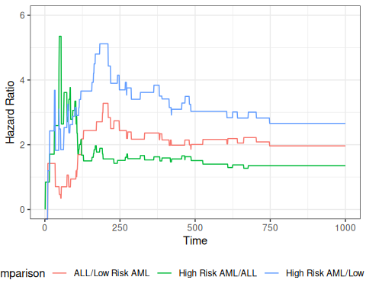
Figure 1: Hazard Ratios by Disease Group for bmt data
We can zoom in on the first 300 days to take a closer look:
bmt_rel_hazard_plot + xlim(c(0,300))
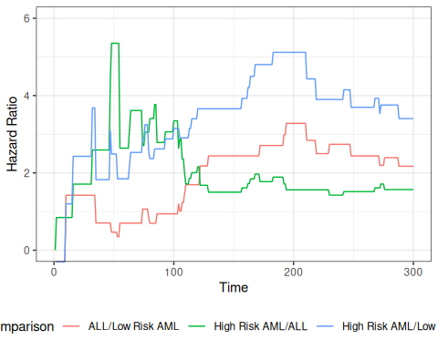
Figure 2: Hazard Ratios by Disease Group (0-300 Days)
The cumulative hazard curves should also be proportional.
library(ggfortify)
plot_cuhaz_bmt =
bmt |>
survfit(formula = Surv(t2, d3) ~ group) |>
autoplot(fun = "cumhaz",
mark.time = TRUE) +
ylab("Cumulative hazard")
plot_cuhaz_bmt |> print()
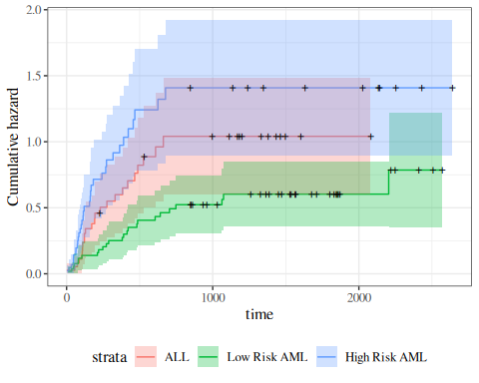
Figure 3: Disease-Free Cumulative Hazard by Disease Group

plot_cuhaz_bmt +
scale_y_log10() +
scale_x_log10()
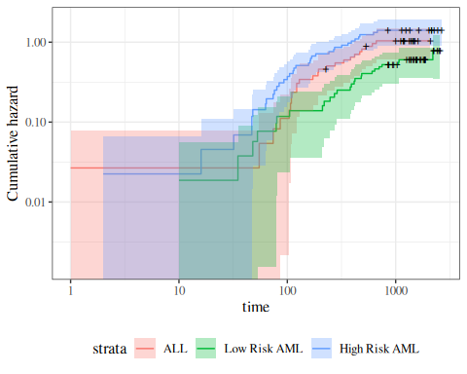
Figure 4: Disease-Free Cumulative Hazard by Disease Group (log-scale)

3.0.1 Smoothed hazard functions
The Nelson-Aalen estimate of the cumulative hazard is usually used for estimates of the hazard. Since the hazard is the derivative of the cumulative hazard, we need a smooth estimate of the cumulative hazard, which is provided by smoothing the step-function cumulative hazard.
The R package muhaz handles this task. What we are looking for is whether the hazard function is more or less the same shape, increasing, decreasing, constant, etc. Are the hazards “proportional”?
library(muhaz)
muhaz(bmt$t2,bmt$d3,bmt$group=="High Risk AML") |> plot(lwd=2,col=3)
muhaz(bmt$t2,bmt$d3,bmt$group=="ALL") |> lines(lwd=2,col=1)
muhaz(bmt$t2,bmt$d3,bmt$group=="Low Risk AML") |> lines(lwd=2,col=2)
legend("topright",c("ALL","Low Risk AML","High Risk AML"),col=1:3,lwd=2)
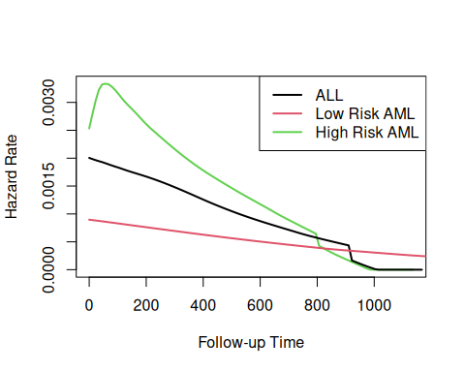
Figure 5: Smoothed Hazard Rate Estimates by Disease Group
Group 3 was plotted first because it has the highest hazard.
Except for an initial blip in the high risk AML group, the hazards look roughly proportional. They are all strongly decreasing.

4. Fitting proportional hazards models to data
Fitting a proportional hazards model means estimating two pieces: the coefficients $\tilde{β}=(β_{1},…,β_{p})$ that govern the covariate effects, and the baseline hazard $λ_{0}(t)$. We estimate them in two stages:
- estimate $\tilde{β}$ by maximizing a partial likelihood in which the unknown baseline $λ_{0}(t)$ cancels out, so the covariate effects can be fit without committing to a shape for the baseline;
- then, with $\hat{\tilde{β}}$ in hand, estimate the baseline cumulative hazard $Λ_{0}(t)$ by the Breslow estimator.
Throughout, assume for simplicity that there are no tied event times; let $t_{1}<t_{2}<⋯<t_{K}$ be the distinct event times for the whole data set, let $R(t_{i})$ be the risk set at time $t_{i}$, and let $(i)$ denote the subject who fails at $t_{i}$ (unique under the no-ties assumption). Recall the model:
$$\begin{aligned}Δη(\tilde{x})&\overset{\text{def}}{=}β_{1}x_{1}+⋯+β_{p}x_{p} \\ θ_{λ}(\tilde{x})&=exp​\left\{Δη(\tilde{x})\right\}​ \\ λ(t|\tilde{x})&=λ_{0}(t) exp​\left\{Δη(\tilde{x})\right\}​ \\ &=θ_{λ}(\tilde{x}) λ_{0}(t)\end{aligned}$$
Stage 1: estimating the coefficients $\tilde{β}$. The key idea is to condition on when the failures happen and ask only which at-risk subject failed at each event time. Over a short interval of width $Δt$, the probability that an at-risk subject $j$ fails at $t_{i}$ is approximately its hazard times the interval width, $λ(t_{i}∣{\tilde{x}}_{j}) Δt=λ_{0}(t_{i}) Δt θ_{λ}({\tilde{x}}_{j})$. So, conditional on exactly one failure at $t_{i}$ among the risk set $R(t_{i})$, the probability that the subject who failed is subject $(i)$ is that subject’s share of the total — and the shared baseline factor $λ_{0}(t_{i}) Δt$ cancels:
Pr(subject (i) fails∣1 failure at ti, R(ti))&=λ0(ti) Δt θλ(x(i))k∈R(ti)​λ0(ti) Δt θλ(xk)&=θλ(x(i))k∈R(ti)​θλ(xk)
Because the baseline factor cancels, this conditional probability depends only on $\tilde{β}$. Multiplying these probabilities across the $K$ event times gives the partial likelihood:
Definition 14 (Cox PH partial likelihood)
Li*(β)&=defθλ(x(i))k∈R(ti)​θλ(xk)L*(β)&=def​i: di=1​​Li*(β)
where, for the distinct event times $t_{1}<⋯<t_{K}$ of the data set:
- $(i)$ is the subject who fails at $t_{i}$ (unique under the no-ties assumption);
- $R(t_{i})\overset{\text{def}}{=}​\left\{j:Y_{j}≥t_{i}\right\}​$ is the risk set at $t_{i}$ (where $Y_{j}=min(T_{j},C_{j})$ is subject $j$’s observed follow-up time) — the subjects still under observation just before $t_{i}$;
- $d_{i}$ is the number of events at $t_{i}$ (so $d_{i}=1$ when there are no ties);
- $θ_{λ}(\tilde{x})\overset{\text{def}}{=}exp​\left\{{\tilde{x}}^{⊤}\tilde{β}\right\}​$ is the hazard ratio (risk score) for covariate pattern $\tilde{x}$.
To prove that this partial likelihood is free of the baseline hazard, we first assemble a chain of general discretized-likelihood building blocks — used only by this proof, so we develop them here rather than in the Intro to Survival Analysis chapter. One piece carries over from that chapter: the interval failure probability $q_{j}(τ)$ (introduced ahead of that chapter’s Kaplan-Meier section, since the Kaplan-Meier derivation also relies on it). From it we build its first-order approximation, the censored-data likelihood, the exact discretized survival factor, the per-interval likelihood factor, and the likelihood regrouped by interval:
Definition 15 (First-order interval failure probability) To first order in $Δt$, the interval failure probability $q_{j}(τ)$ is the hazard times the interval width. We give that approximation its own symbol, the first-order interval failure probability:
$$q_{j}^{*}(τ)\overset{\text{def}}{=}λ(τ) Δt,$$
so that
$$q_{j}(τ)≈q_{j}^{*}(τ).$$

Exm
Example 1 (First-order approximation versus the exact value) Continue the setup of the interval failure probability example: subject $j$ has constant hazard $λ(t)=0.1$ per year, on the half-year interval $[4.0, 4.5)$ with $Δt=0.5$ years. The first-order approximation replaces the exact value with the hazard times the interval width:
$$\begin{aligned}q_{j}^{*}(4.0)&=λ(4.0) Δt&&\text{(definition of }q_{j}^{*}\text{)} \\ &=0.1×0.5&&\text{(substitute }λ=0.1, Δt=0.5\text{)} \\ &=0.05.&&\text{(arithmetic)}\end{aligned}$$
The first-order approximation $q_{j}^{*}(4.0)=0.05$ overstates the exact value $q_{j}(4.0)≈0.0488$ by about $0.0012$, a relative error of roughly $2.5\%$. The discrepancy is exactly the leading term dropped by the linearization $1−exp​\left\{−x\right\}​=x−\frac{x^{2}}{2}+⋯$: here $x=λ(4.0) Δt=0.05$, so the dropped term is $\frac{x^{2}}{2}=\frac{{0.05}^{2}}{2}≈0.00125$, which shrinks to zero as $Δt→0$. This vanishing discrepancy is why proofs based on this discretization become exact in the continuous-time limit.

Lemma 4 (Exact discretization of the survival factor) Partition $[0,\max_{j}Y_{j}]$ into intervals of width $Δt$ with left endpoints $τ$, and assume each observed time $Y_{j}$ falls on an interval boundary (for an interior $Y_{j}$ the identity instead holds in the $Δt→0$ limit). Then each subject’s survival factor is the exact product of its per-interval conditional survival probabilities:
S(Yj∣xj)=τ<Yj​​1−qj(τ)​, (8)
where $q_{j}(τ)$ is the interval failure probability.
Proof
Proof. Surviving to $Y_{j}$ is the intersection of the events “survive interval $τ$”, over all grid intervals $τ<Y_{j}$, which tile $[0,Y_{j})$ exactly because $Y_{j}$ is a grid boundary. By the chain rule for survival over a partition, the probability of this intersection factors into the product, over those intervals, of the conditional probability of surviving each interval given survival to its left endpoint. That conditional survival probability is, by definition, $1−q_{j}(τ)$. The factorization is exact: each factor is the exact conditional survival probability $1−q_{j}(τ)$, not its first-order hazard approximation, so no error is incurred at this step.

Exm
Example 2 (Discretizing a constant hazard) Suppose subject $j$ has constant hazard $λ(t∣{\tilde{x}}_{j})=0.1$/yr and is observed to $Y_{j}=1.5$ yr, discretized with $Δt=0.5$ yr (three intervals, $τ=0, 0.5, 1.0$). Each exact per-interval survival factor is
$$\begin{aligned}1−q_{j}(τ)&=exp​\left\{−\int_{τ}^{τ+0.5}{0.1} du\right\}​&&\text{(exact conditional survival over the interval)} \\ &=exp​\left\{−0.05\right\}​&&\text{(evaluate the integral: }0.1×0.5\text{)} \\ &≈0.9512,&&\text{(arithmetic)}\end{aligned}$$
so Equation 8 gives
S(1.5∣xj)&=τ∈​0, 0.5, 1.0​​​1−qj(τ)​&&(three intervals)&≈0.95123&&(substitute the common per-interval factor)&≈0.8607,&&(arithmetic)
which matches the closed form $S(1.5∣{\tilde{x}}_{j})=exp​\left\{−0.1×1.5\right\}​=exp​\left\{−0.15\right\}​≈0.8607$ exactly, confirming that the discretization introduces no error.

Lemma 5 (Censored-data likelihood) Under noninformative censoring (conditional on $\tilde{x}$, censoring times are independent of event times), the likelihood of the observed data $​\left\{(Y_{j},D_{j},{\tilde{x}}_{j})\right\}​_{j=1}^{n}$ is
$$L=\prod_{j=1}^{n}{S}(Y_{j}∣{\tilde{x}}_{j}) λ(Y_{j}∣{\tilde{x}}_{j})^{D_{j}}, (9)$$
where $Y_{j}=min(T_{j},C_{j})$ is the observed follow-up time and $D_{j}={\text{1}}_{T_{j}≤C_{j}}$ the event indicator.
Proof
Proof. A subject observed to fail ($D_{j}=1$) contributes the event-time density $λ(Y_{j}∣{\tilde{x}}_{j}) S(Y_{j}∣{\tilde{x}}_{j})$, while a subject still censored ($D_{j}=0$) contributes the survival probability $S(Y_{j}∣{\tilde{x}}_{j})$. Under noninformative censoring the two cases combine into the single contribution $S(Y_{j}∣{\tilde{x}}_{j}) λ(Y_{j}∣{\tilde{x}}_{j})^{D_{j}}$ (the likelihood with censoring section). Subjects are independent, so the full likelihood is the product of these contributions over $j$.

Exm
Example 3 (A two-subject likelihood) Suppose subject $1$ fails at $Y_{1}=3$ ($D_{1}=1$) and subject $2$ is still censored at $Y_{2}=5$ ($D_{2}=0$). Then Equation 9 gives
$$L=\underset{\text{subject 1 fails}}{\underset{⏟}{S(3∣{\tilde{x}}_{1}) λ(3∣{\tilde{x}}_{1})}} × \underset{\text{subject 2 censored}}{\underset{⏟}{S(5∣{\tilde{x}}_{2})}}.$$
The failing subject contributes both a survival factor and a hazard factor; the censored subject contributes only a survival factor.

Definition 16 (Per-interval likelihood factor) For a grid interval with left endpoint $τ$ and risk set $R(τ)$, the per-interval likelihood factor collects one factor from every member of $R(τ)$ — a failure factor for the subject who fails in the interval (if any) and a survival factor for each subject who does not:
Lτ=defm∈R(τ)​qm(τ),m fails in interval τ,1−qm(τ),otherwise, (10)
where $q_{m}(τ)$ is the interval failure probability.

Exm
Example 4 (Per-interval factor for a three-subject risk set) Suppose interval $τ$ has risk set $R(τ)=​\left\{1,2,3\right\}​$, with subject $2$ failing in the interval and subjects $1$ and $3$ surviving it. Then the per-interval likelihood factor is
$$L_{τ}=​\left(1−q_{1}(τ)\right)​ q_{2}(τ) ​\left(1−q_{3}(τ)\right)​,$$
a survival factor for each of subjects $1$ and $3$ and a failure factor for subject $2$.

Lemma 6 (Likelihood regrouped by interval) Substituting Equation 8 into Equation 9 and regrouping the factors by interval, the likelihood is the product of the per-interval likelihood factors (Definition 16):
L≈τ​Lτ, (11)
so each interval $τ$ contributes one factor per member of its risk set $R(τ)$. Under the no-ties assumption each interval holds at most one failure.
Proof
Proof. By Lemma 5 and Lemma 4, substituting the discretized survival factor into the likelihood and replacing the failure subject’s hazard-density factor $λ(Y_{j}∣{\tilde{x}}_{j})^{D_{j}}$ by $​\left(q_{j}(Y_{j})/Δt\right)​^{D_{j}}$, via the first-order approximation $q_{j}(Y_{j})≈λ(Y_{j}∣{\tilde{x}}_{j}) Δt$ (Definition 15) rearranged to $λ(Y_{j}∣{\tilde{x}}_{j})≈q_{j}(Y_{j})/Δt$, then absorbing the constant $Δt^{−D_{j}}$ (which is independent of all model parameters),
L≈j=1n​qj(Yj)Djτ<Yj​​1−qj(τ)​​. (12)
Each factor in Equation 12 is indexed by a (subject, interval) pair: subject $j$ contributes one factor to every interval $τ$ with $j∈R(τ)$ — a failure factor $q_{j}(τ)$ if $j$ fails in $τ$, and a survival factor $1−q_{j}(τ)$ otherwise. Reindexing the double product by interval instead of by subject collects, for each $τ$, exactly one factor from every member $m∈R(τ)$ — the per-interval likelihood factor $L_{τ}$ of Definition 16 — giving Equation 11. The $≈$ is inherited from the density approximation in Equation 12; the regrouping itself is an exact reindexing of the same factors.

Exm
Example 5 (Regrouping a two-subject likelihood) Take two subjects at risk over two intervals with left endpoints $τ=0$ and $τ=1$. Subject $1$ survives interval $0$ and fails in interval $1$; subject $2$ survives both intervals. Grouping the factors by subject (Equation 12) gives
$$\underset{\text{subject 1}}{\underset{⏟}{​\left(1−q_{1}(0)\right)​ q_{1}(1)}} × \underset{\text{subject 2}}{\underset{⏟}{​\left(1−q_{2}(0)\right)​​\left(1−q_{2}(1)\right)​}},$$
while grouping the same factors by interval (Equation 11) gives
$$\underset{τ=0, \text{no failure}}{\underset{⏟}{​\left(1−q_{1}(0)\right)​​\left(1−q_{2}(0)\right)​}} × \underset{τ=1, \text{subject 1 fails}}{\underset{⏟}{q_{1}(1)​\left(1−q_{2}(1)\right)​}}.$$
The two products contain identical factors; regrouping only changes the order of multiplication, which is why it is exact.

Under the proportional-hazards model, the first-order interval failure probability splits into a shared baseline factor and a subject-specific hazard ratio:
Definition 17 (Proportional-hazards first-order interval failure probability) Under the proportional-hazards model (Theorem 6), the first-order interval failure probability (Definition 15) factors into a shared baseline term and a subject-specific hazard ratio:
$$q_{j}^{*}(τ)\overset{\text{def}}{=}λ_{0}(τ) Δt θ_{λ}({\tilde{x}}_{j}).$$

Exm
Example 6 (First-order approximation under the PH model) Take a half-year interval $[4.0, 4.5)$ with $Δt=0.5$ yr, baseline hazard $λ_{0}(4.0)=0.1$/yr, and a subject with hazard ratio $θ_{λ}({\tilde{x}}_{j})=2$. The proportional-hazards factorization splits the first-order probability into the shared baseline factor and the subject’s hazard ratio:
$$\begin{aligned}q_{j}^{*}(4.0)&=λ_{0}(4.0) Δt θ_{λ}({\tilde{x}}_{j})&&\text{(definition of }q_{j}^{*}\text{)} \\ &=(0.1×0.5) 2&&\text{(substitute }λ_{0}=0.1, Δt=0.5, θ_{λ}=2\text{)} \\ &=0.05 2&&\text{(arithmetic)} \\ &=0.10.&&\text{(arithmetic)}\end{aligned}$$
Equivalently, the subject’s total hazard is $λ(4.0∣{\tilde{x}}_{j})=λ_{0}(4.0) θ_{λ}({\tilde{x}}_{j})=0.2$/yr, so $q_{j}^{*}(4.0)=λ(4.0∣{\tilde{x}}_{j}) Δt=0.2×0.5=0.10$.

We then build up to the partial likelihood through a chain of proportional-hazards lemmas: the single-subject failure probability and the two factors of each event (whether a failure occurs and which subject it is), and finally the assembly that cancels the baseline hazard.
Lemma 7 (Single-subject failure probability in a risk set) For any subject $j∈R(t_{i})$, under noninformative censoring, the probability that $j$ fails in the interval at $t_{i}$ given that $j$ is at risk is the interval failure probability, and to first order in $Δt$,
$$\begin{aligned}Pr​\left[j\text{ fails at }t_{i}∣j∈R(t_{i})\right]​&=q_{j}(t_{i})&&\text{(definition of }q_{j}(t_{i})\text{)} \\ &≈q_{j}^{*}(t_{i})&&\text{(first-order hazard approximation)} \\ &=λ_{0}(t_{i}) Δt θ_{λ}({\tilde{x}}_{j}).&&\text{(definition of }q_{j}^{*}(t_{i})\text{)}\end{aligned} (13)$$
Proof
Proof. Since $j∈R(t_{i})$ means $Y_{j}=min(T_{j},C_{j})≥t_{i}$, we have both $T_{j}≥t_{i}$ and $C_{j}≥t_{i}$. Under noninformative censoring, the event $C_{j}≥t_{i}$ carries no information about $T_{j}$ given ${\tilde{x}}_{j}$, so conditioning on $j∈R(t_{i})$ is equivalent to conditioning on $T_{j}≥t_{i}$ alone. This conditional failure probability is exactly the interval failure probability $q_{j}(t_{i})$. The first-order interval failure probability (Definition 15) then gives $q_{j}(t_{i})≈q_{j}^{*}(t_{i})$, and the proportional-hazards decomposition (Definition 17) splits $q_{j}^{*}(t_{i})$ into the shared baseline factor $λ_{0}(t_{i}) Δt$ and the subject-specific hazard ratio $θ_{λ}({\tilde{x}}_{j})$.

Exm
Example 7 (Failure probabilities in a three-subject risk set) This example introduces a running scenario reused later in this section: the risk set $R(t_{i})=​\left\{1,2,3\right\}​$ at $t_{i}=4$ yr, with hazard ratios $θ_{λ}({\tilde{x}}_{1})=1$, $θ_{λ}({\tilde{x}}_{2})=2$, $θ_{λ}({\tilde{x}}_{3})=3$, baseline $λ_{0}(4)=0.1$/yr, and grid width $Δt=0.5$ yr, so the shared factor is $λ_{0}(4) Δt=0.05$. Subject $2$ is the one who fails at $t_{i}$. By Equation 13,
$$q_{1}^{*}(4)=0.05, q_{2}^{*}(4)=0.10, q_{3}^{*}(4)=0.15,$$
each the shared $0.05$ scaled by that subject’s hazard ratio $θ_{λ}({\tilde{x}}_{j})$.

Definition 18 (Risk-set score total) The risk-set score total at event time $t_{i}$ is the sum of the subject-specific hazard ratios over everyone at risk at $t_{i}$:
Si=defk∈R(ti)​θλ(xk), (14)
where $R(t_{i})$ is the risk set at $t_{i}$ and $θ_{λ}(\tilde{x})\overset{\text{def}}{=}exp​\left\{{\tilde{x}}^{⊤}\tilde{β}\right\}​$ is the hazard ratio (risk score) for covariate pattern $\tilde{x}$.

Exm
Example 8 (Risk-set score total in the three-subject risk set) For the running scenario of Example 7 — $R(4)=​\left\{1,2,3\right\}​$ with hazard ratios $θ_{λ}({\tilde{x}}_{1})=1$, $θ_{λ}({\tilde{x}}_{2})=2$, $θ_{λ}({\tilde{x}}_{3})=3$ — the risk-set score total (Equation 14) is
$$\begin{aligned}S_{i}&=θ_{λ}({\tilde{x}}_{1})+θ_{λ}({\tilde{x}}_{2})+θ_{λ}({\tilde{x}}_{3})&&\text{(definition of }S_{i}\text{)} \\ &=1+2+3&&\text{(substitute the hazard ratios)} \\ &=6.&&\text{(arithmetic)}\end{aligned}$$

Lemma 8 (The whether-a-failure-occurs factor) To first order in $Δt$, the probability of exactly one failure in the interval at $t_{i}$ is the shared baseline factor times the risk-set score total $S_{i}$ (Definition 18):
$$Pr​\left[1\text{ failure at }t_{i}∣R(t_{i})\right]​≈λ_{0}(t_{i}) Δt S_{i}. (15)$$
Proof
Proof. Treating subjects’ failure events as conditionally independent given $R(t_{i})$ (the Cox-model assumption used throughout; see (Klein and Moeschberger 2003, sec. 8.3)), the probability of exactly one failure is, by inclusion-exclusion,
Pr​1 failure at ti∣R(ti)​=k∈R(ti)​Pr​k fails∣R(ti)​m∈R(ti), m≠k​Pr​m survives∣R(ti)​.
By Lemma 7, $Pr​\left[m\text{ fails}∣R(t_{i})\right]​=q_{m}(t_{i})=O(Δt)$, so each surviving product is m≠k​(1−O(Δt))=1−O(Δt), and dropping the $O(Δt^{2})$ cross-terms (each pair of co-failures has probability $O(Δt^{2})$) leaves the sum of the single-subject pieces. Factoring out the shared baseline,
Pr​1 failure at ti∣R(ti)​&≈k∈R(ti)​qk(ti)&&(drop O(Δt2) cross-terms)&≈k∈R(ti)​qk*(ti)&&(first-order hazard approximation)&=k∈R(ti)​λ0(ti) Δt θλ(xk)&&(definition of qk*(ti))&=λ0(ti) Δtk∈R(ti)​θλ(xk)&&(factor out the shared baseline)&=λ0(ti) Δt Si.&&(definition of Si)

Exm
Example 9 (One-failure probability in the three-subject risk set) Continue the running scenario of Example 7, with $λ_{0}(4) Δt=0.05$ and risk-set score total $S_{i}=6$ (Example 8). By Equation 15, the probability that some one subject fails at $t_{i}=4$ is
$$Pr​\left[1\text{ failure at }4∣R(4)\right]​≈0.05×6=0.30.$$

Lemma 9 (Chain-rule split of an event factor) Under the no-ties assumption, the probability that subject $(i)$ fails at $t_{i}$, given the risk set $R(t_{i})$, factors into a which-subject-fails factor and a whether-a-failure-occurs factor:
$$Pr​\left[(i)\text{ fails at }t_{i}∣R(t_{i})\right]​=\underset{\text{which subject fails}}{\underset{⏟}{Pr​\left[(i)\text{ fails}∣1\text{ failure at }t_{i}, R(t_{i})\right]​}} × \underset{\text{whether a failure occurs}}{\underset{⏟}{Pr​\left[1\text{ failure at }t_{i}∣R(t_{i})\right]​}}. (16)$$
Proof
Proof. Let
- $A\overset{\text{def}}{=}$ “subject $(i)$ fails at $t_{i}$”,
- $B\overset{\text{def}}{=}$ “exactly one failure occurs at $t_{i}$”,
- $C\overset{\text{def}}{=}$ “the risk set at $t_{i}$ is $R(t_{i})$”.
By the chain rule of probability, $Pr(A∩B∣C)=Pr(A∣B∩C) Pr(B∣C)$. Under the no-ties assumption $A⊂B$ (subject $(i)$ failing at $t_{i}$ is automatically a one-failure event), so $A∩B=A$ and therefore $Pr(A∣C)=Pr(A∣B∩C) Pr(B∣C)$, which is Equation 16.

Exm
Example 10 (Splitting the event probability numerically) Continue the running scenario of Example 7, in which subject $2$ is the one who fails at $t_{i}=4$. The left side of Equation 16 is subject $2$’s single-subject failure probability, $q_{2}^{*}(4)=0.10$ (Example 7), and the whether-a-failure factor is $0.30$ (Example 9). The chain rule therefore pins the which-subject factor at
$$Pr​\left[2\text{ fails}∣1\text{ failure at }4, R(4)\right]​=\frac{Pr​\left[2\text{ fails at }4∣R(4)\right]​}{Pr​\left[1\text{ failure at }4∣R(4)\right]​}≈\frac{0.10}{0.30}=\frac{1}{3},$$
and indeed $0.10≈1/3×0.30$ reproduces the left side.

Lemma 10 (The which-subject-fails factor) The which-subject-fails factor of Equation 16 equals the partial-likelihood contribution $L_{i}^{*}(\tilde{β})$ of Definition 14: the shared baseline factor cancels, leaving
$$Pr​\left[(i)\text{ fails}∣1\text{ failure at }t_{i}, R(t_{i})\right]​≈\frac{θ_{λ}({\tilde{x}}_{(i)})}{S_{i}}=L_{i}^{*}(\tilde{β}). (17)$$
Proof
Proof. Solve Equation 16 for the which-subject factor and substitute the numerator $q_{(i)}(t_{i})$ from Lemma 7 and the denominator $λ_{0}(t_{i}) Δt S_{i}$ from Lemma 8; the shared $λ_{0}(t_{i}) Δt$ cancels between numerator and denominator:
$$\begin{aligned}Pr​\left[(i)\text{ fails}∣1\text{ failure at }t_{i}, R(t_{i})\right]​&=\frac{Pr​\left[(i)\text{ fails at }t_{i}∣R(t_{i})\right]​}{Pr​\left[1\text{ failure at }t_{i}∣R(t_{i})\right]​}&&\text{(rearrange)} \\ &≈\frac{q_{(i)}^{*}(t_{i})}{λ_{0}(t_{i}) Δt S_{i}}&&\text{(numerator and denominator from the previous two lemmas)} \\ &=\frac{λ_{0}(t_{i}) Δt θ_{λ}({\tilde{x}}_{(i)})}{λ_{0}(t_{i}) Δt S_{i}}&&\text{(definition of }q_{(i)}^{*}(t_{i})\text{)} \\ &=\frac{θ_{λ}({\tilde{x}}_{(i)})}{S_{i}}&&\text{(cancel the shared }λ_{0}(t_{i}) Δt\text{)} \\ &=L_{i}^{*}(\tilde{β}).&&\text{(definition of }L_{i}^{*}(\tilde{β})\text{)}\end{aligned}$$
The final $=$ is exact: the $λ_{0}(t_{i}) Δt$ factors cancel algebraically, leaving a ratio independent of $Δt$, so the which-subject factor equals the partial-likelihood contribution $L_{i}^{*}(\tilde{β})$ free of both the baseline hazard and the grid width.

Exm
Example 11 (The which-subject factor in the three-subject risk set) Continue the running scenario of Example 7, with subject $2$ failing at $t_{i}=4$ and $S_{i}=6$ (Example 9). By Equation 17,
$$\begin{aligned}L_{i}^{*}(\tilde{β})&=\frac{θ_{λ}({\tilde{x}}_{2})}{S_{i}}&&\text{(which-subject formula, }(i)=2\text{)} \\ &=\frac{2}{6}&&\text{(substitute }θ_{λ}({\tilde{x}}_{2})=2, S_{i}=6\text{)} \\ &=\frac{1}{3},&&\text{(arithmetic)}\end{aligned}$$
independent of the baseline $λ_{0}(4)$ and the grid width $Δt$ — the cancellation that the partial likelihood relies on. This value $1/3$ matches the one pinned by the chain rule in Example 10.

With the lemmas in hand, the proof assembles them and shows the baseline cancels — confirming that the product is free of $λ_{0}$:
Proof
Proof. Adapted from (Klein and Moeschberger 2003, sec. 8.3, Theoretical Note 1, p. 257). This proof draws on the discretized-likelihood building blocks assembled earlier in this section — Lemma 5, Lemma 4, and Lemma 6 — together with the proportional-hazards lemmas Lemma 7, Lemma 8, Lemma 9, and Lemma 10.
Assume noninformative censoring (conditional on $\tilde{x}$, censoring times are independent of event times) and no tied event times. Let $t_{1}<⋯<t_{K}$ be the distinct observed failure times, and let $(i)$ be the subject who fails at $t_{i}$ (unique under the no-ties assumption).
By Lemma 6, the likelihood factors over intervals, L≈τ​Lτ. Separate the $K$ intervals that contain a failure from the rest. A no-failure interval contributes Lτno failure=m∈R(τ)​​1−qm(τ)​; the interval containing $t_{i}$ contributes the event factor $Pr​\left[(i)\text{ fails at }t_{i}∣R(t_{i})\right]​$ times the survival of the other members, which to first order is just the event factor itself, since each other member survives with probability $1−O(Δt)$. Applying Lemma 9 to each event factor, and then Lemma 8 and Lemma 10 to its two pieces,
L&≈​i=1KPr​(i) fails∣1 failure at ti, R(ti)​ Pr​1 failure at ti∣R(ti)​​​τ : no failure​Lτno failure​&&(event chain rule)&≈​i=1Kθλ(x(i))Si​⏟L*(β) (kept) × ​i=1Kλ0(ti) Δt Si​​τ : no failure​m∈R(τ)​​1−qm(τ)​​⏟B(β, λ0) (discarded).&&(whether-failure and which-subject factors) (18)
Under the no-ties assumption each event time has $d_{i}=1$ (where $d_{i}$ is the number of events at $t_{i}$), so the kept product i=1K(⋯)=​i: di=1​​(⋯) matches the form of $L^{*}(\tilde{β})$ in Definition 14.
The partial likelihood keeps the first product, $L^{*}(\tilde{β})$, and drops the second, $B(\tilde{β},λ_{0})$. The discarded factor $B(\tilde{β},λ_{0})$ collects both the whether-a-failure-occurs factors and the entire between-event survival background, and it is the only place the baseline hazard $λ_{0}(⋅)$ appears — equivalently, the shared $λ_{0}(t_{i}) Δt$ cancels from each kept factor in Equation 17 — which is why maximizing $L^{*}(\tilde{β})$ alone frees the estimator from $λ_{0}(⋅)$. The discarded factor is not free of $\tilde{β}$, however: it still depends on $\tilde{β}$ through the risk-set score totals $S_{i}$ and the survival background. Dropping it therefore sacrifices the information about $\tilde{β}$ carried by when (and within how large a risk set) failures occur, retaining only the information in which subject fails at each event time.
The factorization in Equation 18 is a construction rather than an exact decomposition of the joint probability: the factors are not formally independent (the risk set $R(t_{i+1})$ depends on who failed and was censored before $t_{i+1}$, and the discretization is exact only in the $Δt→0$ limit), but Cox showed that treating $L^{*}(\tilde{β})$ as a likelihood — i.e., maximizing it as a function of $\tilde{β}$ — yields estimators with the usual large-sample properties (consistency, asymptotic normality, the standard score and information identities; see also (Klein and Moeschberger 2003, sec. 8.3, Theoretical Note 1)). Under noninformative censoring, each kept factor depends on the observed history only through $R(t_{i})$ and $​\left\{{\tilde{x}}_{j}\right\}​_{j∈R(t_{i})}$, and Equation 17 gives exactly the partial likelihood $L^{*}(\tilde{β})$ of Definition 14.

We maximize this partial likelihood numerically with respect to $\tilde{β}$ (which determines $Δη(\tilde{x})={\tilde{x}}^{⊤}\tilde{β}$ and $θ_{λ}(\tilde{x})=exp​\left\{Δη(\tilde{x})\right\}​$). When there are tied event times some adjustments are needed, but the likelihood is similar. Crucially, the baseline hazard never enters, so we obtain $\hat{\tilde{β}}$ without estimating $λ_{0}$.
Stage 2: estimating the baseline hazard. Once we have the coefficient estimates $\hat{\tilde{β}}=({\hat{β}}_{1},…,{\hat{β}}_{p})$ — and hence $\hat{Δ}η(\tilde{x})$ and ${\hat{θ}}_{λ}(\tilde{x})$ — the baseline cumulative hazard is estimated by the Breslow estimator:
Definition 19 (Breslow estimator of the baseline cumulative hazard)
Λ0(t)=defti≤t​dik∈R(ti)​θλ(xk)
where, for the distinct event times $t_{1}<⋯<t_{K}$ of the data set:
- $d_{i}$ is the number of events at $t_{i}$;
- $R(t_{i})\overset{\text{def}}{=}​\left\{j:Y_{j}≥t_{i}\right\}​$ is the risk set at $t_{i}$ (where $Y_{j}=min(T_{j},C_{j})$ is subject $j$’s observed follow-up time) — the subjects still under observation just before $t_{i}$;
- $θ_{λ}(\tilde{x})\overset{\text{def}}{=}exp​\left\{{\tilde{x}}^{⊤}\tilde{β}\right\}​$ is the hazard ratio (risk score) for covariate pattern $\tilde{x}$.

Exm
Example 12 (Breslow estimator with two event times) Suppose there are two distinct event times $t_{1}=2$ and $t_{2}=4$ (no ties, $d_{1}=d_{2}=1$), with risk-set-weighted totals k∈R(2)​θλ(xk)=10 and k∈R(4)​θλ(xk)=6. Then
$${\hat{Λ}}_{0}(4)=\frac{1}{10}+\frac{1}{6}≈0.267.$$

This estimator reduces to the Nelson-Aalen estimator when there are no covariates; several other estimators have also been proposed. To derive it as a profile likelihood, substitute the proportional-hazards decomposition into the full censored-data likelihood (Lemma 5):
$$L​\left[\tilde{β}, λ_{0}(⋅)\right]​=\prod_{j=1}^{n}{​}\left[λ_{0}({\tilde{T}}_{j}) θ_{λ}({\tilde{x}}_{j})\right]​^{δ_{j}} exp​\left\{−Λ_{0}({\tilde{T}}_{j}) θ_{λ}({\tilde{x}}_{j})\right\}​, (19)$$
where $δ_{j}$ is the event indicator and ${\tilde{T}}_{j}$ the observed time for subject $j$ — the same quantities denoted $D_{j}$ and $Y_{j}$ in the censored-data likelihood lemma, so ${\tilde{T}}_{j}=Y_{j}=min(T_{j},C_{j})$ and $δ_{j}=D_{j}$ — using $λ(t∣\tilde{x})=λ_{0}(t) θ_{λ}(\tilde{x})$ (Theorem 6) and $S(t∣\tilde{x})=exp​\left\{−Λ_{0}(t) θ_{λ}(\tilde{x})\right\}​$ (by Theorem 10, using $S(t)=exp​\left\{−Λ(t)\right\}​$ from the survival/cumulative hazard relationship). Fix $\tilde{β}$ and maximize over $λ_{0}(⋅)$. We build up to the Breslow estimator’s profile-likelihood justification through a chain of lemmas: the point-mass form of the maximizing hazard, the resulting profile likelihood, the maximizer of each point mass, and the assembly that recovers the partial likelihood.
Lemma 11 (Point-mass optimality of the profile baseline hazard) Fix $\tilde{β}$ and maximize the censored-data likelihood Equation 19 over $λ_{0}(⋅)$. The maximizing $λ_{0}(⋅)$ places mass only at the $K$ distinct event times $t_{1}<⋯<t_{K}$, as a discrete hazard measure with point masses $h_{0i}\overset{\text{def}}{=}λ_{0}(t_{i})$:
$$λ_{0}(t)=\left\{\begin{matrix}h_{0i}, & t=t_{i}\text{ for some }i∈​\left\{1,…,K\right\}​, \\ 0, & \text{otherwise}.\end{matrix}\right. (20)$$
Proof
Proof. Subjects with $δ_{j}=0$ contribute only the survival term $exp​\left\{−Λ_{0}({\tilde{T}}_{j}) θ_{λ}({\tilde{x}}_{j})\right\}​$ to Equation 19, since ${λ_{0}({\tilde{T}}_{j})}^{δ_{j}}={λ_{0}({\tilde{T}}_{j})}^{0}=1$ regardless of $λ_{0}$. Adding mass to $λ_{0}$ at any non-event time $t$ increases $Λ_{0}({\tilde{T}}_{j})$ for every subject with ${\tilde{T}}_{j}≥t$, penalizing their survival terms in Equation 19 without any compensating gain in a hazard-density factor — so no mass should be placed away from the $K$ event times.
For an event subject $j$ with $δ_{j}=1$ whose failure occurs at $t_{i}$, consider any allocation of a fixed total mass $h_{0i}$ to a neighborhood of $t_{i}$. The cumulative hazard $Λ_{0}({\tilde{T}}_{j})$ depends only on that total mass, not on how it is distributed within the neighborhood, so the survival penalty $exp​\left\{−Λ_{0}({\tilde{T}}_{j})θ_{λ}({\tilde{x}}_{j})\right\}​$ is unchanged by the allocation. But the hazard-density factor ${λ_{0}(t_{i})}^{δ_{j}}$ in Equation 19 is maximized when all of that mass is concentrated as a single point at $t_{i}$ (so $λ_{0}(t_{i})=h_{0i}$): spreading the same total mass across a wider neighborhood would leave less of it exactly at $t_{i}$, lowering $λ_{0}(t_{i})$ to less than $h_{0i}$, while leaving the survival penalty fixed. Since concentrating the mass strictly increases the hazard-density factor without changing the survival penalty, Equation 19 is maximized by Equation 20.

Exm
Example 13 (Concentrating versus spreading a point mass) Suppose a total mass of $0.1$ is available to place near an event time $t_{1}$. Concentrating it exactly at $t_{1}$ gives $λ_{0}(t_{1})=h_{01}=0.1$, contributing a hazard-density factor of $0.1$ to Equation 19 for the subject failing at $t_{1}$. Splitting the same total mass into two halves — $0.05$ exactly at $t_{1}$ and $0.05$ at a nearby non-event point — leaves only $λ_{0}(t_{1})=0.05$ at $t_{1}$ itself, half the hazard-density factor, while the cumulative hazard $Λ_{0}({\tilde{T}}_{j})$ (and hence every survival term) is unchanged, since both allocations place the same total mass $0.1$ at or prior to any ${\tilde{T}}_{j}≥t_{1}$. Splitting the mass therefore strictly decreases the likelihood, confirming that concentrating all of it at $t_{1}$ is optimal.

Lemma 12 (Profile likelihood in terms of point masses) Substituting the point-mass form of $λ_{0}(⋅)$ (Lemma 11) into the censored-data likelihood Equation 19 gives the profile likelihood as a function of $\tilde{β}$ and the point masses $h_{01},…,h_{0K}$:
$$L​\left[\tilde{β}, h_{01},…,h_{0K}\right]​=\prod_{i=1}^{K}{h_{0i}} θ_{λ}({\tilde{x}}_{(i)}) exp​\left\{−h_{0i} S_{i}\right\}​, (21)$$
where Si=j∈R(ti)​θλ(xj) is the risk-set score total (Definition 18).
Proof
Proof. By Equation 20, Λ0(Tj)=i : ti≤Tj​h0i. Expanding the survival exponent in Equation 19 and swapping the order of summation:
j​Λ0(Tj) θλ(xj)&=j​θλ(xj)i: ti≤Tj​h0i&&(expand Λ0(Tj) as point masses)&=i​h0ij: Tj≥ti​θλ(xj)&&(swap the order of summation)&=i​h0ij∈R(ti)​θλ(xj)&&(R(ti)={j:Tj≥ti})&=i​h0i Si.&&(definition of Si)
Here $R(t_{i})$ uses the “at risk at $t_{i}$” convention (the risk set definition) with the $≥$ boundary — a subject censored exactly at $t_{i}$ is in $R(t_{i})$ and contributes $h_{0i}$ to $Λ_{0}({\tilde{T}}_{j})$. Reindexing the hazard-density product in Equation 19: subjects with $δ_{j}=0$ contribute a factor of ${λ_{0}({\tilde{T}}_{j})}^{0}=1$ (no contribution), and for each subject with $δ_{j}=1$ their event occurred at some $t_{i}$, so $λ_{0}({\tilde{T}}_{j})=h_{0i}$:
j=1n​λ0(Tj) θλ(xj)​δj&=j: δj=1​λ0(Tj) θλ(xj)&&(terms with δj=0 equal 1, dropped)&=i=1Kh0i θλ(x(i)).&&(λ0(Tj)=h0i for event j at event time ti)
Factoring exp​−i​h0i Si​=i​exp​−h0i Si​ and combining factor-by-factor with the hazard-density product gives Equation 21.

Exm
Example 14 (Profile likelihood for two event times) Extend the running scenario of Example 7 with an earlier event time $t_{1}=2$ at which subject $4$ fails, with risk set $R(2)=​\left\{1,2,3,4\right\}​$ and hazard ratios $θ_{λ}({\tilde{x}}_{1})=1$, $θ_{λ}({\tilde{x}}_{2})=2$, $θ_{λ}({\tilde{x}}_{3})=3$, $θ_{λ}({\tilde{x}}_{4})=4$, so $S_{1}=10$ (Definition 18). Subject $4$ then leaves the risk set, so at $t_{2}=4$ the risk set is $R(4)=​\left\{1,2,3\right\}​$ as before, with $S_{2}=6$ (Example 8). By Equation 21, with $K=2$,
$$L​\left[\tilde{β}, h_{01}, h_{02}\right]​=​\left[h_{01}×4×exp​\left\{−h_{01}×10\right\}​\right]​×​\left[h_{02}×2×exp​\left\{−h_{02}×6\right\}​\right]​.$$

Lemma 13 (Profile maximum likelihood estimate of each point mass) The value of $h_{0i}$ that maximizes the profile likelihood Equation 21 (Lemma 12) is
$${\hat{h}}_{0i}\overset{\text{def}}{=}\frac{1}{S_{i}}. (22)$$
Proof
Proof. Taking logs of Equation 21, the log-likelihood is separable in the $h_{0i}$ — each summand depends on only one point mass:
$$ℓ​\left[\tilde{β}, h_{01},…,h_{0K}\right]​=\sum_{i=1}^{K}{log}θ_{λ}({\tilde{x}}_{(i)})+\sum_{i=1}^{K}{​}\left\{logh_{0i}−h_{0i} S_{i}\right\}​.$$
So each $h_{0i}$ can be maximized separately. Differentiate the $i$-th summand with respect to $h_{0i}$ and set the derivative to zero:
$$\begin{aligned}\frac{1}{h_{0i}}−S_{i}&=0&&\text{(stationarity condition)} \\ ⇒ {\hat{h}}_{0i}&=\frac{1}{S_{i}}.&&\text{(solve for }{\hat{h}}_{0i}\text{)}\end{aligned}$$
The second derivative $−1/{h_{0i}}^{2}<0$ confirms this critical point is a maximum, giving Equation 22.

Exm
Example 15 (Maximum likelihood point masses for two event times) Continue the two-event scenario of Example 14, with $S_{1}=10$ at $t_{1}=2$ and $S_{2}=6$ at $t_{2}=4$. By Equation 22,
$${\hat{h}}_{01}=\frac{1}{10}=0.1, {\hat{h}}_{02}=\frac{1}{6}≈0.167.$$
Summing gives the Breslow estimator at $t=4$: ${\hat{Λ}}_{0}(4)={\hat{h}}_{01}+{\hat{h}}_{02}=0.1+0.167=0.267$ (Definition 19).

Lemma 14 (The profile likelihood at the MLE recovers the partial likelihood) Substituting the maximum likelihood point masses ${\hat{h}}_{0i}=1/S_{i}$ (Lemma 13) back into the profile likelihood Equation 21 (Lemma 12) gives, up to a $\tilde{β}$-free constant, the partial likelihood of Definition 14:
$$L​\left[\tilde{β}, {\hat{h}}_{01},…,{\hat{h}}_{0K}\right]​=e^{−K} L^{*}(\tilde{β}). (23)$$
Proof
Proof. Substitute ${\hat{h}}_{0i}=1/S_{i}$ into Equation 21 term by term:
$$\begin{aligned}L​\left[\tilde{β}, {\hat{h}}_{01},…,{\hat{h}}_{0K}\right]​&=\prod_{i=1}^{K}{{\hat{h}}_{0i}} θ_{λ}({\tilde{x}}_{(i)}) exp​\left\{−{\hat{h}}_{0i} S_{i}\right\}​&&\text{(the profile likelihood)} \\ &=\prod_{i=1}^{K}{\frac{θ_{λ}({\tilde{x}}_{(i)})}{S_{i}}} exp​\left\{−S_{i}/S_{i}\right\}​&&\text{(substitute }{\hat{h}}_{0i}=1/S_{i}\text{)} \\ &=\prod_{i=1}^{K}{\frac{θ_{λ}({\tilde{x}}_{(i)})}{S_{i}}} e^{−1}&&\text{(since }S_{i}/S_{i}=1\text{)} \\ &=e^{−K}⋅\prod_{i=1}^{K}{\frac{θ_{λ}({\tilde{x}}_{(i)})}{S_{i}}}.&&\text{(collect the }K\text{ factors of }e^{−1}\text{)}\end{aligned}$$
Under the no-ties assumption each event time $t_{i}$ has $d_{i}=1$, so $\prod_{i=1}^{K}{\frac{θ_{λ}({\tilde{x}}_{(i)})}{S_{i}}}$ equals the partial likelihood $L^{*}(\tilde{β})$ of Definition 14, giving Equation 23.

Exm
Example 16 (Verifying the profile likelihood at the MLE) Continue the two-event scenario of Example 15, with ${\hat{h}}_{01}=0.1$, $S_{1}=10$, $θ_{λ}({\tilde{x}}_{4})=4$ at $t_{1}=2$, and ${\hat{h}}_{02}=1/6$, $S_{2}=6$, $θ_{λ}({\tilde{x}}_{2})=2$ at $t_{2}=4$. Substituting into Equation 21,
$$\begin{aligned}L​\left[\tilde{β}, {\hat{h}}_{01}, {\hat{h}}_{02}\right]​&=​\left[0.1×4×exp​\left\{−0.1×10\right\}​\right]​×​\left[1/6×2×exp​\left\{−1/6×6\right\}​\right]​&&\text{(substitute into the profile likelihood)} \\ &=​\left[\frac{4}{10} e^{−1}\right]​×​\left[\frac{2}{6} e^{−1}\right]​&&\text{(}{\hat{h}}_{0i} S_{i}=1\text{)} \\ &=e^{−2}×\frac{4}{10}×\frac{2}{6},&&\text{(collect the two factors of }e^{−1}\text{)}\end{aligned}$$
matching Equation 23 with $K=2$ and $L^{*}(\tilde{β})=\frac{θ_{λ}({\tilde{x}}_{4})}{S_{1}}×\frac{θ_{λ}({\tilde{x}}_{2})}{S_{2}}=\frac{4}{10}×\frac{2}{6}$.

With the lemmas in hand, the proof assembles them into the Breslow estimator and shows the profile likelihood recovers the partial likelihood:
Proof
Proof. Adapted from (Klein and Moeschberger 2003, sec. 8.3, Theoretical Note 2, p. 258); the original profile-likelihood argument is due to Johansen (1983). This proof assembles four building-block lemmas: Lemma 11, Lemma 12, Lemma 13, and Lemma 14.
Assume, as in the partial-likelihood proof, that there are no tied event times, so each ordered event time $t_{i}$ corresponds to exactly one event, and let $K$ denote the number of distinct event times $t_{1}<⋯<t_{K}$.
Fix $\tilde{β}$. By Lemma 11, the maximizing $λ_{0}(⋅)$ places point masses $h_{0i}\overset{\text{def}}{=}λ_{0}(t_{i})$ only at the $K$ event times. By Lemma 12, substituting this form into Equation 19 gives the profile likelihood Equation 21 in terms of the point masses and the risk-set score totals $S_{i}$ (Definition 18). By Lemma 13, each point mass is maximized at ${\hat{h}}_{0i}=1/S_{i}$. Summing the estimated point masses over event times $t_{i}≤t$ gives the Breslow estimator of the baseline cumulative hazard,
Λ0(t)=ti≤t​h0i=ti≤t​1Si,
matching Definition 19 under the no-ties assumption ($d_{i}=1$ for every $i$). With tied event times, the numerator generalizes to $d_{i}$, the number of events at $t_{i}$ (see (Klein and Moeschberger 2003, sec. 8.8) for the tie-handling adjustments).
By Lemma 14, substituting ${\hat{h}}_{0i}$ back into the profile likelihood recovers the partial likelihood up to a $\tilde{β}$-free constant, $L​\left[\tilde{β}, {\hat{h}}_{01},…,{\hat{h}}_{0K}\right]​=e^{−K} L^{*}(\tilde{β})$, where $L^{*}(\tilde{β})$ is the partial likelihood of Definition 14. Since $e^{−K}$ does not depend on $\tilde{β}$, the profile likelihood is proportional to $L^{*}(\tilde{β})$. This proportionality justifies treating the partial likelihood as a profile likelihood for $\tilde{β}$, with $λ_{0}(⋅)$ concentrated out.

5. Example: Proportional hazards model for the bmt data

5.0.1 Fit the model
library(survival)
bmt.cox <- coxph(Surv(t2, d3) ~ group, data = bmt)
summary(bmt.cox)
#> Call:
#> coxph(formula = Surv(t2, d3) ~ group, data = bmt)
#>
#> n= 137, number of events= 83
#>
#> coef exp(coef) se(coef) z Pr(>|z|)
#> groupLow Risk AML -0.574 0.563 0.287 -2.00 0.046 *
#> groupHigh Risk AML 0.383 1.467 0.267 1.43 0.152
#> ---
#> Signif. codes: 0 '***' 0.001 '**' 0.01 '*' 0.05 '.' 0.1 ' ' 1
#>
#> exp(coef) exp(-coef) lower .95 upper .95
#> groupLow Risk AML 0.563 1.776 0.321 0.989
#> groupHigh Risk AML 1.467 0.682 0.869 2.478
#>
#> Concordance= 0.625 (se = 0.03 )
#> Likelihood ratio test= 13.4 on 2 df, p=0.001
#> Wald test = 13 on 2 df, p=0.001
#> Score (logrank) test = 13.8 on 2 df, p=0.001
The table provides hypothesis tests comparing groups 2 and 3 to group 1. Group 3 has the highest hazard, so the most significant comparison is not directly shown.
The coefficient 0.3834 is on the log-hazard-ratio scale. The next column gives the hazard ratio 1.4673, and a hypothesis (Wald) test.
The (not shown) group 3 vs. group 2 log hazard ratio is 0.3834 − (-0.5742) = 0.9576. The hazard ratio is 2.605.
Inference on all coefficients and combinations can be constructed using coef(bmt.cox) and vcov(bmt.cox) as with logistic and poisson regression.
Concordance is agreement of first failure between pairs of subjects and higher predicted risk between those subjects, omitting non-informative pairs.
The Rsquare value is Cox and Snell’s pseudo R-squared and is not very useful.

5.0.2 Tests for nested models
summary() prints three tests for whether the model with the group covariate is better than the one without
- Likelihood ratio test (chi-squared)
- Wald test (also chi-squared), obtained by adding the squares of the z-scores
- Score = log-rank test, as with comparison of survival functions.
The likelihood ratio test is probably best in smaller samples, followed by the Wald test.

5.0.3 Survival Curves from the Cox Model
We can take a look at the resulting group-specific curves:
km_fit = survfit(Surv(t2, d3) ~ group, data = as.data.frame(bmt))
cox_fit = survfit(
bmt.cox,
newdata =
data.frame(
group = unique(bmt$group),
row.names = unique(bmt$group)))
library(survminer)
list(KM = km_fit, Cox = cox_fit) |>
survminer::ggsurvplot(
# facet.by = "group",
legend = "bottom",
legend.title = "",
combine = TRUE,
fun = 'pct',
size = .5,
ggtheme = theme_bw(),
conf.int = FALSE,
censor = FALSE) |>
suppressWarnings() # ggsurvplot() throws some warnings that aren't too worrying
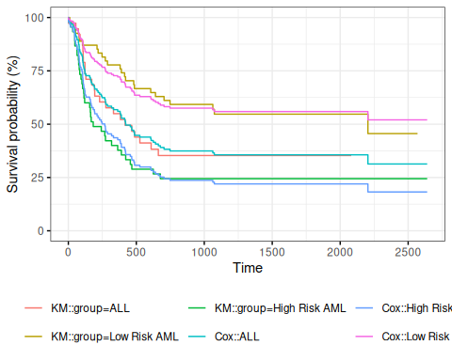
Figure 6: Survival Functions for Three Groups by KM and Cox Model
When we use survfit() with a Cox model, we have to specify the covariate levels we are interested in; the argument newdata should include a data.frame with the same named columns as the predictors in the Cox model and one or more levels of each.
From ?survfit.coxph:
If the newdata argument is missing, a curve is produced for a single “pseudo” subject with covariate values equal to the means component of the fit. The resulting curve(s) almost never make sense, but the default remains due to an unwarranted attachment to the option shown by some users and by other packages. Two particularly egregious examples are factor variables and interactions. Suppose one were studying interspecies transmission of a virus, and the data set has a factor variable with levels (“pig”, “chicken”) and about equal numbers of observations for each. The “mean” covariate level will be 0.5 – is this a flying pig?

5.0.4 Examining survfit
survfit(Surv(t2, d3) ~ group, data = bmt)
#> Call: survfit(formula = Surv(t2, d3) ~ group, data = bmt)
#>
#> n events median 0.95LCL 0.95UCL
#> group=ALL 38 24 418 194 NA
#> group=Low Risk AML 54 25 2204 704 NA
#> group=High Risk AML 45 34 183 115 456
survfit(Surv(t2, d3) ~ group, data = bmt) |> summary()
#> Call: survfit(formula = Surv(t2, d3) ~ group, data = bmt)
#>
#> group=ALL
#> time n.risk n.event survival std.err lower 95% CI upper 95% CI
#> 1 38 1 0.974 0.0260 0.924 1.000
#> 55 37 1 0.947 0.0362 0.879 1.000
#> 74 36 1 0.921 0.0437 0.839 1.000
#> 86 35 1 0.895 0.0498 0.802 0.998
#> 104 34 1 0.868 0.0548 0.767 0.983
#> 107 33 1 0.842 0.0592 0.734 0.966
#> 109 32 1 0.816 0.0629 0.701 0.949
#> 110 31 1 0.789 0.0661 0.670 0.930
#> 122 30 2 0.737 0.0714 0.609 0.891
#> 129 28 1 0.711 0.0736 0.580 0.870
#> 172 27 1 0.684 0.0754 0.551 0.849
#> 192 26 1 0.658 0.0770 0.523 0.827
#> 194 25 1 0.632 0.0783 0.495 0.805
#> 230 23 1 0.604 0.0795 0.467 0.782
#> 276 22 1 0.577 0.0805 0.439 0.758
#> 332 21 1 0.549 0.0812 0.411 0.734
#> 383 20 1 0.522 0.0817 0.384 0.709
#> 418 19 1 0.494 0.0819 0.357 0.684
#> 466 18 1 0.467 0.0818 0.331 0.658
#> 487 17 1 0.439 0.0815 0.305 0.632
#> 526 16 1 0.412 0.0809 0.280 0.605
#> 609 14 1 0.382 0.0803 0.254 0.577
#> 662 13 1 0.353 0.0793 0.227 0.548
#>
#> group=Low Risk AML
#> time n.risk n.event survival std.err lower 95% CI upper 95% CI
#> 10 54 1 0.981 0.0183 0.946 1.000
#> 35 53 1 0.963 0.0257 0.914 1.000
#> 48 52 1 0.944 0.0312 0.885 1.000
#> 53 51 1 0.926 0.0356 0.859 0.998
#> 79 50 1 0.907 0.0394 0.833 0.988
#> 80 49 1 0.889 0.0428 0.809 0.977
#> 105 48 1 0.870 0.0457 0.785 0.965
#> 211 47 1 0.852 0.0483 0.762 0.952
#> 219 46 1 0.833 0.0507 0.740 0.939
#> 248 45 1 0.815 0.0529 0.718 0.925
#> 272 44 1 0.796 0.0548 0.696 0.911
#> 288 43 1 0.778 0.0566 0.674 0.897
#> 381 42 1 0.759 0.0582 0.653 0.882
#> 390 41 1 0.741 0.0596 0.633 0.867
#> 414 40 1 0.722 0.0610 0.612 0.852
#> 421 39 1 0.704 0.0621 0.592 0.837
#> 481 38 1 0.685 0.0632 0.572 0.821
#> 486 37 1 0.667 0.0642 0.552 0.805
#> 606 36 1 0.648 0.0650 0.533 0.789
#> 641 35 1 0.630 0.0657 0.513 0.773
#> 704 34 1 0.611 0.0663 0.494 0.756
#> 748 33 1 0.593 0.0669 0.475 0.739
#> 1063 26 1 0.570 0.0681 0.451 0.720
#> 1074 25 1 0.547 0.0691 0.427 0.701
#> 2204 6 1 0.456 0.1012 0.295 0.704
#>
#> group=High Risk AML
#> time n.risk n.event survival std.err lower 95% CI upper 95% CI
#> 2 45 1 0.978 0.0220 0.936 1.000
#> 16 44 1 0.956 0.0307 0.897 1.000
#> 32 43 1 0.933 0.0372 0.863 1.000
#> 47 42 2 0.889 0.0468 0.802 0.986
#> 48 40 1 0.867 0.0507 0.773 0.972
#> 63 39 1 0.844 0.0540 0.745 0.957
#> 64 38 1 0.822 0.0570 0.718 0.942
#> 74 37 1 0.800 0.0596 0.691 0.926
#> 76 36 1 0.778 0.0620 0.665 0.909
#> 80 35 1 0.756 0.0641 0.640 0.892
#> 84 34 1 0.733 0.0659 0.615 0.875
#> 93 33 1 0.711 0.0676 0.590 0.857
#> 100 32 1 0.689 0.0690 0.566 0.838
#> 105 31 1 0.667 0.0703 0.542 0.820
#> 113 30 1 0.644 0.0714 0.519 0.801
#> 115 29 1 0.622 0.0723 0.496 0.781
#> 120 28 1 0.600 0.0730 0.473 0.762
#> 157 27 1 0.578 0.0736 0.450 0.742
#> 162 26 1 0.556 0.0741 0.428 0.721
#> 164 25 1 0.533 0.0744 0.406 0.701
#> 168 24 1 0.511 0.0745 0.384 0.680
#> 183 23 1 0.489 0.0745 0.363 0.659
#> 242 22 1 0.467 0.0744 0.341 0.638
#> 268 21 1 0.444 0.0741 0.321 0.616
#> 273 20 1 0.422 0.0736 0.300 0.594
#> 318 19 1 0.400 0.0730 0.280 0.572
#> 363 18 1 0.378 0.0723 0.260 0.550
#> 390 17 1 0.356 0.0714 0.240 0.527
#> 422 16 1 0.333 0.0703 0.221 0.504
#> 456 15 1 0.311 0.0690 0.201 0.481
#> 467 14 1 0.289 0.0676 0.183 0.457
#> 625 13 1 0.267 0.0659 0.164 0.433
#> 677 12 1 0.244 0.0641 0.146 0.409
survfit(bmt.cox)
#> Call: survfit(formula = bmt.cox)
#>
#> n events median 0.95LCL 0.95UCL
#> [1,] 137 83 422 268 NA
survfit(bmt.cox, newdata = tibble(group = unique(bmt$group)))
#> Call: survfit(formula = bmt.cox, newdata = tibble(group = unique(bmt$group)))
#>
#> n events median 0.95LCL 0.95UCL
#> 1 137 83 422 268 NA
#> 2 137 83 NA 625 NA
#> 3 137 83 268 162 467
bmt.cox |>
survfit(newdata = tibble(group = unique(bmt$group))) |>
summary()
#> Call: survfit(formula = bmt.cox, newdata = tibble(group = unique(bmt$group)))
#>
#> time n.risk n.event survival1 survival2 survival3
#> 1 137 1 0.993 0.996 0.989
#> 2 136 1 0.985 0.992 0.978
#> 10 135 1 0.978 0.987 0.968
#> 16 134 1 0.970 0.983 0.957
#> 32 133 1 0.963 0.979 0.946
#> 35 132 1 0.955 0.975 0.935
#> 47 131 2 0.941 0.966 0.914
#> 48 129 2 0.926 0.957 0.893
#> 53 127 1 0.918 0.953 0.882
#> 55 126 1 0.911 0.949 0.872
#> 63 125 1 0.903 0.944 0.861
#> 64 124 1 0.896 0.940 0.851
#> 74 123 2 0.881 0.931 0.830
#> 76 121 1 0.873 0.926 0.819
#> 79 120 1 0.865 0.922 0.809
#> 80 119 2 0.850 0.913 0.788
#> 84 117 1 0.843 0.908 0.778
#> 86 116 1 0.835 0.903 0.768
#> 93 115 1 0.827 0.899 0.757
#> 100 114 1 0.820 0.894 0.747
#> 104 113 1 0.812 0.889 0.737
#> 105 112 2 0.797 0.880 0.717
#> 107 110 1 0.789 0.875 0.707
#> 109 109 1 0.782 0.870 0.697
#> 110 108 1 0.774 0.866 0.687
#> 113 107 1 0.766 0.861 0.677
#> 115 106 1 0.759 0.856 0.667
#> 120 105 1 0.751 0.851 0.657
#> 122 104 2 0.735 0.841 0.637
#> 129 102 1 0.727 0.836 0.627
#> 157 101 1 0.720 0.831 0.617
#> 162 100 1 0.712 0.826 0.607
#> 164 99 1 0.704 0.821 0.598
#> 168 98 1 0.696 0.815 0.588
#> 172 97 1 0.688 0.810 0.578
#> 183 96 1 0.680 0.805 0.568
#> 192 95 1 0.672 0.800 0.558
#> 194 94 1 0.664 0.794 0.549
#> 211 93 1 0.656 0.789 0.539
#> 219 92 1 0.648 0.783 0.530
#> 230 90 1 0.640 0.778 0.520
#> 242 89 1 0.632 0.773 0.511
#> 248 88 1 0.624 0.767 0.501
#> 268 87 1 0.616 0.761 0.492
#> 272 86 1 0.608 0.756 0.482
#> 273 85 1 0.600 0.750 0.473
#> 276 84 1 0.592 0.745 0.464
#> 288 83 1 0.584 0.739 0.454
#> 318 82 1 0.576 0.733 0.445
#> 332 81 1 0.568 0.727 0.436
#> 363 80 1 0.560 0.722 0.427
#> 381 79 1 0.552 0.716 0.418
#> 383 78 1 0.544 0.710 0.409
#> 390 77 2 0.528 0.698 0.392
#> 414 75 1 0.520 0.692 0.383
#> 418 74 1 0.512 0.686 0.374
#> 421 73 1 0.504 0.680 0.366
#> 422 72 1 0.496 0.674 0.357
#> 456 71 1 0.488 0.667 0.349
#> 466 70 1 0.480 0.661 0.340
#> 467 69 1 0.472 0.655 0.332
#> 481 68 1 0.464 0.649 0.324
#> 486 67 1 0.455 0.642 0.315
#> 487 66 1 0.447 0.636 0.307
#> 526 65 1 0.439 0.629 0.299
#> 606 63 1 0.431 0.623 0.291
#> 609 62 1 0.423 0.616 0.283
#> 625 61 1 0.415 0.609 0.275
#> 641 60 1 0.407 0.603 0.267
#> 662 59 1 0.399 0.596 0.260
#> 677 58 1 0.391 0.589 0.252
#> 704 57 1 0.383 0.582 0.244
#> 748 56 1 0.374 0.575 0.237
#> 1063 47 1 0.365 0.567 0.228
#> 1074 46 1 0.356 0.559 0.220
#> 2204 9 1 0.313 0.520 0.182

6. Adjustment for Ties (optional)
At each time $t_{i}$ at which more than one of the subjects has an event, let $d_{i}$ be the number of events at that time, $D_{i}$ the set of subjects with events at that time, and let $s_{i}$ be a covariate vector for an artificial subject obtained by adding up the covariate values for the subjects with an event at time $t_{i}$. Let
$${\overset{‾}{η}}_{i}=β_{1}s_{i1}+⋯+β_{p}s_{ip}$$
and ${\overset{‾}{θ}}_{i}=exp​\left\{{\overset{‾}{η}}_{i}\right\}​$.
Note that
ηi&=j∈Di​β1xj1+⋯+βpxjp&=β1si1+⋯+βpsipθi&=exp​ηi​&=j∈Di​θi

Breslow’s method for ties
Breslow’s method estimates the partial likelihood as
L(β|T)&=i​θi[k∈R(ti)​θk]di&=i​j∈Di​θjk∈R(ti)​θk
This method is equivalent to treating each event as distinct and using the non-ties formula. It works best when the number of ties is small. It is the default in many statistical packages, including PROC PHREG in SAS.

Efron’s method for ties
The other common method is Efron’s, which is the default in R.
L(β|T)=i​θij=1di[k∈R(ti)​θk−j−1dik∈Di​θk]
This Efron approximation is closer to the exact discrete partial likelihood when there are many ties.
The third option in R (and an option also in SAS as discrete) is the “exact” method, which is the same one used for matched logistic regression.

Example: Breslow’s method
Suppose as an example we have a time $t$ where there are 20 individuals at risk and three failures. Let the three individuals have risk parameters $θ_{1},θ_{2},θ_{3}$ and let the sum of the risk parameters of the remaining 17 individuals be $θ_{R}$. Then the factor in the partial likelihood at time $t$ using Breslow’s method is
$$\left(\frac{θ_{1}}{θ_{R}+θ_{1}+θ_{2}+θ_{3}}\right)\left(\frac{θ_{2}}{θ_{R}+θ_{1}+θ_{2}+θ_{3}}\right)\left(\frac{θ_{3}}{θ_{R}+θ_{1}+θ_{2}+θ_{3}}\right)$$
If on the other hand, they had died in the order 1, 2, 3, then the contribution to the partial likelihood would be:
$$\left(\frac{θ_{1}}{θ_{R}+θ_{1}+θ_{2}+θ_{3}}\right)\left(\frac{θ_{2}}{θ_{R}+θ_{2}+θ_{3}}\right)\left(\frac{θ_{3}}{θ_{R}+θ_{3}}\right)$$
as the risk set got smaller with each failure. The exact method roughly averages the results for the six possible orderings of the failures.

Example: Efron’s method
Because the exact failure order among tied event times is unobserved, rather than reducing the denominator by one risk coefficient at each step, Efron’s method reduces it by a uniform fractional amount.
$$\left(\frac{θ_{1}}{θ_{R}+θ_{1}+θ_{2}+θ_{3}}\right)\left(\frac{θ_{2}}{θ_{R}+2(θ_{1}+θ_{2}+θ_{3})/3}\right)\left(\frac{θ_{3}}{θ_{R}+(θ_{1}+θ_{2}+θ_{3})/3}\right)$$

7. Building Cox Proportional Hazards Models

7.1 hodg Lymphoma Data Set from KMsurv

7.1.1 Participants
43 bone marrow transplant patients at Ohio State University (Avalos 1993)

7.1.2 Variables
- dtype: Disease type (Hodgkin’s or non-Hodgkins lymphoma)
- gtype: Bone marrow graft type:
- allogeneic: from HLA-matched sibling
- autologous: from self (prior to chemo)
- time: time to study exit
- delta: study exit reason (death/relapse vs censored)
- wtime: waiting time to transplant (in months)
- score: Karnofsky score:
- 80–100: Able to carry on normal activity and to work; no special care needed.
- 50–70: Unable to work; able to live at home and care for most personal needs; varying amount of assistance needed.
- 10–60: Unable to care for self; requires equivalent of institutional or hospital care; disease may be progressing rapidly.

7.1.3 Data
library(dplyr)
library(survival)
library(survminer)
data(hodg, package = "KMsurv")
hodg2 <- hodg |>
as_tibble() |>
mutate(
# We add factor labels to the categorical variables:
gtype = gtype |>
case_match(
1 ~ "Allogenic",
2 ~ "Autologous"
),
dtype = dtype |>
case_match(
1 ~ "Non-Hodgkins",
2 ~ "Hodgkins"
) |>
factor() |>
relevel(ref = "Non-Hodgkins"),
delta = delta |>
case_match(
1 ~ "dead",
0 ~ "alive"
),
surv = Surv(
time = time,
event = delta == "dead"
)
)
hodg2 |> print()
#> # A tibble: 43 × 7
#> gtype dtype time delta score wtime surv
#> <chr> <fct> <int> <chr> <int> <int> <Surv>
#> 1 Allogenic Non-Hodgkins 28 dead 90 24 28
#> 2 Allogenic Non-Hodgkins 32 dead 30 7 32
#> 3 Allogenic Non-Hodgkins 49 dead 40 8 49
#> 4 Allogenic Non-Hodgkins 84 dead 60 10 84
#> 5 Allogenic Non-Hodgkins 357 dead 70 42 357
#> 6 Allogenic Non-Hodgkins 933 alive 90 9 933+
#> 7 Allogenic Non-Hodgkins 1078 alive 100 16 1078+
#> 8 Allogenic Non-Hodgkins 1183 alive 90 16 1183+
#> 9 Allogenic Non-Hodgkins 1560 alive 80 20 1560+
#> 10 Allogenic Non-Hodgkins 2114 alive 80 27 2114+
#> # ℹ 33 more rows

7.2 Proportional hazards model
Table 1: Summary of Proportional Hazards model for Hodgkins Lymphoma data
hodg_cox1 <- coxph(
formula = surv ~ gtype * dtype + score + wtime,
data = hodg2
)
summary(hodg_cox1)
#> Call:
#> coxph(formula = surv ~ gtype * dtype + score + wtime, data = hodg2)
#>
#> n= 43, number of events= 26
#>
#> coef exp(coef) se(coef) z Pr(>|z|)
#> gtypeAutologous 0.6394 1.8953 0.5937 1.08 0.2815
#> dtypeHodgkins 2.7603 15.8050 0.9474 2.91 0.0036 **
#> score -0.0495 0.9517 0.0124 -3.98 6.8e-05 ***
#> wtime -0.0166 0.9836 0.0102 -1.62 0.1046
#> gtypeAutologous:dtypeHodgkins -2.3709 0.0934 1.0355 -2.29 0.0220 *
#> ---
#> Signif. codes: 0 '***' 0.001 '**' 0.01 '*' 0.05 '.' 0.1 ' ' 1
#>
#> exp(coef) exp(-coef) lower .95 upper .95
#> gtypeAutologous 1.8953 0.5276 0.5920 6.068
#> dtypeHodgkins 15.8050 0.0633 2.4682 101.207
#> score 0.9517 1.0507 0.9288 0.975
#> wtime 0.9836 1.0167 0.9641 1.003
#> gtypeAutologous:dtypeHodgkins 0.0934 10.7074 0.0123 0.711
#>
#> Concordance= 0.776 (se = 0.059 )
#> Likelihood ratio test= 32.1 on 5 df, p=6e-06
#> Wald test = 27.2 on 5 df, p=5e-05
#> Score (logrank) test = 37.7 on 5 df, p=4e-07

7.3 Diagnostic graphs for proportional hazards assumption

7.3.1 Analysis plan
- survival function for the four combinations of disease type and graft type.
- observed (nonparametric) vs. expected (semiparametric) survival functions.
- complementary log-log survival for the four groups.

7.3.2 Kaplan-Meier survival functions
km_model <- survfit(
formula = surv ~ dtype + gtype,
data = hodg2
)
library(ggplot2)
library(ggfortify) # registers autoplot.survfit
km_model |>
autoplot(conf.int = FALSE) +
theme_bw() +
theme(
legend.position = "bottom",
legend.title = element_blank(),
legend.text = element_text(size = legend_text_size)
) +
guides(col = guide_legend(ncol = 2)) +
ylab("Survival probability, S(t)") +
xlab("Time since transplant (days)")
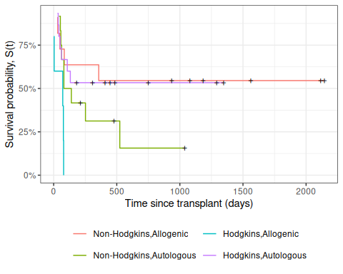
Figure 7: Kaplan-Meier Survival Curves for HOD/NHL and Allo/Auto Grafts

7.3.3 Observed and expected survival curves
# we need to create a tibble of covariate patterns;
# we will set score and wtime to mean values for disease and graft types:
means <- hodg2 |>
summarize(
.by = c(dtype, gtype),
score = mean(score),
wtime = mean(wtime)
) |>
arrange(dtype, gtype) |>
mutate(strata = paste(dtype, gtype, sep = ",")) |>
as.data.frame()
# survfit.coxph() will use the rownames of its `newdata`
# argument to label its output:
rownames(means) <- means$strata
cox_model <-
hodg_cox1 |>
survfit(
data = hodg2, # ggsurvplot() will need this
newdata = means
)
# I couldn't find a good function to reformat `cox_model` for ggplot,
# so I made my own:
stack_surv_ph <- function(cox_model) {
cox_model$surv |>
as_tibble() |>
mutate(time = cox_model$time) |>
tidyr::pivot_longer(
cols = -time,
names_to = "strata",
values_to = "surv"
) |>
mutate(
cumhaz = -log(.data$surv),
model = "Cox PH"
)
}
km_and_cph <-
km_model |>
fortify(surv.connect = TRUE) |>
mutate(
strata = trimws(strata),
model = "Kaplan-Meier",
cumhaz = -log(surv)
) |>
bind_rows(stack_surv_ph(cox_model))
km_and_cph |>
ggplot(aes(x = time, y = surv, col = model)) +
geom_step() +
facet_wrap(~strata) +
theme_bw() +
ylab("S(t) = P(T>=t)") +
xlab("Survival time (t, days)") +
theme(legend.position = "bottom")
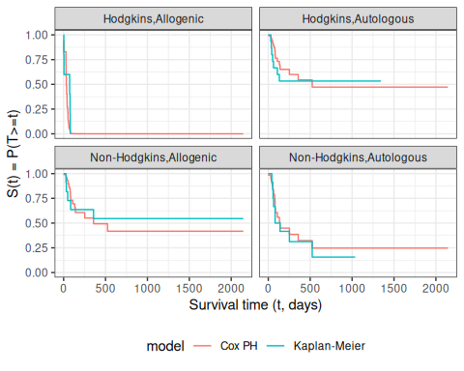
Observed and expected survival curves for hodg2 data

7.3.4 Cumulative hazard (log-scale) curves
Also known as “complementary log-log (clog-log) survival curves”.
na_model <- survfit(
formula = surv ~ dtype + gtype,
data = hodg2,
type = "fleming"
)
na_model |>
survminer::ggsurvplot(
legend = "bottom",
legend.title = "",
ylab = "log(Cumulative Hazard)",
xlab = "Time since transplant (days, log-scale)",
fun = "cloglog",
size = .5,
ggtheme = theme_bw(),
conf.int = FALSE,
censor = TRUE
) |>
magrittr::extract2("plot") +
guides(
col =
guide_legend(
ncol = 2,
label.theme = element_text(size = legend_text_size)
)
)
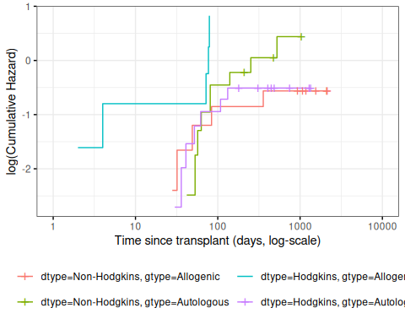
Figure 8: Complementary log-log survival curves - Nelson-Aalen estimates
Let’s compare these empirical (i.e., non-parametric) curves with the fitted curves from our coxph() model:
cox_model |>
survminer::ggsurvplot(
facet_by = "",
legend = "bottom",
legend.title = "",
ylab = "log(Cumulative Hazard)",
xlab = "Time since transplant (days, log-scale)",
fun = "cloglog",
size = .5,
ggtheme = theme_bw(),
censor = FALSE, # doesn't make sense for cox model
conf.int = FALSE
) |>
magrittr::extract2("plot") +
guides(
col =
guide_legend(
ncol = 2,
label.theme = element_text(size = legend_text_size)
)
)
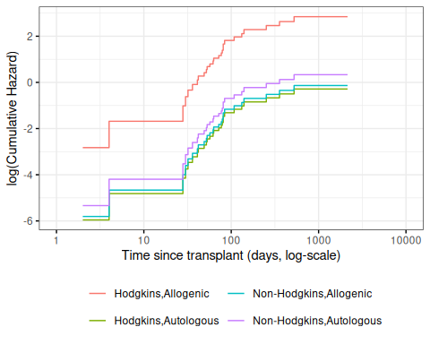
Figure 9: Complementary log-log survival curves - PH estimates
Now let’s overlay these cumulative hazard curves:
na_and_cph <-
na_model |>
fortify(fun = "cumhaz") |>
# `fortify.survfit()` doesn't name cumhaz correctly:
rename(cumhaz = surv) |>
mutate(
surv = exp(-cumhaz),
strata = trimws(strata)
) |>
mutate(model = "Nelson-Aalen") |>
bind_rows(stack_surv_ph(cox_model))
na_and_cph |>
ggplot(
aes(
x = time,
y = cumhaz,
col = model
)
) +
geom_step() +
facet_wrap(~strata) +
theme_bw() +
scale_y_continuous(
trans = "log10",
name = "Cumulative hazard, H(t) (log-scale)"
) +
scale_x_continuous(
trans = "log10",
name = "Survival time (t, days, log-scale)"
) +
theme(legend.position = "bottom")
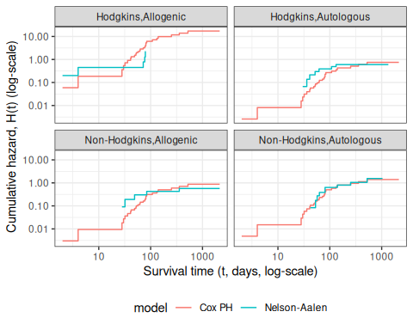
Figure 10: Observed and expected cumulative hazard curves for bmt data (cloglog format)

7.4 Predictions and Residuals

7.4.1 Review: Predictions in Linear Regression
- In linear regression, we have a linear predictor for each data point $i$
$$\begin{aligned}η_{i}&=β_{0}+β_{1}x_{1i}+⋯+β_{p}x_{pi} \\ {\hat{y}}_{i}&={\hat{η}}_{i}={\hat{β}}_{0}+{\hat{β}}_{1}x_{1i}+⋯+{\hat{β}}_{p}x_{pi} \\ y_{i}&∼N(η_{i},σ^{2})\end{aligned}$$
- ${\hat{y}}_{i}$ estimates the conditional mean of $y_{i}$ given the covariate values ${\tilde{x}}_{i}$. This together with the prediction error says that we are predicting the distribution of values of $y$.

7.4.2 Review: Residuals in Linear Regression
- The usual residual is $r_{i}=y_{i}−{\hat{y}}_{i}$, the difference between the actual value of $y$ and a prediction of its mean.
- The residuals are also the quantities the sum of whose squares is being minimized by the least squares/MLE estimation.

7.4.3 Predictions and Residuals in survival models
- In survival analysis, the equivalent of $y_{i}$ is the event time $t_{i}$, which is unknown for the censored observations.
- The expected event time can be tricky to calculate:
$$\hat{\text{E}}[T|X=x]=\int_{t=0}^{∞}{}(t)dt$$

7.4.4 Wide prediction intervals
The nature of time-to-event data results in very wide prediction intervals:
- Suppose a cancer patient is predicted to have a mean lifetime of 5 years after diagnosis and suppose the distribution is exponential.
- If we want a 95% interval for survival, the lower end is at the 0.025 percentage point of the exponential which is qexp(.025, rate = 1/5) = 0.126589 years, or 1/40 of the mean lifetime.
- The upper end is at the 0.975 point which is qexp(.975, rate = 1/5) = 18.444397 years, or 3.7 times the mean lifetime.
- Saying that the survival time is somewhere between 6 weeks and 18 years does not seem very useful, but it may be the best we can do.
- For survival analysis, something is like a residual if it is small when the model is accurate or if the accumulation of them is in some way minimized by the estimation algorithm, but there is no exact equivalence to linear regression residuals.
- And if there is, they are mostly quite large!

7.4.5 Types of Residuals in Time-to-Event Models
- It is often hard to make a decision from graph appearances, though the process can reveal much.
- Some diagnostic tests are based on residuals as with other regression methods:
  - Schoenfeld residuals (via cox.zph) for proportionality
  - Cox-Snell residuals for goodness of fit (Section 7.5)
  - martingale residuals for non-linearity
  - dfbeta for influence.
Definition 20 (Estimated Risk Score) The risk score $θ_{λ}​\left(\tilde{x}\right)​$ (Definition 12) depends on the true, unknown coefficient vector $\tilde{β}$. After fitting the model, we estimate it by the estimated risk score, which substitutes the fitted coefficients $\hat{\tilde{β}}$ for $\tilde{β}$:
$$\hat{θ_{λ}}​\left(\tilde{x}\right)​\overset{\text{def}}{=}exp​\left\{\tilde{x}⋅\hat{\tilde{β}}\right\}​$$

7.4.6 Schoenfeld residuals
Definition 21 (Schoenfeld Residual) For each subject $i$ who experienced an event (not censored) and for each predictor $k$, the Schoenfeld residual is defined as (Grambsch and Therneau 1994):
rikS=xik−j∈R​ti​​xjk θ​xj​j∈R​ti​​θ​xj​
where $R​\left(t_{i}\right)​$ is the risk set at event time $t_{i}$ of subject $i$, $x_{jk}$ is the value of predictor $k$ for subject $j$, and $\hat{θ}​\left({\tilde{x}}_{j}\right)​$ is the estimated risk score (Definition 20) for subject $j$.
Intuitively, $r_{ik}^{S}$ measures how unusual subject $i$’s covariate value is, relative to the risk-weighted average among those at risk when subject $i$ failed. If the proportional hazards assumption holds, these residuals should show no systematic trend over time. A trend signals non-proportionality.
We can test for such a trend with the correlation between Schoenfeld residuals and a function of time. The default in cox.zph() uses the KM survival curve as a transform, which handles censoring better than raw ranks. The cox.zph() function implements a score test proposed in Grambsch and Therneau (1994).
hodg_zph <- cox.zph(hodg_cox1)
print(hodg_zph)
#> chisq df p
#> gtype 0.5400 1 0.462
#> dtype 1.8012 1 0.180
#> score 3.8805 1 0.049
#> wtime 0.0173 1 0.895
#> gtype:dtype 4.0474 1 0.044
#> GLOBAL 13.7573 5 0.017

gtype
ggcoxzph(hodg_zph, var = "gtype")
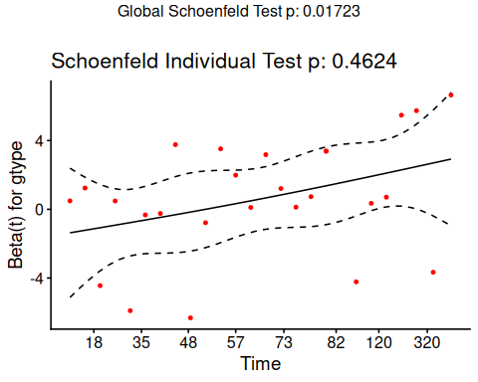

dtype
ggcoxzph(hodg_zph, var = "dtype")
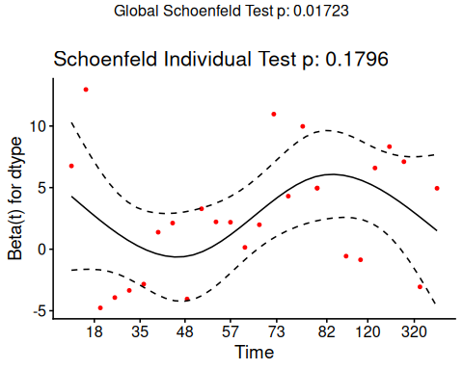

score
ggcoxzph(hodg_zph, var = "score")
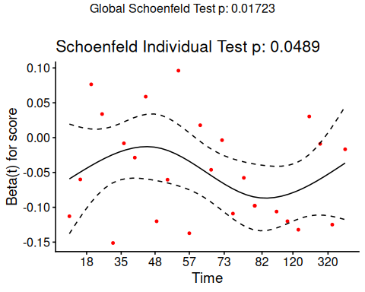

wtime
ggcoxzph(hodg_zph, var = "wtime")
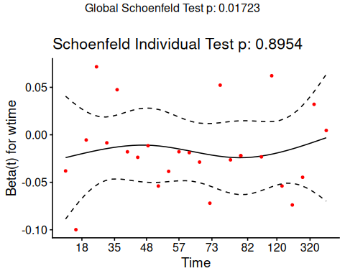

gtype:dtype
ggcoxzph(hodg_zph, var = "gtype:dtype")
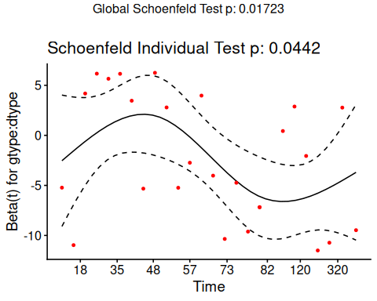

Conclusions
- From the correlation test, the Karnofsky score and the interaction with graft type disease type induce modest but statistically significant non-proportionality.
- The sample size here is relatively small (26 events in 43 subjects). If the sample size is large, very small amounts of non-proportionality can induce a significant result.
- As time goes on, autologous grafts are over-represented at their own event times, but those from HOD patients become less represented.
- Both the statistical tests and the plots are useful.

7.5 Goodness of Fit using the Cox-Snell Residuals
(references: Klein and Moeschberger (2003), §11.2, and Dobson and Barnett (2018), §10.6)

Suppose that an individual has a survival time $T$ which has survival function $S(t)$, meaning that $Pr(T>t)=S(t)$. Then $S(T)$ has a uniform distribution on $(0,1)$:
$$\begin{aligned}Pr(S(T_{i})≤u)&=Pr(T_{i}>S_{i}^{−1}(u)) \\ &=S_{i}(S_{i}^{−1}(u)) \\ &=u\end{aligned}$$

Also, if $U$ has a uniform distribution on $(0,1)$, then what is the distribution of $−ln(U)$?

$$\begin{aligned}Pr(−ln(U)<x)&=Pr(U>exp​\left\{−x\right\}​) \\ &=1−e^{−x}\end{aligned}$$
which is the CDF of an exponential distribution with parameter $λ=1$.

Definition 22 (Cox-Snell generalized residuals)
The Cox-Snell generalized residuals are defined as:
$$r_{i}^{CS}\overset{\text{def}}{=}\hat{Λ}(t_{i}|{\tilde{x}}_{i})$$
If the estimate ${\hat{S}}_{i}$ is accurate, $r_{i}^{CS}$ should have an exponential distribution with constant hazard $λ=1$, which means that these values should look like a censored sample from this exponential distribution.

hodg2 <- hodg2 |>
mutate(cs = predict(hodg_cox1, type = "expected"))
surv_csr <- survfit(
data = hodg2,
formula = Surv(time = cs, event = delta == "dead") ~ 1,
type = "fleming-harrington"
)
autoplot(surv_csr, fun = "cumhaz") +
geom_abline(aes(intercept = 0, slope = 1), col = "red") +
theme_bw()
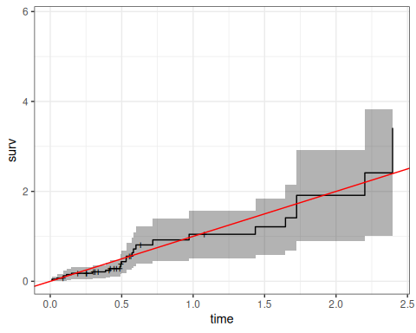
Figure 11: Cumulative Hazard of Cox-Snell Residuals
The line with slope 1 and intercept 0 fits the curve relatively well, so we don’t see lack of fit using this procedure.

7.6 Martingale Residuals
Definition 23 (Martingale Residual) The martingale residual for subject $i$ is:
$$r_{i}^{M}=δ_{i}−r_{i}^{CS}$$
where $δ_{i}=1$ if subject $i$ experienced the event ($0$ if censored) and $r_{i}^{CS}=\hat{Λ}(t_{i}∣{\tilde{x}}_{i})$ is the Cox-Snell residual (Definition 22) (Klein and Moeschberger 2003, sec. 11.3).

 Note
Martingale residuals estimate the excess number of events in the data relative to what the model predicted. They are bounded above by $1$ (a subject who died very early has residual close to $1−0=1$) but unbounded below (a long-lived censored subject in a high-risk group can have a very large negative residual). This asymmetry makes it harder to spot unexpectedly early deaths, motivating the deviance residual.
We will use martingale residuals to examine the functional forms of continuous covariates.

 The Martingale Connection
Originally, a martingale referred to a betting strategy where you bet $1 on the first play, then you double the bet if you lose and continue until you win. This strategy seems like a sure thing, because at the end of each series when you finally win, you are up $1. For example, $−1−2−4−8+16=1$. But this assumes that you have infinite resources. Really, you have a large probability of winning $1, and a small probability of losing everything you have, kind of the opposite of a lottery.
martingale
In probability, a martingale is a sequence of random variables such that the expected value of the next event at any time is the present observed value, and that no better predictor can be derived even with all past values of the series available. At least to a close approximation, the stock market is a martingale. Under the assumptions of the proportional hazards model, the martingale residuals ordered in time form a martingale.

7.6.1 Using Martingale Residuals
Martingale residuals can be used to examine the functional form of a numeric variable.
- We fit the model without that variable and compute the martingale residuals.
- We then plot these martingale residuals against the values of the variable.
- We can see curvature, or a possible suggestion that the variable can be discretized.
Let’s use this to examine the score and wtime variables in the wtime data set.

Karnofsky score
hodg2 <- hodg2 |>
mutate(
mres = hodg_cox1 |>
update(. ~ . - score) |>
residuals(type = "martingale")
)
hodg2 |>
ggplot(aes(x = score, y = mres)) +
geom_point() +
geom_smooth(method = "loess", aes(col = "loess")) +
geom_smooth(method = "lm", aes(col = "lm")) +
theme_classic() +
xlab("Karnofsky Score") +
ylab("Martingale Residuals") +
guides(col = guide_legend(title = ""))
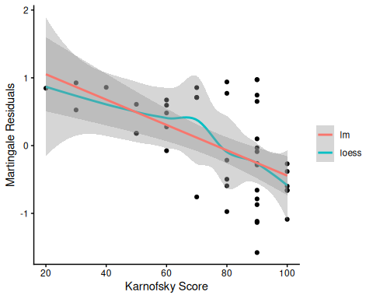
Martingale Residuals vs. Karnofsky Score
The line is almost straight. It could be some modest transformation of the Karnofsky score would help, but it might not make much difference.

Waiting time
hodg2$mres <-
hodg_cox1 |>
update(. ~ . - wtime) |>
residuals(type = "martingale")
hodg2 |>
ggplot(aes(x = wtime, y = mres)) +
geom_point() +
geom_smooth(method = "loess", aes(col = "loess")) +
geom_smooth(method = "lm", aes(col = "lm")) +
theme_classic() +
xlab("Waiting Time") +
ylab("Martingale Residuals") +
guides(col = guide_legend(title = ""))
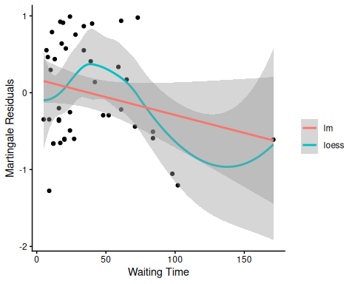
Martingale Residuals vs. Waiting Time
The line could suggest a step function. To see where the drop is, we can look at the largest waiting times and the associated martingale residual.
The martingale residuals are all negative for wtime >83 and positive for the next smallest value. A reasonable cut-point is 80 days.

Updating the model
Let’s reformulate the model with dichotomized wtime.
hodg2 <-
hodg2 |>
mutate(
wt2 = cut(
wtime, c(0, 80, 200),
labels = c("short", "long")
)
)
hodg_cox2 <-
coxph(
formula = Surv(time, event = delta == "dead") ~
gtype * dtype + score + wt2,
data = hodg2
)
hodg_cox1 |> drop1(test = "Chisq")
#> # A tibble: 4 × 4
#> Df AIC LRT `Pr(>Chi)`
#> <dbl> <dbl> <dbl> <dbl>
#> 1 NA 152. NA NA
#> 2 1 168. 17.2 0.0000330
#> 3 1 154. 3.28 0.0702
#> 4 1 156. 5.44 0.0197
hodg_cox2 |> drop1(test = "Chisq")
#> # A tibble: 4 × 4
#> Df AIC LRT `Pr(>Chi)`
#> <dbl> <dbl> <dbl> <dbl>
#> 1 NA 149. NA NA
#> 2 1 169. 21.6 0.00000335
#> 3 1 154. 6.61 0.0102
#> 4 1 152. 4.97 0.0258
The new model has better (lower) AIC.

7.7 Checking for Outliers and Influential Observations
We will check for outliers using the deviance residuals. The martingale residuals show excess events or the opposite, but highly skewed, with the maximum possible value being 1, but the smallest value can be very large negative. Martingale residuals can detect unexpectedly long-lived patients, but patients who die unexpectedly early show up only in the deviance residual. Influence will be examined using dfbeta in a similar way to linear regression, logistic regression, or Poisson regression.

7.7.1 Deviance Residuals
Definition 24 (Deviance Residual) The deviance residual for subject $i$ is defined as (Klein and Moeschberger 2003, sec. 11.3):
$$\begin{aligned}r_{i}^{D}&=sign​\left\{r_{i}^{M}\right\}​\sqrt{−2​\left[r_{i}^{M}+δ_{i}ln​\left(δ_{i}−r_{i}^{M}\right)​\right]​} \\ &=sign​\left\{r_{i}^{M}\right\}​\sqrt{−2​\left[r_{i}^{M}+δ_{i}ln​\left(r_{i}^{CS}\right)​\right]​}\end{aligned}$$
where $sign​\left\{⋅\right\}​$ is the sign function, $r_{i}^{M}$ is the martingale residual (Definition 23), and $r_{i}^{CS}$ is the Cox-Snell residual (Definition 22).
Deviance residuals are roughly centered on 0 with approximate standard deviation 1. By symmetrizing the skewed martingale residuals, they make it equally easy to identify unexpectedly early events (large positive $r_{i}^{D}$) and unexpectedly long survival (large negative $r_{i}^{D}$).

7.7.2 Computing residuals
hodg_mart <- residuals(hodg_cox2, type = "martingale")
hodg_dev <- residuals(hodg_cox2, type = "deviance")
hodg_dfb <- residuals(hodg_cox2, type = "dfbeta")
hodg_preds <- predict(hodg_cox2) # linear predictor
data.frame(lp = hodg_preds, martingale = hodg_mart) |>
ggplot(aes(x = lp, y = martingale)) +
geom_point() +
geom_hline(yintercept = 0, linetype = "dashed") +
theme_bw() +
xlab("Linear Predictor") +
ylab("Martingale Residual")
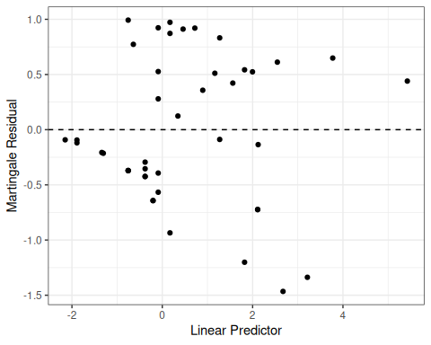
Figure 12: Martingale Residuals vs. Linear Predictor
The smallest three martingale residuals in order are observations 1, 29, and 18.
data.frame(lp = hodg_preds, deviance = hodg_dev) |>
ggplot(aes(x = lp, y = deviance)) +
geom_point() +
geom_hline(yintercept = 0, linetype = "dashed") +
theme_bw() +
xlab("Linear Predictor") +
ylab("Deviance Residual")
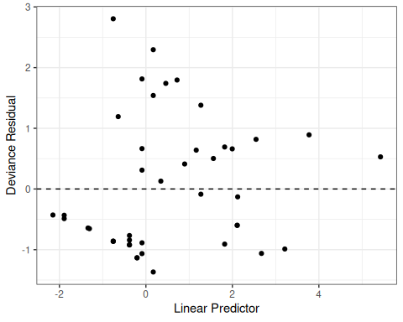
Figure 13: Deviance Residuals vs. Linear Predictor
The two largest deviance residuals are observations 1 and 29. Worth examining.

7.7.3 dfbeta
Definition 25 (dfbeta and dfbetas)
- dfbeta for observation $i$ is the approximate change in the coefficient vector $\hat{\tilde{β}}$ if subject $i$ were removed from the data:
$${\text{dfbeta}}_{i}≈\hat{\tilde{β}}−{\hat{\tilde{β}}}_{(−i)}$$
- computed via a one-step Newton approximation rather than a full refit (Klein and Moeschberger 2003, sec. 11.4).
- dfbetas for observation $i$ standardizes by the estimated standard error of each coefficient:
$${\text{dfbetas}}_{ik}={\text{dfbeta}}_{ik}/​\left({\hat{β}}_{k}\right)​$$
A useful rule of thumb is to examine the observations whose dfbeta values stand out from the rest — those whose removal would shift a coefficient the most — analogous to influence diagnostics such as Cook’s distance in linear regression.

Graft type
data.frame(obs = seq_len(nrow(hodg_dfb)), dfbeta = hodg_dfb[, 1]) |>
ggplot(aes(x = obs, y = dfbeta)) +
geom_point() +
geom_hline(yintercept = 0, linetype = "dashed") +
theme_bw() +
xlab("Observation Index") +
ylab("dfbeta for Graft Type")
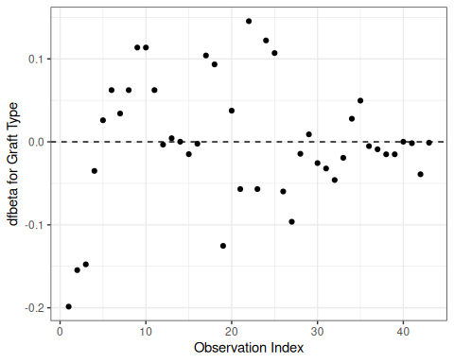
Figure 14: dfbeta Values by Observation Order for Graft Type
The smallest dfbeta for graft type is observation 1.

Disease type
data.frame(obs = seq_len(nrow(hodg_dfb)), dfbeta = hodg_dfb[, 2]) |>
ggplot(aes(x = obs, y = dfbeta)) +
geom_point() +
geom_hline(yintercept = 0, linetype = "dashed") +
theme_bw() +
xlab("Observation Index") +
ylab("dfbeta for Disease Type")
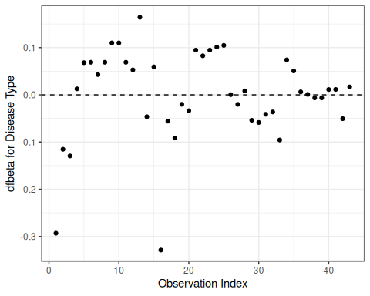
Figure 15: dfbeta Values by Observation Order for Disease Type
The smallest two dfbeta values for disease type are observations 1 and 16.

Karnofsky score
data.frame(obs = seq_len(nrow(hodg_dfb)), dfbeta = hodg_dfb[, 3]) |>
ggplot(aes(x = obs, y = dfbeta)) +
geom_point() +
geom_hline(yintercept = 0, linetype = "dashed") +
theme_bw() +
xlab("Observation Index") +
ylab("dfbeta for Karnofsky Score")
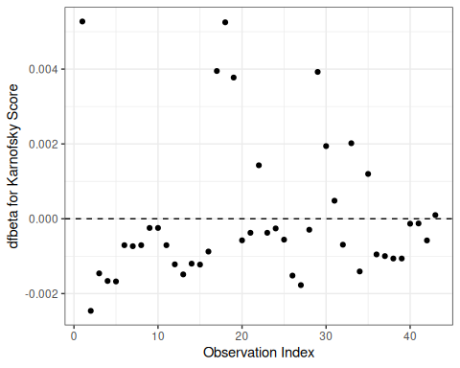
Figure 16: dfbeta Values by Observation Order for Karnofsky Score
The two highest dfbeta values for score are observations 1 and 18. The next three are observations 17, 29, and 19. The smallest value is observation 2.

Waiting time (dichotomized)
data.frame(obs = seq_len(nrow(hodg_dfb)), dfbeta = hodg_dfb[, 4]) |>
ggplot(aes(x = obs, y = dfbeta)) +
geom_point() +
geom_hline(yintercept = 0, linetype = "dashed") +
theme_bw() +
xlab("Observation Index") +
ylab("dfbeta for Waiting Time < 80")
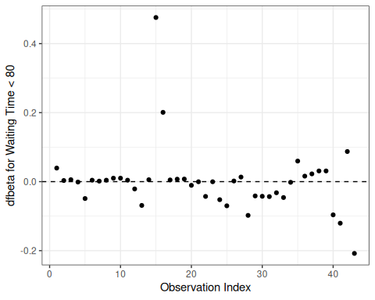
Figure 17: dfbeta Values by Observation Order for Waiting Time (dichotomized)
The two large values of dfbeta for dichotomized waiting time are observations 15 and 16. This behavior may have to do with the discretization of waiting time.

Interaction: graft type and disease type
data.frame(obs = seq_len(nrow(hodg_dfb)), dfbeta = hodg_dfb[, 5]) |>
ggplot(aes(x = obs, y = dfbeta)) +
geom_point() +
geom_hline(yintercept = 0, linetype = "dashed") +
theme_bw() +
xlab("Observation Index") +
ylab("dfbeta for dtype:gtype")
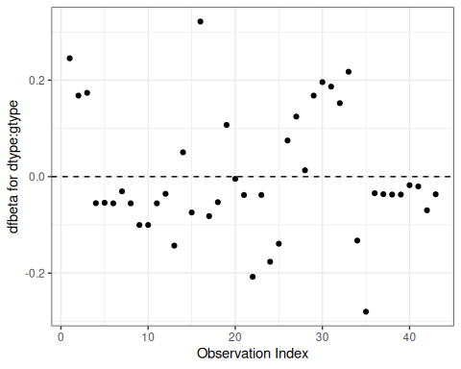
Figure 18: dfbeta Values by Observation Order for dtype:gtype
The two largest values are observations 1 and 16. The smallest value is observation 35.
Table 2: Observations to Examine by Residuals and Influence
Diagnostic | Observations to Examine
Martingale Residuals | 1, 29, 18
Deviance Residuals | 1, 29
Graft Type Influence | 1
Disease Type Influence | 1, 16
Karnofsky Score Influence | 1, 18 (17, 29, 19)
Waiting Time Influence | 15, 16
Graft by Disease Influence | 1, 16, 35

The most important observations to examine seem to be 1, 15, 16, 18, and 29.

7.7.4 Examining influential observations
with(hodg, summary(time[delta == 1]))
#> Min. 1st Qu. Median Mean 3rd Qu. Max.
#> 2.0 41.2 62.5 97.6 83.2 524.0
with(hodg, summary(wtime))
#> Min. 1st Qu. Median Mean 3rd Qu. Max.
#> 5.0 16.0 24.0 37.7 55.5 171.0
with(hodg, summary(score))
#> Min. 1st Qu. Median Mean 3rd Qu. Max.
#> 20.0 60.0 80.0 76.3 90.0 100.0
hodg_cox2
#> Call:
#> coxph(formula = Surv(time, event = delta == "dead") ~ gtype *
#> dtype + score + wt2, data = hodg2)
#>
#> coef exp(coef) se(coef) z p
#> gtypeAutologous 0.6651 1.9447 0.5943 1.12 0.2631
#> dtypeHodgkins 2.3273 10.2505 0.7332 3.17 0.0015
#> score -0.0550 0.9464 0.0123 -4.46 8.2e-06
#> wt2long -2.0598 0.1275 1.0507 -1.96 0.0499
#> gtypeAutologous:dtypeHodgkins -2.0668 0.1266 0.9258 -2.23 0.0256
#>
#> Likelihood ratio test=35.5 on 5 df, p=1.21e-06
#> n= 43, number of events= 26
hodg2[c(1, 15, 16, 18, 29), ] |>
select(gtype, dtype, time, delta, score, wtime) |>
mutate(
comment =
c(
"early death, good score, low risk",
"high risk grp, long wait, poor score",
"high risk grp, short wait, poor score",
"early death, good score, med risk grp",
"early death, good score, med risk grp"
)
)
#> # A tibble: 5 × 7
#> gtype dtype time delta score wtime comment
#> <chr> <fct> <int> <chr> <int> <int> <chr>
#> 1 Allogenic Non-Hodgkins 28 dead 90 24 early death, good score, low …
#> 2 Allogenic Hodgkins 77 dead 60 102 high risk grp, long wait, poo…
#> 3 Allogenic Hodgkins 79 dead 70 71 high risk grp, short wait, po…
#> 4 Autologous Non-Hodgkins 53 dead 90 17 early death, good score, med …
#> 5 Autologous Hodgkins 30 dead 90 73 early death, good score, med …

7.7.5 Action Items
- Unusual points may need checking, particularly if the data are not completely cleaned. In this case, observations 15 and 16 may show some trouble with the dichotomization of waiting time, but it still may be useful.
- The two largest residuals seem to be due to unexpectedly early deaths, but unfortunately this can occur.
- If hazards don’t look proportional, then we may need to use strata, between which the base hazards are permitted to be different. For this problem, the natural strata are the two diseases, because they could need to be managed differently anyway.
- A main point that we want to be sure of is the relative risk difference by disease type and graft type.
library(pander)
hodg_cox2 |>
predict(
reference = "zero",
newdata = means |>
mutate(
wt2 = "short",
score = 0
),
type = "lp"
) |>
data.frame("linear predictor" = _) |>
pander()
Linear Risk Predictors for Lymphoma
 | linear.predictor
Non-Hodgkins,Allogenic | 0
Non-Hodgkins,Autologous | 0.6651
Hodgkins,Allogenic | 2.327
Hodgkins,Autologous | 0.9256
For Non-Hodgkin’s, the allogenic graft is better. For Hodgkin’s, the autologous graft is much better.

7.8 Addressing Diagnostic Issues Through Model Modification
The diagnostic tests and plots reveal two key concerns:
- Non-proportionality of the gtype:dtype interaction and score, flagged by cox.zph on the original model hodg_cox1.
- Influential observations (from the hodg_cox2 dfbeta diagnostics): subjects 1, 15, 16, 18, and 29 have large dfbeta values for specific coefficients.
This section illustrates how to address the non-proportionality finding and verifies that the revision actually helps.

7.8.1 Checking PH for hodg_cox2
Let’s verify whether non-proportionality persists in hodg_cox2 (which already dichotomized wtime):
hodg_cox2_zph <- cox.zph(hodg_cox2)
print(hodg_cox2_zph)
#> chisq df p
#> gtype 0.75420 1 0.385
#> dtype 1.61479 1 0.204
#> score 3.49389 1 0.062
#> wt2 0.00638 1 0.936
#> gtype:dtype 3.56165 1 0.059
#> GLOBAL 13.01172 5 0.023
ggcoxzph(hodg_cox2_zph)
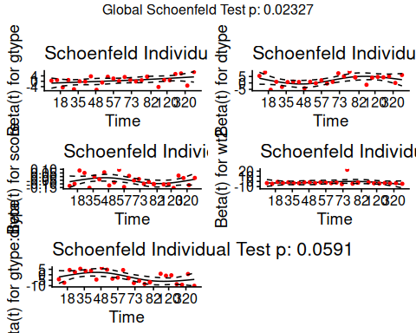
Figure 19: Scaled Schoenfeld residuals for hodg_cox2

7.8.2 Strategy: stratify by disease type
The diagnostics suggest that the hazard-ratio profile for disease type (and its interaction with graft type) is not constant over time. One remedy is a stratified Cox model that allows separate baseline hazards for each disease type, absorbing between-disease trajectory differences into two free baseline functions, while still estimating proportional effects of graft type, Karnofsky score, and waiting time.
hodg_cox3 <- coxph(
formula = surv ~ gtype + score + wt2 + strata(dtype),
data = hodg2
)
summary(hodg_cox3)
#> Call:
#> coxph(formula = surv ~ gtype + score + wt2 + strata(dtype), data = hodg2)
#>
#> n= 43, number of events= 26
#>
#> coef exp(coef) se(coef) z Pr(>|z|)
#> gtypeAutologous 0.0660 1.0683 0.4631 0.14 0.89
#> score -0.0569 0.9447 0.0125 -4.55 5.4e-06 ***
#> wt2long -1.5150 0.2198 1.0422 -1.45 0.15
#> ---
#> Signif. codes: 0 '***' 0.001 '**' 0.01 '*' 0.05 '.' 0.1 ' ' 1
#>
#> exp(coef) exp(-coef) lower .95 upper .95
#> gtypeAutologous 1.068 0.936 0.4310 2.647
#> score 0.945 1.059 0.9218 0.968
#> wt2long 0.220 4.549 0.0285 1.695
#>
#> Concordance= 0.77 (se = 0.056 )
#> Likelihood ratio test= 27.9 on 3 df, p=4e-06
#> Wald test = 23.6 on 3 df, p=3e-05
#> Score (logrank) test = 32.4 on 3 df, p=4e-07

7.8.3 Verifying the fix: cox.zph on the stratified model
hodg_cox3_zph <- cox.zph(hodg_cox3)
print(hodg_cox3_zph)
#> chisq df p
#> gtype 4.921 1 0.027
#> score 1.307 1 0.253
#> wt2 0.132 1 0.717
#> GLOBAL 8.230 3 0.041
ggcoxzph(hodg_cox3_zph)
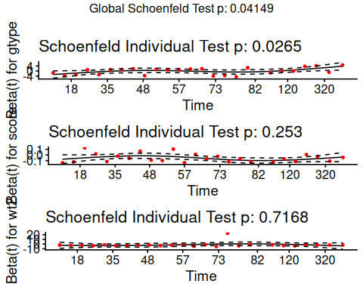
Figure 20: Scaled Schoenfeld residuals for stratified model hodg_cox3
Stratifying by disease type removes the between-disease baseline difference from the proportional-hazards stratum, so the remaining terms should satisfy PH more closely.

7.8.4 Verifying the fix: residual diagnostics
hodg3_dev <- residuals(hodg_cox3, type = "deviance")
hodg3_dfb <- residuals(hodg_cox3, type = "dfbeta")
hodg3_lp <- predict(hodg_cox3)
data.frame(lp = hodg3_lp, deviance = hodg3_dev) |>
ggplot(aes(x = lp, y = deviance)) +
geom_point() +
geom_hline(yintercept = 0, linetype = "dashed") +
theme_bw() +
xlab("Linear Predictor") +
ylab("Deviance Residual")
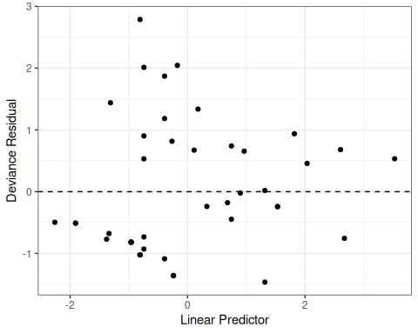
Figure 21: Deviance residuals vs. linear predictor, hodg_cox3
hodg3_dfb_mat <- as.matrix(hodg3_dfb)
colnames(hodg3_dfb_mat) <- names(coef(hodg_cox3))
data.frame(
obs = rep(seq_len(nrow(hodg3_dfb_mat)), times = ncol(hodg3_dfb_mat)),
coefficient = rep(colnames(hodg3_dfb_mat), each = nrow(hodg3_dfb_mat)),
dfbeta = as.vector(hodg3_dfb_mat)
) |>
ggplot(aes(x = obs, y = dfbeta)) +
geom_point() +
geom_hline(yintercept = 0, linetype = "dashed") +
facet_wrap(~coefficient, scales = "free_y") +
theme_bw() +
xlab("Observation Index") +
ylab("dfbeta")
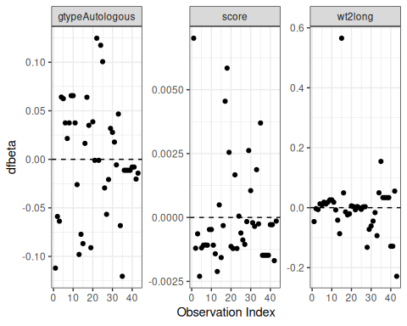
Figure 22: dfbeta values for stratified model hodg_cox3
Comparing these panels with the subjects flagged earlier from the hodg_cox2 diagnostics (1, 15, 16, 18, and 29): subjects 1 and 18 remain the most influential observations for the Karnofsky score coefficient, and subject 15 is still the most influential for dichotomized waiting time, so stratifying by disease type did not neutralize their leverage on the terms that remain in the model. Subject 16, by contrast, is no longer prominent: its earlier influence acted largely through the graft-by-disease-type interaction, which the stratified model absorbs into the disease-specific baseline hazards.

7.8.5 Comparing models
data.frame(
Model = c(
"hodg_cox2: gtype*dtype + score + wt2",
"hodg_cox3: gtype + score + wt2 + strata(dtype)"
),
Parameters = c(length(coef(hodg_cox2)), length(coef(hodg_cox3)))
) |>
knitr::kable(digits = 2)
Table 3: Comparison of unstratified and stratified Cox PH models
Model | Parameters
hodg_cox2: gtype*dtype + score + wt2 | 5
hodg_cox3: gtype + score + wt2 + strata(dtype) | 3

We deliberately omit log-likelihood and AIC from this comparison: the partial likelihood of the stratified model hodg_cox3 is computed within disease-type strata and excludes the between-stratum comparisons that hodg_cox2’s partial likelihood includes, so the two are not on a common scale and their AIC values are not comparable.
The stratified model resolves the PH violation by allowing disease-specific baseline hazards. The trade-off: we can no longer directly estimate a disease-type hazard ratio, as that effect is absorbed into the baseline functions. The graft-type coefficient remains interpretable as the within-stratum hazard ratio comparing autologous to allogeneic grafts.

7.9 Stratified survival models

7.9.1 Revisiting the leukemia dataset (anderson)
We will analyze remission survival times on 42 leukemia patients, half on new treatment, half on standard treatment.
This dataset is the same data as the drug6mp data from KMsurv, but with two other variables and without the pairing. This version comes from Kleinbaum and Klein (2012) (e.g., p281):
anderson <-
paste0(
"http://web1.sph.emory.edu/dkleinb/allDatasets/",
"surv2datasets/anderson.dta"
) |>
haven::read_dta() |>
dplyr::mutate(
status = status |>
case_match(
1 ~ "relapse",
0 ~ "censored"
),
sex = sex |>
case_match(
0 ~ "female",
1 ~ "male"
) |>
factor() |>
relevel(ref = "female"),
rx = rx |>
case_match(
0 ~ "new",
1 ~ "standard"
) |>
factor() |>
relevel(ref = "standard"),
surv = Surv(
time = survt,
event = (status == "relapse")
)
)
print(anderson)

7.9.2 Cox semi-parametric proportional hazards model
anderson_cox1 <- coxph(
formula = surv ~ rx + sex + logwbc,
data = anderson
)
summary(anderson_cox1)
#> Call:
#> coxph(formula = surv ~ rx + sex + logwbc, data = anderson)
#>
#> n= 42, number of events= 30
#>
#> coef exp(coef) se(coef) z Pr(>|z|)
#> rxnew -1.504 0.222 0.462 -3.26 0.0011 **
#> sexmale 0.315 1.370 0.455 0.69 0.4887
#> logwbc 1.682 5.376 0.337 5.00 5.8e-07 ***
#> ---
#> Signif. codes: 0 '***' 0.001 '**' 0.01 '*' 0.05 '.' 0.1 ' ' 1
#>
#> exp(coef) exp(-coef) lower .95 upper .95
#> rxnew 0.222 4.498 0.090 0.549
#> sexmale 1.370 0.730 0.562 3.338
#> logwbc 5.376 0.186 2.779 10.398
#>
#> Concordance= 0.851 (se = 0.041 )
#> Likelihood ratio test= 47.2 on 3 df, p=3e-10
#> Wald test = 33.5 on 3 df, p=2e-07
#> Score (logrank) test = 48 on 3 df, p=2e-10

Test the proportional hazards assumption
cox.zph(anderson_cox1)
#> chisq df p
#> rx 0.036 1 0.85
#> sex 5.420 1 0.02
#> logwbc 0.142 1 0.71
#> GLOBAL 5.879 3 0.12

Graph the K-M survival curves
anderson_km_model <- survfit(
formula = surv ~ sex,
data = anderson
)
anderson_km_model |>
autoplot(conf.int = FALSE) +
theme_bw() +
theme(legend.position = "bottom")
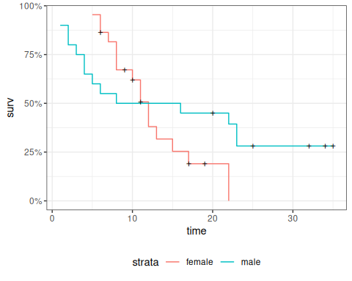
The survival curves cross, which indicates a problem in the proportionality assumption by sex.

7.9.3 Graph the Nelson-Aalen cumulative hazard
We can also look at the log-hazard (“cloglog survival”) plots:
anderson_na_model <- survfit(
formula = surv ~ sex,
data = anderson,
type = "fleming"
)
anderson_na_model |>
autoplot(
fun = "cumhaz",
conf.int = FALSE
) +
theme_classic() +
theme(legend.position = "bottom") +
ylab("log(Cumulative Hazard)") +
scale_y_continuous(
trans = "log10",
name = "Cumulative hazard (H(t), log scale)"
) +
scale_x_continuous(
breaks = c(1, 2, 5, 10, 20, 50),
trans = "log"
)
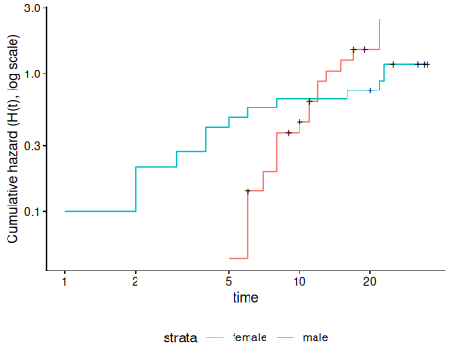
Figure 23: Cumulative hazard (cloglog scale) for anderson data
This issue can be fixed by using strata or possibly by other model alterations.

7.9.4 The Stratified Cox Model
- In a stratified Cox model, each stratum, defined by one or more factors, has its own base survival function $λ_{0}(t)$.
- But the coefficients for each variable not used in the strata definitions are assumed to be the same across strata.
- To check if this assumption is reasonable one can include interactions with strata and see if they are significant (this may generate a warning and NA lines but these can be ignored).
- Since the sex variable shows possible non-proportionality, we try stratifying on sex.
anderson_coxph_strat <-
coxph(
formula = surv ~ rx + logwbc + strata(sex),
data = anderson
)
summary(anderson_coxph_strat)
#> Call:
#> coxph(formula = surv ~ rx + logwbc + strata(sex), data = anderson)
#>
#> n= 42, number of events= 30
#>
#> coef exp(coef) se(coef) z Pr(>|z|)
#> rxnew -0.998 0.369 0.474 -2.11 0.035 *
#> logwbc 1.454 4.279 0.344 4.22 2.4e-05 ***
#> ---
#> Signif. codes: 0 '***' 0.001 '**' 0.01 '*' 0.05 '.' 0.1 ' ' 1
#>
#> exp(coef) exp(-coef) lower .95 upper .95
#> rxnew 0.369 2.713 0.146 0.932
#> logwbc 4.279 0.234 2.180 8.398
#>
#> Concordance= 0.812 (se = 0.059 )
#> Likelihood ratio test= 32.1 on 2 df, p=1e-07
#> Wald test = 22.8 on 2 df, p=1e-05
#> Score (logrank) test = 30.8 on 2 df, p=2e-07
Let’s compare this to a model fit only on the subset of males:
anderson_coxph_male <-
coxph(
formula = surv ~ rx + logwbc,
subset = sex == "male",
data = anderson
)
summary(anderson_coxph_male)
#> Call:
#> coxph(formula = surv ~ rx + logwbc, data = anderson, subset = sex ==
#> "male")
#>
#> n= 20, number of events= 14
#>
#> coef exp(coef) se(coef) z Pr(>|z|)
#> rxnew -1.978 0.138 0.739 -2.68 0.0075 **
#> logwbc 1.743 5.713 0.536 3.25 0.0011 **
#> ---
#> Signif. codes: 0 '***' 0.001 '**' 0.01 '*' 0.05 '.' 0.1 ' ' 1
#>
#> exp(coef) exp(-coef) lower .95 upper .95
#> rxnew 0.138 7.227 0.0325 0.589
#> logwbc 5.713 0.175 1.9991 16.328
#>
#> Concordance= 0.905 (se = 0.043 )
#> Likelihood ratio test= 29.2 on 2 df, p=5e-07
#> Wald test = 15.3 on 2 df, p=5e-04
#> Score (logrank) test = 26.4 on 2 df, p=2e-06
anderson_coxph_female <-
coxph(
formula = surv ~ rx + logwbc,
subset = sex == "female",
data = anderson
)
summary(anderson_coxph_female)
#> Call:
#> coxph(formula = surv ~ rx + logwbc, data = anderson, subset = sex ==
#> "female")
#>
#> n= 22, number of events= 16
#>
#> coef exp(coef) se(coef) z Pr(>|z|)
#> rxnew -0.311 0.733 0.564 -0.55 0.581
#> logwbc 1.206 3.341 0.503 2.40 0.017 *
#> ---
#> Signif. codes: 0 '***' 0.001 '**' 0.01 '*' 0.05 '.' 0.1 ' ' 1
#>
#> exp(coef) exp(-coef) lower .95 upper .95
#> rxnew 0.733 1.365 0.243 2.21
#> logwbc 3.341 0.299 1.245 8.96
#>
#> Concordance= 0.692 (se = 0.085 )
#> Likelihood ratio test= 6.65 on 2 df, p=0.04
#> Wald test = 6.36 on 2 df, p=0.04
#> Score (logrank) test = 6.74 on 2 df, p=0.03
The coefficients of treatment look different. Are they statistically different?
anderson_coxph_strat_intxn <-
coxph(
formula = surv ~ strata(sex) * (rx + logwbc),
data = anderson
)
anderson_coxph_strat_intxn |> summary()
#> Call:
#> coxph(formula = surv ~ strata(sex) * (rx + logwbc), data = anderson)
#>
#> n= 42, number of events= 30
#>
#> coef exp(coef) se(coef) z Pr(>|z|)
#> rxnew -0.311 0.733 0.564 -0.55 0.581
#> logwbc 1.206 3.341 0.503 2.40 0.017 *
#> strata(sex)male:rxnew -1.667 0.189 0.930 -1.79 0.073 .
#> strata(sex)male:logwbc 0.537 1.710 0.735 0.73 0.465
#> ---
#> Signif. codes: 0 '***' 0.001 '**' 0.01 '*' 0.05 '.' 0.1 ' ' 1
#>
#> exp(coef) exp(-coef) lower .95 upper .95
#> rxnew 0.733 1.365 0.2427 2.21
#> logwbc 3.341 0.299 1.2452 8.96
#> strata(sex)male:rxnew 0.189 5.294 0.0305 1.17
#> strata(sex)male:logwbc 1.710 0.585 0.4048 7.23
#>
#> Concordance= 0.797 (se = 0.058 )
#> Likelihood ratio test= 35.8 on 4 df, p=3e-07
#> Wald test = 21.7 on 4 df, p=2e-04
#> Score (logrank) test = 33.1 on 4 df, p=1e-06
anova(
anderson_coxph_strat_intxn,
anderson_coxph_strat
)
#> # A tibble: 2 × 4
#> loglik Chisq Df `Pr(>|Chi|)`
#> <dbl> <dbl> <int> <dbl>
#> 1 -53.9 NA NA NA
#> 2 -55.7 3.77 2 0.152
We don’t have enough evidence to tell the difference between these two models.

7.9.5 Conclusions
- We chose to use a stratified model because of the apparent non-proportionality of the hazard for the sex variable.
- When we fit interactions with the strata variable, we did not get an improved model (via the likelihood ratio test).
- So we use the stratifed model with coefficients that are the same across strata.

7.9.6 Another Modeling Approach
- We used an additive model without interactions and saw that we might need to stratify by sex.
- Instead, we could try to improve the model’s functional form - maybe the interaction of treatment and sex is real, and after fitting that we might not need separate hazard functions.
- Either approach may work.
anderson_coxph_intxn <-
coxph(
formula = surv ~ (rx + logwbc) * sex,
data = anderson
)
anderson_coxph_intxn |> summary()
#> Call:
#> coxph(formula = surv ~ (rx + logwbc) * sex, data = anderson)
#>
#> n= 42, number of events= 30
#>
#> coef exp(coef) se(coef) z Pr(>|z|)
#> rxnew -0.3748 0.6874 0.5545 -0.68 0.499
#> logwbc 1.0637 2.8971 0.4726 2.25 0.024 *
#> sexmale -2.8052 0.0605 2.0323 -1.38 0.167
#> rxnew:sexmale -2.1782 0.1132 0.9109 -2.39 0.017 *
#> logwbc:sexmale 1.2303 3.4223 0.6301 1.95 0.051 .
#> ---
#> Signif. codes: 0 '***' 0.001 '**' 0.01 '*' 0.05 '.' 0.1 ' ' 1
#>
#> exp(coef) exp(-coef) lower .95 upper .95
#> rxnew 0.6874 1.455 0.23185 2.038
#> logwbc 2.8971 0.345 1.14730 7.315
#> sexmale 0.0605 16.531 0.00113 3.248
#> rxnew:sexmale 0.1132 8.830 0.01899 0.675
#> logwbc:sexmale 3.4223 0.292 0.99539 11.766
#>
#> Concordance= 0.861 (se = 0.036 )
#> Likelihood ratio test= 57 on 5 df, p=5e-11
#> Wald test = 35.6 on 5 df, p=1e-06
#> Score (logrank) test = 57.1 on 5 df, p=5e-11
cox.zph(anderson_coxph_intxn)
#> chisq df p
#> rx 0.136 1 0.71
#> logwbc 1.652 1 0.20
#> sex 1.266 1 0.26
#> rx:sex 0.149 1 0.70
#> logwbc:sex 0.102 1 0.75
#> GLOBAL 3.747 5 0.59

7.10 Time-varying covariates
(adapted from Klein and Moeschberger (2003), §9.2)

7.10.1 Motivating example: back to the leukemia dataset
# load the data:
data(bmt, package = "KMsurv")
bmt |>
as_tibble() |>
print(n = 5)
#> # A tibble: 137 × 22
#> group t1 t2 d1 d2 d3 ta da tc dc tp dp z1
#> <int> <int> <int> <int> <int> <int> <int> <int> <int> <int> <int> <int> <int>
#> 1 1 2081 2081 0 0 0 67 1 121 1 13 1 26
#> 2 1 1602 1602 0 0 0 1602 0 139 1 18 1 21
#> 3 1 1496 1496 0 0 0 1496 0 307 1 12 1 26
#> 4 1 1462 1462 0 0 0 70 1 95 1 13 1 17
#> 5 1 1433 1433 0 0 0 1433 0 236 1 12 1 32
#> # ℹ 132 more rows
#> # ℹ 9 more variables: z2 <int>, z3 <int>, z4 <int>, z5 <int>, z6 <int>,
#> # z7 <int>, z8 <int>, z9 <int>, z10 <int>
This dataset comes from the Copelan et al. (1991) study of allogenic bone marrow transplant therapy for acute myeloid leukemia (AML) and acute lymphoblastic leukemia (ALL).

Outcomes (endpoints)
- The main endpoint is disease-free survival (t2 and d3) for the three risk groups, “ALL”, “AML Low Risk”, and “AML High Risk”.

Possible intermediate events
- graft vs. host disease (GVHD), an immunological rejection response to the transplant (bad)
- acute (AGVHD)
- chronic (CGVHD)
- platelet recovery, a return of platelet count to normal levels (good)
One or the other, both in either order, or neither may occur.

Covariates
- We are interested in possibly using the covariates z1-z10 to adjust for other factors.
- In addition, the time-varying covariates for acute GVHD, chronic GVHD, and platelet recovery may be useful.

Preprocessing
We reformat the data before analysis:
# reformat the data:
bmt1 <-
bmt |>
as_tibble() |>
mutate(
# `id` will be used to connect multiple records for the same individual:
id = dplyr::row_number(),
group = group |>
case_match(
1 ~ "ALL",
2 ~ "Low Risk AML",
3 ~ "High Risk AML"
) |>
factor(levels = c("ALL", "Low Risk AML", "High Risk AML")),
`patient age` = z1,
`donor age` = z2,
`patient sex` = z3 |>
case_match(
0 ~ "Female",
1 ~ "Male"
),
`donor sex` = z4 |>
case_match(
0 ~ "Female",
1 ~ "Male"
),
`Patient CMV Status` = z5 |>
case_match(
0 ~ "CMV Negative",
1 ~ "CMV Positive"
),
`Donor CMV Status` = z6 |>
case_match(
0 ~ "CMV Negative",
1 ~ "CMV Positive"
),
`Waiting Time to Transplant` = z7,
FAB = z8 |>
case_match(
1 ~ "Grade 4 Or 5 (AML only)",
0 ~ "Other"
) |>
factor() |>
relevel(ref = "Other"),
hospital = z9 |> # `z9` is hospital
case_match(
1 ~ "Ohio State University",
2 ~ "Alferd",
3 ~ "St. Vincent",
4 ~ "Hahnemann"
) |>
factor() |>
relevel(ref = "Ohio State University"),
MTX = (z10 == 1) # a prophylatic treatment for GVHD
) |>
select(-(z1:z10)) # don't need these anymore
bmt1 |>
select(group, id:MTX) |>
print(n = 10)
#> # A tibble: 137 × 12
#> group id `patient age` `donor age` `patient sex` `donor sex`
#> <fct> <int> <int> <int> <chr> <chr>
#> 1 ALL 1 26 33 Male Female
#> 2 ALL 2 21 37 Male Male
#> 3 ALL 3 26 35 Male Male
#> 4 ALL 4 17 21 Female Male
#> 5 ALL 5 32 36 Male Male
#> 6 ALL 6 22 31 Male Male
#> 7 ALL 7 20 17 Male Female
#> 8 ALL 8 22 24 Male Female
#> 9 ALL 9 18 21 Female Male
#> 10 ALL 10 24 40 Male Male
#> # ℹ 127 more rows
#> # ℹ 6 more variables: `Patient CMV Status` <chr>, `Donor CMV Status` <chr>,
#> # `Waiting Time to Transplant` <int>, FAB <fct>, hospital <fct>, MTX <lgl>

7.10.2 Time-Dependent Covariates
- A time-dependent covariate (“TDC”) is a covariate whose value changes during the course of the study.
- For variables like age that change in a linear manner with time, we can just use the value at the start.
- But it may be plausible that when and if GVHD occurs, the risk of relapse or death increases, and when and if platelet recovery occurs, the risk decreases.

7.10.3 Analysis in R
- We form a variable precovery which is = 0 before platelet recovery and is = 1 after platelet recovery, if it occurs.
- For each subject where platelet recovery occurs, we set up multiple records (lines in the data frame); for example one from t = 0 to the time of platelet recovery, and one from that time to relapse, recovery, or death.
- We do the same for acute GVHD and chronic GVHD.
- For each record, the covariates are constant.
bmt2 <- bmt1 |>
# set up new long-format data set:
tmerge(bmt1, id = id, tstop = t2) |>
# the following three steps can be in any order,
# and will still produce the same result:
# add aghvd as tdc:
tmerge(bmt1, id = id, agvhd = tdc(ta)) |>
# add cghvd as tdc:
tmerge(bmt1, id = id, cgvhd = tdc(tc)) |>
# add platelet recovery as tdc:
tmerge(bmt1, id = id, precovery = tdc(tp))
bmt2 <- bmt2 |>
as_tibble() |>
mutate(status = as.numeric((tstop == t2) & d3))
# status only = 1 if at end of t2 and not censored
Let’s see how we’ve rearranged the first row of the data:
bmt1 |>
dplyr::filter(id == 1) |>
dplyr::select(id, t1, d1, t2, d2, d3, ta, da, tc, dc, tp, dp)
#> # A tibble: 1 × 12
#> id t1 d1 t2 d2 d3 ta da tc dc tp dp
#> <int> <int> <int> <int> <int> <int> <int> <int> <int> <int> <int> <int>
#> 1 1 2081 0 2081 0 0 67 1 121 1 13 1
The event times for this individual are:
- t = 0 time of transplant
- tp = 13 platelet recovery
- ta = 67 acute GVHD onset
- tc = 121 chronic GVHD onset
- t2 = 2081 end of study, patient not relapsed or dead
After converting the data to long-format, we have:
bmt2 |>
select(
id,
tstart,
tstop,
agvhd,
cgvhd,
precovery,
status
) |>
dplyr::filter(id == 1)
#> # A tibble: 4 × 7
#> id tstart tstop agvhd cgvhd precovery status
#> <int> <dbl> <int> <int> <int> <int> <dbl>
#> 1 1 0 13 0 0 0 0
#> 2 1 13 67 0 0 1 0
#> 3 1 67 121 1 0 1 0
#> 4 1 121 2081 1 1 1 0
Note that status could have been 1 on the last row, indicating that relapse or death occurred; since it is false, the participant must have exited the study without experiencing relapse or death (i.e., they were censored).

7.10.4 Event sequences
Let:
- A = acute GVHD
- C = chronic GVHD
- P = platelet recovery
Each of the eight possible combinations of A or not-A, with C or not-C, with P or not-P occurs in this data set.
- A always occurs before C, and P always occurs before C, if both occur.
- Thus there are ten event sequences in the data set: None, A, C, P, AC, AP, PA, PC, APC, and PAC.
- In general, there could be as many as $1+3+(3)(2)+6=16$ sequences, but our domain knowledge tells us that some are missing: CA, CP, CAP, CPA, PCA, PC, PAC
- Different subjects could have 1, 2, 3, or 4 intervals, depending on which of acute GVHD, chronic GVHD, and/or platelet recovery occurred.
- The final interval for any subject has status = 1 if the subject relapsed or died at that time; otherwise status = 0.
- Any earlier intervals have status = 0.
- Even though there might be multiple lines per ID in the dataset, there is never more than one event, so no alterations need be made in the estimation procedures or in the interpretation of the output.
- The function tmerge in the survival package eases the process of constructing the new long-format dataset.

7.10.5 Model with Time-Fixed Covariates
bmt1 <-
bmt1 |>
mutate(surv = Surv(t2, d3))
bmt_coxph_TF <- coxph(
formula = surv ~ group + `patient age` * `donor age` + FAB,
data = bmt1
)
summary(bmt_coxph_TF)
#> Call:
#> coxph(formula = surv ~ group + `patient age` * `donor age` +
#> FAB, data = bmt1)
#>
#> n= 137, number of events= 83
#>
#> coef exp(coef) se(coef) z Pr(>|z|)
#> groupLow Risk AML -1.090648 0.335999 0.354279 -3.08 0.00208 **
#> groupHigh Risk AML -0.403905 0.667707 0.362777 -1.11 0.26555
#> `patient age` -0.081639 0.921605 0.036107 -2.26 0.02376 *
#> `donor age` -0.084587 0.918892 0.030097 -2.81 0.00495 **
#> FABGrade 4 Or 5 (AML only) 0.837416 2.310388 0.278464 3.01 0.00264 **
#> `patient age`:`donor age` 0.003159 1.003164 0.000951 3.32 0.00089 ***
#> ---
#> Signif. codes: 0 '***' 0.001 '**' 0.01 '*' 0.05 '.' 0.1 ' ' 1
#>
#> exp(coef) exp(-coef) lower .95 upper .95
#> groupLow Risk AML 0.336 2.976 0.168 0.673
#> groupHigh Risk AML 0.668 1.498 0.328 1.360
#> `patient age` 0.922 1.085 0.859 0.989
#> `donor age` 0.919 1.088 0.866 0.975
#> FABGrade 4 Or 5 (AML only) 2.310 0.433 1.339 3.988
#> `patient age`:`donor age` 1.003 0.997 1.001 1.005
#>
#> Concordance= 0.665 (se = 0.033 )
#> Likelihood ratio test= 32.8 on 6 df, p=1e-05
#> Wald test = 33 on 6 df, p=1e-05
#> Score (logrank) test = 35.8 on 6 df, p=3e-06
drop1(bmt_coxph_TF, test = "Chisq")
#> # A tibble: 4 × 4
#> Df AIC LRT `Pr(>Chi)`
#> <dbl> <dbl> <dbl> <dbl>
#> 1 NA 726. NA NA
#> 2 2 734. 12.5 0.00192
#> 3 1 733. 9.22 0.00240
#> 4 1 733. 9.51 0.00204
bmt1$mres <-
bmt_coxph_TF |>
update(. ~ . - `donor age`) |>
residuals(type = "martingale")
bmt1 |>
ggplot(aes(x = `donor age`, y = mres)) +
geom_point() +
geom_smooth(method = "loess", aes(col = "loess")) +
geom_smooth(method = "lm", aes(col = "lm")) +
theme_classic() +
xlab("Donor age") +
ylab("Martingale Residuals") +
guides(col = guide_legend(title = ""))
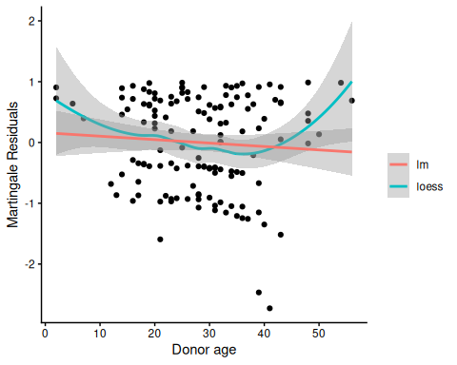
Martingale residuals for Donor age
A more complex functional form for donor age seems warranted; left as an exercise for the reader.
Now we will add the time-varying covariates:
# add counting process formulation of Surv():
bmt2 <-
bmt2 |>
mutate(
surv = Surv(
time = tstart,
time2 = tstop,
event = status,
type = "counting"
)
)
Let’s see how the data looks for patient 15:
bmt1 |>
dplyr::filter(id == 15) |>
dplyr::select(tp, dp, tc, dc, ta, da, FAB, surv, t1, d1, t2, d2, d3)
#> # A tibble: 1 × 13
#> tp dp tc dc ta da FAB surv t1 d1 t2 d2 d3
#> <int> <int> <int> <int> <int> <int> <fct> <Surv> <int> <int> <int> <int> <int>
#> 1 21 1 220 1 418 0 Other 418 418 1 418 0 1
bmt2 |>
dplyr::filter(id == 15) |>
dplyr::select(id, agvhd, cgvhd, precovery, surv)
#> # A tibble: 3 × 5
#> id agvhd cgvhd precovery surv
#> <int> <int> <int> <int> <Surv>
#> 1 15 0 0 0 ( 0, 21+]
#> 2 15 0 0 1 ( 21,220+]
#> 3 15 0 1 1 (220,418]

7.10.6 Model with Time-Dependent Covariates
bmt_coxph_TV <- coxph(
formula = surv ~
group + `patient age` * `donor age` + FAB + agvhd + cgvhd + precovery,
data = bmt2
)
summary(bmt_coxph_TV)
#> Call:
#> coxph(formula = surv ~ group + `patient age` * `donor age` +
#> FAB + agvhd + cgvhd + precovery, data = bmt2)
#>
#> n= 341, number of events= 83
#>
#> coef exp(coef) se(coef) z Pr(>|z|)
#> groupLow Risk AML -1.038514 0.353980 0.358220 -2.90 0.0037 **
#> groupHigh Risk AML -0.380481 0.683533 0.374867 -1.01 0.3101
#> `patient age` -0.073351 0.929275 0.035956 -2.04 0.0413 *
#> `donor age` -0.076406 0.926440 0.030196 -2.53 0.0114 *
#> FABGrade 4 Or 5 (AML only) 0.805700 2.238263 0.284273 2.83 0.0046 **
#> agvhd 0.150565 1.162491 0.306848 0.49 0.6237
#> cgvhd -0.116136 0.890354 0.289046 -0.40 0.6878
#> precovery -0.941123 0.390190 0.347861 -2.71 0.0068 **
#> `patient age`:`donor age` 0.002895 1.002899 0.000944 3.07 0.0022 **
#> ---
#> Signif. codes: 0 '***' 0.001 '**' 0.01 '*' 0.05 '.' 0.1 ' ' 1
#>
#> exp(coef) exp(-coef) lower .95 upper .95
#> groupLow Risk AML 0.354 2.825 0.175 0.714
#> groupHigh Risk AML 0.684 1.463 0.328 1.425
#> `patient age` 0.929 1.076 0.866 0.997
#> `donor age` 0.926 1.079 0.873 0.983
#> FABGrade 4 Or 5 (AML only) 2.238 0.447 1.282 3.907
#> agvhd 1.162 0.860 0.637 2.121
#> cgvhd 0.890 1.123 0.505 1.569
#> precovery 0.390 2.563 0.197 0.772
#> `patient age`:`donor age` 1.003 0.997 1.001 1.005
#>
#> Concordance= 0.702 (se = 0.028 )
#> Likelihood ratio test= 40.3 on 9 df, p=7e-06
#> Wald test = 42.4 on 9 df, p=3e-06
#> Score (logrank) test = 47.2 on 9 df, p=4e-07
Platelet recovery is highly significant.
Neither acute GVHD (agvhd) nor chronic GVHD (cgvhd) has a statistically significant effect here, nor are they significant in models with the other one removed.
update(bmt_coxph_TV, . ~ . - agvhd) |> summary()
#> Call:
#> coxph(formula = surv ~ group + `patient age` + `donor age` +
#> FAB + cgvhd + precovery + `patient age`:`donor age`, data = bmt2)
#>
#> n= 341, number of events= 83
#>
#> coef exp(coef) se(coef) z Pr(>|z|)
#> groupLow Risk AML -1.049870 0.349983 0.356727 -2.94 0.0032 **
#> groupHigh Risk AML -0.417049 0.658988 0.365348 -1.14 0.2537
#> `patient age` -0.070749 0.931696 0.035477 -1.99 0.0461 *
#> `donor age` -0.075693 0.927101 0.030075 -2.52 0.0118 *
#> FABGrade 4 Or 5 (AML only) 0.807035 2.241253 0.283437 2.85 0.0044 **
#> cgvhd -0.095393 0.909015 0.285979 -0.33 0.7387
#> precovery -0.983653 0.373942 0.338170 -2.91 0.0036 **
#> `patient age`:`donor age` 0.002859 1.002863 0.000936 3.05 0.0023 **
#> ---
#> Signif. codes: 0 '***' 0.001 '**' 0.01 '*' 0.05 '.' 0.1 ' ' 1
#>
#> exp(coef) exp(-coef) lower .95 upper .95
#> groupLow Risk AML 0.350 2.857 0.174 0.704
#> groupHigh Risk AML 0.659 1.517 0.322 1.349
#> `patient age` 0.932 1.073 0.869 0.999
#> `donor age` 0.927 1.079 0.874 0.983
#> FABGrade 4 Or 5 (AML only) 2.241 0.446 1.286 3.906
#> cgvhd 0.909 1.100 0.519 1.592
#> precovery 0.374 2.674 0.193 0.726
#> `patient age`:`donor age` 1.003 0.997 1.001 1.005
#>
#> Concordance= 0.701 (se = 0.027 )
#> Likelihood ratio test= 40 on 8 df, p=3e-06
#> Wald test = 42.4 on 8 df, p=1e-06
#> Score (logrank) test = 47.2 on 8 df, p=1e-07
update(bmt_coxph_TV, . ~ . - cgvhd) |> summary()
#> Call:
#> coxph(formula = surv ~ group + `patient age` + `donor age` +
#> FAB + agvhd + precovery + `patient age`:`donor age`, data = bmt2)
#>
#> n= 341, number of events= 83
#>
#> coef exp(coef) se(coef) z Pr(>|z|)
#> groupLow Risk AML -1.019638 0.360725 0.355311 -2.87 0.0041 **
#> groupHigh Risk AML -0.381356 0.682935 0.374568 -1.02 0.3086
#> `patient age` -0.073189 0.929426 0.035890 -2.04 0.0414 *
#> `donor age` -0.076753 0.926118 0.030121 -2.55 0.0108 *
#> FABGrade 4 Or 5 (AML only) 0.811716 2.251769 0.284012 2.86 0.0043 **
#> agvhd 0.131621 1.140676 0.302623 0.43 0.6636
#> precovery -0.946697 0.388021 0.347265 -2.73 0.0064 **
#> `patient age`:`donor age` 0.002904 1.002908 0.000943 3.08 0.0021 **
#> ---
#> Signif. codes: 0 '***' 0.001 '**' 0.01 '*' 0.05 '.' 0.1 ' ' 1
#>
#> exp(coef) exp(-coef) lower .95 upper .95
#> groupLow Risk AML 0.361 2.772 0.180 0.724
#> groupHigh Risk AML 0.683 1.464 0.328 1.423
#> `patient age` 0.929 1.076 0.866 0.997
#> `donor age` 0.926 1.080 0.873 0.982
#> FABGrade 4 Or 5 (AML only) 2.252 0.444 1.291 3.929
#> agvhd 1.141 0.877 0.630 2.064
#> precovery 0.388 2.577 0.196 0.766
#> `patient age`:`donor age` 1.003 0.997 1.001 1.005
#>
#> Concordance= 0.701 (se = 0.027 )
#> Likelihood ratio test= 40.1 on 8 df, p=3e-06
#> Wald test = 42.1 on 8 df, p=1e-06
#> Score (logrank) test = 47.1 on 8 df, p=1e-07
Let’s drop them both:
bmt_coxph_TV2 <- update(bmt_coxph_TV, . ~ . - agvhd - cgvhd)
bmt_coxph_TV2 |> summary()
#> Call:
#> coxph(formula = surv ~ group + `patient age` + `donor age` +
#> FAB + precovery + `patient age`:`donor age`, data = bmt2)
#>
#> n= 341, number of events= 83
#>
#> coef exp(coef) se(coef) z Pr(>|z|)
#> groupLow Risk AML -1.032520 0.356108 0.353202 -2.92 0.0035 **
#> groupHigh Risk AML -0.413888 0.661075 0.365209 -1.13 0.2571
#> `patient age` -0.070965 0.931495 0.035453 -2.00 0.0453 *
#> `donor age` -0.076052 0.926768 0.030007 -2.53 0.0113 *
#> FABGrade 4 Or 5 (AML only) 0.811926 2.252242 0.283231 2.87 0.0041 **
#> precovery -0.983505 0.373998 0.337997 -2.91 0.0036 **
#> `patient age`:`donor age` 0.002872 1.002876 0.000936 3.07 0.0021 **
#> ---
#> Signif. codes: 0 '***' 0.001 '**' 0.01 '*' 0.05 '.' 0.1 ' ' 1
#>
#> exp(coef) exp(-coef) lower .95 upper .95
#> groupLow Risk AML 0.356 2.808 0.178 0.712
#> groupHigh Risk AML 0.661 1.513 0.323 1.352
#> `patient age` 0.931 1.074 0.869 0.999
#> `donor age` 0.927 1.079 0.874 0.983
#> FABGrade 4 Or 5 (AML only) 2.252 0.444 1.293 3.924
#> precovery 0.374 2.674 0.193 0.725
#> `patient age`:`donor age` 1.003 0.997 1.001 1.005
#>
#> Concordance= 0.7 (se = 0.027 )
#> Likelihood ratio test= 39.9 on 7 df, p=1e-06
#> Wald test = 42.2 on 7 df, p=5e-07
#> Score (logrank) test = 47.1 on 7 df, p=5e-08

7.11 Recurrent Events
(Adapted from Kleinbaum and Klein (2012), Ch 8)
- Sometimes an appropriate analysis requires consideration of recurrent events.
- A patient with arthritis may have more than one flareup. The same is true of many recurring-remitting diseases.
- In this case, we have more than one line in the data frame, but each line may have an event.
- We have to use a “robust” variance estimator to account for correlation of time-to-events within a patient.

7.11.1 Bladder Cancer Data Set
The bladder cancer dataset from Kleinbaum and Klein (2012) contains recurrent event outcome information for eighty-six cancer patients followed for the recurrence of bladder cancer tumor after transurethral surgical excision (Byar and Green 1980). The exposure of interest is the effect of the drug treatment of thiotepa. Control variables are the initial number and initial size of tumors. The data layout is suitable for a counting processes approach.
This drug is still a possible choice for some patients. Another therapeutic choice is Bacillus Calmette-Guerin (BCG), a live bacterium related to cow tuberculosis.

Data dictionary
Variables in the bladder dataset
Variable | Definition
id | Patient unique ID
status | for each time interval: 1 = recurred, 0 = censored
interval | 1 = first recurrence, etc.
intime | `tstop - tstart (all times in months)
tstart | start of interval
tstop | end of interval
tx | treatment code, 1 = thiotepa
num | number of initial tumors
size | size of initial tumors (cm)
- There are 85 patients and 190 lines in the dataset, meaning that many patients have more than one line.
- Patient 1 with 0 observation time was removed.
- Of the 85 patients, 47 had at least one recurrence and 38 had none.
- 18 patients had exactly one recurrence.
- There were up to 4 recurrences in a patient.
- Of the 190 intervals, 112 terminated with a recurrence and 78 were censored.

Different intervals for the same patient are correlated.
- Is the effective sample size 47 or 112? This difference might narrow confidence intervals by as much as a factor of $\sqrt{112/47}=1.54$
- What happens if I have 5 treatment and 5 control values and want to do a t-test and I then duplicate the 10 values as if the sample size was 20? This falsely narrows confidence intervals by a factor of $\sqrt{2}=1.41$.
bladder <-
paste0(
"http://web1.sph.emory.edu/dkleinb/allDatasets",
"/surv2datasets/bladder.dta"
) |>
read_dta() |>
as_tibble()
bladder <- bladder[-1, ] # remove subject with 0 observation time
print(bladder)
bladder <-
bladder |>
mutate(
surv = Surv(
time = start,
time2 = stop,
event = event,
type = "counting"
)
)
bladder_cox1 <- coxph(
formula = surv ~ tx + num + size,
data = bladder
)
# results with biased variance-covariance matrix:
summary(bladder_cox1)
#> Call:
#> coxph(formula = surv ~ tx + num + size, data = bladder)
#>
#> n= 190, number of events= 112
#>
#> coef exp(coef) se(coef) z Pr(>|z|)
#> tx -0.4116 0.6626 0.1999 -2.06 0.03947 *
#> num 0.1637 1.1778 0.0478 3.43 0.00061 ***
#> size -0.0411 0.9598 0.0703 -0.58 0.55897
#> ---
#> Signif. codes: 0 '***' 0.001 '**' 0.01 '*' 0.05 '.' 0.1 ' ' 1
#>
#> exp(coef) exp(-coef) lower .95 upper .95
#> tx 0.663 1.509 0.448 0.98
#> num 1.178 0.849 1.073 1.29
#> size 0.960 1.042 0.836 1.10
#>
#> Concordance= 0.624 (se = 0.032 )
#> Likelihood ratio test= 14.7 on 3 df, p=0.002
#> Wald test = 15.9 on 3 df, p=0.001
#> Score (logrank) test = 16.2 on 3 df, p=0.001
 Note
The likelihood ratio and score tests assume independence of observations within a cluster. The Wald and robust score tests do not.

adding cluster = id
If we add cluster= id to the call to coxph, the coefficient estimates don’t change, but we get an additional column in the summary() output: robust se:
bladder_cox2 <- coxph(
formula = surv ~ tx + num + size,
cluster = id,
data = bladder
)
# unbiased though this reduces power:
summary(bladder_cox2)
#> Call:
#> coxph(formula = surv ~ tx + num + size, data = bladder, cluster = id)
#>
#> n= 190, number of events= 112
#>
#> coef exp(coef) se(coef) robust se z Pr(>|z|)
#> tx -0.4116 0.6626 0.1999 0.2488 -1.65 0.0980 .
#> num 0.1637 1.1778 0.0478 0.0584 2.80 0.0051 **
#> size -0.0411 0.9598 0.0703 0.0742 -0.55 0.5799
#> ---
#> Signif. codes: 0 '***' 0.001 '**' 0.01 '*' 0.05 '.' 0.1 ' ' 1
#>
#> exp(coef) exp(-coef) lower .95 upper .95
#> tx 0.663 1.509 0.407 1.08
#> num 1.178 0.849 1.050 1.32
#> size 0.960 1.042 0.830 1.11
#>
#> Concordance= 0.624 (se = 0.031 )
#> Likelihood ratio test= 14.7 on 3 df, p=0.002
#> Wald test = 11.2 on 3 df, p=0.01
#> Score (logrank) test = 16.2 on 3 df, p=0.001, Robust = 10.8 p=0.01
#>
#> (Note: the likelihood ratio and score tests assume independence of
#> observations within a cluster, the Wald and robust score tests do not).
robust se is larger than se, and accounts for the repeated observations from the same individuals:
round(bladder_cox2$naive.var, 4)
#> [,1] [,2] [,3]
#> [1,] 0.0400 -0.0014 0.0000
#> [2,] -0.0014 0.0023 0.0007
#> [3,] 0.0000 0.0007 0.0049
round(bladder_cox2$var, 4)
#> [,1] [,2] [,3]
#> [1,] 0.0619 -0.0026 -0.0004
#> [2,] -0.0026 0.0034 0.0013
#> [3,] -0.0004 0.0013 0.0055
These values are the ratios of correct confidence intervals to naive ones:
with(bladder_cox2, diag(var) / diag(naive.var)) |> sqrt()
#> [1] 1.24449 1.22309 1.05576
We might try dropping the non-significant size variable:
# remove non-significant size variable:
bladder_cox3 <- bladder_cox2 |> update(. ~ . - size)
summary(bladder_cox3)
#> Call:
#> coxph(formula = surv ~ tx + num, data = bladder, cluster = id)
#>
#> n= 190, number of events= 112
#>
#> coef exp(coef) se(coef) robust se z Pr(>|z|)
#> tx -0.4117 0.6625 0.2003 0.2515 -1.64 0.1017
#> num 0.1700 1.1853 0.0465 0.0564 3.02 0.0026 **
#> ---
#> Signif. codes: 0 '***' 0.001 '**' 0.01 '*' 0.05 '.' 0.1 ' ' 1
#>
#> exp(coef) exp(-coef) lower .95 upper .95
#> tx 0.663 1.509 0.405 1.08
#> num 1.185 0.844 1.061 1.32
#>
#> Concordance= 0.623 (se = 0.031 )
#> Likelihood ratio test= 14.3 on 2 df, p=8e-04
#> Wald test = 10.2 on 2 df, p=0.006
#> Score (logrank) test = 15.8 on 2 df, p=4e-04, Robust = 10.6 p=0.005
#>
#> (Note: the likelihood ratio and score tests assume independence of
#> observations within a cluster, the Wald and robust score tests do not).

7.12 Age as the time scale
See Canchola et al. (2003).

8. Competing Risks
This section is adapted from (Vittinghoff et al. 2012, chap. 6).

8.0.1 What Are Competing Risks?
Definition 26 (Competing Risks Data) Competing risks data arise when multiple events can occur, and follow-up can end due to occurrence of one or more of those types of events, precluding observation of at least one of the other event types.
Competing risks are common in medical research. For example, in a study of bone fracture risk in elderly men, participants may:
- Experience the event of interest (fracture)
- Die before experiencing a fracture (competing event)
- Be lost to follow-up or reach the end of the study period (censored)

Why Competing Risks Matter
When analyzing time-to-event data, standard survival analysis methods make assumptions about censoring. The independent censoring assumption assumes that the future risk of censored observations can be represented by those who remain under follow-up.
This assumption is reasonable for:
- Administrative censoring (end of study)
- Loss to follow-up (if unrelated to outcome risk)
However, this assumption is questionable for competing events like death, because:
- We cannot extrapolate beyond participant lifetimes
- Death fundamentally alters the risk set for the primary outcome
- Projecting to a setting “without death” creates a hypothetical population

Approaches to Analyzing Competing Risks Data
Two main approaches exist for analyzing competing risks:
- Elimination approach: Extrapolates to a scenario where a competing event is not possible (appropriate for losses to follow-up)
- Accommodation approach: Acknowledges and allows for the competing risks in the analysis (appropriate for death and other true competing events)

8.0.2 Notation for Competing Risks
We denote competing risks outcome data using two variables:
- $Y$: time of the first observed event of any type
- $δ=k$: if the $k$-th event type occurs first
where each of the $K$ possible types of failure are denoted by a numerical code.
Example coding scheme:
- 0: loss to follow-up (censored)
- 1: event of interest (e.g., fracture)
- 2: competing event (e.g., death)
A participant followed for 18 months who dies before experiencing a fracture would have $Y=18$ months and $δ=2$.

8.0.3 Summaries for Competing Risks Data

Cause-Specific Hazard Functions
Definition 27 (Cause-Specific Hazard Function) The cause-specific hazard function for event type $k$, denoted $h_{k}(t)$, is the short-term rate at which participants experience the onset of the $k$-th event among those who have not yet experienced the event of interest or a competing event prior to time $t$.
Key properties:
- The numerator counts only events of type $k$
- The denominator includes all participants who could have developed the event by time $t$
- Reduces to the ordinary hazard function when there is only one failure type
Estimation:
To estimate and model cause-specific hazard functions:
- Set up data as ordinary survival data
- Define the $k$-th failure type as the only “event”
- Treat all competing causes (including death) as “censored”
You can then examine predictor effects on the cause-specific hazard using standard Cox proportional hazards models.

Cumulative Incidence Functions
Definition 28 (Cumulative Incidence Function) The cumulative incidence function (CIF) for cause type $k$ at time $t$, denoted $F_{k}(t)$, is the proportion of the population who have experienced the $k$-th event prior to time $t$.
The cumulative incidence function:
- Measures the prevalence of a particular event at each time $t$
- Accounts for all competing risks
- Differs from cause-specific hazards in how it treats competing events
Interpretation (MrOS study):
In the MrOS study, at 5 years of follow-up:
- 8% of men had experienced a hip fracture
- 9.3% had died without a fracture
- 82.7% remained alive without fracture

8.0.4 Estimation of Cumulative Incidence
The cumulative incidence at time $t$ is calculated as:
Fk(t)=ti≤t​KM​ti−1​×dkini
where:
- $t_{i}$ are the ordered event times
- $d_{ki}$ is the number of type-$k$ events at time $t_{i}$
- $n_{i}$ is the number at risk at time $t_{i}$
- ${}_{\text{KM}}​\left(t_{i−1}\right)​$ is the Kaplan-Meier estimate of event-free survival just before time $t_{i}$
The estimation proceeds in steps:
- Calculate the overall event-free probability at each time point using the Kaplan-Meier method (combining all event types)
- For each time interval, calculate the probability of a new type-$k$ event as:
  - Probability of being event-free at the start of the interval
  - Times the rate of type-$k$ events during the interval
- The cumulative incidence is the cumulative sum of these time-specific probabilities

Numerical Example: MrOS Study
The mros dataset from the rmb package contains data from the Osteoporotic Fractures in Men (MrOS) study (Orwoll et al. 2005), a prospective cohort study of older men. The outcome variable is coded as:
- 0: censored (no fracture or death during follow-up)
- 1: hip fracture (event of interest)
- 2: death without fracture (competing event)
ggplot(cif_df) +
aes(x = time, y = cif, color = event) +
geom_step() +
labs(
x = "Years of follow-up",
y = "Cumulative incidence",
color = "Event type",
caption = "Data: rmb::mros (MrOS study, Orwoll et al. 2005)"
) +
scale_y_continuous(limits = c(0, 0.20)) +
theme_bw() +
theme(legend.position = "bottom")
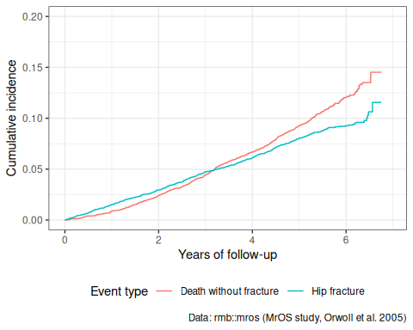
Figure 24
At approximately 5 years of follow-up:
- About 8% of men had experienced a hip fracture
- About 9.3% had died without a fracture
These two cumulative incidences sum to less than the overall event probability because many men are still event-free at 5 years.

Naive vs. Proper Cumulative Incidence
A naive approach treats competing events as censored and uses the standard Kaplan-Meier method: $1−{}_{\text{KM}}​\left(t\right)​$. This overestimates the true cumulative incidence because it assumes censored individuals (including those who died) have the same risk as those still event-free.
# Naive KM estimate for fracture (treating death as censored)
km_naive <- survfit(
Surv(years, status == 1) ~ 1,
data = mros_data
)
naive_df <- tibble(
time = km_naive$time,
cif = 1 - km_naive$surv,
method = "Naive KM (1 - S(t))"
)
proper_df <- fracture_cif |>
mutate(method = "Proper CIF")
comparison_df <- bind_rows(naive_df, proper_df)
ggplot(comparison_df) +
aes(x = time, y = cif, color = method) +
geom_step() +
labs(
x = "Years of follow-up",
y = "Estimated probability of fracture",
color = "Method",
caption = "Data: rmb::mros (MrOS study)"
) +
scale_y_continuous(limits = c(0, 0.15)) +
theme_bw() +
theme(legend.position = "bottom")
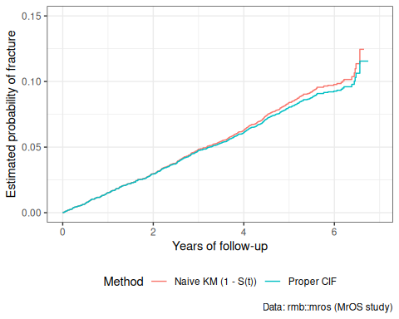
Figure 25
The naive KM curve overestimates the probability of fracture because it imagines a hypothetical world without competing mortality. The proper CIF curve represents the actual clinical probability of experiencing a fracture.

8.0.5 Modeling Competing Risks
When analyzing competing risks data with predictors, two main approaches are available:

Cause-Specific Hazards Models
Fit separate Cox models for each event type, treating other event types as censored:
Advantages:
- Standard software can be used
- Straightforward interpretation of hazard ratios
- Can assess effects on each failure type separately
Limitations:
- Results do not directly estimate cumulative incidence
- Interpretation can be challenging when effects differ across event types

Subdistribution Hazards Models (Fine-Gray Model)
An alternative approach directly models the cumulative incidence function using subdistribution hazards (Fine and Gray 1999).
The Fine-Gray model:
- Directly estimates the effect on cumulative incidence
- Keeps participants who experience competing events in the risk set
- Requires specialized software (e.g., cmprsk package in R)

References
Canchola, Alison J, Susan L Stewart, Leslie Bernstein, et al. 2003. “Cox Regression Using Different Time-Scales.” Western Users of SAS Software (San Francisco, California). https://www.lexjansen.com/wuss/2003/DataAnalysis/i-cox_time_scales.pdf.
Copelan, Edward A, James C Biggs, James M Thompson, et al. 1991. Treatment for Acute Myelocytic Leukemia with Allogeneic Bone Marrow Transplantation Following Preparation with BuCy2. https://doi.org/10.1182/blood.V78.3.838.838.
Cox, David R. 1972. “Regression Models and Life-Tables.” Journal of the Royal Statistical Society: Series B (Methodological) 34 (2): 187–202.
Dobson, Annette J, and Adrian G Barnett. 2018. An Introduction to Generalized Linear Models. 4th ed. CRC press. https://doi.org/10.1201/9781315182780.
Fine, Jason P., and Robert J. Gray. 1999. “A Proportional Hazards Model for the Subdistribution of a Competing Risk.” Journal of the American Statistical Association 94 (446): 496–509. https://doi.org/10.1080/01621459.1999.10474144.
Grambsch, Patricia M, and Terry M Therneau. 1994. “Proportional Hazards Tests and Diagnostics Based on Weighted Residuals.” Biometrika 81 (3): 515–26. https://doi.org/10.1093/biomet/81.3.515.
Johansen, Søren. 1983. “An Extension of Cox’s Regression Model.” International Statistical Review / Revue Internationale de Statistique 51 (2): 165–74. https://doi.org/10.2307/1402746.
Klein, John P, and Melvin L Moeschberger. 2003. Survival Analysis: Techniques for Censored and Truncated Data. Vol. 1230. Springer. https://link.springer.com/book/10.1007/b97377.
Kleinbaum, David G, and Mitchel Klein. 2012. Survival Analysis: A Self-Learning Text. 3rd ed. Springer. https://link.springer.com/book/10.1007/978-1-4419-6646-9.
Orwoll, Eric, Judith B. Blank, Elizabeth Barrett-Connor, et al. 2005. “Design and Baseline Characteristics of the Osteoporotic Fractures in Men (MrOS) Study – a Large Observational Study of the Determinants of Fracture in Older Men.” Contemporary Clinical Trials 26 (5): 569–85. https://doi.org/10.1016/j.cct.2005.04.005.
Vittinghoff, Eric, David V Glidden, Stephen C Shiboski, and Charles E McCulloch. 2012. Regression Methods in Biostatistics: Linear, Logistic, Survival, and Repeated Measures Models. 2nd ed. Springer. https://doi.org/10.1007/978-1-4614-1353-0.

