Advanced Quarto Article
UC Davis Seroepidemiology Research Group (UCD-SERG)
2026-05-13
library(rpt)

1 Overview
This article demonstrates advanced features of Quarto for package documentation. Unlike vignettes, articles are only available on the documentation website and are not included in the package bundle.

2 When to Use Articles vs Vignettes
Vignettes should be used for:
- Core package documentation
- Essential usage examples
- Content that users need offline
Articles are better for:
- Extended tutorials
- Case studies and detailed examples
- Content with large datasets or external dependencies
- Supplementary material

3 Advanced Quarto Features

3.1 Cross-References
Quarto makes it easy to create cross-references. For example, see Figure 1 for a scatter plot and Table 1 for a summary table.
# Generate sample data
set.seed(123)
x <- rnorm(100)
y <- 2 * x + rnorm(100, 0, 0.5)
# Create scatter plot
plot(x, y,
main = "Example Scatter Plot",
xlab = "X Variable",
ylab = "Y Variable",
pch = 16,
col = rgb(0.2, 0.4, 0.6, 0.6))
abline(lm(y ~ x), col = "red", lwd = 2)
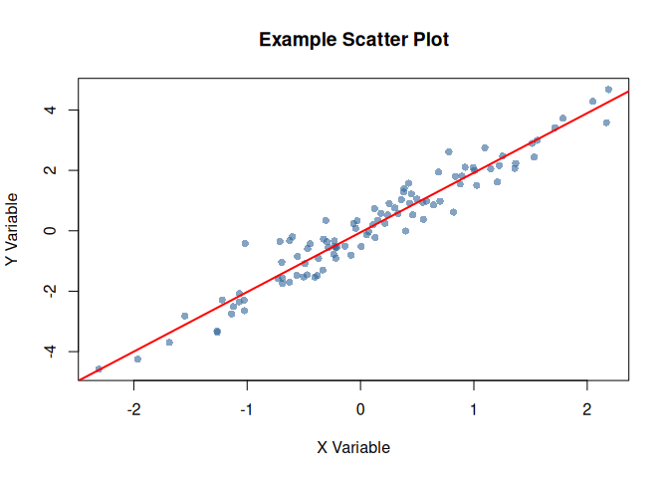
Figure 1: Scatter plot demonstrating cross-referencing

3.2 Summary Tables
data_summary <- data.frame(
Statistic = c("Mean", "Median", "SD", "Min", "Max"),
X = c(mean(x), median(x), sd(x), min(x), max(x)),
Y = c(mean(y), median(y), sd(y), min(y), max(y))
)
knitr::kable(data_summary, digits = 3)
Table 1: Summary statistics for example data
Statistic | X | Y
Mean | 0.090 | 0.127
Median | 0.062 | 0.137
SD | 0.913 | 1.865
Min | -2.309 | -4.586
Max | 2.187 | 4.675

As shown in Table 1, the variables have similar distributions.

3.3 Code Folding
You can make code chunks foldable:
# Prepare more complex data
complex_data <- data.frame(
id = 1:50,
group = rep(c("A", "B"), each = 25),
value1 = rnorm(50, 100, 15),
value2 = rnorm(50, 50, 10)
)
# Calculate group statistics
group_stats <- aggregate(
cbind(value1, value2) ~ group,
data = complex_data,
FUN = function(x) c(mean = mean(x), sd = sd(x))
)
print(group_stats)
#> group value1.mean value1.sd value2.mean value2.sd
#> 1 A 101.61247 14.63952 51.727220 10.047051
#> 2 B 98.13191 13.84514 53.261796 8.934998

3.4 Tabsets

Plot View
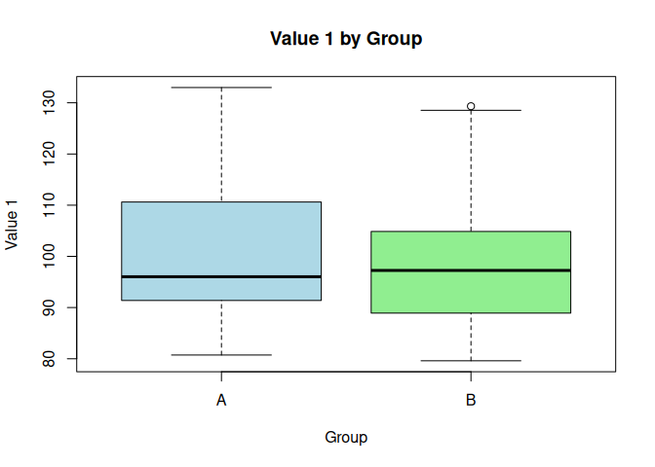

Summary View
#> id group value1 value2
#> Min. : 1.00 Length :50 Min. : 79.60 Min. :32.43
#> 1st Qu.:13.25 N.unique : 2 1st Qu.: 89.29 1st Qu.:46.76
#> Median :25.50 N.blank : 0 Median : 96.64 Median :51.04
#> Mean :25.50 Min.nchar: 1 Mean : 99.87 Mean :52.49
#> 3rd Qu.:37.75 Max.nchar: 1 3rd Qu.:107.93 3rd Qu.:59.34
#> Max. :50.00 Max. :132.98 Max. :72.93

Raw Data
#> id group value1 value2
#> 1 1 A 132.98216 46.24397
#> 2 2 A 119.68619 44.38124
#> 3 3 A 96.02282 46.56083
#> 4 4 A 108.14791 50.90497
#> 5 5 A 93.78490 65.98509
#> 6 6 A 92.85630 49.11435
#> 7 7 A 88.17096 60.80799
#> 8 8 A 91.08074 56.30754
#> 9 9 A 124.76361 48.86360
#> 10 10 A 99.18958 34.67098

3.5 Advanced Callouts
 Important Considerations
When using this package in production:
- Always validate input data
- Check for missing values
- Consider computational complexity

 Performance Warning
Large datasets may require additional memory and processing time.

3.6 Columns Layout
Left Column
This demonstrates a two-column layout in Quarto.
- Feature 1
- Feature 2
- Feature 3
Right Column
You can place different content in each column.
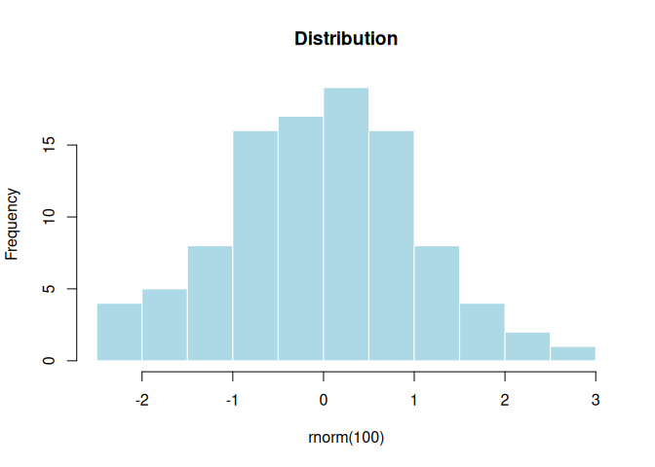

4 Working with Package Functions
Here’s how to use the package’s example function with different inputs:
# Numeric vector
example_function(c(5, 10, 15, 20, 25))
#> [1] 15
# Using with generated data
random_data <- runif(10, min = 0, max = 100)
example_function(random_data)
#> [1] 47.43

5 Theorem Environments
The callouty-theorem extension renders Quarto theorem and proof environments as styled callout blocks. This makes theorems, definitions, examples, and proofs visually distinct and easier to navigate.

5.1 Definitions and Theorems
Definition 1 (Standard Error) The standard error of the mean for a sample of size $n$ with standard deviation $s$ is:
$$SE=\frac{s}{\sqrt{n}}$$

Theorem 1 (Central Limit Theorem) Let $X_{1},X_{2},…,X_{n}$ be independent and identically distributed random variables with mean $μ$ and finite variance $σ^{2}$. Then as $n→∞$:
$$\frac{\overset{‾}{X}−μ}{σ/\sqrt{n}}\overset{d}{→}N(0,1)$$

 Proof
Proof. See any standard probability textbook.

5.2 Lemmas and Corollaries
Lemma 1 (Variance of a Sum) For independent random variables $X$ and $Y$:
$$\text{Var}(X+Y)=\text{Var}(X)+\text{Var}(Y)$$

Corollary 1 (Confidence Interval from CLT) By Theorem 1 and Definition 1, an approximate 95% confidence interval for $μ$ is:
$$\overset{‾}{x}±1.96⋅SE$$

5.3 Examples and Exercises
Example 1 (95% Confidence Interval) For the sample below, we calculate a 95% confidence interval for the mean:
set.seed(42)
sample_vals <- rnorm(50, mean = 5, sd = 2)
n <- length(sample_vals)
se <- sd(sample_vals) / sqrt(n)
ci <- mean(sample_vals) + c(-1, 1) * 1.96 * se
cat(sprintf("Mean = %.3f, 95%% CI: [%.3f, %.3f]\n", mean(sample_vals), ci[1], ci[2]))
#> Mean = 4.929, 95% CI: [4.290, 5.567]

Exercise 1 (Exercise: Computing Standard Error) Compute the standard error for a sample of size $n=100$ with sample standard deviation $s=15$.

Solution
Solution.
$$SE=\frac{15}{\sqrt{100}}=\frac{15}{10}=1.5$$

6 Mathematical Notation
Quarto excels at mathematical notation. Here’s an example of a statistical formula:
The standard error of the mean is calculated as:
$$SE=\frac{s}{\sqrt{n}}$$
where $s$ is the sample standard deviation and $n$ is the sample size.
For a confidence interval:
$$CI=\overset{‾}{x}±t_{α/2,n−1}⋅SE$$

7 Tips and Best Practices
 Expanding tip section
Click to expand this section for additional tips:
- Use descriptive chunk labels for better organization
- Set global chunk options at the beginning
- Use cross-references to link related content
- Leverage callouts for important information
- Consider code folding for long code blocks

8 Conclusion
This article demonstrates the advanced capabilities of Quarto for creating rich, interactive documentation for R packages.

9 Learn More
- Visit the package website
- Check out the GitHub repository
- Read the Quarto documentation

10 References

