Name: D Navya
Registration Number: BL.EN.U4AIE23050
Reinforcement Learning Laboratory
Lab Experiment 1
Exploring Reinforcement Learning Environments using Gymnasium
Course | Reinforcement Learning
Semester | VII
Duration | 3 Hours
Course Outcome | CO1
Environment | Walker2d-v5 (Gymnasium MuJoCo)

Experiment Objectives
By the end of this laboratory, students will be able to:
- Install the Reinforcement Learning development environment.
- Create and execute Gymnasium environments.
- Explore the observation and action spaces of RL environments.
- Execute a random agent.
- Observe rewards, episode termination, and environment behaviour.
- Compare different RL benchmark environments.

1. Environment Setup
Gymnasium was installed along with its MuJoCo dependency, which is what actually powers the Walker2d-v5 environment:
pip install gymnasium[mujoco]
This lab was run on Google Colab, and the default GLFW rendering backend doesn't work there since Colab has no display attached. Setting MuJoCo to use the headless EGL backend instead fixed it — this has to be set before gymnasium or mujoco get imported:
import os
os.environ["MUJOCO_GL"] = "egl"
import gymnasium as gym
import numpy as np
import matplotlib.pyplot as plt
import imageio
The Walker2d-v5 environment was then created using:
env = gym.make("Walker2d-v5", render_mode="rgb_array")

2. About the Environment — Walker2d-v5
Walker2d is a 2D bipedal robot simulated in MuJoCo. It has seven body parts in total: a torso, two thighs, two legs, and two feet, connected by six hinge joints. The agent has to apply torque at these six hinges to make the robot walk forward without falling.

3. Observation and Action Spaces
The observation and action spaces were inspected directly from the environment object:
print(env.observation_space)
print(env.action_space)
Property | Observation Space | Action Space
Type | Box(-inf, inf, (17,), float64) | Box(-1.0, 1.0, (6,), float32)
Shape | (17,) | (6,)
Low | -inf (all elements) | -1.0 (all elements)
High | +inf (all elements) | +1.0 (all elements)
Meaning | Joint positions (qpos) and joint velocities (qvel) of the walker's body parts | Torques applied at the 6 hinge joints (thigh, leg, foot × left/right)
Table 1: Observation and Action space summary for Walker2d-v5
The 17-dimensional observation vector encodes the walker's joint angles and joint angular velocities (with the torso x-position excluded by default), while the 6-dimensional action vector applies continuous torque values to each hinge joint independently.

4. Initial State of the Environment
After resetting the environment with a fixed seed, the initial rendered frame was captured to visually confirm the walker's starting pose:
observation, info = env.reset(seed=42)
frame = env.render()
plt.imshow(frame)
plt.axis("off")
plt.title("Initial State")
plt.show()
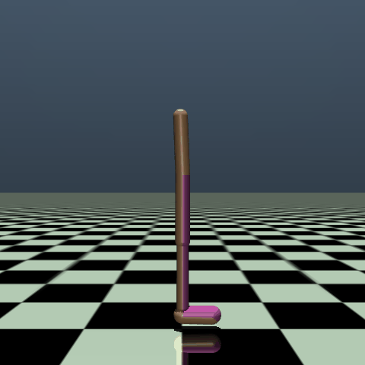
Figure 1: Initial state of the Walker2d-v5 environment (rendered via EGL, headless)

5. Running a Random Agent
A random agent was executed by sampling actions uniformly from the action space at every timestep, using env.action_space.sample(). Five episodes were run consecutively (each reset with a different seed) and their rendered frames were combined into a single animation to observe the walker's behaviour under random torques:
for ep in range(num_episodes):
observation, info = env.reset(seed=ep)
episode_over = False
while not episode_over:
action = env.action_space.sample()
observation, reward, terminated, truncated, info = env.step(action)
frames.append(env.render())
episode_over = terminated or truncated
Results per episode:
Episode | Steps Survived | Total Reward
1 | 12 | -0.19
2 | 14 | -1.90
3 | 24 | 3.13
4 | 23 | 5.93
5 | 14 | -4.26
Table 2: Episode length and total reward under a random policy (5 episodes)
Across all five episodes, the walker survived for very few steps before becoming “unhealthy” (falling outside the allowed torso height or angle range) and terminating. The longest episode lasted only 24 out of a possible 1000 timesteps.

6. Reward Analysis
The total reward returned at each step is composed of three terms: a forward-motion reward, a control-cost penalty, and a survival bonus. These individual components were logged at every step via the info dictionary and averaged across all steps of all episodes:
Reward Component | Average Value (per step)
reward (total) | 0.0311
reward_forward | -0.9094
reward_ctrl | -0.0020
reward_survive | 0.9425
Table 3: Average reward components per step across all episodes
The negative average reward_forward shows that under random torques the walker's torso mostly drifted backward rather than forward, which makes sense since random actions have no directional intent. reward_ctrl stays small because control cost is weighted lightly (1e-3). reward_survive averages close to 1.0 simply because it's 1.0 on every healthy step and 0 only on the final falling step, and most of the steps in a short episode are still healthy ones.

7. Success Rate
Walker2d-v5 doesn't have a built-in pass/fail flag, so for this lab, success was defined as an episode surviving the full 1000-timestep horizon (ending in truncation rather than termination). None of the five episodes came anywhere close — the longest was 24 steps — so the success rate here is 0%. This isn't surprising: a policy that picks random torques every step has no way to keep a bipedal robot balanced. Actually training the agent (with PPO, SAC, etc.) is what the later labs will get into.

8. Comparing RL Benchmark Environments
To contrast the complexity of Walker2d-v5 against a simpler classical-control benchmark, its observation and action spaces were compared with CartPole-v1:
Environment | Observation Space | Action Space
CartPole-v1 | Box(4,) — continuous | Discrete(2)
Walker2d-v5 | Box(17,) — continuous | Box(6,) — continuous
Table 4: Comparison of observation/action space complexity
CartPole-v1 only has two discrete actions (push left or push right) and a 4-value observation, so it's easy to solve even with simple methods. Walker2d-v5 is a different scale of problem — continuous 6-dimensional actions and a 17-dimensional observation — which is part of why it's considered one of the harder Gymnasium environments to solve.

9. Observations
- Observation space is continuous and unbounded (−∞ to +∞) — it's joint angles and angular velocities.
- Action space is continuous, bounded to [−1, 1] for each of the 6 hinge torques.
- Random policy basically fails right away — episodes only lasted 12 to 24 steps out of 1000.
- Reward per episode swung a lot (−4.26 to +5.93) just depending on which way the random torques happened to push the torso before it fell.
- Forward-reward was negative on average, so the random agent wasn't making any real forward progress.
- Had to switch MuJoCo's rendering backend from GLFW to EGL to get anything to render on Colab, since there's no display there.

10. Conclusion
This lab covered the basic workflow for working with a Gymnasium MuJoCo environment — getting it installed, dealing with the headless-rendering issue on Colab, checking out the observation and action spaces, running a random agent, and looking at what the reward and termination info actually tell you. Walker2d-v5's 17-dimensional observations and 6-dimensional continuous actions make it a lot harder than something like CartPole, and the random policy pretty much confirms that: 0% success rate, episodes ending in under 20 steps on average. That's the expected result though — it's really just a baseline to compare against once an actual RL algorithm gets trained on this environment in a later lab.

