Lapse rate manual

This is geared towards both students and faculty! Please add to or revise it as you see fit. My intention here is to provide a set of procedures to be consistent across blocks. However, I’d rather have data than consistency. I’ve done my best to solve problems ahead of time, but there I will have undoubtedly missed things. If there’s a good reason to deviate from what I’ve laid out in this document, then do it! I trust all of your judgement. I can’t adequately express how lucky I feel to be working on this with such a great group. I appreciate you!
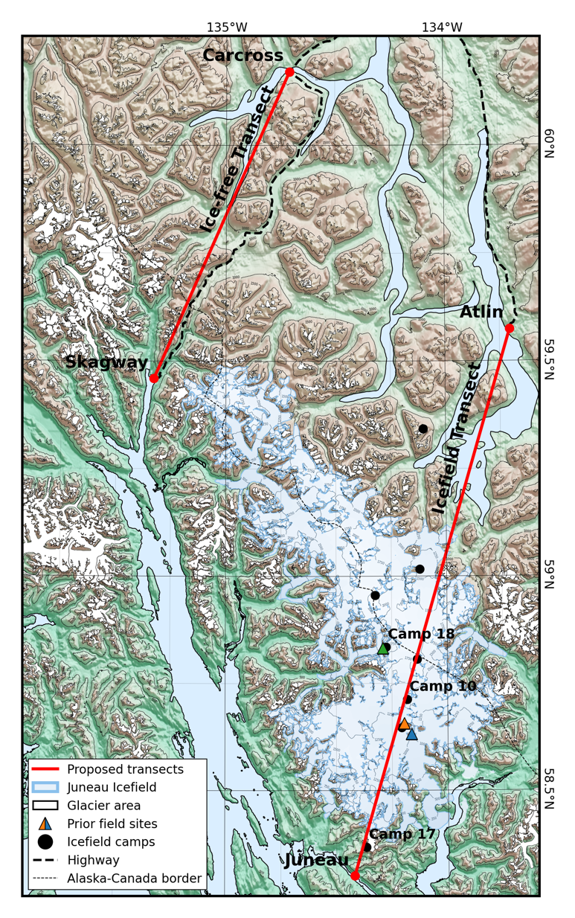

How to use this document
In MS Word, locate the “view” tab, and check the “Navigation Pane” box. In the sidebar, click the bullet list icon to show the outline of this document.
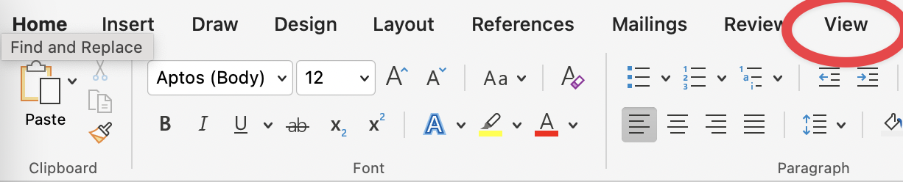

Quickstart

Overall goals
The goal is to put out 30 stakes along the traverse path, with approximately even distribution across the icefield.

Field day outline

Day before
- Charge drill batteries
- Package sensors in solar shields and mount to stakes
- Pick approximate stake placement locations
- Fill out pre-deployment information
  - Record sensor model, SN, and whether it is shielded

Day of
- Select site, and take a GPS point
- Attach the extension to the main pole
- Drill hole and place pole
- Take a photo of the deployment, ideally including any identifiable view/features that could aid in finding the stake in spring

**Record the following information in the field notebook**
- Latitude, longitude, and elevation of the installation
- Length of stake above and below the surface
- Height of each sensor above the surface
- Time of deployment
- Any notes about the deployment or nearby identifiable features

Back in camp
- Fill out the deployment spreadsheet (todo)
- Transfer photo to field computer
- Transcribe any other field notes

Leaving camp checklist
- Installation hardware
  - Deployed sensors
  - 4 m pole
  - 2 m pole
  - Plywood spacer
  - HVAC tape
  - Hose clamps
  - Plastic zip ties
  - Metal cable ties
- Drill auger
  - Charged battery
  - Drill
  - Drill auger adapter
  - 2-3x Auger flights
  - Cutting head
- The rest
  - Tape measure/laser measure
  - Extra hardware kit
    - 2 zip ties, 2 cable ties, 3 short screws, 2 long screw, 1 drill bit, 1 driver bit, 4” x 6” mylar, 2’ HVAC tape, extra plywood spacer, 1 hose clamp, 1 ski strap
    - Optionally CA or PU glue
  - Field notebook, pencil
  - Phone with HOBOConnect & mapping app
  - Mini pliers/multitool

Preparing a sensor installation

Deployment schematic
Note that the process may have evolved slightly from what is shown here.
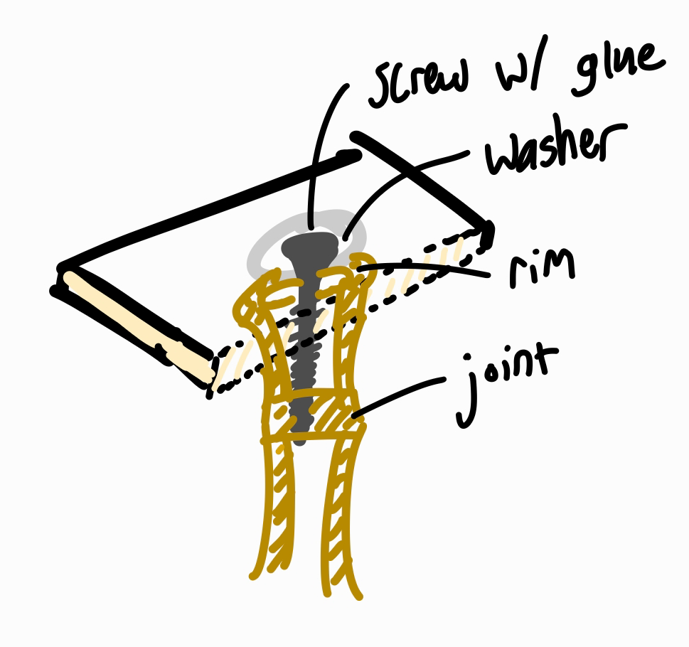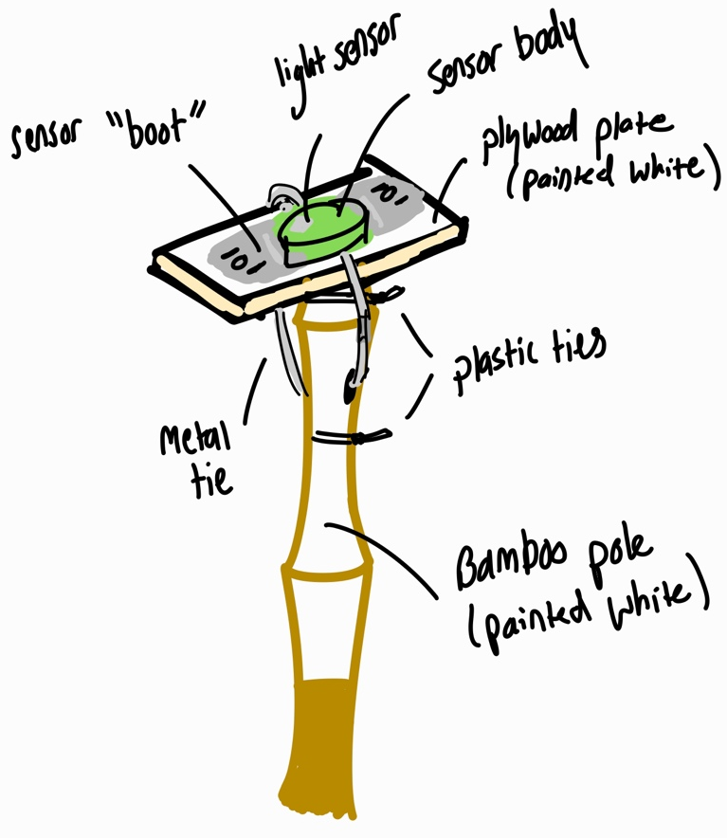

Additional sensors
- Spacing between sensors is arbitrary, but I’ve been shooting for 1 m between each. I have aspirations of using the data to constrain the height of the snow surface and characterize stability. It’s also for redundancy/solar forcing.

Drilling the hole
if the drill can’t spin the bit, it will spin you and/or itself. Injury is unlikely, but I’ve had it twist my wrist hard enough to be wary, and it also delivered a memorable uppercut to my chin with its battery. If you are worried about the bit seizing (or are using it for anything other than augering), you can start out using the clutch to prevent excessive torque.

Instructions
Drill the hole such that ~1.5-2.5m of stake is below the surface at the end of the melt season. Adjust within this range based on location and the amount of expected melt remaining. For example, slightly shallower at the ice divide since it will be snowed in first. Additional length above the surface is also desirable here so that there’s a chance of it melting out by summer. If you are toward the terminus of the Taku in early July (and your name is Allen), you might want to put it in the full 2.5 – 3m.

I’m most concerned about the stakes surviving fall windstorms. My guestimate is that these are a greater risk for sites downglacier, and where the topography would channel winds from the southwest. Err on the side of putting stakes in too deep.

In the accumulation zone, my sense is to aim for the height of the top-most sensor to exceed the depth of any nearby mass-balance pits by at least 1 m. In the ablation zone, an annual balance gradient of ~6.5 m SWE / (vertical) km is a reasonable approximation. If that doesn’t leave you with a clear choice, send me an InReach message and I can pull up an ELA.

See the following from Kovacs for tips on use:
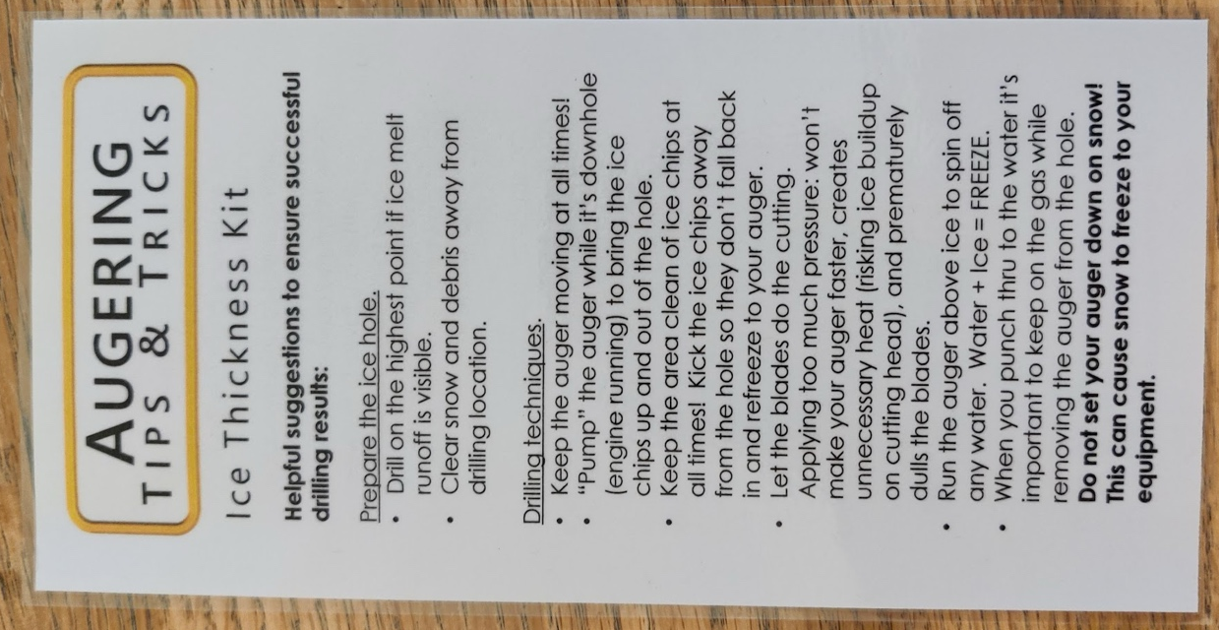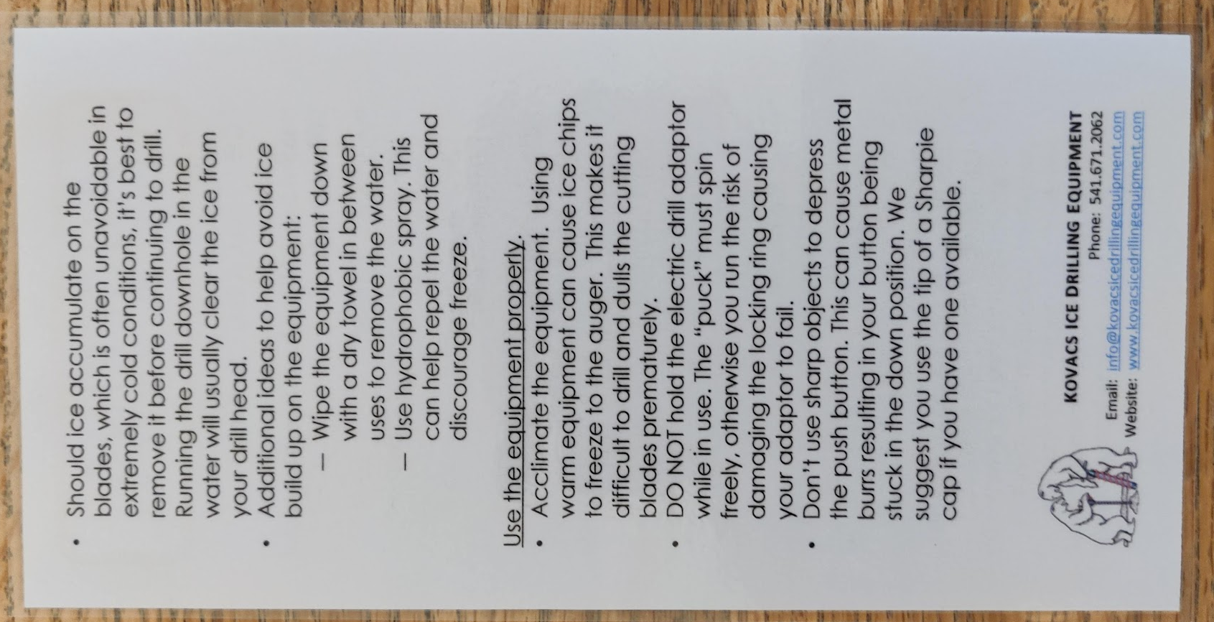

Additional tips (feel free to add to this):
- If the auger is seizing/refreezing quickly, try applying a silicone lubricant or oil-based coating (wax perhaps?)
- Make sure the drill isn’t on hammer mode

Sensors
We are using 4 models of sensors: 2 generations of HOBO pendants (30 new, 90 old), HOBO microstations (6), and iButtons (40). The pendants measure temperature and light. The microstations have temperature and RH. The iButtons only measure temperature.

Each model of sensor will have a distinct role. The new pendants have an improved light sensor, so will be reserved for the tops of poles. The old pendants will have solar shields and will be the main source of temperature data. In total, there will be 1 new pendants and 2 old pendants on each stake. The new and old pendants will be attached at a similar height, and the last old pendant will be attached ~2 m below the first two.

The microstations are the highest accuracy sensors and our only RH measurements. We also only have ~6 of them, and want to make sure ~6 are successfully recovered next year. For those reasons, the best spot for the microstations are at the camps, either in the Richardson shield (or in a building, where not available). These will have approximately even spacing across the icefield, and so will “anchor” the observations from the pole network.

The iButtons will be reserved for the teaching program, and are available for any experiments you or the students come up with. The pendants that have not yet been deployed can also be used for student experiments.

Proposed stake sites

Picking a location
Use your best judgement!

Keep in mind the local slope gradient, aspect, and wind/avalanche redistribution. A convex slope may be advantageous in high-accumulation areas, or a north-facing aspect in high melt areas. If these features aren’t too dramatic, they may aid in data collection without having a huge effect on the results
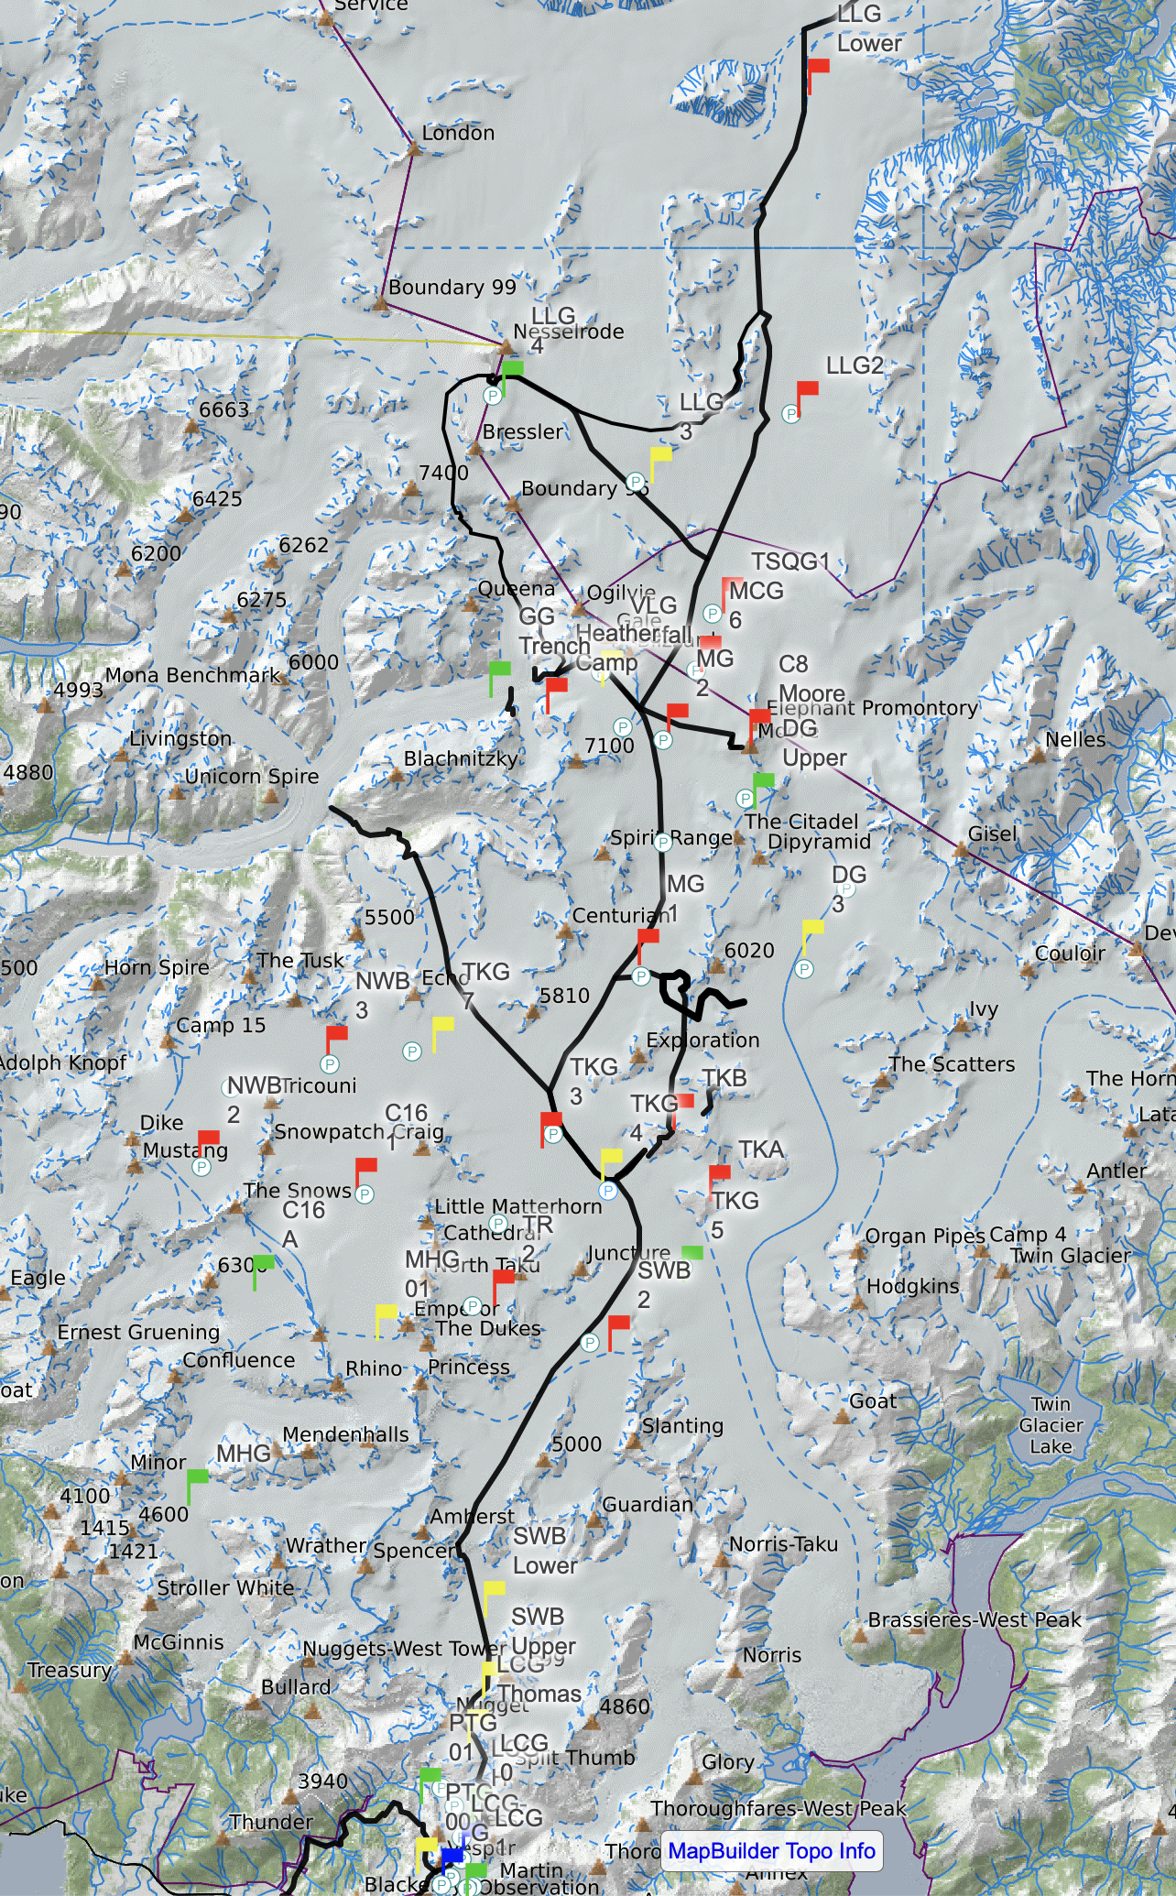
Red = highest priority
Green = lower priority

Not included on here are the microstations and light sensors at each camp.

Icesat2
https://openaltimetry.earthdatacloud.nasa.gov/data/icesat2/
If possible put sensors on the Icesat2 line

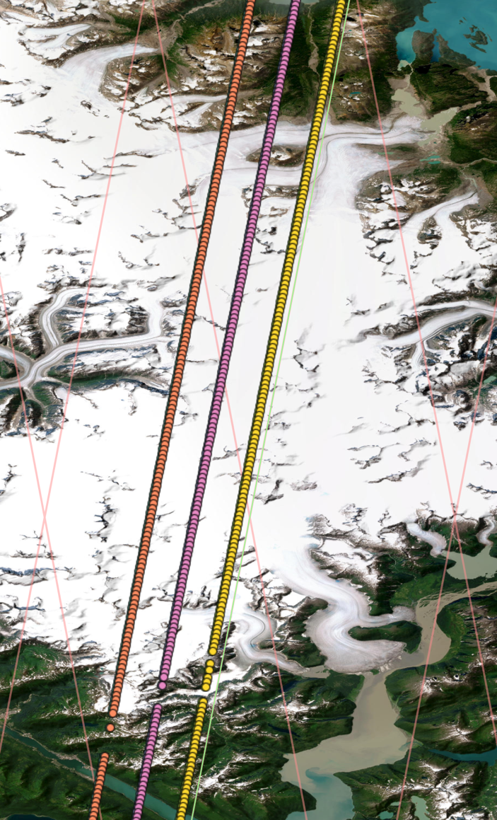
Track 197

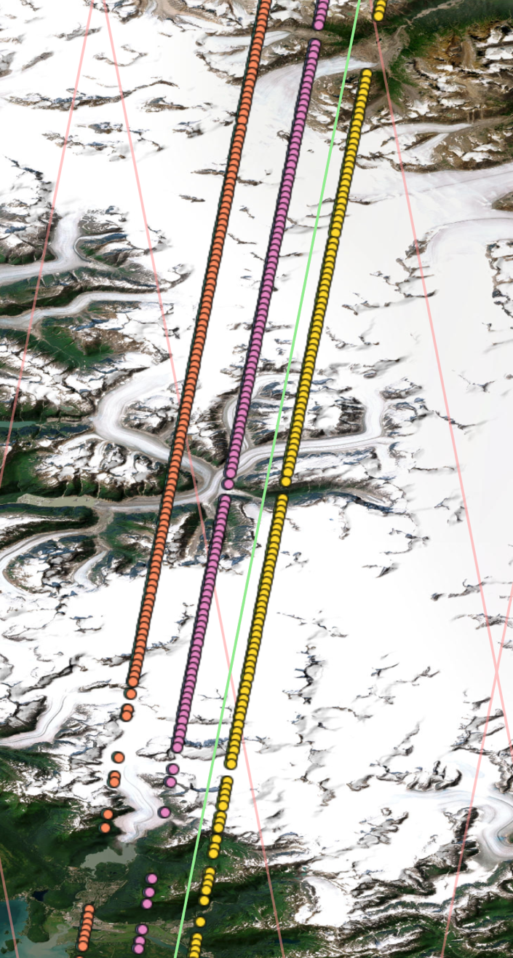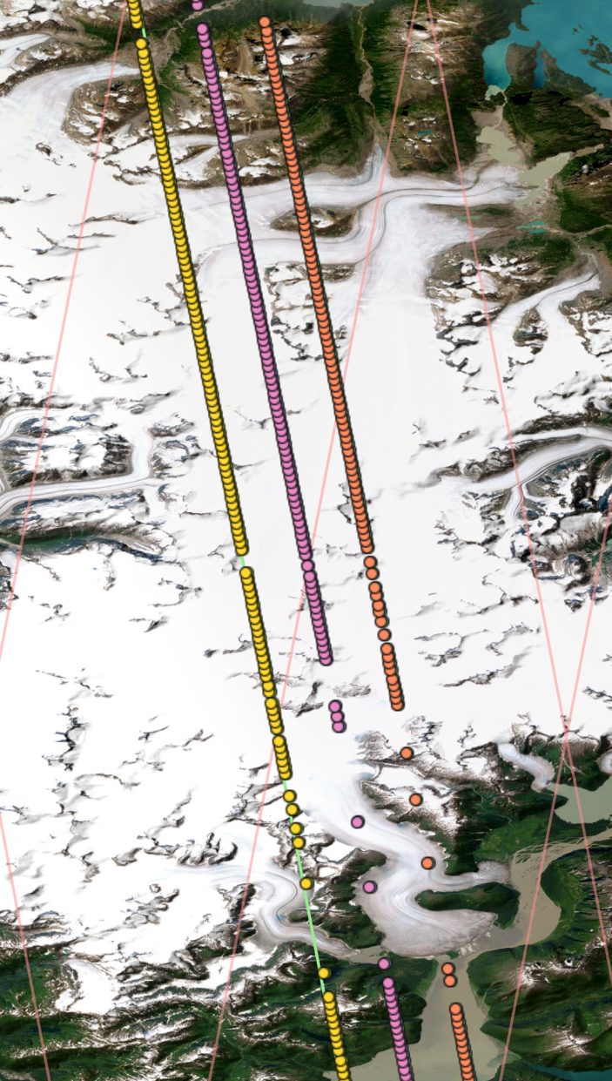
Track 1142 / Track 235

HOBOconnect (new pendants)
Todo: Deployment settings & tutorial

HOBOware (old pendants)
Todo: Deployment settings and tutorial

Appendix
(stuff you shouldn’t need to deal with)

Mounting the sensor
Bamboo has great properties but can be tricky to work with. I don’t have any experience with bamboo, so I took a while to mess around with various options for affixing a plywood plate for the sensor. I would encourage you to do something similar to get a feel for when/how it fails. I’ll try to make sure there are a couple extra poles for this purpose. Cut off sections just above the joint and try some ideas. I think the sensor mounting is the most likely point of failure for these installs, so I want to provide any information that might be useful.

Experiments
Here are some of my impressions:
- The most common issue was splitting the bamboo. Any screw into the wall of the bamboo needs to be pre-drilled. Even when predrilled, any screw not running perpendicular to the pole has a solid chance of splitting it. Screws into the joint interface won’t split it.
- For big poles, the interface at the joints is strong to compressive force, but holds screws poorly. However it does hold screws well for the small poles. At the thin end of the small poles, the weak interface material found on the larger poles is almost absent. Instead, the walls pinch together and do a much better job of holding the threads. For the large poles, a viable alternative would be to cut a few inches above the joint, then fill the interior of the bamboo by gluing in a wooden plug made from a dowel that can be screwed into instead.
- Careful not to cut the poles too close to the joint. Most screws have their most aggressive threads near their end, and are often unthreaded near the head (depending on what screw I settle on, this might not be an issue).
- The exception to this will be for affixing a sensor to the top of a large pole. Cutting the pole right at the joint gives a continuous flat surface. It may be bad for screws, but it will be excellent for glue. With that much surface area, a bond using PU glue will be extremely strong.
- I bent a small pole almost 90 degrees before it snapped, which is crazy! It also failed in a great way, kind of like a cartoon gun barrel. It was no longer stiff, but it was still one piece, and I’d guess retained a large portion of its tensile strength. I see this as a good sign that we will be able to recover everything even if the poles fail.
- I tried affixing a small pole to the end of a big pole. I overlapped approximately one joint on each. Zip ties do not cut it here. If you have to use zip ties, use at least 3 and wrap around the joint with HVAC tape. The plywood spacer is a critical piece here, but it is currently unclear to me whether it is better for it to be wider or narrower than the poles.

Takeaways
- For small poles, a screw and glue will work well to secure a plate to the top. A very small hole can be drilled below the joint for a loop of safety wire.
- For large poles, glue alone should be sufficient to hold the plate to the top, though it should specifically be at a joint and with PU glue. Safety wire or a metal zip tie would be a suitable backup, though I lean towards wire. Avoid wire cable/rope. A dowel plug (secured with PU glue) and screw would also be suitable.
- Use something that can be securely tightened to affix the small poles to the large poles. I don’t trust plastic zip ties for this. Ideally, use 2 hose clamps. Wrap once or twice with HVAC tape to prevent gradual motion.
- Attaching a shielded sensor to the side of a pole should be straightforward. For new pendants, 2 zip ties through the mounting boot is sufficient. For the old pendants, a zip tie around the sensor body is sufficient, with a loop of safety wire passing through hole at the top of the sensor and through the bamboo.
- Tape and/or zip ties are useful as a backup against splitting while installed. But if a pole splits before you install it, just cut the section off or use a different pole.
- There are a lot of ways one could do this, and at least a few of them would work well. Please feel free to iterate on this!

Instructions
Based on the above experiments, here is a step-by-step guide for how to attach a sensor to the top of a narrow pole:
- Cut off top of pole so that the first joint is 1-2” from the top of the pole. The length remaining depends on the length of the screw you will use (I’ll ideally have done this for you).
- Apply PU (Gorilla) Glue to the rim of the pole (CA glue or Titebond 3 wood glue will work in a pinch)
- Place washer on screw and drive it into the wood plate until the screw is nearly through the plate.
- Apply small amount of PU glue to the threads of screw.
- Screw plywood plate to top of pole, with screw centered in the opening of the bamboo and the plywood centered on the screw. The screw should pass through the full thickness of the joint, pulling the plate securely against the top of the pole. Careful to avoid overtightening.

For a thick pole:
- Cut the pole at the joint to maximize surface area
- Apply PU glue and plate to the top of the pole

For either case, finish with the following steps:
- Carefully drill a small hole directly through the bamboo below the next joint. Loop safety wire between the sensor and the mounting boot and through the hole.
- Apply a small amount of PU glue to the underside of the mounting boot near the screw holes
- Attach the sensor with 2 screws through the holes on the mounting boot.
- Tension safety wire and twist pigtail
- Apply a small amount of PU glue between the mounting boot and the plywood at the screw hole. Do not apply PU glue to the sensor itself. Screw the mounting boot to the plywood plate.
- As a backup, drill a hole below the bottom of the screw perpendicular to the bamboo, and opposite the orientation of the plywood plate (e.g., front-back vs. side-side). Drill slowly (light pressure) to prevent bamboo from splitting.
- Thread a metal zip tie in-between the sensor and the sensor mounting boot, then through the hole. This will hold the sensor to the plywood plate. Orient the cable tie so the head is along the bamboo and the tail of the tie points towards the ground. Tuck the tail into the hole if possible. Be careful not to cover the light sensor!
Alternatively, use safety wire and twist a pigtail ~2 in.
You could also use wire cable and cable clamps, but in my experience, these are difficult to tension and more prone to error. The additional strength of the cable is unnecessary, so I’d recommend using wire.

Enough to get a pole 90% of the way there from scratch if for some reason it needed to be redone. Never a bad idea, but you can probably ditch it for just one pole. Consider doubling for >= 3 poles.
Though, I suspect joints are more likely to break from bending and should probably be centered in the overlap
PU glue expands, making it particularly good for end-grain joints. It also has a higher breaking strength than wood glue or CA glue for these materials.
If, for some reason, you are using an old pendant for the top of the pole, omit this step and instead apply PU glue to the interface between the sensor housing and the plywood

