Title Goes Here

Myfirstname Mylastname1,✉, and Yourfirstname Yourlastname2

20 March, 2020

Text of abstract

1 University of One Place  
2 University of Another Place

✉ Correspondence: [Myfirstname Mylastname <[fl@oneplace.edu](mailto:fl@oneplace.edu)>](mailto:fl@oneplace.edu)

# Introduction

Here is a citation (Marwick, 2017)

# Background

# Methods

# Results

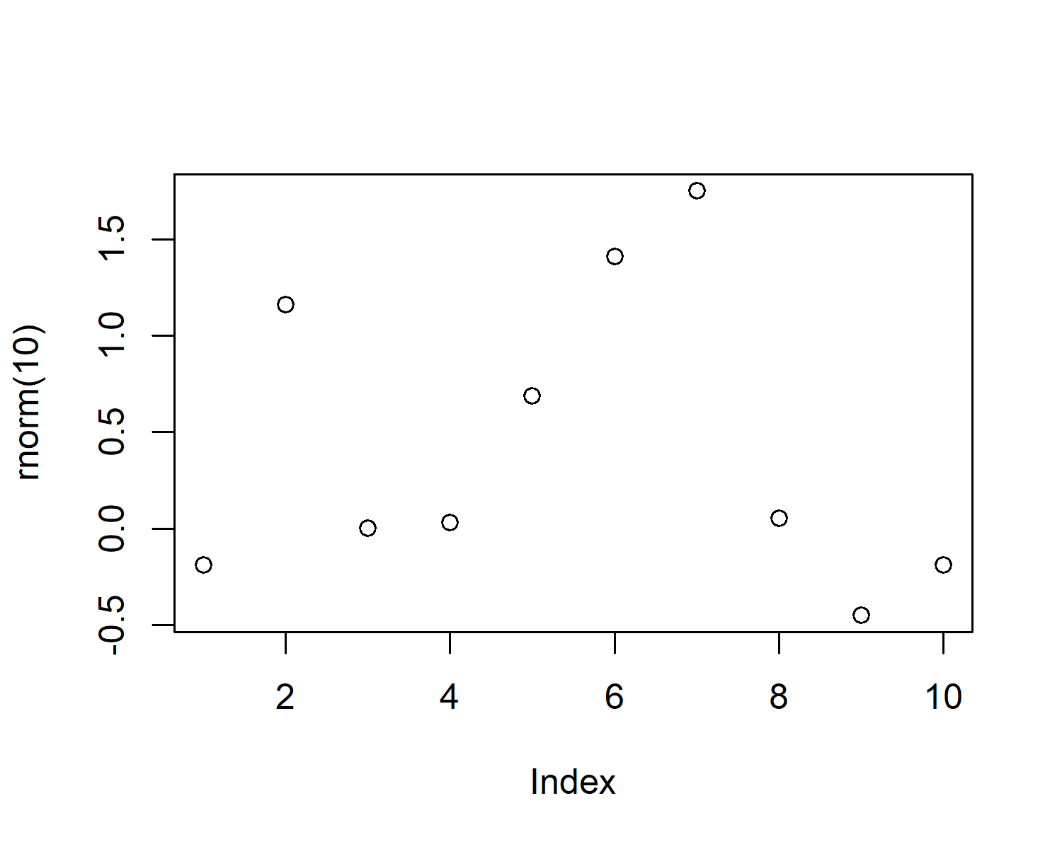

Figure 1: A plot of random numbers

Figure 1 shows how we can have a caption and cross-reference for a plot

Here is an example of inline code 3.14 in the middle of a sentence.

# Discussion

# Conclusion

# Acknowledgements

# References

Marwick, B., 2017. Computational reproducibility in archaeological research: Basic principles and a case study of their implementation. Journal of Archaeological Method and Theory 24, 424–450. <https://doi.org/10.1007/s10816-015-9272-9>

### Colophon

This report was generated on 2020-03-20 00:52:24 using the following computational environment and dependencies:

#> - Session info ---------------------------------------------------------------  
#> setting value   
#> version R version 3.5.1 (2018-07-02)  
#> os Windows 10 x64   
#> system x86_64, mingw32   
#> ui RTerm   
#> language (EN)   
#> collate English_United States.1252   
#> ctype English_United States.1252   
#> tz Europe/Berlin   
#> date 2020-03-20   
#>   
#> - Packages -------------------------------------------------------------------  
#> package * version date lib source   
#> assertthat 0.2.1 2019-03-21 [1] CRAN (R 3.5.3)  
#> backports 1.1.5 2019-10-02 [1] CRAN (R 3.5.3)  
#> bookdown 0.18 2020-03-05 [1] CRAN (R 3.5.3)  
#> callr 3.4.2 2020-02-12 [1] CRAN (R 3.5.3)  
#> cli 2.0.2 2020-02-28 [1] CRAN (R 3.5.3)  
#> crayon 1.3.4 2017-09-16 [1] CRAN (R 3.5.1)  
#> desc 1.2.0 2018-05-01 [1] CRAN (R 3.5.3)  
#> devtools 2.2.2 2020-02-17 [1] CRAN (R 3.5.3)  
#> digest 0.6.25 2020-02-23 [1] CRAN (R 3.5.3)  
#> ellipsis 0.3.0 2019-09-20 [1] CRAN (R 3.5.3)  
#> evaluate 0.14 2019-05-28 [1] CRAN (R 3.5.3)  
#> fansi 0.4.1 2020-01-08 [1] CRAN (R 3.5.3)  
#> fs 1.3.2 2020-03-05 [1] CRAN (R 3.5.3)  
#> glue 1.3.2 2020-03-12 [1] CRAN (R 3.5.3)  
#> highr 0.8 2019-03-20 [1] CRAN (R 3.5.3)  
#> htmltools 0.4.0 2019-10-04 [1] CRAN (R 3.5.3)  
#> knitr 1.28 2020-02-06 [1] CRAN (R 3.5.3)  
#> magrittr 1.5 2014-11-22 [1] CRAN (R 3.5.1)  
#> memoise 1.1.0 2017-04-21 [1] CRAN (R 3.5.3)  
#> pkgbuild 1.0.6 2019-10-09 [1] CRAN (R 3.5.3)  
#> pkgload 1.0.2 2018-10-29 [1] CRAN (R 3.5.3)  
#> prettyunits 1.1.1 2020-01-24 [1] CRAN (R 3.5.3)  
#> processx 3.4.2 2020-02-09 [1] CRAN (R 3.5.3)  
#> ps 1.3.2 2020-02-13 [1] CRAN (R 3.5.3)  
#> R6 2.4.1 2019-11-12 [1] CRAN (R 3.5.3)  
#> Rcpp 1.0.3 2019-11-08 [1] CRAN (R 3.5.3)  
#> remotes 2.1.1 2020-02-15 [1] CRAN (R 3.5.3)  
#> rlang 0.4.5 2020-03-01 [1] CRAN (R 3.5.3)  
#> rmarkdown 2.1 2020-01-20 [1] CRAN (R 3.5.3)  
#> rprojroot 1.3-2 2018-01-03 [1] CRAN (R 3.5.3)  
#> sessioninfo 1.1.1 2018-11-05 [1] CRAN (R 3.5.3)  
#> stringi 1.4.6 2020-02-17 [1] CRAN (R 3.5.3)  
#> stringr 1.4.0 2019-02-10 [1] CRAN (R 3.5.3)  
#> testthat 2.3.2 2020-03-02 [1] CRAN (R 3.5.3)  
#> usethis 1.5.1 2019-07-04 [1] CRAN (R 3.5.3)  
#> withr 2.1.2 2018-03-15 [1] CRAN (R 3.5.1)  
#> xfun 0.12 2020-01-13 [1] CRAN (R 3.5.3)  
#> yaml 2.2.1 2020-02-01 [1] CRAN (R 3.5.3)  
#>   
#> [1] C:/Users/dpaulus/Documents/R/R-3.5.1/library

The current Git commit details are:

#> Local: master C:/Users/dpaulus/Dropbox/phd/1stJournal/rambfunddata  
#> Remote: master @ origin (https://github.com/d-paulus/rambfunddata.git)  
#> Head: [2bd9351] 2020-03-19: initial commit