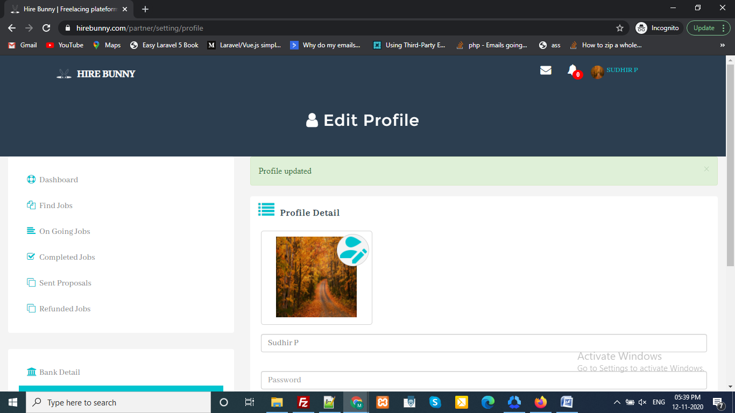

- If no Notification remove ‘0’ from client and partner

- Client → Registration → verify OTP
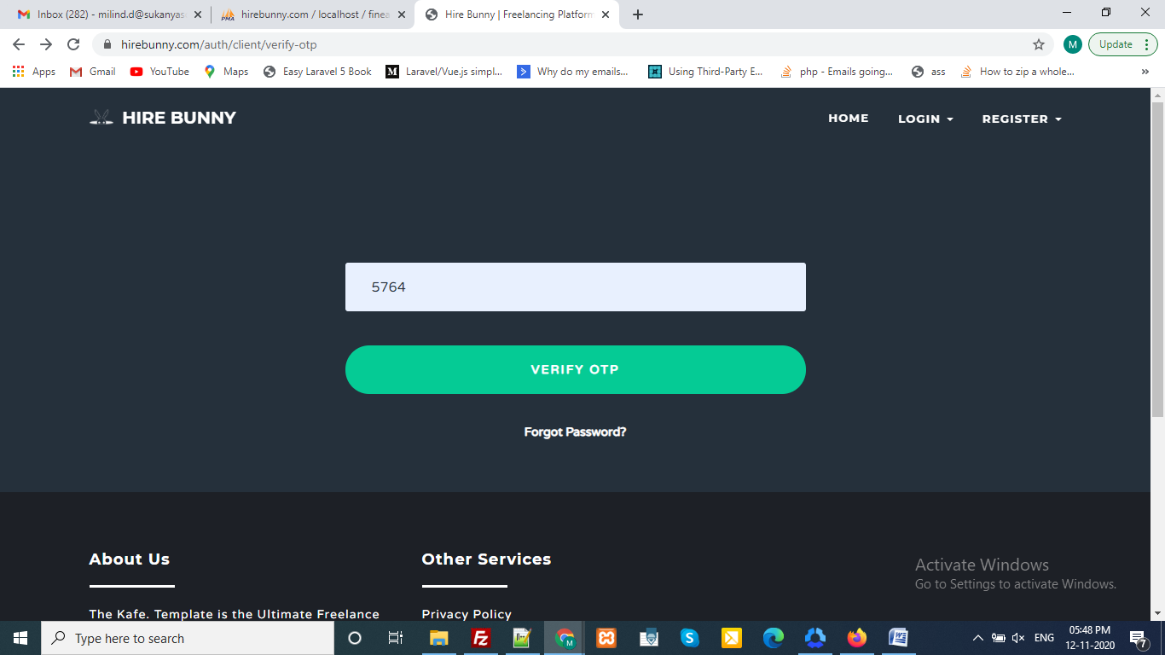
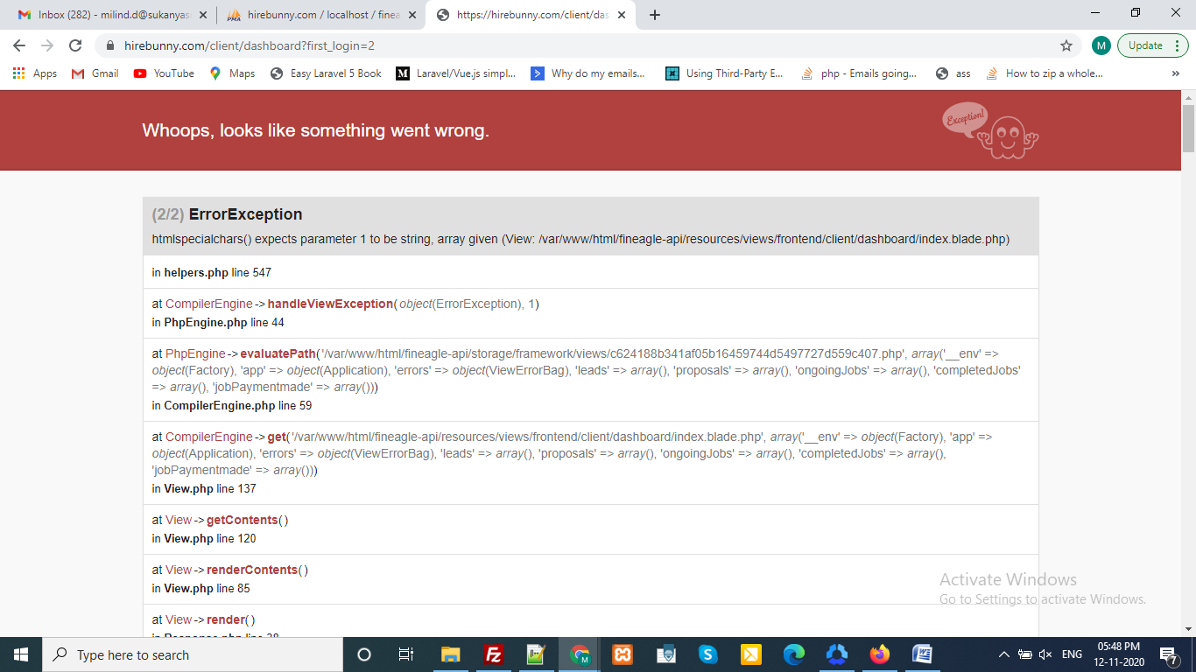

Shows error But Still Registration is done and data is saved in user table.

- New User → Client Login
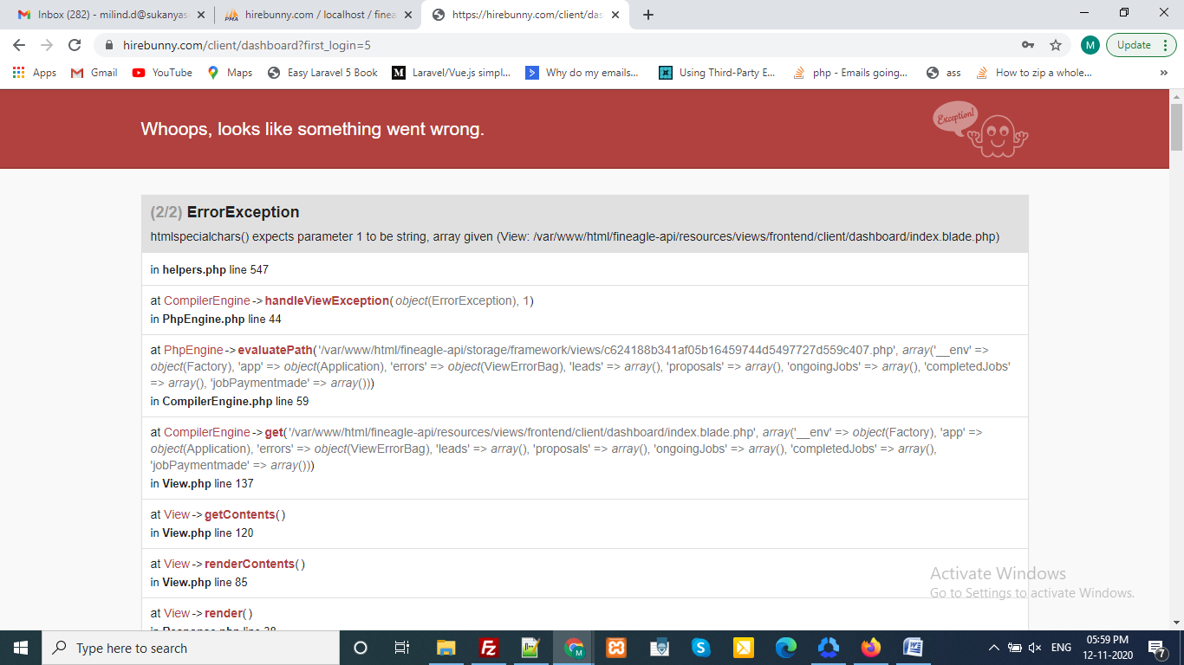

- IF Client recived 2 proposals for same job from different partner button functionality need to check

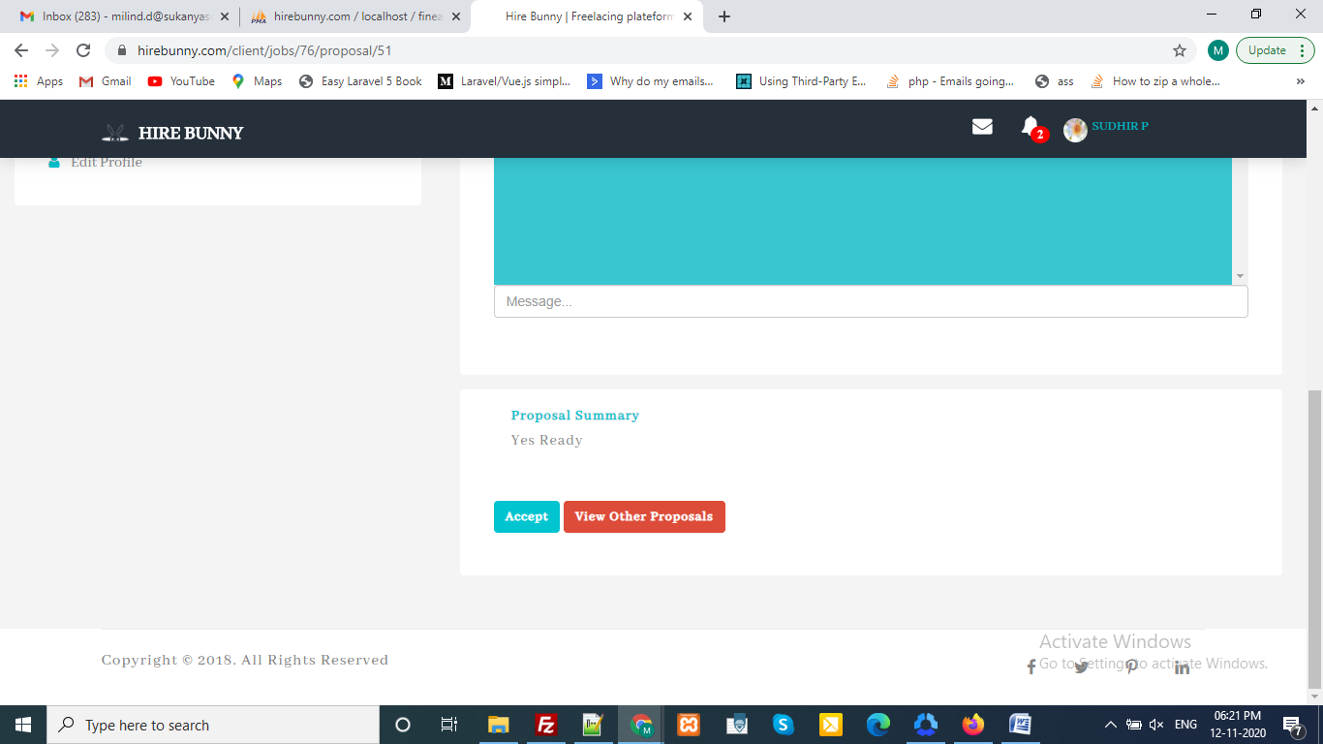

- Client Recevied Notifications links for new job proposal need to check
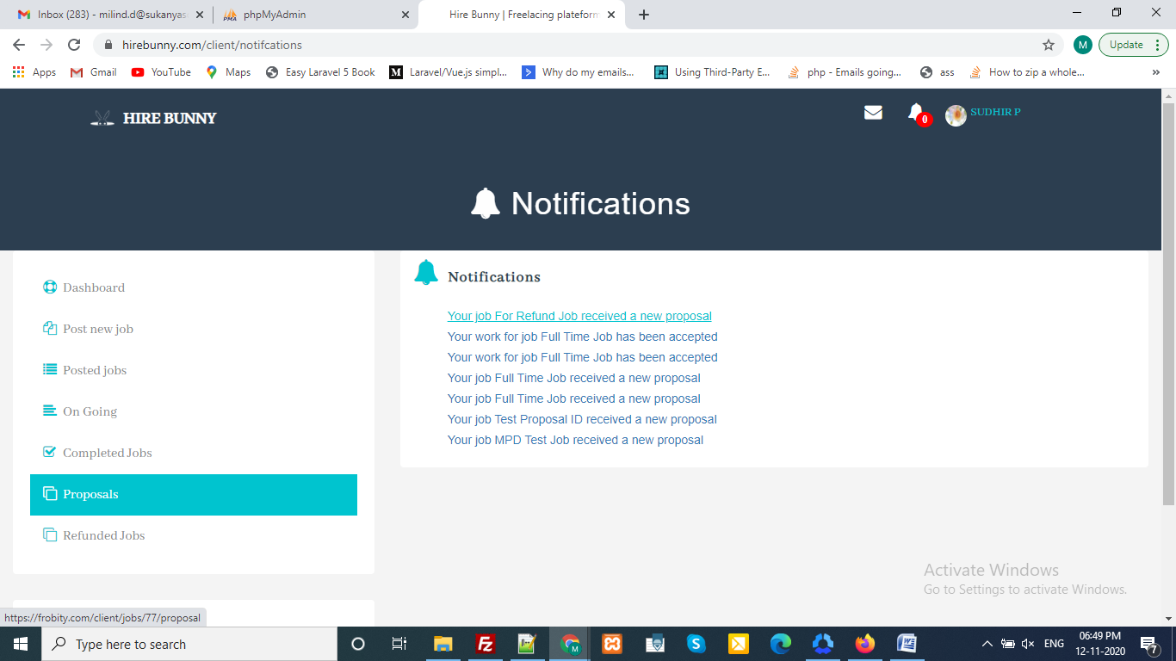

- Notifications links for partner also need to check
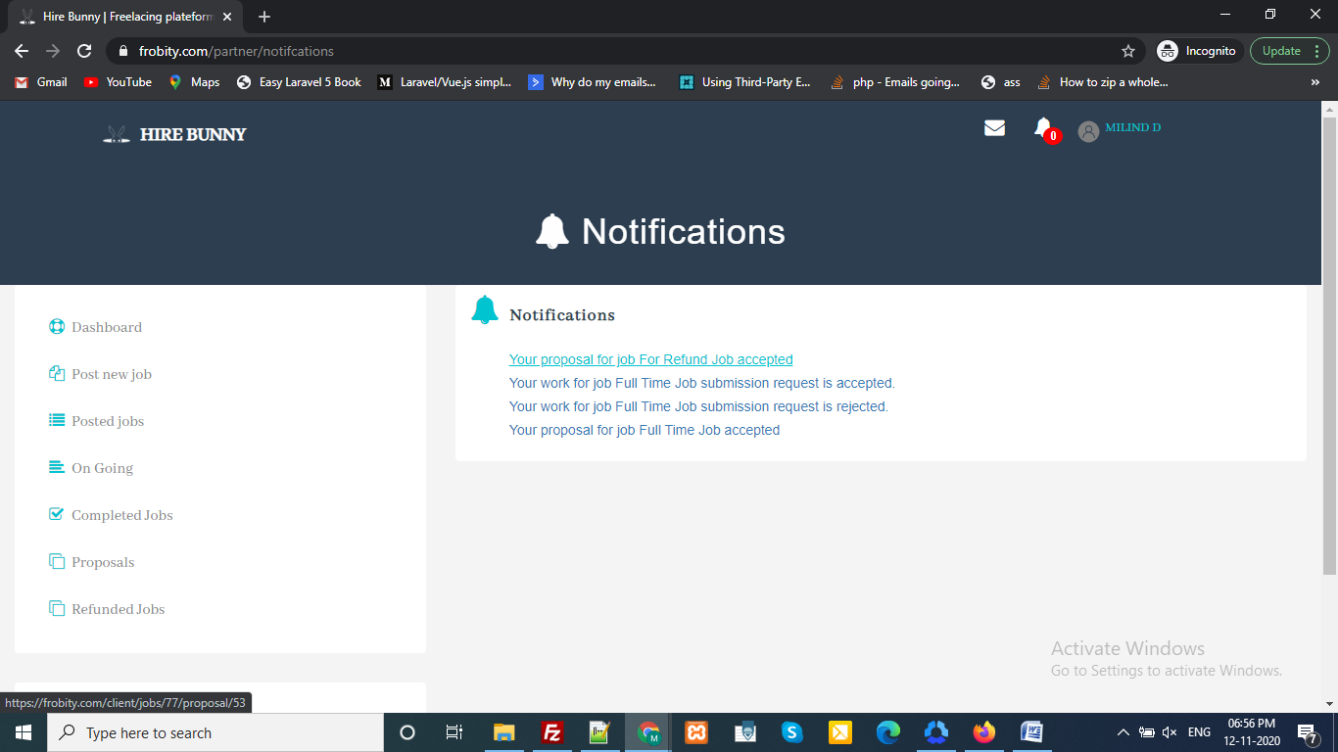

- Refund request from partner messages need to display on frontend such as errors,success etc
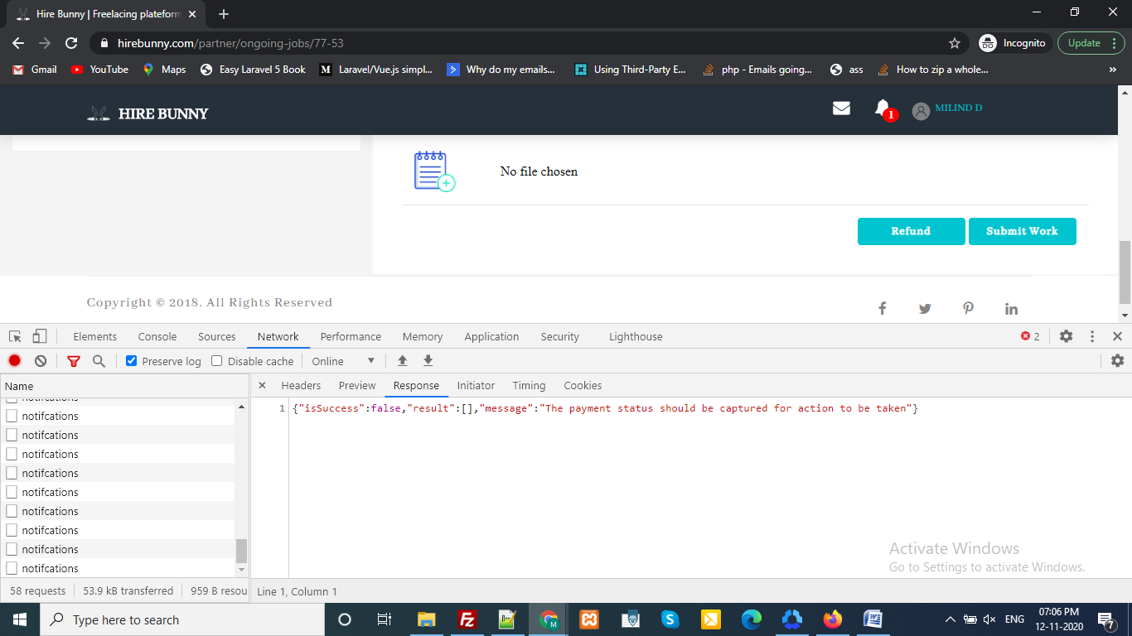

- Refund from client needs to check for it’s functionality

- Replacement Hire Bunny to frobity

D:\hirebunny\resources\views\emails\work-submission.blade.php

<li><a style="text-decoration: none;" href="mailto:info@fineagleservices.com?Subject=Fineagle%20Support" target="_top"><i class="fa fa-envelope" aria-hidden="true"></i> &nbsp;&nbsp;info@hirebunny.com</a></li>
Line 99: <li><a style="text-decoration: none;" href="mailto:sales@example.com?Subject=Fineagle%20Sales" target="_top"><i class="fa fa-envelope" aria-hidden="true"></i> &nbsp;&nbsp;sales@hirebunny.com</a></li>

D:\hirebunny\resources\views\emails\work-rejection.blade.php
<li><a style="text-decoration: none;" href="mailto:info@fineagleservices.com?Subject=Fineagle%20Support" target="_top"><i class="fa fa-envelope" aria-hidden="true"></i> &nbsp;&nbsp;info@hirebunny.com</a></li>
Line 99: <li><a style="text-decoration: none;" href="mailto:sales@example.com?Subject=Fineagle%20Sales" target="_top"><i class="fa fa-envelope" aria-hidden="true"></i> &nbsp;&nbsp;sales@hirebunny.com</a></li>

D:\hirebunny\resources\views\emails\work-acceptance.blade.php
<li><a style="text-decoration: none;" href="mailto:info@fineagleservices.com?Subject=Fineagle%20Support" target="_top"><i class="fa fa-envelope" aria-hidden="true"></i> &nbsp;&nbsp;info@hirebunny.com</a></li>
Line 99: <li><a style="text-decoration: none;" href="mailto:sales@example.com?Subject=Fineagle%20Sales" target="_top"><i class="fa fa-envelope" aria-hidden="true"></i> &nbsp;&nbsp;sales@hirebunny.com</a></li>

D:\hirebunny\resources\views\emails\unverified-member.blade.php
<li><a style="text-decoration: none;" href="mailto:info@fineagleservices.com?Subject=Fineagle%20Support" target="_top"><i class="fa fa-envelope" aria-hidden="true"></i> &nbsp;&nbsp;info@hirebunny.com</a></li>
Line 99: <li><a style="text-decoration: none;" href="mailto:sales@example.com?Subject=Fineagle%20Sales" target="_top"><i class="fa fa-envelope" aria-hidden="true"></i> &nbsp;&nbsp;sales@hirebunny.com</a></li>

D:\hirebunny\resources\views\emails\proposal-acceptance.blade.php
<li><a style="text-decoration: none;" href="mailto:info@fineagleservices.com?Subject=Fineagle%20Support" target="_top"><i class="fa fa-envelope" aria-hidden="true"></i> &nbsp;&nbsp;info@hirebunny.com</a></li>
Line 99: <li><a style="text-decoration: none;" href="mailto:sales@example.com?Subject=Fineagle%20Sales" target="_top"><i class="fa fa-envelope" aria-hidden="true"></i> &nbsp;&nbsp;sales@hirebunny.com</a></li>

D:\hirebunny\resources\views\emails\new-proposal.blade.php
<li><a style="text-decoration: none;" href="mailto:info@fineagleservices.com?Subject=Fineagle%20Support" target="_top"><i class="fa fa-envelope" aria-hidden="true"></i> &nbsp;&nbsp;info@hirebunny.com</a></li>
Line 99: <li><a style="text-decoration: none;" href="mailto:sales@example.com?Subject=Fineagle%20Sales" target="_top"><i class="fa fa-envelope" aria-hidden="true"></i> &nbsp;&nbsp;sales@hirebunny.com</a></li>

D:\hirebunny\resources\views\emails\new-job-notification.blade.php
<li><a style="text-decoration: none;" href="mailto:info@fineagleservices.com?Subject=Fineagle%20Support" target="_top"><i class="fa fa-envelope" aria-hidden="true"></i> &nbsp;&nbsp;info@hirebunny.com</a></li>
Line 99: <li><a style="text-decoration: none;" href="mailto:sales@example.com?Subject=Fineagle%20Sales" target="_top"><i class="fa fa-envelope" aria-hidden="true"></i> &nbsp;&nbsp;sales@hirebunny.com</a></li>

D:\hirebunny\resources\views\emails\new-job-invitation.blade.php
<li><a style="text-decoration: none;" href="mailto:info@fineagleservices.com?Subject=Fineagle%20Support" target="_top"><i class="fa fa-envelope" aria-hidden="true"></i> &nbsp;&nbsp;info@hirebunny.com</a></li>
Line 99: <li><a style="text-decoration: none;" href="mailto:sales@example.com?Subject=Fineagle%20Sales" target="_top"><i class="fa fa-envelope" aria-hidden="true"></i> &nbsp;&nbsp;sales@hirebunny.com</a></li>

D:\hirebunny\resources\views\emails\email-otp.blade.php
<li><a style="text-decoration: none;" href="mailto:info@fineagleservices.com?Subject=Fineagle%20Support" target="_top"><i class="fa fa-envelope" aria-hidden="true"></i> &nbsp;&nbsp;info@hirebunny.com</a></li>
Line 99: <li><a style="text-decoration: none;" href="mailto:sales@example.com?Subject=Fineagle%20Sales" target="_top"><i class="fa fa-envelope" aria-hidden="true"></i> &nbsp;&nbsp;sales@hirebunny.com</a></li>

D:\hirebunny\config\mail.php (2 hits)
Line 59: 'address' => env('MAIL_FROM_ADDRESS', 'info@hirebunny.com'),

D:\hirebunny\resources\views\emails\email-otp.blade.php (5 hits)
Line 98: <li><a style="text-decoration: none;" href="mailto:info@fineagleservices.com?Subject=Fineagle%20Support" target="_top"><i class="fa fa-envelope" aria-hidden="true"></i> &nbsp;&nbsp;info@hirebunny.com</a></li>
Line 99: <li><a style="text-decoration: none;" href="mailto:sales@example.com?Subject=Fineagle%20Sales" target="_top"><i class="fa fa-envelope" aria-hidden="true"></i> &nbsp;&nbsp;sales@hirebunny.com</a></li>

D:\hirebunny\resources\views\frontend\partner\layout.blade.php
Line 315: authDomain: "hirebunny-17728.firebaseapp.com",
Line 316: databaseURL: "https://hirebunny-17728.firebaseio.com",
Line 317: projectId: "hirebunny-17728",
Line 318: storageBucket: "hirebunny-17728.appspot.com",

