**Page –** [**https://frobity.com/hire-freelance-web-designer**](https://frobity.com/hire-freelance-web-designer)

**Need to cerate “Web Designer”section in below and add link on on it –**

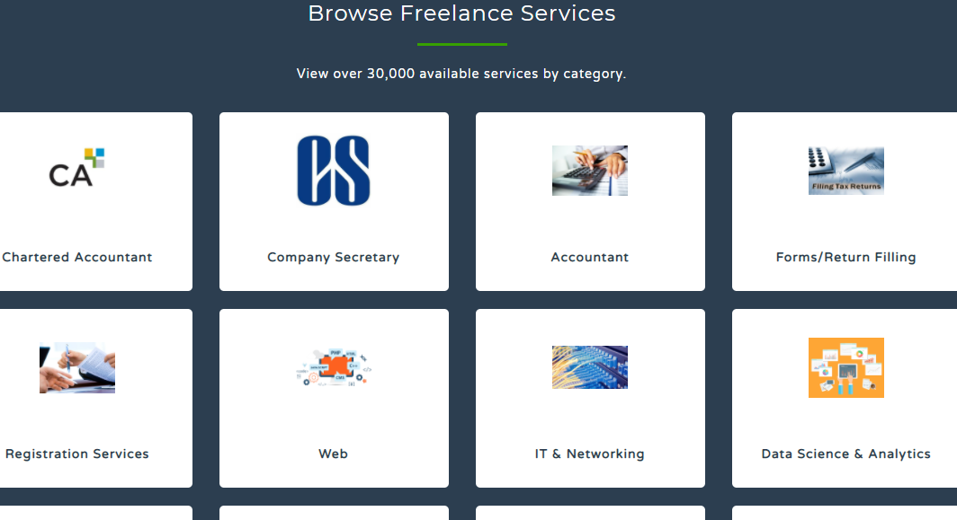

**Hire a freelance web designer from India’s popular freelancing site – Frobity.com**

Your website is your biggest asset. Be it a blog, an e-commerce store, or a brand website, this digital presence needs to be done up flawlessly because it is the first platform of interaction between you and your potential customers, followers, and audience.

But web designing and development can be a costly affair. Not when you have Frobity.com to **hire freelance web designers**, though.

**Why should I hire freelance web designers?**

Designing a website, all on your own, is not highly recommended. There are multiple aspects and features that you need to take care of. Only trained and qualified people who have experience working with sites of different types can do a fair job. Hiring full-time web designers can be costly, but freelancers are substantially affordable. Also, the work quality is significantly higher because freelancers also have years of hands-on experience after completing a dedicated course on web designing and development.

The freelancing community is growing worldwide today. Freelancers can offer better services at the most competitive prices because they are doing multiple projects simultaneously while maintaining superior work-life quality.

Since the work-from-home is the new corporate culture and freelancing comes with innumerable benefits, freelancers are increasing every passing day. Most of them are working professionals who have chosen to embrace freelancing because it helps them manage their work, home, and life optimally.

**Why should I hire freelance web designers from Frobity.com?**

* We are one of the fastest-growing freelancer platforms in the virtual world. We are extremely proud of our rich and increasing database of freelancers.
* At Frobity.com, we ensure that the freelancing community's crème le crème is registered and available to work on your projects. We have a progressively engaging approach for scouting, sourcing, and communicating with our freelancers.
* We call our registered freelancers our 'Partners.' It is because our platform is - for freelancers and by freelancers. They deserve kudos for moving out of the defined ways of career and profession to take on freelancers' roles.
* **Hire freelance web designers** from Frobity.com because our platform offers freelancers from specialized fields like –
* web designing,
* IT & Networking,
* Data Science & Analytics,
* Designing,
* writing,
* translation,
* architecture,
* registration services,
* administrative support,
* customer service,
* sales and marketing, and
* legal.
* All your freelancing needs are fulfilled at the same place because [Frobity.com](https://frobity.com/freelance-tax-and-accountants-work) has expert freelancers from diversified fields, including financial services like Company Secretary, Chartered Accountant, Accountants, and IT Return services.