**Page –** [**https://frobity.com/freelance-wordpress-web-developer**](https://frobity.com/freelance-wordpress-web-developer)

**Need to create “WordPress Developer” section in below and add link on it –**

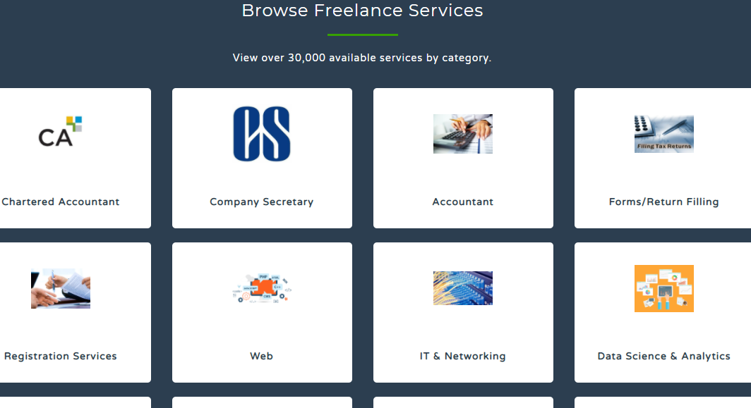

**<h2> For finding top-rated freelance WordPress web developers India </h2>**

It is interesting to note that WordPress powers almost 27% of all websites today. It is a powerful open-source PHP content management system that facilitates the creation of blogs, sites, and e-commerce sites. In the content management software industry (CMS), WordPress has a voluminous share of about 76.4%.

Since WordPress is such a top favourite amongst site owners, blog owners, and online merchants, specialized WordPress developers should be designing your site. Hiring experts can mean shooting way beyond your budget. We, at Frobity.com, understand this. That is why we designed a dynamic platform that helps you find the best and most qualitative freelance professionals suitable for your project. **Freelance WordPress web developers**from Frobity.com can make your WP site seamlessly and offer the services at reasonable prices.

[**www.frobity.com**](http://www.frobity.com)**– India's very own freelancing website**

It has been a few years of our existence, and today we are one of the chosen platform for highly qualified and trained freelancers to register with us. It is a journey that has been inspiring and exciting. Today, we have a burgeoning community of **freelance WordPress web developers**. One of the reasons we are trusted by the best in the freelancing community is that we work closely with our clients. In the process, we encourage our freelancers' growth and development while making certain that there are good-quality and credible assignments offered to them.

Frobity.com is committed to enhancing the way typical work happens. As more and more working professionals turn freelancers, they do so because of the independence that they get to enjoy as freelancers. Also, the earnings are handsome, and it is a different level of satisfaction that they get to taste when an assignment is complete well and lauded by the client.

Our **freelance WordPress web developers** are not only trained and experts in this domain; they are also people who are focused and committed to delivering value to clients with their professional services. When you choose Frobity to hire freelancers, you can be certain you have made the right choice. With the promise of top-notch service and work quality, our freelancers ensure that they stick to deadlines and timelines.

Thanks to our freelancers, Frobity.com has a standing of its own in the virtual medium. We have evolved from nothing and are in the process of continually evolving as we add more domain expertise to our platform so that we become your one-stop solution provider freelancers.