**Page –** [**https://frobity.com/freelance-platform-for-web-developers**](https://frobity.com/freelance-platform-for-web-developers)

**Need to create “Web Developer” section in below and add link on it –**

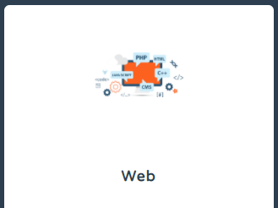

**<h2> The best freelance platform for web developers – Frobity </h2>**

Whether you are a commercial entity launching your online business, an individual blogger keen to change your audience's perspectives, or an established brand planning to grow big, you need a dominating and inspiring website forming a tremendous user experience. The top sites of the world spend tonnes of resources – money, human resources, and time – to design and develop such powerful websites that become their channel to get enhanced traffic and grow sales.

The good thing is that designing, modifying, or tweaking such impeccable sites can now be handed over to freelancers, who are talented and creative and yet affordable. To hire the best freelancers, welcome to Frobity.com. We are one of the biggest **freelance sites for web developers** in India. Not just freelance web developers, you can hire freelancers from as many as 16 domains, including financial and IT return services, writing and administrative services, IT and networking services, legal services, architecture and design services, and web design and development services.

**Use Frobity.com, the best freelance platform for web developers for all your web development requirements.**

Web developers are in demand these days. It is because exquisitely designed websites are the basic requirement of a business today. The online traffic judges a site or its effectiveness by a simple look at the site, and they do not take more than 0.05 seconds to do so. In that short duration, they form an opinion of the site. If it is not a pleasant one, they will move away and influence their friends, family, and acquaintances.

Understandably, competent and proficient web developers are in great demand today. Use [www.frobity.com](http://www.frobity.com), India's foremost **freelance site for web developers**, to find the perfect match for your site development work.

We have the best talents here. After all, we are reputed as one of the fastest-growing and **best freelance platforms for web developers**. Our freelance web developers registered with us are all domain experts with years of hands-on experience and an impeccable track record.

Our outstanding credibility in the market as the **best freelance platform for web developers** has come from our commitment to make this platform dynamically progressive. Also, we invest in engaging and engaging with our freelancers, making them feel wanted. We offer them a platform for dialogue and exchange of ideas and interact with them to upgrade their skills and knowledge.

Frobity.com, India's gen-next **freelance site for web developers**, was created with the concept of offering freelancers and clients a means to put their best foot forward. You upload the assignments, and our partner freelancers offer their bids by submitting their applications, samples of their work, and their charges. Using our smart online platform, you can immediately assess the applicants' strengths and respond to those who seem fit for the job.